2019

Gower College Swansea
DSP Assignment
Jack Solomon
SOL11107605
Contents

Task 1 - Introduction 2
Locating the Error Tone 2
FFT 2
Filter Design 3
Transition Band 4
Normalised Frequencies 5
Calculating Taps 5
Analysing the Filter 6
Filter Response 7
The Matlab Filter 8
Task 2 – Introduction 9
Early Days of Mobile Communication 9
TDMA GSM 9
TDMA Cell Planning 10
Reducing Interference in TDMA 11
WCDMA UMTS 11
WCDMA Cell Planning 12
Bandwidth Clearance for 5G 12
Conclusion 13
Bibliography 14

Task 1 - Introduction
The objective of this assignment is to create an FIR filter to filter an audio file which has been corrupted with an error tone. To create a successful FIR filter, a number of procedures have to be completed. The program ‘Matlab’ was used to create the filter. An FIR filter is described as;
“A Finite Impulse Response (FIR) filter is a filter structure that can be used to implement almost any sort of frequency response digitally. An FIR filter is usually implemented by using a series of delays, multipliers, and adders to create the filter's output.” (Barr, 2002)

Locating the Error Tone
The first step to solve the problem was to identify and locate the error tone from within the program. This was done by creating a set of coding in matlab to load, play and display the audio file in order for it then to be successfully removed.
Figure 1 shows the code used to plot the graph and to play the audio file. Line 3 shows the audio file being uploaded to the program. Line 4 shows a transfer function being applied to the audio file to convert the file from the time domain and into the frequency domain. To view the audio file in the frequency domain, a graph was plotted (line 8).
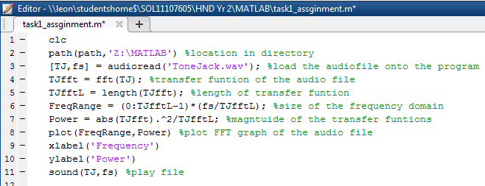
Figure 1

FFT
The purpose of the transfer function is to view the audio file in its frequency domain to locate the error tone. Figure 2 shows the graph which has been produced after the transfer function and the error tone is believed to be the spike on the graph. Line 11 shows the command used to play the corrupt audio file, as seen in figure 2.
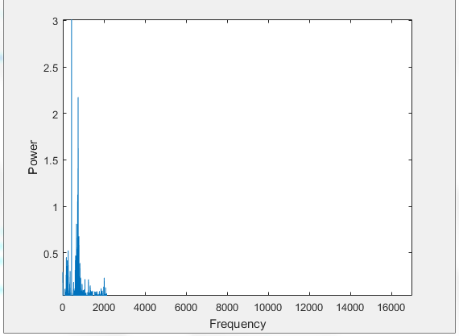
Potential error-tone.
Figure 2

Filter Design
The first step to designing a filter is to determine the frequency of the error tone from within the audio file. This is an essential part to the filter design process. The purpose of this filter is to block out a desired frequency (the error tone) from the audio file. Figure 3 is an enhanced view of audio file. In this instance the frequency which needs to be filtered out is around 425Hz.
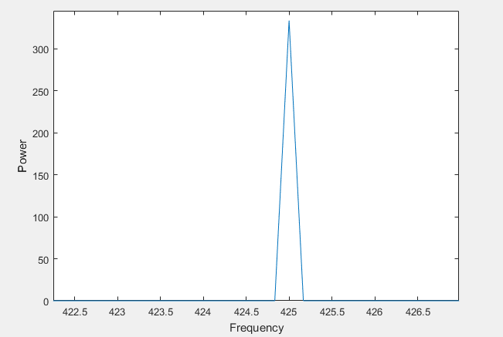
Figure 3

Transition Band
As well as the frequency, the ‘Transition band’ of the filter will need to be carefully decided. This determines how much of the audio file is being removed by the filter. Figure 4 shows a sketch of how bigger and smaller transition bands would look like on an FIR filter. The red filter is wide, meaning the transition band is great. If the transition band is too wide, then too much of the audio file has been removed. On the other hand, the green filter is sharp. If the transfer band is too sharp then it will remove less of the audio file but will also result in greater taps needed. The more taps which are needed will result in the filter becoming more expensive as well as creating more delay in the filter. The goal is to have a filter like the blue which is in the middle of both. (Orfanidis, 2010)
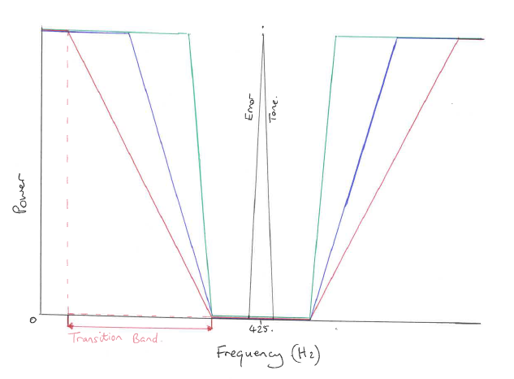
Figure 4
Lines 13-15 in figure 5 show the low & high cut values and the transition band value.
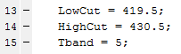
Figure 5

Normalised Frequencies
The name of the program used to create the code is called ‘matlab’. While using matlab, it only allows normalised frequencies. Therefore, the transition band’s high and low cut frequencies will need to be normalised. (MatlabHelp)
To calculate the normalised frequencies, the Nyquist rate needs to be calculated. The Nyquist rate is half the sampling frequency which is shown on line 17 below in figure 6. Lines 19-21 in figure 6 show the normalised frequencies being calculated.
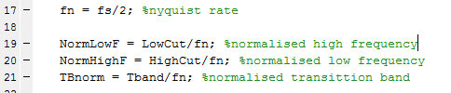
Figure 6

Calculating Taps
When calculating the number of taps needed in the filter, the number 3.3 will need to be divided by the normalised transition band. This number comes from the hamming code table, as shown in figure 7. The smaller the transition band, the more taps are required. (Franklin)
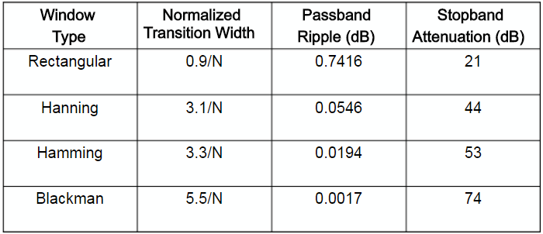
Figure 7
To apply this information to the program, the commands shown in figure 8 were used. The final step is to create the filter. Line 27 uses the matlab command ‘fir1’ to create the filter. Line 28 uses the command ‘filter’ to apply the filter to the audio file ‘TJ’.
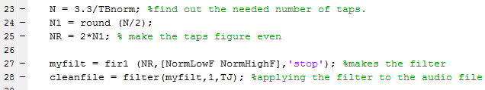Figure 8

Analysing the Filter
After the new filtered audio file has been created it needs to be analysed. Therefore, the decision was made to perform another fourier transform to see if the filter successfully removed the spike in the graph shown in figure 2. To do this a new set of code is created as shown below in figure 9. The exact same procedure used in figure 1 was used for figure 9, except different variables were used.
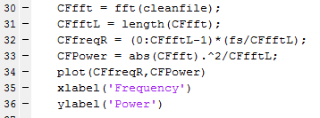
Figure 9
Line 34 uses the command ‘plot’ to plot the graph of the created audio file. Figure 10 shows the new created graph of the audio file. It is clear that the creation of the filter was successful and the spike has been removed. (MatlabHelp)
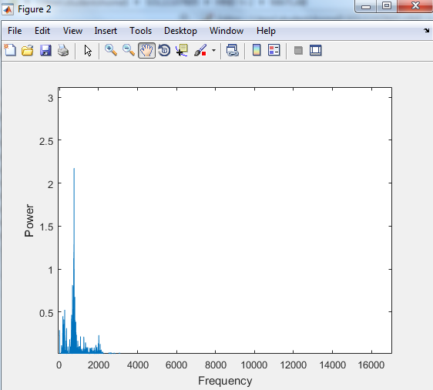
Figure 9

Although the spike has been removed, the error tone may be located in a different frequency. To make sure that the error tone has been removed, the new audio file must be played to see if it is still present. The commands used in figure 11 were used to play the new created audio file.
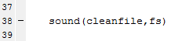
Figure 11

Filter Response
Figure 12 is the filter response showing the magnitude and the frequency of the filter. To view the filter response the term ‘freqz(myfilt)’ is typed into the command window. The total gain of the filter is around 5.5dB. This is a low amount and it is surprising that the tone has been successfully removed from the audio file.
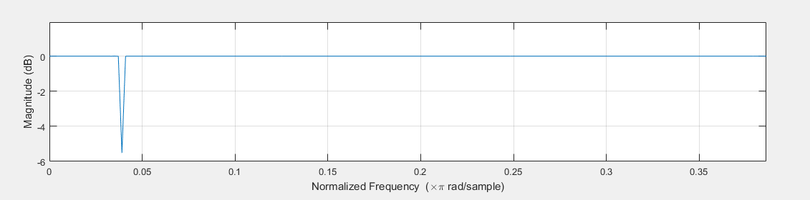
Figure 12
An FIR filter is a linear filter. Figure 13 shows a steady gradual decrease which is expected in a FIR filter.
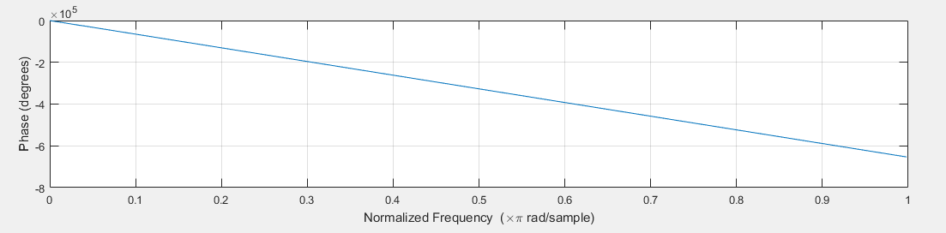
Figure 13

The Matlab Filter
clc
path(path,'Z:\MATLAB') %location in directory
[TJ,fs] = audioread('ToneJack.wav'); %load the audiofile onto the program
TJfft = fft(TJ); %transfer funtion of the audio file
TJfftL = length(TJfft); %length of transfer funtion
FreqRange = (0:TJfftL-1)*(fs/TJfftL); %size of the frequency domain
Power = abs(TJfft).^2/TJfftL; %magntuide of the transfer funtions
plot(FreqRange,Power) %plot FFT graph of the audio file
xlabel('Frequency')
ylabel('Power')
%sound(TJ,fs) %play file

LowCut = 419.5;
HighCut = 430.5;
Tband = 5;

fn = fs/2; %nyquist rate

NormLowF = LowCut/fn; %normalised high frequency
NormHighF = HighCut/fn; %normalised low frequency
TBnorm = Tband/fn; %normalised transittion band

N = 3.3/TBnorm; %find out the needed number of taps.
N1 = round (N/2);
NR = 2*N1; % make the taps figure even

myfilt = fir1 (NR,[NormLowF NormHighF],'stop'); %makes the filter
cleanfile = filter(myfilt,1,TJ); %applying the filter to the audio file

CFfft = fft(cleanfile);
CFfftL = length(CFfft);
CFfreqR = (0:CFfftL-1)*(fs/CFfftL);
CFPower = abs(CFfft).^2/CFfftL;
plot(CFfreqR,CFPower)
xlabel('Frequency')
ylabel('Power')

sound(cleanfile,fs)

Task 2 – Introduction
The rise of mobile communications continues to explode and therefore, the demand for mobile networking is rising. Along with the massive demand for social media; businesses, schools and pretty much everything in-between are going paperless in attempt to becoming “digital”. But what effect is this having on the mobile networks?

Early Days of Mobile Communication
Mobile communications have come a long way from the days of the “Push-to-Talk” system used in the 1950s. This system would use a single transmitter on top of a tall building. A single channel was used for sending and receiving signals. To talk, the user would push a button which would enable transition but would disable reception. In the 1970s, private companies created their own systems around the world. This system later became part of the 1st Generation (1G). Systems such as FDMA were used in the 1st Generation to transmit and receive signals. Frequency Division Multiple Access (FDMA) provides chunks of the frequency spectrum to different users for data transition. Guard bands were introduced to prevent interference.

TDMA GSM
Global System for Mobile Communication GSM is digital cellular technology used for transmitting mobile voice and data services. It describes the protocols for 2G digital cellular networks used by mobile devices such as mobile phones and tablets.
Time division multiple access or TDMA was first used in 2nd Generation (2G) systems. Its function was to increase the amount of data that can be carried. It allows multiple users to share common frequencies without interferences by allocating different times from within each 200KHz channel. Only one user can use each time slot at any given time. “When a mobile radio communicates with a TDMA system, it is assigned a specific time position on the radio channel. By allowing several users to use different time positions (time slots) on a single radio channel, TDMA systems increase their ability to serve multiple users with a limited number of radio channels.” (Lawrence Harte, 2012)
With regards to the TDMA GSM system there are 8 bursts (time slots) within each frequency. There is a total of 20m/s speech over a number of bursts. When transmitting and receiving, this system uses radio channel pairs. One of the radio frequency channel for the downlink and one for the uplink.

0 |  |  |  |  | x |  | 7
Call
0 |  |  | x |  |  |  | 7
Figure 1; shows how different times slots are used when two users are connected to each other.

TDMA Cell Planning
In TDMA systems, cell planning is used to divide geological areas to allow frequencies to be re-used. All the available frequencies are divided up into groups to form a cluster. Within a cluster, each cell will have a different frequency (Haque, 2013).
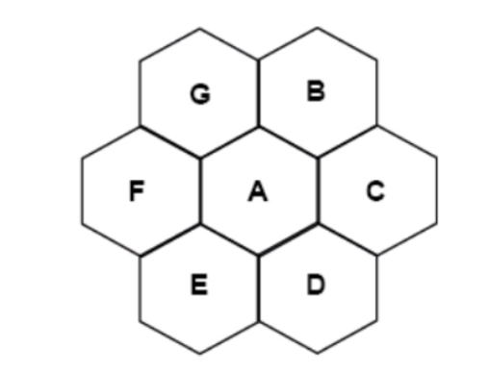
Figure 2; Demonstrating an example of a cluster (Haque, 2013).
By repeating these clusters, cellular networking can be built.
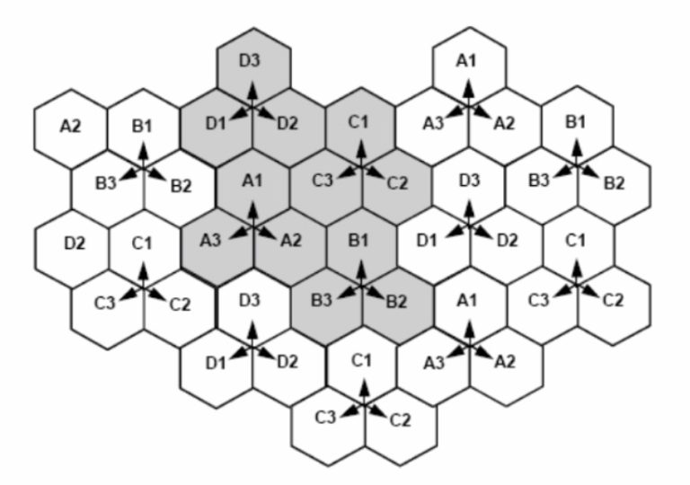
Figure 3; shows an example of a cellular network (Haque, 2013).
Frequencies used in one cell can be re-used in another, however, only once past a certain distance. The exact set up used in each cluster but continuously repeated to allow the same distances between neighbouring clusters. This is known as frequency re-use.
The purpose of frequency re-use is to maximise coverage and capacity. To increase capacity, cells and clusters are made smaller depending on the population of the area. This allows more people to use the system. By doing this however, interference is at a higher risk as the neighbouring frequencies are closer together.

Reducing Interference in TDMA
When signals are transmitted from a distance, there is a time delay which can cause interference. To prevent this a technique called ‘Timing Advance’ is needed. This is when the time slot is adjusted accordingly to prevent collisions and interferences with the users either side.
An equalisation tool can be used to prevent distortion when transmitting and receiving signals. For example, if a single signal is transmitted, it can collide into a mountain. This will cause interference as two or more signals are trying to be received.
Frequency Hopping Spread Spectrum (FHSS) is an application used to switch transmitting radio signals to a number of different frequency channels. Because frequency hopping is wireless technology that spreads its signal over rapidly hopping radio frequencies, it is highly resistant to interference and is difficult to intercept. Interference at a specific frequency only affects the transmission during that extremely short interval, making FHSS secure. (Allen, 2017)
Discontinuous Transmission (DTX) decreases the transmission when there is a gap in speech periods while maintaining an adequate level of output quality. When a pause gap in speech is detected during a voice call, the radio transmissions for the duration of the pause are discontinued or suspended. Discontinuous transmission tends to reduce interference from cells nearby and also to mobile stations close to the base station. Transmitted time is decreased when discontinuous transmission is used; resulting in the total power consumption being reduced. (2008)
To reduce a potential error, transmission must be done on a minimum power as much as possible. This helps the system become more efficient.

WCDMA UMTS
Universal Mobile Telecommunications Service (UMTS) are part of the 3rd generation of mobile communications. UMTS is the successor of the older GSM networks and it increases the data speeds of up to 45Mbps.
The third generation of technologies for mobile networks has added a lot of new features aside from the typical calling and messaging capabilities of older 2G networks. Wide-band Code Division Multiple Access (WCDMA) is 3rd generation technology that uses the CDMA air interface. WCDMA works on WCDMA mobile phones as well as laptops and portable devices with WCDMA modems.
WCDMA utilizes two 5MHz channels, one from the base station to a mobile device (downlink) and another from the mobile device to the base station (uplink). The 5MHz channel is an upgrade in comparison to the 1.25MHz channel used by the older CDMA. The increased bandwidth along with other techniques is designed to increase the number of users who can use the channel while increasing the total bandwidth that can be utilised for the data. (Joan)

WCDMA Cell Planning
Cell planning is also used in WCDMA but it differs from TDMA. TDMA splits up geological areas into clusters with each cell using a different frequency to prevent interference. WCDMA however, allows adjacent cells to obtain the same frequency without interference. This is done by using an algorithm call Direct-sequence Spread System (DSSS).
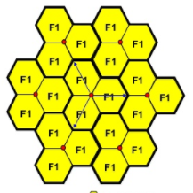
Figure 4; Shows an example of WCDMA cell planning (Haque, 2013).
Direct Spread System (DSSS) is a modulation technique used to decrease signal interference in WDCMA systems. The application spreads the signal which causes the resulting wideband channel to become noisier. This allows for greater resistance to interference. (2016)

Bandwidth Clearance for 5G
Telecommunications companies are set with a mammoth task to supply the massive demand. Even though the 4G system has only been around for a few of years, it is reaching its limits already. Therefore, the start of the 5G network is being prepared and will be with us soon. To ensure that the 5G reaches its potential, the 700MHz bandwidth is in the process of being cleared for 4G and 5G use. Currently the 700MHz bandwidth is occupied by DTT (digital terrestrial television). The government along with telecommunications companies plan to re-tune existing transmissions used in DTT to new frequencies without impacting viewers. (Mattera, 2018)

Conclusion
To conclude mobile networks systems have evolved greatly over to meet the ever-growing demand. Many of the techniques outlined in this report are the key factors to allow mobile networking to improve. The strength, speed, capacity, efficiency, security and availability of transmitting and receiving signals has improved over time. Telecommunications companies continue to create new methods to improve and maximise the mobile network which is essential to meet the demand.

Bibliography
2008. Key Sight. [Online] December 2008. http://rfmw.em.keysight.com/rfcomms/refdocs/gsm/gprsla_gen_bse_dtx.html.
Allen, Scott. 2017. Texas Instruments. [Online] July 2017. https://e2e.ti.com/blogs_/b/connecting_wirelessly/archive/2017/07/17/the-importance-of-frequency-hopping.
Barr, Michael. 2002. Introduction to Finite Impulse Response Filters for DSP. BarrGroup.com. [Online] Sunday January 2002. [Cited: 24th May 2019.] https://barrgroup.com/Embedded-Systems/How-To/Digital-Filters-FIR-IIR.
2016. DSSS - Direct Sequence Spread Spectrum - Telecom ABC. Telecombac.com. [Online] 11 November 2016. www.telecomabc.com.
Franklin, Shon. SlidePlayer. SlidePlayer.com. [Online] https://slideplayer.com/slide/8652014/.
Haque, Sanjida. 2013. GMS, Cell Planning & Frequency Reuse. SlideShare.net. [Online] 25 July 2013. https://www.slideshare.net/sanjida2222/presentationj.
Joan, Ben. Difference Between UMTS and WCDMA Network Technologies. DifferenceBetween.net. [Online] http://www.differencebetween.net/miscellaneous/difference-between-umts-and-wcdma-network-technologies/.
Lawrence Harte, Bruce Bramley, Mike Davis. 2012. Introduction to GSM. 2012. p. 116.
MatlabHelp. MatlabHelp. Matlab. [Online]
Mattera, Tony. 2018. What is 700MHz Clearance? arquiva.com. [Online] 2 july 2018. https://www.arqiva.com/views/blog/what-is-700mhz-clearance/.
Orfanidis, Sophocles J. 2010. Introduction To Signal Processing. 2010, p. 795.

