Slide 0

Slide 1- Introduction
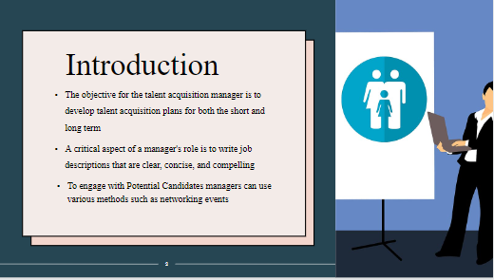
Speaker Note
As a Talent Acquisition Manager at the Restaurant, the primary objective is to develop talent acquisition plans that address the company's short-term and long-term staffing needs. As stated by Nimri et al. (2021), managers should use targeted keywords and phrases that will resonate with potential candidates while setting the Restaurant apart from its competitors.
Slide 2- Referral Program
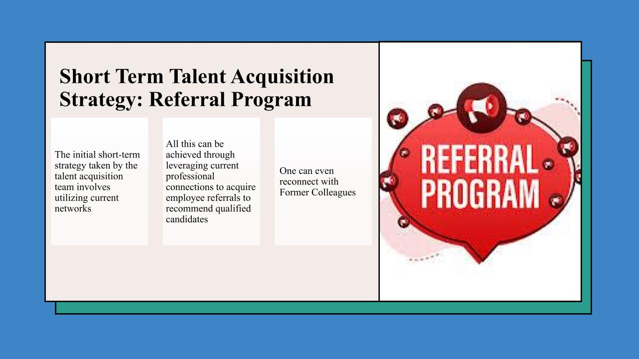
Speaker Note
As per the view of Chen, Riantama and Chen (2020), referral programs can be a cost-effective way to recruit new employees because they rely on current employees to find potential candidates, rather than relying solely on external recruitment methods which may require advertising expenses. Referral candidates are more likely to be a good fit for the company culture, leading to higher retention rates and lower turnover.

Slide 3- Social Media Presence
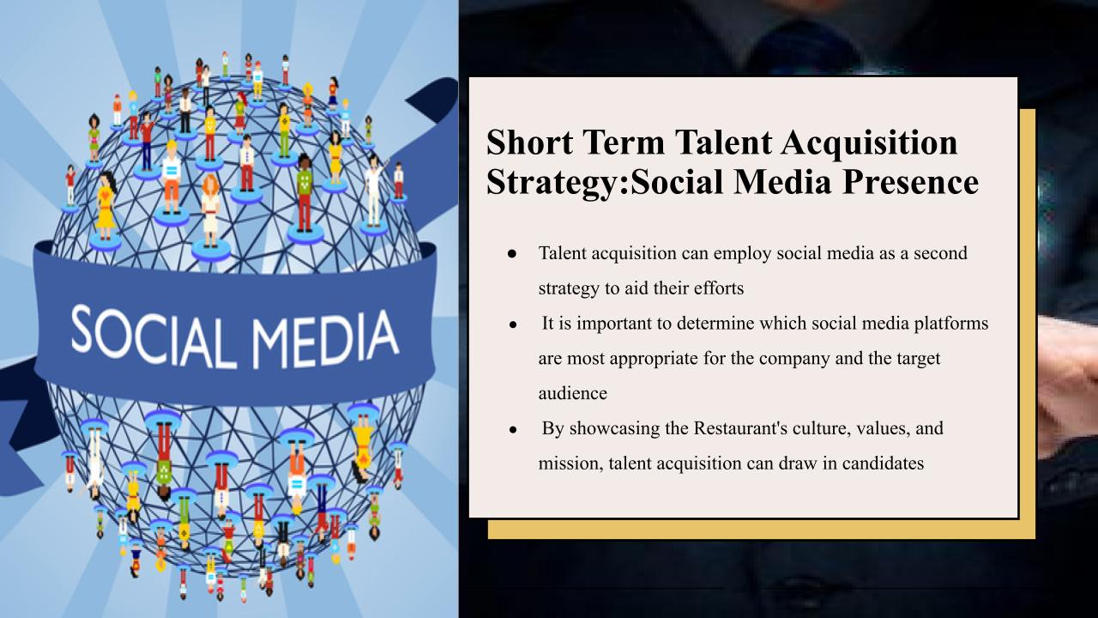
Speaker Note
Social Media is an important short-term strategy. According to Ardiatama (2021), creating a social media plan that involves tailored messaging, content, and campaigns can significantly assist in reaching potential candidates. Moreover, social media platforms can be utilized to advertise job vacancies and furnish comprehensive details about the role. This can help to reach potential candidates who may not be actively looking for a job but could be interested in joining the Restaurant.

Slide 4- Talent Pools
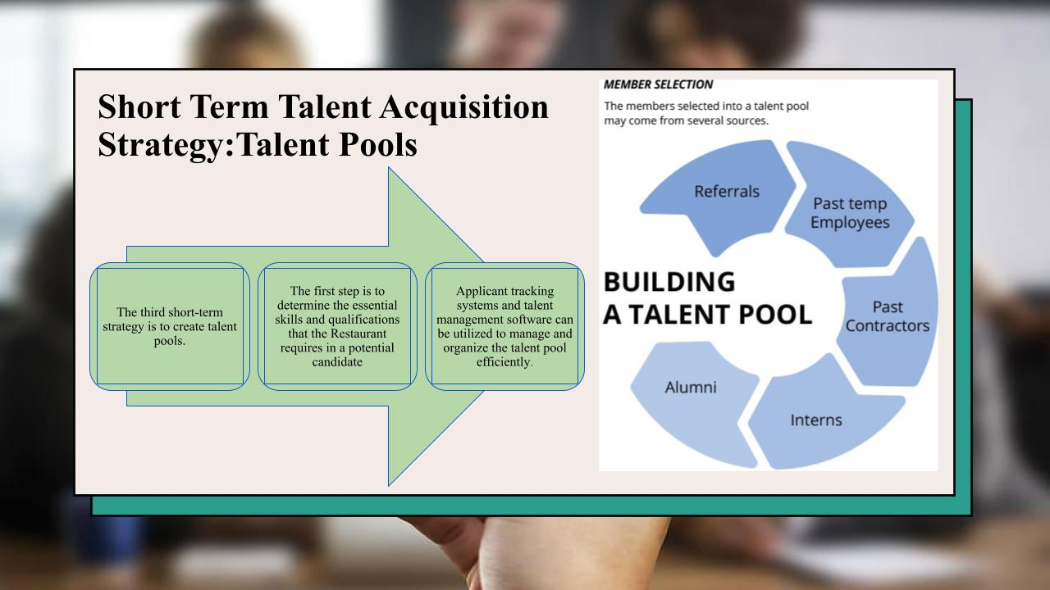
Speakers Note
Talent pools are groups of potential candidates who have shown interest in working for a Restaurant or who have the skills and qualifications that the company is looking for. As opined by Al-Abdallah, Dandis and Al Haj Eid (2022), by maintaining a talent pool, companies can save time and resources in recruiting, as they already have a pool of potential candidates to draw from when a position becomes available.

Slide 5- Establishing a Brand Image
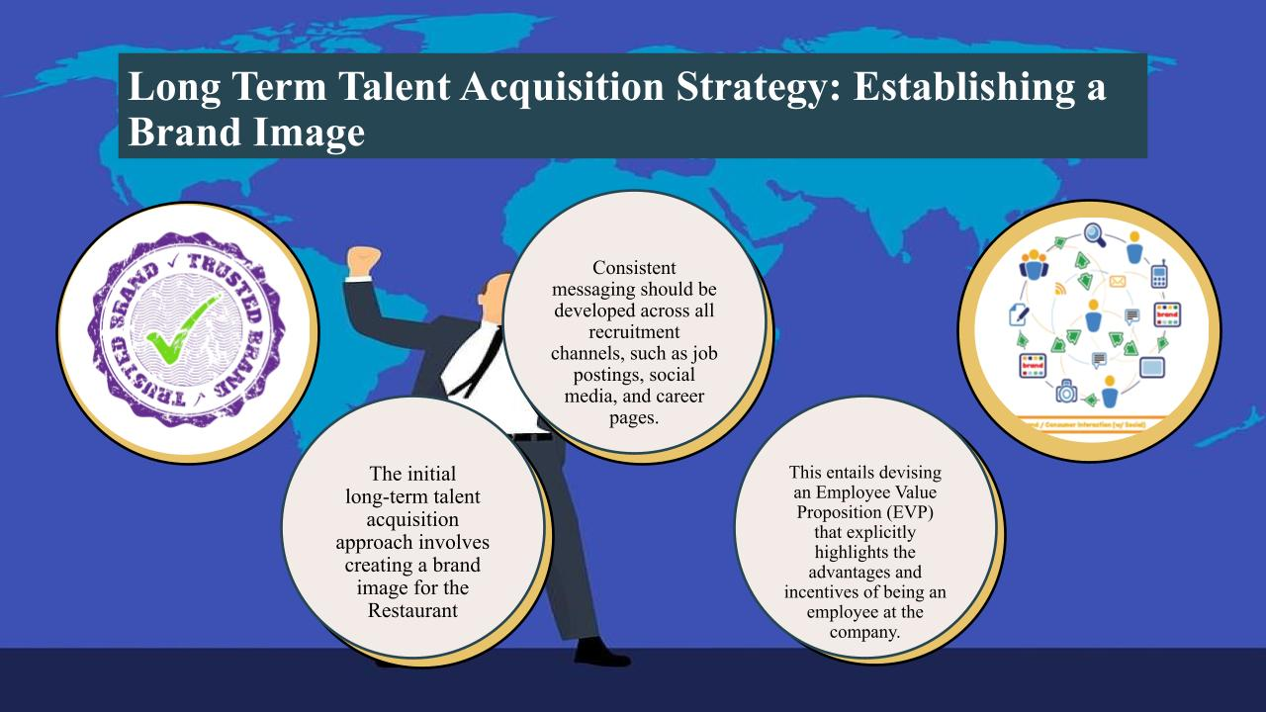
Speakers Note
To establish a strong brand image, restaurants should aim for consistency across all visual elements. As stated by Gehrels and Gehrels (2019), this helps build brand recognition and creates a cohesive and professional look across all marketing materials, products, and customer touchpoints. It is also essential to ensure that the brand image is reflective of the company's values and mission. Overall, establishing a strong brand image is critical for businesses looking to build a loyal customer base.

Slide 6- Investing in Training
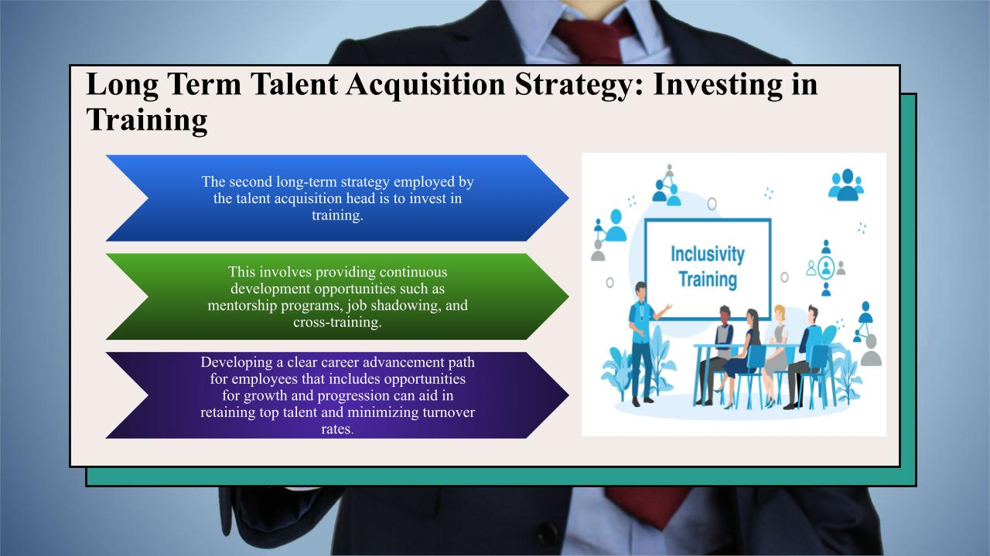
Speakers Note
Investing in training is a critical aspect of developing and retaining talent within an organization. It is true that providing employees with opportunities for ongoing learning and development not only helps to improve their skills and knowledge but also demonstrates the company's commitment to their growth and career advancement (Han et al., 2022).

Slide 7- Improved Recruitment Process
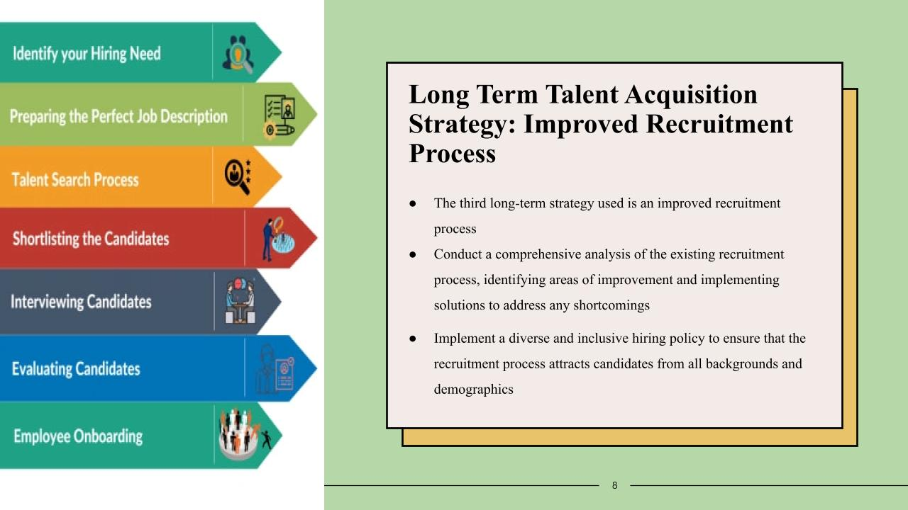
Speakers note
By investing in training, companies can also improve employee engagement, motivation, and job satisfaction. According to Romanko and O’Mahony (2022), employees who feel supported and valued are more likely to be productive, innovative, and committed to the organization. Furthermore, investing in training can also result in cost savings for the company. A highly skilled workforce is more efficient, effective, and able to handle complex tasks, reducing errors and improving productivity.

Slide 8- Offering competitive salaries

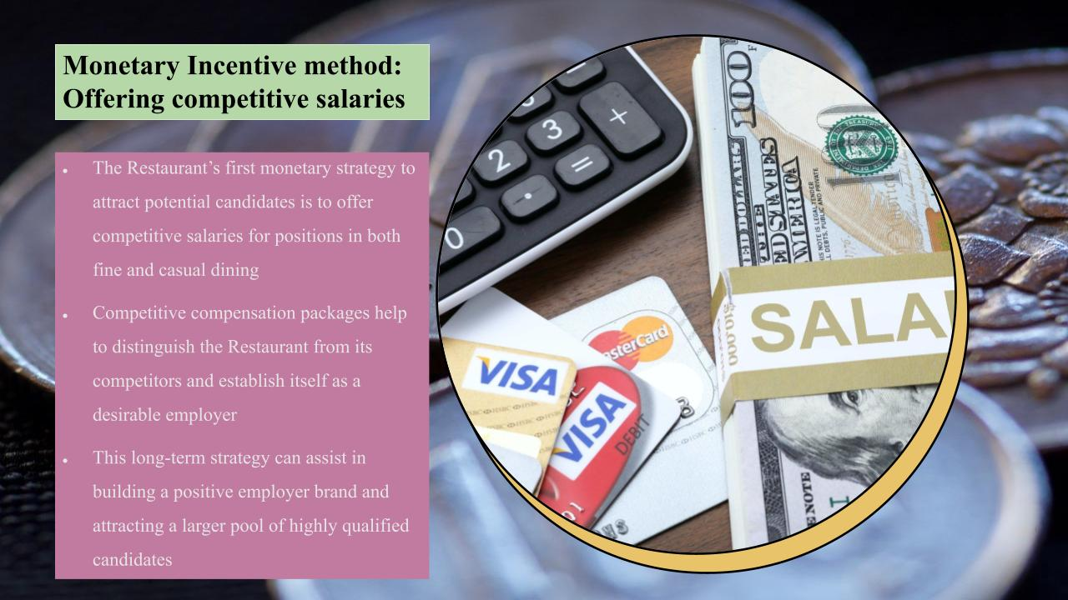
Speakers Note
As per the view of Akanda et al. (2021), to attract potential candidates, the Restaurant has implemented a monetary strategy focused on offering competitive salaries for positions in both fine and casual dining. By providing attractive compensation packages, the company aims to retain and attract top talent in the industry, setting itself apart from its competitors. This approach is part of a long-term strategy aimed at building a positive employer brand and expanding the pool of highly qualified candidates.

Slide 9- Providing bonuses
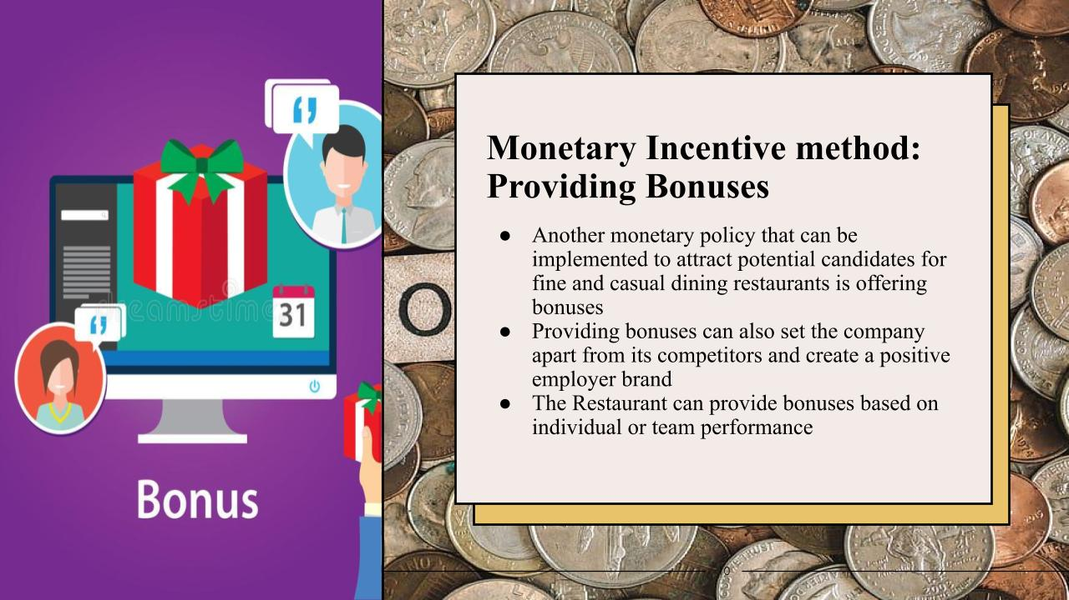
Speakers Note
In addition to offering competitive salaries, providing bonuses can be a great way to incentivize and reward the restaurant staff for their hard work and dedication. The Restaurant has the flexibility to offer bonuses to its staff based on various criteria, including individual or team performance, and tenure (Lee et al., 2023). By offering bonuses based on these factors, the Restaurant can incentivize and motivate its employees.

Slide 10- Providing flexible working hours
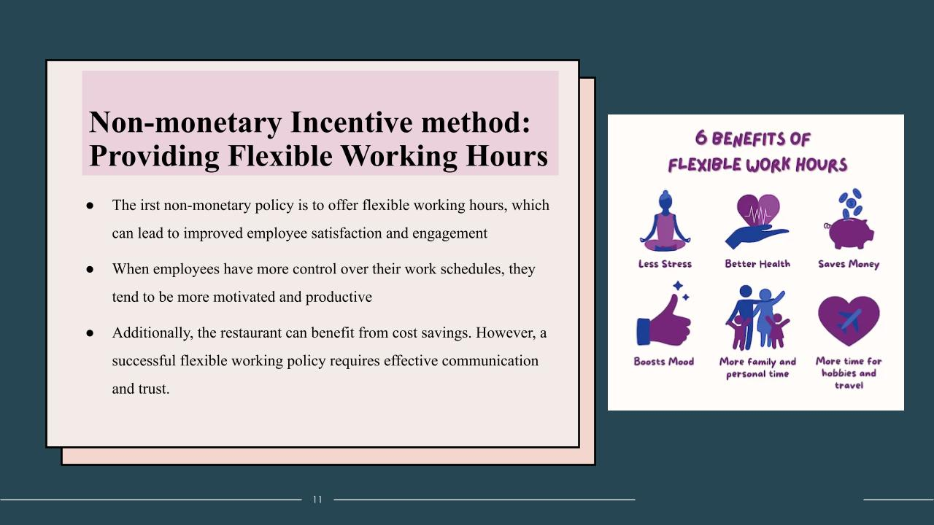Speakers Note
As stated by Akanda et al. (2021), flexible working hours can be a great way to attract and retain top talent in the restaurant industry. The Restaurant’s primary non-monetary strategy is to provide flexible working hours, which can enhance employee satisfaction and engagement. Allowing employees to have greater control over their work schedules can lead to increased motivation and productivity.

Slide 11- Introducing job rotation

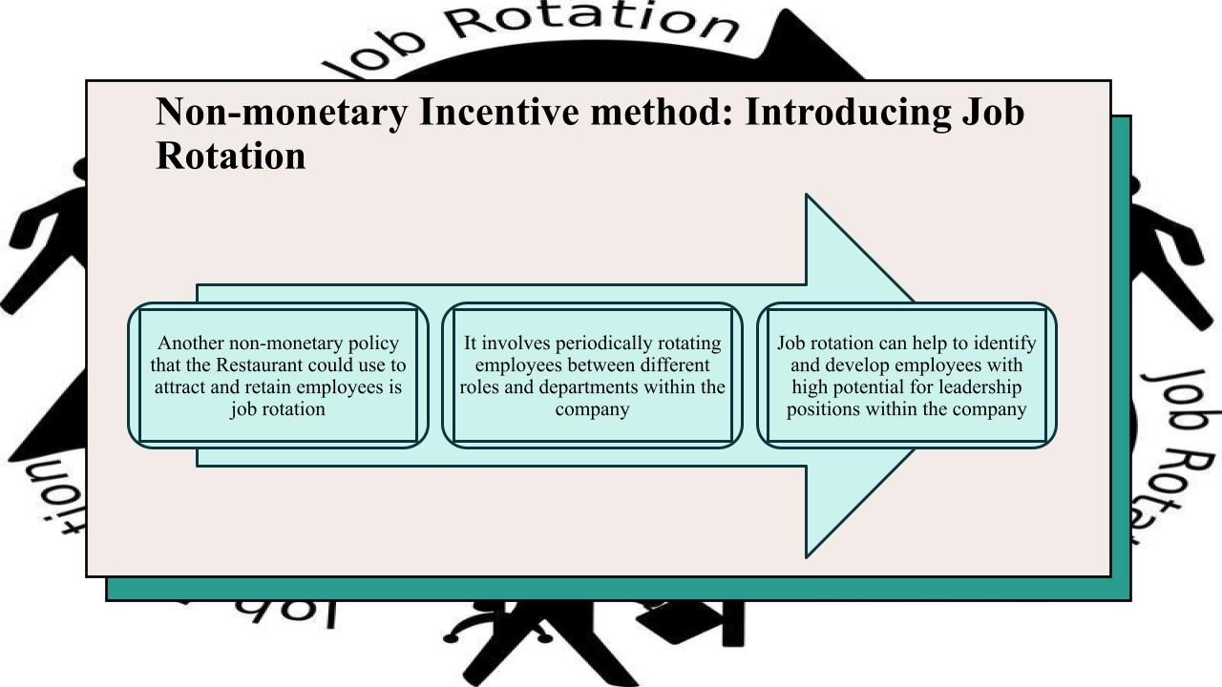Speakers Note
Job rotation can provide employees with a variety of experiences and opportunities for learning and development, leading to improved job satisfaction and motivation. Additionally, however, it is important to ensure that job rotations are structured in a way that provides adequate training and support for employees to succeed in their new roles (Romanko and O’Mahony, 2022). Job rotation can be a valuable tool for employee development and engagement in the restaurant industry.

Slide 12- Conclusion
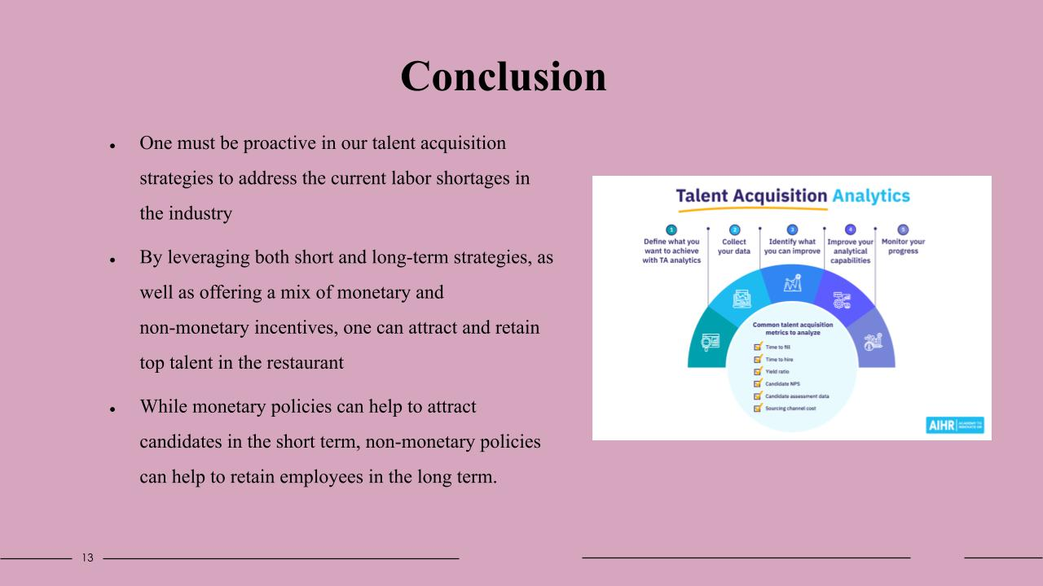Speakers Note
In the restaurant industry, where the competition for top talent is high and labour shortages are common, it is essential to have a well-rounded approach to talent acquisition. Offering competitive salaries and bonuses can attract potential candidates to work in the restaurant industry, differentiate the company from its competitors, and potentially lead to better retention rates.

Ref List
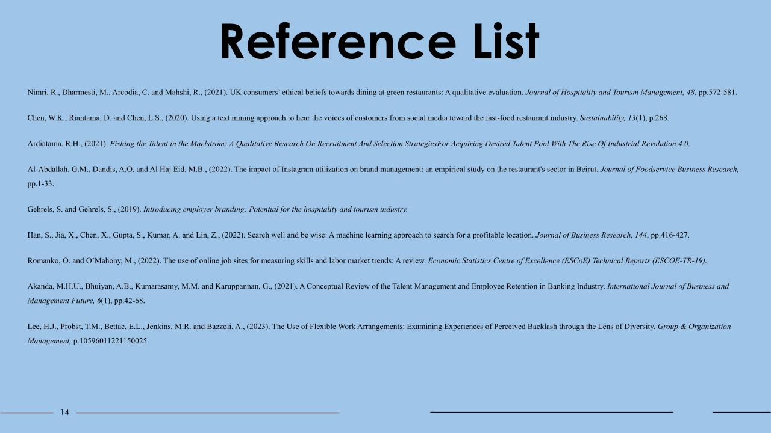
Nimri, R., Dharmesti, M., Arcodia, C. and Mahshi, R., (2021). UK consumers’ ethical beliefs towards dining at green restaurants: A qualitative evaluation. Journal of Hospitality and Tourism Management, 48, pp.572-581.
Chen, W.K., Riantama, D. and Chen, L.S., (2020). Using a text mining approach to hear the voices of customers from social media toward the fast-food restaurant industry. Sustainability, 13(1), p.268.
Ardiatama, R.H., (2021). Fishing the Talent in the Maelstrom: A Qualitative Research On Recruitment And Selection StrategiesFor Acquiring Desired Talent Pool With The Rise Of Industrial Revolution 4.0.
Al-Abdallah, G.M., Dandis, A.O. and Al Haj Eid, M.B., (2022). The impact of Instagram utilization on brand management: an empirical study on the restaurant's sector in Beirut. Journal of Foodservice Business Research, pp.1-33.
Gehrels, S. and Gehrels, S., (2019). Introducing employer branding: Potential for the hospitality and tourism industry.
Han, S., Jia, X., Chen, X., Gupta, S., Kumar, A. and Lin, Z., (2022). Search well and be wise: A machine learning approach to search for a profitable location. Journal of Business Research, 144, pp.416-427.
Romanko, O. and O’Mahony, M., (2022). The use of online job sites for measuring skills and labor market trends: A review. Economic Statistics Centre of Excellence (ESCoE) Technical Reports (ESCOE-TR-19).
Akanda, M.H.U., Bhuiyan, A.B., Kumarasamy, M.M. and Karuppannan, G., (2021). A Conceptual Review of the Talent Management and Employee Retention in Banking Industry. International Journal of Business and Management Future, 6(1), pp.42-68.
Lee, H.J., Probst, T.M., Bettac, E.L., Jenkins, M.R. and Bazzoli, A., (2023). The Use of Flexible Work Arrangements: Examining Experiences of Perceived Backlash through the Lens of Diversity. Group & Organization Management, p.10596011221150025.


