Community Engagement Report



Module Name: Community Engagement
Project Name: Matthew’s House
Name: Ella Williams
Student Number: 1707424

Table of Contents

- Executive Summary………………………………………………………………………………………...3
- Introduction…………………………………………………………………………………………………….4-6
2.1. Report Remit
2.2. Brief Background of the Organisation
2.3. The Problem
- Problem Solving Techniques……………………………………………………………………………6-14
3.1. Solving the Problem
3.2. Problem Solving Implementation
- Conclusion……………………………………………………………………………………………………….15
- References………………………………………………………………………………………………………16-17

List of Figures

Figure 3.1: Ishikawa Diagram………………………………………………………………………………7
Figure 3.2: The 5 Whys………………………………………………………………………………………..9
Figure 3.3: The 5 Whys expansion……………………………………………………………………….9
Figure 3.1.4: Matthew’s House's Fishbone Diagram…………………………………………….11
Figure 3.1.5: Statistics for Social Networking Worldwide…………………………………….12
Figure 3.2.6: Matthew's House Facebook Figures……………………………………………….14

- Executive Summary

This report provides a real world case study. The real world case study that was chosen was “problems you faced during your first semester project”. This includes background information about the organisation, as well as the problem the organisation is facing. The purpose of this report is to show the reader how problems can be fixed if you follow the problem solving techniques that have been proven to help find a solution.
In the first semester I worked with a not for profit organisation called Matthew House to undertake a project. The organisation was created to give hope to vulnerable people in Swansea. Within Matthew’s House there is one employee called Thom who works for the organisation and we communicated with him throughout the project. This meant if there were any problems we would go to Thom. During the project there were 5 team members including myself and we were given aims to complete. The aims were to spread awareness and raise money to help fund their organisation. This was because the organisation itself were struggling to spread awareness, as well as raise money, which is why we were set those tasks.
Within this report I used two different problem techniques to solve the problem Matthew’s House was facing. The two techniques were the Ishikawa Diagram and the 5 Why’s.
The findings of the report consist of how Matthew’s House have two problems which are how the organisation needs to raise more money and how not enough people know of the organisation. However, when I was completing the Ishikawa diagram I found that the organisation cannot raise a lot of money if people are not aware that the organisation exists, so there was one main problem to solve.
The outcome of the diagram showed to solutions to the problem which were to advertise more and make more people trust the organisation when they do become aware of its existence. To do this the organisation needs to put banners up in the centre of Swansea, not just outside the organisations building as not enough people will see it. This also includes handing out leaflets about the organisation to help make more people aware. If Matthew’s House thoroughly worked on their solutions towards their problem then they would see a huge difference. To do that they will have to monitor everything they do and compare statistics from before and after they started. If they are successful then they will be able to continue in the on-going future. I would recommend Matthew’s House to do this as it will benefit them a lot.

- Introduction

2.1. Report Remit
This report will include a real case study, which will include background information about the organisation I worked with as well a problem that has been faced by the company.
This report will also analyse the problem, apply decision making techniques when assessing the possible solutions and plan how I will implement the solution. Problem solving methods will be used throughout the report to link this together.

2.2. Background of the Organisation
Throughout the first semester of university I worked with an Organisation called Matthew’s House. Matthew’s House is a not-for-profit organisation that was created to help vulnerable people in Swansea (Lynch, About us, 2018). Vulnerable people could be either homeless, an alcoholic or addicted to drugs. The organisation give hope and offer food to the local community.
In 2015, Matthew’s House was founded by a group of 30 friends who all had the ambition to give back to their local community (Lynch, 2017). The organisation is located in the Hill Church, which is in the heart of Swansea where people can access it easily. Within the building there is also a café set up, which the organisation call ‘Matt’s Café’ for homeless people, so they are able to east a warm meal. There is not a certain price for each meal, people can just pay what they can. However, to feed every person it costs 70p.

2.3. The Problem
For every organisation there are always problems along the way that they will face but every organisation gets through it if they are determined to be successful.
Adair states how a ‘problem’ is something that is ‘thrown in front of you’ (Adair, 2016, p. 42).
Although the organisation is set up for a great cause, it has faced some problems such as:
- How the organisation need to raise more money.
- How not enough people know of the organisation.

Due to Matthew’s House being a not-for-profit organisation they will always need to raise money to stay running. For the organisation to be open for one day it costs £30 and without the money the organisation would have to shut down, which would affect a lot of people. A lot of homeless people rely on the organisation to be open on Monday’s, Tuesday’s, Friday’s and Sunday’s so they are able to socialise and have a warm affordable meal. Fundraising is the only way Matthew’s House are able to get money to fund the organisation. However, not enough people are aware of the organisation itself so this is very difficult for Matthew’s House to get people to support them by fundraising or donating money. Without people being aware of the organisation they will not be able to help.
Without money to support the organisation the volunteers and the only employee, Thom, will struggle to keep Matthew’s House open. This effects all the people who come to the Church for support, food or a social life as they are now relying on Matthew’s House to stay open and give them hope to carry on living their everyday lives, even though times can be hard. However, this may have a huge effect on the volunteers and employees as all their hard work and effort has gone into Matthew’s House and they will not want to lose that.

- Problem Solving Techniques
Problem solving is the process of working individually or in a team through the details of a problem, in order to reach a solution (Business-Dictionary, Problem Solving, 2018).
There are lots of problem solving techniques in which people can use to solve the problem they are facing. To solve the problems for Matthew’s House I used two type of diagrams:
- Ishikawa Diagram
- The 5 Whys
Ishikawa Diagram
In the 1960’s professor Kaoru Ishikawa invented a pioneer of the quality management. This diagram was created to help people brainstorm all the possible causes for a problem (Rouse, 2014).

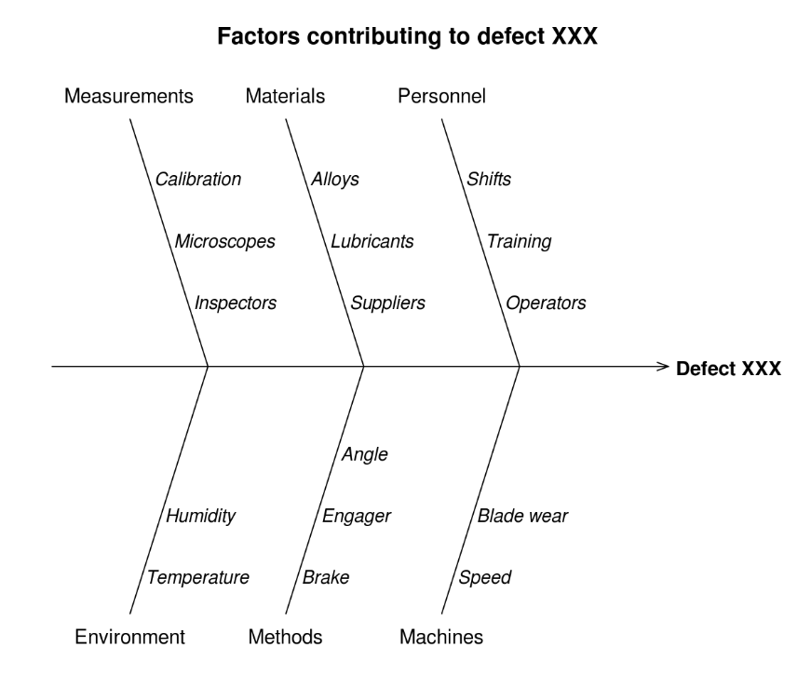
Figure 3.1: Ishikawa Diagram.
As figure 3.1 shows how you can fill the diagram with lots of information to help brainstorm. If you fill the diagram out correctly it shows the causes of a specific event (Price, 2009).
The diagram is extremely useful for you to focus on things you need to make changes too, which are areas that are more than likely to have a greater outcome. This diagram was created so people can breakdown their problems in different areas, so they are then able to see what they can change (Price, 2009).

Although, methods can be changed and you are able to use headings that apply to you (Price, 2009).
When using this technique the group will have to identify the problem first and then brainstorm the different areas which could have something to do with the problem. Once the problems have been listed, as a group you should be able to see which ones have caused the problem the most. The problems create the fish’s spine, in which the group will then need to analyse each part of the spine to find an answer. This technique makes people want to find the overall problem once they have found what each cause was (Price, 2009).
For the diagram to work you have to create a head for the fish and state what the problem is. Then you have to create a backbone for the fish, leading off the head and connect all the main causes that contribute to the main problem, by drawing arrows from the spine (Rouse, 2014).
Although this diagram is extremely helpful if the person who is using it cannot identify the accurate causes of the problems they might struggle and may not be able to find helpful solutions for the problem (Price, 2009).
The 5 Why’s
In the 1930’s Sakichi Toyoda developed The 5 Why’s technique. Toyoda was also the inventor and founder of the Toyota industry. Instead of people trying to figure what the problem is without witnessing it, Toyoda created the technique so people have to actually see the problem first. This is called the “go and see” technique. He believes decision making will be more successful this way (Murugaiah, 2018).
To use The 5 Why’s there are seven steps to take in order to complete the process.
- Gather a Team
It is important to assemble a group of people who are familiar with the problem and are aware that you are trying to fix the problem.
- Define the Problem
With the team you must discuss and create a brief statement that everyone agrees on. This shows how everyone is together on the agreement on what the problem is.
- Ask the First “Why?”
Next, you need to ask yourself and the team why the problem keeps occurring. The answers cannot be guesses, they have to be serious answers which can be backed up from things that have actually happened. Every answer must be recorded so it can be looked back upon.

- Ask “Why?” Four More Times
Once the first “Why?” has been asked from the answers the team were giving you then need to ask why they have occurred from that.
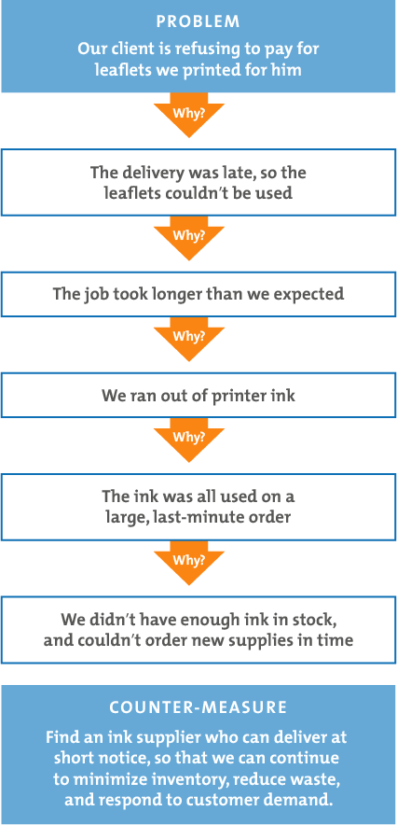
Figure 3.2: The 5 Whys

For example, in figure 3.2 it shows how there is a problem placed at the top and the first “why?” was asked, and then from every answer a “why?”. However, this technique can expand and create loads of reasons to what the problem may be caused by, which you can see in figure 3.3.

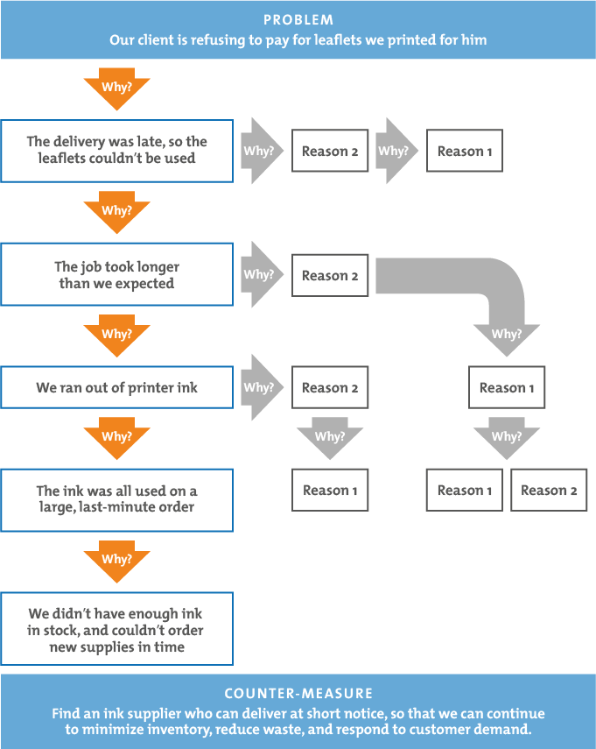
Figure 3.3: The 5 Whys expansion

However, for the fifth step you will be able to see that there will be no more answers when you ask “why?” because you have found the problem (MindTools, 2018).

3.1. Solving the Problem
To help solve Matthew’s Houses problems of making more people aware of the organisation and to find a fast way of raising money I am going to use the Ishikawa diagram to help me.

Too many charities to choose from
Not enough advertisement
Only use Facebook and Twitter for social media
People find it hard to choose

Only put banners outside the Church
Various charities that may offer the same thing

There are not enough people aware of Matthew’s House

No one can fundraise for the charity if they do not know about it
People may not put money towards the organisation as they may not think it makes a difference.

Hard to raise money

Figure 3.1.4: Matthew’s House's Fishbone Diagram
I have created my own Ishikawa diagram for Matthew’s House to see what the potential causes to the problem are.
Firstly, I put the real problem at the front which was “There are not enough people aware of Matthew’s House”. Although there are two initial problems, the reason to why Matthew’s House cannot raise money is because not enough people know of the organisation and they will not be able to help fundraise or donate their money as they are unsure. This is why I put the other problem within this diagram as it is one of the main causes from the problem.
Next, I put there is “not enough advertisement” to help make more people aware of the organisation. This is a huge problem because although the organisation is a not-for-profit they still need to advertise to help to get people to fundraise for them or donate some money.
Hernandez believes “if you do not advertise then you do not exist” (Hernandez, 2015). People are more likely to know companies who do “aggressive marketing” as consumers become more aware of the organisation and what they have to offer. This shows how you have to advertise no matter what your organisation is. As you can see in the diagram I have stated how Matthew’s House only use Facebook and Twitter as their social media pages. Although Facebook and Twitter are the main uses of social media, Matthew’s House should try and use Instagram and YouTube more, as YouTube is getting bigger every day and the organisation could share videos on what they are doing for the organisation or videos when they are fundraising. This would help to make more people aware and hopefully make more people want to help make a difference.

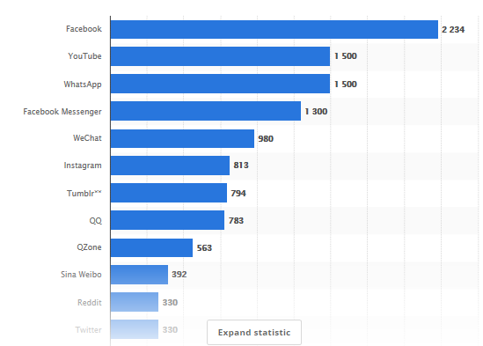
Figure 3.1.5: Statistics for Social Networking Worldwide

Problem
There are not enough people who are aware of Matthew’s House

Figure 3.1.4 it shows the most popular social networks worldwide (from April 2018) in millions. Facebook is the main used social media site with 2,234 million users, with YouTube second at 1,500 million users. Matthew’s House should use Instagram as a social media site as there are 813 million users on that social media site and this would help to make more people aware of the organisation whilst sharing pictures and videos (Statista, 2018).

Also, they only put banners up outside their organisation and if they want people to become more aware of the organisation they should put banners up down town where homeless people will see them and know where to go. Also, they could hand out leaflets to people in town.
The second bone coming from the spine shows the heading of “Too many charities to choose from”. This is because at the moment, there are 1.2 million charities and foundations in the world right now (Williams, 2010). This does not help Matthew’s House as not enough people are aware of the organisation in Swansea and there are so many charities and organisations in the world today people cannot give to everyone. Also, there are many organisations that help homeless people. For example, a group of friends, including Thom who founded the organisation got the idea of starting Matthew’s House from an organisation up in Cardiff. This means there are loads of organisations just like Matthew’s House and they need to make themselves more known so they raise more money.
The third bone coming from the spine shows the heading of “Hard to raise money”. This is related to the problem because if people are not aware of the Matthew’s House the organisation will find it difficult to raise money to fund their organisation. People will not be able to fundraise for the organisation if they are not aware they exist and what their purpose is. This means Matthew’s House are differently going to have to change their advertising strategy to help make more people aware of their organisation. Also people find it hard to trust charities as they do not know where their money is really going. Studies have shown that people do not trust charities and the lowest record has shown since the monitoring began in 2005. The percentage was 67% but now has fallen to 57% and now charities have begun to panic (Shawcross, 2016). This is because charities do not show wat they end up doing with the money they get given and it makes people wary. So, to prevent this from happening to Matthew’s House they need to show people what they do with their money.

3.2. Problem Solving implementation
Overall, I found two solutions for the problem Matthew’s House is facing:
- To advertise more
- To make people trust the organisation when they are aware of it.

I have thoroughly gone through the causes of the problem and the two main causes were how Matthew’s House does not advertise their organisation as well as they could do which is making it difficult for them to make people aware of the organisation. This makes it extremely difficult for them to make their organisation stronger by helping more people, to do this they need the help of others and their donations.
To improve on this, Matthew’s House need to advertise more through social media. This could be by posting videos on YouTube, on the fundraising events they do to show people how they are a reliable organisation. Also, Matthew’s House could create an Instagram account and post pictures on what they are doing. However, social media is not the only way of advertising as they could be direct by putting banners up in the centre of Swansea for people to see and realise that there are actual charities helping homeless people on the streets. This is because a lot of people see homeless people on the streets and do not realise there are organisations set up like Matthew’s House to help. Also, if there are banners everywhere homeless people would become aware that there is somewhere for them to go. This would be extremely helpful as it spreads awareness and helps homeless people know that there is somewhere for them to go.
To put the problem solving into action, using timeframes would be an effective approach. Timeframes are a period of time in which certain events of different types of things are meant to happen in. There is not a specific set time, and not every timeframe is the same as they could last seconds or years (Business-Dictionary, 2018). For example, Matthew’s House would be able to start working on their solution straight away by advertising more. The organisation could use social media first by creating an Instagram page and a YouTube channel and share their accounts on their Facebook Page and Twitter for their 397 followers to see (Matthew's-House-Swansea, 2018). The public would then be able to like or share the posts the organisation create, which will help towards advertising the organisation and spreading awareness.
The organisation would also be able to use the banners and leaflets they have inside their organisation and put them up around the town of Swansea for everyone to see. This would be a long-term advertising technique and would reach a large audience as the centre of Swansea is a high foot traffic area (Print-place, 2017). Also, the organisation would be able to use posters as a marketing company believe “flyers can be used to promote almost anything” (Print-place, 2017). This would not take up a lot of time and the volunteers of Matthew’s House would be able to put leaflets up and hand them out to the public who walk through the Swansea centre.

Not only would people be able to become aware of the organisation if they saw banners and leaflets in the centre of Swansea but homeless people would also become aware and hopefully want to go to Matthew’s House. Supermarkets may also see the banners and leaflets and want to help Matt’s Café out by donating food they cannot sell anymore as it has or is close to passing their sell by date.
Another solution to the problem would be ‘to make people trust the organisation when they are aware of it’. This would benefit from the first solution as when people become more aware of the organisation and see how friendly the volunteers are, people will then be able to see how much Matthews House means to them and how hard they are working just so it exists today.
The solutions to the problem would be able to be communicated to the stakeholders through meetings to discuss whether they like the solutions to the problems and the approaches that have been made.
To see if the solutions for the problems work affectively, measurements of success would be put into place. This would include:
- How many meals are served.
- How many one off donations
- The followers on social media

For example, Matthew’s House would know how many meals they do in Matt’s Café roughly on the days they are open, so they would be able to see if there is any increase in people coming to the café. The café is open to anyone, so people who are and are not homeless are able to eat in that café, and can give what they like.
Also, the organisation would be able to see how many one off donations they are given. Hopefully if Matthew’s House advertise more they would be able to see the difference in advertising and not advertising as more people are more likely to donate money if they know about the good cause.
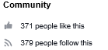
Lastly, Matthew’s House would be able to see the amount of follower they have on social media. At the moment Matthew’s House have 371 likes and 379 followers on Facebook and it is more than likely they would see an increase in the numbers once people become aware of who they are.
Figure 3.2.6: Matthew's House Facebook Figures
Matthew’s House and would be able to see if the solutions for the problems benefit their organisation from undertaking the three measurements of success.
4. Conclusion
To conclude, Matthew’s House need to thoroughly look at their problems and see what the causes are to their problems, so it doesn’t affect their organisation too much. However, from doing this, the solutions found from this process will help and benefit the organisation a lot and Matthew’s House will be able to see this when measure their success.

References

Adair, J. (2016). How problems differ from decisions. In J. Adair, Decision Making and Problem Solving (p. 43).
Business-Dictionary. (2018). Problem Solving. Retrieved from Business Dictionary : www.businessdictionary.com/definition/problem-solving.html
Business-Dictionary. (2018). Timeframe. Retrieved from Business Dictionary: www.businessdictionary.com/definition/time-frame.html
Hernandez, J. G. (2015, February 17). If You Don't Advertise - You Don't Exist. Retrieved from Leadership Summaries: http://jesusgilhernandez.com/2015/02/17/if-you-dont-advertise-you-dont-exist/
Lynch, T. (2017). First meeting with Thom about Matthews House. (J. R. Ella, Interviewer)
Lynch, T. (2018). About us. Retrieved from Matthews House: http://matthewshouse.org.uk/about/
Matthew's-House-Swansea. (2018). Matthew's House Swanse Facebook Page. Retrieved from https://www.facebook.com/MatthewsHouseSwansea/
MindTools. (2018). 5 Whys. Retrieved from MindTools: https://www.mindtools.com/pages/article/newTMC_5W.htm
Murugaiah, U. (2018). Scrap loss reduction using the 5‐whys analysis. Retrieved from Emerald insight: https://www.emeraldinsight.com/doi/full/10.1108/02656711011043517
Price, D. (2009). Ishikawa Diagram. In D. Price, The Principles and Practice of Change (p. 281).
Print-place. (2017, February 20). Markerting With Posters and Flyers. Retrieved from Print Place: https://www.printplace.com/blog/marketing-with-posters-and-flyers/
Rouse, M. (2014). Fishbone Diagram. Retrieved from Whatis.com: https://whatis.techtarget.com/definition/fishbone-diagram
Shawcross, W. (2016, June 28). Trust in charities is at an all-time low. Time to change . Retrieved from The Guardian: https://www.theguardian.com/commentisfree/2016/jun/28/trust-charities-low-charitable-work-public
Statista. (2018, April). Most popular social media networks worldwide . Retrieved from The Statistics Portal : https://www.statista.com/statistics/272014/global-social-networks-ranked-by-number-of-users/
Williams, G. (2010, March 15). Number of Charities and Foundations Passes 1.2 Million. Retrieved from Philianthropy: https://www.philanthropy.com/article/Number-of-Charities-and/195165

