
Engine performance characteristics
University of Wales Trinity Saint David

January 1, 2021
Harry t s bolton
2003518

Contents
1.0 - Chapter 1: Introduction 2
2.0 - Chapter 2: Experimental Procedure 3
3.0 - Chapter 3: Results 4
4.0 – Chapter 4: Analysis 5
5.0 – Chapter 5: Conclusion 7
6.0 – Chapter 6: Evaluation 8
7.0 – Chapter 7: Bibliography/ References 9

1.0 - Chapter 1: Introduction

What I hope to achieve.
My aim of this assignment is to: Describe what a dyno is, my experience when carrying out a dyno test, the results from said tests, showing graphs and calculations from the tests, comparing my results to others,
The modern method of testing and determining horsepower is by using an engine dynamometer. In one type of engine dynamometer setup, the engine drives a large generator (dynamo). By placing an electric load in the circuit, bhp at various rpm can be determined. (Martin W. Stockel, Martin T. Stockel, Chris Johanson, P. 110).
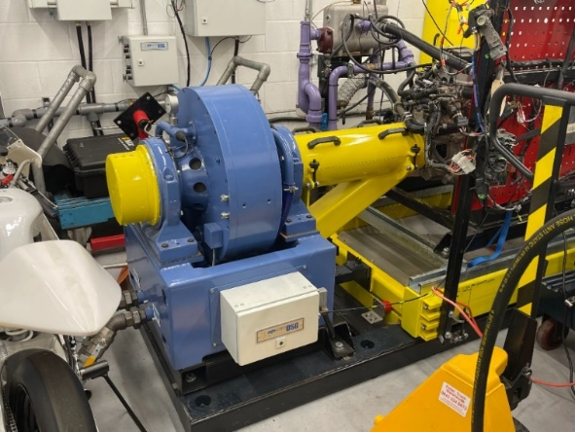

Figure 1.
The generator dynamo can be loaded until the engine rpm is at a certain point with the throttle wide open. Horsepower is calculated using the instrument readings. (Martin W. Stockel, Martin T. Stockel, Chris Johanson, P. 110).
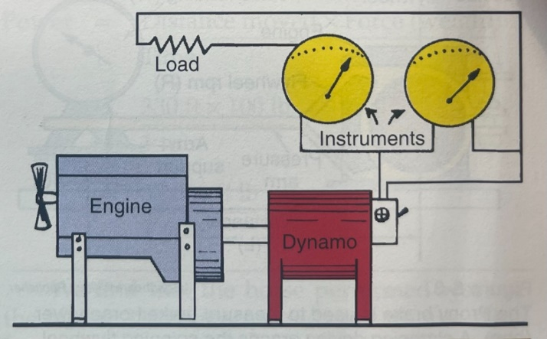

Figure 2.
This image demonstrates the general idea of an engine dynamometer (Figure 2).
When carrying out the dyno test, I gathered my own raw data and calculated the following: Force (N), Engine Speed (rpm), Torque (Nm), Power (W), Corrected Power (W) and BMEP (Pa).
From this information I was able to create multiple graphs showing Torque v Engine Speed, Corrected Power v Engine Speed and BMEP v Engine Speed.

2.0 - Chapter 2: Experimental Procedure

Run through of the dyno test
The dyno adds load with electromagnets inside the disc shape at the end of the dyno and adds that onto the end of the engine. This electric load in the circuit means we can determine the bhp at various rpm.
We calibrated the Dyno to make sure that the data was correct, we could do this as we know the mass of the weight and the distance of the arm so we can therefore work out the force and compare it to the reading on the computer. This then allowed us to see how accurate it was and if the data was reliable / repeatable.
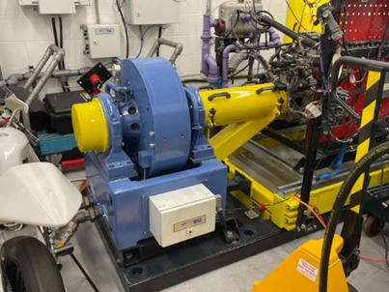
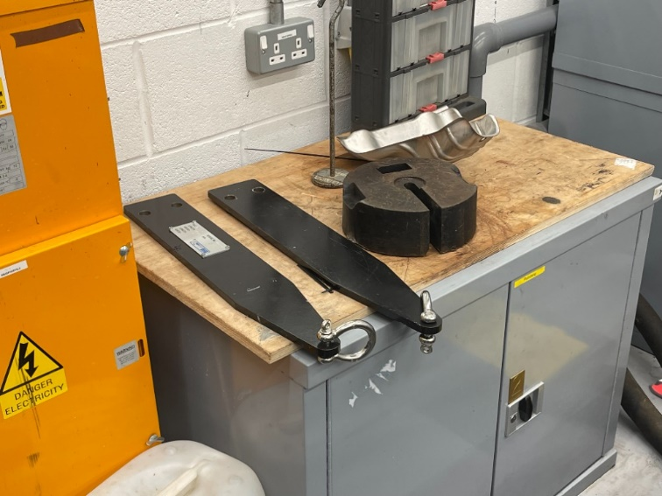
The reason we did a sweep test over a step test was that a sweep test to gives a nice range of results opposed to a step test that holds at every data point we had selected.
Figure 3 - shows a photo of the Dyno I used to carry out my tests
Figure 4 - shows a photo of the arms and weights used on the Dyno when carrying out the tests
Figure 4
Figure 3

3.0 - Chapter 3: Results
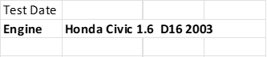
On this page is the raw data collected during the dyno testing. As you can see, we collected the Force (N), Engine Speed (rpm) as well as the temperature, Barometric Pressure, Humidity and Torque arm length.
Figure 5

4.0 – Chapter 4: Analysis

Calculations
As well as finding the Force (N) and Engine Speed (rpm) I also calculated the Torque (Nm), Power (W), Corrected Power (W) and BMEP (Pa).

When calculating these numbers, you need to know the correct equations for the results you have.

When calculating Torque, the equation I used was
$$T=WR$$
T = Torque (Nm), W = Engine Load (N), R = Radius of Torque Arm (m)

The next calculation was to find the Power, for this I used the equation
$$P= \frac{2πNT}{60}$$
P = Power (W), N = Engine Speed (rpm), T = Torque (Nm)

The next calculation was to find the Corrected Power, to find this I used
$$Ps=(\frac{1.01325}{Pa}×\sqrt{\frac{Ta}{293}}$$
Ps = Corrected Power (W), 1.01325 = Standard pressure in bar, Pa = Ambient Pressure, Ta = Ambient Temperature, 293 = Standard temperature in Kelvin.

The final calculation was to find the BMEP, to find this I used the equation
$$BMEP= \frac{60×2×BP}{l×A×N×n}$$
BMEP = BMEP (Pa), BP = Corrected Power (W), l = Stoke (m), A = Area (m2), N = Engine Speed (rpm), n = number of cylinders

Equations (Abi Summerfield, P. 22, 23, 27)
Graphs
Once all the calculations had been completed, I was then able to use the data to create graphs showing Torque v Engine Speed, Corrected Power v Engine Speed and BMEP v Engine Speed.
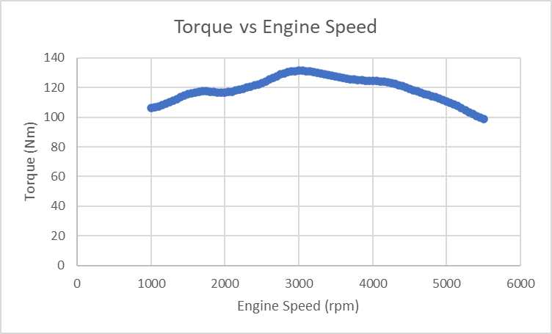
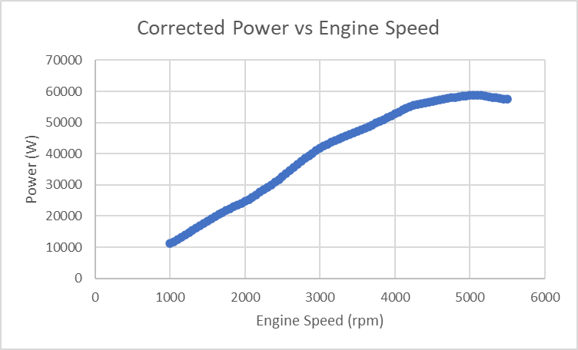
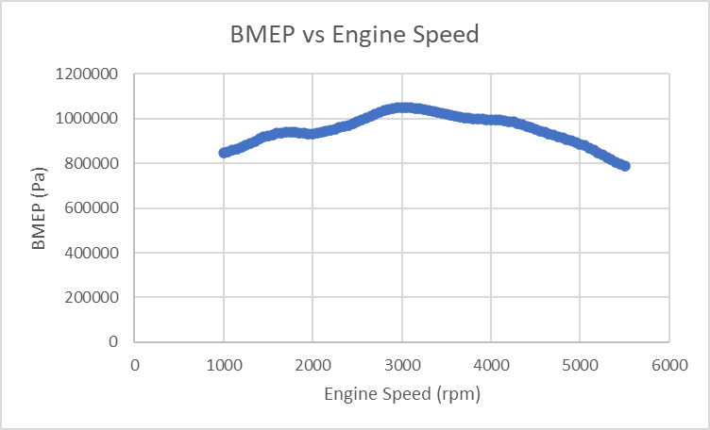
Figure 6
Figure 7
Figure 8

5.0 – Chapter 5: Conclusion

Shapes of the graphs
How the results have come out how you expected them to
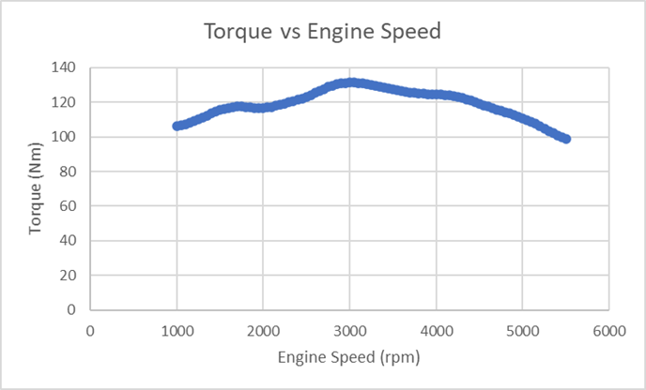
Validating the graphs by comparing them to other graphs to say yes, our engine test was good, and our engine was in a good state.
Now that my graphs are complete, I can validate them. How I’ll be doing this is by comparing my graphs to other graphs made by someone else who had also carried out the same tests as me.
Figure 9
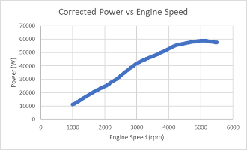
I’ll start off by comparing my first graph (Torque v Engine Speed shown in figure 9) vs the Torque v Engine Speed graph shown in figure 11 which shows a sample light duty automotive diesel engine performance curve (John Manning, P. 107). In figure 11 as the engine speed increases so does the torque, then at around 2700-3200 rpm the torque is at its peak and then eventually starts to decrease as the engine speed keeps rising. This is also represented in figure 9 (my graph) so therefore shows that my test was somewhat accurate meaning that the engine was in a good state and working properly.
Figure 10
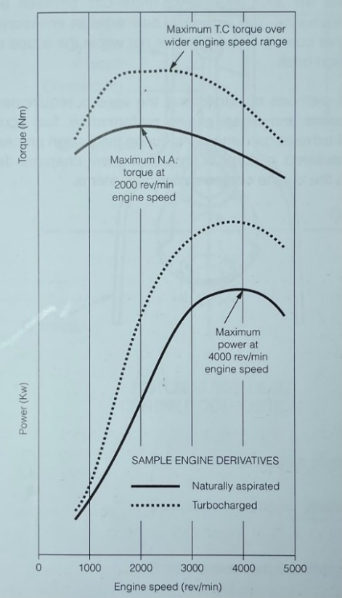
Comparing my second graph (Corrected Power v Engine Speed in Figure 10) vs the Power vs Engine Speed graph shown in figure 11 again showing a sample light duty automotive diesel engine performance curve (John Manning, P. 107). In figure 11 as engine speed increases the power rapidly increases until around 4000 rpm then the power starts to level out and then eventually starts to drop (decrease).
Before plotting the graphs, I had a brief understanding of what they would look like. I knew as Engine Speed (rpm) started / increased so would Torque as the engine starts to work. However, “at high RPM, torque drops off” this is “primarily from intake and exhaust flow restriction. Volumetric Efficiency declines because the engine can't breathe any faster. Mechanical efficiency also declines at higher RPM, due to increased frictional resistance. This further reduces torque at the output” (MESIMPSON, July 10, 2008).
Figure 11
In conclusion the test was successful as it produced accurate information meaning the data shown on the graphs were accurate and therefore meaning the engine was in a good state.

6.0 – Chapter 6: Evaluation

Talk about eliminating errors – we try keep the engine cool with a cooling system, keep conditions uniform, make sure test is done the same way every time to get repeatable results
For my evaluation for the dyno test I will be talking about eliminating the possible errors that could occur during the test and how I went about this making sure to reduce the possible margins for error during the test.
The reason for eliminating / reducing the margins for error is that it allows for repeatable and reliable information across the tests. For example, when running tests on the dyno to collect information for my graphs the dyno was kept cool with a cooling “First, it removes excess heat from the engine; second, it maintains the engine operating temperature where it works most efficiently; and finally, it brings the engine up to the right operating temperature as quickly as possible” (Caltech, February 24, 1997).
Each test was carried out under the same supervisions meaning the data / results collected would be repeatable and reliable.

7.0 – Chapter 7: Bibliography/ References

- Abi Summerfield, 2021, Vehicle Technology Handbook – ACHA4004, P. 22, 23, 27
- February 24, 1997, Caltech, California Institute of Technology
- John Manning, Internal Combustion Engine Design, P. 107
- Martin W. Stockel, Martin T. Stockel and Chris Johanson, 2015, Auto Fundamentals 11th Edition, P. 110
- MESIMPSON, July 10, 2008, Mechanical Engineering, Physics Forum, #1

