Methodology
Introduction:
A research methodology sets out the procedures and techniques used to identify and analyse certain topics (Heever 2022). Having a plan that sets out how and why the research will be conducted will help to answer the overarching question that the research aims to answer: Can adverse childhood experiences determine criminality in looked after or care experienced children and young people? The method being used to demonstrate the process of this methodology is the research onion created by Saunders et al in 2007 as seen in Figure 1. Through the six layers, the research onion is designed to help guide a researcher when looking into how to structure and design their research (Mardiana 2020). The research onion will allow for the research to cover all the objectives within this study; the first objective of the study is to identify the prevalence of criminality in care experienced and looked after children and young people. The second objective is to evaluate the long-term effects adverse childhood experiences have on children and young people who are in care or are care experienced. The main focus of the methodology is to investigate the third and final objective which is to evaluate the public perception of the link between adverse childhood experiences and crime as well as what can be done to reduce criminality.

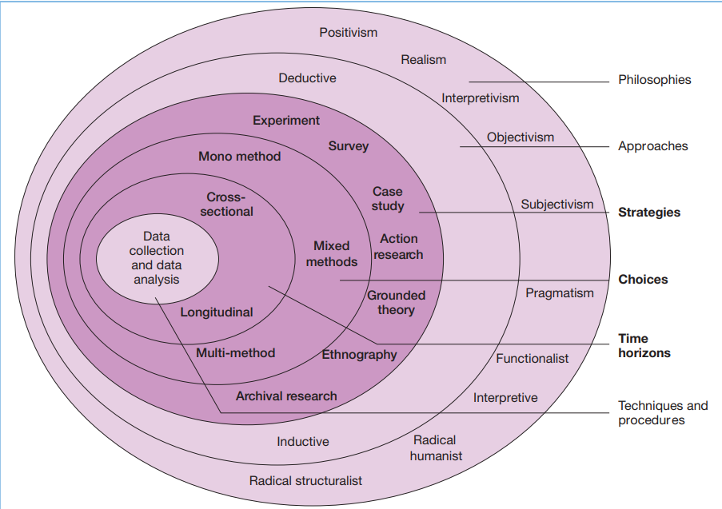
Figure 1 – The research ‘onion’ (Saunders, Lewis, and Thornhill 2007, page 132)
Research philosophies:
When it comes to looking at research philosophies it is important to identify what perspective is needed, this research study follows an epistemological view. Epistemology refers to the study of knowledge, it investigates the what, why and how of knowledge and how it may be affected (Greco 2021). Questioning current knowledge is what is needed within the question of this study, as it focuses on determining criminality based on Adverse childhood experiences within a specific demographic of people. Epistemology branches into interpretivism which will be used within this study. Interpretivism is the idea that reality is ever-changing and is different for everyone, as an individual’s experience changes the way reality is viewed based upon their perspective (University of Nottingham 2023). Due to the nature of the research, everyone may have a different viewpoint when it comes to this topic meaning that using an interpretive philosophy is the ideal approach. The idea of this research is to question the views and reality of children and young people in care and those who are care experienced.

Research approach:
The research approach that will be used throughout this study is inductive reasoning, Kim (2021, page 151) says that inductive research involves starting with research and establishing a theory, followed by further observing and investigating to find an overall theory. By researching you can establish a theory based on what you have seen or on the lack of what you have seen. By starting with looking into the subject area you can see where the research gaps are and try to focus on what needs to be discussed, in this study it would be the perspective of children and young people in care or who have care experience. Inductive research is the method being used due to the idea that the overall study is based on research and is trying to establish a theory based on investigation into adverse childhood experiences and public perception.

Research strategies:
Descriptive research is used to describe what or why something has happened, this can usually be done through observations or surveys when researching (Nassaji 2015, page 131). The idea that this strategy is designed to describe specifically what and why something is happening helps to evaluate the link between the public perception of children and young people who are in care or are care experienced that have experienced adverse childhood experiences as well as seeing what others think can help reduce criminality in this area. Another reason for using the strategy of descriptive research is that it allows for the use of both qualitative and quantitative data during collection (Dudobskiy 2024). Throughout the process of collecting data, it will use a survey which will be designed to collect both qualitative and quantitative data to be able to evaluate more effectively.

Choices:
To investigate the public perception and how to combat criminality within children and young people; the research will use both quantitative and qualitative data. This choice was decided because it will be looking not only at the prevalence and long-term effects but also at the perspectives of those within society. Using mixed methods within research adds more value to the understanding and interpretation than it would by using singularly just qualitative or quantitative data alone (McKim 2017, page 203). By creating a better understanding it allows for others to gain a more well-rounded knowledge of the topic, for example, it would allow for people to express feelings and opinions while still collecting data that can be measured. This would allow for the research to see prevalence and well as evaluate perspective.

Time horizon.
Time horizon refers to the amount of time it will take to conduct and gather the data needed for the study in this case. A cross-sectional approach allows for an investigator to do data collection within a short timescale, often focusing on investigating the relationship between variables (Hulley et al 2013, page 88). Having an approach that allows for data to be collected in a short time benefits this study because it is not only being conducted over a short period but also needs to investigate the relationship between variables which demonstrates why this may be an ideal method. Cross-sectional studies are usually fast to conduct and inexpensive (Setia 2016). Due to the nature of this research, this is the ideal option due to the short time frame that it spans across as well as the fact that it is not funded.

Technique and procedures:
Techniques and procedures make up the final inner layer of the research onion, this layer covers data collection and analysis, this will cover the investigation of the third objective about the public perception of the relationship between adverse childhood experiences and criminality as well as what can be done to combat this. By following the previously stated approaches and strategies, a survey will be used to collect relevant mixed data. The Office for Health Improvement and Disparities (2020) states that by using a mixture of qualitative and quantitative data it will allow the research to create a deeper understanding based on what has been collected. A deeper understanding allows for a more well-rounded analysis which may make it more accurate when answering the overall question. To collect mixed data a range of open and closed questions will be used, especially as the research is looking into perspective. Surveys can be used in a few ways such as by mail, over the phone, and in-person interviews (Scheuren 2004, page 11). Due to the many methods of conducting a survey and the cost efficiency as well as the time needed, these methods will not be used which is why online surveys would be ideal. Through this study, it will use a survey that consists of a mixture of both closed and open questions, this will ensure that both the qualitative and quantitative data can be collected.

The sample size of the survey will depend upon the number of responses that it gains, an ideal number of responses would be between 100 to 300 although this is not guaranteed. Before the survey begins there will be a question asking for the age of the participant this is because those over eighteen years of age can give consent to their information being shared, not only this but the age can help identify the changes in perspectives around this topic. Once the data has been collected it will be analysed using thematic analysis. Thematic analysis refers to finding and analysing data by seeing if there are themes within the data that can help to answer a research question (Maguire and Delahunt 2017, page 3353). By identifying themes, it makes it easier to answer the question as well as offer suggestions of what could be done to reduce criminality in children and young people. Slutsky (2014, page 67) states that if the data collected shows trends or any correlation a graph is the best way to display the data. The data collected will therefore be displayed using charts and graphs allowing for said themes and trends to be seen clearly.

Limitations:
Some limitations and reflections need to be considered, due to the topic of the survey being adverse childhood experiences. There will need to be a prewarning prior to the introduction of the survey, this will allow the participant to gain a brief understanding of the content covered in the survey. One issue that may arise is reliability, this refers to whether or not the research can be replicated and if it will get the same results (Lueng 2015, page 326). The reliability of the survey can be affected by many issues such as people misunderstanding the question or even showing bias. Bias could be shown depending on who participates in the survey as certain job roles may affect their knowledge and perspective of the topic. Another issue that can be affected by these issues is validity; Heale and Twycross (2015, page 66) say that validity refers to the accuracy of the study. Ensuring validity is important as the survey and research needs to follow the third objective otherwise the research would be unable to answer the question for which it is intended.

References:
Dudovskiy, J. (2024). Descriptive Research. Available at: https://research-methodology.net/descriptive-research/ (Accessed 7/02/2024)
Greco, J. (2021). ‘Epistemology’ Routledge Encyclopedia of Philosophy. Available at: https://www.rep.routledge.com/articles/overview/epistemology/v-3 (Accessed 7/02/2024).
Heale, R. and Twycross, A. (2015). ‘Validity and Reliability in Quantitative Studies’. Evidence Based Nursing, volume 18, issue 3, pp.66–67. doi: http://dx.doi.org/10.1136/eb-2015-102129. (Accessed 08/02/2024)
Heever, M.V.D. (2022). Research Support: Research Methodology. Available at: https://libguides.wits.ac.za/c.php?g=693518&p=4914913#:~:text=What%20is%20Research%20Methodology%3F (Accessed 5/02/2024)
Hulley, S. Cummings, S. Newman, T. (2013) ’Designing Cross-Sectional and Cohort Studies’, in Gaertner, R, (eds) Designing Clinical Research, 4th edition. Philadelphia. Pages 88-97. Available at: Designing Clinical Research - Stephen B. Hulley, Steven R. Cummings, Warren S. Browner, Deborah G. Grady, Thomas B. Newman - Google Books (Accessed 07/02/2024)
Kim, S.M. (2021). ‘Inductive or deductive? Research by maxillofacial surgeons’. Journal of the Korean Association of Oral and Maxillofacial Surgeons, volume 47, issue 3, pp.151–152. Available at: Inductive or deductive? Research by maxillofacial surgeons - PubMed (nih.gov) (Accessed 7/02/2024).
Leung, L. (2015). ‘Validity, reliability, and Generalizability in Qualitative Research’. Journal of Family Medicine and Primary Care, volume 4, issue 3, pp.324–327. doi: https://doi.org/10.4103/2249-4863.161306. (Accessed 08/02/2024)
Maguire, M. and Delahunt, B. (2017). ‘Doing a thematic analysis: A practical, step-by-step guide for learning and teaching scholars’. All Ireland Journal of Higher Education, volume 9, issue 3, pp.3351–33514. Available at: https://ojs.aishe.org/index.php/aishe-j/article/view/335/553 (Accessed 8/02/2024)
Mardiana, S. (2020) ‘Modifying research onion for information systems research’, Solid State Technology. Available at: Please cite as follows: Mardiana, S. (2020) (researchgate.net) (Accessed: 07/02/2024).
McKim, C. (2017). ‘The Value of Mixed Methods Research’. Journal of Mixed Methods Research, issue 2, pp.202–222. Available at: https://journals.sagepub.com/doi/epub/10.1177/1558689815607096 (Accessed 7/02/2024)
Nassaji, H. (2015). ‘Qualitative and descriptive research: Data type versus data analysis’. Language Teaching Research, volume 19, issue 2, pp.129–132. doi: https://doi.org/10.1177/1362168815572747. (Accessed 07/02/2024)
Office for Health Improvement and Disparities (2020). Mixed Methods Study. Available at: https://www.gov.uk/guidance/mixed-methods-study (Accessed 8/02/2024)
Saunders, M. Lewis, P. Thornhill, A. (2007) The research ‘onion’ [diagram] Available at: research_methods_for_business_students (1).pdf (Accessed 06/02/2024)
Scheuren, F. (2004). What is a Survey. Available at: https://fweil.com/s2211/whatisasurvey.pdf (Accessed 7/02/2024)
Setia, M.S. (2016). ‘Methodology Series Module 3: Cross-sectional Studies’. Indian Journal of Dermatology, volume 61, issue 3, pp.261–264. Available at: Methodology Series Module 3: Cross-sectional Studies - PubMed (nih.gov) (Accessed 7/02/2024).
Slutsky, D. (2014). ‘The Effective Use of Graphs’. Journal of Wrist Surgery, Volume 3, issue 2, pp.67–68. Available at: 10-1055-s-0034-1375704.pdf (nih.gov) (Accessed 8/02/2024)
University of Nottingham (2023). Understanding Pragmatic Research. Available at: https://www.nottingham.ac.uk/helmopen/rlos/research-evidence-based-practice/designing-research/types-of-study/understanding-pragmatic-research/section02.html#:~:text=Interpretivism%20is%20based%20on%20the (Accessed 5/02/2024)

