user

DIGITAL SKILLS AND RESEARSH METHODS
MADALINA SUMANARU
ID 1810137

Digital Skills and Research Methods

Table of Contents
Introduction 4
Digital technology 5
Impact of digital technology on workplaces 5
Social Media and its impact on workplaces 7
Conclusion 10

Introduction
Digital technologies have been an extremely important factor in recent times that has helped in the process of development of the workplaces. The digital technologies have eased in the process of communication and developed the effectiveness among the employees in the workplace. There are a variety of threats faced by the workplaces in order to conduct the business process by an organization. Digital technologies have helped in reduction of such risk also. This study will provide a variety of insights regarding digital technologies taking social media under consideration. The ways it helps in communicational development along with information gathering as well marketing will also be discussed.

Digital technology
Digital technology has been one of the greatest innovations in the workplace. Its introduction has been an extremely essential because it has given a variety of benefits to the changing way of business in terms of communication, organizational aspect, gathering information, enhancement of productivity, cost management and effectiveness, options of customization, collaboration increment, reduction in the breach of security, employees' efficiency increment, enabling remote and others (Kannan, 2017). Digital technologies include a variety of technological advancements such as mobile technologies, social media marketing, cloud computing, online platforms and many more.

Impact of digital technology on workplaces
The changing way of communication in business is one of the most important factors that has happened over the years. With the introduction of social networking sites, mobiles and smartphones, platforms of chatting have eventually resulted in the development of communication. Variety of emails can be sent through the platforms along with audio-visual communication that can be done through several digital technologies where the presence of the people are not required at the workplace anymore (Tiago and Verissimo, 2014). Video and audio conferences can also be another essential digital technology that eventually helps in the process of communication.
In order to achieve the goal, an organization uses new technologies that make the progress of work extremely fast in the workplace (Taiminen and Karjaluoto, 2015). The cost effectivity is also extremely reduced based on the digital technologies. The fiscal health of the organizations has increased due to cost-effective policies did through digital technologies. For an instance, SaaS tool is considered as a digital technology that is used for the elimination purpose of task handling manually. Moreover, the profitability increases over the time resulting in the growth of the organization. The workplace also remains due to the use of digital technology.
Facial recognition and fingerprint also help in the process of development of an organization. These incidents are often done in order to pursue with the attendance markings in a workplace. In the old times, there are different log books and attendance books are maintained in order to keep the attention of employees in an organization. However, these works were often time-consuming and generated a lot of problems in order to do such jobs. In these days, the fingerprint that is known as biometry is used in order to generate do the attendance easily. In addition, such biometric inputs are often used as passwords in the order to protect the systems in a workplace (Leonardi, 2014). On the other hand, customization option is another digital technology's benefit that is found in a workplace. There are several managements software used in the workplace in order to customize the operations executed every day. It is also helpful in the case of provisions of services. The collaboration also increases due to the up growing use of digital technology. The people are connected together based on digital technology. People living in different places can be linked at any time, based on digital technologies.
The companies become able to inform their clients regarding the development and progress of the projects. That eventually helps in the growth of the organization and helps in the process of development. Security breaches are other problems that have made the workplaces concerned always. However, these breaches can also be reduced over the time based on the uses of digital technologies. These threats are usually helping in the process of data theft and leaks, which can be reduced based on such digital technologies. Implementation of proper measures of security helps in the process of making the safety of the data (Ashley and Tuten, 2015). Moreover, the work of the employees and their activities are always kept under serious attention and watched properly and reduction occurs in all sorts of wrong practices.
The efficiencies of the employees are also increased that eventually results in client satisfaction. The modern tools of technology make the time management easier than before and deadlines can be met smoothly by the employees in the workplace. The effort and time get reduced based on activities on daily basis. This allows the employees to come up with new ideas and innovative solutions. Moreover, the feedback and doubts from the customers eventually get catered easily (Ashley, 2015). Remote working is enabled by the digital technologies that are used in a particular workplace. For an instance, space of co-working, teleconferencing has reshaped the workplace completely. Internet-based models of service are enabled based on mobile and cloud technology that has allowed remote and instant access. The interconnected places of work are tied to many locations and virtual conferencing, portability hinge them. In fact, with the help of video conferencing, It has become easier for the employees to take part in the meetings from anywhere in the world.

Social Media and its impact on workplaces
Social media has been one of the most important inventions that has changed the business scenario of the entire world. Social media has included various platforms in order to come up with new innovations. In recent times, social media has helped in connecting different people all over the world. There has been Linkedin,YouTube, Facebook, Instagram, Twitter and many other platforms that help in the development of the workplaces. For an instance, communications can also be used as an important factor that has become much easier due to the introduction of social platforms (Agnihotri et al., 2016). The social platforms have been another factor that has eventually helped in the process of development in communication among the employees in the workplace. The employees can engage with each other based on live platforms through social media platforms such as Facebook. Through YouTube, it becomes extremely necessary to develop audio-visual contents for the clients and that help in the process of development of a workplace. There are different pictures that can be uploaded through Instagram and tweets also helps in creating awareness among consumers. Social media helps in the process of accountability, timely delivery, and efficiency, responsibilities in the workplace.
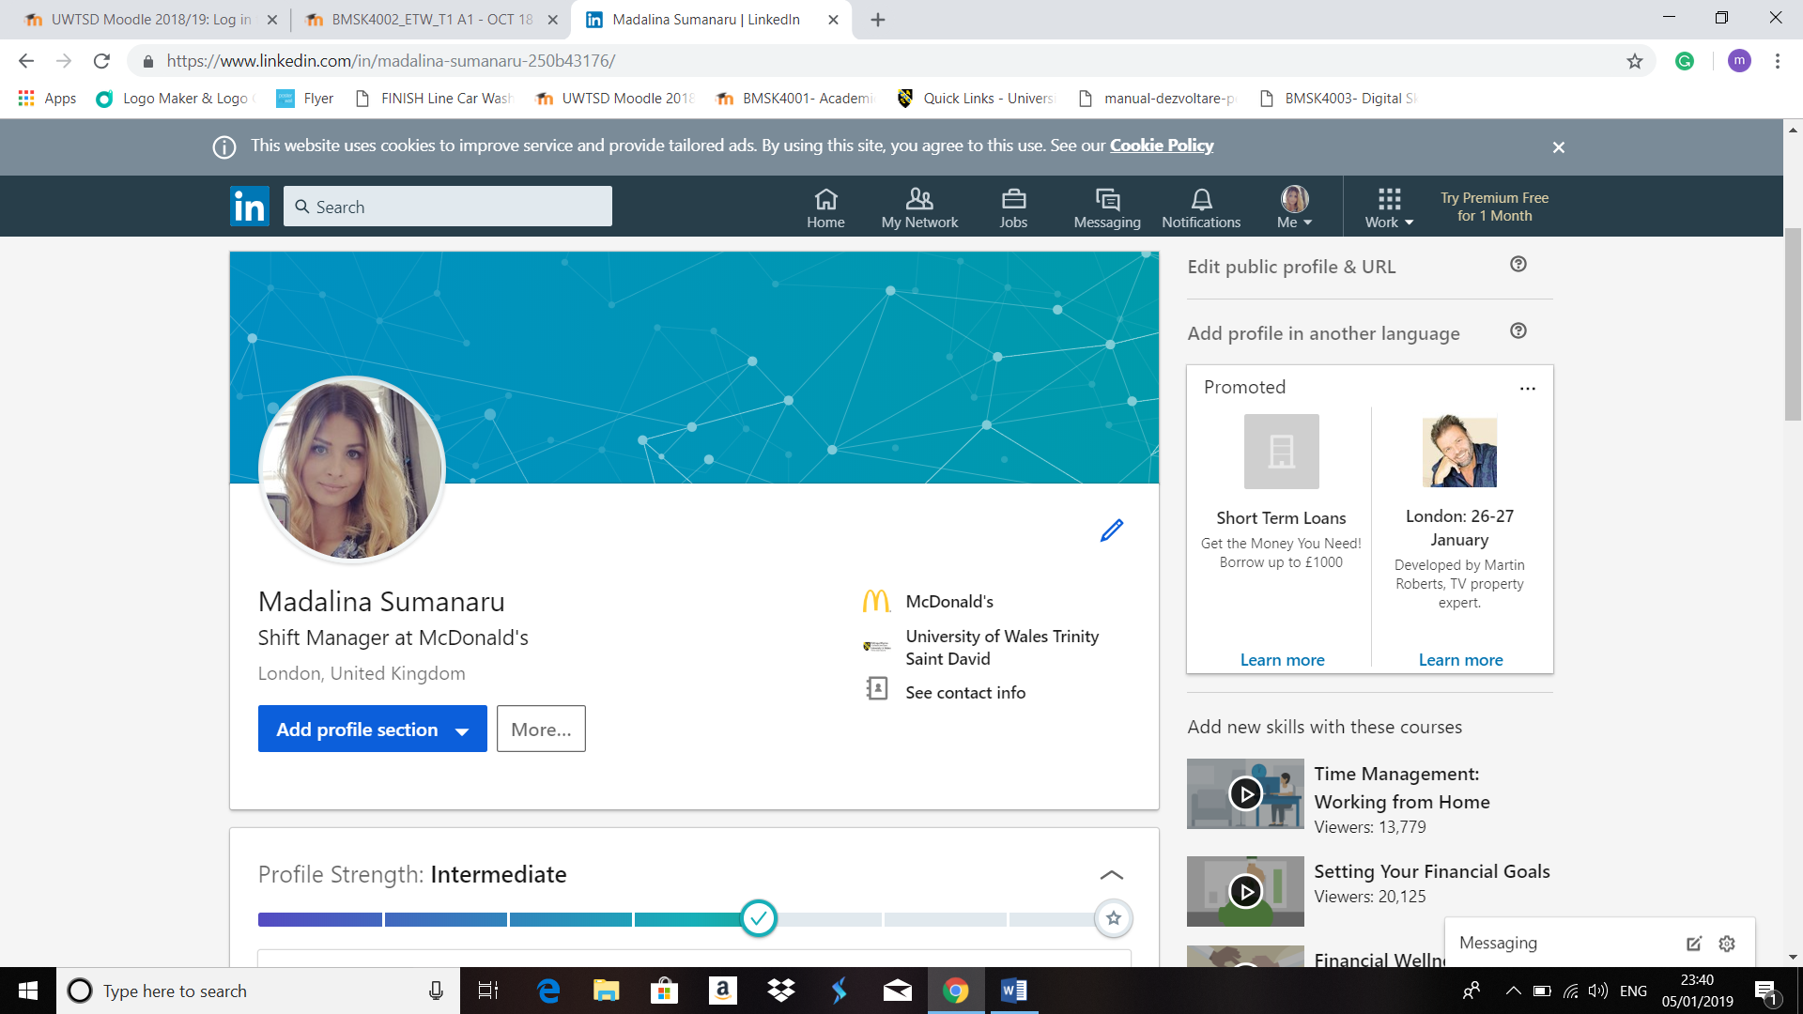
https://www.linkedin.com/in/madalina-sumanaru-250b43176/
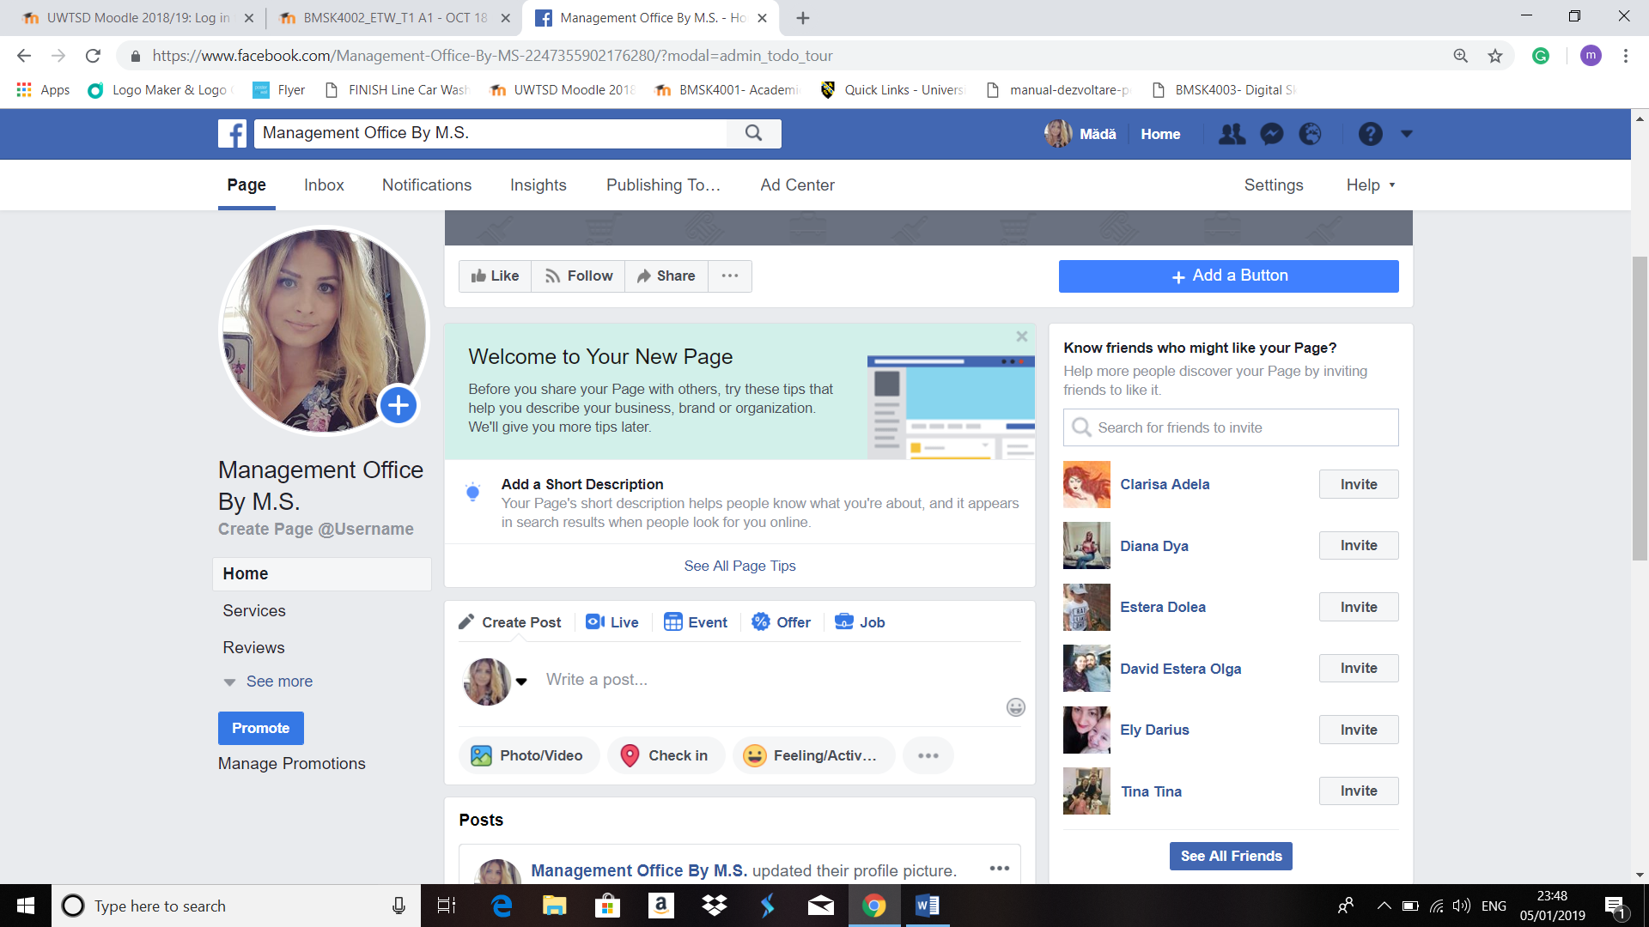
https://www.facebook.com/Management-Office-By-MS-2247355902176280/?modal=admin_todo_tour
The communication can eventually develop between the colleagues in a workplace and the employees and the clients (Hollensen and Raman, 2014). Social media also help in the reduction of failure in a particular project. Information gathering in a workplace through social media is another factor that eventually helps in the process of development of a business. There are a variety of people who remain engaged through social media and communicate with each other regarding the products and services of different organizations. Usually, companies become able to understand the different demands of the customers. It helps the companies in order to come up with innovations regarding products and can eventually come up with the products and services aligning them to the interests and preferences of the targeted consumers. There are several theories that can eventually be used while depicting the impact of social media in the workplace. These theories eventually include media synchronicity theory and social capital theories under consideration. The social media also becomes an essential tool for marketing for the organizations. The marketing tools are also interrelated to the promotional tactics that can be used in order to come up with different solutions. The marketing becomes extremely easy in order to cater to a larger number of the consumer base.
The consumers from different parts of the world communicate through such platforms. These platforms also help in the process of development while catering to different consumers. There are a variety of consumers that can be served through social media in the least possible time. There are a variety of situations the customers provide different feedback regarding the product and service (Patrick et al., 2014). There are negative comments also present, which help the companies to come up with feasible solutions. The more the solutions are smooth, the more customers get attracted to the companies and customer loyalty eventually increases. The employees in a workplace can come up with innovative marketing ideas. One of the main factors associated with marketing is a promotion that has got revolutionized due to the introduction of social media. There are several promotional tactics that can be taken under consideration while using social media. Innovative contents, online posters, pictorial presentations can be made in order to attract more and more customers. The more and more customers get attracted towards the products and services of organizations, more the organizations become able to generate more and more revenue. The gain in profitability from market sales also increases resulting in the growth of the organization (Shaikh et al., 2016).
The online presence of the company eventually helps in direct communication with the consumers. Social media is one of the most important platforms that has helped in marketing the products and services directly to customers. With the help of social media, targeted customers can be specified. This eventually helps the company to set the objectives and goals with a clear vision towards the achievement. The communication between the employees of the companies eventually increases more and more and a variety of social media activities can be conducted based on that. These eventually increase the efficiency among the employees and they become able to meet the deadlines very easily. As social media helps in the direct communication process between the business and the customers, hence, the customers feel more and more important in the process of business (Scott, 2015). The more the customers feel they are important to a certain organization, his/her intention becomes to get more and more loyal to the company. The increase in loyalty eventually develops the customers' retention for a certain organization. The increase in the customers’ retention eventually develops the market sales and the organizations become able to grow relationship marketing strategies.
Hence, this proves that social media is an essential platform for the workplace and such digital technology has helped the workplace to get developed more and more.

Conclusion
From the above information from various sources, it can be concluded that digital technologies have an extremely important impact on the development of a workplace. For a particular workplace, there are several factors such as communication, information gathering, marketing and many more sections that can be served with the help of digital technologies. Social media has been considered and various aspects of social media are discussed. Social media has helped in the growth of a workplace with its own benefits and this study has provided adequate information in order to come up with new insights into digital technologies under the light of social media.

References
Tuten, T.L. and Solomon, M.R., 2017. Social media marketing. Sage.
Hollensen, S. and Raman, A., 2014. Social Media Marketing. Marketing Canada-Journal.
Patrick, K.J., Snyder, R., Margolis, M., Alahverdian, M. and Barbera, S., trendyr LLC, 2014. Social media marketing. U.S. Patent Application 13/670,238.
Ashley, C. and Tuten, T., 2015. Creative strategies in social media marketing: An exploratory study of branded social content and consumer engagement. Psychology & Marketing, 32(1), pp.15-27.
Shaikh, N., Siddiqui, M.E., Vasatkar, K., Jagtap, Y. and Sankpal, L.J., 2016. Social media marketing. International Research Journal of Engineering and Technology, 3(6), pp.870-872.
Scott, D.M., 2015. The new rules of marketing and PR: How to use social media, online video, mobile applications, blogs, news releases, and viral marketing to reach buyers directly. John Wiley & Sons.
Leonardi, P.M., 2014. Social media, knowledge sharing, and innovation: Toward a theory of communication visibility. Information systems research, 25(4), pp.796-816.
Taiminen, H.M. and Karjaluoto, H., 2015. The usage of digital marketing channels in SMEs. Journal of Small Business and Enterprise Development, 22(4), pp.633-651.
Agnihotri, R., Dingus, R., Hu, M.Y. and Krush, M.T., 2016. Social media: Influencing customer satisfaction in B2B sales. Industrial Marketing Management, 53, pp.172-180.
Tiago, M.T.P.M.B. and Veríssimo, J.M.C., 2014. Digital marketing and social media: Why bother?. Business Horizons, 57(6), pp.703-708.
Kannan, P.K., 2017. Digital marketing: A framework, review and research agenda. International Journal of Research in Marketing, 34(1), pp.22-45

