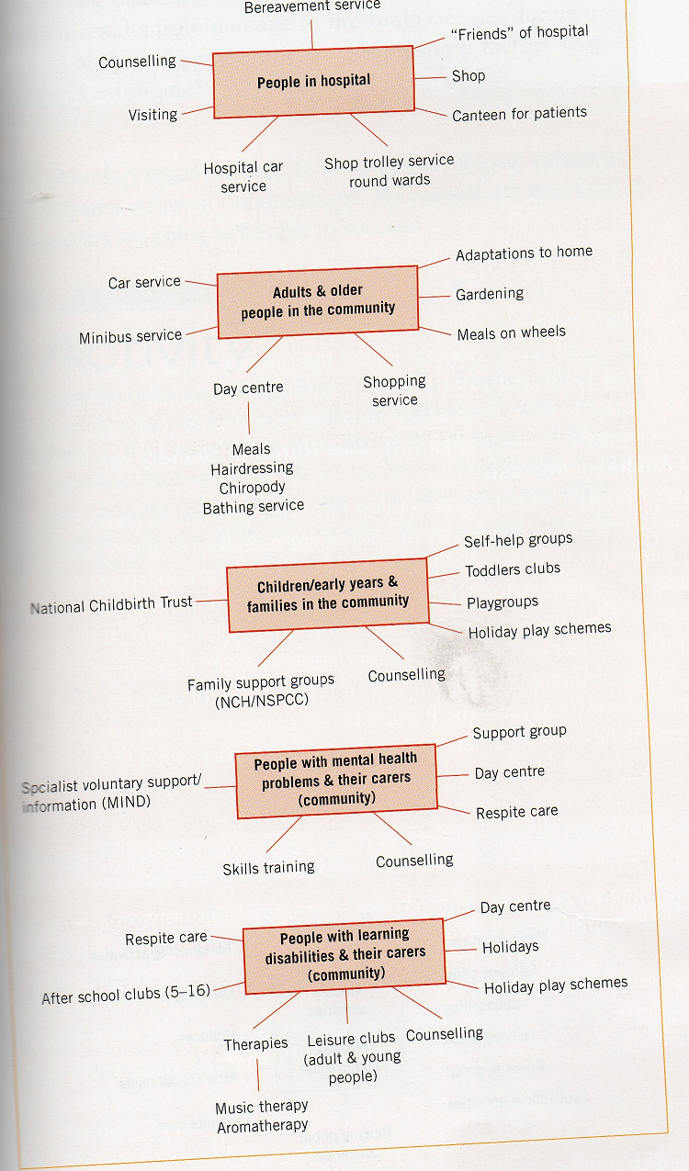
Examples of Voluntary Services for Different Client Groups

