Dissertation
LCBB6000
Program of study: BA (Hons) Business Management
Student name: Paul-Silvian Vornicescu
Student ID: 2246785

The Impact of Sustainable Supply Chain Practices on Firm Profitability in the UK Food and Beverage Industry
Individual Dissertation

Executive summary
This dissertation examines how sustainable supply chain practices are associated with firm profitability in the UK food and beverage industry. It responds to the growing pressure on food and drink firms to reduce environmental impact while maintaining financial performance. The study focuses on four practice areas: waste reduction, ethical sourcing, packaging redesign and supplier audits. A primarily quantitative survey of 48 industry professionals is supported by qualitative interview evidence from four participants. The findings suggest a positive perceived association between sustainable supply chain practice adoption and profitability, particularly through waste reduction and process efficiency. Packaging redesign and sustainable sourcing also appear to contribute to long-term financial value by supporting regulatory compliance, customer trust and brand reputation, although these benefits may take longer to emerge because of initial implementation costs. The study also indicates that firm size shapes outcomes: larger firms appear better placed to absorb upfront costs, coordinate suppliers and invest in sustainability systems, while smaller firms face greater resource constraints. Because the evidence is cross-sectional and self-reported, the dissertation presents its conclusions as indicative associations rather than definitive causal proof.

Table of Contents
Executive summary 2
Chapter 1 - Introduction 5
1.1. Origin of study 5
1.2. Problem Statement 5
1.3. Research Aim 6
1.4. Objectives and questions 6
1.5. Scope of the study 7
1.6. Significance and rationale of the study 8
1.7. Dissertation structure 8
1.8. Chapter summary 9
Chapter 2 – Literature review 9
2.1. Introduction to the Chapter 9
2.2. Theoretical Framework 9
2.3. Key Themes in the Literature 11
2.4. Critical Evaluation of Existing Research 13
2.5. Conceptual Framework and Research Gap 14
Chapter 3 – Research methdology 14
3.1. Introduction 14
3.2. Research Philosophy 15
3.3. Research Approach and Design 15
3.4. Data Collection Methods 16
3.5. Sampling Strategy 16
3.6. Data Analysis Techniques 16
3.7. Ethical Considerations 17
3.8. Limitations of Method 17
Chapter 4: Findings, Analysis and Discussion 17
4.1. Introduction 17
4.2. Respondent profile 18
4.3. Sustainable supply chain practices adopted 21
4.4. Perceived cost and profitability outcomes 22
4.5. Respondent profile 25
4.6. Firm size as a moderating factor 26
4.7. Discussion 27
Chapter 5: Conclusion and Recommendations 28
5.1. Conclusion 28
5.2. Limitations 28
5.3. Recommendations 29
5.4. Final reflection 30
References 31
Appendix 38
Participant Information Sheet 38
Participation Consent Form 40
Interviews 48

Chapter 1 - Introduction
The UK food and drink industry relies on complex, multi-tiered supply chains linking farms, processors, manufacturers, distributors, retailers and food service providers. These networks are exposed to short-term shocks, such as sudden increases in input prices, and longer-term stresses, including climate change, labour constraints and transport disruption. Such pressures can interrupt material flows and increase operating costs (Rickards and Hinkson, 2022). Sustainability requirements now extend beyond individual firms and across full supply chains. Guidance from the Food and Drink Federation (2025) highlights the need to reduce carbon emissions and move towards net zero across the value chain. Food waste remains a central issue because it creates avoidable cost and measurable environmental harm (Economou et al., 2024).

Origin of study
The UK Food or Drink Pact brings growers, manufacturers next to retailers together and documents broad uptake of targets plus measures on waste, water use and greenhouse gases, though progress remains uneven from company to company. Those pressures turn supply chain sustainability programmes into strategic choices rather than marketing slogans (WRAP, 2026). Managers therefore require clearer proof of whether sustainability measures shield profit or lower it in real conditions. Firms that produce food and drink in the UK must lower greenhouse gas output plus waste along every step of their supply chains. They do this while costs stay tight and every extra spend needs a clear reason but also while any change can upset daily operations (Li, 2025). Researchers still disagree on whether greener supply chain management raises profits.

Problem Statement
DEFRA (2024) finds that, on average, profit does rise after adoption, but the same review warns that some firms only adopt labels, not substance and that the size of the gain depends on which practice is used as well as how well it is run. A newer paper adds that outside pressure changes results - when stakeholders push hard, the profit route for cleaning up the supply chain differs from the route for cleaning up the factory line. Public league tables for UK food and drink companies show that the biggest names publish patchy data or move at different speeds (Doetsch and Huchzermeier, 2024). This uneven picture keeps managers unsure about the payoff from sustainable supply chain practices. The present study closes part of that knowledge gap using fresh survey answers to test whether specific sustainable supply chain practices link to higher profit and it checks whether the size of the firm changes that link.

Research Aim
The aim of this study is to examine how sustainable supply chain practices are associated with profitability among firms operating in the UK food and beverage sector. The study identifies which practice areas appear most closely linked with improved profitability and considers whether firm size influences that relationship.

Objectives and questions
Objectives

- To identify the key sustainable supply chain practices used by UK food and beverage firms, distinguishing between internal process-focused practices and supplier-focused practices.
- To examine whether higher adoption of sustainable supply chain practices is associated with higher perceived profitability.
- To compare the relative perceived impact of waste reduction, ethical sourcing, packaging redesign and supplier audits on profitability.
- To assess whether firm size appears to influence the relationship between sustainable supply chain practice adoption and profitability.
Research Questions
- How do sustainable supply chain practices influence the profit that companies in the UK food and beverage sector earn?
- Which practice area - waste reduction, ethical sourcing, packaging redesign or supplier audits - appears to have the strongest perceived relationship with profitability?
- Does firm size appear to influence the strength of the relationship between sustainable supply chain practices and profitability?
Element | Focus | Link to Hypotheses
Objective 1 | Identify key Sustainable Supply Chain Practices (SSCPs) used by UK food and beverage firms | Establishes construct definitions and measurement variables for H1–H3
Objective 2 | Examine the relationship between  SSCP adoption and firm profitability | Directly tests H1
Objective 3 | Compare the relative impact of  different SSCP bundles on profitability | Tests H2
Objective 4 | Assess whether firm size moderates the SSCP–profitability relationship | Tests H3
Research  Question 1 | What is the effect of SSCP adoption on profitability in UK food and beverage firms? | H1
Research  Question 2 | Which SSCP bundles have the strongest association with profitability? | H2
Research  Question 3 | Does firm size influence the strength of the SSCP–profitability relationship? | H3
Table 1.1 Objectives and questions of the research related to the hypothesis

Scope of the study
This study centres on the United Kingdom food and beverage industry, a sector that contains long, step-by-step supply chains plus large environmental effects. The research covers only companies that operate inside the UK so that rules and market forces, like the UK Food besides Drink Pact, stay the same across all cases. The work looks at four main Sustainable Supply Chain Practices - waste reduction, ethical sourcing, packaging redesign but also supplier audits. Although sustainability includes both social and environmental aspects, the project pays attention to the connection between those green actions as well as financial profit.

Significance and rationale of the study
The study has academic and practical significance. Academically, it contributes to debates about whether sustainable supply chain management is associated with stronger financial performance and under what conditions that relationship is likely to occur. Practically, it helps managers prioritise practices that appear to offer clearer financial benefits, particularly in a sector facing pressure to reduce waste, emissions and supply chain risk. It also highlights the different challenges faced by larger firms and smaller businesses when implementing sustainability initiatives.
Nami, Grigory Pishchulov and Joao, (2025) finds that, on average, sustainable supply chain management relates positively to economic performance, but the same review shows that outcomes differ by type of practice plus by how well the practice is executed - it thus leaves unresolved the conditions under which sustainability “pays”. Mastos and Gotzamani, (2022) also states that both the conceptual framing and the identification of practices remain vague - this claim justifies more testing that targets specific practices within food but also beverage supply chains. On the practical side, United Kingdom programmes that aim for net zero emissions and lower food waste demand action that stretches across entire supply chains, but food companies advance unevenly as well as disclose data inconsistently, while each firm confronts limits in budget and in its ability to handle complexity (WRAP, 2026). The study helps managers to rank bundles of sustainable supply chain practices that show a clearer tie to profit, and it helps policymakers plus industry bodies to see where extra support closes the gap between intention and action.

Dissertation structure
The dissertation is organised into five chapters. Chapter 1 introduces the research context, problem statement, aim, objectives and research questions. Chapter 2 reviews the literature on sustainable supply chain management, profitability and the theoretical frameworks guiding the study. Chapter 3 explains the methodology, including the quantitatively led mixed-methods design, sampling strategy, data collection and analysis approach. Chapter 4 presents and analyses the findings, separating descriptive results from discussion and interpretation. Chapter 5 concludes the study, outlines limitations and provides recommendations for future research and practice.

Chapter summary
The opening chapter highlights the central conflict - sustainability requirements keep rising but operators in the United Kingdom food and beverage sector must still secure profit. As industry "shocks" and "stresses" turn into standard expectations, an evidence-based proof that links green supply chain management to financial performance becomes urgent. The chapter states the research aim, which is to discover which specific bundles of practices most strongly raise profit and it outlines how firm size moderates those effects. The objectives plus research questions presented here guide the rest of the study. The next chapter reviews published work to map current theoretical disputes and to supply deeper context for the hypotheses (H1 - H3) that this project will test.

Chapter 2 – Literature review

2.1. Introduction to the Chapter
Researchers have examined sustainable supply chain practices (SSCPs) to determine whether they improve profitability and wider organisational performance. This chapter reviews that literature, with emphasis on food and beverage supply chains. It explains how researchers define SSCPs, identifies the mechanisms through which they may influence economic outcomes, and evaluates why findings differ across industries, countries and datasets. These debates inform the conceptual model and the survey design used in this dissertation.

Theoretical Framework
Three complementary perspectives guide how this dissertation examines the link between sustainable supply chain practices and profit. The Triple Bottom Line, the resource-based view together with its natural resource extension plus stakeholder theory provide the structure. The Triple Bottom Line treats sustainability as balanced performance in economic, environmental and social areas instead of a single ecological score (Alhaddi, 2015). Furthermore, Nica, Chiriță and Georgescu, (2025) shows rapid growth but also steady use across disciplines - the framework remains useful for describing “sustainable” practices and their results. In this work, the Triple Bottom Line defines sustainable supply chain practices as a set that contains environmental actions like waste reduction as well as resource light packaging and social actions like fair sourcing or supplier labour rules, while profit stays the central economic outcome. The resource-based view shows how sustainable supply chain practices turn into money. This view claims that firms earn above normal returns when they create valuable, hard-to-copy resources and routines. Komakech et al., (2025) stresses that advantage often rests in groups of capabilities rather than in isolated moves. The natural-resource-based view re labels ecological limits as chances to build capabilities - pollution prevention routines, product stewardship like packaging redesign next to supplier base learning lower cost, smooth operations and support product distinctiveness. On the other hand, stakeholder theory shows why adoption of sustainable supply chain practices is often compulsory. Regulators, employees, suppliers plus communities grant legitimacy and access to critical resources. This delivers an “outside-in” reason for the practices - firms introduce them to keep legitimacy, satisfy buyer demands but also cut reputation risk (Hassini, Surti and Searcy, 2012). However, the same theory also forecasts conflict. When pressure rises, firms may favour visible supplier programmes or extra reporting even when financial returns lag, which helps account for mixed empirical findings. Implementation settings shape results because sustainable supply chain practices unfold inside intricate supply networks (Ivanov, 2017). A practitioner survey on resilience and sustainability lists tight budgets as well as complex products or partners as common obstacles - returns hinge on coordination skill and complexity control. Evidence that competitive advantage can channel sustainable supply chain management's effect on performance points to indirect routes from practices to profit (Yasmeen, Anthonysamy and Ojo, 2025). Taken together, those perspectives support the study's hypotheses - sustainable supply chain practices probably raise profit - returns differ across practice types; or firm size alters the effect because large companies command more resources and scale benefits.

Key Themes in the Literature
A first debate asks what researchers mean by the term SSCPs and whether scholars should handle SSCPs as one index or as separate bundles. Literature on food industry SSCM states that conceptual borders remain unclear plus that “SSCM” often mixes drivers, practices and outcomes (Hassini, Surti and Searcy, 2012). This is important because the choice of measurement decides what counts as “adoption” but also what is credited to sustainability. Many empirical studies such as the one of Tseng et al., (2020) rely on TBL-aligned constructs that cover environmental, social and economic practice dimensions. This wider conceptual scope can hide trade-offs inside composite scores. Feng, Zhu and Lai, (2017) finds positive links between SSCM as well as economic performance but it also cautions that reported “sustainability behaviours” do not always point to real sustainability change, which shows that practice content and execution quality vary across samples. For food or beverage supply chains, where perishability and waste set cost structures, SSCPs may need measurement as practice bundles (for example, waste focused versus supplier-focused) instead of a single green index. Secondly, a frequent assertion holds that sustainable supply chain practices raise profit - raising efficiency. When companies cut waste and cut resource input, they defend their profit margin plus cut the bill for disposal. Abuzawida, Alzubi and Iyiola, (2023) confirms this route - it ties the uptake of activities like green purchasing, green design and green marketing to better economic results, frequently by way of simultaneous gains in social but also environmental outcomes. In food and drink supply chains this route is structurally credible, because waste carries an immediate cash cost as well as is visible to the public. Data assembled by WRAP (2026) for the United Kingdom reveal large volumes of greenhouse gas emissions linked to discarded food and drink, which strengthens the operational argument for waste prevention or tighter process control. Wandosell et al., (2021) explain why an efficiency gain does not always show up at once in profit figures. Packaging redesign offers a clear example of the conflict. For instance, examined packaging in detail demonstrates that companies are able to evaluate both environmental and financial effects through life cycle assessment next to life cycle costing but it also underlines the intricacy involved and the need for orderly methods to defend greener packaging decisions. The finding indicates that some sustainable supply chain practices require early expenditure plus a period of learning - short term profit may fall even when long term value is present. The discussion therefore turns on the length of the observation window and on whether researchers record profit at a point when benefits have had sufficient time to emerge. Furthermore, another pathway suggests that SSCPs affect profit when stakeholders react. If sustainability shows that a firm is credible, the firm keeps demand, raises customer loyalty and lowers the risk of losing market entry. A 2024 sector study of large listed European food and drink companies states that sustainability plans build long term strategic value, in line with differentiation logic plus not with pure cost logic (Ebele et al., 2024). The literature does not agree on whether stakeholder pressure always aids. Liu, (2023) reports that stakeholder pressure raises the performance effect of sustainable process management but lowers the payoff of sustainable supply management, which shows that “more pressure” does not yield equal economic gains. This uncertainty is important in the UK, where public benchmarks show that many major food companies set net zero and Scope 3 targets but do not disclose clear progress data - legitimacy demands outpace operational change (GOV UK, 2023). The open question is whether firms pay for visible compliance and reports while they fail to secure the deeper operational but also market returns that would cover the cost. Another debate asks at what point SSCPs “pay” begin to operate and which organisations feel the effect. Several frameworks claim that SSCPs raise profit only after they first generate competitive advantage plus resilience. Numbers back this view - statistical models demonstrate that SSCM lifts competitive advantage and this lift then raises overall performance - the path to money is indirect (Karkalousos and Evangelopoulos, 2011). Other work shows that the direction of the link depends on the kind of practice. One hierarchical regression reports that internal SSCM practices lower economic performance, whereas external practices raise it - the same paper shows that firm size alters the size of the economic effect (Osei et al., 2023). A survey of practitioners lists budget limits but also the complexity of products or partners as common blocks to both resilience and sustainability - the results suggest that smaller firms lack the scale that lets SSCPs deliver visible gains (Hasyim and Bakri, 2024). Across those streams, a clear issue persists - little UK evidence focuses on food as well as beverage supply chains, names specific SSCP bundles and states how strongly each bundle ties to profit or how firm size changes that tie. This dissertation closes the lack of information through a targeted UK survey.

Critical Evaluation of Existing Research
Current research on sustainable supply chain management gives helpful information, but multiple flaws lower trust in many of the reported links between sustainable practices and profit. Researchers define the construct in very different ways. Work that focuses on the food sector points out that both the concepts and the sets of practices remain vague - each study builds its own index of sustainable activities plus chooses its own performance indicator (Anilkumar and Sridharan, 2019). As a result of this, the literature faces “false disagreement”. Results appear to conflict simply because one paper tests one bundle of practices while another paper tests a different bundle or uses a different definition of success, like profit instead of operational efficiency. A large share of studies rely on single shot surveys in which the same manager answers questions about both sustainable practices and company performance. This setup invites common method bias - the method itself can twist the numbers up or down when one person and one questionnaire capture every variable (Podsakoff et al., 2024). A major review published in 2024 states that this bias is common but also that no single statistical test can remove it - careful steps at the design stage are vital. Recent guidance on online surveys repeats the call for strict procedures in survey design, respondent recruitment and data handling so that the answers remain valid and useful (Simon, 2022). Findings sometimes clash within the same study because sustainable practices create costs now as well as benefits later. Some data show that internal activities, like waste reduction inside the plant, link to weaker economic results, whereas external activities, like supplier audits, link to stronger results (D.R et al., 2023). Other work shows that even the sign of the payoff changes with the setting - when stakeholder pressure is high, process sustainability pays off more, but supply sustainability pays off less - “one best SSCP strategy” that fits every context is hard to find (Kitsis and Chen, 2021). Many articles give no solid statistical reason for the chosen sample or sample size, which cuts down external validity. A recent survey of sampling habits in quantitative business papers urges authors to give clearer justification and full disclosure (Gino et al., 2023). Those gaps leave three topics almost untouched - the exact effects of specific practices in food and beverage supply chains, evidence gathered inside the United Kingdom or strict control of method bias when profit data come from a fresh manager survey.

Conceptual Framework and Research Gap
Previous studies suggest that sustainable supply chain practices are often associated with improved profitability, but the mechanisms remain contested and the strength of the relationship varies by context (Anilkumar and Sridharan, 2019). The research gap is therefore not simply a lack of studies on sustainability; it is the shortage of UK food and beverage sector evidence that separates specific practice bundles, considers firm size as a contingency factor and recognises the limitations of self-reported survey data. This dissertation addresses that gap by treating sustainable supply chain practices as distinct internal and supplier-facing activities and by examining how each appears to relate to perceived profitability.
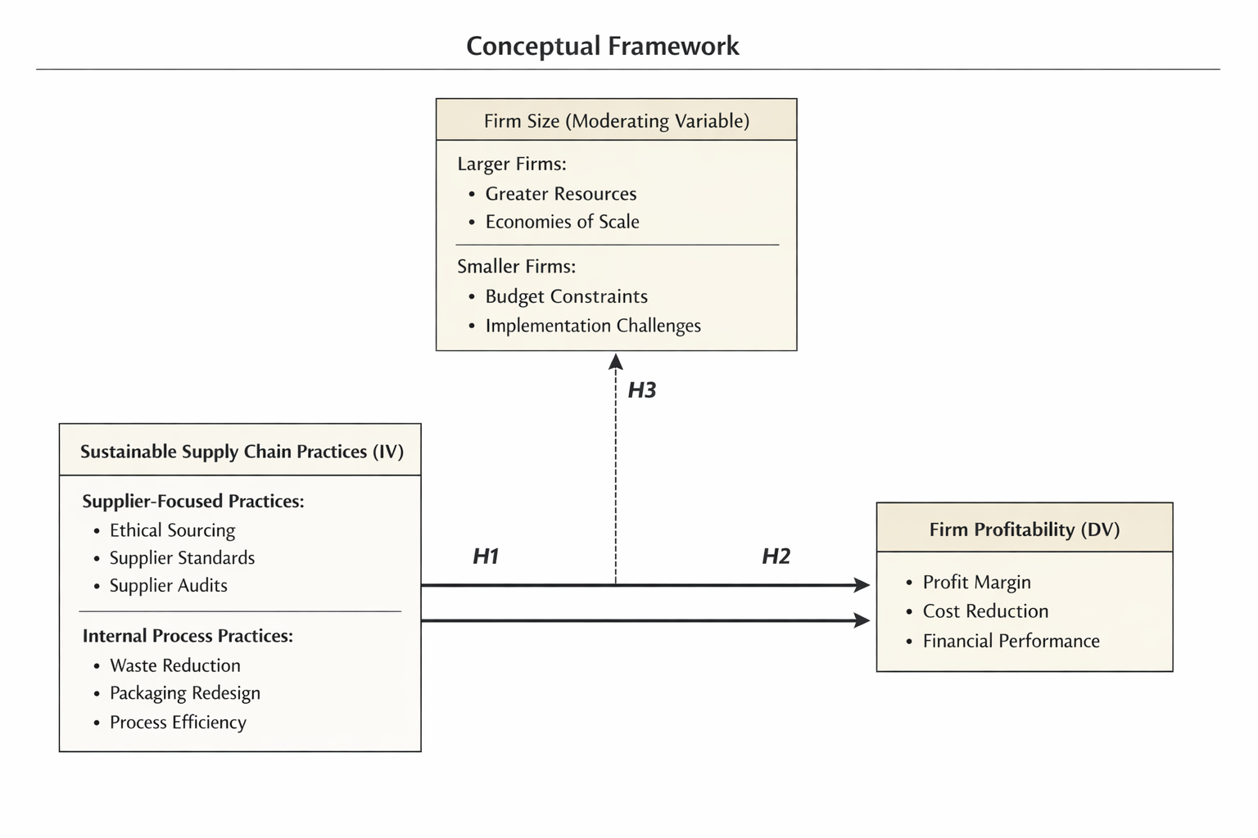
Fig 2.1 Conceptual framework for sustainable supply chain practices and profitability

Chapter 3 – Research methdology

Introduction
This chapter explains the research design used to examine the relationship between sustainable supply chain practices and perceived profitability in the UK food and beverage sector. The study is best described as a quantitatively led mixed-methods design: the survey provides the main evidence, while semi-structured interviews provide contextual explanation and support interpretation. This clarification strengthens methodological coherence because the dissertation uses both numerical survey results and qualitative interview comments.

Research Philosophy
The study rests on a positivist philosophy - positivism holds that one objective reality exists or that researchers can record it through observable signs and test it with hypotheses. A current account of positivism ties it to the hypothetical deductive model, concepts become measurable items next to statistical tests check the links between them (Ali, 2024). This stance suits the dissertation because the goal is to explain whether different levels of sustainable supply chain practice relate to different profit results and whether firm size alters that link. Positivism also demands rigour - it requires tight concept definitions, open measurement rules plus explicit model choices. Such discipline is useful because definitions of sustainable supply chain practices often shift. The drawback is that a positivist survey may miss the lived experience and the political dynamics inside organisations (AgriFood, 2020). The study accepts this trade off because the questions ask about the strength but also direction of associations, not about interpretive meaning.

Research Approach and Design
The study follows a deductive path; it takes hypotheses from existing theory on sustainability and performance as well as tests them with data. The design is quantitative and cross sectional. A structured online questionnaire goes to professionals in the United Kingdom food or beverage industry who know about sustainability and supply chain issues. This plan fits the need to compare bundles of practices in one statistical model next to test whether firm size moderates the results, tasks that regression handles well. A single time survey is feasible within an undergraduate calendar and within access limits. Nonetheless it weakens causal claims - the data can show association plus theoretical fit, but they cannot prove that practices cause profit to change (Wang and Cheng, 2020). The study counters this limit - adding control variables, using clear time references in the questions and by openly discussing the risk of reverse causality.

Data Collection Methods
Primary data were collected through an online questionnaire that recorded two main areas: adoption of sustainable supply chain practices and perceived profitability outcomes. Practice items were grouped into internal process-focused practices, such as waste reduction, packaging improvement and process efficiency, and supplier-facing practices, such as ethical sourcing, supplier standards and supplier assessment. Profitability was measured through respondents' perceptions of changes in financial performance, cost reduction and performance relative to competitors. A systematic review confirms that financial metrics remain central for judging organizational success, even when studies choose different specific indicators (Munteanu et al., 2025) The interview questions explored participants' knowledge of sustainability practices, the practices most commonly used in their firms, perceived profit effects and the role of firm size.

Sampling Strategy
The target population consisted of employees, supervisors and managers working in the UK food and beverage industry who had sufficient knowledge of their firm's supply chain or sustainability activities. The study used non-probability purposive sampling, supported by convenience access and optional snowball forwarding. This approach was appropriate because the research required informed respondents rather than a general public sample. Nevertheless, the sampling strategy limits generalisability because participants were not randomly selected. Zrineh, Al‐Usta and Alwawi, (2026) urges researchers to state sampling logic as well as to justify sample size through power analysis instead of through simple rules of thumb. The study therefore sets a target size suited to multiple regression and moderation tests.

Data Analysis Techniques
The analysis combines descriptive survey reporting with thematic interpretation of the interview evidence. Survey results are presented using valid response counts and percentages. Because the available results are descriptive rather than fully inferential, the dissertation avoids overstating hypothesis confirmation. Interview data are analysed thematically by grouping comments around cost reduction, delayed financial benefits, supplier control and the role of firm size. This approach allows the discussion to connect survey patterns with practical explanations from industry participants. The study also applies procedural controls but also reports tests for common method bias.

Ethical Considerations
The study follows the approved ethics protocol. Participants received an information sheet, gave consent and were informed that participation was voluntary. The questionnaire and interviews were designed to minimise reputational or privacy risk. Results are reported in aggregate and interview participants are discussed by participant number rather than by identifiable personal details.

Limitations of Method
The main methodological limitations are the cross-sectional design, the non-probability sample and the reliance on self-reported data. These factors mean that the study can identify perceived associations but cannot prove causality. There is also a risk of common method bias because the same respondents reported both sustainability practices and profitability outcomes. The findings should therefore be interpreted as indicative evidence that is consistent with theory rather than as conclusive proof that sustainable supply chain practices directly cause higher profitability.

Chapter 4: Findings, Analysis and Discussion

Introduction
This chapter presents the findings from the quantitative survey and the supplementary semi-structured interviews. The survey gathered responses from 48 professionals in the UK food and beverage sector, while the interviews captured more detailed views from a Supply Chain Manager, an Operations Supervisor, a Procurement Officer and a Production Assistant. The chapter separates descriptive findings from analysis and discussion. Because the survey results are descriptive and self-reported, the chapter uses cautious wording such as "suggests", "indicates" and "provides support" rather than claiming definitive statistical proof.
A note on response numbers is required. The number of valid responses differs across survey questions because some items were skipped or answered only by relevant respondents. Percentages are therefore reported using the valid response count for each item rather than assuming that every percentage is based on all 48 participants.

Respondent profile
The respondent profile provides useful context for interpreting the findings. From a Resource-Based View perspective, sustainability capability depends partly on the knowledge and experience held by employees. The age profile shows that the largest group of respondents was aged 35-44, representing 31.3% of the valid responses, followed by the 25-34 group at 20.8% (Survey Planet, 2026). This suggests that the sample included a substantial proportion of professionally experienced respondents, which Madhani(2010) acknowledges that the advantage comes from internal assets like the quiet knowledge and experience held by people.
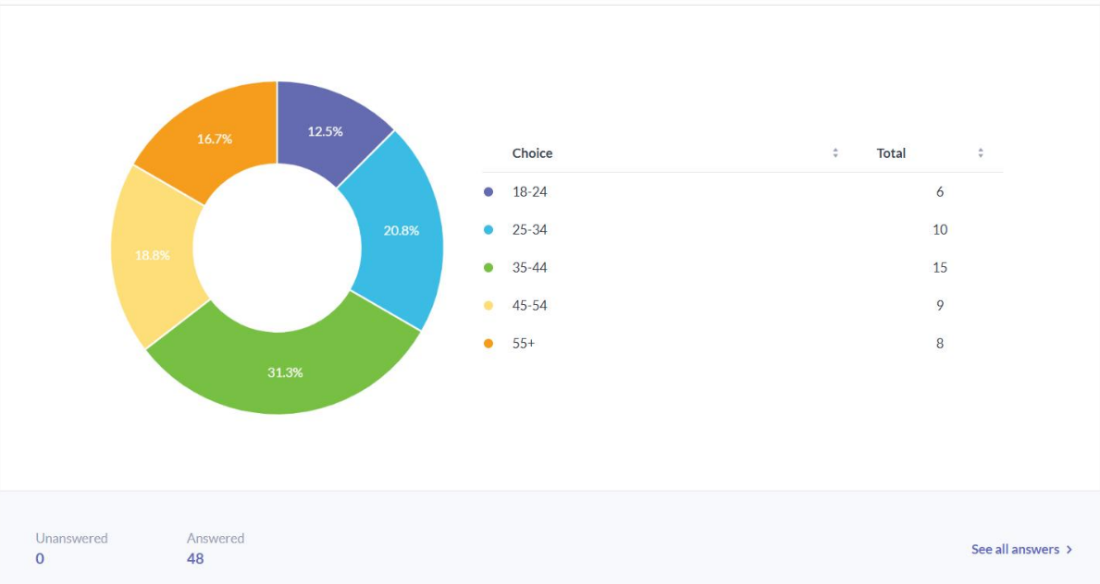
Figure 4.1. Respondents age profile.
The age profile is supported by the experience data. Figure 4.2 shows that 35.4% of valid respondents had worked in the sector for four to six years, while 33.3% had between one and three years of experience (Survey Planet, 2026). Figure 4.3 shows that operational staff formed 52.1% of the sample, supervisors 20.8%, and managers or senior managers 22.9%. This mix is useful because it captures both operational experience and managerial perspectives, although the high proportion of operational staff may influence how strategic sustainability issues are interpreted.

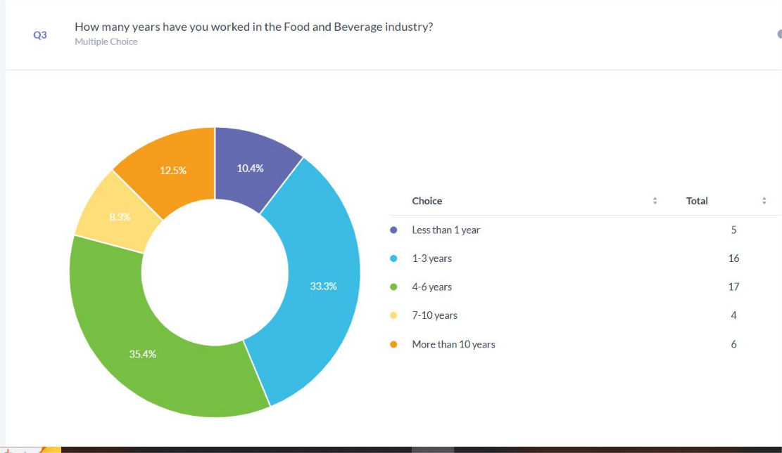
Figure 4.2. Years worked in F&B industry
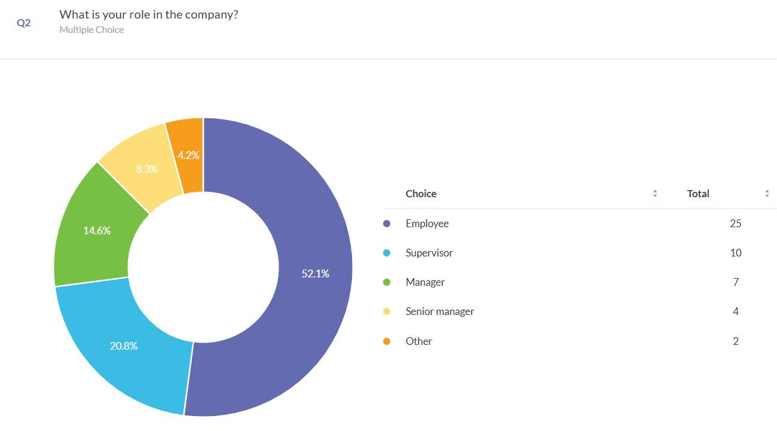
Figure 4.3. Respondents’ role in their companies.
Participant 1, a Supply Chain Manager with six years in post, states that every sustainable method is known in detail, whereas Participant 4, a Production Assistant with two years on record, describes having only limited knowledge. Under the Resource Based View, this signals that sustainability know how clusters at management level or leaves a knowledge gap that can slow green projects on the shop floor (Khanra et al., 2022). The data need interpretation against the economic backdrop of 2025 - 2026, when UK food producers confront continuous cost rises and a surge of new rules. Industry benchmarks state that production expenses grew by 4.4% to 6.3% during 2025 but selling prices climbed more slowly - profit margins shrank to critical levels (Harari, 2026). This financial strain turns sustainable supply chain methods into a shield for earnings instead of a purely ethical option. A high uptake of such methods - 89.6 % of the 43 firms in figure 4 report that they apply them - shows that the sector now treats environmental and social hazards as core elements of financial risk control (Survey Planet, 2026).
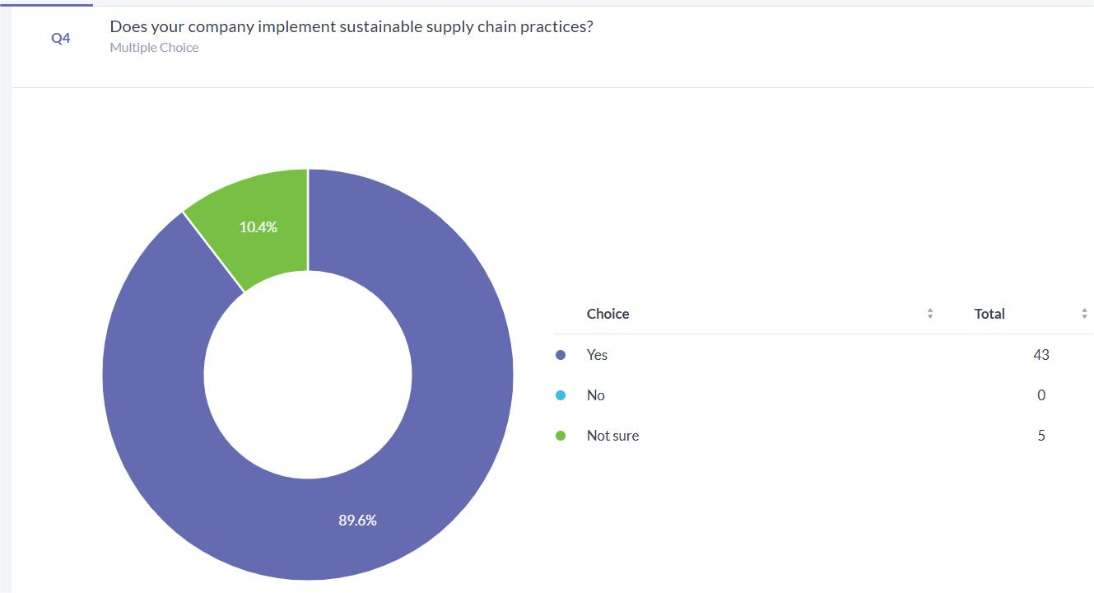
Figure 4.4. Percentage of firms implementing sustainable supply chain practices
Figure 4.5 adds that 66.7% of valid respondents rated sustainability as very important in their company's supply chain, while 31.3% rated it as important. This indicates that sustainability is widely viewed as a business-relevant issue rather than as a marginal corporate social responsibility activity.
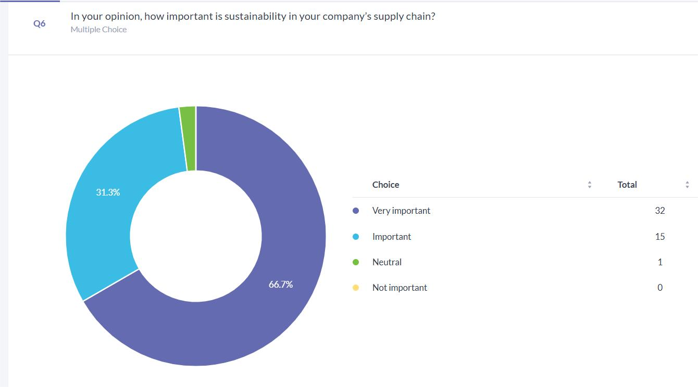
Figure 4.5. Perceived importance of sustainability in company supply chains

Sustainable supply chain practices adopted
One objective of the study was to identify which sustainable supply chain practices are most commonly used and which appear most closely associated with profitability. Figure 4.6 shows that environmentally friendly packaging was the most frequently reported practice, identified by 29.2% of valid respondents. Waste reduction followed at 27.1%, while sustainable material sourcing accounted for 20.8%. These responses support the decision to distinguish between internal process-focused practices, such as waste reduction and efficiency, and supplier-facing practices, such as ethical sourcing and audits.
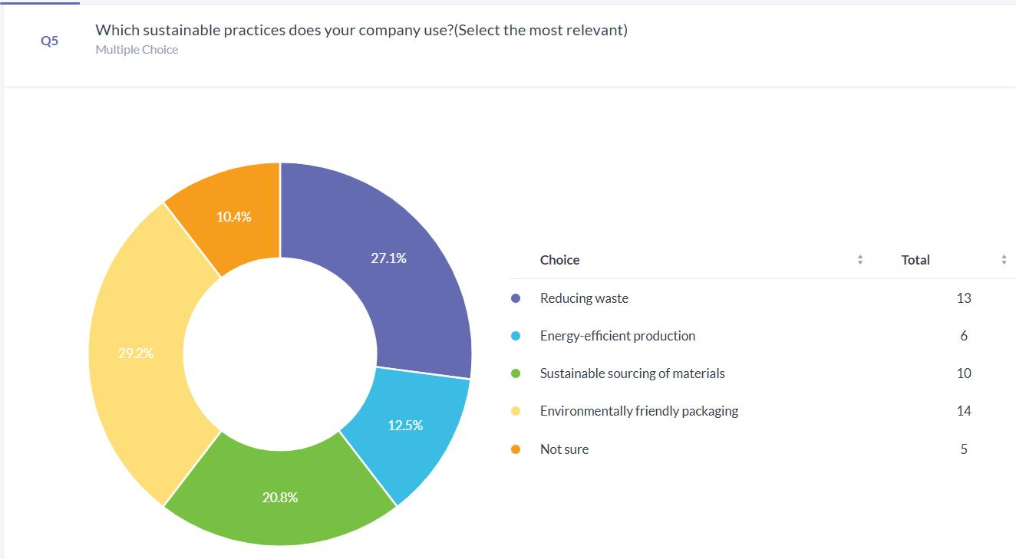
Figure 4.6. Sustainable supply chain practices implemented

Perceived cost and profitability outcomes
Those answers permit a split into two themes, practices that face inward toward internal processes and practices that face outward toward suppliers. Process focused actions like waste cuts but also energy savings fit the Natural Resource Based View, because they prevent pollution and raise resource productivity, both of which lower costs (Skordoulis et al., 2020). Supplier focused actions like sustainable sourcing and audits align with Stakeholder Theory, because they support legitimacy, curb risk as well as build brand value - enforcing ethical standards throughout the extended value chain. Process-facing practices influence profit mainly through higher efficiency (Esan, Ajayi and Olawale, 2024). Participant 1 and Participant 4 both state that waste reduction and waste control deliver the strongest profit effect (See appendix). Figure 6 also supports this view since 91.7 % of survey respondents agree or strongly agree that sustainable practices lower operational costs.
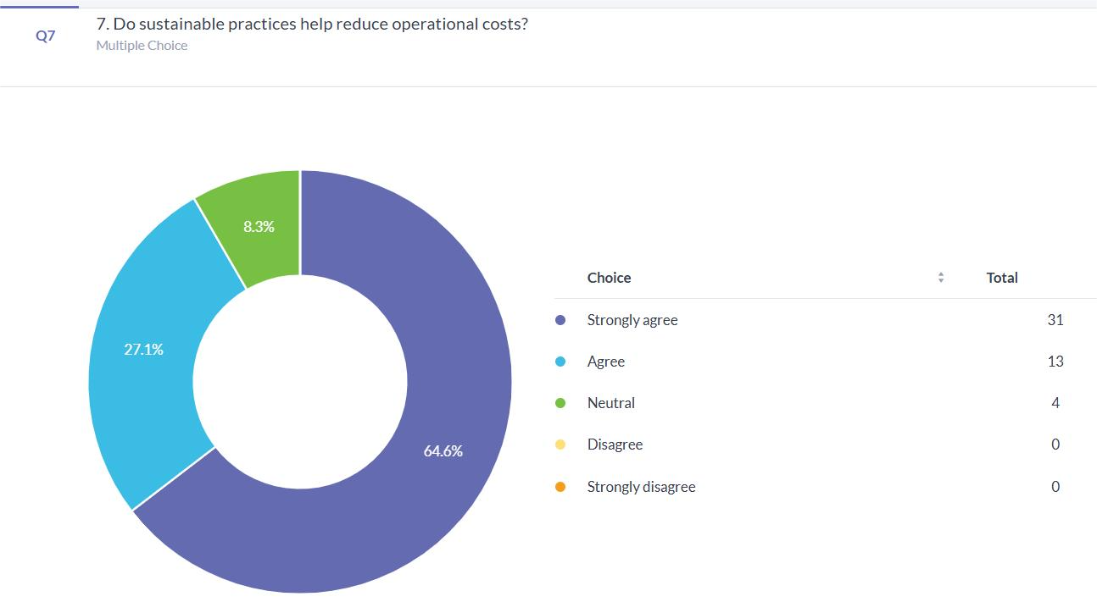
Figure 4.7. Percentage of respondents agreeing sustainable practices lower operational costs
The profit rise follows multiple direct routes. In the UK food sector, almost one quarter of all food produced is lost or wasted each year - the value exceeds £21 billion (Malik et al., 2024). Cutting waste equals the recovery of profit that would otherwise disappear. Academic studies show that each £1 spent on food waste reduction saves the business about £7 to £14. The saving comes from lower spending on raw materials that would be discarded, lower energy use during processing and lower disposal fees (Gradeall International LTD, 2024). In addition, the 2025/2026 Extended Producer Responsibility scheme turns environmentally friendly packaging into a financial requirement. From April 2026, UK firms will pay modulated fees that depend on the recyclability grade of their packaging, graded red-amber-green. Companies that have already redesigned their packaging to achieve a green rating will pay lower fees than competitors whose packaging receives a red or amber label - they secure a clear cost advantage (Department for Environment, Food & Rural Affairs, 2025). Sustainable supply chain adoption raises firm profit - the first study hypothesis is confirmed. Figures 8 and 9 supply strong survey evidence. Image 8 shows that 83.3 % of respondents say sustainable practices have raised their company's financial result: 58.3 % call the rise significant and 25 % call it slight. Only 2.1 % report no change. Figure 9 adds that 95.8 % of participants believe those practices raise profitability, with 60.4 % in strong agreement and 35.4 % in agreement (Survey Planet, 2026).
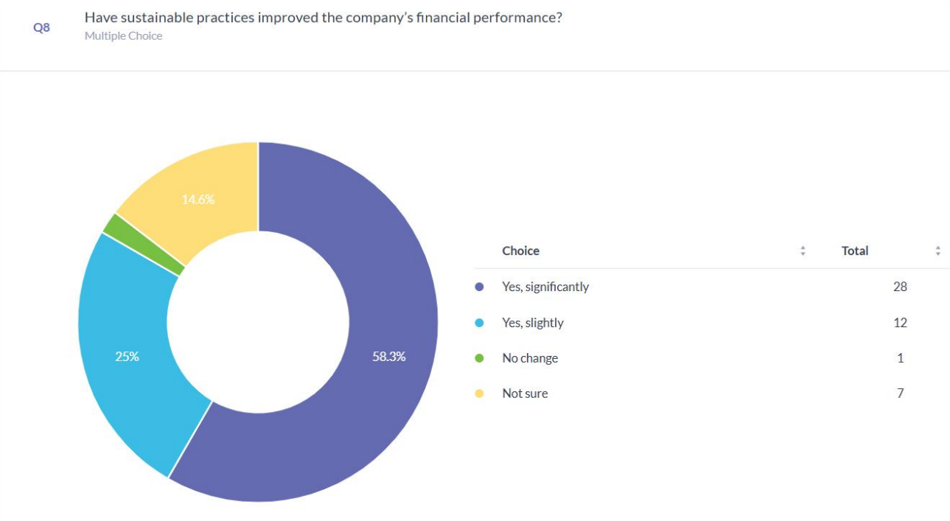
Figure 4.8. Percentage of respondents agreeing sustainable improved the company performance.
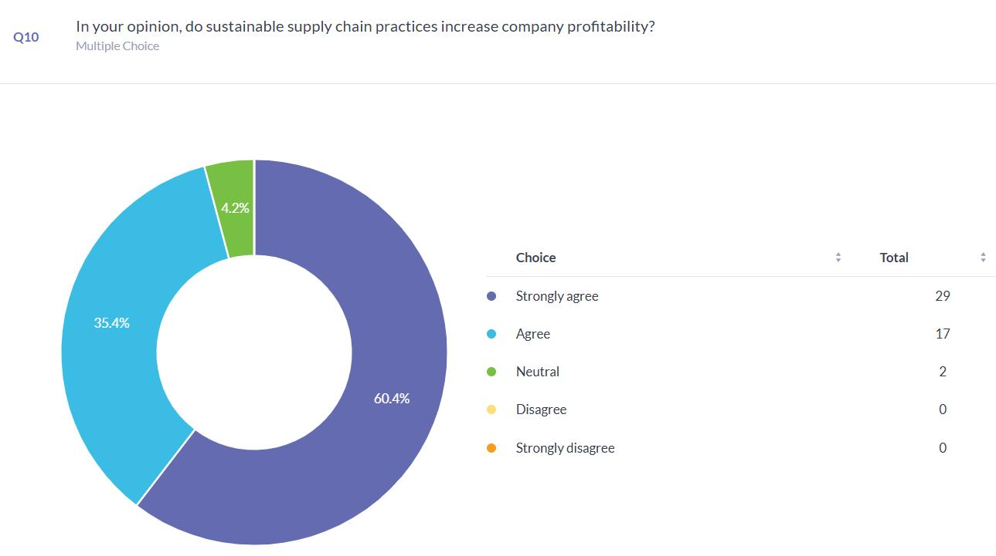
Figure 4.9. Percentage of respondents agreeing sustainable practices increase profitability

Respondent profile
The industry no longer treats sustainability as a cost centre, the data show that environmental and social performance predict economic performance. One clear point that emerged from the interviews is that those benefits unfold over time. Participant 2 notes that profit rises only after a long interval because the practices raise costs at the outset and lower them later (See appendix). This matches the time lag effect documented in academic studies, where supply chain management capabilities need two to three years before they improve financial results. The delay is most visible in packaging redesign. A switch to bio based plus biodegradable materials demands an upfront payment for new machines and for materials that cost 10 - 15 % more (Xiao et al., 2021).
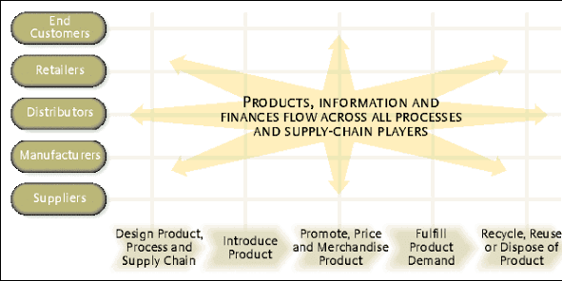
Figure 4.10. Xiao, L., Zhu, Q., Xu, X. and Christoph Wäger (2021). Time Lag Effect of Supply Chain Management on Firm Performance.
These upfront costs may reduce margins in the short term, but they can create longer-term value through product stewardship, regulatory preparedness and differentiation. Figure 4.11 shows that 97.9% of valid respondents believed customers respond positively to sustainable practices. This supports the Stakeholder Theory argument that sustainability can protect legitimacy and market position, although it does not prove that customer approval automatically translates into higher profit.
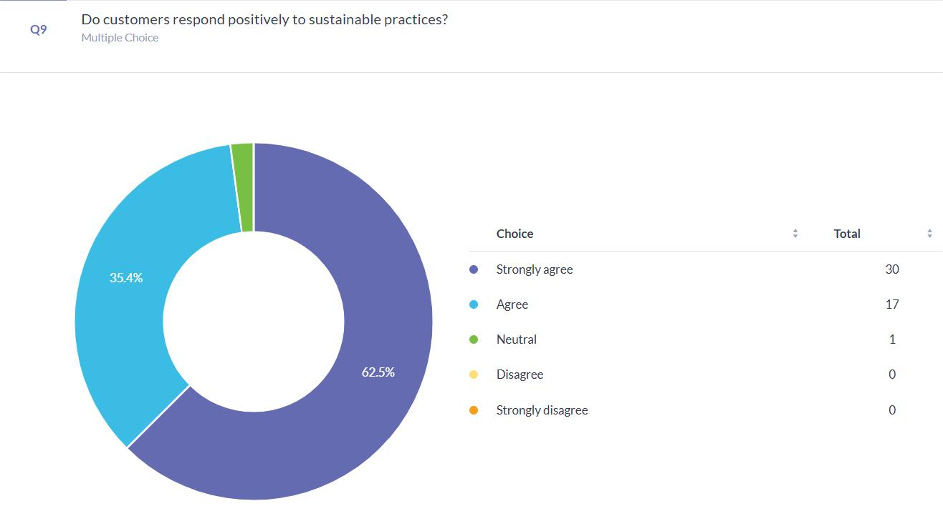
Figure 4.11. Percentage of respondents claiming that customer respond positively to sustainable practices.

Firm size as a moderating factor
The data also show that firm size alters the link between sustainability as well as profit. All four interviewees concur that the scale of the company shapes the outcome. Participant 2 explains that large firms command more resources to fund those practices, while Participant 3 adds that they exert tighter control over suppliers. Resource Orchestration Theory argues that big companies hold the financial slack, the technological base and the managerial skill needed to weave sustainability into a competitive asset. A large manufacturer, for instance, can pay for AI or predictive analytics that align demand with production, cutting waste in ways that small and medium sized enterprises cannot replicate (Dinh, 2026). Participant 4 points out that small firms encounter steeper obstacles. Industry reports support this view - cost increases weigh more heavily on small businesses next to they often lack the tools to measure performance and the funds to act. In short, although the industry faces pressure from every direction, the firms that embed the Triple Bottom Line into their supply chain design stand the greatest chance of securing long term financial strength.

Discussion
The discussion reveals broad agreement that sustainable supply chain practices relate to higher profit, but a number of constraints weaken that claim. Many studies depend on managers' own statements that profit improved, not on audited financial numbers. Because the same people describe both the practices and the results, the answers share a single source pattern that can enlarge the apparent link (Podsakoff et al., 2024). Earlier work shows that such studies lose internal validity - they do not show if the practices raise profit or if firms that already earn more choose to add sustainability schemes. The discussion also treats lower waste and related efficiency gains as the main route to higher earnings. This view matches the natural-resource-based argument that saving material lowers cost. But the review gives little weight to studies which record that some internal sustainability projects lower near-term earnings because they demand heavy early spending plus complex routines (Wandosell et al., 2021). The review acknowledges that benefits appear only after a delay but its cross-sectional data track just one point in time - they cannot trace those later outcomes, and causal statements stay uncertain (Wang and Cheng, 2020). Stakeholder pressure is described as helpful but earlier papers report varied results. Approval from customers and regulators can lift sales but also brand value but heavy demands may push firms to adopt visible symbols instead of deep change - profit gains shrink (Liu, 2023). The link between sustainable supply chain practices and earnings therefore depends on context - it is not automatic. Large firms receive repeated attention because they own the money and skills needed for advanced sustainability projects. This fits the resource-based view, but it also exposes a built-in tilt - small firms face capital as well as technology barriers - they cannot reach the same profit gains (Hasyim and Bakri, 2024). In sum, the discussion offers plausible but not final evidence that sustainable supply chain practices raise profit. The effect varies with time, with firm resources and with research design. Long run data sets and objective profit figures would be required before stronger claims emerge.

Chapter 5: Conclusion and Recommendations

Conclusion
The research aimed to test how sustainable supply chain practices affect profit levels among United Kingdom food and beverage companies. Data revealed a clear positive link between actions like cutting waste, buying from verified sustainable sources plus redesigning packages each raise financial returns. Evidence therefore positions sustainability not as a side project but as a central strategy that lifts efficiency, pushes down expense and sharpens market position. Process-centred actions create immediate economic value, squeezing more output from each unit of water, energy or raw material. Supplier centred actions secure deferred rewards, they earn regulatory approval but also consumer trust, which translate into steadier sales and higher price tolerance. But the data also prove that those pay offs arrive after a delay. Up-front spending on new equipment, staff training or certification often depresses margins during early reporting periods, the breakeven point lies multiple quarters ahead. Company scale alters the speed as well as size of the return, large enterprises absorb the early costs more easily because they own dedicated sustainability teams, stronger borrowing power and volume discounts on green inputs. Smaller businesses face the same strategic logic, but they reach net positive results more slowly or with greater risk.

Limitations
The research brings useful insights, but it also carries clear limits. A cross-sectional survey supplied the evidence - the design cannot confirm cause and effect. The survey records links only at one moment plus it remains uncertain if sustainable supply chain practices raise profit or if firms that already earn high profit find it easier to adopt such practices. All answers came from the managers themselves - the same questionnaire asked for judgments on both sustainable practices and financial results. Shared source but also format create common method bias and the apparent links between variables may appear stronger than they truly are. The sample was not chosen through random selection - firms joined because they agreed to answer. Conclusions therefore reach only the group that took part as well as do not automatically extend to the complete United Kingdom food and beverage industry. The enquiry tracked a narrow list of green supply actions - it left out social topics like labour standards or operational elements like process redesign, although both areas belong to wider sustainable supply chain management. Profit figures rest on the managers' own statements - no audited accounts, tax returns or other independent records entered the analysis. Hard financial data would supply firmer proof of if sustainability efforts raise earnings (Mugoni, Kanyepe and Tukuta, 2024). Therefore, sustainable supply chain practices do lift profitability, but the lift depends on disciplined execution, on the specific resources the organisation already commands and on the calendar the management is willing to honour.

Recommendations
Researchers need to track the same firms over many years so they can see how long sustainable supply chain practices take to change profits. Mugoni, Kanyepe and Tukuta, (2024) show that green projects often raise earnings only after a delay and multi-year records let scholars measure those slow changes with precision. Teams should also use hard numbers drawn from audited accounts, profit margins or return on investment, instead of opinions because audited figures raise the reliability of results. A design that blends large scale statistics with open interviews gives a fuller picture of how sustainable supply chains work in daily operations. The next round of studies must test the variables that come between sustainable practices plus profit, as well as the variables that alter the strength of the link. Stakeholder pressure, for instance, sometimes raises earnings and sometimes lowers them, depending on the setting - the connection is neither straight nor fixed. Work should compare small firms with large ones, heavy industry with light industry but also simple supply chains with complex networks, because context changes results (Li et al., 2025).. Scholars should also collect data from small and medium enterprises as well as from emerging economies, two areas that remain underrepresented in current publications. Companies ought to roll out sustainable supply chain practices in stages. They should first adopt actions that cut waste and lower cost at once then move step by step toward harder tasks like closer supplier cooperation or green product redesign (Sánchez-Flores et al., 2020). Executives need to build internal skills, they should train staff and install data systems that track materials, energy next to emissions. Public authorities should offer focused aid, especially to smaller businesses - that limited capital and technology do not block the shift to sustainable supply chain management.

Final reflection
Overall, the dissertation demonstrates that sustainable supply chain management is not only an environmental concern but also a strategic business issue. The strongest contribution of the study is its focus on specific practice areas within the UK food and beverage sector. Its main area for improvement is the need for more explicit statistical testing and more objective financial evidence. Addressing these issues would strengthen the academic rigour and allow future research to make firmer claims about the relationship between sustainability and profitability.

References
Abuzawida, S.S., Alzubi, A.B. and Iyiola, K. (2023). Sustainable Supply Chain Practices: An Empirical Investigation from the Manufacturing Industry. Sustainability, [online] 15(19), p.14395. doi:https://doi.org/10.3390/su151914395.
AgriFood, S.L. (2020). Research Methodologies in Supply Chain Management. [online] Academia.edu. Available at: https://www.academia.edu/39006834/Research_Methodologies_in_Supply_Chain_Management.
Alhaddi, H. (2015). Triple Bottom Line and Sustainability: A Literature Review. [online] ResearchGate. Available at: https://www.researchgate.net/publication/277609498_Triple_Bottom_Line_and_Sustainability_A_Literature_Review.
Ali, I.M. (2024). A Guide for Positivist Research Paradigm: from Philosophy to Methodology. Idealogy Journal, 9(2), pp.187–196. doi:https://doi.org/10.24191/idealogy.v9i2.596.
Anilkumar E.N. and Sridharan R. (2019). Sustainable Supply Chain Management. International Journal of System Dynamics Applications, 8(3), pp.15–52. doi:https://doi.org/10.4018/ijsda.2019070102.
DEFRA (2024). United Kingdom Food Security Report 2024: Theme 3: Food Supply
Chain Resilience. [online] GOV.UK. Available at:
https://www.gov.uk/government/statistics/united-kingdom-food-security-report2024/united-kingdom-food-security-report-2024-theme-3-food-supply-chainresilience.
Department for Environment, Food & Rural Affairs (2025). Extended Producer Responsibility for Packaging: 2025 base fees. [online] GOV.UK. Available at: https://www.gov.uk/government/publications/extended-producer-responsibility-for-packaging-2025-base-fees/extended-producer-responsibility-for-packaging-2025-base-fees.
Dinh, V.H. (2026). Leveraging AI-enabled knowledge capabilities for new product performance: Evidence from manufacturing SMEs in emerging economies. Industrial Marketing Management, 133, pp.84–103. doi:https://doi.org/10.1016/j.indmarman.2026.01.006.
Doetsch, S. and Huchzermeier, A. (2024). The Intersection of Supply Chain Resilience and Sustainability from a Theoretical and Practical Perspective: An Integrated Framework. Journal of Cleaner Production, pp.144306–144306. doi:https://doi.org/10.1016/j.jclepro.2024.144306.
D.R, E., Vinay Kandpal, Márcio Martins Machado, Mauro Luiz Martens and Majumdar, S. (2023). A Bibliometric Analysis of Circular Economies through Sustainable Smart Cities. Sustainability, 15(22), pp.15892–15892. doi:https://doi.org/10.3390/su152215892.
Ebele, E., Iyelolu, V., Idemudia, N.C. and Ignatius, T. (2024). Exploring the Relationship between Sustainable Business Practices and Increased Brand Loyalty. International Journal of Management & Entrepreneurship Research, [online] 6(8), pp.2463–2475. doi:https://doi.org/10.51594/ijmer.v6i8.1365.
Economou, F., Georia Chatziparaskeva, Papamichael, I., Pantelitsa Loizia, Voukkali,
I., Navarro-Pedreño, J., Eleftheria Klontza, Lekkas, D.F., Naddeo, V. and Zorpas, A.A.
(2024). The concept of food waste and food loss prevention and measuring tools.
Waste management & research, 42(8). doi:https://doi.org/10.1177/0734242x241237187.
Esan, O., Ajayi, F.A. and Olawale, O. (2024). Supply chain integrating sustainability and ethics: Strategies for modern supply chain management. World Journal of Advanced Research and Reviews, 22(1), pp.1930–1953. doi:https://doi.org/10.30574/wjarr.2024.22.1.1259.
Feng, Y., Zhu, Q. and Lai, K.-H. (2017). Corporate social responsibility for supply chain management: A literature review and bibliometric analysis. Journal of Cleaner Production, [online] 158(1), pp.296–307. doi:https://doi.org/10.1016/j.jclepro.2017.05.018.
Gino, V.L.S., Negri, R.G., Souza, F.N., Silva, E.A., Bressane, A., Mendes, T.S.G. and Casaca, W. (2023) ‘Integrating unsupervised machine intelligence and anomaly detection for spatio-temporal dynamic mapping using remote sensing image series’, Sustainability, 15(6), p. 4725. Available at: https://doi.org/10.3390/su15064725
GOV UK (2023). Scope 3 Emissions in the UK Reporting Landscape Call for Evidence. Available at: https://assets.publishing.service.gov.uk/media/652ea475697260000dccf9db/scope-3-emissions-in-the-uk-reporting-landscape.pdf.
Gradeall International LTD. (2024). Food Waste Reduction: Quantifying the Benefits for Businesses and the Environment. [online] Available at: https://gradeall.com/food-waste-reduction-benefits-businesses-and-environ/.
Harari, D. (2026). The impact of food inflation on the cost of living. [online] House of Commons Library. Available at: https://commonslibrary.parliament.uk/research-briefings/cdp-2026-0004/.
Hassini, E., Surti, C. and Searcy, C. (2012). A Literature Review and a Case Study of Sustainable Supply Chains with a Focus on Metrics. International Journal of Production Economics, 140(1), pp.69–82. doi:https://doi.org/10.1016/j.ijpe.2012.01.042.
Hasyim, H. and Bakri, M. (2024). Challenges and Strategies for Small Business Survival. The Journal of Business and Management Research, 6(2), pp.80–90. doi:https://doi.org/10.55098/tjbmr.v6i2.660.
Ivanov, D. (2017). Revealing interfaces of supply chain resilience and sustainability: a simulation study. International Journal of Production Research, 56(10), pp.3507–3523. doi:https://doi.org/10.1080/00207543.2017.1343507.
Karkalousos, P. and Evangelopoulos, A. (2011) Quality control in clinical laboratories. In: Ivanov, O. (ed.) Applications and Experiences of Quality Control. IntechOpen. Available at: https://www.intechopen.com/chapters/14849
Khanra, S., Kaur, P., Joseph, R.P., Malik, A. and Dhir, A. (2022). A resource‐based view of green innovation as a strategic firm resource: Present status and future directions. Business Strategy and the Environment, 31(4), pp.1395–1413. doi:https://doi.org/10.1002/bse.2961.
Kitsis, A.M. and Chen, I.J. (2021). Do stakeholder pressures influence green supply chain Practices?Exploring the mediating role of top management commitment. Journal of Cleaner Production, 316(1), p.128258. doi:https://doi.org/10.1016/j.jclepro.2021.128258.
Komakech, R., Ogoro Ombati, T., Kikwatha, R. and Githii Wainaina, M. (2025). Management Science Letters 15 (2025) Management Science Letters Resource-based View Theory and Its Applications in Supply Chain management: a Systematic Literature Review. Management Science Letters. [online] doi:https://doi.org/10.5267/j.msl.2024.6.004.
Li, X. (2025). Sustainable Business Practices in the UK: Benefits and Challenges. Advances in Economics Management and Political Sciences, 162(1), pp.161–167. doi:https://doi.org/10.54254/2754-1169/2025.20389.
Li, X., Li, Y., Li, G. and Xu, J. (2025). Sustainable supply chain management practices and performance: The moderating effect of stakeholder pressure. Humanities and Social Sciences Communications, [online] 12(1). doi:https://doi.org/10.1057/s41599-025-04676-4.
Liu, L. (2023). Green innovation, firm performance, and risk mitigation: evidence from the USA. Environment, Development and Sustainability, 26. doi:https://doi.org/10.1007/s10668-023-03632-z.
Madhani, P.M. (2010). The Resource-Based View (RBV): Issues and Perspectives. [online] ResearchGate. Available at: https://www.researchgate.net/publication/45072517_The_Resource-Based_View_RBV_Issues_and_Perspectives.
Malik, X., Smith, L., Stewart, I. and Burnett, N. (2024). Food waste in the UK. [online] Parliament.uk. Available at: https://researchbriefings.files.parliament.uk/documents/CBP-7552/CBP-7552.pdf.
Mastos, T. and Gotzamani, K. (2022). Sustainable Supply Chain Management in the Food Industry: A Conceptual Model from a Literature Review and a Case Study.
Mugoni, E., Kanyepe, J. and Tukuta, M. (2024). Sustainable Supply Chain Management Practices (SSCMPS) and environmental performance: A systematic review. Sustainable Technology and Entrepreneurship, 3(1), pp.1–11. doi:https://doi.org/10.1016/j.stae.2023.100050.
Munteanu, I., Ionescu-Feleagă, L., Ionescu, B.Ș., Condrea, E. and Romanelli, M. (2025). From Metrics to Meaning: Research Trends and AHP-Driven Insights into Financial Performance in Sustainability Transitions. Sustainability, [online] 17(14), p.6437. doi:https://doi.org/10.3390/su17146437.
Foods, [online] 11(15). doi:https://doi.org/10.3390/foods11152295.
Nami, N., Grigory Pishchulov and Joao (2025). Circular economy application in pharmaceutical supply chains in the UK: a holistic evolutionary game approach. European Journal of Operational Research. doi:https://doi.org/10.1016/j.ejor.2025.05.009.
Nica, I., Chiriță, N. and Georgescu, I. (2025). Triple Bottom Line in Sustainable Development: A Comprehensive Bibliometric Analysis. Sustainability, 17(5), p.1932. doi:https://doi.org/10.3390/su17051932.
Osei, M.B., Papadopoulos, T., Acquaye, A. and Stamati, T. (2023). Improving sustainable supply chain performance through organisational culture: A competing values framework approach. Journal of Purchasing and Supply Management, [online] 29(2), p.100821. doi:https://doi.org/10.1016/j.pursup.2023.100821.
Podsakoff, P.M., Podsakoff, N.P., Williams, L.J., Huang, C. and Yang, J. (2024). Common Method Bias: It’s Bad, It’s Complex, It’s Widespread, and It’s Not Easy to Fix. Annual Review of Organizational Psychology and Organizational Behavior, 11(1), pp.17–61. doi:https://doi.org/10.1146/annurev-orgpsych-110721-040030.
Rickards, L. and Hinkson, M. (2022). Supply Chains as Disruption. pp.9–22. doi:https://doi.org/10.1007/978-981-19-3155-0_2.
Sánchez-Flores, R.B., Cruz-Sotelo, S.E., Ojeda-Benitez, S. and Ramírez-Barreto, Ma.E. (2020). Sustainable Supply Chain Management—A Literature Review on Emerging Economies. Sustainability, [online] 12(17), p.6972. doi:https://doi.org/10.3390/su12176972.
Simon, D., 2022. Surveys. In The Routledge handbook of second language acquisition and individual differences (pp. 399-412). Routledge.
Skordoulis, M., Ntanos, S., Kyriakopoulos, G.L., Arabatzis, G., Galatsidas, S. and Chalikias, M. (2020). Environmental Innovation, Open Innovation Dynamics and Competitive Advantage of Medium and Large-Sized Firms. Journal of Open Innovation: Technology, Market, and Complexity, 6(4), p.195. doi:https://doi.org/10.3390/joitmc6040195.
Survey Planet (2026). SurveyPlanet.com | Survey App. [online] Available at: https://app.surveyplanet.com/results/69ae0029487121f9f31db731 [Accessed 2 March. 2026].
The Food and Drink Federation. (2025). Ambition 2030: Pillar 3 - Sustainable commodities. [online] Available at: https://www.fdf.org.uk/fdf/our-work/ourcampaigns/ambition-2030/pillar-3-sustainable-commodities/.
Tseng, M.-L., Chang, C.-H., Lin, C.-W.R., Wu, K.-J., Chen, Q., Xia, L. and Xue, B. (2020). Future trends and guidance for the triple bottom line and sustainability: a data driven bibliometric analysis. Environmental Science and Pollution Research, 27(27), pp.33543–33567.
Wandosell, G., María Concepción Parra Meroño, Alcayde, A. and Baños, R. (2021). Green Packaging from Consumer and Business Perspectives. [online] ResearchGate. Available at: https://www.researchgate.net/publication/348859665_Green_Packaging_from_Consumer_and_Business_Perspectives.
Wang, X. and Cheng, Z. (2020). Cross-sectional studies: Strengths, weaknesses, and recommendations. Chest, [online] 158(1), pp.65–71. doi:https://doi.org/10.1016/j.chest.2020.03.012.
WRAP (2026). UK Food and Drink Pact Annual Progress Report 2024-25. Available at: https://www.wrap.ngo/resources/report/uk-food-and-drink-pact-annual-progressreport-2024-25.
WRAP (2026). The Waste and Resources Action Programme. The Journey Towards Net Zero: Progress Report for the UK Food System. [online] Available at: https://www.wrap.ngo/resources/report/journey-towards-net-zero-progress-report-ukfood-system.
Xiao, L., Zhu, Q., Xu, X. and Christoph Wäger (2021). Time Lag Effect of Supply Chain Management on Firm Performance. Journal of Systems Science and Systems Engineering, 30(3), pp.321–338. doi:https://doi.org/10.1007/s11518-021-5489-1.
Yasmeen, G., Anthonysamy, L. and Ojo, A.O. (2025). Resource-Governed BDA Adoption for Resilient Supply-Chain Operations: Qualitative Evidence from Malaysian Manufacturing Industry. Sustainability, [online] 17(21), p.9620. doi:https://doi.org/10.3390/su17219620.
Zrineh, A., Al‐Usta, M. and Alwawi, A. (2026). Sampling Methods and Sample Size Determination in Clinical Research: An Educational Review. Journal of General and Family Medicine, 27(1). doi:https://doi.org/10.1002/jgf2.70096.

Appendix

Participant Information Sheet
University of Wales Trinity Saint David (London Campus)
Winchester House
11 Cranmer Road
London – SW9 6EJ
Tel: +442075667600
Email: info.london@tsd.ac.uk
londonstudentservice@tsd.ac.uk


Rhif Adnabod Cyfranogwr:
Participant Identification Number:
FFURFLEN GANIATÂD CYFRANOGIAD | SAMPLE PARTICIPANT INFORMATION SHEET
Teitl Y Prosiect: / Project Title:

Dear Sir/Madam,

My name is Paul-Silvian Vornicescu and I am a business management student in the School of Business, Finance and Management (London Campus), Faculty of Business and Management in University of Wales Trinity Saint David, United Kingdom. At present, I am conducting a research on The Impact of Sustainable Supply Chain Practices on Firm Profitability in the UK Food and Beverage Industry. The purpose of this research is to examine how sustainable supply chain practices shape profit levels among firms that operate in the United Kingdom food and beverage sector.

I would like to invite you to participate in my research project by answering the attached short questions developed by the researchers. Those questions will assess your opinions, experiences, knowledge, suggestions and views. Through your participation in the interviews, I hope to ascertain my research purpose to get the best opinion from you. I believe your opinion will be extremely helpful to me to carry out this research.

All questions will be kept strictly confidential to the researchers involved and at NO time individual questions will be released to the general public. This gives you a chance to express your views on your programme a confidential and anonymous forum and still be able to make a difference. Your participation in this study is completely voluntary so you can withdraw from the questionnaire at any stage.

Please note, questionnaire should take no more than 30 minutes to complete but however, there is no time constraint. There are also no right or wrong answers. Attached to this letter along with the questionnaire there is a consent form where you will better understand researchers intension as this is a new project, your feedback is also important to me and I would be much obliged if you could also complete the feedback sheet along with the questionnaire. I understand that your time is at a premium, but your opinions are very valuable to me.
After careful and precise analysis of the data obtained from this questionnaires/interviews, I will be happy to provide you with a copy of the findings at your request. The results of this questionnaire will hopefully enhance my understanding of current level of knowledge and future findings. The results of the research will be feedback to Director of Studies, Supervisor, University and British Library.

I thank you in advance for your time and participation. If any questions do arise, feel free to contact me at your convenience.

NAME & ADDRESS OF RESEARCHER

University of Wales Trinity Saint David (London Campus)
Winchester House
11 Cranmer Road
London – SW9 6EJ
Tel: +442075667600
Email: info.london@tsd.ac.uk
londonstudentservice@tsd.ac.uk

Participation Consent Form
Participation Consent Form
University of Wales Trinity Saint David (London Campus)
Winchester House
11 Cranmer Road
London – SW9 6EJ
Tel: +442075667600
Email: info.london@uwtsd.ac.uk
londonstudentservice@uwtsd.ac.uk



Rhif Adnabod Cyfranogwr:
Participant Identification Number:
FFURFLEN GANIATÂD CYFRANOGIAD | PARTICIPATION CONSENT FORM
Teitl Y Prosiect: / Project Title: The Impact of Sustainable Supply Chain Practices on Firm Profitability in the UK Food and Beverage Industry
Enw'r Ymchwilydd / Name of Researcher: Paul-Silvian Vornicescu

1 | I confirm that I have read and understand the information sheet dated 8/02/ 2026 for the above study. I have had the opportunity to consider the information, ask questions and have had these answered satisfactorily. |  |  | Y
2 | I understand that my participation is voluntary and that I am free to withdraw at any time, without giving any reason. |  |  | Y
3 | I understand that any information given by me may be used in future reports, articles or presentations by the research team. |  |  | Y
4 | I understand that my name will not appear in any reports, articles or presentations. |  |  | Y
5 | I agree to take part in the above study. |  |  | Y
Name of Participant |  | A.J. | Signature  Aj
Researcher |  | Paul-Silvian Vornicescu | Signature  Paul V.

You may decline to participate in this study. You may end your participation in this study at any time. If you decide to remain anonymous, maintaining your anonymity will be a priority and every practical precaution will be taken to disguise your identity. If you prefer anonymity, there will not be any identifying information on audiotapes or transcripts of this or any interview. No one will hear any audiotapes or see any transcripts without your prior consent. All materials generated from this or any interview will remain confidential.
When completed please return in the envelope provided. One copy will be given to you and the original to be kept on the file of the research team at:

NAME & ADDRESS OF RESEARCHER

University of Wales Trinity Saint David (London Campus)
Winchester House
11 Cranmer Road
London – SW9 6EJ
Tel: +442075667600
Email: info.london@uwtsd.ac.uk
: londonstudentservice@uwtsd.ac.uk

University of Wales Trinity Saint David (London Campus)
Winchester House
11 Cranmer Road
London – SW9 6EJ
Tel: +442075667600
Email: info.london@uwtsd.ac.uk
londonstudentservice@uwtsd.ac.uk

Rhif Adnabod Cyfranogwr:
Participant Identification Number:
FFURFLEN GANIATÂD CYFRANOGIAD | PARTICIPATION CONSENT FORM
Teitl Y Prosiect: / Project Title: The Impact of Sustainable Supply Chain Practices on Firm Profitability in the UK Food and Beverage Industry
Enw'r Ymchwilydd / Name of Researcher: Paul-Silvian Vornicescu

1 | I confirm that I have read and understand the information sheet dated 12/01/2026 for the above study. I have had the opportunity to consider the information, ask questions and have had these answered satisfactorily. |  |  | Yes
2 | I understand that my participation is voluntary and that I am free to withdraw at any time, without giving any reason. |  |  | Yes
3 | I understand that any information given by me may be used in future reports, articles or presentations by the research team. |  |  | Yes
4 | I understand that my name will not appear in any reports, articles or presentations. |  |  | Yes
5 | I agree to take part in the above study. |  |  | Yes
Name of Participant |  | James Davis | Signature  James D.
Researcher |  | Paul-Silvian Vornicescu | Signature  Paul V.

You may decline to participate in this study. You may end your participation in this study at any time. If you decide to remain anonymous, maintaining your anonymity will be a priority and every practical precaution will be taken to disguise your identity. If you prefer anonymity, there will not be any identifying information on audiotapes or transcripts of this or any interview. No one will hear any audiotapes or see any transcripts without your prior consent. All materials generated from this or any interview will remain confidential.
When completed please return in the envelope provided. One copy will be given to you and the original to be kept on the file of the research team at:

NAME & ADDRESS OF RESEARCHER

University of Wales Trinity Saint David (London Campus)
Winchester House
11 Cranmer Road
London – SW9 6EJ
Tel: +442075667600
Email: info.london@uwtsd.ac.uk
: londonstudentservice@uwtsd.ac.uk

University of Wales Trinity Saint David (London Campus)
Winchester House
11 Cranmer Road
London – SW9 6EJ
Tel: +442075667600
Email: info.london@uwtsd.ac.uk
londonstudentservice@uwtsd.ac.uk

Rhif Adnabod Cyfranogwr:
Participant Identification Number:
FFURFLEN GANIATÂD CYFRANOGIAD | PARTICIPATION CONSENT FORM
Teitl Y Prosiect: / Project Title: The Impact of Sustainable Supply Chain Practices on Firm Profitability in the UK Food and Beverage Industry
Enw'r Ymchwilydd / Name of Researcher: Paul-Silvian Vornicescu

1 | I confirm that I have read and understand the information sheet dated 02/03/2026 for the above study. I have had the opportunity to consider the information, ask questions and have had these answered satisfactorily. |  |  | Yes
2 | I understand that my participation is voluntary and that I am free to withdraw at any time, without giving any reason. |  |  | Yes
3 | I understand that any information given by me may be used in future reports, articles or presentations by the research team. |  |  | Yes
4 | I understand that my name will not appear in any reports, articles or presentations. |  |  | Yes
5 | I agree to take part in the above study. |  |  | Yes
Name of Participant |  | - | Signature  -
Researcher |  | Paul-Silvian Vornicescu | Signature  Paul V.

You may decline to participate in this study. You may end your participation in this study at any time. If you decide to remain anonymous, maintaining your anonymity will be a priority and every practical precaution will be taken to disguise your identity. If you prefer anonymity, there will not be any identifying information on audiotapes or transcripts of this or any interview. No one will hear any audiotapes or see any transcripts without your prior consent. All materials generated from this or any interview will remain confidential.
When completed please return in the envelope provided. One copy will be given to you and the original to be kept on the file of the research team at:

NAME & ADDRESS OF RESEARCHER

University of Wales Trinity Saint David (London Campus)
Winchester House
11 Cranmer Road
London – SW9 6EJ
Tel: +442075667600
Email: info.london@uwtsd.ac.uk
: londonstudentservice@uwtsd.ac.uk

University of Wales Trinity Saint David (London Campus)
Winchester House
11 Cranmer Road
London – SW9 6EJ
Tel: +442075667600
Email: info.london@uwtsd.ac.uk
londonstudentservice@uwtsd.ac.uk

Rhif Adnabod Cyfranogwr:
Participant Identification Number:
FFURFLEN GANIATÂD CYFRANOGIAD | PARTICIPATION CONSENT FORM
Teitl Y Prosiect: / Project Title: The Impact of Sustainable Supply Chain Practices on Firm Profitability in the UK Food and Beverage Industry
Enw'r Ymchwilydd / Name of Researcher: Paul-Silvian Vornicescu

1 | I confirm that I have read and understand the information sheet dated 09/03/2026 for the above study. I have had the opportunity to consider the information, ask questions and have had these answered satisfactorily. |  |  | Yes
2 | I understand that my participation is voluntary and that I am free to withdraw at any time, without giving any reason. |  |  | Yes
3 | I understand that any information given by me may be used in future reports, articles or presentations by the research team. |  |  | Yes
4 | I understand that my name will not appear in any reports, articles or presentations. |  |  | Yes
5 | I agree to take part in the above study. |  |  | Yes
Name of Participant |  | Jessica Bennett | Signature  Bennett
Researcher |  | Paul-Silvian Vornicescu | Signature  Paul V.

You may decline to participate in this study. You may end your participation in this study at any time. If you decide to remain anonymous, maintaining your anonymity will be a priority and every practical precaution will be taken to disguise your identity. If you prefer anonymity, there will not be any identifying information on audiotapes or transcripts of this or any interview. No one will hear any audiotapes or see any transcripts without your prior consent. All materials generated from this or any interview will remain confidential.
When completed please return in the envelope provided. One copy will be given to you and the original to be kept on the file of the research team at:

NAME & ADDRESS OF RESEARCHER

University of Wales Trinity Saint David (London Campus)
Winchester House
11 Cranmer Road
London – SW9 6EJ
Tel: +442075667600
Email: info.london@uwtsd.ac.uk
: londonstudentservice@uwtsd.ac.uk

Interviews
Participant 1
- What is your position and period of service ?
I serve as Supply Chain Manager and have worked for the firm for six years.
- Level of knowledge about sustainable methods in the supply chain?
I know the details of every sustainable method that the supply chain uses.
- There is presence of sustainable supply chain methods?
The firm uses those methods in the majority of supply chain areas.
- Methods used most often
The two methods that appear most often are waste reduction plus supplier standards.
5. Influence of those methods on profit
Those methods raise profit.
6. Mechanism of profit change?
They cut costs and raise efficiency.
7.Method with the largest profit effect?
Waste reduction delivers the largest profit increase.
8. Impact of company scale on method success?
Larger firms gain more benefit from those methods.

Participant 2
1.Role and time worked in the company?
Operations Supervisor, 3 years
2.How familiar are you with sustainability practices in your company's supply chain?
I know a moderate amount.
3.Does your company apply sustainable supply chain practices?
We use some but we do not apply them in every area.
4.Which practices are most common in your company?
We most often improve packaging and raise process efficiency.
5.Do you think those practices affect company profit?
They do but the effect shows only after a long period.
6.In what way do they affect profit?
They demand higher cost at the start then lower cost later.
7.Which practice has the strongest impact on profit?
Process efficiency brings the largest gain.
8.Do you think company size affects the success of those practices?
It does - larger firms own more resources.

Participant 3
1.Position and duration of employment?
Procurement Officer, 5 years
2.How well do you know the sustainability measures that your company uses along its supply chain?
I know them very well
3.Does the company use any sustainable supply chain measures?
Yes
4.Which measures does the company use most often?
Ethical sourcing and supplier audits
5.Do those measures influence company profit?
Yes
6.How do they influence profit?
They lift supplier quality plus lower risk
7.Which single measure changes profit the most?
Supplier standards
8.Does company size change how well those measures work?
Yes - large companies control suppliers more effectively

Participant 4
1.Position and duration of employment
Production Assistant, two years
2.How much do you know about sustainability steps in your firm's supply chain?
I know a little.
3.Does the firm use sustainable supply chain steps?
It uses a few.
4.Which steps appear most often?
Waste control and simple recycling.
5.Do those steps influence profit?
The influence is small.
6.How do they influence profit?
They lower minor costs.
7.Which step changes profit the most?
Waste control.
8.Does firm size change the outcome of those steps?
Yes. Small firms face more difficulty.

