Notes for presentation
Intro
- Subtitle of choice “how is Cardiff airport wing utilised for short haul flights?”
- Subtitle of topic mentioned- rise of tourism demand, sustainability and economic growth
- My quote “this isn’t a weakness but a strong strength everyone should lean towards”
- My reason to the quote- what may appear to be a fact is a strategic reason
Slide 2
Point 1
- Cardiff opened their airport for short-haul flights
- Cardiff airport is its own international airport, despite competitions with larger airports
- Cardiff airport is the main function for Wales sector
Point 2
- £200m in Gross Value Added annually and supports thousands of jobs in the South Wales region
- thriving strength for Cardiff airport within the Wales environment.
- More jobs, more travellers
- Higher growth in Cardiff sector
Point 3
- Boost within local economy, more jobs around
- New routes and choices for travelers
- Supporting where Cardiff airport is positioned
Point 4
- End of September 2025, 928,000 passengers travelled through the airport, a 5.3% increase on the previous year”
- The growth of short haul flights is expanding
- Many airlines have a positive choice to work alongside them
- Demand led growth, not underuse!!
Slide 3- theories
Maslow
- Focuses on lower and mid level needs
- Priorities- Safety, affordability and convenience
Plog law
- Strength on Cardiff airport
- Attracts mid-centric passengers
- Travel with lower-cost, lower risk and good-value destinations
- Chooses destinations more closes to home rather than further abroad
Doxey Irridex
- Community attitudes, adaptive capacity and competitive performances are central to sustainable tourism development”
- Stage of euphoria
- Locals seeing a difference in the community
- Think positive = more visitor experience and strong substructure for sustainable side
Conclusion
- Last slides go to show this is a strong FOR debate
- Its being used to their fullest potential
- Smaller airports can defeat much larger ones through short haul flights
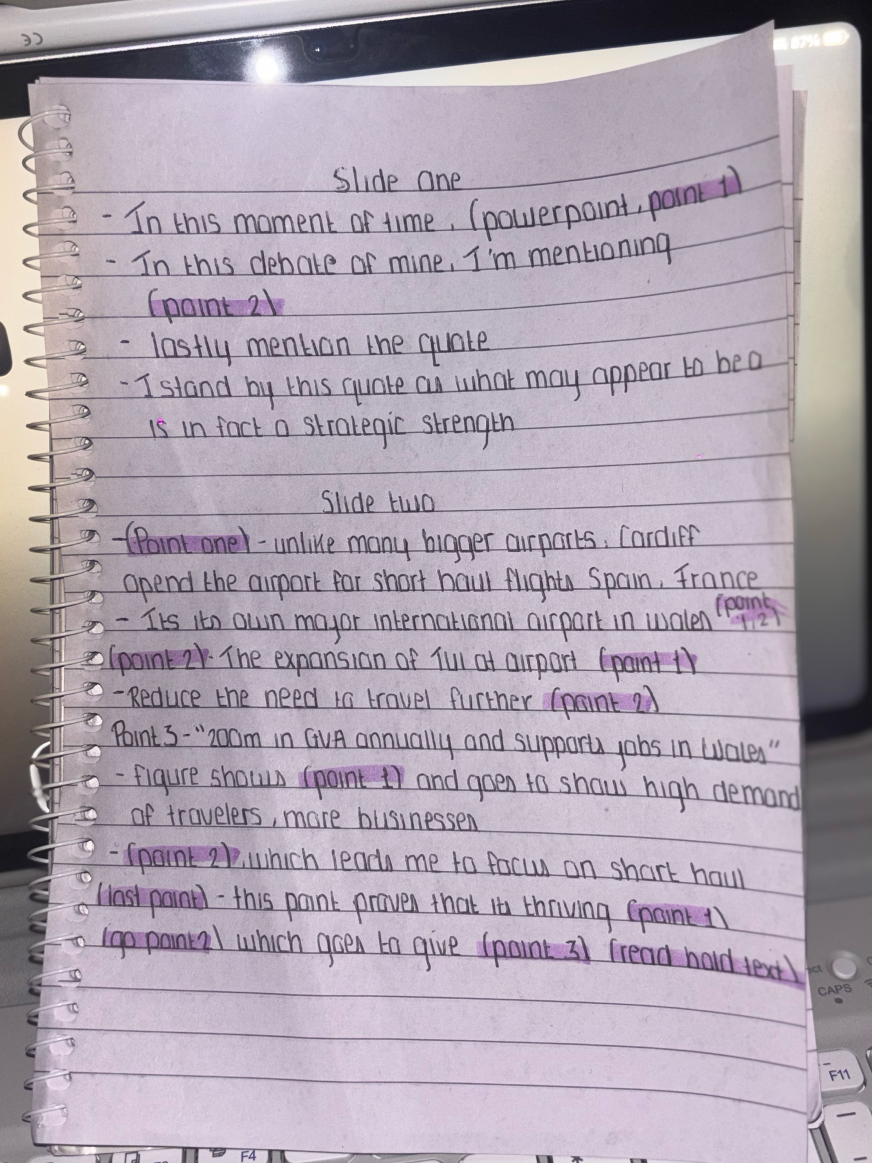
- Being utilised the best way possible for wales


