

Certificate of Higher Education in Employability Skills
LEVEL 4
Digital skills for personal development and business growth

Student name: Iveta Ondikova
Student ID: 2322230

Table of Contents
Task 1 2
Trends and Insights 2
Conclusion 5
References 10
Task 2 11
Summary 11
Making marketing materials with Canva 13
References 16
Task 3 17
References 19
Task 4 20

Task 1

Trends and Insights
Question 5 (Features), Question 6 (Payment Preferences), Question 7 (Pain Points), and Question 8 (Learning Style) were the most important ones to research after getting answers and looking at the data.
Features (Question 5): Customized Workout Plans (85%) and Meal Planning/Nutrition Guides (70%) were the most popular features, followed by Progress Tracking (65%). It shows that people want customization and useful tools to help them reach their exercise goals. Community/social functions (30%) were not as popular, which suggests that users are more focused on themselves.

Payment Preferences (Question 6): Most people (40%) were ready to pay $5–$10 a month, but 35% would rather have free apps. Only 15% said they would be willing to pay more than $20. Based on these results, we need a price plan that is competitive and strikes a good mix between value and cost.

Pain Points: Question 7
Lack of Time (60%) and Lack of Motivation (50%) were the most common problems. This shows how important it is for apps to have features that make things easier and inspire people. The cost of services or products (30%) also came up as a major factor, highlighting the need for options that are low in cost.

Learning style: Question 8:
The most popular choice among participants was video tutorials (55%), followed by interactive tools (25%). The percentages show that visual and interesting material is becoming more popular compared to boring writing guides (15%). (Royston, 2024)

How to Use the Results to Grow Your Business
Refining Features: Since personalized meal plans and workout plans are so popular, the app should focus on adding advanced formulas that let users make their own plans. Adding things like tracking progress with thorough data would make users more interested. (Duong, 2024)
Price Strategy: A freemium plan might work best, where basic features are free and advanced tools, like live teaching or detailed progress data, cost an extra $5 to $10.
Problems Solved: The app can include short, high-intensity interval training (HIIT) exercises and flexible schedule choices to help people who are short on time. Game-like features such as daily runs or success badges could be added for incentives. (Sethu, 2023)
Content Strategy: Users would be interested in a large library of video lessons with qualified teachers. Users might also be more interested if there were engaging tools like virtual workout plans or diet advisers that are run by AI.

Trends and Patterns
Personalization Over Community: The desire for customized features shows a movement toward exercise solutions that are tailored to each person. This information shows that, unlike most exercise apps that focus on social networking, there may be a chance to make a unique selling proposition (USP) that is all about personal growth.

Value-Conscious Audience: Users who are willing to pay show that they know the value of exercise apps but are also price-conscious. To turn free people into paid members, you will need a clear value offer. (ScienceDirect, 2021)

Demand for Motivation Tools: The fact that people are focusing on motivating tasks shows that they want features that help them stick with something for a long time, like notes, encouraging messages, or motivational quotes.

Graphs and Visual Support
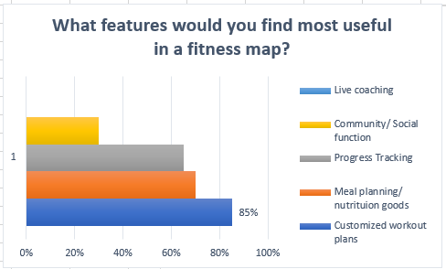

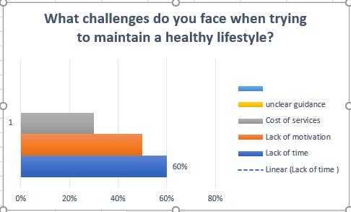
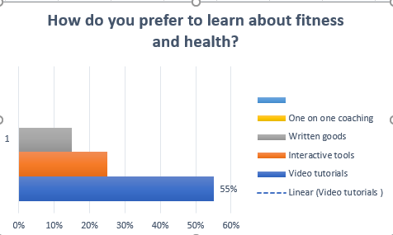

Conclusion
Using the results of this poll to help shape the growth of the exercise app. Improving user wants means focusing on things like personalization, low cost, and interesting material. Utilizing these insights helps the business meet the needs of the market, which raises its chances of success.

Questionnaire with a minimum of 10 questions

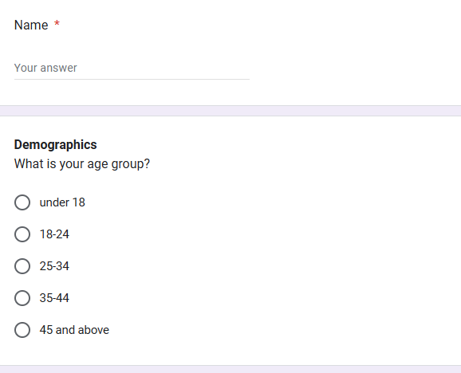
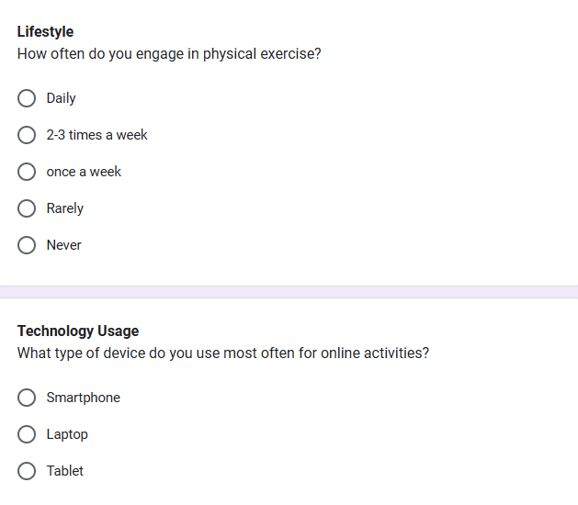
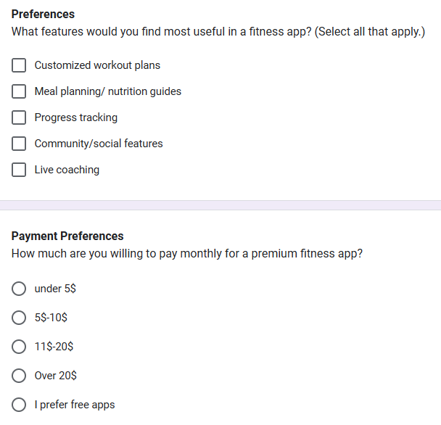
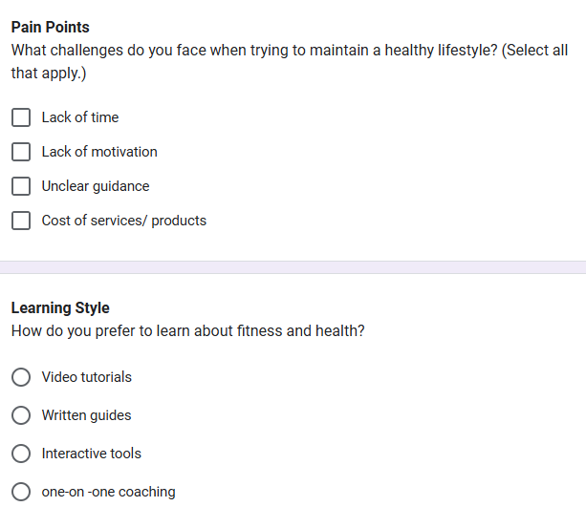
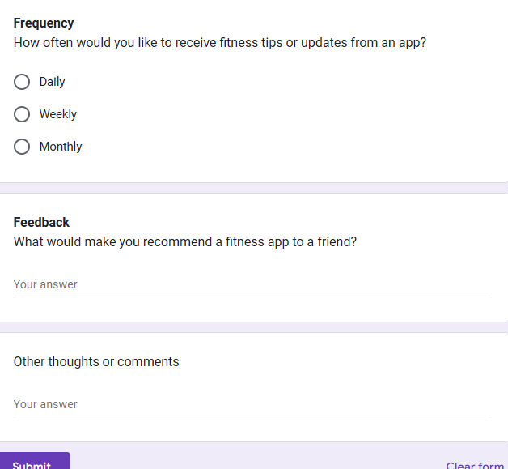

References
Duong, V., 2024. How To Create Fitness App: A Step-by-step Guide In 2024. 9 November.
Royston, C., 2024. An Introduction to Marketing Management. An Introduction to Marketing Management, 31 October .
ScienceDirect, 2021. International Journal of Information Management. August , Volume 59.
Sethu, K., 2023. Exploring Freemium Pricing Strategies With The Best Examples. 7 July , p. TOGAI.

Task 2

Summary
Using information from a questionnaire, I created a two-page website and marketing tools to go with it to push my business idea, which is an exercise app. The goal of this task was to turn the poll results into user-centered design decisions that meet the target audience's most important needs, wants, and pain points. Here is a description of how the answers to the questionnaire helped with the creation of the website and marketing materials, with a focus on SEO, content strategy, and segmentation.

Analysis of Questionnaire Data
The poll gave useful information about the likes, dislikes, and needs of possible users, which made it possible to create the website and marketing materials with a more focused approach. The main things that the research showed were:
Customization and Personalization: There was a high demand for customizable meal plans and nutrition guides (70% of those who asked for them). This shows that users value customized solutions more than stock ones.
Payment Preferences: Most of the people who answered were ready to pay a small monthly fee ($5–$10), but a lot of them would rather have free apps. Based on these numbers, we need a flexible price plan that lets you choose between free functions and paid improvements.
The most common problems were not having enough time (60%) and not being motivated (50%). This shows how important it is to have workouts that are quick and have features that motivate people.
Learning Preferences: Video lessons were chosen by 55% of respondents as the best way to learn. This means that the app's material should focus on visual and interactive learning tools.
Website Design
Home Page (Page 1)
The goal of the site is to catch the visitor's attention, make the app's value offer clear, and get people to sign up. Based on the information from the poll, I added the following:
Headline: "Achieve Your Fitness Goals—Anytime, Anywhere!" Users stressed the need for mobile exercise options that can be used on the go, which fits with the title.
Features: I made the most popular features stand out in a clear, easy-to-understand way. For example, personalized workout plans (85%), meal guides (70%), and progress tracking (65%). This shows off the app's main features and meets users' needs for unique, useful tools.
Appeal to the eye: Video lessons that show you how to use the app make the experience more lively and visual. This is an important part of the website that makes it interesting and useful for 55% of users who prefer video lessons.
Need to do something (CTA): Big CTA buttons like "Start Your Free Trial Today" and "Explore Premium Features" push users to act right away, which shows that they want to quickly get to the app's features.
SEO Optimization: I used key words like "customized fitness plans," "affordable fitness app," and "on-the-go workouts" in meta tags and text to make sure search engines could find the website. This fits with the trend of going after people who are price careful and want cheap choices

Page 2: Features and Prices
The benefits of the app are described on the second page, which is mostly used to get people to buy it. The answers to the poll helped shape the framework of this page, which is made up of the following sections:

Features: This part of the app describes its best features, such as the ability to customize workouts, plan meals, track progress, and provide encouraging tools. Key lessons are highlighted by a video loop, making it easy for users who learn best by seeing to interact with the material. Because 25% of people want dynamic and interesting features, tools like setting goals and tracking progress are emphasized.
Table of prices: I came up with a flexible price plan based on the fact that 40% of people are willing to pay $5 to $10 per month. The free plan comes with simple meal plans and workout plans. The paid plan, on the other hand, has more advanced features, such as customized plans, live lessons, and detailed progress tracking. People who want to use it for free and people who are ready to pay for extra features will both like the prices.

FAQ: This part answers some of the most common questions users have about the free plan, tracking progress, and making sure your device works with the app. The ideas about managing time and worries about devices led to the addition of clear, brief replies that could reduce user confusion.

Making marketing materials with Canva
I used Canva to design advertising materials to help the website and make interesting marketing materials. Some of these things were flyers, posters, and social media posts. What we learned from the surveys was very important in shaping the content and layout of these materials:
Segmentation: Different types of users were targeted by the marketing materials, such as busy workers who need ways to save time and fitness fans who want to make their workouts unique. Banners highlighted the workouts that could be done in little time and the features that could suit the needs of users who are short on time (60%) and like personalized solutions (85%). (Virtuagym, 2024)
Appeal to the eye: Users like video lessons and interactive content, so the marketing materials had images that caught the eye and made it clear what to do. I also included pictures of the app's design and tools for tracking progress, which show how nice the app looks. (Hollingsworth, 2023)
SEO Things to Think About: The marketing materials were made with SEO in mind, using terms that are linked to health, customization, and low prices. There were hashtags and terms like #FitnessOnTheGo, #CustomizedPlans, and #AffordableFitness on handouts and social media posts to make sure they were seen on many platforms. (Nicholson, 2024)
4. Putting information on websites and in marketing materials
By looking at the data, I was able to tell that users can be roughly split into two groups: those who want personalized plans and those who want to save time and play games. The marketing tools and website were made to speak directly to these groups with messages that are relevant to their needs.
Content Strategy: Video lessons (55%) and interactive tools (25%) were the most popular types of content, so that's what the website and marketing materials were mostly about. Video carousels and live progress tracking are on the features page, and marketing materials use images to draw attention to these features.
Problem Areas: Lack of time (60%) and lack of motivation (50%) were directly addressed in both the website content and marketing materials. Tools that save time, like HIIT workouts, were stressed, and features that motivate, like badges and runs, were emphasized to get people to use the site. (NIH, n.d.)
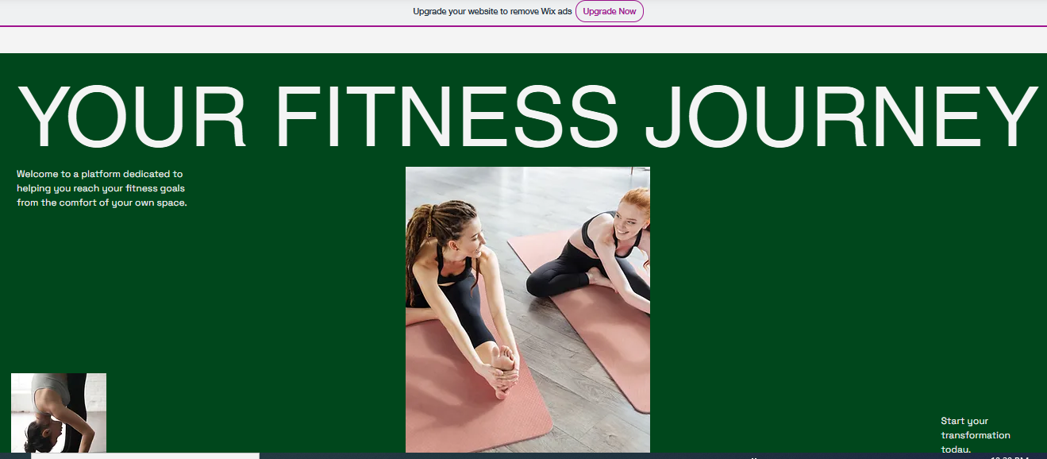

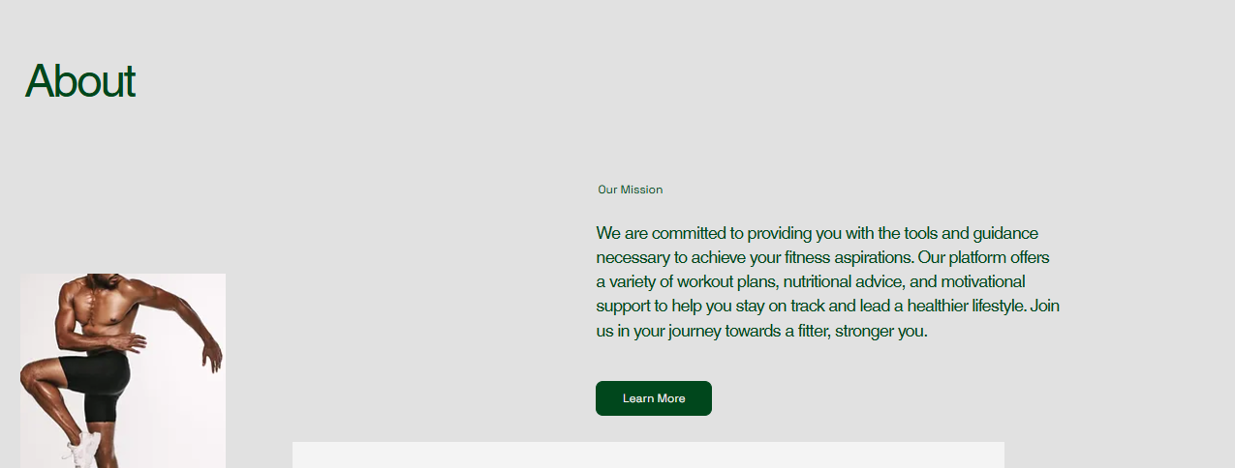
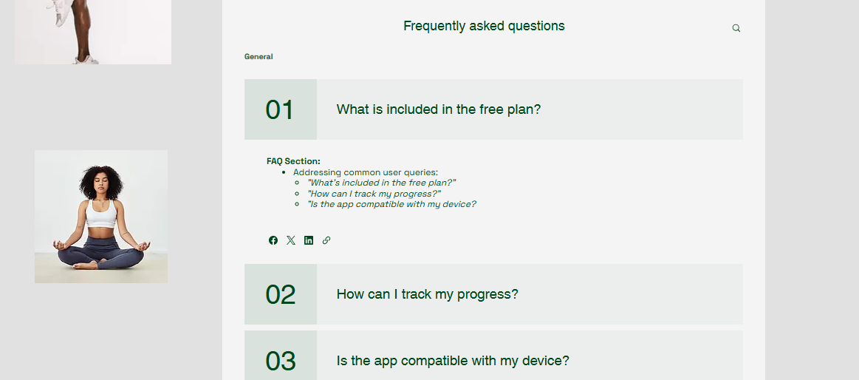


References

Hollingsworth, S., 2023. 7 Reasons Why Content Needs Amazing Images, Videos & Visuals. 29 April.
Nicholson, R., 2024. How to Create an SEO Strategy for 2024 [Template Included].
NIH, n.d. National Library of Medicine. .
Virtuagym, 2024. 20 Proven Ways to Attract Customers to Your Fitness Studio. 7 May.

Task 3

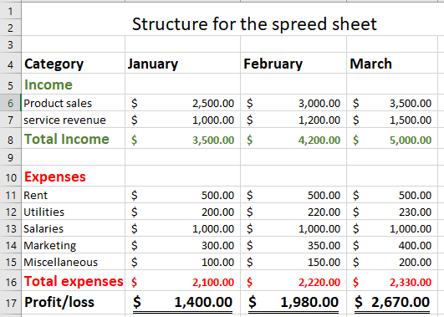

Essay on the Importance of Excel in the Digital Era
Introduction
For small businesses, Microsoft Excel is now a must-have in this digital world. Users can easily organize, examine, and show data thanks to its flexibility and power. One of the most important tools for businesses of all kinds is Excel, which can do complicated math, make visible reports, and keep correct records. With a focus on how it can be used for financial management, decision-making, and business growth, this article will look at how important Excel is in today's business world.
Financial Management

Excel is especially useful for managing money. It lets companies make specific financial plans, keep track of their income and spending, and look at their cash flow. Businesses can handle a lot of their financial jobs with easy formulas and functions like SUM, IF, and VLOOKUP. Excel can handle a lot of data, which helps businesses keep track of different sources of income, figure out returns, and predict how their finances will do in the future.

By showing financial information in charts, Excel also makes making budgets easier and helps companies make sure they don't go over their budgets. By using graphs and charts to clearly compare different financial possibilities, you can make quick decisions based on good information. (Quach, n.d.)
Data Analysis and Reporting
Excel is also very important for analyzing data. By giving people tools like PivotTables, you can easily organize and study huge amounts of data, which can help you make business decisions. To improve processes and make marketing plans work better, businesses can keep an eye on key performance indicators (KPIs), sales data, or trends in how customers act.

Excel's data presentation tools, like bar charts, pie charts, and trend lines, are very helpful for making reports that are interesting and make complicated data easy for stakeholders to understand. Businesses need this feature in order to evaluate performance, spot trends, and clearly share their results with leaders, investors, or clients. (Team, 2024)

Making Choices and Plans
In the digital age, decisions are made with more and more info. Excel helps businesses make choices based on facts by giving them a way to model different situations. For example, a business can use Excel to guess what will happen with different price plans, assets, or market conditions. Businesses have an edge over their competitors when they can do "what-if" studies, which help them plan for changes and respond quickly. (Rosenberg, 2024)

Excel can help with strategy planning more because it can connect to other software platforms, like CRM and ERP systems. Excel helps businesses make comprehensive reports that help them plan for the future by combining data from various sources.

Enhancing Business Growth
Excel helps businesses grow by making them more productive and efficient. Its simple but strong features let users speed up processes, cut down on mistakes, and handle jobs that take a lot of time. Excel also helps teams work together by letting multiple people work on the same document, either through sharing drives or cloud-based services like Microsoft 365.

Excel is flexible enough to stay useful for businesses as they change because it is a tool for ongoing growth. Excel can be changed to fit the needs of different business tasks and industries. It can be used to handle goods, build relationships with customers, or make financial models.

Conclusion
In conclusion, Excel is an important program for small businesses to have in the digital age because it helps with managing finances, analyzing data, making decisions, and growing the business. It is very useful for businesses that want to improve operations, boost productivity, and boost growth because it is flexible, easy to use, and works with other systems. Excel is still one of the best ways to manage a company, even though businesses depend more and more on data and analytics to get around in the digital world.

References
Quach, M., n.d. The Top 8 Most Important Excel Skills for Finance. p. Career Principles .
Rosenberg, E., 2024. The importance of excel in business. 8 August .
Royston, C., 2024. An Introduction to Marketing Management. An Introduction to Marketing Management, 31 October .
Team, I. E., 2024. 9 Excel Tools for Professionals (And How To Use Them). 16 August .

Task 4
Word Explanation of Video Techniques
https://youtube.com/shorts/Z1eEkcm20hs?si=FOCgErrNL9hOzqf9

In its three-minute video ad for the exercise app, the company uses stories to get people interested in the app while also highlighting its unique features. The video starts with an exciting opening in which I quickly appear to show that I'm honest and connect with viewers on a human level. This builds trust and sets the scene for the story's main idea: how to easily reach fitness goals despite problems like lack of time and desire.
The story follows the structure of the Hero's Journey, showing a believable character who is having trouble with health issues. As the character finds the app, which gives them personalized meal plans, workout plans, and encouraging tools, the story starts to come together. Visuals that show progress and short clips of interactive video lessons that match the preferred learning style found in the poll draw attention to the change.
The video uses upbeat music and motivating words to make people feel something, addressing their problems and encouraging them to act. The images show features like short HIIT workouts and success badges that stress customization, cost, and ease of use.
At the end, there is a call to action that says, "Start Your Fitness Journey Today." The company logo and a short tour of the app layout support this. This way of telling stories makes the audience feel strong and encourages them to download the app, which increases company awareness and involvement.

