A guide to understanding the impact of ADHD on a child’s educational achievement and family life


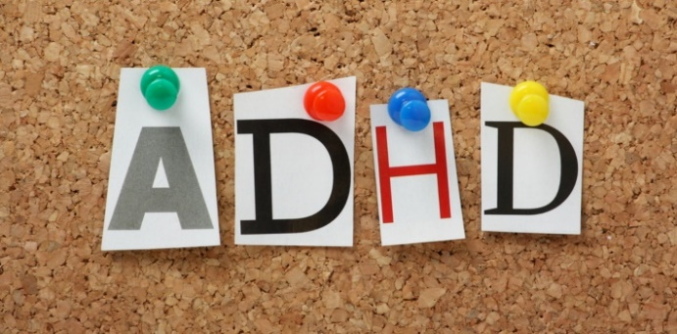

- A useful guide for parents and children

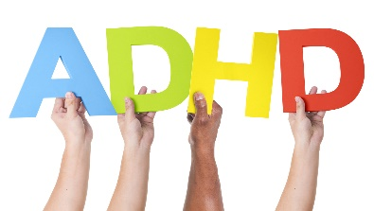

So, what is ADHD?
(NICE, 2009)

What are the key signs of ADHD?



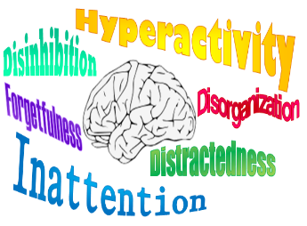



(NICE, 2009)
Inattention  The 3 key characteristics of ADHD explained | Hyperactivity | Impulsivity
Cannot pay attention to detail | Often fidgets with hands | Interrupts when others are talking
Difficulty in paying attention during tasks |  | 
Does not seem to be listening | Cannot wait their turn | Runs excessively
Often forgetful in daily tasks |  | 
Often seems to lose things needed for daily tasks | Difficulty remaining still when seated | Finds carrying out quiet activities difficult
Common symptoms associated with ADHD
How is your child feeling?

Sleep disturbance


(NICE, 2009)

How common is ADHD?
(Ford et al, 2003)


ADHD: The facts and figures…
A recent survey has found that approximately 4 million children have been diagnosed with ADHD.
Over half of these are taking medication to help treat ADHD.

How common is ADHD?
(Ford et al, 2003)

ADHD is a very common disorder

Did you know that ADHD is often co-morbid with other learning difficulties, such as dyslexia?

It has also been estimated that 3.4% of adults have been diagnosed with ADHD.
Polanczyk, G., de Lima, M. S., Horta, B. L., Biederman, J., & Rohde, L. A. (2007)

What factors can ADHD impact?

Well-being
Academic performance
- ADHD can often lead to the misconception that a young child is miss-behaving
- This can impact many aspects of a young child’s life, including…
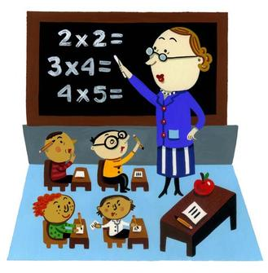

This Photo by Unknown Author is licensed under CC BY-SA


This Photo by Unknown Author is licensed under CC BY-SA


Family life

Social life/skills


- Education
- Adhd
- Impulsive
- Distraction
- Social skills
- Common
- Parents
Parents


p | f | g | e | d | u | c | a | t | i | o | n | o | c
a | d | h | d | t | y | u | c | d | j | k | i | l | o
r | d | t | j | k | l | s | b | z | w | q | n | h | m
e | f | d | i | s | t | r | a | c | t | i | o | n | m
n | d | b | h | y | d | x | v | k | l | e | w | a | o
t | s | o | c | i | a | l | s | k | i | l | l | s | n
s | c | v | j | u | f | e | r | x | s | k | l | h | e
e | i | m | p | u | l | s | i | v | e | f | b | d | r


How can ADHD impact educational performance?
Preschool Children
ADHD children face difficulties regarding impulse control, hyperactivity and attentional capacity. These factors impact a child’s ability to focus during classroom activities and their ability to have positive peer interactions.

Studies have shown that school children diagnosed with ADHD experience vast academic and educational issues (Loe, & Feldman 2007).

Peer interactions, focusing on teachers and listening to figures of authority are all essential skills needed within education. (Lahey et al. 1998; Spira & Fischel 2005)



Primary school years…

ADHD and educational performance
Who was used in this study?
A sample of 225 boys were used, all aged between 6 and 12 years old.
All participants had previously had a diagnosis of ADHD.
Research has been carried out that aimed to look at the relationship between ADHD and self-esteem.


(Treuting, & Hinshaw, 2001).


The research…

How did they carry out their research?
Self-reports were used.

This enabled researchers to gain a better insight into the children’s feelings.

What did they predict?
It was predicted that lower self-esteem would be found in participants with ADHD, when compared with those who do not have ADHD.

What does this research tell us?


This research tells us that boys with ADHD are likely to have lower academic and social self-esteem scores, compared with those who do not have ADHD.

This shows that ADHD can impact educational performance.


Difficulties regarding reading and mathematical skills have also been found in children with ADHD (Mariani, & Barkley 1997).
Young children with ADHD have been found to experience problems with memory, academic skills, reasoning and cognitive ability (DuPaul et al 2001).
ADHD and educational performance



A longitudinal study conducted by McGee (1991) followed young children who had key characteristics of ADHD, from a young age through to adolescence. At the ages of 7 and 9, it was found that the ADHD group had significantly poorer abilities in reading when compared with the control group. When the children turned 15, the ADHD group remained behind in their reading performance scores.

ADHD and educational performance continued…
In a more recent study by Rabiner (2000) supported the findings by McGee (1991).

Rabiner (2000) used a sample of 387 young children with ADHD symptoms, he studied their reading abilities and found that inattention and hyperactivity were both associated with reading performance.

A child’s ability to read can impact educational performance.


Shall we recap?




Each of these factors are influenced by ADHD, they also impact family functioning.
How can ADHD impact the family?
Conflict


Marital functioning
Strained relationships

Poor sleeping patterns
Siblings
Stress

ADHD and family functioning
How can ADHD impact the family?

Johnston and Mash (2001) looked at the effect a child with ADHD can have on the family.
They concluded that ADHD children increase the risk of disturbances in the family, this included disturbances within parent-child relationships. They also found an increase in parent stress levels and a strain on marital functioning.
All of which are factors that can impact family functioning.




Siblings
He found that siblings were influenced in three different ways; caretaking, sorrow and loss and victimisation.
Harping (2005) explored the way in which siblings can be influenced by having another sibling with ADHD.



Siblings also noted that their parents expected them often to care for their sibling with ADHD, because ADHD children often struggle with social situations.

During the study, siblings stated that they feel victimised by their siblings because of their aggressive tendencies; this included physical and verbal aggression.


ADHD children often suffer with poor sleeping patterns
Poor sleeping patterns
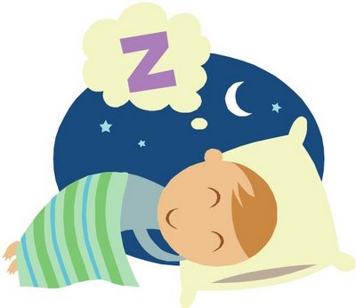
Throughout the day they are very much ‘on the go’ and when sleep is deprived daytime behaviour can become worse.

This can result in parents having little time to themselves and having to constantly watch their child throughout the day.

As well as this, family relationships can be strained and often break down.
(Harpin, 2005)

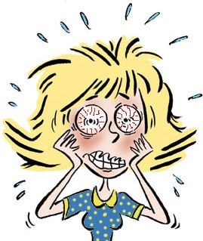
Parent mental health

Higher levels of anxiety and
depression have been
found in parents of ADHD children.
Research has been carried out which examined the relationship between parent stress and ADHD. Results concluded that parents of ADHD children stated they felt more stressed in comparison to parents who do not have ADHD children. It was confirmed that the more severe the ADHD symptoms were, the greater the stress experienced by parents. (Theule, Wiener, Tannock, & Jenkins, 2013)

Parent mental health can impact the way a family functions.


Participants
Parents of children aged 6 – 12 with ADHD and parents of non-ADHD children.
Parent – Child Relationships
Schroeder, V. M., & Kelley, M. L. (2009) looked at family functioning and parenting children who have had a diagnosis of ADHD.

What did they find?
Parents of the ADHD children reported having more issues with controlling their child’s behaviour; they also reported more family conflict and a more disorganised family environment.



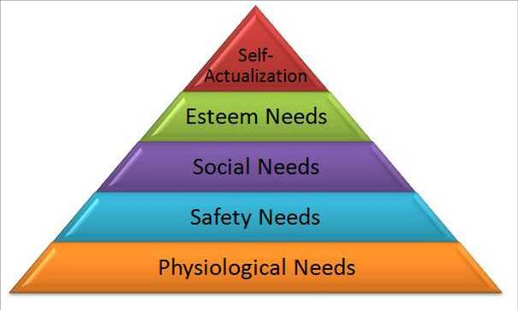
The family and ADHD
Let’s Recap



Receiving Help!
ASK FOR HELP

Talk to someone
- A teacher
- Support groups
- A friend
- A parent

Children and parents need support.
Do you need help?
You can find useful links and telephone numbers at the end of this leaflet.


https://youngminds.org.uk/find-help/conditions/adhd/
Find a parent’s survival guide here
HELPLINES

https://youngminds.org.uk/search-results/?terms=adhd
A link for children
Young Minds is a UK based charity that champions the mental health and well-being of young people. As well as this, they offer support for parents.

ADDers
http://www.adders.org/
ADDers are a website which offer more information and help concerning ADHD. As well as this, here you can find useful support groups.

Useful Phone Numbers:
YOUNG MINDS - 0808-802-5544
ADDISS - 020 8952 2800

Reference List
Adders.org. (2017). ADD/ADHD online information. Retrieved on 18th December from http://www.adders.org/
Atkinson, M., & Hollis, C. (2010). NICE guideline: attention deficit hyperactivity disorder. Archives of Disease in Childhood-Education and Practice, 95(1), 24-27.
Bussing, R., Zima, B. T., & Perwien, A. R. (2000). Self-esteem in special education children with ADHD: relationship to disorder characteristics and medication use. Journal of the American Academy of Child & Adolescent Psychiatry, 39(10), 1260-1269.
Centers for Disease Control and Prevention (CDC. (2005). Mental health in the United States. Prevalence of diagnosis and medication treatment for attention-deficit/hyperactivity disorder--United States, 2003. MMWR. Morbidity and mortality weekly report, 54(34), 842.
Daley, D., & Birchwood, J. (2010). ADHD and academic performance: why does ADHD impact on academic performance and what can be done to support ADHD children in the classroom?. Child: care, health and development, 36(4), 455-464.
Fayyad, J., De Graaf, R., Kessler, R., Alonso, J., Angermeyer, M., Demyttenaere, K., ... & Lépine, J. P. (2007). Cross–national prevalence and correlates of adult attention–deficit hyperactivity disorder. The British Journal of Psychiatry, 190(5), 402-409.
Harpin, V. A. (2005). The effect of ADHD on the life of an individual, their family, and community from preschool to adult life. Archives of disease in childhood, 90(suppl 1), i2-i7.
Johnston, C., & Mash, E. J. (2001). Families of children with attention-deficit/hyperactivity disorder: review and recommendations for future research. Clinical child and family psychology review, 4(3), 183-207.

Kendall, T., Taylor, E., Perez, A., & Taylor, C. (2008). Guidelines: diagnosis and management of attention-deficit/hyperactivity disorder in children, young people, and adults: summary of NICE guidance. BMJ: British Medical Journal, 337(7672), 751-753.
Lassen, S. (2006). What is ADHD?.
Parent Support Guide (2017). Retrieved on 20th December from https://youngminds.org.uk/
Polanczyk, G., de Lima, M. S., Horta, B. L., Biederman, J., & Rohde, L. A. (2007). The worldwide prevalence of ADHD: a systematic review and metaregression analysis. American journal of psychiatry, 164(6), 942-948.
Schroeder, V. M., & Kelley, M. L. (2009). Associations between family environment, parenting practices, and executive functioning of children with and without ADHD. Journal of child and family studies, 18(2), 227-235.
Segenreich, D., Fortes, D., Coutinho, G., Pastura, G., & Mattos, P. (2009). Anxiety and depression in parents of a Brazilian non-clinical sample of attention-deficit/hyperactivity disorder (ADHD) students. Brazilian Journal of Medical and Biological Research, 42(5), 465-469.
Treuting, J. J., & Hinshaw, S. P. (2001). Depression and self-esteem in boys with attention-deficit/hyperactivity disorder: Associations with comorbid aggression and explanatory attributional mechanisms. Journal of Abnormal Child Psychology, 29(1), 23-39.
Theule, J., Wiener, J., Tannock, R., & Jenkins, J. M. (2013). Parenting stress in families of children with ADHD: A meta-analysis. Journal of Emotional and Behavioral Disorders, 21(1), 3-17.
Young Minds. (2017). ADHD. Retrieved 19th December from https://youngminds.org.uk/find-help/conditions/adhd/
All images were obtained from Google Images and Bing 2017.

