Knowledge And Information Management of Amazon.com

By: Florina Loredana Lupulescu 1922055
Module: Knowledge and Information Management Skills for the workplace BMSW5106
Tutor: Mohamad Kalam
University of Wales Trinity Saint David

Tutor: Mohamad Kalam

NNMM

Executive Summary
To gain success and focus on the business goals and objectives, it is important for the business to ensure the use of knowledge management and information management skills in the workplace through which they can easily focus on the positive aspects of their business demands. The overall report is based on the business activities and knowledge management criteria that are to be adopted to review their business features. The report is based in content on Amazon which is one of the world’s largest retail organisations. The report has provided knowledge management theories that showcase the use and importance of information in a company and the way this is acquired. On the other hand, the report has also examined certain challenges that are faced by Amazon in terms of maintaining their knowledge management and information in the workplace and a framework together with recommendation has been proposed.
TABLE OF CONTENTS
Introduction 1
Knowledge and Information management (KIM) 2
Background of Amazon.com the organisation around this study 2
What is Knowledge management (KM)? 3
Why KM is important for any organisation including Amazon? 4
How KM helps the organisations in satisfying customers and achieving competitive advantage? 5
Evaluation of knowledge and information management models/theories 7
Investigating of Knowledge Management practices used by Amazon 11
Conclusion and recommendations 14
References 17
Appendices 20
Appendix 1 Poster Presentation Evaluation of the proposed KM framework for Amazon 21

Introduction
Employee satisfaction, productivity and the success of an organisation are increased because of effective knowledge management. Furthermore, increased information transmission leads to better decisions at all levels of the organisation, from top to bottom. The present report will look at Amazon an American multinational technology corporation that focuses on e-commerce, artificial intelligence, and digital streaming. The company was founded on 1994 by Jeff Bezos and is a huge online retailer that sells books, music, movies, housewares, electronics, toys, and a variety of other items (Hall, 2020). The study will outline the overview of Amazon.com and the knowledge management practices used to manage its information and suggestions of improvement to handle any future challenges will be given. In addition to that it will explain the significance of understanding the effective storing, sharing and integration of useful knowledge. Furthermore, it will demonstrate the evaluation of effective theories of knowledge management and information culture within the organisation like the SECI model that focuses on creation of knowledge and Bukowitz and Williams model of knowledge management that focuses on value creation.
The expectation of writing this report is to recommend a possible Knowledge Management framework that Amazon can use in the future.

Knowledge and Information management (KIM)

Background of Amazon.com the organisation around this study
Hall (2020) describes Amazon in an article, to be a retailer, e-book reader, and web service provider that has gained the reputation of being a popular example in the world of electronic commerce. The company's headquarters are in Seattle, Washington. In addition to providing online services, it also provides data storage and processing resources through the Internet. Amazon started selling books as their first product even producing the Kindle e-book readers in 2007, which have been so successful, as a result Amazon.com has become a huge powerful player in the book publishing sector. What it offered to their customers was personalised tools that helped them choose products based on their past purchases.
In 2002, the company introduced Amazon Web Services (AWS), which offered developers and marketers with data on Internet traffic patterns, Web site popularity, and other statistics. In 2006, the Elastic Compute Cloud (EC2) was added to its AWS service. This was immediately followed by their Simple Storage Service (S3), which significantly boosted the company's income. AWS is still the company's most successful operation. Later, with its Amazon Studios department, Amazon began producing its own television series and films (Amazon, 2021).
Bezos imagined the firm as a technology company at its core, with the primary goal of making online transactions easier for customers, thing that he achieved as today Amazon employs over 1 million people (Coppola, 2021). In comparison to 1995, when annual profits were only hundreds of thousands of dollars, rising to 600 million in three years, Amazon earned over 19 billion in American dollars in 2008, and their annual profits are now passing 100 billion, an increase over the COVID-19 epidemic period due to the increase in home shopping (Hall, 2020).
In the past many doubted Amazon will succeed but the name proves the contrary as once Bezos exclaimed that he named the company Amazon after “the biggest river in the world” and so is the company today, one of the biggest, leading organisations in the world (Britannica, T. Editors of Encyclopaedia, 2022).

Figure 1: Amazon
(Source: amazon.com, 2021)

What is Knowledge management (KM)?
Knowledge is seen differently by authors; some see it as a resource that may be used in place of other resources. According to Nonaka and Takeuchi (1995), knowledge is defined as “justified belief”, in which beliefs are utilised to support self-interests. They cited (Toffler 1990, p.7) who adds that knowledge is the ultimate kind of power and the key to the future change of power.
Knowledge management (KM) is the process of effectively managing a company's information or knowledge, as well as associated capabilities. In the field of information technology, knowledge management has evolved as a major area of practice and research. The automated economy, strategic leadership, corporate culture, organisational behaviour, organisational culture, intelligent systems, process improvement, and organisational performance evaluation are just a few of the themes covered in this field. Knowledge management is a method for supporting knowledge-related tasks such as knowledge creation, capture, transformation, and application (Bhatt, 2002).
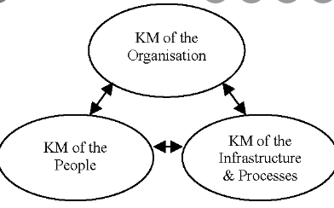
Figure 2: Knowledge management
(Source: semanticscholar.org)

Why KM is important for any organisation including Amazon?
In the present business climate, firms must employ knowledge to increase performance and assure long-term sustainability. Management is both a key part of an organization's effectiveness and a beneficial tool in the company's toolset (Martins et al., 2019). Organizational management requires knowledge, which has been regarded as a critical resource for their success in recent years (Mosconi, 2013). A company's business structure must be very flexible and responsive to effectively handle knowledge (Bhatt, 2002). Knowledge management that is effective may have a significant impact on the company's success. Knowledge management in an organisation is essential because it improves communication and collaboration, it may also help you learn more about your customers through a customer acquisition method, customers and staff are empowered to tackle complicated challenges without seeking assistance, and time spent researching information is reduced (Hooker, 2019).
Bhatt (2002) argues that public information can be monitored and controlled by an organisation, while private knowledge is more difficult to manage. By fostering a culture of collaboration and informal coordination, management may better handle private knowledge. Employee knowledge is improved, and new organisational knowledge is developed in this way. Individual knowledge is a valued asset in any company, but if management does not properly cultivate intellectual resources, individual self-expressions can become organisational liabilities. Management must promote an environment in which people are encouraged to share their knowledge. Adding that because of individual interactions, individuals' knowledge is enhanced, and organisational knowledge is created.
Amazon succeeds in knowledge management, employing a variety of basic knowledge management and user experience concepts to meet the demands of its workers. Such as the necessity to house a single interface to fulfil the demands of all its users. This makes all goods easy to search and access, allowing Amazon to expand and broaden its business from selling books and other types of equipment to having its own product lines that compete with almost anything possible (Willis, 2021).

How KM helps the organisations in satisfying customers and achieving competitive advantage?
Organizations' distinct competitive advantage is largely based on knowledge, and knowledge management (KM) assists them in adapting to changes in the business environment. A multinational company's competitive advantage is built on the creation and sharing of knowledge. (Kazuo, 2006). Marketing companies must assimilate enough of their consumers' viewpoint and experience to anticipate value-adding goods and services and use that vision to drive the creation of the innovation. The goods and services that an organisation generates and sells to its clients reflect its organisational knowledge.
Nonaka and Takeuchi (1995) argue that information is gathered from the outside and distributed inside the organisation, that it is kept as part of the company's foundation, and that it is used by those working on new technologies and products. They claim that this activity is the actual success that drives continuous innovation in Japanese businesses, and that continuous innovation leads to competitive advantage. They add that in an organisation, individual intelligence will become more significant, and knowledge will become the new competitive resource.

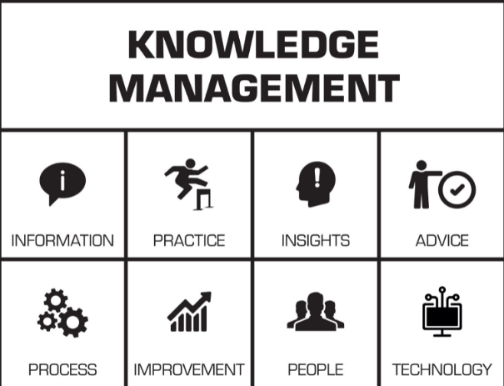
Figure 3: Knowledge management
(Source: kmslh.com 2019)

Evaluation of knowledge and information management models/theories
The goods and services that an organisation generates and sells to its clients reflect its organisational knowledge (Bhatt, 2002). Product development is critical because it is at the centre of innovation and competitive advantage, and it necessitates investment in knowledge generation inside and between departments (Kazuo, 2006). A company's competitive advantage in the current market is knowledge. Talented managers who produce and gather knowledge should be hired, developed, and retained. He suggests that the practical approach for enabling knowledge management is to use action learning to build leaders with the necessary knowledge. Ichijo and Nonaka, (2006) claim that action learning is the greatest technique to create an enabling framework for developing and sharing information, as well as healthy social ties among company leaders, as an attempt to produce leaders who demonstrate a strong approach to knowledge management. All knowledge is dependent on a supportive environment and positive social interactions.
Learning, cooperation, and experimentation are all part of the management process of knowledge as are the integration of varied sets of tasks and the installation of sophisticated information systems like the Internet, intranets, and extranets (Bhatt, 2002).
The SECI model of Knowledge Dimensions – model ideal for knowledge creation process
Ikujiro Nonaka and Hirotaka Takeuchi created this model to describe how information is shared and converted at all levels of an organisation. Specifies four methods for combining and transferring information, and for sharing knowledge inside an organisation. It is built on two forms of knowledge: explicit and tacit knowledge. Explicit knowledge is information that is easily transferable to others and can be encoded, evaluated, and verbalised. Tacit knowledge refers to information that is difficult to pass on to others, as well as to codify, evaluate, and express. It is frequently based on personal experience and includes beliefs, talents, and abilities. The SECI model is built around the Japanese idea of 'Ba' (which means 'place') (Martin and Root, 2009).
Furthermore, the SECI Model of Knowledge Dimensions argues that information is formed through the conversion of tacit to explicit knowledge, and so therefore distinguishes four types of knowledge conversions in companies: Socialization, Externalization, Combination, Internalization.
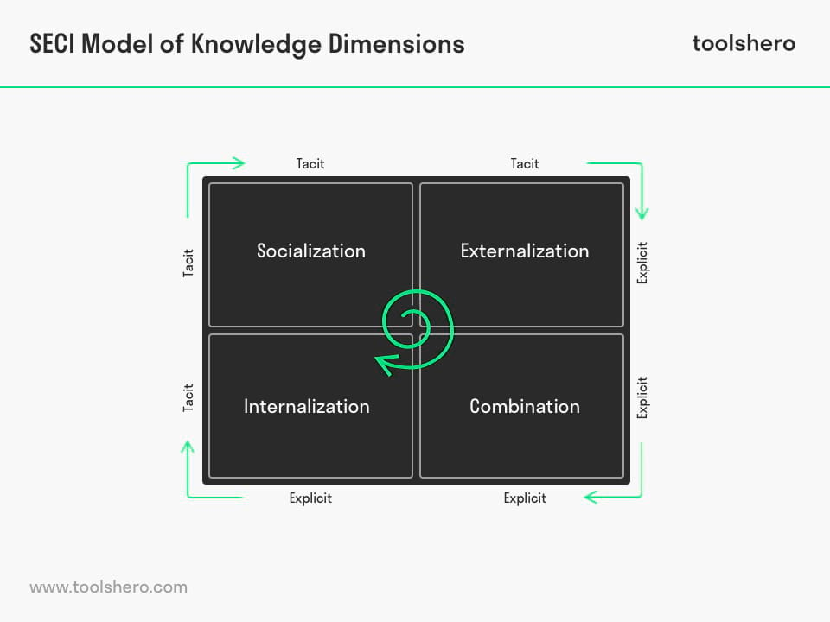
Socialization (“originating Ba”) - Knowledge is transformed from tacit to tacit at this level. Knowledge is also passed on through practise, advice, and observation, although it is frequently acquired through conversation.
Externalization (“interacting Ba”) - Knowledge is transformed from tacit to explicit at this level. Because tacit information cannot always be defined, figuring out how something works might be tricky.
Combination (“cyber Ba”) - Knowledge is transformed from explicit to explicit at this level. This implies that existing sources like books, records, and memoranda are mixed to generate new information, such as research.
Internalization (“exercising Ba”) - Explicit information is transformed into tacit knowledge throughout the Internalization process. Explicit knowledge is taken from sources and acquired via the analysis of data. After that, the knowledge is internalised, which means that the existing knowledge is transformed.
Explicit knowledge can be easily processed by a computer, transmitted electronically, or stored in a database, but tacit knowledge is more difficult to process or transmit; it must be converted into words and numbers so that anyone can understand it before it can be communicated and stored in an organisation. Organizational knowledge is produced in this form, from tacit to explicit (Nonaka and Takeuchi, 1995).
Without the effort of the individual and the interaction that occurs in the group, organisations cannot develop knowledge on their own. Dialogue, experience sharing, discussion, and observation may all help to improve this engagement. As a result, in the knowledge generation process, where individuals engage with one another, teams are important. Managers are important players in the knowledge production process because they combine the tacit knowledge of front-line employees and top executives, make it explicit, and integrate it into new products and technology (Nonaka and Takeuchi, 1995).
The Bukowitz and Williams model of knowledge management
Mohajan (2016) examines the Bukowitz and Williams model in his study and argues that this model explains how companies create value by generating, maintaining, and using a strategically right database of knowledge. Repositories, connections, technologies, communication infrastructure, functional skill sets, process know-how, environmental responsiveness, organisational intelligence, and external sources are all part of this model.
The model is divided into seven stages, each of which focuses on longer-term processes of aligning intellectual capital with strategic goals:
Get stage: It's the initial step, and it involves gathering knowledge needed to make decisions, solve issues, or innovate.
Used stage: It's about finding new and creative methods to integrate data to enhance organisational innovation. Individuals are emphasised first, followed by organisations.
The learn stage describes the formal process of learning from experiences to get a competitive edge. After that, both achievements and may be used to form an organisational memory, allowing for organisational learning. Organizational learning is essential because it serves as a bridge between the application of existing ideas and the creation of new ones.
The contribute stage is concerned with getting employees to contribute to the repository what they have learnt. Individual knowledge may be made visible and accessible throughout the business when and when it is needed, allowing individuals to prevent mistakes.
The assess stage: It is more focused on the organisational and group level. It's for the sake of intellectual capital. It is the process of a company's intellectual capital being evaluated on a regular basis. Highlights new types of capital such as human, customer, and organisational capital (knowledge bases, business processes, technology infrastructure, values, norms, and culture), as well as intellectual capital (the link between human, customer, and organisational capital).
By using resources, the build/sustain stage assures that the company's future intellectual capital will maintain the organisation sustainable and competitive. Resources must be provided to knowledge generation and maintenance and employees should be able to tap into the company's current knowledge base and apply it to their work.
The ultimate stage in this model is the divestment. This is a let-go stage in which the business should have the resources to better utilise its intellectual capital externally.
The SECI model, created by Nonaka and Takeuchi, is focused on collaboration between tacit and explicit knowledge. Knowledge is considered as a moving object that focuses on organisational knowledge development and transfer. This is very famous and has been applied in fields like engineering, manufacturing and software engineering, education, and management. For example, Scully et al. (2013) added that SECI model found to be useful in strategic human resource management practices.
The Bukowitz and Williams KM incorporates two essential phases: learning knowledge content and deciding whether to keep or divest the organisation of that knowledge content. Because the concept of both tacit and explicit knowledge has been integrated, this KM is more thorough.
Although both models are trying to capture different processes in the organisation, by facilitating a system that acquires and stores knowledge to aid the good functioning of the organisation through learning and improvement, I incline to the use of Nonaka and Takeuchi’s, SECI model as this considers the capture of this knowledge as the key to continuous improvement and find it easy to use in an organisation.

Investigating of Knowledge Management practices used by Amazon
Rosenberg (2014) describes Amazon’s way of using KM as being genius adding that because of their focus on customer experience, Amazon is one of the most successful e-commerce companies in the world. Because consumers are at the heart of Amazon's business, the company seeks to add value to their experience by making it more personalised. Some of the ways Amazon uses KM are:
- Everything is done through their website, which makes it familiar and convenient for their consumers.
- Outstanding content management in which information is shown in the same manner and order for each product while tracking and preserving data in a nugget.
- Content that is modular where every page is divided into easy-to-read parts. Workers can get to this information fast and just the information they need without wasting time.
- Personalization that is almost magical. Customers are amazed by how much information Amazon has about them. The more individuals use the website, the more Amazon learns about them and can link them with extra information they need in their search. When the system recognises the users and presents them with the material they require, productivity and efficiency are improved.
- Crowdsourcing is created when consumers are given tools like rating, reviews, and analysis of what they like or what they bought.
- Transactions are easy and consistent. The most important part of any KM initiative is its ease of use.
- Subscribing to get notifications, reminders, and frequent updates; allowing the system to do the searching for you; the KM system boosts efficiency when combined with personalisation.
- Customer feedback is valuable because Amazon values what consumers have to say and provides feedback to them as well. One of the most effective ways to measure KM performance is through user feedback on the value of content.
- Amazon's customer service is minimized since its website is user-friendly and provides comprehensive product information. Cost savings might be realised by reducing contact centre or email inquiries.
- Amazon provides excellent online help that is simple to understand, utilise, and read, enhancing consumer satisfaction and their whole experience. "Help" being KM.
- Amazon provides mobility by allowing users to access their apps from any device, at any time.
Amazon adapts to customer requests and interests, as well as connecting them to information provided by others; it took many years to develop their web-based service, but it was worth the effort, as it is now a multi-billion-dollar company and others can follow and benefit from their business model.
Outcomes that Amazon has been achieving
The management information system (MIS) at Amazon.com supports in the decision-making process by supplying the required information in a timely and correct manner as required by an up-to-date and effective system. As a result, the value of the data provided and the speed with which the service is delivered are two of the benefits of digital technology in decision-making.
Amazon uses the strategy of change hidden information into explicit knowledge to get the most out of the company's productive capacity and maximise its value.
Furthermore, the primary goal of Amazon Inc's knowledge management is to maximise income as much as possible. They are trying to improve company performance, as well as the quality and quantity of innovation, to be more competitive.
Another reason for implementing knowledge management is to help you stand out from the competition. The United States of America is crucial for Amazon because innovation is a fundamental driver of competitive advantage since it expands a company's technical capabilities (Dwivedi et al., 2020). Organizations who are unable to innovate at a consistent rate will be unable to attract new clients on a regular basis, resulting in the company's downfall. Businesses that could innovate, on the other hand, can sustain their market competitiveness (Abubakar et al., 2019).
Areas that Amazon can improve to overcome challenges
Amazon's marketing tactics, which could be more customised, might better answer customer demands. Using customer data from specific communities to create newsletters that are targeted to the specific needs of the consumer community may assist to promote this practise (Ahmed et al., 2017).
Amazon's success is undeniable, but the company's IT and e-commerce systems are continually evolving, necessitating regular updating. At this moment, the significance of management information systems (MIS) becomes clear.
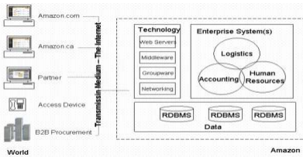
Figure 4: E-commerce security
(Source: questjournals.org 2021)

Technical issues are the most important impediment to moving forward with a revised adoption as a result, Amazon remains vulnerable to phishing attacks, which require customers to provide passwords to Amazon users who have already registered. To raise consumer awareness of the problem, strong anti-efforts are required.
One of the most difficult challenges is persuading, directing, or otherwise influencing people within businesses to share their knowledge. It's a huge change management issue that will put a manager’s leadership to the test. Knowledge sharing and learning that is effective requires organisational culture change, new management practises, senior management commitment, and technological support (Gupta et al. 2000).

Conclusion and recommendations
It is concluded from the above report that the impact of knowledge management in company is effective as knowledge is the capacity to use both implicit and explicit knowledge to solve problems, make decisions, or develop an organization's basic principles.
The findings have shown that Knowledge Management has been regarded as a critical feature of businesses attempting to gain long-term strong competitive advantage through innovation and learning.
Additionally, knowledge management has shown to be a highly effective management tool since it is strongly tied to the objectives and business strategy of a company. Within an organisation, knowledge management is a continual cycle, a process of changing information into knowledge. A knowledge management model is a structured method of looking at an organization's knowledge management process to study its qualities and customise it to the organization's unique needs. The use of knowledge management models like SECI model of creating knowledge or the Bukowitz and Williams model of value creation have proved to be useful tools that companies like Amazon can adopt and use to help manage their knowledge within the organisation.
The ability to share information is the most significant characteristic of knowledge management and Amazon is a prof that it employs knowledge management strategies to share, create and exchange information. And should continue to do so by learning new ways of creating knowledge and continuous innovation.
Recommendations
In the case of Amazon, a recommendation would be to recognize the involvement of the teams as they are vital in the knowledge generating process, as individuals interact with one another. Support and training offered to individuals and for this the role of a manager is important as he combines the knowledge from employees and top executives, making it explicit and then is integrated in products and services and technology.
Framework recommended
Amazon is doing a good job so far with the way they use their knowledge to enhance customer experience which is exchange has brought value to the company and overall success, but it can also consider a different approach to help with their decision making and improve their performance.
According to Mosconi (2013) decision performance can be improved if the combination of the processes, technology, structure, and culture within the organisation are considered when managing knowledge. So, a framework around decision making to help manage organisational knowledge would benefit Amazon because culture for example encourages knowledge sharing, the strategy is the process and activities that support the creation of knowledge, the structure supports the development of knowledge and defines roles to support this, and technology aids the organisation with tools and means to sustain knowledge management. By introducing these in the everyday activities of the company, Amazon, together with their employees will be able to create knowledge and improve decision making, soon resulting in a culture that functions more effectively.

References
Abubakar, A.M., Elrehail, H., Alatailat, M.A. and Elçi, A., 2019. Knowledge management, decision-making style, and organizational performance. Journal of Innovation & Knowledge, 4(2), pp.104-114.
Ahmed, Z., Mansor, Z. and Ahmad, K., (2017). An analysis of knowledge management challenges in agile global software development. Journal of Telecommunication, Electronic and Computer Engineering (JTEC), 9(3-4), pp.63-66.
Amazon, 2021: [Online][Accessed through]<amazon.com>[Accessed on 25th November 2021] and
https://www.amazon.com/Amazon-Gift-Card-Print-Logo/dp/B07P76HM3B> [Accessed on 25th November 2021]
Bhatt, G. (2002). Strategies for individual and organizational knowledge. Journal of Knowledge Management, 6(1), 31-39. Journal of Knowledge Management. 6. 31-39. 10.1108/13673270210417673. https://www.researchgate.net/publication/242023663_Strategies_for_individual_and_organizational_knowledge_Journal_of_Knowledge_Management_61_31-39
Britannica, T. Editors of Encyclopaedia (2022, January 8). Jeff Bezos. Encyclopedia Britannica. [Online] at: https://www.britannica.com/biography/Jeff-Bezos [Accessed 7 December 2021].
Coppola, D., (2021) Number of Amazon.com employees 2007-2020. [Online] at: • Amazon: number of employees 2018 | Statista [Accessed 7 December 2021].
Duan, Y., Edwards, J.S. and Dwivedi, Y.K., 2019. Artificial intelligence for decision making in the era of Big Data–evolution, challenges and research agenda. International Journal of Information Management, 48, pp.63-71.
Dwivedi, Y.K., Hughes, D.L., Coombs, C., Constantiou, I., Duan, Y., Edwards, J.S., Gupta, B., Lal, B., Misra, S., Prashant, P. and Raman, R., 2020. Impact of COVID-19 pandemic on information management research and practice: Transforming education, work and life. International Journal of Information Management, 55, p.102211.
Ferreira, J., Mueller, J. and Papa, A., 2018. Strategic knowledge management: theory, practice, and future challenges. Journal of Knowledge Management.
Gupta, B. & Iyer, L. & Aronson, J. (2000). Knowledge management: Practices and challenges. Industrial Management and Data Systems. 100. 17-21. 10.1108/02635570010273018.
Hall, M. (2020). Amazon.com. Encyclopedia Britannica. [Online] at: https://www.britannica.com/topic/Amazoncom [Accessed December 2021].
Hellebrandt, T., Heine, I. and Schmitt, R.H., 2018. Knowledge management framework for complaint knowledge transfer to product development. Procedia Manufacturing, 21, pp.173-180.
Hooker, T., (2019). How Knowledge Management Can Help You and Your Customers. [Online] at: How Knowledge Management Can Help You and Your Customers (document360.com) [Accessed December, 2021].
Ichijo, K. and Nonaka, I., 2006. Knowledge creation and management: new challenges for managers. Oxford university press.
Kmslh.com: [Online] [Accessed through] https://www.kmslh.com/differences-between-information-management-and-knowledge-management/>[Accessed on 25th November 2021]
Martin, L. & Root, D. (2009). Knowledge creation in construction: The SECI model. Association of Researchers in Construction Management, ARCOM 2009 - Proceedings of the 25th Annual Conference.
Martins, V.W.B., Rampasso, I.S., Anholon, R., Quelhas, O.L.G. and Leal Filho, W., 2019. Knowledge management in the context of sustainability: Literature review and opportunities for future research. Journal of cleaner production, 229, pp.489-500.
Mohajan, H. (2016). A Comprehensive Analysis of Knowledge Management Cycles. Journal of Environmental Treatment Techniques. 4. 121-129.
Mosconi, E., (2013). Linking Knowledge Management and Organizational Performance. International Business Research. 6. 68. 10.5539/ibr.v6n9p68 . https://www.researchgate.net/publication/260021454_Linking_Knowledge_Management_and_Organizational_Performance
Nonaka, I. and Takeuchi, H. (1995), The Knowledge Creating Company. How Japanese Companies Create the Dynamics of Innovation, Oxford University Press, Oxford.
Questjournals.org 2021: [Online][Accessed through]<http://www.questjournals.org/jrbm/papers/vol4-issue11/B4111117.pdf>[Accessed on 25th November 2021]
Rosenberg, M. (2014). Enhancing value by using KM principles, [Online] available at: The Knowledge Management Genius of Amazon.com | Learning Solutions Magazine Accessed on 9 December 2021.
Scully, J. W., Sandra C. Buttigieg, A. F., Duncan S., and Gregson, M. (2013). “The Role of SHRM in Turning Tacit Knowledge into Explicit Knowledge: A Cross-National Study of the UK and Malta.” International Journal of Human Resource Management 24 (12): 2299–320. https://doi.org/10.1080/09585192.2013.781432
Semanticscholar.org 2021: [Online] Accessed through: https://www.semanticscholar.org/paper/A-Theoretical-Framework-for-Knowledge-Management-Rubenstein-Montano-Liebowitz/241336c7817a5e90952bccac40771950cf56c804 [Accessed on 25th November 2021]
Willis, B., (2021). 5 Companies Examples With A+ Knowledge Management Skills. [Online] at: 5 Companies Examples With A+ Knowledge Management System (proprofskb.com) [Accessed December 2021].
Zeeman, A. (2019). SECI Model (Nonaka & Takeuchi). Retrieved [insert date] from tools hero: https://www.toolshero.com/quality-management/seci-model-nonaka-takeuchi/

Appendices

Appendix 1: Poster presentation – Practical evaluation of the proposed KM Framework for Amazon

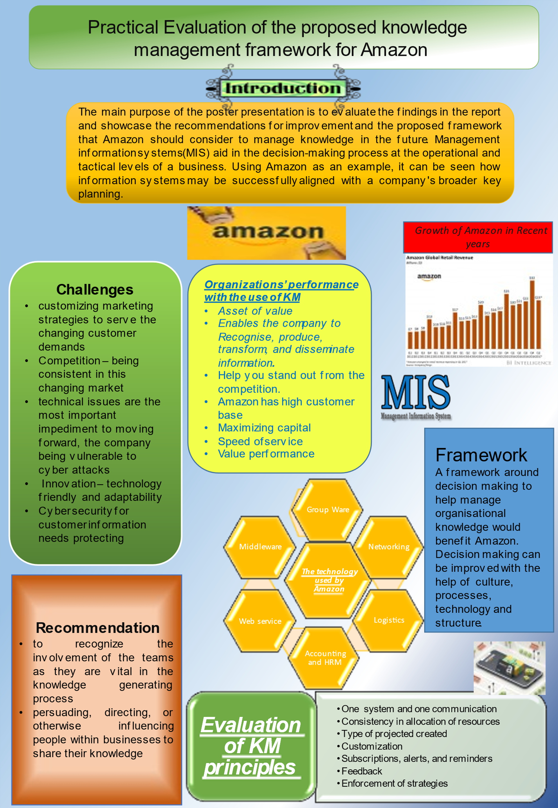
Knowledge management has caught the interest of business and management experts because to its potential to deliver strategic benefits to firms in terms of sustainability, productivity, and development (Ferreira et al., 2018). According to the literature, knowledge management is regarded as a key and important component of a company's success and competitiveness. Knowledge management is defined as the basis for establishing a company's mission, processes, and techniques so that the company's information may be utilised and learned to provide activities, economic and social value for customers, communities, and organisation’s success.
Purpose of the poster presentation
The main purpose of the poster presentation is to evaluate the findings in the report and showcase the recommendations for improvement and the proposed framework that Amazon should consider managing knowledge in the future. Management information systems (MIS) aid in the decision-making process at the operational and tactical levels of a business. Using Amazon as an example, it can be seen how information systems may be successfully aligned with a company's broader key planning. Amazon enhanced its E strategy and developed a website system that was distinct from its scheduling system.

Here are some knowledge management difficulties that Amazon should consider:
Competition - The worldwide market is always shifting. Competitors are spending a lot of money to push Amazon back. Relaxation is not an option. To be the number one retailer shop, it is quite difficult and requires consistency in the market. Plus, the growing competition is a risk for Amazon’s loyal customers.
Following through with the right culture - The recommendation understands the culture of organisation. Whenever selecting a knowledge management system (KMS), it is critical to assess the organization's culture since it determines how workers act and do their duties.
Protecting information from Cyberthreats - The company is doing this through serving their customers and providing them access to their most preferred products without any impediments to information. But doing it in a secure way is an issue and is recommended that Amazon strengthens their security of information.
Technology innovation - The integration of customer relationship management and information management into Amazon's broader business strategy have been two technologies fuelling the company's growth. Although the use of AI to upgrade their customer interaction with virtual agents can be considered as it cuts down on costs on the customer service centre. technology is progressing. To maintain its market position, a company like "amazon" must be adaptable and technologically friendly. Amazon's new Drone Delivery System technology implies that soon, the company is likely to invest a considerable amount of money in technology.
For Amazon to perform knowledge management is important so a proposed framework involving decision making is suggested. Knowledge management and decision making have a common goal: to improve the effectiveness and efficiency of choices and actions based on information and knowledge. This goal motivates the desire to better manage knowledge and, as a result, enhances decision-making in the knowledge-work environment (Mosconi, 2013).
According to Ferreira et al. (2018) there are three main components to consider in KM: the importance of people, procedures, and technology which cannot be underestimated. It takes a combination of people, procedures, and the ability to apply information for an organisation to thrive and if the technology can assist consumers in achieving their objectives in an intuitive and customised manner, it will enhance the overall customer experience.
Benefits: It enhances the process of decision making in which it is possible for workers to increase the quality and timeliness of decision-making by transmitting and receiving data from and throughout the business. Even before making a choice, integrated information technologies make it simpler to access the viewpoints of a range of people with a variety of ideas giving the organisation a fresh, broader perspective on the decisions they make. Next it helps in increasing the satisfaction of consumer where there is an increased value given to clients is made possible via knowledge exchange and cross-collaborative efforts (Hellebrandt et al., 2018). As a result, the business may provide quicker responses and speed up the process to enhance a service or product. It also gives value to the organisation’s objectives

