
modern digital technology
Effects at workplace

Sharif Uddin (1605545) Group 6
UWTSD
Program:
Certificate of Higher Education For Skills at Workplace
Module:
Digital Skills and Research Methods
Lecturer:
Renuga Jayakumar

Contents

Introduction: 1
The Report: 1
Social media: 1
Twitter: 2
Facebook: 3
Emails: 3
Smart Devices: 4
Cloud Storage: 4
Video and Conference calling: 4
Experiences: 5
Conclusion: 6
References: 7

Introduction:

Digital technology and social media are part of our everyday life, as well as it helps us to communicate with our family and friends the technology is also effective in our work. The technology has come long way over the years as our life is depends a lot on the digital technology. It certainly has impact on our life and with the help of smart devices the work can be done much easier way and communication has become very easy. Everyone is using a smart device all the time even while travelling by train, plane, buses and other journeys. The devices also help to do work while travelling with the help of internet. Social media has become very relevant in our personnel and employment usage, at work we use this platform for marketing and communication purposes, customers also can use this service to get in touch and place orders and keep track of their order and delivery, also its easier to receive bills, statements and other important information.

The Report:

Social media:

According to a survey data of 292 participants ( Anon.2018) it was revealed that consumers use peer communication using social media to access websites of social media network to see marketing development of companies. Social media such as Facebook, twitter, LinkedIn and and emails are very useful services for personnel business use. LinkedIn:
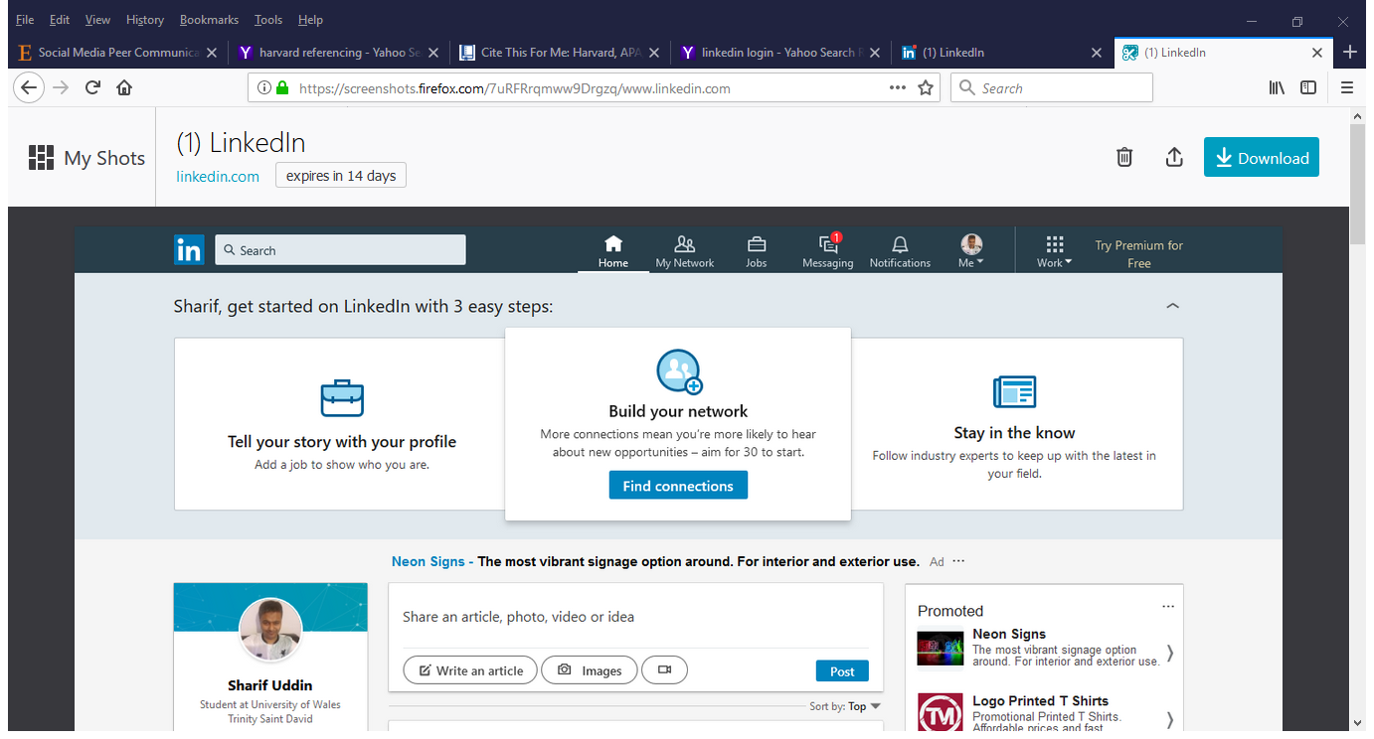
https://screenshots.firefox.com/7uRFRrqmww9Drgzq/www.linkedin.com
LinkedIn is a very useful service its like online CV of yourself where we can have all our information of what we are doing what we can do, we can upload our qualifications, experiences as well as our colleagues and employers can give references, also people can see who are we connected to and what are their impression about us. We can upload photos, videos etc.

Twitter:
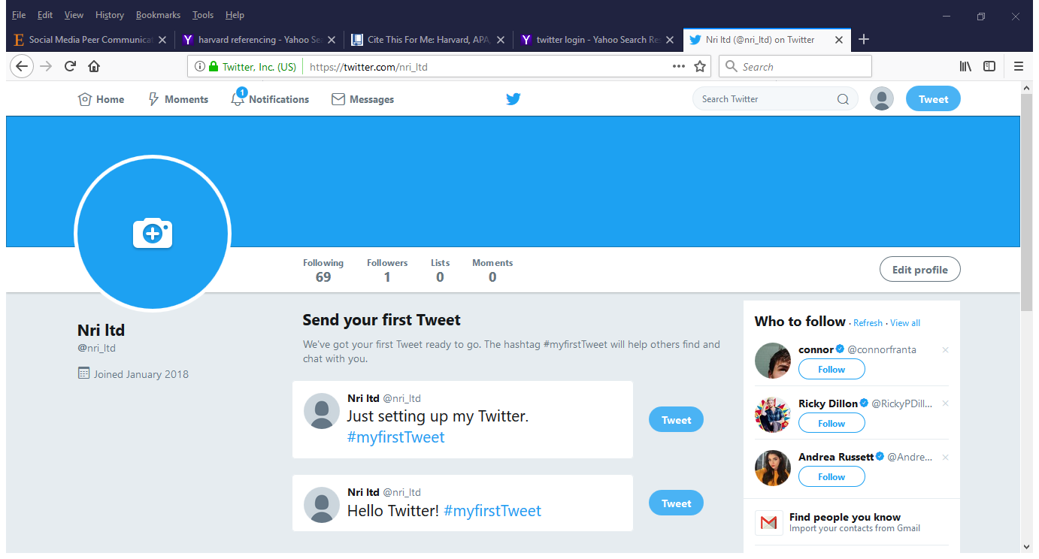
https://twitter.com/nri_ltd

Twitter is another online social media service which helps to connect with friends and customers, it can be used for personnel and business use where we can upload new messages or alternative serivices we have to offer, like we can follow customers and friends they can also follow us and give their feedback.

Facebook:

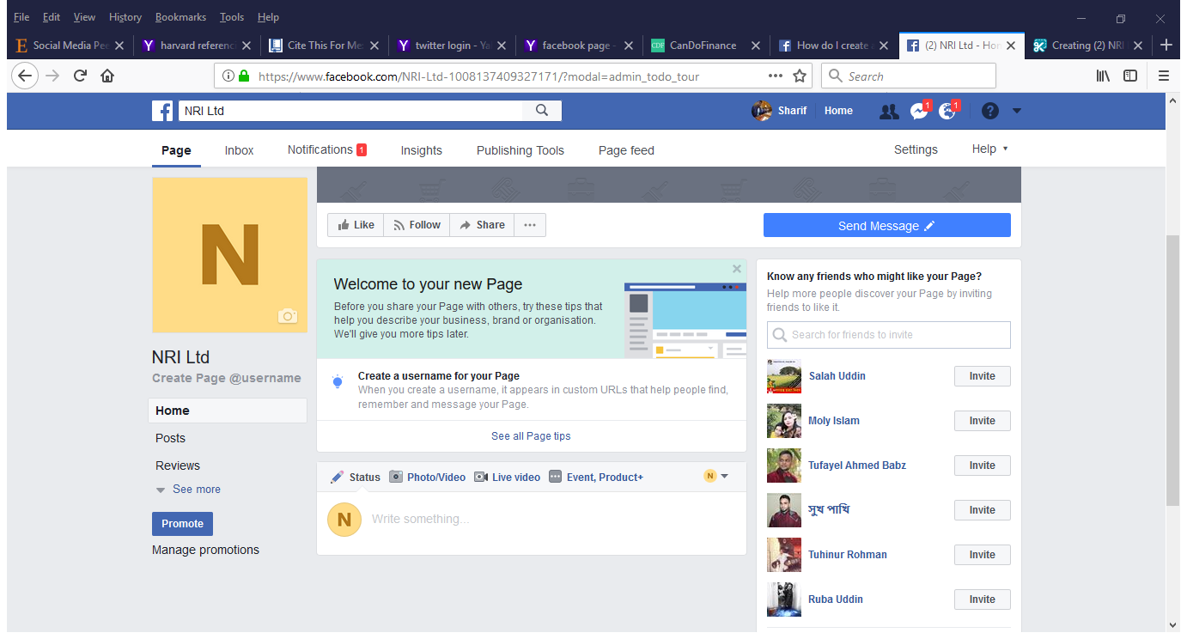
https://www.facebook.com/NRI-Ltd-1008137409327171/?modal=admin_todo_tour
Facebook is one of quickest online social media to use as its used by 2.07 million people across the world ( Anon.2018), as it is one of highest used social media platform all the business have a Facebook account, with this service its very easy to advertise our products and services where consumers can interact instantly.

Emails:

Email services has taken over letters and receipts and as well as quotations and memos. also, customers can use these services to send orders, complaints and any recommendations. The email service providers are outlook, Gmail or google mail, AOL mail, yahoo mail and others. Gmail and outlook are very popular and most widely used. Outlook was previously called Hotmail old customers are still using Hotmail and Gmail was known as google mail. These both services are quite similar in only Gmail has few extra folders like notes and folders. Also transferring photos and videos, but there is certain limits therefore when there is too many files or big files and data if required to send that can be done using One drive for Outlook and google drive for Gmail, with these services its simple to share files with other users.
Outlook: | Gmail
Simple to use | Little complicated
Easier to organise | Too many folders
Better spam handling | Everything shows together

Smart Devices:

Smart devices are very helpful tools these are mobile phones, iPad, tablets and laptops. With these devices our work has become much easier, work can be done while travelling or anywhere at our free time, Samsung mobiles are like minicomputer, this device can download files, photos, music, videos and lot more, also it can be used for video calling using medias like skype and other video calling applications. Apple devices are good for video calling other apple devices for which alternative apps are not required unless it will be used for calling other non-Apple devices, downside of Apple iPad is or any apple products are it does not let you download directedly but via iTunes, also its very secured as Samsung devices can be infected by virus and malware more often.

Cloud Storage:

This service is to keep our files stored in an online account where our files like written work, photos and videos also other important files can be stored on a on accounts like outlook’s OneDrive which gives 100GB of free space and Gmail’s google drive which gives 15GB of free storage space. also, there is drop box which is another online storage service provider which gives 5GB of free storage, when those limits are reached then there is certain charges with each provider to get further storage space facility. There other cloud services are from apple which is iCloud and from Samsung called Samsung cloud which are used by both respective devices of the brands.

Video and Conference calling:

Another helpful service is video calling which also can use for conference call , by using this service many people can interact live with each other , which is like face to face conversation using smart devices through internet, lot of companies use this service so the customers and companies can have better understanding and knowing each other.

Experiences:

In this fast and modern world social media and smart devices has taken our day to day life into another level as we mostly rely on these tools. We are very much dependable on these services we use them on and off work. It is very helpful and convenient as its accessible from anywhere as long as internet service is available. These services help us to organise our work better as it saves papers and hard files which was difficult to find when something was needed. At workplaces modern technologies are taking a huge role as it has made work more easier to communicate with customers. The courier and delivery services are using these technologies more as it can track the location of the driver and able to update the customer what time will their order or product arrive, if there is any kind of problem persist then they can also notify the customer. The restaurants are using the technology to take orders, so they don’t use handwriting anymore also they are using their own website and other companies who sends order to them by using smart devices. The smart devices and internet service are often using to send and receive instant photos and so any circumstance occurs information can be exchanged instantly with evidence so both parties can have satisfactory and sufficient information. In an article (Kabanda, 2016) discusses that how digital technology has impact on the generation, the use of computers and internet are used to have new ideas and innovations and employees can be more creative and t0 their work. Since the technologies has come in use lots of different ideas have been expand it , while using these services and tool lot of new companies were invented and lot of jobs are created, lot of people work from home on computers and laptops some people uses their smart devices for small businesses as well. Its great to use as well as sometimes it can be a problem when internet is down, or devices are infected that’s when the trouble occurs, if the work is mainly relied on internet and smart devices there will be these issues to face. The cloud storage is helpful as the data is stored so when the service up and running again it won’t be lost, but if there is a need for resetting devices then lots of information could be lost if it’s not backed up. The social media is not a problem as its mainly used for socialising and marketing so if there’s a problem with internet services not working it won’t have big impact in business, but off course it’s very useful. The digital technology is so advanced it has become main source of our day to day life in work and social life, there lots of similar services are available to use which does similar activities. The technology has brought the world together as within minutes everyone connected with everyone, sales and transactions can be done throughout the world by click of a button, businesses are gaining more turnover as they are no longer limited for customers. As world of business is moving faster and globally digitalised (Anon, 2018) employees are collaborating in a greater degree than before, according to a survey which conducted by Teknion that 88 percent of companies offer their employees smart devices like mobile smart phones and tablets as well almost 90 percent of companies increasing their investments in productive-enabling technologies like voice activation and video conferencing services, this new system has resulted in 30 percent of savings in cost of expenses The employees need to have the ability to use this technology to gain success in employment so at work its major challenge to be able to compete and cope with digital technology.

Conclusion:
The digital technology helps us do our work with more organisation, it has taken lot of stress away from us at work and social life, at work we use less paper less writing and drawing everything we do on devices and computers, we save our work either online cloud accounts or on our devices or computers and laptops, the technology have both sides good and bad so its better to have a back up for all our work, like in restaurants if the internet system is down then it becomes difficult for customers to order they call using phones and employees have to take orders with pen and paper but if the system is up and running it saves time as all information comes through device applications or email service. Most businesses now rely on digital technology which is cost effective and fast way to communicate with the world including employees and customers. It also helps to keep track of what competitors are offering so the company can offer something better. The workforce work force can have more creativity with the technology, they can experiment and offer more to work. Social media is good media of communication and marketing, we are in a digital world where everyday something new is coming which are very effective in our everyday life.

References:
Anon, (2018). [online] Available at: http://Social Media Peer Communication and Impacts on Purchase Intentions: A Consumer Socialization Framework [Accessed 9 Jan. 2018].
Anon, (2018). [online] Available at: http://The Top 20 Valuable Facebook Statistics – Updated January 2018 [Accessed 9 Jan. 2018].
Kabanda, P. (2016). Creative Natives in the Digital Age: How Digital Technology Has Revolutionized Creative Work. SSRN Electronic Journal.
Anon, (2018). [online] Available at: http://Five Essential Elements of the Digital Workplace [Accessed 10 Jan. 2018].

