Vehicle Technology
Engine Performance Characteristics
Jonathan Pugh
1808090
01/01/2020

This assignment is to test an engine and evaluate the results in the questions featured above. The engine is from a Honda CRX 1.6i 16v (ED9) 130 PS (1987-›1991). Here are some of the technical specifications and data regarding said engine:

Transverse front engine with a compression ratio of 9.5:1
4 cylinders with a cylinder volume of 398cm^3 in line 1590 cm^3 (bore 75mm x 90mm) & (stroke 1590cm^3)
16 valve single injection with 4 valves per cylinder

Power 130PS (96kW / 128 bhp) at 6800 rpm (Max RPM 7300 rpm)
Weight (EU): 1015 kg / 2238 lbs (kerb weight)
Weight/power ratio: 7,8 kg/PS (17.5 lbs/hp / 94 kW/T)
Torque weight ratio: 142 Nm/T

Fuel Consumption economical 6.9 L/100 (34.1 mpg) / Sport 12.9 L/100 (18.2 mpg)

Production range from 1983 with the end of production in 1991 and was produced in Suzuka Plant, Suzuka, Mie, in japan

The ED9 engine was produced in 1983 for the Honda civic CRX. The CRX was a front wheel drive sport compact. The CRX was originally launched as a Honda ballade but eventually changed its name to the CRX.
The CRX has a place in motorsport especially in the UK. Due to the parts being so widely available. The CRX is most commonly used in autocross, drag and road racing events

Model | 1988 | 1989 | 1990 | 1991 | Total
Honda CRX HF | 17,516 | 23,846 | 22,947 | 2,617 | 66,926
Honda CRX | 29,000 | 23,000 | 24,000 | 25,000 | 101,000
Honda CRX Si | 18,054 | 18,735 | 14,009 | 14,447 | 65,245
Total | 64,570 | 65,581 | 60,956 | 42,064 | 233,171
Below is a table showing production of the CRX by model year:

Table 1 : Production rate (Crxcommunity.com)

now on to the actual assignment.

The engine dynamometer test is used to obtain raw data of a load from the ED9 engine from a late 80s early 90s Honda CRX. The test will show load, speed and fuel consumption rate with the throttle opening to 100%. Then you must enter the collected data on your own into a suitable spread sheet. Then calculate the correct power, torque BMEP, SFC and overall thermal efficiency.

The equipment used is a apicomDSG dynamometer. The apicomDSG is connected to several safety features including an extractor fan, sprinkler system and safety mechanisms on all the doors. Below is the rig setup itself showing the dynamometer, engine and wiring loom.
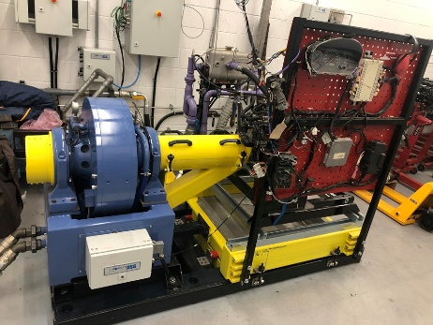
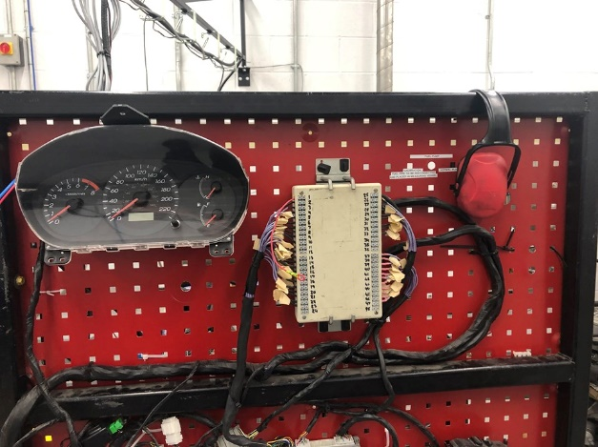
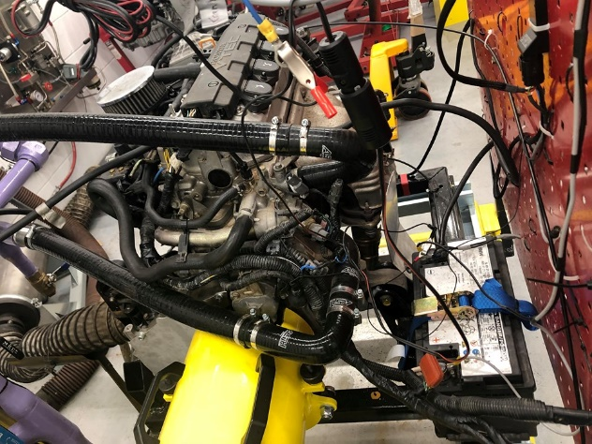
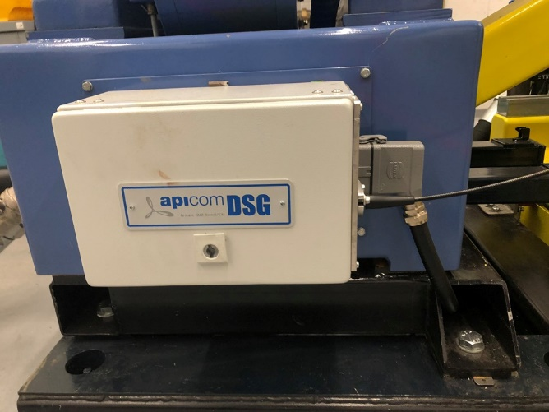
the dynamometer is manufactured by a company called apicomDSG. Apicom DSG Ltd is a UK based privately owned company that supplies systems for petrol and diesel engines, transmission components and end of line testing worldwide. The apicom DSG dynamometer is a hydraulic dyno, the benefits of a hydraulic dyno is that they are relatively small compared to some other dyno types. They have a simple structure, easy operation and installation and are very accurate compared to other less efficient dynos.
Figure 3: apicom DSG dynamometer
Figure 2: apicom DSG dynamometer
Figure 1: apicom DSG dynamometer

Figure 4: apicom DSG dynamometer

Here is the software that was used to record the data and is again produced by apicom DSG, the software is called DaTAQ and has several versions ranging from DaTAQ Prolog with basic processes and functions to DaTAQ pro that has everything you will need with the engine dynamometer.
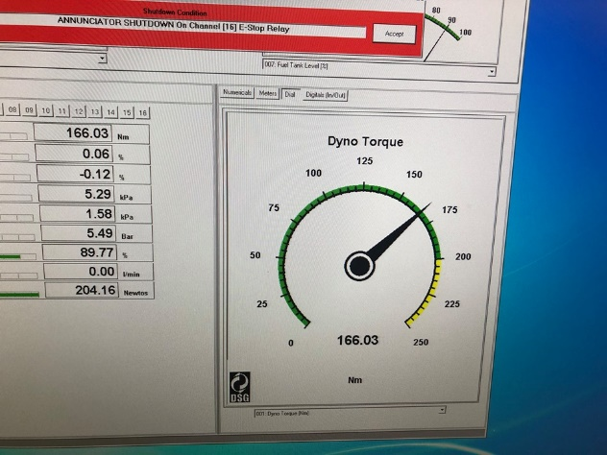

Figure 5: apicom DSG DaTAQ software

After having a safety tour of the facilities and equipment we then turned on the equipment and vacated the room to the observatory room. In pairs we then took it in turns to control the engine speed and dyna speed to get a feel of the dials and how much pressure was needed to control the engine.
It is very similar to driving a manual car, in that you need to keep the engine speed up to match the revs to prevent stalling. After the initial learning to handle the engine speed and dyno speed simultaneously we then learned how to control the apicom systems and how to record data with said system. The apicom DSG system is fairly intuitive and can be picked up very quickly even for a novice.
With all the systems ready and in place we then started the engine and set the limit, engine speed and time to get to said speed. The software then takes over and records data at the intervals set by the programmer. Once the system has completed all of the intervals it then slows the engine down t a speed also set by the user and comes to a complete stop. The data is then uploaded into a spreadsheet with all of the data that the user has asked for.
We were then given a copy of the spreadsheet with most of the data removed and had to use equations to calculate the missing data.

- Torque.
Torque is calculated with the equation
$$T=WR$$
W = force and R = Radius
Therefore, torque is T = 110.79 x 0.815775

T = 90.38 Nm

- Graph of Torque against engine speed

To calculate peak torque, find the max HP which is 128.222, then find the max rpm which is 7300.
Then calculate peak torque use equation (5252 x 128.222) / 7300
Which gives an answer of 92.24958137
Then you must convert it to lbs/ft by multiplying the answer by 1.3558179483314
Giving you 125.073638148 lbs/ft

Chart 1: torque VS Engine speed

- BP or Break Power is calculated by using

$$BP=\frac{2πNT}{60}$$

So 2pi x revolutions per sec x torque all over 60
At 1000 rpm the revolutions per second is 16.6rev/s

$$\frac{2πx16.6x90.3811}{60}$$
= 157.1137985W

- The correct power for temperature and pressure is calculated by using the equation

$$\frac{P_{s}}{BP}=\frac{1.01325}{p_{a}}\sqrt{\frac{T_{a}}{293}}$$

- Graph of power against engine speed

Chart 2: Power vs Engine Speed

- The specific fuel consumption (S.F.C)

$$S.F.C=\frac{V×0.75×3600}{t×1000×BP}$$
The find V = $(r^2)v$
The volumetric flow rate is l/min x the specific gravity of fuel (0.739).
V = 0.074 x 0.739 = 0.0520256
BP = 157.7447776
t = ?
$$S.F.C=\frac{0.0520256×0.75×3600}{t×1000×157.7447776}$$
= 8.905x10^-4

- Graph of S.F.C against engine speed

Chart 3: S.F.C vs Engine speed

- The piston area of the engine is calculated by this equation

$$A=\frac{πd^{2}}{4}$$

A Honda D16A6 piston also known as a D16Z2 is 75mm (0.075m) in diameter

$$A=\frac{π{0.075}^{2}}{4}$$
= $4.414x{10}^{-3}$ m²

- The B.M.E.P (Break Mean Effected Pressure) is calculated with the formula

$$BP=\frac{B.M.E.P ×L×A×N×n}{60×2}$$

First the formula must be transposed to make

$$\frac{120 x BP}{L×A×N×n} = B.M.E.P$$
L = Engine stroke = 1590cm³
A = Piston area = $4.414x{10}^{-3}$ m²
N = Load =110.7917011
n = number of cylinders = 4

$$\frac{120 x 157.7447776}{1590 x 4.414x{10}^{-3} x 110.7917011 x 4} = B.M.E.P$$

B.M.E.P = 6.086106693.

- The break thermal efficiency is calculated with this equation

$$η_{t}=\frac{(BP/1000)}{S.F.C (\frac{kg}{sec})×C.V}$$
The calorific value of fuel is 45.8 MJ/kg (megajoules per kilogram) petrol has a slightly higher value than diesel

$$η_{t}=\frac{(157.7447776/1000)}{0.000890483(\frac{kg}{sec})×45.8}$$
$η_{t}$= 3.867798844

Load | Dyno Speed | Fuel Flow Rate | Lambda
Newtons | rpm | l/min | Lambda | radius (m) | Torque | Brake Power | Volumetric flow rate | S.F.C | B.M.E.P
110.792 | 1000 | 0.070 | 1.348 | 0.816 | 90.381 | 157.745 | 0.052 | 0.001 | 6.086
111.063 | 1050 | 0.072 | 1.342 | 0.816 | 90.602 | 166.037 | 0.054 | 0.001 | 6.390
111.539 | 1100 | 0.074 | 1.333 | 0.816 | 90.991 | 174.690 | 0.054 | 0.001 | 6.695
112.170 | 1150 | 0.073 | 1.323 | 0.816 | 91.506 | 183.664 | 0.054 | 0.001 | 6.999
112.938 | 1200 | 0.074 | 1.309 | 0.816 | 92.132 | 192.961 | 0.055 | 0.001 | 7.303
113.884 | 1250 | 0.079 | 1.291 | 0.816 | 92.904 | 202.684 | 0.058 | 0.001 | 7.608
114.983 | 1300 | 0.079 | 1.269 | 0.816 | 93.801 | 212.827 | 0.058 | 0.001 | 7.912
116.186 | 1350 | 0.080 | 1.241 | 0.816 | 94.782 | 223.324 | 0.059 | 0.001 | 8.216
117.338 | 1400 | 0.084 | 1.222 | 0.816 | 95.721 | 233.891 | 0.062 | 0.001 | 8.521
118.577 | 1450 | 0.085 | 1.208 | 0.816 | 96.732 | 244.802 | 0.063 | 0.001 | 8.825
119.670 | 1500 | 0.089 | 1.201 | 0.816 | 97.624 | 255.579 | 0.066 | 0.001 | 9.129
120.585 | 1550 | 0.093 | 1.201 | 0.816 | 98.370 | 266.118 | 0.069 | 0.001 | 9.433
121.357 | 1600 | 0.096 | 1.206 | 0.816 | 99.000 | 276.459 | 0.071 | 0.001 | 9.738
121.978 | 1650 | 0.099 | 1.212 | 0.816 | 99.507 | 286.559 | 0.073 | 0.001 | 10.042
122.465 | 1700 | 0.100 | 1.225 | 0.816 | 99.904 | 296.421 | 0.074 | 0.001 | 10.346
122.903 | 1750 | 0.103 | 1.236 | 0.816 | 100.261 | 306.230 | 0.076 | 0.001 | 10.651
123.391 | 1800 | 0.109 | 1.243 | 0.816 | 100.659 | 316.230 | 0.081 | 0.001 | 10.955
123.977 | 1850 | 0.114 | 1.245 | 0.816 | 101.137 | 326.557 | 0.084 | 0.001 | 11.259
124.681 | 1900 | 0.117 | 1.244 | 0.816 | 101.712 | 337.290 | 0.087 | 0.001 | 11.564
125.468 | 1950 | 0.121 | 1.244 | 0.816 | 102.354 | 348.351 | 0.089 | 0.001 | 11.868
126.314 | 2000 | 0.126 | 1.242 | 0.816 | 103.044 | 359.691 | 0.093 | 0.001 | 12.172
127.224 | 2050 | 0.128 | 1.237 | 0.816 | 103.786 | 371.339 | 0.094 | 0.001 | 12.477
128.165 | 2100 | 0.131 | 1.232 | 0.816 | 104.554 | 383.210 | 0.097 | 0.001 | 12.781
129.060 | 2150 | 0.134 | 1.225 | 0.816 | 105.284 | 395.074 | 0.099 | 0.001 | 13.085
129.835 | 2200 | 0.138 | 1.214 | 0.816 | 105.916 | 406.688 | 0.102 | 0.001 | 13.389
130.413 | 2250 | 0.141 | 1.204 | 0.816 | 106.388 | 417.785 | 0.104 | 0.001 | 13.694
130.775 | 2300 | 0.145 | 1.201 | 0.816 | 106.683 | 428.253 | 0.107 | 0.001 | 13.998
130.955 | 2350 | 0.150 | 1.200 | 0.816 | 106.830 | 438.166 | 0.111 | 0.001 | 14.302
131.048 | 2400 | 0.154 | 1.197 | 0.816 | 106.906 | 447.807 | 0.114 | 0.001 | 14.607
131.112 | 2450 | 0.156 | 1.192 | 0.816 | 106.958 | 457.358 | 0.115 | 0.001 | 14.911
131.131 | 2500 | 0.160 | 1.186 | 0.816 | 106.973 | 466.758 | 0.118 | 0.001 | 15.215
131.081 | 2550 | 0.163 | 1.181 | 0.816 | 106.933 | 475.915 | 0.120 | 0.001 | 15.520
130.936 | 2600 | 0.168 | 1.180 | 0.816 | 106.814 | 484.707 | 0.124 | 0.001 | 15.824
130.686 | 2650 | 0.171 | 1.176 | 0.816 | 106.610 | 493.084 | 0.127 | 0.001 | 16.128
130.396 | 2700 | 0.175 | 1.173 | 0.816 | 106.374 | 501.276 | 0.129 | 0.001 | 16.432
130.051 | 2750 | 0.178 | 1.171 | 0.816 | 106.092 | 509.205 | 0.132 | 0.001 | 16.737
129.711 | 2800 | 0.180 | 1.172 | 0.816 | 105.815 | 517.110 | 0.133 | 0.001 | 17.041
129.394 | 2850 | 0.183 | 1.170 | 0.816 | 105.556 | 525.055 | 0.135 | 0.001 | 17.345
129.080 | 2900 | 0.188 | 1.167 | 0.816 | 105.300 | 532.971 | 0.139 | 0.001 | 17.650
128.771 | 2950 | 0.193 | 1.162 | 0.816 | 105.048 | 540.863 | 0.142 | 0.001 | 17.954
128.520 | 3000 | 0.199 | 1.155 | 0.816 | 104.843 | 548.957 | 0.147 | 0.001 | 18.258
128.467 | 3050 | 0.206 | 1.147 | 0.816 | 104.800 | 557.877 | 0.152 | 0.001 | 18.563
128.680 | 3100 | 0.210 | 1.138 | 0.816 | 104.974 | 567.964 | 0.155 | 0.001 | 18.867
129.074 | 3150 | 0.216 | 1.126 | 0.816 | 105.295 | 578.889 | 0.160 | 0.001 | 19.171
129.473 | 3200 | 0.218 | 1.112 | 0.816 | 105.621 | 589.899 | 0.161 | 0.001 | 19.476
129.896 | 3250 | 0.223 | 1.102 | 0.816 | 105.966 | 601.073 | 0.165 | 0.001 | 19.780
130.363 | 3300 | 0.226 | 1.089 | 0.816 | 106.347 | 612.515 | 0.167 | 0.001 | 20.084
130.798 | 3350 | 0.229 | 1.079 | 0.816 | 106.702 | 623.871 | 0.169 | 0.001 | 20.388
131.215 | 3400 | 0.234 | 1.069 | 0.816 | 107.042 | 635.200 | 0.173 | 0.001 | 20.693
131.575 | 3450 | 0.236 | 1.062 | 0.816 | 107.336 | 646.311 | 0.174 | 0.001 | 20.997
131.860 | 3500 | 0.242 | 1.054 | 0.816 | 107.568 | 657.096 | 0.179 | 0.001 | 21.301
132.020 | 3550 | 0.245 | 1.051 | 0.816 | 107.699 | 667.294 | 0.181 | 0.001 | 21.606
132.027 | 3600 | 0.255 | 1.048 | 0.816 | 107.704 | 676.724 | 0.188 | 0.001 | 21.910
131.902 | 3650 | 0.258 | 1.044 | 0.816 | 107.602 | 685.473 | 0.190 | 0.001 | 22.214
131.653 | 3700 | 0.264 | 1.042 | 0.816 | 107.399 | 693.552 | 0.195 | 0.001 | 22.519
131.332 | 3750 | 0.265 | 1.040 | 0.816 | 107.137 | 701.210 | 0.196 | 0.001 | 22.823
130.907 | 3800 | 0.269 | 1.038 | 0.816 | 106.791 | 708.265 | 0.199 | 0.001 | 23.127
130.350 | 3850 | 0.274 | 1.039 | 0.816 | 106.336 | 714.527 | 0.202 | 0.001 | 23.432
129.694 | 3900 | 0.276 | 1.042 | 0.816 | 105.801 | 720.165 | 0.204 | 0.001 | 23.736
129.037 | 3950 | 0.283 | 1.045 | 0.816 | 105.265 | 725.702 | 0.209 | 0.001 | 24.040
128.423 | 4000 | 0.285 | 1.047 | 0.816 | 104.764 | 731.391 | 0.210 | 0.001 | 24.344
127.832 | 4050 | 0.287 | 1.048 | 0.816 | 104.282 | 737.126 | 0.212 | 0.001 | 24.649
127.299 | 4100 | 0.289 | 1.048 | 0.816 | 103.847 | 743.114 | 0.214 | 0.001 | 24.953
126.844 | 4150 | 0.293 | 1.048 | 0.816 | 103.476 | 749.489 | 0.217 | 0.001 | 25.257
126.404 | 4200 | 0.295 | 1.047 | 0.816 | 103.117 | 755.887 | 0.218 | 0.001 | 25.562
126.034 | 4250 | 0.297 | 1.045 | 0.816 | 102.815 | 762.646 | 0.220 | 0.001 | 25.866
125.705 | 4300 | 0.302 | 1.042 | 0.816 | 102.547 | 769.607 | 0.223 | 0.001 | 26.170
125.313 | 4350 | 0.306 | 1.039 | 0.816 | 102.227 | 776.126 | 0.226 | 0.001 | 26.475
124.869 | 4400 | 0.309 | 1.036 | 0.816 | 101.865 | 782.267 | 0.228 | 0.001 | 26.779
124.359 | 4450 | 0.310 | 1.033 | 0.816 | 101.449 | 787.925 | 0.229 | 0.001 | 27.083
123.728 | 4500 | 0.314 | 1.029 | 0.816 | 100.934 | 792.734 | 0.232 | 0.001 | 27.387
122.960 | 4550 | 0.317 | 1.026 | 0.816 | 100.308 | 796.571 | 0.234 | 0.001 | 27.692
122.056 | 4600 | 0.319 | 1.024 | 0.816 | 99.571 | 799.404 | 0.236 | 0.001 | 27.996
121.062 | 4650 | 0.321 | 1.021 | 0.816 | 98.759 | 801.508 | 0.237 | 0.001 | 28.300
120.047 | 4700 | 0.321 | 1.018 | 0.816 | 97.931 | 803.333 | 0.237 | 0.001 | 28.605
119.031 | 4750 | 0.325 | 1.018 | 0.816 | 97.103 | 805.011 | 0.240 | 0.001 | 28.909
117.941 | 4800 | 0.325 | 1.017 | 0.816 | 96.213 | 806.033 | 0.240 | 0.001 | 29.213
116.732 | 4850 | 0.326 | 1.015 | 0.816 | 95.227 | 806.079 | 0.241 | 0.001 | 29.518
115.420 | 4900 | 0.328 | 1.014 | 0.816 | 94.157 | 805.242 | 0.242 | 0.001 | 29.822
114.094 | 4950 | 0.328 | 1.014 | 0.816 | 93.075 | 804.113 | 0.243 | 0.001 | 30.126
112.766 | 5000 | 0.329 | 1.016 | 0.816 | 91.992 | 802.782 | 0.243 | 0.001 | 30.431
111.413 | 5050 | 0.330 | 1.016 | 0.816 | 90.888 | 801.076 | 0.244 | 0.001 | 30.735
110.011 | 5100 | 0.330 | 1.019 | 0.816 | 89.744 | 798.830 | 0.244 | 0.001 | 31.039
108.555 | 5150 | 0.331 | 1.020 | 0.816 | 88.556 | 795.982 | 0.245 | 0.001 | 31.343
107.061 | 5200 | 0.334 | 1.019 | 0.816 | 87.338 | 792.652 | 0.247 | 0.001 | 31.648
105.581 | 5250 | 0.331 | 1.018 | 0.816 | 86.131 | 789.213 | 0.245 | 0.001 | 31.952
104.182 | 5300 | 0.332 | 1.017 | 0.816 | 84.989 | 786.172 | 0.246 | 0.001 | 32.256
102.860 | 5350 | 0.331 | 1.017 | 0.816 | 83.911 | 783.516 | 0.244 | 0.001 | 32.561
101.672 | 5400 | 0.339 | 1.017 | 0.816 | 82.941 | 781.702 | 0.250 | 0.001 | 32.865
100.661 | 5450 | 0.344 | 1.016 | 0.816 | 82.117 | 781.102 | 0.254 | 0.001 | 33.169
99.880 | 5500 | 0.349 | 1.013 | 0.816 | 81.480 | 782.150 | 0.258 | 0.001 | 33.474

Baro | Humidity | Ambient temp
mBar | % | Deg C
1024.55 | 39.79 | 24
Table 2: excel dynamometer results

References

Table 1: Crxcommunity.com. (2020). CRX Community Forum • View topic - CRX Suspension Tech, READ if you're a suspension newbie!. [online] Available at: https://crxcommunity.com/viewtopic.php?t=4900&postdays=0&postorder=asc&start=0 [Accessed 1 Jan. 2020].

