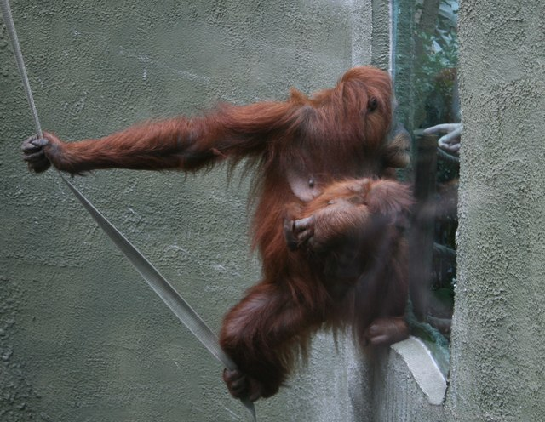
Figure 0.1: Orangutan mother and baby at Chester Zoo (Photo: Jeff Buck, 2008)

Evaluating the history and future of zoos and conservation
Lucy Fairbrother
30 March 2023
Contents
1 Introduction 1
2 Exotic menageries to Noah's Ark 2
2.1 Captive breeding as saviour to species loss 2
2.2 The challenges of reintroduction 3
2.3 Charisma over conservation need 3
2.4 The problem of genetics 4
2.5 Ensuring animal welfare 4
2.6 Conclusions 5
3 Towards a new paradigm 6
3.1 A more integrated approach 6
3.2 Scientific research 6
3.3 Education 6
3.4 Conservation finance 7
3.5 Conclusions 7
4 A coordinated approach 8
5 Conclusion 9
6 References 10

Tables and figures
Figure 0.1: Orangutan mother and baby at Chester Zoo (Photo: Jeff Buck, 2008) i
Figure 2.1: a) Black-footed ferret (Photo: J. Michael Lockhart / USFWS, 2010); b) Scimitar oryx (Photo: Waddey, 2009) 2
Figure 2.2: a) Chatham Island robin (Photo: Frances Schmechel, 2004); b) Californian condor (Photo: Phil Armitage, 2007) 3
Figure 2.3: Images taken during an investigation at South Lakes Safari Zoo (Photos: Born Free Foundation, 2022) 5

Introduction
The world is facing an unprecedented crisis of biodiversity loss, which has far-reaching implications for not only nature but also human well-being (WWF, 2020). The scale and speed of destruction of nature demands a coordinated global effort to maintain and restore habitats and halt anthropogenic extinction of species (CBD, 2022).
Zoos and aquariums have evolved significantly since their historical place as menageries of exotic animals to being centres of research, education and conservation programmes (Bostock, 1993). Globally, zoos play an increasing role in conservation, from captive breeding programmes, to supporting efforts to maintain and restore habitats, to providing educational and financial resources, but ensuring that these roles are effective demands coordination between institutions, associations and governments.
Although it is recognised that there are many organisations that breed or house animals for public exhibition, this report will focus on institutions that meet the criteria for membership (even if not an existing member) of the World Association of Zoos and Aquariums (WAZA), being publicly accessible zoos, aquariums or similar institutions established primarily for cultural, educational, scientific, and conservation purposes (WAZA, 2023).

Exotic menageries to Noah's Ark

Captive breeding as saviour to species loss
Wildlife conservation has been widely included in the objectives of zoos at least since the 1960s (Kendall and Bergl, 2019), but as the awareness of the threat to global biodiversity has increased, the role of zoos has expanded to meet conservation goals. The World Conservation Union policy statement on captive breeding (IUCN, 1987) recognised the need to establish sustainable captive populations to mitigate species loss in declining habitats, with a view to reintroducing individuals into the wild when habitat conditions were suitable. Zoos were encouraged to take an active role in maintaining populations of at-risk species, given that they already had the facilities and expertise to do so (Brichieri‐Colombi et al., 2019).
18 (out of 71) terrestrial vertebrate species downgraded on the IUCN Red List across 10 years were downgraded due to ex situ management efforts, most commonly as a result of reintroducing individuals to the wild (Gant, Mair and McGowan, 2021). Even today, there are 20 animals native to the British Isles that would be threatened with significant declines or extinction without BIAZA zoos (BIAZA, 2022).
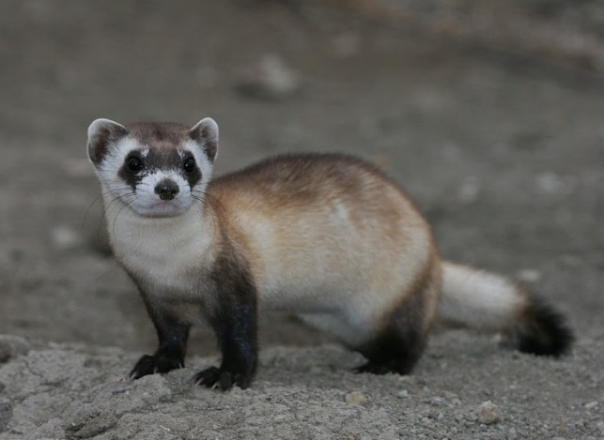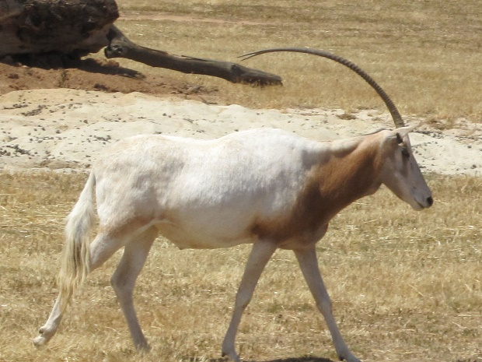
Figure 2.1: a) Black-footed ferret (Photo: J. Michael Lockhart / USFWS, 2010); b) Scimitar oryx (Photo: Waddey, 2009)
There have been several notable examples of species brought back from the brink of extinction due to the involvement of zoos. The entire wild population of black-footed ferrets (Mustela nigripes) (Figure 2.1(a)) were taken into captivity (Dobson and Lyles, 2000) and a breeding program resulted in 4,100 animals being reintroduced to the wild by 2014 (Santymire et al., 2014). The flagship species scimitar-horned oryx (Oryx dammah) was saved from extinction in the wild through artificial insemination and reintroductions (Soorae, 2018) (Figure 2.1(b)).
However, despite these case studies being heralded as conservation success stories, there remains challenges to the long-term success of the wild population. Reintroductions are successful in the long-term only where breeding meets the needs of the wild population and where there is suitable habitat for release.

The challenges of reintroduction
Zoos have been crucial at providing a temporary sanctuary where there has been a sudden change in the environment, such as the introduction of a non-native predator. The population of Chatham Island black robins (Petroica traversi) (Figure 2.2a)) remained on only a single island after the introduction of mammal predators (NZ Department of Conservation, 2020). Interventions in egg-hatching boosted the population to 250 while the mammals were removed from the islands (Forsdick, et al., 2017). By contrast, intensive management of the wild population of California condors (Gymnogyps californianus) (Figure 2.2b)) is still required following their reintroduction from a zoo-bred population (USFWS, 2021) because the main threat to the species from poisoning remains inadequately addressed (SDZWA, 2023).
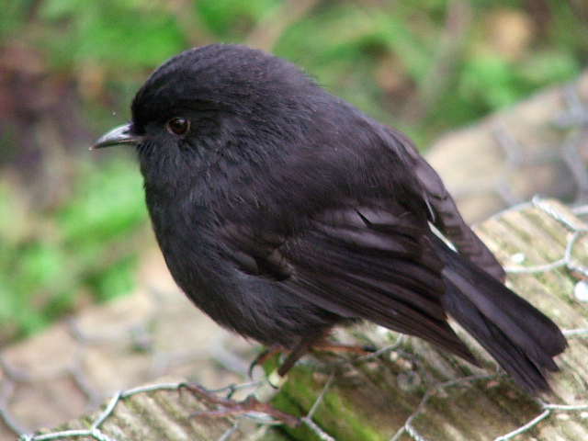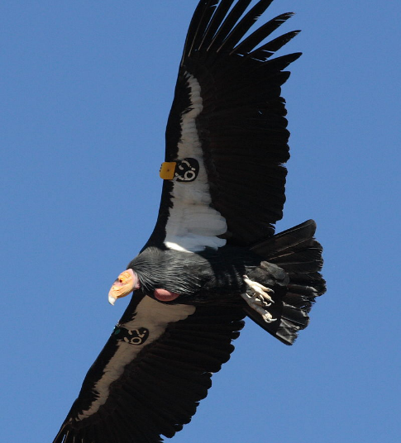
Figure 2.2: a) Chatham Island robin (Photo: Frances Schmechel, 2004); b) Californian condor (Photo: Phil Armitage, 2007)
In these examples, although it is difficult to argue that the populations would be better off without the interventions led by zoos, it is clear that captive breeding programmes are insufficient without the simultaneous support of in situ efforts. They also represent limited circumstances in which captive breeding will be justifiable in ensuring the long-term survival of a species, i.e. where extirpation has happened or is likely and where the external threats to the population have been addressed. While it is acknowledged that dozens of species would not exist without conservation action that relied on the participation of zoos (Conde et al., 2011), they represent a drop in the ocean of global biodiversity loss.

Charisma over conservation need
The need to attract visitors creates pressure on zoos to focus on the most charismatic species, often large terrestrial mammals (Bowkett, 2009). As a result, zoos will not necessarily focus on species most at risk of extinction. The proportion of terrestrial species in zoos that are threatened represents a lower proportion than the number of threatened species overall (Conde et al., 2013).
Some authors encourage a shift towards smaller species that are more threatened, such as amphibians, and a fewer number of species to ensure the best use of limited space (Spooner et al., 2023). However, moving away from flagship large vertebrates is likely to reduce attendance (Carr, 2016; Mooney et al., 2020). There is therefore likely to be a trade-off between helping species at greatest conservation need and maintaining a sustainable income.

The problem of genetics
This trade-off also affects zoos’ capacity to house a sufficient number of individuals at a low enough density to replicate near-natural conditions while mitigating the deleterious effects of captivity on a population’s genetics (Powell, 2019). In one review, 23% of taxa were not being sustainably managed to avoid genetic inbreeding (Farhadinia et al., 2020). Although captive populations can occasionally help to bolster genetic variability in the wild, as in the case of the bearded vulture (Gypaetus barbatus) (Gautschi, et al., 2003), wild populations supplemented by captive breeding have frequently suffered from deleterious genetic effects that can be directly linked back to the methods used in captivity (Gilbert et al., 2017).
To preserve genetic diversity, zoos should aim to maintain around 90% genetic diversity for at least 100 years, which requires a target population of at least 50 individuals (Conde et al., 2013; Powell, 2019). This target will often be impractical for a single zoo with limited space, particularly with larger vertebrates that require more space, although this challenge can be overcome by coordination at a regional level to maintain a sustainable metapopulation (Conde et al., 2013).
Failing to maintain sufficient genetic diversity in captive populations can reduce fitness and ultimately result in population declines following reintroductions, even where there are only small reductions in fitness (Willoughby and Christie, 2019). Species with shorter life spans and higher replacement rates can demonstrate significant physical and behavioural changes over a few generations (Wilcox & Martin, 2006).
Zoos can mitigate the negative effects on genetic variability by taking steps to avoid captive adaptation through naturalistic enclosures, using knowledge of genetics to inform breeding outcomes, and reducing the frequency of release into the wild (Klimova et al., 2022; Siciliano‐Martina et al., 2022). However, these pose challenges of increasing costs and limited space (Willoughby and Christie, 2019).

Ensuring animal welfare
There has been an encouraging emphasis on animal welfare in policy and standards set by associations (Binding et al., 2020). EAZA and BIAZA both support and assess their members in welfare standards, and in the UK, the Secretary of State’s Standards of Modern Zoo Practice (DEFRA, 2012), currently under consultation, are expected to gain a statutory footing in the Animal Welfare (Kept Animals) Bill 2021 [(Animal Welfare (Kept Animals) Bill, 2021)].
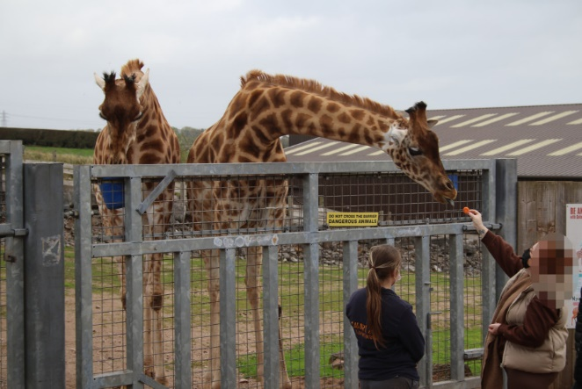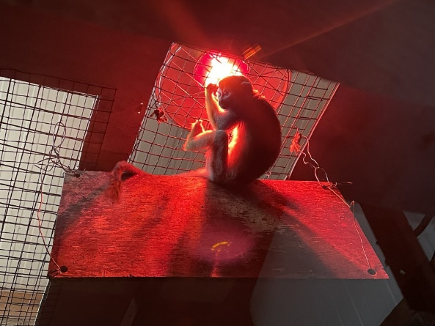
Figure 2.3: Images taken during an investigation at South Lakes Safari Zoo (Photos: Born Free Foundation, 2022)
However, real-world practice does not necessarily always reflect these standards and even today there continues to be examples of poor treatment of animals in captivity, even within licenced zoos (Born Free Foundation, 2012). Poor treatment of animals is reportedly continuing at a Cumbrian zoo (Figure 2.3), following the temporary loss of its licence in 2017 following the death of animals from emaciation and hypothermia (Born Free Foundation, 2022).
Even reputable zoos are reported to fall short of the welfare standards that are imposed by legislation and industry standards (Kaplan, 2021). This understandably has raised criticism of the ethics of taking animals from the wild to raise them in captivity, even where it is to meet conservation objectives (Keulartz, 2015). The translocation of animals from the wild into countries outside their range (particularly those countries which may have greater financial resources) has been regarded at its extreme as a neocolonial exploitation that diverts funds from in situ efforts (Hayward et al., 2018).

Conclusions
The challenges of captive breeding and the limitations to its effectiveness, from the reliance on ex situ conditions and the limited number of species that it is applicable to, has driven a shift towards a more holistic approach to conservation in zoos, where the primary focus is on protecting species within their native habitats. The next section will explore how the role of zoos in conservation has so widened.

Towards a new paradigm

A more integrated approach
As the trend for prioritising captive-breeding programmes has come and gone (Bowkett, 2009), there has been increasing pressure on zoos to give greater support to in situ conservation efforts (Conde et al., 2011; Pritchard et al., 2012). As exemplified by the “One Plan” approach championed by WAZA (Barongi et al., 2015), there has been a shift towards seeing captive breeding and reintroduction as part only of a more holistic approach to conservation in zoos, where zoos take on a multi-functional role including research, education and financial support, which addresses the many factors in the decline of biodiversity (Keulartz, 2015; Spooner et al., 2023).
This has followed an evolution in understanding of our thinking about conservation from the perspective of a single species to species as elements within an interdependent ecosystem. The decline of species has not happened in a vacuum, but because of anthropogenic threats such as habitat degradation and climate change. Failing to address these threats would mean that zoos would only be addressing a fraction of the whole problem.

Scientific research
The presence of a consistent and easily accessible population of animals provides unique opportunities to monitor species behaviour and genetics, and, as research in zoos is often based on practical needs, it tends to be interdisciplinary and with immediate practical application (Spooner et al., 2023). Their contribution goes beyond the purely industry-applicable: more than two thirds of EAZA members publish articles in peer-reviewed journals (Hvilsom et al., 2020).
There remain limitations to the impact of zoos on conservation research. For example, certain taxa are underrepresented because of the limited number of species held in zoos, in particular reptiles, amphibians, and invertebrates (Hutchins, Wiese and Smith, 2019). Furthermore, the behaviour or physiology of captive animals is not necessarily reflective of the population in the wild, even if enclosures are made to be naturalistic. Nonetheless, even some information may be better than none, if species are near impossible to study in their natural setting, and wild environments are variable, so studies of a particular population in a particular location are not always applicable more widely

Education
WAZA and national associations have taken a lead in encouraging zoos to provide education that meets a range of conservation objectives, including fostering empathy for wildlife and motivating pro-environmental behaviours, incorporating ideas of animal welfare (Thomas, 2020). With a large global audience, zoos have a unique opportunity to provide information alongside memorable experiences with animals. Zoos can help to connect young people with nature, particularly where their access to nature may be limited (Kleespies et al., 2020).
Although some studies have found that visitors to zoos ranked education lower than the animal-viewing experience as factors that attracted them to the zoo (Lee, 2015; Knežević and Ljuština, 2016), there are signs that visitors increasingly expect zoos to provide a level of education and information about conservation (Fraser and Sickler, 2008) [(AZA, unpublished data, cited in (Kendall and Bergl, 2019)).]
Where zoos provide good educational facilities, visits can increase understanding of biodiversity (Moss, Jensen and Gusset, 2014; Counsell et al., 2020), and there is evidence that this can also result in behavioural change. A targeted educational campaign on palm oil at Melbourne Zoo brought about positive change in self-reported purchasing behaviour (Pearson et al., 2014).

Conservation finance
It has been argued that zoos should dedicate the majority of its budget towards providing funding and technical support of in situ conservation activities (Kendall and Bergl, 2019). Zoos are already major financers of global conservation programmes. In 2011, zoos (mainly in North America and Europe) were the 3rd largest provider of species conservation funding (Gusset and Dick, 2011).
However, dedicating a portion of budgets creates a tension between 1) maximising the visitor experience to attract ticket sales and 2) ensuring animal welfare and the species and population numbers that best contribute to species conservation. The funding provided from any one institution may be relatively small and could be uncertain because of commercial pressures. Zoos faced a financial crisis from a drop in visitor income during the Covid pandemic and funds from conservation and education projects were diverted towards maintaining the zoos core facilities (BIAZA, 2022).
Although there could be an argument for zoos to receive finance from other sources, whether from other grant-giving bodies or the government, that would place them in competition with other conservation organisations for a very limited funding pool, where zoos are already uniquely placed in their ability to raise funds from commercial activities.

Conclusions
While the multi-functional role of zoos can open new opportunities in other areas, there are likely to be trade-offs as zoos attempt to function as sustainable businesses, educational institutions and also conservation organisations. The ability of zoos to meet pressures from policy objectives and public demands will depend on ensuring that these roles are complementary rather than conflicting.
With different zoos having different species, facilities, expertise, and budgets, greater coordination between zoos will improve each institution’s ability to make a meaningful impact. Enabling zoos to operate as a network allows for more stable funding, knowledge transfer and species management at a metapopulation level. Associations and governments therefore need to ensure that they encourage cooperation wherever possible.

A coordinated approach
In the last few years there has been acknowledgement that coordination and standards are needed at a regional, national and international level to ensure that action taken is effective. Zoo associations and governments have begun to institute frameworks for more strategic conservation programmes, with conservation being held up as the key role of zoos in the 21st century (Barongi et al., 2015; EAZA, 2017; BIAZA, 2022).
The One Plan approach has encouraged a view of zoos as participants in a global network, where there is a coordinated effort to conserve species both inside and outside their natural habitat (Conde et al., 2013). The UK has also taken steps to raising standards in British zoos and encouraging positive steps towards a more strategic approach to conservation. The Animal Welfare (Kept Animals) Bill 2021 will require zoos to contribute meaningfully to conservation, including participating in species management plans and in situ projects (DEFRA, 2021). However, this move to improve collaboration at a network level has been stymied by new regulatory barriers between the UK and the EU (Tapper, 2022).

Conclusion
The contribution of zoos to conservation is greatly strengthened by their multi-functional role in conservation, where each activity, from captive breeding, to education, to research, is bolstered by the other. This is reflected in the shift away from viewing zoos as “Noah’s Ark”, with a misplaced emphasis on protecting any one species in a vacuum, to one important player in the global effort to preserve whole habitats and ecosystems, both as a direct supporter of in situ programmes, to educating and inspiring the next generation of conservationists.
Individual zoos, and national and global associations have taken promising steps to put conservation at the forefront of zoos’ activities. Although good practice in welfare and genetically-informed breeding is not shared amongst all zoos globally, the UK is showing encouraging leadership in codifying high standards of welfare and conservation in legislation.

References
Animal Welfare (Kept Animals) Bill (2021). Available at: https://bills.parliament.uk/bills/2880.
Barongi, R., Fisken, F.A., Parker, M. and Gusset, M. (2015) Committing to conservation: the world zoo and aquarium conservation strategy. World Association of Zoos and Aquariums (WAZA). Available at: https://www.waza.org/wp-content/uploads/2019/03/WAZA-Conservation-Strategy-2015_Portrait.pdf (Accessed: 23 March 2023).
BIAZA (2022) ‘BIAZA Strategic Plan 2022-2026’. Available at: https://biaza.org.uk/downloader/2111 (Accessed: 30 March 2023).
Binding, S., Farmer, H., Krusin, L. and Cronin, K. (2020) ‘Status of animal welfare research in zoos and aquariums: Where are we, where to next?’, Journal of Zoo and Aquarium Research, 8(3), pp. 166–174. Available at: https://doi.org/10.19227/jzar.v8i3.505.
Born Free Foundation (2012) The EU Zoo Inquiry 2011. An evaluation of the implementation and enforcement of EC Directive 1999/22, relating to the keeping of animals in zoos. Report Findings and Recommendations. Available at: https://www.bornfree.org.uk/publications/eu-zoo-inquiry (Accessed: 10 March 2023).
Born Free Foundation (2022) ‘Investigation: South Lakes Safari Zoo’. Available at: https://www.bornfree.org.uk/raise-the-red-flag/south-lakes-safari-zoo (Accessed: 30 March 2023).
Bostock, S.S.C. (1993) Zoos and animal rights: the ethics of keeping animals. London ; New York: Routledge.
Bowkett, A.E. (2009) ‘Recent Captive-Breeding Proposals and the Return of the Ark Concept to Global Species Conservation’, Conservation Biology, 23(3), pp. 773–776. Available at: https://doi.org/10.1111/j.1523-1739.2008.01157.x.
Brichieri‐Colombi, T.A., Lloyd, N.A., McPherson, J.M. and Moehrenschlager, A. (2019) ‘Limited contributions of released animals from zoos to North American conservation translocations’, Conservation Biology, 33(1), pp. 33–39. Available at: https://doi.org/10.1111/cobi.13160.
Carr, N. (2016) ‘Ideal animals and animal traits for zoos: General public perspectives’, Tourism Management, 57, pp. 37–44. Available at: https://doi.org/10.1016/j.tourman.2016.05.013.
CBD (2022) ‘Kunming-Montreal Global Diversity Framework CBD/COP/15/L.25’. Convention on Biological Diversity.
Conde, D.A., Colchero, F., Gusset, M., Pearce-Kelly, P., Byers, O., Flesness, N., Browne, R.K. and Jones, O.R. (2013) ‘Zoos through the Lens of the IUCN Red List: A Global Metapopulation Approach to Support Conservation Breeding Programs’, PLoS ONE. Edited by M. Hayward, 8(12). Available at: https://doi.org/10.1371/journal.pone.0080311.
Conde, D.A., Flesness, N., Colchero, F., Jones, O.R. and Scheuerlein, A. (2011) ‘An Emerging Role of Zoos to Conserve Biodiversity’, Science, 331(6023), pp. 1390–1391. Available at: https://doi.org/10.1126/science.1200674.
Counsell, G., Moon, A., Littlehales, C., Brooks, H., Bridges, E. and Moss, A. (2020) ‘Evaluating an in-school zoo education programme: an analysis of attitudes and learning: Evaluation of zoo education’, Journal of Zoo and Aquarium Research, 8(2), pp. 99–106. Available at: https://doi.org/10.19227/jzar.v8i2.439.
DEFRA (2012) ‘Secretary of State’s Standards of Modern Zoo Practice’. Department for Environment, Food and Rural Affairs. Available at: https://assets.publishing.service.gov.uk/government/uploads/system/uploads/attachment_data/file/69596/standards-of-zoo-practice.pdf (Accessed: 30 March 2023).
DEFRA (2021) ‘Standards of Modern Zoo Practice for Great Britain: for consultation’. Department for Environment, Food and Rural Affairs. Available at: https://consult.defra.gov.uk/animal-health-and-welfare/1d5d9f40/supporting_documents/Standards%20of%20Modern%20Zoo%20Practice%20for%20Great%20Britain.pdf (Accessed: 30 March 2023).
Dobson, A. and Lyles, A. (2000) ‘Black-Footed Ferret Recovery’, Science, 288(5468), pp. 985–988. Available at: https://doi.org/10.1126/science.288.5468.985.
EAZA (2017) ‘Strategic Plan 2017-2020: Progressive zoos and aquariums collaborating to lead on conservation’. Available at: https://www.eaza.net/assets/Uploads/Strategies/Strategic-plan-2017-2020.pdf (Accessed: 20 March 2023).
Farhadinia, M.S., Johnson, P.J., Zimmermann, A., McGowan, P.J.K., Meijaard, E., Stanley‐Price, M. and Macdonald, D.W. (2020) ‘Ex situ management as insurance against extinction of mammalian megafauna in an uncertain world’, Conservation Biology, 34(4), pp. 988–996. Available at: https://doi.org/10.1111/cobi.13496.
Fraser, J. and Sickler, J. (2008) Handbook of Research Key Findings and Results from National Audience Survey. Association of Zoos and Aquariums. Available at: https://wzam.org/wp-content/uploads/Fraser.Sickler.2008_Why-Zoos-and-Aquariums-Matter-Handbook.pdf (Accessed: 30 March 2023).
Gant, J.R., Mair, L. and McGowan, P.J.K. (2021) ‘Fragmented evidence for the contribution of ex situ management to species conservation indicates the need for better reporting’, Oryx, 55(4), pp. 573–580. Available at: https://doi.org/10.1017/S0030605319000784.
Gilbert, T., Gardner, R., Kraaijeveld, A.R. and Riordan, P. (2017) ‘Contributions of zoos and aquariums to reintroductions: historical reintroduction efforts in the context of changing conservation perspectives’, International Zoo Yearbook, 51(1), pp. 15–31. Available at: https://doi.org/10.1111/izy.12159.
Gusset, M. and Dick, G. (2011) ‘The global reach of zoos and aquariums in visitor numbers and conservation expenditures’, Zoo Biology, 30(5), pp. 566–569. Available at: https://doi.org/10.1002/zoo.20369.
Hayward, M.W., Ripple, W.J., Kerley, G.I.H., Landman, M., Plotz, R.D. and Garnett, S.T. (2018) ‘Neocolonial Conservation: Is Moving Rhinos to Australia Conservation or Intellectual Property Loss: Neocolonial conservation of rhinos’, Conservation Letters, 11(1), p. e12354. Available at: https://doi.org/10.1111/conl.12354.
Hutchins, M., Wiese, R.J. and Smith, B. (2019) ‘Research in zoos and aquariums’, in Scientific foundations of zoos and aquariums: Their role in conservation and research. Kaufman, A., Bashaw, M.J., Maple, T. Eds. Cambridge University Press, pp. 1–43.
Hvilsom, C., Åhman Welden, H.L., Stelvig, M., Nielsen, C.K., Purcell, C., Eckley, L. and Frost Bertelsen, M. (2020) ‘The contributions of EAZA zoos and aquariums to peer-reviewed scientific research’, Journal of Zoo and Aquarium Research, 8(2), pp. 133–138. Available at: https://doi.org/10.19227/jzar.v8i2.486.
IUCN (1987) The IUCN Policy Statement on Captive Breeding. Gland, Switzerland: SSC Captive Breeding Specialist Group. Available at: https://portals.iucn.org/library/sites/library/files/documents/PP-001.pdf (Accessed: 26 March 2023).
Kaplan, G. (2021) ‘Casting the Net Widely for Change in Animal Welfare: The Plight of Birds in Zoos, Ex Situ Conservation, and Conservation Fieldwork’, Animals, 12(1), p. 31. Available at: https://doi.org/10.3390/ani12010031.
Kendall, C. and Bergl, R.A. (2019) ‘Evolving approaches to zoo-based conservation’, in Scientific foundations of zoos and aquariums: Their role in conservation and research. Kaufman, A., Bashaw, M.J., Maple, T. Eds. Cambridge University Press, pp. 45–63.
Keulartz, J. (2015) ‘Captivity for Conservation? Zoos at a Crossroads’, Journal of Agricultural and Environmental Ethics, 28(2), pp. 335–351. Available at: https://doi.org/10.1007/s10806-015-9537-z.
Kleespies, M.W., Gübert, J., Popp, A., Hartmann, N., Dietz, C., Spengler, T., Becker, M. and Dierkes, P.W. (2020) ‘Connecting High School Students With Nature – How Different Guided Tours in the Zoo Influence the Success of Extracurricular Educational Programs’, Frontiers in Psychology, 11, p. 1804. Available at: https://doi.org/10.3389/fpsyg.2020.01804.
Klimova, A., Gutiérrez-Rivera, J.N., Sánchez-Sotomayor, V. and Hoffman, J.I. (2022) ‘The genetic consequences of captive breeding, environmental change and human exploitation in the endangered peninsular pronghorn’, Scientific Reports, 12(1). Available at: https://doi.org/10.1038/s41598-022-14468-4.
Knežević, M. and Ljuština, M. (2016) ‘Who is Visiting the Zagreb Zoo: Visitors’ Characteristics and Motivation’, Sociologija i prostor [Preprint]. Available at: https://doi.org/10.5673/sip.55.2.4.
Lee, H.-S. (2015) ‘Measurement of visitors’ satisfaction with public zoos in Korea using importance-performance analysis’, Tourism Management, 47, pp. 251–260. Available at: https://doi.org/10.1016/j.tourman.2014.10.006.
Mooney, A., Conde, D.A., Healy, K. and Buckley, Y.M. (2020) ‘A system wide approach to managing zoo collections for visitor attendance and in situ conservation’, Nature Communications, 11(1), p. 584. Available at: https://doi.org/10.1038/s41467-020-14303-2.
Moss, A., Jensen, E. and Gusset, M. (2014) ‘Zoo visits boost biodiversity literacy’, Nature, 508(7495), pp. 186–186. Available at: https://doi.org/10.1038/508186d.
Pearson, E.L., Lowry, R., Dorrian, J. and Litchfield, C.A. (2014) ‘Evaluating the conservation impact of an innovative zoo‐based educational campaign: “Don’t Palm Us Off” for orang‐utan conservation’, Zoo Biology, 33(3), pp. 184–196. Available at: https://doi.org/10.1002/zoo.21120.
Powell, D.M. (2019) ‘Collection planning for the next 100 years: What will we commit to save in zoos and aquariums?’, Zoo Biology, 38(2), pp. 139–148. Available at: https://doi.org/10.1002/zoo.21453.
Pritchard, D.J., Fa, J.E., Oldfield, S. and Harrop, S.R. (2012) ‘Bring the captive closer to the wild: redefining the role of ex situ conservation’, Oryx, 46(1), pp. 18–23. Available at: https://doi.org/10.1017/S0030605310001766.
Santymire, R.M., Livieri, T.M., Branvold-Faber, H. and Marinari, P.E. (2014) ‘The Black-Footed Ferret: On the Brink of Recovery?’, in W.V. Holt, J.L. Brown, and P. Comizzoli (eds) Reproductive Sciences in Animal Conservation. New York, NY: Springer New York (Advances in Experimental Medicine and Biology), pp. 119–134. Available at: https://doi.org/10.1007/978-1-4939-0820-2_7.
SDZWA (2023) ‘California Condor (Gymnogyps californianus) Fact Sheet: Managed Care’, San Diego Zoo Wildlife Alliance Library. Available at: https://ielc.libguides.com/sdzg/factsheets/californiacondor/managedcare (Accessed: 26 March 2023).
Siciliano‐Martina, L., Light, J.E., Riley, D.G. and Lawing, A.M. (2022) ‘One of these wolves is not like the other: morphological effects and conservation implications of captivity in Mexican wolves’, Animal Conservation, 25(1), pp. 77–90. Available at: https://doi.org/10.1111/acv.12724.
Soorae, Pritpal.S. (ed.) (2018) Global reintroduction perspectives: 2018. Case studies from around the globe. 6th edn. IUCN, International Union for Conservation of Nature. Available at: https://doi.org/10.2305/IUCN.CH.2018.08.en.
Spooner, S.L., Walker, S.L., Dowell, S. and Moss, A. (2023) ‘The value of zoos for species and society: The need for a new model’, Biological Conservation, 279. Available at: https://doi.org/10.1016/j.biocon.2023.109925.
Tapper, J. (2022) ‘Brexit threatening endangered species as red tape hits zoo breeding programmes’, The Guardian, 13 August. Available at: https://www.theguardian.com/world/2022/aug/13/brexit-threatening-endangered-species-as-red-tape-hits-zoo-breeding-programmes (Accessed: 30 March 2023).
Thomas, S. (2020) Social Change for Conservation: The World Zoo and Aquarium Conservation Education Strategy. WAZA Executive Office, p. 89. Available at: https://www.waza.org/wp-content/uploads/2020/10/10.06_WZACES_spreads_20mbFINAL.pdf.
USFWS (2021) ‘Establishment of a Nonessential Experimental Population of the California Condor in the Pacific Northwest; Final Rule’, Federal Register, 86(55). Available at: https://www.fws.gov/sites/default/files/federal_register_document/2021-05646.pdf (Accessed: 26 March 2023).
WAZA (2023) ‘How to become a WAZA member’. Available at: https://www.waza.org/members/how-to-become-a-waza-member/ (Accessed: 23 March 2023).
Willoughby, J.R. and Christie, M.R. (2019) ‘Long‐term demographic and genetic effects of releasing captive‐born individuals into the wild’, Conservation Biology, 33(2), pp. 377–388. Available at: https://doi.org/10.1111/cobi.13217.
WWF (2020) Living Planet Report 2020 - Bending the curve of biodiversity loss. Almond, R.E.A., Grooten M. and Petersen, T. (Eds). Gland: WWF (Living planet report, 2020). Available at: https://www.wwf.org.uk/sites/default/files/2020-09/LPR20_Full_report.pdf (Accessed: 30 March 2023).

