Targedau / Targets | Sut rydych wedi gweithio ar hwn /  How you have worked on this | Ceir enghraifft ar /  An example can be found on
Targed/Target 1 | Avoid using authors' initials with in-text references. | Page 2
Targed/Target 2 | Continue with your wide ranging use of academic literature. | Page 4

Critically reflect on your progress in planning, preparing and teaching lessons that incorporate specific pedagogical principles. (This evidence should be taken from your Professional Learning Passport –PLP.) Identify up to three of these pedagogical principles as an area for development and justify the next steps in your development. Total word count: 4897

  - Part one: 2092 words

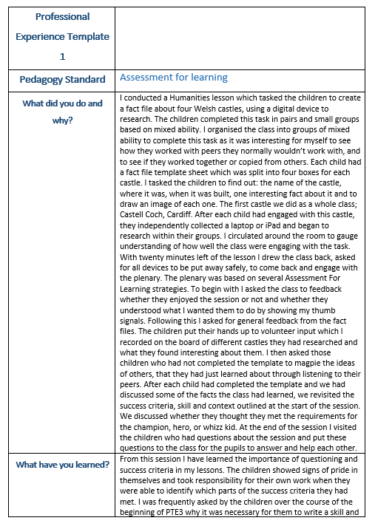

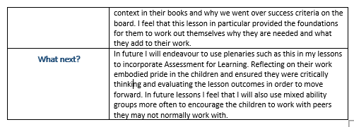

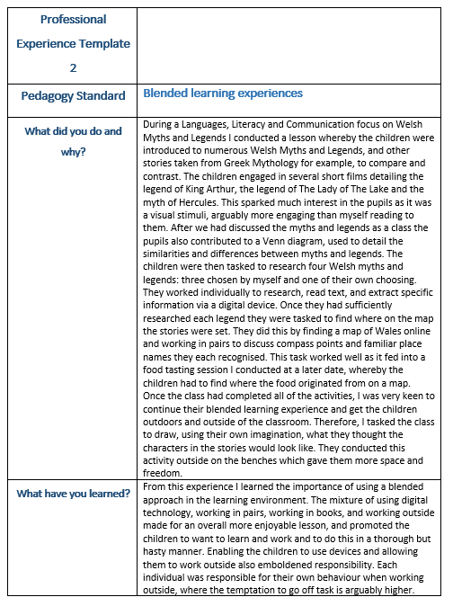

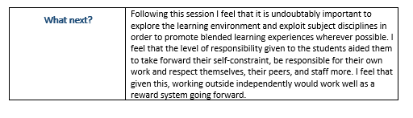

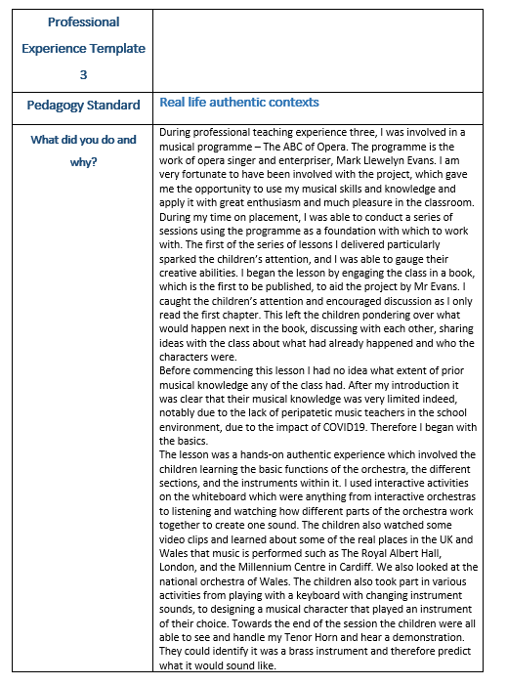

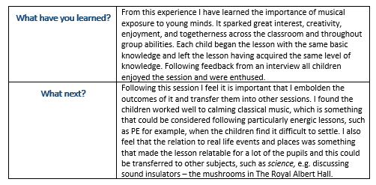

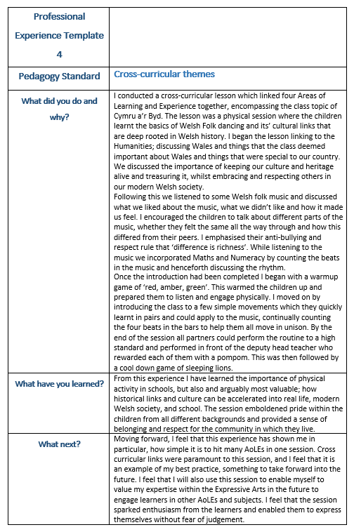

  - Part two: 2805 words
The purpose of the ECAD6008 assignment is to enhance professional development by critically reflecting on aspects of ones’ practice. Two of the curriculum’s pedagogical principles have been identified as areas for development: reinforcement of cross curricular responsibilities and employing a broad range of teaching approaches (Welsh Government, 2022). The two pedagogical principles have been identified through personal and professional development, particularly throughout professional teaching experiences.
I have chosen to focus on reinforcing cross curricular responsibilities as an area for development, as fulfilling lessons which are cross curricular linked are paramount to achieving best practice and establishing the foundations for good teaching and learning. Each of the four purposes aims to equip learners to leave education as valued and respectful members of society in Wales and the world (Welsh Government, 2015). Barnes (2015) conveys that the world outside of the classroom, and beyond the education system, is cross curricular. Barnes (2015) states that one cannot learn about the world and sufficient skills needed to understand it, through just one curriculum subject. This is something which is emulated by the development of Areas of Learning and Experience (AoLE) in the new curriculum. The AoLEs arguably provide broader opportunities for practitioners to plan and prepare lessons with embedded cross curricular responsibilities.
The second pedagogical principle which I have chosen as an area for development is employing a broad range of teaching approaches. Blended learning experiences form an integral part of classroom practice. Blended learning has become a significant component of normal classroom practice following the impact of COVID19 on schools, as set out by the Welsh Government (2021). However, it is important that one emphasises that blended, and hybrid teaching and learning is not a pedagogy specifically derived from the impact of the pandemic. Gecer & Dag (2012) affirm that these approaches are designed to aid students to experience meaningful learning. The pandemic has arguably overshadowed the true benefits of blended learning; therefore this pedagogical principle has been chosen in order to explore its’ potential impact on classroom practice.
The new curriculum for Wales reflects the changing society in which we live and aims to prepare our learners to be a part of our modern, diverse, and technologically advanced nation. The Areas of Learning and Experience included within the curriculum reflect the changing values within the curriculum and Wales. The AoLEs arguably soften the boundaries between subject disciplines and mitigate the issues associated with preparing cross curricular lessons. Donaldson (2015) notes that cross curricular learning was marginalised before the development of the new curriculum. Donaldson (2015) adds that linking AoLEs and providing cross curricular learning experiences directly impacts on wellbeing and cultural goals. However, it should be considered that some believe cross curricular teaching and learning can lead to surface learning and a lack of coherency in subject knowledge (Kerry, 2010).
On the other hand, Kerry (2010) also indicates that cross curricular experiences can enhance lesson content and make sessions more relevant. Rowley and Cooper (2009) seem to support this notion, claiming that cross curricular links, particularly within the humanities, enable connections to form from the past to the present. This was something which was particularly prominent to myself during professional teaching experience three. During my time at a school in mid-south Wales I conducted a Welsh folk dancing lesson (see part one). The session linked well to the class topic of ‘Cymru a’r Byd’ and engaged the children in an exciting activity which emboldened Welsh culture and history. The lesson crossed the boundaries of four AoLEs: humanities, health and wellbeing, maths and numeracy and the expressive arts. I used the humanities AoLE to begin my lesson and provide the foundation of knowledge for the children to understand why the lesson was relevant to them and how it linked to their culture and the history within the locality. The cross curricular links in the lesson enabled the children to bring the lesson and the history behind it into relevance, Timmerman (2017) supports this stating that cross curricular links can aid practitioners to bring their lessons into the real world.
Lessons which delve into the past, particularly the history of the locality embolden a sense of belonging in children, as concluded by the word ‘cynefin’ (Welsh Government, 2022). Cross curricular links can provide relevance to lessons by connections with local heritage and differing cultures. Culturally informed sessions arguably provide a platform for children to become ethically aware, Vygotsky’s theory informs one that culture is significant in learning for cognitive development (Woolfolk, 1998). Vygotsky also notes that connections with the community and locality can help learners to achieve and develop (Woolfolk, 1998).
Despite some lessons enabling easy links across AoLEs, Kerry (2011) acknowledges that some subject areas and themes are more challenging to provide cross curricular links to than others. The CCEA (2020), notes that applying maths, in particular, to real world examples and other subject areas can be a challenge. Ward-Penny (2011) supports this, stating that skills do not always easily transfer from one subject to another.
It could be argued that blended learning experiences provide the foundation to build on cross curricular themes and transferrable skills. The two pedagogical approaches aid teaching and learning and contribute to the qualities and skills needed in order for pupils to develop holistically. Piaget (2003) states in his stages of cognitive development that during the preoperational and concrete operational stages of child development, thinking and language is refined through the development of logical thinking and reasoning. It could be argued that cross curricular themes provide the context on which to begin to build on logical reasoning in relation to relevance in the real world. However, it should be considered that some believe Piaget’s views neglect modern societal values and do not consider cultural interaction, (Babakr, et al. 2019). On the other hand, the new curriculum aims to embolden modern Welsh society, therefore the stages of cognitive development could still be considered relevant in relation to cross curricular engagement.
Offering blended learning experiences can be another way of enriching pupils’ learning experiences (Poon, 2013). Poon (2013) suggests that there are clear correlations between blended learning and ultimate achievement. Bonk & Graham (2005) support this notion, implying that exposure to multiple learning environments emphasises a more inclusive setting. Bonk & Graham state that pupils are a varied set of individuals who learn in differing ways. Subsequently, it is noted that pupils display higher achievement levels when exposed to varied learning processes (Bonk & Graham, 2015).
Hockley (2018) appears to agree that blended learning can support and improve learning outcomes. Hockley (2018) seems to suggest that there is much deliberation regarding the definition of blended learning but specifies that it is commonly referred to as a mixture of face-to-face teaching with computer technology. Hockley (2018) adds that blended learning can offer interaction to pupils in a non-standard form, this may be useful for children who struggle with confidence to integrate. This is particularly prominent to society at the moment as we have been able to see the diverse impact technology has had, and blended learning has had on young people throughout the pandemic.
It is with no doubt that digital technology adds to the dimension of the modern-day classroom and can highly impact on learner outcomes and engagement. Cox and Marshall (2007) support this claim, furthering that ICT can have positive effects on learning. However, it is also noted that socio-economic factors and school budgets can negatively impact on the plethora of ICT and digital technology opportunities offered. Furthermore, Welsh parliament (2020) recognise that the financial impact as a result of the pandemic is substantial to education providers, and although financial support has been outlined, one cannot help but assume that this financial loss could negatively impact on digital opportunities for pupils.
Tubin, et al. (2004) emphasises planning for ICT usage can help to integrate digital opportunities into the classroom, however Tubin, et al. (2004) also stresses that there is a lack of support to aid practitioners to do so. This view, however, should be critically evaluated and questioned as the source is arguably out of date, therefore the relevance and validity could be contested. Such support is arguably now available for teachers. This is shown in Albertsen, et al. (2014) journal on digital literacy, which includes lesson plans available for download. Resources such as this are emboldened by the Welsh Government’s (2022) digital competence framework, outlined as part of the cross curricular skills framework in the new curriculum for Wales.
Planning for blended learning opportunities within the classroom and exposure to digital devices was something which I personally struggled to develop throughout my professional teaching experiences. I found it particularly challenging within the foundation phase as the children’s digital skills were compromised. However, perhaps due to the nature of the shift in society’s digital skills in general following the pandemic (PWC, 2021), by my third placement incorporating digital technology in my lessons became somewhat easier. I found that some lessons in particular lent themselves well as open opportunities to incorporate digital aspects.
A myths and legends lesson I conducted on PTE3 (see part one) was particularly appropriate to digitally enhance. The pupils were exposed to several different myths and legends from Wales and the world, and after comparing and contrasting them, were able to research four Welsh myths and legends: three which I had tasked them to research and one of their own choice. The children researched using devices such as laptops and tablets individually. This worked particularly well as the children were able to search for text which they used to extract information; their inference skills were highlighted in a way which previously had remained limited due to comprehension books.
Following the completion of numerous tasks I was able to further enhance the lesson by taking it outdoors. I tasked the children to complete an artistic activity whereby they drew their own interpretations of the characters in the myths and legends. They were split into groups of four and allocated a work bench outside. The change in learning environment had clear positive implications on the pupils: their work and their demeanour. Although some behaviour issues arose at the beginning, once the pupils began to work they developed responsibility and pride for their work, meaning behaviour settled and improved. Taking the class outside helped to embolden responsibility for themselves and bolstered respect for their peers as well as myself. Taking the lesson outdoors particularly exploited subject disciplines and enabled the pupils to flourish in the learning environment.
Although blended learning is widely associated with digital engagement (Castro, 2019), blended learning experiences in other educational spaces can contribute to the whole of blended learning opportunities. Education Scotland (2022) state in their COVID19 recovery document that blended learning can encompass learning experiences which take place in a variety of learning environments including outdoors. Outdoor education can provide benefits to both learning and teaching (Wales Council for Outdoor Learning, 2021), and offer a welcome change to the typical learning environment.
It is widely believed that outdoor learning offers an alternative setting in which to learn, however it also facilitates the development of skills and qualities such as an appreciation for the environment and the world we live in (Glaab & Heyne, 2019), emboldening informed citizenship (Welsh Government, 2022).
In order for children to develop holistically it is vital that they experience a range of varied experiences both in and out of education. Sun (2017) expresses that outdoor experiences are key to holistic development and are essential to all pupils. Sun (2017) claims that a lack of exposure to the natural environment can lead to obesity in children and a lack of respect for the environment and the world around us. Dillon (2016) supports this, claiming that outdoor learning provides the platform on which to develop cognitive skills more effectively than in the classroom environment. However, Dillon (2016) also recognises that there are specific barriers which hinder the ability to expose pupils to the outdoors. Dillon (2016) stresses that practitioner’s lack of confidence in teaching outdoors and their fears over health and safety severely impact the level of outdoor opportunities offered to pupils. Thomas (2010) appears to support this notion, stating that teachers are often overwhelmed with the responsibility of taking children into outdoor settings, as they have to take on conflicting roles. Dillon (2016) also stresses that as children get older their enthusiasm to engage with outdoor activities dwindles. Perhaps this explains why the Foundation Phase places greater emphasis on using the outdoors as a learning environment than the other stages within schools (Welsh Government, 2009).
Despite the clear obstacles to facilitating outdoor learning there is no doubt that it offers many unparalleled benefits to education. Al, et al. (2012) comments that the Montessori approach, developed by Maria Montessori is a child-led approach that bolsters independence in children and encourages individual exploration of outdoor learning spaces. Al, et al. (2012) adds that such an approach enables children to directly experience the environment first hand, rather than learning through books. Such a method is present in both the Reggio Emilia approach of Italy and the Te Whariki curriculum in New Zealand. Both adopt an approach centred on the child’s place in the environment and exploration of the world around the child.
Independent learning and exploration of the environment is embedded into the Reggio Emilia approach. The Reggio Emilia approach, founded by Loris Malaguzzi, emboldens a child centred approach whereby the children learn at their own freedom supporting curiosity (Ayla, 2014). Children in Reggio schools are exposed to outdoor opportunities supporting cultural and learner identity. Cagliari, et al. (2016) conveys the idea that self-discovery and crossed subject disciplines within the environment are paramount to the approach.
Similarly, the Tè Whariki curriculum offers a holistic approach which centres around developing learners’ sense of belonging and place in the environment in order for them to become valued society members (New Zealand Government, 2016). The Tè Whariki curriculum underpins many of the same values as outlined in the curriculum for Wales. The four purposes provide the foundations on which to build lessons and prepare our learners to take their role in society. The pedagogical principles reinforce the curriculum and are designed to support learners through metacognition in a learning environment which encourages learners to take responsibility for themselves (Welsh Government, 2022).
In summary, from planning and preparing for both cross curricular and blended learning experiences, it has been concluded that in order to continue to develop personal practice and embolden the role of a reflective practitioner, steps will be taken in order to move forward. Throughout ones’ time engaging with classroom practice and through teaching experiences, a grasp of the importance of the pedagogical principles has been obtained. The principles form the foundation on which planning and preparation for learners stand upon.
In the future, when planning for cross curricular contexts one will endeavour to do so at every opportunity possible. In order to achieve this one must break the boundaries of subject disciplines to exploit the AoLEs, in order to provide relevance and real-life contexts to lessons. This would mean less of a focus on isolated subjects and more overall rounded teaching and learning. Simpler links such as connections to the humanities in order to provide a foundation of contextual understanding should be easily obtained when moving forward to Newly Qualified Teacher (NQT) planning.
Lessons which are constructed with a blended learning approach in mind may also aid development and transition of cross curricular links, as some learning environments lend themselves particularly well to specific AoLEs. Blended learning experiences and exploiting learning environments ensure all learners engage in opportunities to learn in different ways. When looking at the QTS standards for teaching and leadership, one can denote that success in planning and delivering lessons which support cross curricular links and blended learning experiences means development in personal pedagogy and professional development and offers one’s own expertise in innovation and leadership (Welsh Government, 2018).
These blended learning experiences supported by cross curricular engagement may be achieved through small groups or through a carousel approach, which is something to keep in mind when moving forward to the NQT year. Steinert (2004) states that teaching in small groups and/or focus groups enables the pupils to think more independently whilst interacting within a group. Tiberius (2012) supports this notion stressing that teaching large groups imposes issues which do not relate to smaller groups, such as time spent with each pupil. Although it is important to consider the constraints of limited classroom staff etc, it is felt that implementing this approach may aid myself to develop personal and professional progress. Such progress should be achieved through meeting QTS standards and encompassing the four purposes to engage with all of the pedagogical principles when planning, preparing, and delivering sessions, particularly those identified for development in this assignment.

References:
Al, S. et al. (2012) A Different Perspective on Education: Montessori and Montessori School Architecture. 46, pp. 1866-1871. Available at: https://www.sciencedirect.com/science/article/pii/S1877042812015224 [Accessed: 06/04/2022].
Albertsen, H. et al. (2014). Cultivating Digital Literacy in our Schools: Constructing Quality Professional Development. Available at: https://scholarworks.gvsu.edu/mrj/vol46/iss2/4/ [Accessed: 07/04/2022].
Arseven, Ayla. (2014). The Reggio Emilia approach and curriculum development process. International Journal of Academic Research. Available at: https://www.researchgate.net/publication/274133939_The_Reggio_Emilia_approach_and_curriculum_development_process [Accessed: 06/04/2022].
Babakr, Z. H, et al. (2019). Piaget’s Cognitive Developmental Theory: Critical Review. In: Education - Quarterly Reviews. (2). Soran University: The Asian Institute of Research. Available at: https://files.eric.ed.gov/fulltext/EJ1274368.pdf [Accessed: 05/04/2022].
Barnes, J. (2015). An introduction to cross-curricular learning. Available at: file:///C:/Users/user/Downloads/AnIntroductiontoCCLearningdraft.pdf [Accessed: 06/04/2022].
Bonk, C. J. & Graham, C. (2005) The Handbook of Blended Learning: Global Perspectives, Local Designs. Available at: https://books.google.co.uk/books?id=tKdyCwAAQBAJ&dq=blended+learning+experiences&lr=&source=gbs_navlinks_s [Accessed: 06/07/2022].
Cagliari, P. et al. (2016). Loris Malaguzzi and the Schools of Reggio Emilia - A selection of his writings and speeches, 1945-1993. (1), London: Routledge.
Castro, R. (2019). Blended learning in higher education: Trends and capabilities. Available at: https://link.springer.com/article/10.1007/s10639-019-09886-3 [Accessed: 05/04/2022].
CCEA, (2020). Using Mathematics across the Curriculum. Available at: https://ccea.org.uk/learning-resources/using-mathematics-across-curriculum [Accessed: 04/04/2022].
Cox, M. J. & Marshall, G. (2007). Effects of ICT: Do we know what we should know? Available at: https://link.springer.com/article/10.1007/s10639-007-9032-x [Accessed: 06/04/2022].
Dillon, J. (2016). Towards a Convergence Between Science and Environmental Education. Available at: https://books.google.co.uk/books?id=MzslDwAAQBAJ&dq=pros+and+cons+of+outdoor+learning+&lr=&source=gbs_navlinks_s [Accessed: 06/04/2022].
Donaldson, G. (2015). Successful Futures: Independent Review of Curriculum and Assessment Arrangements in Wales. Available at: https://gov.wales/sites/default/files/publications/2018-03/successful-futures.pdf [Accessed: 04/04/2022].
Education Scotland, (2022). COVID19 Recovery Plan. Available at: https://education.gov.scot/media/ka1duf1l/cergblendedlearningnew.pdf [Accessed: 06/04/2022].
Gecer, A. & Dag, F. (2012). A Blended Learning Experience. Available at: https://files.eric.ed.gov/fulltext/EJ978452.pdf [Accessed: 06/07/2022].
Glaab, S. & Heyne, T. (2019). Focus wildlife park: Outdoor learning at workstations for primary school children. Available at: https://www.tandfonline.com/doi/full/10.1080/1533015X.2018.1554461 [Accessed: 06/04/2022].
Hockley, N. (2018). Blended Learning. (2). Available at: https://academic.oup.com/eltj/article-abstract/72/1/97/4812363?redirectedFrom=fulltext [Accessed: 05/04/2022].
Kerry, T. (2010). Cross-Curricular Teaching in the Primary School: Planning and Facilitating Imaginative Lessons. (1). New York: Routledge. Available at: https://books.google.co.uk/books?id=lPItCgAAQBAJ&dq=problems+with+cross+curricular+teaching&lr=&source=gbs_navlinks_s [Accessed 06/04/2022].
Kerry, T. (2015). Cross-Curricular Teaching in the Primary School: Planning and Facilitating Imaginative Lessons. (2). New York: Routledge. Available at: file:///C:/Users/user/Downloads/10.4324_9781315766010_previewpdf.pdf [Accessed: 06/04/2022].
New Zealand Government, (2016). Te Whariki, Early Childhood Curriculum. Available at: https://www.education.govt.nz/assets/Uploads/Te-Whariki-Early-Childhood-Curriculum-04-11-low-res.pdf [Accessed: 06/04/2022].
Piaget, J. (2003). Part I: Cognitive Development in Children--Piaget Development and Learning. Journal of Research in Science Teaching. Available at: https://eric.ed.gov/?id=ej773455 [Accessed: 05/04/2022].
Poon, J. (2013). Blended learning: an institutional approach for enhancing students' learning experiences. Journal of online learning and teaching. (9). Available at: https://dro.deakin.edu.au/eserv/DU%3A30057995/poon-blendedlearning-2013.pdf [Accessed: 06/04/2022].
PWC, (2021). Pandemic has accelerated digital upskilling, but key groups still miss out - PwC survey. 16/03/21. Available at: https://www.pwc.com/gx/en/news-room/press-releases/2021/pwc-hopes-and-fears-survey-2021.html [Accessed: 05/04/2022].
Rowley, C. & Cooper, H. (2009). Cross-curricular Approaches to Teaching and Learning. (1) California: SAGE Publications. Available at: https://books.google.co.uk/books?id=Q7gaAwAAQBAJ&dq=cross+curricular+learning&lr=&source=gbs_navlinks_s [Accessed: 05/04/2022].
Steinert, Y. (2004). Student perceptions of effective small group teaching. Available at: https://onlinelibrary.wiley.com/doi/full/10.1046/j.1365-2923.2004.01772.x [Accessed: 07/04/2022].
Sun, Q. (2017). Learning with nature: exploring three types of landscapes that facilitate outdoor learning for middle schools. Available at: https://esploro.libs.uga.edu/esploro/outputs/graduate/Learning-with-nature-exploring-three-types/9949334242502959 [Accessed: 07/04/2022].
Thomas, G. (2010). Facilitator, Teacher, or Leader? Managing Conflicting Roles in Outdoor Education. California: SAGE Publications. Available at: https://journals.sagepub.com/doi/abs/10.1177/105382590903200305 [Accessed: 06/04/2022].
Tiberius, R. G. (2012). Small Group Teaching- a trouble-shooting guide. (3). Available at: file:///C:/Users/user/Downloads/9781315042213_previewpdf.pdf [Accessed: 07/04/2022].
Timmerman, V. (2018). Cross-curricular teaching: How does it work? Available at: https://web.archive.org/web/20180514171537id_/http:/www.ciep.fr/sites/default/files/atoms/files/crosscut-cross-curricular-teaching-how-does-it-work-synthesis.pdf [Accessed: 05/04/2022].
Tubin, et al. (2004). Teachers Planning and Implementing ICT-Based Practices. Available at: https://eric.ed.gov/?id=EJ737636 [Accessed: 06/04/2022].
Wales Council for Outdoor Learning, (2021). High Quality Outdoor Learning. Available at: https://www.walescouncilforoutdoorlearning.org/hqoldoc [Accessed: 06/04/2022].
Ward-Penny, R. (2011). Cross-curricular teaching and learning in the secondary school: Mathematics. (1). Abingdon: Routledge. Available at: file:///C:/Users/user/Downloads/9780203835630_previewpdf.pdf [Accessed: 06/04/2022].
Welsh Government, (2009). Foundation Phase outdoor learning handbook. Cardiff: Crown Copyright. Available at: https://hwb.gov.wales/storage/fcb8539c-9be7-4883-8542-35d7b54b56f2/foundation-phase-outdoor-learning-handbook.pdf [Accessed: 05/04/2022].
Welsh Government, (2015). The four purposes of the curriculum for Wales. Available at: https://gov.wales/sites/default/files/publications/2018-03/the-four-purposes-of-the-curriculum-for-wales.pdf [Accessed: 06/04/2022].
Welsh Government, (2021). Blended Learning. Available at: https://hwb.gov.wales/blended-learning [Accessed: 05/04/2022].
Welsh Government, (2022). Area of Learning and Experience: Humanities. Available at: https://hwb.gov.wales/curriculum-for-wales/humanities/statements-of-what-matters [Accessed: 05/04/2022].
Welsh Government, (2022). Digital Competence Framework. Available at: https://hwb.gov.wales/curriculum-for-wales/cross-curricular-skills-frameworks/digital-competence-framework [Accessed: 06/04/2022].
Welsh Government, (2022). Implementation and practical considerations - Hwb. Available at: https://hwb.gov.wales/curriculum-for-wales/designing-your-curriculum/implementation-and-practical-considerations [Accessed: 07/04/2022].
Welsh Parliament, (2020). Impact of COVID-19 on children and young people. Available at: https://senedd.wales/laid%20documents/cr-ld13315/cr-ld13315%20-e.pdf [Accessed: 05/04/2022].
Woolfolk, R. L. (1998). The cure of souls: Science, values, and psychotherapy. Washington: American Psychological Association. Available at: https://psycnet.apa.org/record/1998-07086-000 [Accessed: 06/04/2022].

