BA (Hons) Leadership and Management Skills for the Workplace

Student Name: Ameera Khan
Student Number: 1810760
Module: Knowledge and Information Management
Module code: BMSW5106
Assignment Title: Mid-Term Formative Assessment
Lecturer: Dr Buddhi Pathak

Table of Contents
- Task 1: Question 1 How Limited Time, Data and Information Effects Decision Making................Page 3
- DIKW Hierarchy Pyramid............Page 3
- Data....................Page 3
- Information.............Page 4
- Knowledge.............Page 5
- Wisdom.............Page 5
- Task 1: Question 2 Five Decisions, Determining Data, Information and Knowledge.............Page 5
- Task 1: Question 3 Types of Knowledge.............Page 6
- Tacit Knowledge.............Page 7
- Explicit Knowledge.............Page 7
- Does a Card Game Player use Tacit or Explicit Knowledge? .............Page 8
- Task 1: Question 4 Computer Based Information Systems.............Page 9
- Executive support systems (ESS) .............Page 10
- Management information systems (MIS) .............Page 10
- Decision support systems (DSS) .............Page 10
- Knowledge management systems (KMS) .............Page 10
- Office Automation Systems (OAS) .............Page 11
- Task 1: Question 5 Organisational Structure.............Page 11
- Strategic Systems.............Page 11
- Management Systems.............Page 11
- Operations Systems.............Page 12
- Interrelationships of Information Systems.............Page 12
- Task 2 Question 1 American Airlines Strategy for Success.............Page 13
- Porters Generic Strategies Framework.............Page 13
- Applying Michael Porters Generic Strategy to American Airlines.............Page 14

Cost Leadership.............Page 14

Differentiation.............Page 15
- Focus strategy.............Page 15
- Task 2 Question 2 Porters Five Forces.............Page 15

Supplier Power.............Page 16

Buyer Power.............Page 16
- Threat of substitute.............Page 16
- Threat of New Entrants.............Page 17
- Competitive Rivalry.............Page 17
- Task 2 Question 3 Why American Airlines Was Unable to Maintain Their Competitive Advantage.............Page 17
- Task 2 Question 4 How information systems are transforming business and why they are essential for managing a business.............Page 18
- Task 2 Question 5 Major New Information System Trends.............Page 18

Data Collection Automation.............Page 19

Information Analysis Automation.............Page 19

Cross Function Integration.............Page 19
- References.............Page 20

Task 1: Question 1 How Limited Time, Data and Information Effects Decision Making
Within an organisation information is one of the most significant resources. The decision-making process is successful when reliable information has been analysed.
This section of the report will be focussed on the definition of knowledge and knowledge management.
Knowledge Management is a powerful resource for organisations, which enables businesses to adapt, survive and compete in the ever-evolving environment around us.
In order for knowledge management to succeed, organisations need to build a deeper understanding of the different elements which make up knowledge (Thompson, E. P., Kruglanski, A. W., & Spiegel, S. 2000).
DIKW Hierarchy Pyramid
Russel Ackoff articulated the DIKW Hierarchy Pyramid. The image illustrates the data, information, knowledge and wisdom hierarchy. The pyramid clearly shows how plentiful the data is and how little wisdom is generated after the data has been filtered and the information has been condensed (Rowley J E, 2007).
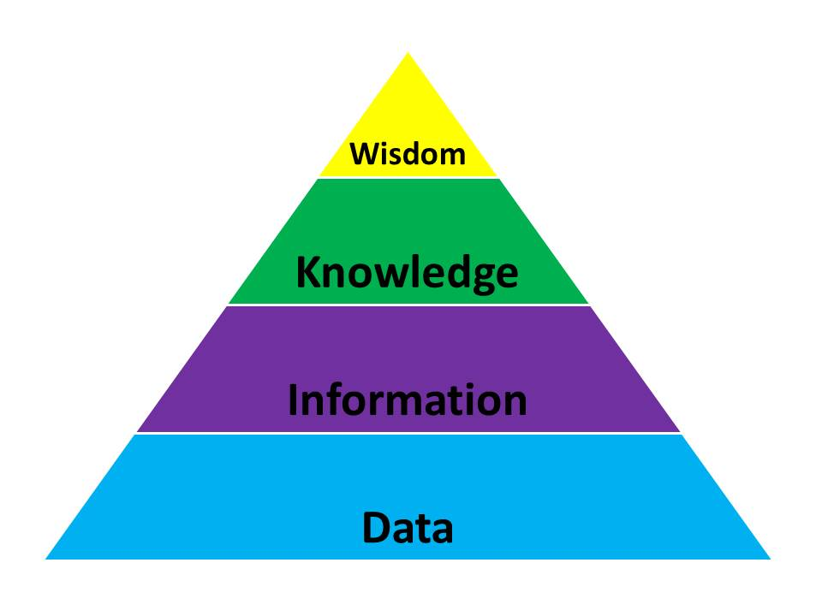(Ackoff R. L, 1989)
Data
Data can be a fact or a set of qualitative or quantitative factors of a particular situation. The data values are raw, insignificant and they have the least impact on a typical manager in this form (Thierauf,1999).
The report will now consider the definitions of data, information, knowledge and wisdom with a case study of The London Metropolitan University. The report will look at how the decision making is affected by limited time, data and information. Universities around the world collect terabytes of data about their students, from numbers of students enrolling onto courses, attendance, test scores, their gender, their age even data about their religious beliefs, ethnicity and financial status
In the UK the London Metropolitan University has a significant 18.6% dropout rate in 2019 and ranking 118th out of 130 (League table performance 2020/2021). The data shows that a higher rate of disadvantaged students are dropping out. As well as financial issues, there is possibly many other variables for the disadvantaged students causing them to leave in their first year of study.
From the moment a student has expressed interest in a course, data is used to check suitability and offer places. There is then a limited amount of time to collate this data into information and produce strategies to help students stay in education and complete their degree course at the London Metropolitan University. A recent study (S. Nam, 2019) considered the use of AI in universities to reduce the average 7.6% of first year degree student dropping out of full-time education.
Information
Once data is collated, arranged and condensed (Davenport T, 2000) it provides us with information. Information can now be used to answer a question or discuss an idea. In the case of the London Metropolitan University, strategies can be developed before students’ starts their first term to cater for individual students and support their needs. According to the research (S. Nam, 2019), Early Warning Systems or EWS is a computerised information management system which will focus on students’ profiles to determine which students are at a high risk of leaving studies and provide the evidence to the decision makers in the university to implement strategies to increase student retention and academic success. With the data effectively converted into information, the data is now relevant and has purpose (Bali et al 2009).
Currently the decision makers at the London Metropolitan University have the data, however, lack the capacity to convert large amounts of data into information with the time constraints between the application process and the start of the course. Effective knowledge management systems can equip decision makers with the information they need to design efficient strategies.
Knowledge
Knowledge is more dependent on human cognitive abilities. Knowledge when we build a consciousness and understanding of information. Knowledge encompasses the ability to acquire and translate information (Gamble P. R, 2001). Decision makers at the London Metropolitan University can devise their strategies accordingly with the knowledge gained from information.
Wisdom
Wisdom can be seen as the Practical application of knowledge. Wisdom is the use of knowledge to formulate decisions and build an in depth understanding of a situation or idea. Wisdom can give the London Metropolitan University data driven evidence for developing a more personalised application process in course selection for students, strategies could be designed to assist academic advisers, lecturers, and students.
Task 1: Question 2 Five Decisions; Determining Data, Information and Knowledge
As humans we are constantly processing data on a daily basis. There are numerous examples in our daily lives. The table below demonstrates how I processed data into information and knowledge for five decisions I have made today.
Decision | Data | Information | Knowledge
What time should I go for a walk? | The weather App on my phone states that there is a 0% chance of rain between 12pm and 4pm | The data suggests that it will not rain between 12pm and 4pm. | I will go to the local park for a 40 minutes’ walk at 2.30pm.
Should I wear a coat? | The temperature will be 12 degrees Celsius. | The temperature will be mild and not too cold. | As the weather is not too cold, I will not wear a coat.
I want to make pancakes and look online for a recipe. | BBC Good Food states the ingredients: 100g plain flour  2 large eggs  300ml milk  1 tbsp sunflower or vegetable oil | The BBC Good Food recipe: mix together all the ingredients in a bowl and cook on an oiled frying pan. | I followed the recipe and made the pancakes, as it is a simple recipe, I can retain the information and recreate them easily.
I wanted to listen to a book on Audible. | I saw a book called ‘This Morning I Met A Whale’ by Michael Morpurgo | The reviews for the book were positive and the blurb was very interesting. Michael Morpurgo is one of my favourite authors. | The book was an amazing, emotional story based on a true account of when a whale was stranded in the Thames. The story helped me to build an understanding of the problems in the world.
I wanted to choose between two different snacks. | Snickers bar 24g of fat  Dairy Milk 30g of fat | The Dairy Milk contains more fat than the Snickers. | I chose to eat the Snickers as it contained less fat.

Task 1: Question 3 Types of Knowledge
The report has looked at how knowledge differs from data and information. Once data and information has been processed, we then have knowledge. This section will look at different types of knowledge. For organisations knowing the meaning and distinguishing the difference between tacit and explicit knowledge is significant to build an understanding of ‘knowledge management’.
Some of the key terms in knowledge management are;
- Knowledge sharing; refers to when two parties mutually share knowledge
- Knowledge exchange; is when an exchange of knowledge takes place, either for other knowledge or in exchange for something else.
- Knowledge transfer; when knowledge is extracted and shared.
- Knowledge distribution is when knowledge is distributed across a party for training or teaching purposes.

Tacit Knowledge
Tacit knowledge is sometimes referred to as knowing-how. It is knowledge which is embedded in our minds and comes from experience, on jobs, peoples’ values, beliefs, intuitions and interactions. Tacit knowledge is difficult to extract and teach, for example it is a bit like when someone has learnt how to ride a bicycle, they use tacit knowledge in learning to balance with experience. However, it is difficult to extract that knowledge and teach someone else how to ride a bicycle.
Explicit Knowledge
Explicit knowledge is sometimes referred to as knowing-that. Explicit knowledge is codified, written words in books, journals, emails, manuals, databases, etc. explicit knowledge is information which has been documented to create guidelines and facilitate processes requiring action. Explicit knowledge is information that can be easily seen, taught, read, verbalised, communicated, shared, absorbed and there is already large quantities documented.
Many organisations have recognised the value of tacit knowledge. However, extracting tacit knowledge and converting it into explicit knowledge is a challenging process. Tacit knowledge, which is extracted and absorbed easily by some, can prove difficult to teach or explain to others. In this case the knowledge transfer allows the tacit knowledge to become explicit. However, when the tacit knowledge cannot be transferred the tacit knowledge remains tacit. Due to the high value of tacit knowledge, organisations research on how tacit knowledge can be extracted to be shared with others (Baumard, P. 1999).
Does a Card Game Player use Tacit or Explicit Knowledge?
A player in a game of cards uses both tacit knowledge and explicit. The rules and instructions of the game would be explicit knowledge, as these are set rules and guidelines of how to play the game. The player would need to learn how to play the game initially, then use their own intuitions, insights and inference skills to analyse their position and next moves in the game and formulate strategies by anticipating and pre-empting their opponents moves, this would need to be done using tacit knowledge. The more they play the game, the more experience they gain, which is tacit knowledge. The players success in the card game depends upon the accuracy of their tacit knowledge.
There is an automated feedback system with all games, the players outcome shows whether their tacit knowledge is successful or needs more updating with new skills to gain a better outcome for the next game. For example, if the card player was playing Poker and they have a bad hand but decide to continue playing. Even though they may already be aware of the term poker face, which is a technique experienced players’ use to have an impassive expression on their face to mask their true feelings of possessing a bad or very good hand, the player may continue to express their true feelings, which would give their opponents the advantage. Over time a card player can develop the ‘poker face’ skills, using experience from their tacit knowledge. As the ‘poker face’ skills have been honed over many years by experienced players, written or explanatory guidance can be seen as explicit knowledge.
The value of this type of knowledge, in the example of the card players knowledge, is highly valuable as a game is played to be won. However, as this knowledge is shared and not exclusively one player’s, the value in this sense is reduced as the competitors also possess the same skills will also have the same advantages (Berman, S L, Down, J & Hill, C W L 2002).
This type of knowledge transfer also reduces the tacit knowledge as it is transferred, all of the knowledge is not carried over and some knowledge is not passed on, as demonstrated in the image below.

Task 1: Question 4 Computer Based Information Systems
Large organisations rely on ‘information systems’, to process their data and manage their information. There are a variety of information systems to deal with the various requirements of information processing (Thompson, J. D. 1967).
Within an organisation with many levels, the requirement for different information is varied, as demonstrated in the diagram below.
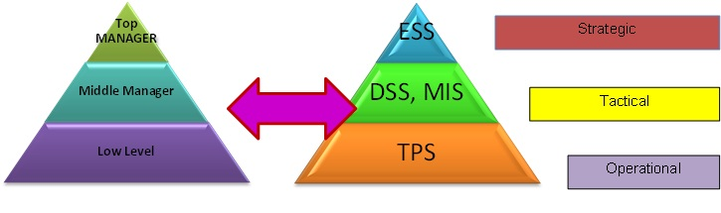
Executive Support Systems (ESS)
Senior level management staff would need information for business strategy planning. They require Executive support systems or ESS. These systems are designed to aid strategic decision making. The ESS will collate and analyse a lot of data and produce a summary of the information (Teece, D. J, Pisano, G., & Shuen, A. 1997).
Senior managers in the marketing team for Asda would require all the data and information from surveys, sales reports, advert responses, to analyse how effective previous and current campaigns have been, to be able to decide how to move forward.
Management Information Systems (MIS)
Middle level managers and supervisors would need information to monitor and control operations. They require Management information systems or MIS. These information systems deal with information which is internal to an organisation. MIS systems take data from transaction processing systems and produce summary’s and reports from this information. For middle level management in Asda they may review the performance and productivity of the shop floor staff and take into account, the reports of the speed of work of their staff, absences, incident and error reports.
Decision Support Systems (DSS)
This information management system is designed to assist managers in decision making, by creating alternative options, especially when managers are uncertain about the outcomes of plan’s they may have. DSS uses spreadsheets and a lot of data to show outcomes of options.
Asda may use DSS for analytics in sales and trends in their cash flow. This helps managers and decision makers to determine the health of the organisation.
Knowledge Management Systems (KMS)
Knowledge management systems or KMS are used to help Operations level employees, by providing the staff with the required information they need to carry out their jobs.
It helps businesses like Asda with sharing and creating information. The answers of frequently asked questions can be stored and saved online for Asda’s customers and internal staff.
KMS are efficient systems which categorise and distribute knowledge. For knowledge sharing with employees, within Asda the KMS could use an intranet.
Transaction Processing Systems TPS
TPS is used to accurately and efficiently process transactions. Asda has various TPS to deal with customer transactions, payroll, tax payments, supplier and stock control systems.
Office Automation Systems (OAS)
This would be used to improve the productivity of employees who are required to process data and information. Within Asda’s HR department there is a variety of OAS used for sending messages containing information to Asda employees, this significantly reduces the amount of time it takes to create, gain access to and receive organisational messages.
Task 1: Question 5 Organisational Structure
Within large organisations there are different levels, each with their own specialties and interests in the organisation. To manage these different levels there are a variety of systems. There is not a single system which can manage all the information in a large organisation. However, multiple systems could individually deal with information required by different areas of the business. Organisations are divided into a strategic-level, management level and operational levels and can be separated further into functional divisions like sales/marketing, production/manufacturing, HR and finance/accounting. Systems can be designed to cater for these different areas within a business (Anthony, 1965).
Strategic Systems
Information systems which are computer based, can assist managers at all levels throughout an organisation. At a strategic level, senior managers can utilise information systems to aid in developing strategies, predicting future trends, assess the internal and external environment and consider the organisations current abilities.
Management Systems
Systems developed for management levels in an organisation provide information to assist managers to monitor and control employees, administrative tasks
Management information systems can provide support in decision making. For example, in Asda, how many members of staff would be needed, during peak times in peak seasons.
Operations Systems
Supports systems for managers at an operational-level aid manager, by tracking activities like sales, deposits, transactions and payroll. The main purpose is to generate answers for generating answers for the most frequent queries to assist operations, by monitoring.
Interrelationships of Information Systems
The information systems are related to one another in an organisation. TPS is usually a significant source of data for the other information systems, however, ESS receives data from the lower level information systems. Information systems within an organisation are interconnected and can share data between them. For instance, in Asda order data collected by the sales information system may be relayed to the manufacture information system as a guidance for production, for coordinating the deliveries in the respective order of purchase and it can also send data to MIS for finance reports.
To integrate the information systems in an organisation, would make the flow of information more efficient. It would also provide a viewing platform for senior level staff, to see the industry performance overall. However, this process is challenging. Integrating different information systems is complex, time consuming and costly. Senior level staff would need to decide which systems should be integrated, based on how effective this would be, weighed against the overall costs.
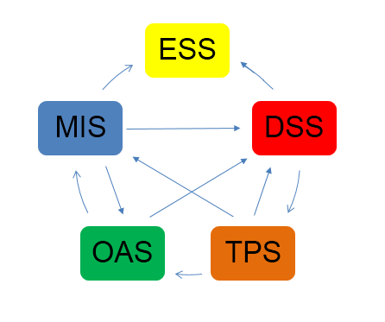

Task 2 Question 1 American Airlines Strategy for Success
Describe how the overall approach adopted by American Airlines incorporated Porter’s basic competitive strategies of ‘cost leadership’ and ‘product differentiation’.
This section of the report will analyse the SABRE reservation system produced by American Airlines and IBM. The report will look at how Business Information Systems (BIS) can be utilised by organisations to gain the competitive advantage.
Porters Generic Strategies Framework
Michael Porter designed a framework to illustrate how organisations could gain the competitive advantage by selecting the most apt strategies. The strategies the framework focusses on are; focus, cost leadership and differentiation. Organisations like American Airlines could gain the competitive advantage by reducing their costs, offering a different range of products or services than their competitors or by focussing on marketing and focussing on their company brand or by focussing on how much of their products they could offer to a smaller or larger segment of the market.
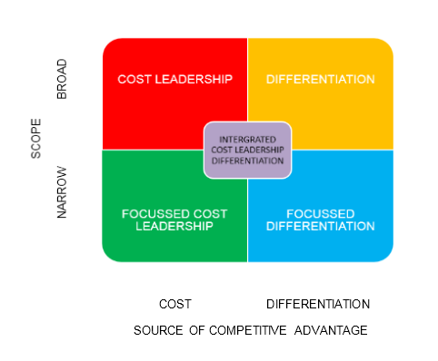

Applying Michael Porters Generic Strategy to American Airlines
American Airlines launched their BIS, SABRE (Semi-Automated Business Research Environment in 1960. SABRE was an innovation in information systems, built with IBM. In the first instance SABRE was used as an electronic reservation system. It was used to replace the manual hand-written reservation system. This made the process of reserving seats with American Airlines much faster and efficient (Duliba et al., 2001). The cost of implementing SABRE came at an initial cost of $40 million (£25 million), it was significantly advantageous for American Airlines, their main business process was now automated, making many operations in the business much simpler (Varian, 2010).
American Airlines is a multi-national company with global recognition. The airline industry is highly competitive. For American Airlines to maintain their top position in the market, they have combined elements of Porters generic strategies including; cost leadership, differentiation and focus on the pressures from competitors (Curtis and Cobham, 2009; Reinartz et al., 2004).
American Airlines strategies for the growth of the organisation were aggressive to achieve their targets. The report will now highlight the factors of Porters generic strategies as used by American Airlines;

Cost Leadership
The cost leadership strategy requires an organisation to lower their prices to gain the advantage over competitors, American Airlines gained a competitive advantage by lowering the cost to the customers. They were able to achieve this by using SABRE, as they saved 30% of costs. Using SABRE meant they did not need as much staff and they used this opportunity to pass some savings to their customers (Burgelman et al., 2008).
- Through cheaper air fares, American Airlines can retain the top position in the industry
- Lower prices also mean, expanding their customer market, as flights are more affordable, they will attract custom from the middle-class customers too. This strategy satisfies the middle-class customers demand for more value.
- As well as affordability American Airlines recognises that customers need ease of accessibility. This requires strong marketing, which creates more brand awareness and gives them a strong global position in the market.
- By improving efficiency with SABRE and making savings, American Airlines were able to offer more lower prices, discounts, promotions and money off vouchers. These schemes further increased the brand popularity (Melville and Ross, 2010).

Differentiation
Differentiation strategy involves an organisation developing a unique product or service to differentiate their company from others. With unique products which are highly appealing to customers. With their unique products and services combined with cost leadership strategies American Airlines could retain their position at the top of the industry (Burgelman et al., 2008).
- With differentiation strategy using SABRE, American Airlines could further increase their customer base.
- American Airline’s investments in consumer research and innovations, built a strong and loyal relationship with their customers (Sabre Airline Solutions, 2012).
- Using differentiation strategy in marketing American Airlines invested heavily in marketing with celebrity endorsements to differentiate from their competitors and increase their foothold with their strong company brand.
- With a faster more efficient modernised style of booking, American Airlines stood out from the crowd (Stair and Reynolds, 2012).
Focus strategy
The focus strategy encourages businesses to concentrate their attention on otherwise narrowly neglected areas of the market.
- For instance, American Airlines expanded by focussing on the middle-class customers.
- Revising their branding in accordance with customer reviews and responses, would result in satisfied customers and achieve value for money in their marketing campaigns.

Task 2 Question 2 Porters Five Forces
The Porter’s five forces analysis tool helps organisations examine the factors effecting success in an organisation. The report will now analyse American Airlines competitive strengths and weaknesses using Porters five forces.

Supplier Power
American Airlines has many suppliers throughout the world, catering for their needs. The most supplier power would have to be that of the aircraft manufacturers, as there are only two main suppliers, Boeing and Airbus. All the other suppliers of goods and services have very little power to bargain, as there is an abundance of these smaller suppliers, therefore, American Airlines has the advantage as they can easily change these smaller suppliers, if the value or quality is not there.

Buyer Power
With innovations rapidly changing the way businesses operate, customers were now demanding that all the details were readily available, as the innovators American Airlines were able to harness the control of buyer power (Bocji et al., 2009). As the airline industry evolved, the customers evolved too. With the increase in CRS, the customers now have more ease in switching to a different airline. For this reason, American Airlines is forced to invest more heavily into quality and customer satisfaction. Other costly incentives like discounts and money off promotions to encourage customer loyalty. Customers have strong buyer power, which makes the airline industry much more competitive. American Airlines is able to retain some bargaining power due to the popularity of their brand, which makes them the more appealing airline to customers (Linoff and Barry, 2011).
Threat of Substitute
The threats to American Airlines are moderately low. Their main threats are the other big airline carriers and other modes of transport. The threats from other transport options are mainly domestic, however, American Airlines does have to compete with other major airlines internationally. American Airlines does possess some power here with their customer loyalty to the brand.

Threat of New Entrants

The threat from new entrants into the industry is low, this is mainly due to the large start-up cost of setting up an airline company. The barriers to enter the airline industry are very high due to many factors including the large financial investment, political and legal factors.
Competitive Rivalry
The threats from competitors is high, as rivalry between the major airlines is intense. With other major airlines having large fleets of aircraft, strong brand image and modern technology, the competition has increased.
Task 2 Question 3 Why American Airlines Was Unable to Maintain Their Competitive Advantage
With American Airlines growing in strengths with SABRE, it became necessary for other airlines survival to incorporate computerised reservation systems, CRS. United Airlines joined the competition with APOLLO, Worldspan merged with Northwest Airline’s PARS system, TWA's, Delta's DATAS and Europe was also fast catching up with the use of CRS. Even though American Airlines were at the forefront of innovating, as no single airline possessed a complete stake in the CRS, competitive rivalry was now unprecedented (Power and Shards, 2009).
The Airline Deregulation Act was announced in 1978. This meant that the airline industry had been deregulated in certain areas like creating new routes, new entrants into the industry and prices. This created a free market in American aviation, creating even more competition (Central American Common Market, CACM, 2009).
American Airlines combatted the increased competition in 1981 with new strategies. Using their innovating Yield Management systems, they had access to customer data, analysing the data enabled them to focus on customer needs and desires. They developed the first airline loyalty program for their customers, AAdvantage (Stair and Reynolds, 2012).
American Airlines opened hubs in many airports for their customers. They were also now flying a wide range of aircraft, allowing them to add transatlantic services (Sabre Holdings, 2012).
In 1999, American Airlines merged with other airlines including; British Airways, Cathay Pacific, Canadian Airlines, and Qantas and together they founded the Oneworld alliance.
With continued mergers and cost cutting campaigns, American Airlines remains in the top three in the airline industry till today and their future prospects are strong too.
Task 2 Question 4 How information systems are transforming business and why they are essential for managing a business
In business today, Information systems are essential for organisations to conduct business. Within competitive industries survival is dependent on an organisations ability to achieve goals and develop strategies to stay ahead of their competitors and without information systems these goals would be impossible in today's climate (Curtis and Cobham, 2009). Organisations use information systems to gain success in various areas including operations, product development, services, decision making and strategy development, selecting business models, customer relations and accessing competitors.
The infrastructure of organisations nowadays is built on Information systems. Technology like email, online conference calls, and mobile phones are essential communications tools for businesses. Information systems are imperative to support organisations communication to flow efficiently and analysing large amounts of data very quickly, to assist in decision making. Information systems also allow organisations to purchase, sell, market, collect and analyse customer feedback. Organisations in a competitive industry, need to be more efficient than their competition. By applying digital changes, organisations can evolve to meet their customers evolving needs. The Internet has sparked globalisation by drastically lowering the price of goods and marketing them globally. Information systems detect new trends and are able to predict purchasing patterns, this enables businesses to pre-emptively prepare for their customers’ requirements.

Task 2 Question 5 Major New Information System Trends
Organisations need more sophisticated information systems to combine all the data they have within their organisations and data from outside their organisation which effects their business. The requirements of users within an organisation also evolve. Three significant information systems trends which will impact the development of future information systems include;

Data Collection Automation
Companies have a great need for intelligent information systems to collect data from online, to monitor customer activities.
Companies can prepare for emerging opportunities and develop strategies to deal with threats (Payne and Frow, 2005).
Although there is great value in uncovering insights in consumer behaviour, building a dependency and relying on data may ultimately dehumanise decisions made by big organisations, which lack in human experience and intuition.

Information Analysis Automation
Management have a significant requisite for analysis tools. An element of information analysis automation is augmented human decision making and judging the condition of the future environment (Boody et al., 2009).
However, successful in building more efficiency than humans, information analysis automation cannot be fully relied on to predict environmental outcomes and would be unable to predict such unprecedented situations, such as the recent Covid-19 pandemic.

Cross Function Integration
Many organisations have a need for their data and analysis systems to be integrated. One organisation can be using many information management systems within their organisation. Connecting these tools for more efficiency and to create a main access point.
Information management systems are very costly to implement within a business and adding a technical integration system would add to these costs and would have to be updated along with analytical and data systems. Nevertheless, these systems should still be considered and implemented in accordance with the level of requirements, so the return of the investments is profitable.

References
Ackoff, R. L. (1989). From data to wisdom. Journal of Applied Systems Analysis 15: 3-9.
Anthony, R. (1965) Planning and Control Systems: A Framework for Analysis. Division of Research, Graduate School of Business Administration, Harvard University, Boston.
Bali, R.K. & Wickramasinghe, Nilmini & Lehaney, Brian. (2009). Knowledge management primer. Knowledge Management Primer. 1-135. 10.4324/9780203894712.
Baumard, P. 1999. Tacit knowledge in organizations (S. Wauchope, Trans.). London: SAGE Publications.
Berman, S. L., Down, J., & Hill, C. W. L. 2002. Tacit knowledge as a source of competitive advantage in the National Basketball Association. Academy of Management Journal, 45(1): 13-31.
Bocji, P., Chaffey, A. & Hickie, A. (2009) Business Information Systems: Technology, Development, and Management. Harlow, England: Prentice Hall.
Boddy, D., Boonstra, A. & Kennedy, G. (2009) Managing Information Systems: An Organizational Perspective. Harlow, England: Pearson Education.
Burgelman R.A., Clayton, M.C. & Wheelwright, S.C. (2008) Strategic Management of Technology and Innovation. United States: McGraw Hill Publishers.
CACM (2009) Logic of lemmings in Compiler Innovation. Communications of the ACM, 52(5), pp.7-9.
Curits, G. & Cobham, D. (2009) Business Information Systems: Analysis, Design, and Practice. Harlow, England: Pearson Education.
Davenport, Thomas & Prusak, Laurence. (1998). Working Knowledge: How Organizations Manage What They Know. 10.1145/348772.348775.
Duliba, K.A., Kauffman, R.J. & Lucas, H.C. (2001) Appropriating Value from Computerized Reservation System Ownership in the Airline Industry. Organization Science, 12(6) pp.702-728.
Gamble P. R and Blackwell J, “Knowledge Management A State of the Art Guide,” Kogan Page Ltd., London, 2001.
League table performance 2020/2021, University League Table https://www.thecompleteuniversityguide.co.uk/universities/london-metropolitan-university Accessed on 10 July 2020
Linoff, G. & Barry, M. (2011) Data Mining Techniques: For Marketing, Sales, and Customer Relationship Management. Indianappolis: Wiley Publishing Co.
Melville, M. & Ross, S. (2010) Information Systems Innovation for Environmental Sustainability. MIS Quarterly, 34(1) pp.1-21.
Payne, A. & Frow, P. (2005) A Strategic Framework for Customer Relationship Management. Journal of Marketing, 69(4) pp.167-176.
Power, D. & Shards, R. (2009) Decision Support Systems. Springer
Handbook of Automation, 1, pp.1538-1549
Reinartz, W.J., Kraft, M. & Hoyer, W.D. (2004) The Customer Relationship Management Process: Its Measurement and Impact on Performance. Journal of Marketing Research, 41, pp.293-305.
Rowley, J E. “The wisdom hierarchy: representations of the DIKW hierarchy.” Journal of Information Science 33 (2007): 163 - 180.
Sabre Airline Solutions. (2012) Customer Sales and Service. [Online] Available at: http://www.sabreairlinesolutions.com/home/products_services/customer_sales_service Accessed on 08 July 2020
Sabre Holdings. (2012) Sabre History. [Online] Available at: http://www.sabre.com/home/about/sabre_history/ Accessed on 08 July 2020
Stair, R. & Reynolds, G. (2012) Fundamentals of Information Systems. New York: Cengage Learning.
SungJin Nam and Perry Samson (2019). Integrating Students’ Behavioral Signals and Academic Profiles in Early Warning System. 20th International Conference, AIED 2019 Chicago, IL, USA, June 25–29, 2019 Proceedings, Part 1.
Teece, D. J., Pisano, G., & Shuen, A. 1997. Dynamic capabilities and strategic management. Strategic Management Journal, 18(7): 509-533. 175
Thierauf, R. (1999). Knowledge Management Systems for Business, Quorum Books, Westport, CT.
Thompson, E. P, Kruglanski, A. W., & Spiegel, S. 2000. Attitudes as knowledge structures and persuasion as a specific case of subjective knowledge acquisition. In G. R. Maio, & J. M. Olson (Eds.), Why we evaluate: Functions of attitudes: 466. Mahwah, NJ: Lawrence Erlbaum Associates, Inc.
Thompson, J. D. 1967. Organizations in Action. New York: McGraw-Hill.
Varian, H. (2010) Computer-mediated Transactions. American Economic Review, 6(2) pp.1-28.

