

Module Code: BMMB7006
Module Title: Global Business Challenges
Lecturer: Rebecca Francis-Davies

Student Name: AL AMIN
Student ID: 2506610


Advising Microsoft on the Growth of Artificial Intelligence and Its Implications for Risk Management in the United Kingdom and the European Union


Executive Summary
This report aims to examine how the fast-paced development of artificial intelligence changed the field of risk management in Microsoft, especially the areas of data governance, ethical AI, regulatory compliance and customer trust in the United Kingdom and the European Union. Being a global multinational organisation in cloud infrastructure, AI platforms and enterprise applications, Microsoft is uniquely placed in the global AI value chain, but this is also an opportunity to face complex regulatory, operational and reputational risks (Microsoft Corporation, 2025a; McKinsey and Company, 2025).
The findings indicate that AI is not merely a technological advancement but a strategic driver of competitive advantage and organisational vulnerability. The principles-based approach to regulation in the UK is flexible but lacks enforcement clarity, but the EU AI Act offers binding requirements, risk categories and substantial fines, thus influencing the overall approach to compliance used by Microsoft in the international context (UK Government, 2023; European Parliament, 2024). Such issues as cross-border data flows, explainability requirements, and data governance challenges contribute to the complexity of the operations, and ethical concerns like bias and transparency have a direct impact on the stakeholder trust (Floridi, 2021; Bender et al., 2021).
The report suggests that Microsoft should implement a harmonised model of governance that is based on the EU standards, enhance its AI risk management framework, and introduce responsible AI practices at every level of operation. It is suggested to implement a phased implementation plan to increase the level of governance maturity, regulatory compliance, and stakeholder confidence. Finally, the report concludes that Microsoft can achieve long-term success in AI through its capacity to combine innovation and sound governance and make responsible AI a sustainable source of competitive advantage (Barney, 1991; Bradford, 2020).

Table of Contents
Executive Summary 3
1. Introduction 7
2. Main Findings 8
2.1 Microsoft and the strategic context of AI 8
2.1.1 Microsoft as a multi-layer AI firm 8
2.1.2 Why Microsoft is suitable for the RFD brief 10
2.1.3 Strategic implication 11
2.2 PESTLE analysis of Microsoft’s AI environment 11
2.2.1 Political and geopolitical pressures 11
2.2.2 Economic and macroeconomic pressures 12
2.2.3 Social and cultural pressures 13
2.2.4 Technological, legal and environmental pressures 14
2.3 Regulatory analysis: United Kingdom and European Union 14
2.3.1 The UK approach 14
2.3.2 The EU approach 15
2.3.3 Comparative implications for Microsoft 16
2.4 Data governance and cross-border data management 17
2.4.1 Why data governance is central 17
2.4.2 Data lineage, provenance and accountability 17
2.4.3 Cross-border processing and the European Data Boundary 18
2.4.4 Strategic implication 19
2.5 Ethical AI, explainability and model risk 19
2.5.1 From principles to practice 19
2.5.2 Bias, fairness and societal harm 20
2.5.3 Explainability, documentation and model transparency 20
2.5.4 Red-teaming, safety and misuse 21
2.6 Customer trust, stakeholder risk and competitive advantage 22
2.6.1 Trust as a strategic variable 22
2.6.2 Stakeholder mapping 23
2.6.3 Strategic implication 23
2.7 Governance architecture and enterprise risk management 24
2.7.1 Why AI governance must sit within enterprise risk management 24
2.7.2 Board and executive oversight 24
2.7.3 Three-lines logic and maturity 24
2.8 Implementation plan 25
2.8.1 Phased execution logic 25
2.8.2 Phase 1: Foundation, months 1–6 26
2.8.3 Phase 2: Build, months 7–18 26
2.8.4 Phase 3: Lead, months 19–24 27
3. Conclusion 27
Reference List 29

List of Figures
Figure 1. Microsoft as a Multi-Layer AI Firm (Author) 7
Figure 2. Microsoft AI Value Chain and Risk Exposure (Author) 10
Figure 3. PESTLE Analysis of Microsoft’s AI Environment (Author) 13
Figure 4. UK–EU AI Regulatory Comparison Timeline (Author) 15
Figure 5. Microsoft AI Data Governance Cycle (Author) 18
Figure 6. AI Model Risk Lifecycle (Author) 19
Figure 7. Stakeholder Map for Microsoft AI Governance (Author) 21
Figure 8. Phased AI Implementation Roadmap (Author) 25

List of Figures
Table 1. Microsoft’s AI position in the value chain (Microsoft Corporation, 2026; Dalirazar and Sabzi, 2023) 8
Table 2. PESTLE analysis of Microsoft’s AI environment (Brynjolfsson, Li and Raymond, 2025; McKinsey and Company, 2025) 11
Table 3. UK–EU regulatory comparison (UK Government, 2023; Bradford, 2020) 15
Table 4. Data governance risks for Microsoft (Microsoft Corporation, 2025d; Microsoft Corporation, 2026; Morley et al., 2021) 17
Table 5. Ethical AI and model-risk controls (Biecek, 2022; Awadallah et al., 2024) 20
Table 6. Stakeholder expectations in Microsoft’s AI ecosystem (Freeman, 2010; Jones et al., 2016) 22
Table 7. Proposed AI governance architecture for Microsoft (Efe, 2023; Microsoft Corporation, 2022; Microsoft Corporation, 2024) 23
Table 8. Implementation plan (Elisov et al., 2025) 26

1. Introduction
The artificial intelligence has emerged as one of the most significant forces that influence the modern international business landscape due to its impact on productivity, competitive dynamics in the market, regulations, labour organisation, data management and customer confidence (Cerutti et al., 2025). In the case of multinational corporations, AI is no longer a technical concern that is addressed by software engineers or data scientists in particular. Rather it has turned out to be a strategic and governance problem that lies in the convergence of economics, politics, law and organisational decision-making. It is particularly relevant in the framework of Global Business Challenges module where critical analysis of macroeconomic environment, the international business setting, global decision-making and the interdependence of technological, legislative, political and economic change are to be considered. However, one can only regard AI as a global business issue and not merely a new digital tool (World Economic Forum, 2026).
Microsoft is a particularly appropriate organisation to analyse in this context since it is running on multiple layers of AI economy at the same time (Microsoft Corporation, 2025a). It offers cloud computing using Azure, tools to build and deploy AI using platforms and developer kits, and has built AI into popular enterprise applications like Microsoft 365, GitHub and Dynamics. This implies that Microsoft faces risks as a technology breaker, and also as an infrastructure provider, enterprise companion, platform owner and global provider to controlled industries. Its size and global scope as well as disclosures to the public predetermine its suitability as a top-tier advisory report, of the type that RFD Global needs (Microsoft Corporation, 2025b).
The report discusses the risk management of AI in Microsoft by comparing the United Kingdom and the European Union. These two areas are of specifically high importance as they represent the divergence in AI regulation. The UK remains biased towards a flexible, regulator-oriented and pro-innovation model, whereas the EU has introduced the AI Act as a legal framework that governs AI trustfully and risk-based (UK Government, 2023; European Commission, 2025). It is on this backdrop that the report assesses the stance of Microsoft in terms of the key themes mandated by the assignment regulatory analysis, data governance, ethical AI, customer trust, and implementation planning (Freeman, 2010; Bradford, 2020).

2. Main Findings

2.1 Microsoft and the strategic context of AI

2.1.1 Microsoft as a multi-layer AI firm
Microsoft is not just adopting AI within one department. It is commercialising AI in infrastructure, developer tools, software platforms and end-user products (Microsoft Corporation, 2026). This renders Microsoft an oddly appropriate company in the assignment due to its complexity as a multinational company where both upstream and downstream activities are exposed to AI. Azure is a compute, cloud and storage platform of AI systems that are provided by Microsoft. It uses AI in daily business using Microsoft 365, Dynamics and industry-focused solutions (Microsoft Corporation, 2026).
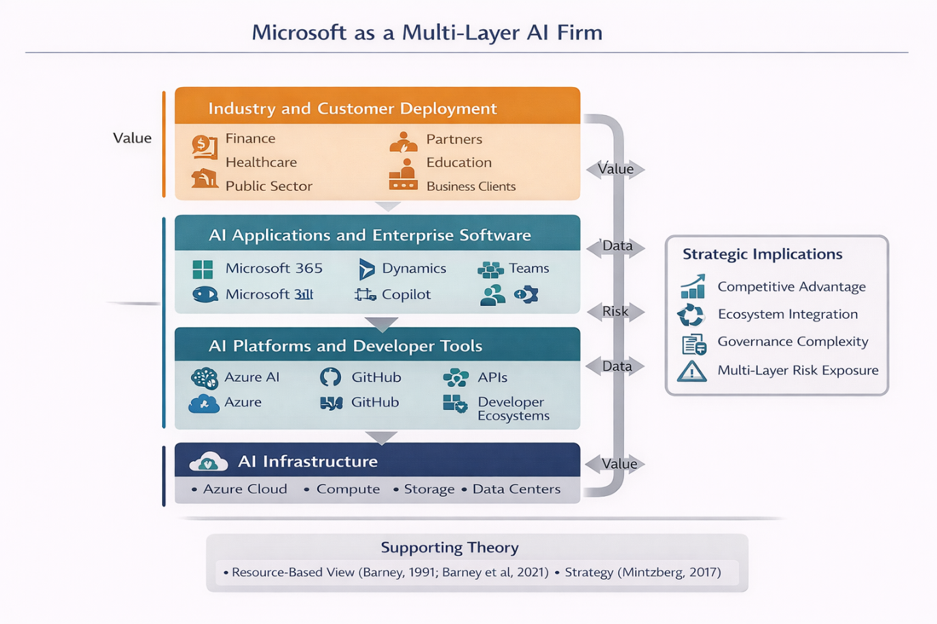
Figure 1. Microsoft as a Multi-Layer AI Firm (Author)
The Resource-Based View can be used to explain this position. The first argument that was presented by Barney is that sustained competitive advantage happens when the resources and capabilities held by the firms are valuable, rare, imitable and not substitutable (Barney, 1991). The AI potential of Microsoft obviously includes such valuable technical resources as cloud infrastructure, engineering skills and access to the ecosystem, but the organisational ability to manage such resources on a scale can be more defensible strategic resource. This is subsequently reinforced by RBV scholarship that ties resources to bigger value creation designs as compared to exclusive resources (Barney et al., 2021).
The economic results of Microsoft demonstrate the importance of the given issue. Microsoft Cloud revenue has grown to 168.9 billion and the revenue of Azure and other cloud services have grown by 34 per cent citing the annual report 2025, and this indicates the level to which the growth in the future will be anchored on the demand of the cloud and AI (Microsoft Corporation, 2025b). However, the same article reports that AI-related infrastructure expenditures will most probably keep up the expenses and might decrease the margins of operation, with governance becoming an issue of capital discipline in addition to compliance (Microsoft Corporation, 2025a). The perspective of strategy as a hand-crafted process and not an analytical plan proposed by Mintzberg proves applicable in this situation, as the AI strategy of Microsoft needs to be constantly modified with the appearance of new risks instead of being determined by a single policy document (Mintzberg, 2017).
Table 1. Microsoft’s AI position in the value chain (Microsoft Corporation, 2026; Dalirazar and Sabzi, 2023)
Business layer | Microsoft examples | Strategic value | Main risks
Infrastructure | Azure cloud, data centres (Microsoft Corporation, 2025). | Scale, lock-in, enterprise demand | Cyber risk, resilience, energy intensity
Platform | Azure AI, GitHub, APIs | Ecosystem growth, developer dependence | Misuse, documentation burden, role ambiguity
Applications | Microsoft 365 Copilot, Dynamics (Microsoft Corporation, 2026). | Productivity, subscription expansion | Hallucination, overreliance, explainability gaps
Enterprise deployment | Public sector, finance, healthcare contracts | High-value adoption | Regulatory scrutiny, trust and contractual exposure

2.1.2 Why Microsoft is suitable for the RFD brief
The RFD Global student guidance indicates that the chosen company should have real AI exposure in other functions, high degree of multinational, corporate disclosure and relevance to regulation-prone environments, availability (Microsoft Corporation, 2025). All these are applicable to Microsoft. It is a multinational corporation which operates in the UK and EU and which publishes responsible AI, risk, annual performance and European data governance. It is also a company, which products affect the adoption of AI in other organisations, which means that the quality of the governance of this firm affects not only the risk within but also the risk profile of the customers and partners (Leslie, 2019).
Porter competitive analysis can also be used to put the position of Microsoft into perspective. Large technology firms have intense competition, it remains somewhat challenging to enter the frontier of AI because of the compute, talent and capital requirements, and customer requirements are escalating because enterprise clients require more legal and ethical assistance (Porter, 1979). According to Freeman, companies can create value through giving priority to various interests of the stakeholders as compared to having a tunnel vision on the shareholder value (Freeman, 2010). The actions of AI within Microsoft affect enterprise clients, employees, regulators, programmers, governmental agencies and the community in general. Its system of governance should thus consider beyond market efficiency (Microsoft Corporation, 2025).
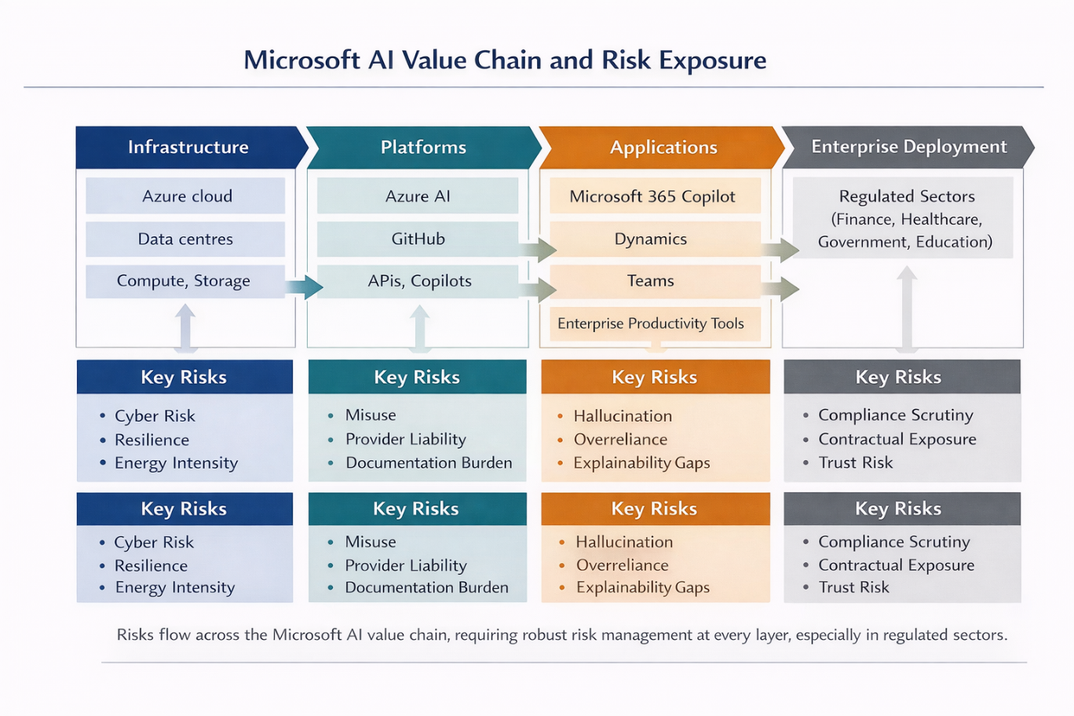
Figure 2. Microsoft AI Value Chain and Risk Exposure (Author)

2.1.3 Strategic implication
The main implication here is that the AI strategy at Microsoft should be considered as an enterprise governance question, but not a technology implementation programme. Because the risks are amassed in a network-connected manner, any governance breakdowns in one place can ruin the confidence in the larger ecosystem (Heger et al., 2025). This is why the accountable AI systems of Microsoft cannot be evaluated in the light of the symbolic validity alone but also in the light of the efficiency of the operation. This is justified by the organisational maturity studies that prove that responsible AI is based on the premise of governance, team structure and routines, but not on the principles.

2.2 PESTLE analysis of Microsoft’s AI environment

2.2.1 Political and geopolitical pressures
The politics of AI have taken a new twist. AI has turned into an object of industrial policy, digital sovereignty, national competitiveness and geopolitical competition. Governments are becoming strategic in their data, chip, compute and model resources (Floridi, 2021). This is an opportunity and a constraint in the case of Microsoft. On the one hand, governments want to be sure of dependable suppliers of digital transformation and modernisation of the public sector (Rastogi and Trivedi, 2016). The geopolitical fragmentation further adds to the expense of doing business across jurisdictions with different standards and the growing sensitivity in regard to data location and critical infrastructure (Dalirazar and Sabzi, 2023). This bigger picture is backed by the 2026 risk analysis of the World Economic forum, which lists geopolitical confrontation, misinformation and technological risks as some of the direst global problems (World Economic Forum, 2026).
Such a political climate is also echoed in the policy approach of the UK that has adopted a pro-innovation stance with a growing focus on AI safety and state competence (UK Government, 2023). EU has taken a more legal route and that translates to the fact that political preferences are directly translated to binding market regulations (European Commission, 2025).

2.2.2 Economic and macroeconomic pressures
The economic case in support of AI is sound but the value distribution is biased (Brynjolfsson, Li and Raymond, 2025). The demand of cloud infrastructure and AI is high, which plays to the advantage of Microsoft, but profitability of AI is moderated by the expense of infrastructure, price competition, customer willingness and unpredictable productivity results. Quantifiable improvements in some knowledge-work cases are being found in generative AI studies, but also improvements are found to be contingent on task complexity, user skill and organisational support (Dell’Acqua et al., 2023). Studies by the IMF also posit that AI can also widen international, domestic disparities, unless there is appropriate adoption management by institutions and companies (Cerutti et al., 2025).
This is significant to Microsoft as enterprise customers do not buy AI because it exists. When they think that the value is credible and the risk can be handled, then they buy. The state-of-AI report by McKinsey also states that many organisations are still rewiring their structures and governance to extract value out of AI effectively, which suggests that the implementation of AI is also linked to organisational preparedness to the same extent as the maturity of the technology is (McKinsey and Company, 2025).
Table 2. PESTLE analysis of Microsoft’s AI environment (Brynjolfsson, Li and Raymond, 2025; McKinsey and Company, 2025)
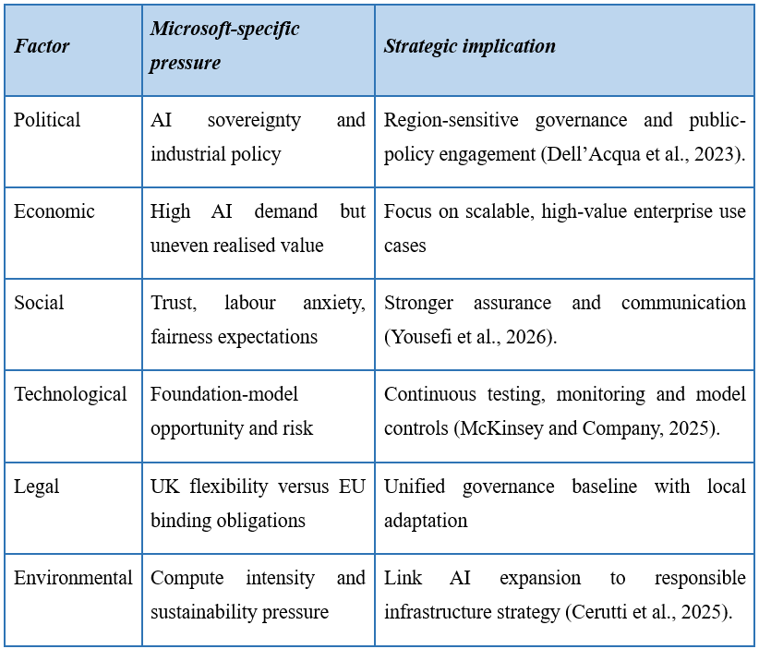

2.2.3 Social and cultural pressures
The social aspect is the main one since the AI of Microsoft is integrated into the work software and enterprise systems. AI therefore affects the working trends on or off, justice perceptions, control by the manager and autonomy of users. The reason why the practice of new systems adoption is mediated by trust, role expectations and behavioural responses, and is not solely mediated by the rational cost-benefit assessment is a lesson of business psychology and organisational behaviour (McKenna, 2020). The cross-cultural contexts of the transparency, control and hierarchy stakeholder expectations can also be different between locales, but the Hofstede framework can be useful in illuminating them, though with a sense of care and caution (Hofstede, 2011).
Such problems are of commercial importance. The less transparent, equitable and contestable AI systems employees/customers are viewed as, the less they will adopt and the less trust they will have (Microsoft Corporation, 2022). This confirms the importance of transparency, user education and escalation channels as product and governance strategy at Microsoft.

2.2.4 Technological, legal and environmental pressures
Microsoft is better off in terms of scale and integration, which is technology-wise, but foundation-model literature elucidates that scale improves systemic exposure and opportunity (Bommasani et al., 2021). The large models bring about new benefits in a task, however, also increasing the probability of spreading the failures, bias or misuse across the products. Other evidence Red-teaming products using generative AI is once again evidence that risk is dynamically evolving and may require continually updating controls instead of previously-tested controls (Bullwinkel et al., 2025).
In law, Microsoft must deal with a change in the general principles towards concrete requirements (Yousefi et al., 2026). Responsibility, legal data processing, explainability, and documentation have emerged as a fundamental issue, particularly in the UK GDPR environment and the EU AI Act (ICO, 2023; European Parliament, 2024).
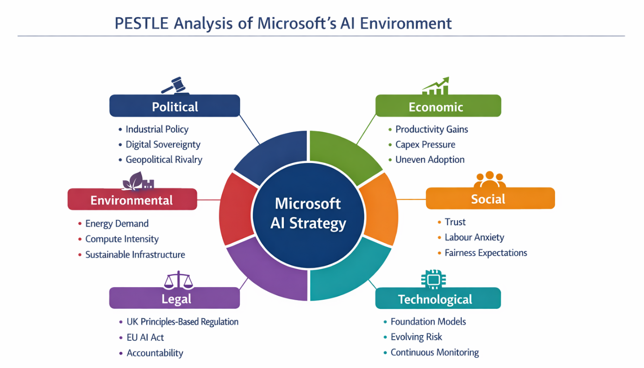
Figure 3. PESTLE Analysis of Microsoft’s AI Environment (Author)

2.3 Regulatory analysis: United Kingdom and European Union

2.3.1 The UK approach
The white paper by the UK Government in 2023 proposes a principles-based and context-oriented framework that is constructed around the concepts of safety, transparency, fairness, accountability and contestability (UK Government, 2023). There is no single AI regulator in the UK, as the task is shared by the current regulators, such as the ICO, CMA, FCA and Ofcom. This strategy has a couple of strengths towards Microsoft.
Uncertainty however comes with flexibilities. Since the implementation of the AI is decentralized, Microsoft has to track the manner in which various regulators define AI-related harms in practice. This can also complicate compliance especially when a product that is used in other sectors is used. The fact that a distributed regulatory model can be followed by capability and coordination problems is also depicted in the Department for Science, Innovation and Technology overview by the National Audit Office (National Audit Office, 2024). The UK thus provides agility, but not ease.

2.3.2 The EU approach
The EU AI act introduces a risk-based form, which is more formal. It differentiates prohibited uses, high-risk systems, limited-risk systems and minimal-risk systems, and assigns obligations like transparency, human oversight, conformity assessment, post-market monitoring and record keeping to the appropriate categories (European Parliament, 2024; European Commission, 2025). The big implication in the case of Microsoft is that governance must be auditable.
The AI Act is not a technical regulation, but rather an attempt to create a regime of governance over AI in Europe, enforceable (Veale and Borgesius, 2021). This is important as Microsoft is in multiple potential positions simultaneously, providing, deploying, and enabling platforms, depending on the service and use case. One of the complexities is multi-role exposure.
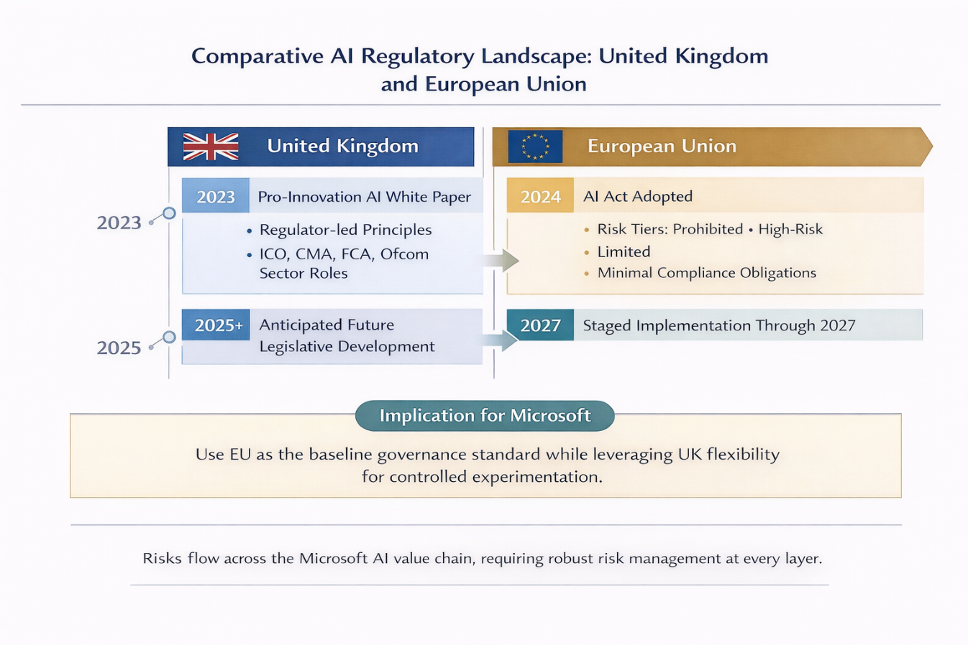
Figure 4. UK–EU AI Regulatory Comparison Timeline (Author)

2.3.3 Comparative implications for Microsoft
The reason why Microsoft will harmonise upwards comes in the Institutional Theory. Law exerts coercive pressure, professional expectations of trustworthy AI exert normative pressure and the convergence of large firms on similar governance models in uncertain environments is a phenomenon that generates mimetic pressure (DiMaggio and Powell, 1983). This is enhanced by Bradford in his Brussels Effect, which demonstrates that EU regulations frequently become workable international defaults to multinational companies since it is not efficient to work with different systems in different jurisdictions (Bradford, 2020). The ideal solution of Microsoft is thus to be the EU standard as the point of operation and the UK as the home of well-managed innovation.
Table 3. UK–EU regulatory comparison (UK Government, 2023; Bradford, 2020)
Dimension | United Kingdom | European Union | Implication for Microsoft
Regulatory style | Principles-based, regulator-led | Binding, risk-based legislation | Need unified governance with local adaptation
Core strength | Flexibility and innovation support | Clarity of formal obligations (Bradford, 2020). | Combine agility with auditable controls
Main challenge | Fragmented interpretation | High compliance and documentation burden | Centralised legal and risk coordination (UK Government, 2023).
Strategic use | Controlled experimentation | Enterprise baseline | Harmonise upward where feasible

2.4 Data governance and cross-border data management

2.4.1 Why data governance is central
Microsoft uses data governance as the operational heart of its AI risk profile since the quality, legality and trust of AI rely on the integrity of the data processes it relies on. The RFD guidance is right in focusing on purpose limitation, data lineage, consent management and cross-border transfers (Bilal et al., 2025). These issues are of particular concern to Microsoft, since it operates both enterprise and end-user data on a large scale in various jurisdictions. The problem of data governance should be seen not only as the legal one but as the question of fairness and responsibility as the quality of the structure of the informational environment (Floridi, 2021) according to the work about trustworthy AI and information ethics (Ai, 2019).

2.4.2 Data lineage, provenance and accountability
The governance issue facing Microsoft starts with being aware of what data is acquired where, why and under what control. Grubru et al. propose datasheet as a tool to promote transparency of the source, creation and purpose of data (Gebru et al., 2021). The same argument holds very much truth in the case of Microsoft because enterprise trust relies on the ability of the customers to distinguish among training data, telemetry, user prompt and generated output. In the absence of a definite lineage, explainability and accountability are diminished (Awadallah et al., 2024).
The own Responsible AI Standard established by Microsoft provides the governance structure, which consists of documentation, impact assessment and review (Microsoft Corporation, 2022).

2.4.3 Cross-border processing and the European Data Boundary
The UK-EU comparison has a cross-border data governance feature. The European Data Boundary and roadmap Microsoft has invested heavily into is a good indicator of trust and compliance to European enterprise customers (Microsoft Corporation, 2025d; Microsoft Corporation, 2026). The action will bring about a greater legitimacy to Microsoft since it will show that the company is sensitive to the concerns of sovereignty and locality. The fact that support, security, responding to incidents, and some of the processes operate, still complicate the cross-border governance, may remain a legal and practical challenge (Ai, 2019).
Table 4. Data governance risks for Microsoft (Microsoft Corporation, 2025d; Microsoft Corporation, 2026; Morley et al., 2021)
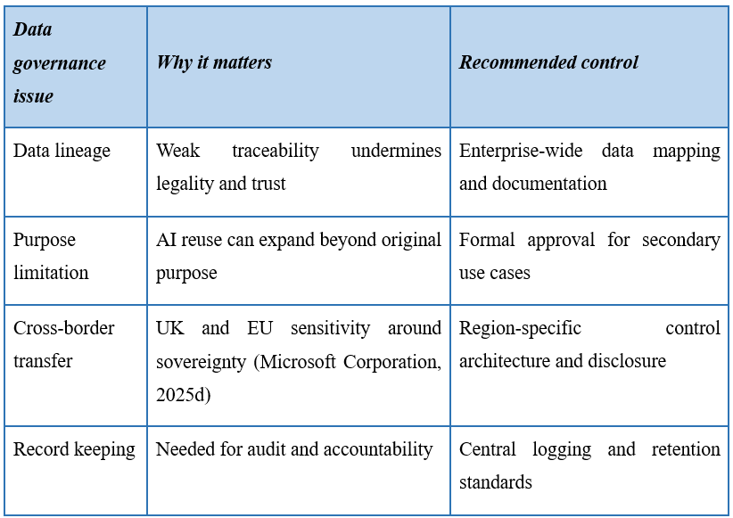

2.4.4 Strategic implication
The implication of the wider context is that data governance is to be managed as a competitive advantage. When customers are sure that the data processing is trackable, managed and contractually defendable, they will be more inclined to implement AI services of Microsoft. This is consistent with RBV as governance ability can even become valuable and difficult to copy when it is institutionalized into enterprise routines (Barney, 1991; Barney, Ketchen Jr and Wright, 2021).
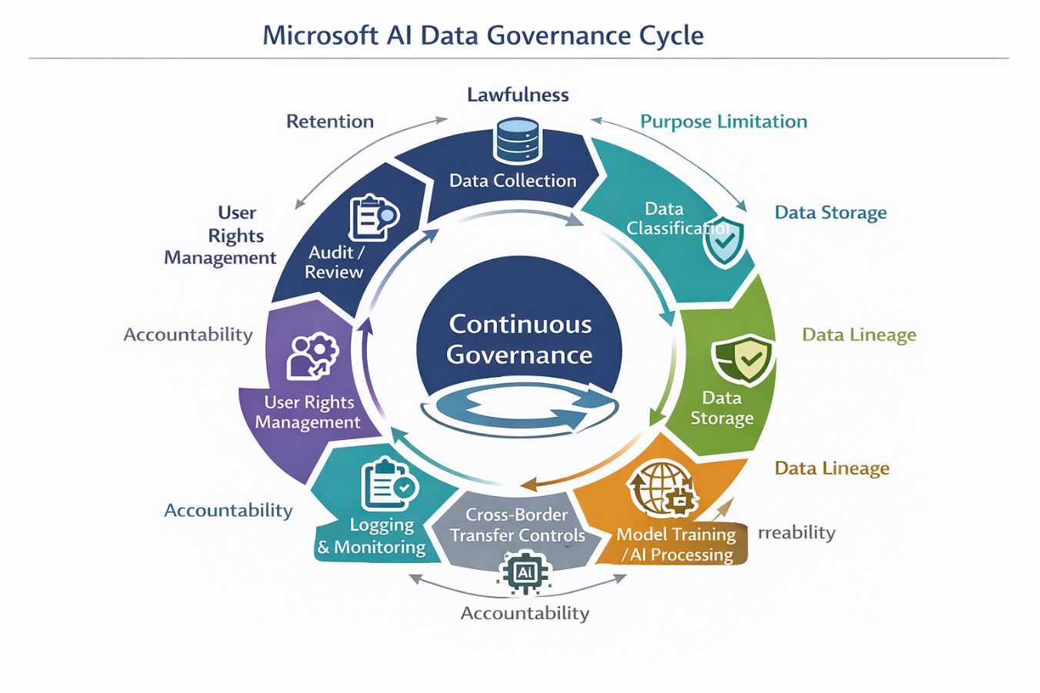
Figure 5. Microsoft AI Data Governance Cycle (Author)

2.5 Ethical AI, explainability and model risk

2.5.1 From principles to practice
Many organisations that proclaim AI principles is great; few of them apply it into practice (OECD, 2024). Morley et al. propose that the difficult AI governance transition is changing its focus to what principles ought to be to how they are operationalised (Morley et al., 2021). Official governance reports of Microsoft imply a significant shift towards this direction by impact evaluation, in-house guidelines, escalation channels and accountable artificial intelligence (Microsoft Corporation, 2022; Microsoft Corporation, 2024). But size renders it hard to do. A principle can be proclaimed at head-quarters, but risk is realised in local design decisions, product teams and customer deployments.
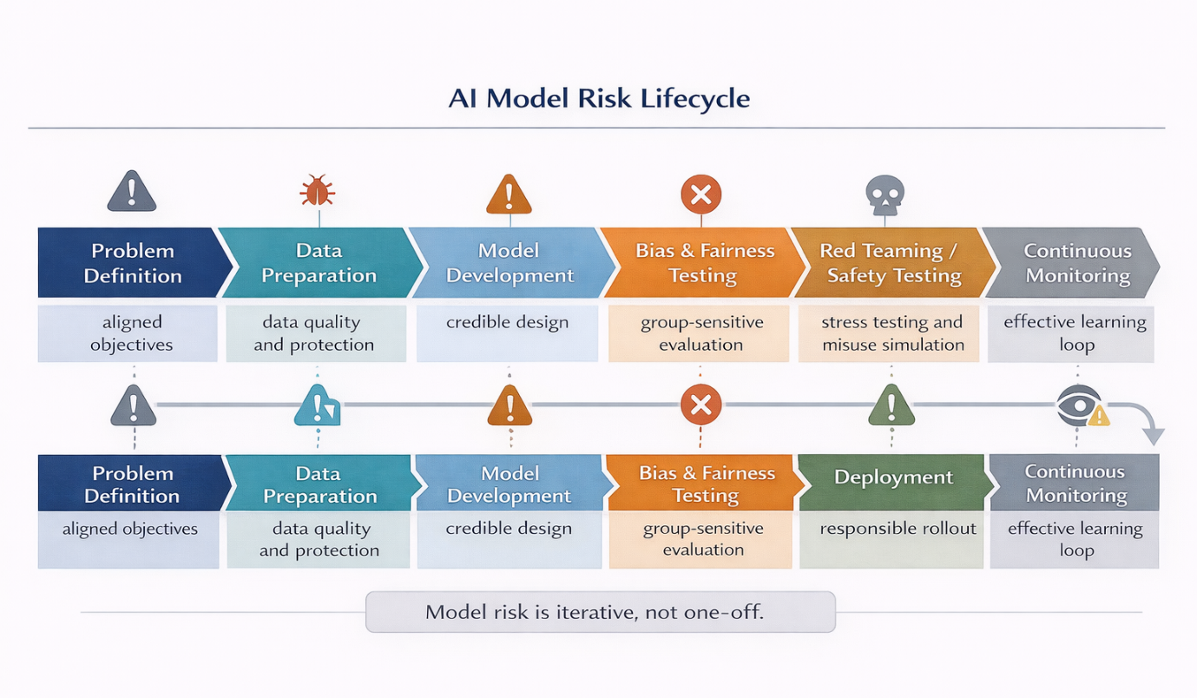
Figure 6. AI Model Risk Lifecycle (Author)

2.5.2 Bias, fairness and societal harm
The social inequality in the ethical literature on AI reiterates that the outputs of models can reproduce or enhance the social inequality when the data, purpose or implementation conditions are not optimal (Bender et al., 2021; Jobin et al., 2019). This is particularly significant to Microsoft since its tools are frequently employed in decision-support settings as opposed to being informational. Case-based studies in medicine and education also demonstrate that AI systems can be technically amazing and yet yield disproportionate results among groups unless fairness and contestability is designed in initially (Fabijan et al., 2024; Smith et al., 2024). Fairness in the case of Microsoft must therefore be product specific as opposed to generic.

2.5.3 Explainability, documentation and model transparency
There is a need to explain because when the outputs appear to be authoritative, they cannot be interpreted and cannot be challenged which diminishes trust. Wachter, Mittelstadt and Floridi dispute naive claims that legal regimes will inevitably see the existence of a full right to explanation, but their own analysis empowers and does not weaken the need to have effective accountability procedures (Wachter et al., 2017). Markus, Kors and Rijnbeek demonstrate that different strategies of explainability vary based on the context and the audience, which would be relevant in the case of Microsoft since the right level of explainability will vary across low-risk productivity tools, high-impact enterprise applications and regulated sector implementations (Markus et al., 2021).
The documentation tools (datasheets, model cards etc) are, therefore, not bureaucratic extensions but governance requirements. They help to clarify the purpose, limitations, assumptions and performance limits (Gebru et al., 2021). The significance of simple yet rigorous questioning prior to deployment is also supported by the fact that Biecek places an emphasis on performance, opaqueness, consequences and assumptions (Biecek, 2022).

2.5.4 Red-teaming, safety and misuse
The fact that Microsoft will report on its transparency in 2025 and that Bullwinkel et al. examined more than a hundred red-teaming products of generative AI indicate that safety assurance will be iterative (Microsoft Corporation, 2025c; Bullwinkel et al., 2025). Threats are dynamic especially when the models are connected to both the plugins and enterprise workflows or external data. Another study by Awadallah et al. shows that AI-related cyber risk is becoming more intricate and therefore, there is no necessity to differentiate between AI governance and security governance but rather, to combine them (Awadallah et al., 2024).
Table 5. Ethical AI and model-risk controls (Biecek, 2022; Awadallah et al., 2024)
Risk area | Key concern | Recommended Microsoft response
Bias and fairness | Uneven outcomes across users | Group-sensitive evaluation and escalation
Explainability | Opaque outputs undermine trust | Layered explanation for users and enterprise buyers (Biecek, 2022).
Documentation | Weak accountability trails | Mandatory model cards and data documentation
Safety and misuse | Dynamic attack and failure patterns | Pre-release and post-release red-teaming (Awadallah et al., 2024).
Human oversight | Overreliance on AI outputs | Human review in high-impact uses

2.6 Customer trust, stakeholder risk and competitive advantage

2.6.1 Trust as a strategic variable
Trust is not an ethical ideal, but a business requirement to implement AI in the business. Even the 2025 transparency reporting by Microsoft itself states that governance and ability to manage risks is a major barrier to scaling AI and organisations using responsible AI tools claim more privacy, confidence in decisions, reputation and trust (Microsoft Corporation, 2025c). It implies that the demand-side benefits of responsible AI are achievable, particularly in enterprise markets with procurement decisions being susceptible to legal and reputational risks.
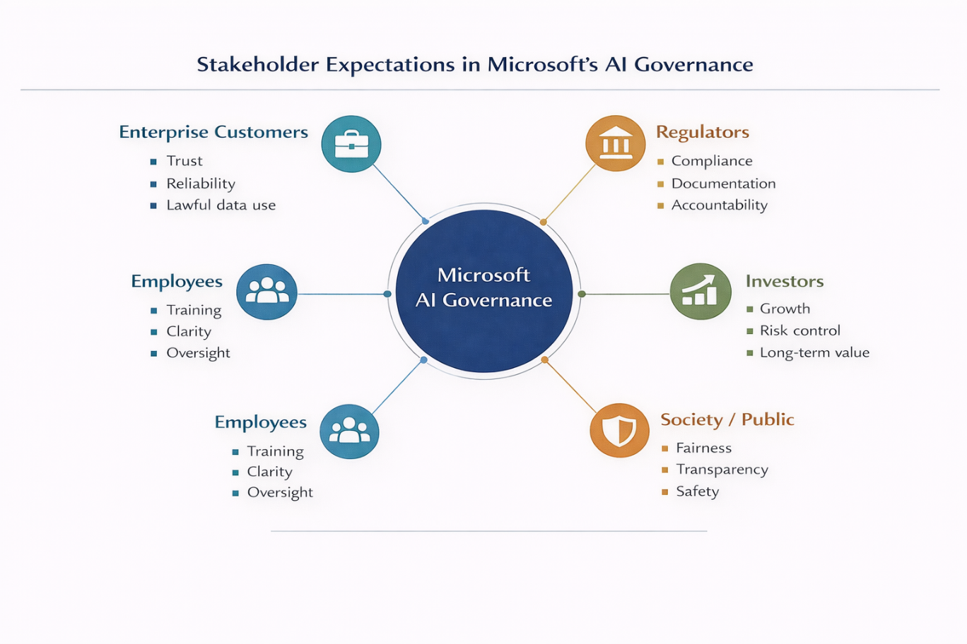
Figure 7. Stakeholder Map for Microsoft AI Governance (Author)

2.6.2 Stakeholder mapping
Stakeholder Theory offers a practical approach in this case. The customers would want to have quality products, lawful data processing and audit. The regulators want compliance, transparency and accountability. Workers want guidance, training and reasonable control of working process change. Investors would like to grow with unregulated downside risk. The expectations of the society at large are fairness and contestability (Freeman, 2010; Jones et al., 2016). The challenge that Microsoft faces is to strike the balance between these interests without falling into the realm of ambiguity of rhetoric.
Table 6. Stakeholder expectations in Microsoft’s AI ecosystem (Freeman, 2010; Jones et al., 2016)
Stakeholder | Main expectation | Risk if unmet
Enterprise customers | Trustworthy, controllable AI | Slower adoption, contract loss
Regulators | Compliance and documentation | Fines, investigations, restrictions (Freeman, 2010)
Employees | Clarity, training, governance | Internal misuse, resistance, errors
Investors | Growth with managed risk | Valuation pressure, governance concerns (Jones et al., 2016)
Wider society | Fairness, accountability, safety | Reputational damage and political backlash

2.6.3 Strategic implication
Strategically, this means that trust must be considered as a competitive advantage of Microsoft. This is in line with the RBV and the stakeholder theory: trust can maintain switching costs, customer retention and legitimacy but only when it is coupled with credible systems, and not branding.

2.7 Governance architecture and enterprise risk management

2.7.1 Why AI governance must sit within enterprise risk management
AI governance cannot be limited to product policy teams. It must be incorporated into the enterprise risk management since AI is affecting legal, operational, cyber, reputational and strategic risk simultaneously. The ISO 31000 and COSO ERM are still helpful as they focus on the integrated risk identification, assessment, treatment and review on the organisational level (De Oliveira et al., 2017; Dias, 2017; Efe, 2023). The applicability of NIST AI Risk Management Framework is particularly important since it can turn AI risk into the govern, map, measure and manage functions that can be aligned with the enterprise structure (NIST, 2023).

2.7.2 Board and executive oversight
AI risk cannot be hidden every now and again, Microsoft needs to ensure that AI risk is visible on the board through regular reporting (Efe, 2023). The board should be reported on high-impact AI systems, regulatory readiness, and trends of incidents and customer trust indicators quarterly. Legal, security, privacy, engineering and business leadership should be coordinated at executive level by a cross-functional AI Risk Council. The existing responsible AI models of Microsoft are a step forward, yet they are expanding in size and regulatory change would facilitate more effective integration with enterprise risk and internal audit (Microsoft Corporation, 2022; Microsoft Corporation, 2024).

2.7.3 Three-lines logic and maturity
Operational teams should maintain the first line of control, functional compliance and responsible-AI functions should challenge the second line of control, and internal audit/equivalent assurance functions should be the third line of control. Heger et al. show that organisational maturity in the responsible AI is such structural embedding as opposed to ad hoc review (Heger et al., 2025).
Table 7. Proposed AI governance architecture for Microsoft (Efe, 2023; Microsoft Corporation, 2022; Microsoft Corporation, 2024)
Governance level | Main role | Output
Board | Strategic oversight | Quarterly AI risk dashboard
Executive AI Risk Council | Coordination and escalation | Risk decisions and prioritization (Microsoft Corporation, 2024).
Product and engineering teams | First-line ownership | System design, testing, documentation
Legal, privacy, security, RAI functions | Second-line challenge | Reviews, approvals, controls (Microsoft Corporation, 2022; Microsoft Corporation, 2024).
Internal audit / assurance | Independent oversight | Periodic effectiveness review

2.8 Implementation plan

2.8.1 Phased execution logic
The implementation plan should provide responses to: who does, by when, measured how and at what cost. The reason is that a step-by-step plan is the most realistic and prioritises the plan as suggested in the RFD guide. Implementation should take the form of foundation, build and leadership over the twenty-four months by Microsoft.
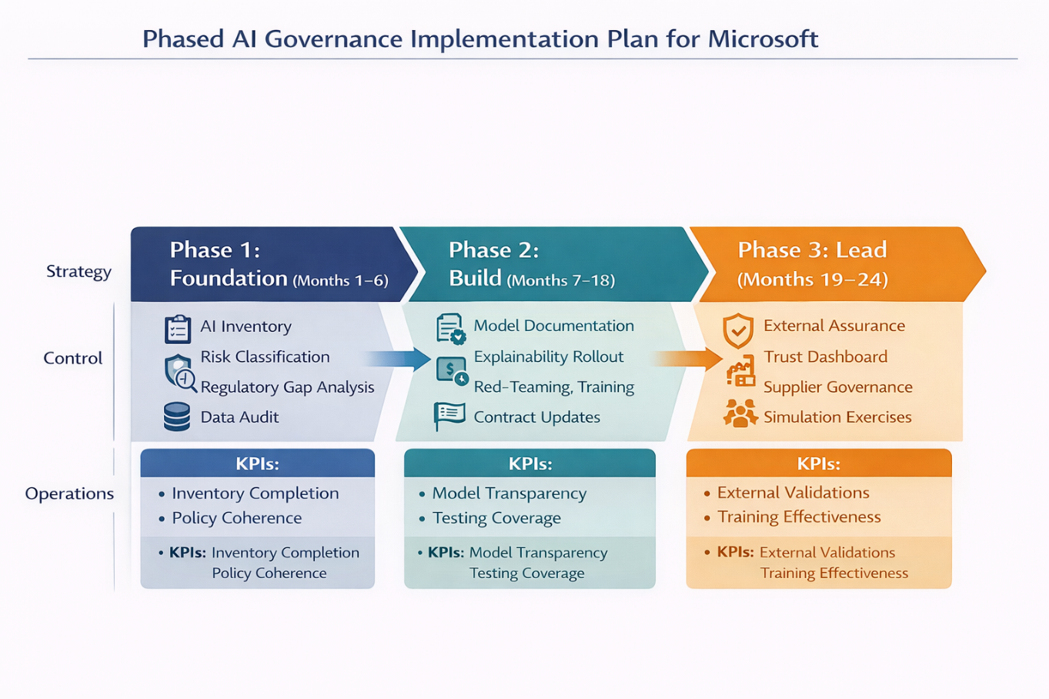
Figure 8. Phased AI Implementation Roadmap (Author)

2.8.2 Phase 1: Foundation, months 1–6
The first step should develop a complete AI inventory that comprises material systems of the Azure, Microsoft 365, GitHub, Dynamics and high-impact sector implementations. Each system should be designated with risk tier based on the logic of EU AI Act where applicable (Microsoft Corporation, 2024). The gap analysis of regulatory requirements is to map the current controls with UK and EU requirements. Audits of data must verify lineage, transfer routes and documentation (European Parliament, 2024). The most crucial KPI is the complete inventory coverage and risk categorization of all the material AI systems.

2.8.3 Phase 2: Build, months 7–18
The second phase should step up operational controls. High impact systems must be obligated with model cards, data sheets, impact assessment and red teaming. Explainability and human-oversight requirements must be implemented as part of design workflows by engineering teams. Increased risk services are supposed to be changed to customer-facing documentation and language of the contract. Legal, product, security and sales teams should be increased in staff training. Documentation and review coverage of relevant systems should be the main KPI of more than ninety per cent.

2.8.4 Phase 3: Lead, months 19–24
The last step must be that of assurance and external credibility. Microsoft is encouraged to release an extended trust and governance dashboard, full independent assurance to controls chosen, enhance supplier governance and carry out enterprise-wide incident tests. This is what converts maturity of internal control to market trust.
Table 8. Implementation plan (Elisov et al., 2025)
Phase | Timing | Main actions | KPI
Foundation | Months 1–6 | AI inventory, risk-tiering, regulatory gap analysis, data audit | 100% inventory of material AI systems
Build | Months 7–18 | Documentation, red-teaming, training, contract updates | 90%+ coverage of high-impact controls
Lead | Months 19–24 | External assurance, dashboard, simulations, supplier governance (Elisov et al., 2025). | Annual trust and assurance reporting completed

The tactical significance of the gradual strategy is that it is not a repeat mistake of thinking that AI governance is one policy measure. Rather, it sees governance as a dynamic capacity that is associated with life cycles of products, international regulation and market trust.

3. Conclusion
This report has argued that Microsoft’s AI strategy should be interpreted not simply as a story of technological leadership, but as a test of whether a multinational corporation can scale AI in a way that remains lawful, trustworthy and resilient across divergent regulatory and market environments (DiMaggio and Powell, 1983). The discussion shows that Microsoft is in a highly vulnerable position in the AI economy since it is both a cloud infrastructure provider and AI platforms and enterprise applications. The multi-layer status opens up significant business prospects, yet it increases the risk of regulatory attention, cross-border data issues, model risk, cyber-vulnerability and stakeholder mistrust. AI cannot be regulated as such a limited product matter then. It has to be enshrined as a part of enterprise risk management, board management, customer assurance, and international strategy (Barney, 1991; Porter, 1979; Microsoft Corporation, 2025a).
The comparison between the UK and the EU has revealed that Microsoft has two different yet related governance environments. The UK has a more flexible, principles-based and regulator-oriented model that can potentially aid innovation and quicker experimentation, the AI Act in the EU introduces a more formal and binding framework, which relies on risk categories, documentation, human oversight and accountability requirements (UK Government, 2023; European Parliament, 2024). In the case of Microsoft, the most effective strategic response is to implement an EU-compatible governance baseline but with UK flexibility to allow innovation under strict control. This practice aligns with institutional pressure, stakeholder expectation and the rationality of the Brussels Effect, according to which big multinational companies tend to harmonise upwards and do not have fragmented compliance systems by region (DiMaggio and Powell, 1983; Bradford, 2020).
The report further concludes that AI scale is not necessarily the greatest future competitive advantage of Microsoft, but the trustworthiness of its governance capability. Regulatory and reputational downside can be minimized with effective AI inventory, risk-tiering, data-lineage control, explainability, red-teaming, stakeholder communication and board-level oversight can be enhanced, and customer confidence and long-term value creation increased. By aligning the governance maturity with the rate of the AI growth, Microsoft will be able to reinforce its role as a strong technology firm as well as a reliable multinational leader in the upcoming stage of AI-driven global business (Floridi, 2021; Microsoft Corporation, 2025c; Bullwinkel et al., 2025).

Reference List
Ai, H. (2019) High-level expert group on artificial intelligence. Ethics guidelines for trustworthy AI, 6(15.3), 2024.
Awadallah, A., Eledlebi, K., Zemerly, M. J., Puthal, D., Damiani, E., Taha, K., et al. (2024) ‘Artificial intelligence-based cybersecurity for the metaverse: Research challenges and opportunities’, IEEE Communications Surveys and Tutorials, 27(2), pp. 1008–1052.
Barney, J. (1991) ‘Firm resources and sustained competitive advantage’, Journal of Management, 17(1), pp. 99–120.
Barney, J. B., Ketchen Jr, D. J. and Wright, M. (2021) ‘Resource-based theory and the value creation framework’, Journal of Management, 47(7), pp. 1936–1955.
Bender, E. M., Gebru, T., McMillan-Major, A. and Shmitchell, S. (2021) ‘On the dangers of stochastic parrots: Can language models be too big?’, in Proceedings of the 2021 ACM Conference on Fairness, Accountability, and Transparency, pp. 610–623.
Biecek, P. (2022) ‘Performance, opaqueness, consequences, and assumptions: Simple questions for responsible planning of machine learning solutions’, arXiv preprint, arXiv:2208.09966.
Bilal, M., Raza, M., Altherwy, Y., Alsuhaibani, A., Abduljabbar, A., Almarshad, F., et al. (2025) ‘Foundation models in computational pathology: A review of challenges, opportunities, and impact’, arXiv preprint, arXiv:2502.08333.
Bommasani, R., Hudson, D. A., Adeli, E., Altman, R., Arora, S., von Arx, S., et al. (2021) ‘On the opportunities and risks of foundation models’, arXiv preprint, arXiv:2108.07258.
Bradford, A. (2020) The Brussels Effect: How the European Union Rules the World. Oxford: Oxford University Press.
Brynjolfsson, E., Li, D. and Raymond, L. (2025) ‘Generative AI at work’, The Quarterly Journal of Economics, 140(2), pp. 889–942.
Bullwinkel, B., Minnich, A., Chawla, S., Lopez, G., Pouliot, M., Maxwell, W., et al. (2025) ‘Lessons from red teaming 100 generative AI products’, arXiv preprint, arXiv:2501.07238.
Cerutti, E., Cerutti, M. E. M., Pascual, A. I. G., Kido, Y., Li, L., Melina, M. G., et al. (2025) The Global Impact of AI: Mind the Gap. International Monetary Fund.
Dalirazar, S. and Sabzi, Z. (2023) ‘Strategic analysis of barriers and solutions to development of sustainable buildings using PESTLE technique’, International Journal of Construction Management, 23(1), pp. 167–181.
De Oliveira, U. R., Marins, F. A. S., Rocha, H. M. and Salomon, V. A. P. (2017) ‘The ISO 31000 standard in supply chain risk management’, Journal of Cleaner Production, 151, pp. 616–633.
Dell'Acqua, F., McFowland III, E., Mollick, E. R., Lifshitz-Assaf, H., Kellogg, K., Rajendran, S., et al. (2023) ‘Navigating the jagged technological frontier: Field experimental evidence of the effects of AI on knowledge worker productivity and quality’, Harvard Business School Technology and Operations Mgt. Unit Working Paper, 24-013.
Dias, A. A. D. S. P. (2017) ‘A more effective audit after COSO ERM 2017 or after ISO 31000: 2009?’, Revista Perspectiva Empresarial, 4(2), pp. 73–82.
DiMaggio, P. J. and Powell, W. W. (1983) ‘The iron cage revisited: Institutional isomorphism and collective rationality in organizational fields’, American Sociological Review, 48(2), pp. 147–160.
Efe, A. (2023) ‘A comparison of key risk management frameworks: COSO-ERM, NIST RMF, ISO 31000, COBIT’, Denetim ve Güvence Hizmetleri Dergisi, 3(2), pp. 185–205.
Elisov, M., Pshinnik, K., Bordunos, A. and Zhirosh, O. (2025) Generative AI and Potential for Augmentation: A Data-Driven Analysis of Labor Market in Russia.
European Commission (2025) AI regulatory framework publication. Available at: https://op.europa.eu/en/publication-detail/-/publication/d79f3e5d-41bc-11f0-b9f2-01aa75ed71a1/language-en (Accessed: 16 April 2026).
European Parliament (2024) Artificial Intelligence Act. Available at: https://artificialintelligenceact.eu/wp-content/uploads/2024/04/TA-9-2024-0138_EN.pdf (Accessed: 16 April 2026).
Fabijan, A., Zawadzka-Fabijan, A., Fabijan, R., Zakrzewski, K., Nowosławska, E. and Polis, B. (2024) ‘Assessing the accuracy of artificial intelligence models in scoliosis classification and suggested therapeutic approaches’, Journal of Clinical Medicine, 13(14), p. 4013.
Floridi, L. (2021) ‘Establishing the rules for building trustworthy AI’, in Ethics, Governance, and Policies in Artificial Intelligence. Cham: Springer International Publishing, pp. 41–45.
Freeman, R. E. (2010) Strategic Management: A Stakeholder Approach. Cambridge: Cambridge University Press.
Gebru, T., Morgenstern, J., Vecchione, B., Vaughan, J. W., Wallach, H., III, H. D. and Crawford, K. (2021) ‘Datasheets for datasets’, Communications of the ACM, 64(12), pp. 86–92.
Heger, A. K., Passi, S., Dhanorkar, S., Kahn, Z., Wang, R. and Vorvoreanu, M. (2025) ‘Towards a responsible AI organizational maturity model’, Proceedings of the ACM on Human-Computer Interaction, 9(7), pp. 1–33.
Hofstede, G. (2011) ‘Dimensionalizing cultures: The Hofstede model in context’, Online Readings in Psychology and Culture, 2(1), p. 8.
Information Commissioner’s Office (ICO) (2023) Explaining decisions made with artificial intelligence. Available at: https://ico.org.uk/for-organisations/uk-gdpr-guidance-and-resources/artificial-intelligence/explaining-decisions-made-with-artificial-intelligence/ (Accessed: 16 April 2026).
Jobin, A., Ienca, M. and Vayena, E. (2019) ‘The global landscape of AI ethics guidelines’, Nature Machine Intelligence, 1(9), pp. 389–399.
Jones, D., Florentino, H., Cantane, D. and Oliveira, R. (2016) ‘An extended goal programming methodology for analysis of a network encompassing multiple objectives and stakeholders’, European Journal of Operational Research, 255(3), pp. 845–855.
Leslie, D. (2019) Understanding Artificial Intelligence Ethics and Safety. arXiv preprint, arXiv:1906.05684.
Markus, A. F., Kors, J. A. and Rijnbeek, P. R. (2021) ‘The role of explainability in creating trustworthy artificial intelligence for health care: A comprehensive survey of the terminology, design choices, and evaluation strategies’, Journal of Biomedical Informatics, 113, p. 103655.
McKenna, E. (2020) Business Psychology and Organizational Behaviour. Abingdon: Routledge.
McKinsey and Company (2025) The state of AI: How organizations are rewiring to capture value. Available at: https://www.mckinsey.com/~/media/mckinsey/business%20functions/quantumblack/our%20insights/the%20state%20of%20ai/2025/the-state-of-ai-how-organizations-are-rewiring-to-capture-value_final.pdf (Accessed: 16 April 2026).
Microsoft Corporation (2022) Microsoft Responsible AI Standard: General Requirements. Available at: https://cdn-dynmedia-1.microsoft.com/is/content/microsoftcorp/microsoft/final/en-us/microsoft-brand/documents/Microsoft-Responsible-AI-Standard-General-Requirements.pdf (Accessed: 16 April 2026).
Microsoft Corporation (2024) Governing AI: A blueprint for the future. Available at: https://cdn-dynmedia-1.microsoft.com/is/content/microsoftcorp/microsoft/msc/documents/presentations/CSR/Governing-AI-A-Blueprint-for-the-Future.pdf (Accessed: 16 April 2026).
Microsoft Corporation (2025) Annual Report 2025. Available at: https://www.microsoft.com/investor/reports/ar25/index.html (Accessed: 16 April 2026).
Microsoft Corporation (2025) Form 10-K Annual Report. Available at: https://www.sec.gov/Archives/edgar/data/789019/000095017025100235/msft-20250630.htm (Accessed: 16 April 2026).
Microsoft Corporation (2025) Microsoft’s EU Data Boundary: Roadmap and compliance milestones. Available at: https://cdn-dynmedia-1.microsoft.com/is/content/microsoftcorp/microsoft/final/en-us/microsoft-product-and-services/security/pdf/empowering-europe-microsofts-eu-data-boundary-roadmap-and-compliance-milestones_20256-02-26.pdf (Accessed: 16 April 2026).
Microsoft Corporation (2025) Responsible AI Transparency Report 2025. Available at: https://cdn-dynmedia-1.microsoft.com/is/content/microsoftcorp/microsoft/msc/documents/presentations/CSR/Responsible-AI-Transparency-Report-2025-vertical.pdf (Accessed: 16 April 2026).
Microsoft Corporation (2026) European Data Boundary for the EU. Available at: https://www.microsoft.com/en/trust-center/privacy/european-data-boundary-eudb (Accessed: 16 April 2026).
Mintzberg, H. (2017) ‘Crafting strategy’, in The Aesthetic Turn in Management. Abingdon: Routledge, pp. 477–486.
Morley, J., Floridi, L., Kinsey, L. and Elhalal, A. (2021) ‘From what to how: An initial review of publicly available AI ethics tools, methods and research to translate principles into practices’, in Ethics, Governance, and Policies in Artificial Intelligence. Cham: Springer International Publishing, pp. 153–183.
National Audit Office (2024) Department for Science, Innovation and Technology: Overview 2023–24. Available at: https://www.nao.org.uk/wp-content/uploads/2024/11/dsit-overview-2023-24.pdf (Accessed: 16 April 2026).
National Institute of Standards and Technology (2023) AI Risk Management Framework. Available at: https://nvlpubs.nist.gov/nistpubs/ai/nist.ai.100-1.pdf (Accessed: 16 April 2026).
OECD (2024) OECD AI Principles. Available at: https://www.oecd.org/en/topics/sub-issues/ai-principles.html (Accessed: 16 April 2026).
Porter, M. E. (1979) ‘How competitive forces shape strategy’, in Readings in Strategic Management. London: Macmillan Education UK, pp. 133–143.
Rastogi, N. and Trivedi, M. K. (2016) ‘PESTLE technique–a tool to identify external risks in construction projects’, International Research Journal of Engineering and Technology (IRJET), 3(1), pp. 384–388.
Smith, J. M., Williamson, J. and McGill, M. (2024) ‘Equity implications of using AI tools in the college admissions process’, in AI for Education: Bridging Innovation and Responsibility at the 38th AAAI Annual Conference on AI.
UK Government (2023) A pro-innovation approach to AI regulation. Available at: https://assets.publishing.service.gov.uk/media/64cb71a547915a00142a91c4/a-pro-innovation-approach-to-ai-regulation-amended-web-ready.pdf (Accessed: 16 April 2026).
Veale, M. and Borgesius, F. Z. (2021) ‘Demystifying the draft EU artificial intelligence act’, arXiv preprint, arXiv:2107.03721.
Wachter, S., Mittelstadt, B. and Floridi, L. (2017) ‘Why a right to explanation of automated decision-making does not exist in the general data protection regulation’, International Data Privacy Law, 7(2), pp. 76–99.
World Economic Forum (2026) Global Risks Report 2026. Available at: https://reports.weforum.org/docs/WEF_Global_Risks_Report_2026.pdf (Accessed: 16 April 2026).
Yousefi, F., Dehnavieh, R., Laberge, M., Haghdoost, A., Sasseville, M., Hekmat, S. N., et al. (2026) ‘Integrating artificial intelligence (AI) in primary health care (PHC) systems: A framework-guided comparative qualitative study’, in Healthcare, 14(2), p. 145.

