BA (Hons) Business Management
Module Code: LCBB6000 – Dissertation
Assignment Title: Research Proposal

Research Title: The Impact of Leadership Styles on Employee Motivation and Organisational Productivity: A Study of the UK Retail Sector

Student Name: Mihaela Ruxandra Iancu
Student ID: :2133740

Table of Contents
1. Introduction and Preliminary Planning 3
Background and Context 3
Problem Statement 3
Aim 3
Objectives 3
Research Questions 4
Justification and Rationale 4
Structure Overview 4
2. Literature Review 4
Key Leadership Theories 4
Motivation Theories 5
Group Leadership and Organisational Productivity. 6
UK Retail-Specific Findings 6
Gap in Knowledge 6
3. Methodology 7
Research Design 7
Research Philosophy 7
Research Approach 7
Research Method 7
Justification for Secondary Data 8
Data Collection Method 8
Data Sources 8
Data Analysis Strategy 9
Ethics and Limitations 9
4. Timeline (Gantt Chart) 9
5. References 10

1. Introduction and Preliminary Planning

Background and Context
The UK retail industry is among the largest private sector employers with almost 10 percent of the total number of employees (ONS, 2023). Nonetheless, it experiences the same issue of operational problems and working forces such as high employee turnover, poor employee engagement, and challenges to sustain the productivity in an environment that is changing rapidly (CIPD, 2022). Leadership is a key factor in such a situation. This means that the leadership style employees of the retail use can directly affect the level of motivation and the effectiveness of employees working in the retail sector, where the success of a retail is most measurable. However, several organisations find it hard to embrace leadership styles that can keep up with the demands of a contemporary workforce that is usually diverse and par-time (Forbes, 2023).

Problem Statement
Although people have greatly accepted the importance of leadership in business success, there is a huge knowledge gap of how various leadership styles directly influence employee motivation and organisational productivity in the retail environment. Most of the academic research extrapolates the results to other industries or studies the large corporate setting, but little has done so in the retail field and particularly in non-executive, customer-facing jobs. In addition, although some leadership models are discussed extensively in management training, little has been done to evaluate how they perform in the real pressures of retail work using sector-specific data.

Aim
To examine the effects of the various leadership styles on the motivation level and the organisational output in the retail industry in UK through the secondary data sources.

Objectives
- To establish the most prevalent leadership styles in the UK retail businesses.
- To evaluate the effect of every leadership style on employee motivation based on the existing studies.
- To test the relationship between employee motivation and organisational productivity results.
- To determine the leadership practices that are viewed as the most effective in the retail setting.

Research Questions
- What do the prevailing leadership styles currently used in UK retail organisations look like?
- What do recent research studies reveal about the effects of each style on employee motivation?
- How is employee motivation correlated with employee productivity in retailing?
- What leadership styles can be most effective to enhance motivation and performance?

Justification and Rationale
This study has scholarly and real-life significance. In the academic scene, it adds to the scanty corpus of sector-specific leadership research, especially on the topic of employee motivation. In practice, the results may be used to assist HR professionals, store managers, and business leaders in retail to make changes to the leadership development programs and implement styles that are closer to the realities of their employees. These insights are timely and actionable in a period of post-pandemic recovery and staffing shortage and productivity pressure (McKinsey and Company, 2023).

Structure Overview
This proposal goes on by reviewing literature available, explaining the methodology in detail with the use of secondary data, a timeline of the project and reference list in the Harvard style.

2. Literature Review

Key Leadership Theories
Transformational leadership theories have been acclaimed to be effective in increasing motivation by way of vision and inspiration. This model seems to be much applicable in the UK retail sector where the underpaid and unappreciated frontline workers can be found to work in most cases, since it focuses on personal recognition and growth (Bass, 1985) As it is critically understood though, the speed and turnover nature of the retail structure might restrict the effectiveness of its implementation as leaders may not have time to mentor or thoroughly train the personnel (Retail Week, 2023).
On the contrary, a transactional leadership, where rewards and penalties are used, is widespread in retail since it revolves around KPI achievement (Iqbal et al., 2020). Although this may enhance in the short term productivity, in the long run this hardly enhances motivation. More importantly, it can even result in disengagement where targets are placed on employee wellbeing too big to handle, which recent CIPD (2022) reports on staff burnout in UK stores have raised concerns about.
Situational leadership and servant leadership also offer some insights. The frontline retail challenges are also in line with servant leadership, which focuses on empathy and employee needs (Eva et al., 2019). Nevertheless, it is not commonly applied when working in big retail chains where middle managers do not always have freedom. Situational leadership can be more appropriate to retail because of the high frequency of role rotation and mixed experience but the model presupposes the flexibility of the leadership that is often limited by strict corporate hierarchies in the UK retail (Yukl, 2017).
Transformational leadership is theory but difficult in the context of the UK retail because of time and resource scarcity. Transactional leadership fits performance based environment but might decrease motivation. Servant leadership has potential that is not adopted. Both theories are useful, but their application to the situation in retail needs to be looked at more closely.

Motivation Theories
The Two-Factor Theory by Herzberg has been frequently used in the retail sector to draw the line between hygiene (pay, security) and motivators (growth, recognition). The given theory is particularly applicable to UK retail where low wages are widespread, and yet workers still require some meaning and motivation in their jobs (Alshammari et al., 2020). Its critics, however, claim it simplifies the emotional needs of customer-facing jobs, the motivation of which also depends on the support of managers and organisational culture (CIPD, 2022).
Self-Determination Theory (SDT) would also prove helpful since it puts special emphasis on autonomy, competence, and relatedness as the key motivating factors (Deci and Ryan, 2000). SDT demonstrates potential in UK retail as the authors may believe that a particular leadership style such as transformational or servant may be improved to boost motivation by providing the staff with increased control and emotional support. Nevertheless, the theory presupposes a low minimum of managerial support that is not always present in all the understaffed or overstretched retail stores.
The theory of Herzberg is applicable to the retail industry that is concerned with salary and recognition, whereas Self-Determination Theory could provide a better understanding of motivation in the long perspective. Nevertheless, the focus on autonomy of SDT is usually impractical in the inflexible retailing positions.

Group Leadership and Organisational Productivity.
It is evident that leadership style has an influence on organisational outcomes. Higher engagement and performance relate to transformational leadership (Afsar et al., 2019). However, it is inconsistent in the case of the UK retail. According to a McKinsey (2023) report, only 30% of UK retail workers are inspired by their managers but this is not according to theory.
Transactional leadership can also increase productivity in the short run but can increase turnover - which has been long-term problem in the UK retail market with annual turnover of more than 60 percent in some chains (ONS, 2023). Research such as Judge and Piccolo (2004) demonstrates that this style is not resonant with emotions, and that is getting more significant with younger employees.

UK Retail-Specific Findings
The UK retailing labour force is distinctive as it is younger, more diverse, and more part-time than the majority of industries (CIPD, 2022). Motivation is frail because of the high customer demand, low wages, and career prospects. Although the role of leadership is paramount, most of the UK retail managers do not receive any formal training in motivational theory, and in most cases they have transactional habits because of sales targets (KPMG, 2021).
According to recent reports by CIPD (2022) and Retail Week (2023), stores with more transformational or people-first leadership experience higher retention rates of staff and consumer satisfaction but tend to resort to command-and-control leadership.

Gap in Knowledge
Although theory clearly connects leadership style and motivation and productivity, majority of the studies are done in general or corporate setting. The secondary research on the UK retail sector, in particular, utilisation of actual industry data, is minimal. Moreover, there are not many studies that examine leadership, motivation and productivity as a single perspective - a composite perspective that this study will strive to develop based on valid secondary data.
The theories reviewed present the basis of answering the research questions. RQ1 and RQ2 are directly informed by leadership models such as transformational and transactional because they describe the influence of the various styles on motivation. The theories of motivation justify RQ2 and RQ3 because they find out the motivation to engage in retail. Collectively, these frameworks inform the study on whether leadership in UK retail any positive contribution on both employee motivation and organisational productivity has as examined in secondary data.

3. Methodology

Research Design
This study has an explanatory design where the researcher seeks to find out the effects of leadership styles on the motivation of employees and organisational productivity in the UK retail industry. The explanatory design suits well since the aim is not to explain only the leadership practices, but to search cause-and-effect relationships between leadership, motivation, and performance by utilizing the available real-life data (Saunders et al., 2019).

Research Philosophy
The study is based on a positivist philosophy, which presupposes that reality is objective and quantifiable. Positivism is also applicable when the study is based on empirical, observable data, e.g., published reports in the industry, HR analytics, and extensive surveys (Bryman, 2016). The positivist position is used because the research employs secondary data due to the credibility of the materials employed such as the government databases, consultancy whitepapers and peer-reviewed research, which would provide consistency and replicability in the interpretation of findings.

Research Approach
The study is deductive, basing itself on the known theories (including transformational and transactional leadership theories, motivation theories like the one offered by Herzberg or SDT) and conducting a test against the available data in the UK retail sector. The idea here is to evaluate the existence of the anticipated relationships, such as the enhancement of motivation through transformational leadership, with actual secondary evidence. A deductive approach is also useful in generalising throughout the retail sector, which is a major objective of this proposal (Collis and Hussey, 2017).

Research Method
The study will utilize a qualitative secondary methodology whereby the existing credible sources will be used in examining how leadership styles determine motivation and productivity of employees in the UK retail sector. The secondary data is suitable because there are industry reports, scholarly researches, and statistical records that offer general information about various organisations.

Justification for Secondary Data
Primary data collection was also taken into consideration but was excluded because of time constraints, the barriers to accessibility as well as ethical considerations. Direct access to retail staff/managers, to interview them, would take a long time to get the approvals and would also create practical delays. On the contrary, the secondary sources present a forte of data which can be analysed within the project time span. They also enable cross company comparisons, and therefore, the results can be generalised.

Data Collection Method
The research is based on secondary data alone, and no primary data collection is done. Secondary sources include:
- Journal articles (databases such as JSTOR, EBSCO, Google Scholar) of this type will be peer-reviewed and included.
- State and governmental data (e.g. ONS, Gov.uk employment reports).
- Reports of the industry (e.g. CIPD, McKinsey, PwC, KPMG).
- Company reports (e.g. reports on leadership strategies in the main UK retailers).
- Trade magazines (e.g. Retail Week, Forbes, Harvard Business Review).
.

Data Sources
The research uses secondary data only, focusing on high-quality, credible sources published from 2017 onwards. No primary interviews or surveys will be conducted. Data will be collected from:
- CIPD Reports – e.g. Good Work Index, Leadership Development in Retail
- ONS (Office for National Statistics) – e.g. labour productivity, turnover rates in retail
- Retail Week – case studies and leadership trend reports in UK retail
- McKinsey & Company – State of Retail 2023 (UK-focused leadership and productivity analysis)
- PwC – UK Retail Outlook, with insights into operational leadership practices
- Company Reports – e.g. Tesco, Marks & Spencer, Sainsbury’s sustainability and workforce strategy reports
- Academic Journals – Peer-reviewed studies from The Leadership Quarterly, Journal of Retailing, Human Resource Management Journal

Data Analysis Strategy
Thematic content analysis will be used to review data where patterns are identified and correspond to the research questions. Such themes will comprise description of leadership style, employee responses and performance outcomes. Differences between retailers will enhance validity of results.

Ethics and Limitations
The research will be conducted at the level of academic integrity through the usage of the public and the properly cited sources only. It has limitations such as the use of third party interpretations and lack of direct employee voice. The variety of sources and reputable sources eliminates this risk, however.

4. Timeline (Gantt Chart)
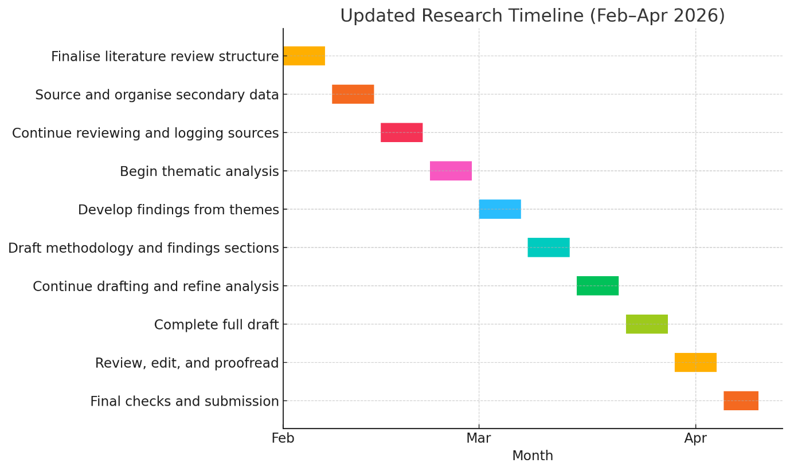
The study will be carried out between February and April 2026. February will be devoted to the literature review and sourcing secondary data. March will entail writing and analysis. The submission, editing and the final draft shall be done by early April. The overlap of the tasks is minimal to guarantee consistent development over the brief period (10 weeks).

5. References
Afsar, B., Cheema, S. and Javed, F. (2019) ‘Transformational leadership and innovative work behavior: The role of motivation and commitment’, Journal of Business Research, 92, pp. 1–13.
Alshammari, F.S., Almutairi, N.S. and Alshammari, L.F. (2020) ‘Application of Herzberg's Two-Factor Theory in assessing and enhancing employee motivation: A case study’, International Journal of Human Resource Studies, 10(3), pp. 172–183.
Bryman, A. (2016) Social Research Methods. 5th edn. Oxford: Oxford University Press.
CIPD (2022) Good Work Index 2022: Job quality in the UK. London: Chartered Institute of Personnel and Development. Available at: https://www.cipd.org/uk/knowledge/reports/good-work-index/ (Accessed: 21 October 2025).
Collis, J. and Hussey, R. (2017) Business Research: A Practical Guide for Undergraduate and Postgraduate Students. 4th edn. London: Palgrave Macmillan.
Deci, E.L. and Ryan, R.M. (2000) ‘The “what” and “why” of goal pursuits: Human needs and the self-determination of behavior’, Psychological Inquiry, 11(4), pp. 227–268.
Eva, N., Robin, M., Sendjaya, S., van Dierendonck, D. and Liden, R.C. (2019) ‘Servant leadership: A systematic review and call for future research’, The Leadership Quarterly, 30(1), pp. 111–132.
Forbes (2023) Why Great Leadership Is Non-Negotiable In Retail Recovery. Available at: https://www.forbes.com/sites/forbesbusinesscouncil/2023/04/20/why-great-leadership-is-non-negotiable-in-retail/(Accessed: 18 October 2025).
Gagné, M., Deci, E.L. and Ryan, R.M. (2018) ‘Self-determination theory applied to work motivation and organizational behavior’, in Ryan, R.M. (ed.) The Oxford Handbook of Human Motivation. 2nd edn. Oxford: Oxford University Press, pp. 297–317.
Iqbal, N., Anwar, S. and Haider, N. (2020) ‘Effect of leadership style on employee performance’, Journal of Business and Management, 22(1), pp. 21–29.
Judge, T.A. and Piccolo, R.F. (2004) ‘Transformational and transactional leadership: A meta-analytic test of their relative validity’, Journal of Applied Psychology, 89(5), pp. 755–767.
KPMG (2021) Navigating Retail Challenges: UK Consumer Outlook. Available at: https://home.kpmg/uk/en/home/insights/2021/10/navigating-retail-challenges.html (Accessed: 27 October 2025).
McKinsey & Company (2023) State of Retail Report 2023: Rethinking Leadership Post-COVID. Available at: https://www.mckinsey.com/industries/retail/our-insights/state-of-retail-report-2023 (Accessed: 22 October 2025).
Newman, A., Le, H., North-Samardzic, A. and Cohen, M. (2020) ‘The effects of servant leadership on followers’ job performance: The mediating role of work engagement’, Journal of Business Ethics, 156(3), pp. 681–695.
Ng, T.W.H. (2017) ‘Transformational leadership and performance outcomes: Analyses of multiple mediation pathways’, The Leadership Quarterly, 28(3), pp. 385–417.
ONS (2023) Retail Employment in the UK: Labour Market Overview, July 2023. London: Office for National Statistics. Available at: https://www.ons.gov.uk (Accessed: 25 October 2025).
PwC (2023) UK Retail Outlook 2023: Resetting for the Future. Available at: https://www.pwc.co.uk/industries/retail-consumer/insights/uk-retail-outlook-2023.html (Accessed: 24 October 2025).
Retail Week (2023) Leadership in Crisis: What’s Holding Retail Back? Available at: https://www.retail-week.com/leadership-in-crisis-report-2023 (Accessed: 20 October 2025).
Rigby, C.S. and Ryan, R.M. (2018) ‘Self-determination theory in human resource development: New directions and practical considerations’, Advances in Developing Human Resources, 20(2), pp. 133–147.
Saunders, M., Lewis, P. and Thornhill, A. (2019) Research Methods for Business Students. 8th edn. Harlow: Pearson Education.
Warrick, D.D. (2017) ‘What leaders can learn about teamwork and developing high performance teams from organization development practitioners’, Performance Improvement, 56(3), pp. 13–21.
Yukl, G. (2017) Leadership in Organizations. 9th edn. Harlow: Pearson.

