International Business

Student Name: Vladimir Rebrik
Student Number: (1914780)
Assignment Title: International Business
Module Code: (LCMB7014)
Lecturer: Dr Hossein Shokri

Table of Contents

Table of Contents........................................................................................................2
1. Introduction ............................................................................................................3
2. Company background.............................................................................................4
3. Vodafone objectives and strategies........................................................................4
4. Countries specifications...........................................................................................4
5. External analysis......................................................................................................5
6. Country risks............................................................................................................9
7. Value and supply chains.......................................................................................10
7. Internal analysis.....................................................................................................14
8. International strategies...........................................................................................15
9. Vodafone Germany entry modes...........................................................................17
10. Corporate social responsibility..............................................................................18
11. Conclusion and recommendations........................................................................19
12. References............................................................................................................20
13. Appendix................................................................................................................24

Introduction
As a part of the UWTSD's MBA "International Business" module learning, this report studies internationalisation strategies using Vodafone, a British company, and its branch Vodafone Germany, as a case study. The report commences with a brief overview of the company's background, including history, ownership, development, and significant milestones. Additionally, the report's author presents the key objectives and strategies that Vodafone has established for itself. To ensure the report's credibility, the author has referred to open but trustworthy sources of information, including the Vodafone official website and annual and sustainable reports. To perform internal and external analyses, the author conducted a comparative Pestle analysis of the UK and Germany, examined Porter's Five Forces for industry analysis, SWOT analysis and reviewed the telecommunications market in Germany. Most of those findings are included in the report's appendix. In this report, the author learned and used Porter's Diamond Theory of national advantage to better understand Germany as a host country and investigate why Vodafone decided to operate in that country. The report also delves into Vodafone's entry process into the German telecommunications market and the international strategy implemented by the company.
The report analyses various aspects related to Vodafone's business operations, including potential risks in Germany, the value chain of the company, global international strategies employed by MNEs like Vodafone, and corporate social responsibility (CSR) as a concept and its application in Vodafone.
In the report's conclusion section, the author briefly summarises findings and analysis and gives some recommendations to Vodafone's top management based on the report's research and his perspective and vision.

Company background
The global mobile phone giant, Vodafone, originated in 1983 as a subsidiary of Racal Electronics - a British electronics company. As it was Its primary objective, Vodafone established a cellular telephone network in the United Kingdom and, two years later, in 1985 - the first commercial cellular network in Europe. It merged with Airtouch in 1991 to become Vodafone Group plc and started trading on NASDAQ. In 2000, Vodafone entered the German market by acquiring German telecommunications giant Mannesmann AG making it the largest mobile phone company in the world. Vodafone bought India's largest mobile phone company Hutchison Essar in 2007. They entered the Chinese market with a 40% acquisition of China Mobile in 2012. In 2020, Vodafone acquired Liberty Global's mobile operations in Germany, Austria, and the Czech Republic (Vodafone, 2023). Nowadays, Vodafone operates in 200+ countries, serving 300+ million subscribers. In 2022, they had 104k employees, €45.7 billion in revenue, and €12.3 billion in profit (Vodafone, 2023). Vodafone has a complex ownership structure where BlackRock is the largest shareholder holding about 6% of the shares; other shareholders include Vanguard Group, Fidelity Investments, and State Street Corporation (MarketScreener, 2022).
Vodafone Objectives and Strategies
Vodafone has outlined its strategic objectives to become the best-in-class telecommunication company in Europe and Africa and Europe's leading platform for business. They are focused on delivering further efficiencies through digital transformation, standardisation of products and procedures, and automation of processes. Moreover, the company aims to grow its revenues, improve its cash conversion, expand its margins, and allocate that capital effectively (Vodafone IR, 2023).
Vodafone Group has identified three customer commitments to support its strategic objectives:
• to provide customers with the best connectivity products and services
• to make it easy for clients to do business with them
• to create an organisational culture where everyone feels welcome and valued.
Vodafone's enabling strategies include maintaining its leading gigabit networks, improving and developing policies and regulations to create healthier industry structures, and building an inclusive and sustainable digital society. They also aim to deliver further efficiencies to all their operational processes to become the most simplified and efficient operator possible (Vodafone.co.uk, 2023).
Countries' Specifications
Home country - UK
• The population of the United Kingdom in mid-2021 was 67 million, while England had the highest growth rate at 6.5%. Wales had the lowest growth rate at 1.4% (Park, 2022).
• According to the MarketLine Country Risk Index - MLCRI Q4 2022, the UK ranked 23rd out of 153 nations with a score of 25.3 in the low-risk nations category (below 30). The UK's overall risk score is lower than the West European and global averages.
Compared to other West European countries, the UK performed better in legal, technological, environmental and infrastructure parameters. The UK scored higher in macroeconomic risk indicators with a marginally high score of 26.0 compared to the West European average of 25.6 in the MLCRI Q4 2022 (MarketLine, 2023).
• Based on the latest economic forecast by the Confederation of British Industry (CBI), the UK economy has performed better than anticipated in the first half of 2023 and is poised to avoid a recession. According to the CBI, 0.4% GDP growth in 2023, upgraded to 1.8% in 2024. (CBI, 2023).
Host Country - Germany
• In 2022, Germany's population is 84.4 million, the most significant since unification. Net immigration was the primary factor, with 1.46 million individuals arriving, up from 329k in 2021 (Tradingeconomics, 2023).
• According to the MarketLine Country Risk Index - MLCRI Q4 2022 report, Germany ranked 12th among 153 nations. The country scored below 30 and placed it in the low-risk nations category. Germany's overall risk score was lower than most Western European countries, except Switzerland, Sweden, Finland, and Denmark. Germany's score of 23.4 out of 100 was also better than the world average in MLCRI Q4 2022. Germany performed well in terms of political, macroeconomic, technological, and infrastructure risks compared to Western Europe's countries average. However, its social and demographic structure showed a relatively higher risk score (MarketLine, 2023).
• Germany's economy shrank by 0.3% in Q1 2023, causing a recession due to high prices of energy sources and borrowing costs. Consumers reduced spending. Government spending dropped by 4.9%, but fixed investment increased by 3%. Net exports contributed 0.7 percentage points to GDP (Tradingeconomics, 2023).
External Analysis
Typically, MNEs gather information to identify and exploit opportunities and goal-setting through external and internal environmental analyses. The PEST framework is a simple, effective, and versatile way to understand changes in a broad context. It divides influential factors into political, economic, social, and technological categories to identify threats and opportunities for enterprises. PEST can be expanded to PESTLE by adding legal and environmental factors. PESTLE analysis helps assess new investment environments and develop global expansion strategies (Rugman,2012).
Comparative PESTEL Analysis of the business environment in the UK and Germany (see Appendix 1-3).
In Europe, the UK and Germany are major economies that provide attractive business opportunities for companies of every size. However, businesses must know some key differences between these two countries. Political and economic stability is a significant factor to consider. While both countries have stable political systems and strong economies, Germany is typically considered more stable. Germany's economy is the largest in the EU and has a significant export market. The UK's economy is solid and sustainable but more reliant on financial services. The tax policies in the UK and Germany are similar, but there are some differences. For instance, the UK has a higher corporation tax; however, the UK offers a range of tax breaks and incentives that can make it an appealing option for businesses looking to establish or expand their operations in the country.
Regarding the labour market, the UK and Germany have some important differences. For example, the UK's labour market is more flexible than Germany's, making it easier for companies to hire and fire employees. However, German employees have more job security due to the country's more stable labour market and employability law. The business cultures in the UK and Germany are different. The UK's business culture is more informal and entrepreneurial, while Germany's is more formal and hierarchical. However, both countries, according to PESTLE analyses (see Appendix 1-3), are between the top countries favourable for business.
Porter's Five Forces (Industry) analysis of the German Telecommunications industry
A multinational enterprise (MNE) conducts a comprehensive competitive landscape analysis using Porter's five forces (Industry) to anticipate future developments. By evaluating each of the five forces, the MNE can determine the attractiveness or unattractiveness of each market. This information guides companies in making decisions such as maintaining market strength, introducing new products and services, improving productivity, differentiating current offerings from competitors, enhancing quality, and targeting specific niches (Rugman,2012).
According to Porter's Five Forces analysis conducted by the author of this report (see Appendix 5), the threat of new entrants into the German telecommunications industry is Low due to high barriers to entry. Still, technology giants like Google and Amazon could pose a risk. The bargaining power of suppliers is Low, while the bargaining power of buyers is Moderate due to the limited number of providers and the essential nature of telecommunications services. The threat of substitute products or services is Moderate, with substitutes like OTT, Skype, and WhatsApp being a minor threat. Existing firms have a High level of rivalry, with four significant players competing on price, service, and innovation. Factors that could affect the industry in the future include the growth of mobile data traffic, the adoption of fixed-line broadband services, the development of new technologies and the regulatory environment. Businesses that can adapt to the changing landscape have opportunities in this Germany's highly technological, dynamic, and challenging industry.
German Telecommunications Industry Market Analysis
Market analysis is gathering information about a particular market to make informed decisions. It involves demand analysis, which identifies customer needs and price categories, competitive analysis, which defines the competition's strengths and weaknesses; and industry analysis, which identifies trends and regulation policies and impacts. Market analysis is essential for companies to make informed and rational decisions (Feinberg, Kinnear, and Taylor, 2013).
According to the German Telecommunication Market Analysis provided by the author of this report (see Appendix 6), the Telecommunication industry is mature, stable, and highly competitive in Germany. The market is dominated by four major players: Telekom Deutschland, Vodafone Germany, Telefónica Germany, and 1&1 Drillisch, and the whole industry is characterised by the following trends:
1. The continued growth of mobile data traffic: The amount of mobile data traffic in Germany is growing as more people use their smartphones and tablets to access the internet. By the research, this trend will continue as new technologies, such as 5G, will be more widely introduced.
2. The increasing adoption and use of fixed-line broadband services: Fixed-line broadband services are becoming highly popular in Germany as more people use the internet for streaming video, gaming, and other bandwidth-intensive activities. This trend will continue because the demand for high-speed internet access grows.
3. Widely developing new technologies: The German telecommunications industry is constantly progressing in new technologies, such as 5G, which are developed. Introducing and using the latest technologies are expected to significantly impact the market in the future, as they offer the potential to improve performance and reduce costs.
The German telecommunications industry is a challenging market where companies encounter several challenges, including competition, regulation, and technological change. However, the industry is also evolving, and companies have opportunities.
Porter's Diamond Theory of National Advantage
In 1990 Michael Porter introduced Porter's Diamond Theory of National Advantage which explains why some countries are more competitive in specific industries. He suggested that a country's success in an industry relies on its ability to constant innovating and upgrade. According to Porter, every nation has four elements that contribute to its competitiveness to different extents and are known as the Porter diamond and include:
1) Factor conditions
Companies require natural and human resources and infrastructure to produce goods and services. Their lack makes the country struggle to compete in the global market.
2) Demand conditions
It is essential to consider the nature and size of the customer base within the home market. High demand in the domestic market may impact customer demand within foreign markets.
3) Related and supporting industries
Collaborating with other industries in a country can boost growth opportunities in other sectors.
4) Firm strategy, structure, and rivalry
Business success depends on strategic planning, structures, and rivalry, which vary by country. Strategies set new goals, structures facilitate operations, and rivalry fosters innovation and changes.
These four dimensions interact and can boost a country's business advantage and competitiveness (Wild and Wild, 2015).
Porter's Diamond in Germany
1) Factor conditions
Germany benefits from natural resources and its vast land for clean energy production, with wind power being a key factor. Germany has Europe's largest onshore wind capacity and the third largest globally, with over 28,000 turbines producing 58 GW. The country's expansion rate has slowed recently but saw a 2.4 GW increase in 2022 (Wehrmann, 2017). Germany is one of the largest markets with a strategic location in central Europe - just one factor contributing to Porter's national diamonds. Germany's advanced infrastructure surpasses most European countries, including seaports, waterways, highways, railways, cutting-edge technology, and spacious, high-quality warehouses. Logistics plays a vital role in the German economy, generating over €270 billion for the country's budget and attracting domestic and foreign investments (Britannica, 2023).
Germany has a primarily homogeneous population with native German speakers. Their education system is renowned for its focus on professional training and selective university programs. About 20% of their workers are unskilled, reflecting their employer's emphasis on education and the need to attract skilled workers from other countries. Unions in Germany are seen as partners rather than opponents of business, where works councils express common interests, and labour has representation on managerial boards. About one-third of German workers belong to a trade union, and labour costs are high (Britannica, 2023).
2) Demand conditions
Germany's economic growth is increasingly driven by domestic demand, where the government is boosting investments and supporting the internal market through loans to enterprises with lower interest rates. The strict environmental and quality standards mandated by German regulations have a crucial impact on demand, with EU regulations also exerting considerable influence on fundamental industrial sectors such as machinery, chemical and power clusters (Federal Statistical Office, 2023).
3) Related and supporting industries
Germany has a solid scientific infrastructure with universities, labs, non-university institutes, companies, and federal/Länder institutions. The country's Machinery and Equipment industry, its most innovative sector, provides sub-components for chemical, electronic, automotive, and renewable energy production. The German Federation of Industrial Research Associations (AiF) supports local suppliers and contributes to renewable energy technology transfer processes and research activity. Germany is also home to research infrastructures with global significance, such as DESY and DKRZ.
4) Firm strategy, structure, and rivalry
Germany's central geographic and political position in the EU has made it a European market leader with a diversified economy. German companies have high-efficiency rates through offshoring and outsourcing practices. Its small and medium enterprises are world market leaders in innovation and contribute to German export success. Germany has excellent intellectual property and proprietary rights protection, an effective legal system with a culture based on respect for the law and competitive tax rates. Its unique corporate governance system promotes cooperation between workers and employers with government support (MarketLine, 2023).
Country Risks
Political risk
When a multinational enterprise (MNE) expands its operations across different countries, it becomes vulnerable to political risks, which means that local decisions, events, or conditions may lead to a loss of investment value or a lower-than-expected rate of return. Political risks vary depending on the market specifications, with some countries being less risky due to their fair legal systems, stable institutions, and the rule of law.
Economic risk
Investing in an international market carries economic risk, which stems from changes in government policies, market fluctuations and counterparty credit risk. Businesses can spread their investments across different countries to reduce this risk through collaboration, simultaneously lowering the probability of all assets being impacted by an economic downturn.
Legal risk
Legal risk arises from a failure to comply with statutory or regulatory obligations. Generally, all laws in the host country will apply to (MNE) business operations, including the filing procedures, employment law, environmental law, tax law, and ownership requirements (Daniels, 2019).
Business risks in Germany
As seen from the PESTLE analysis (Appendix 1), the (MNE) can meet Germany's economic and political risks.
The German economy is expected to stagnate in 2023 due to several risks from 2022 that have carried over into the current year. Rising costs, particularly energy prices, continue to weigh on German businesses. Over three-fourths of the companies experiencing inflation said energy prices are their most significant challenge. The following problems in the line are the increased costs of raw materials (63%) and supply chain issues (55%) (JPMorgan, 2023).
Here are some causes of those challenges:
1. One of the primary risks is supply chains which have improved overall but have been hampered by the new outbreak of Covid-19 in China at the beginning of 2023.
2. Reciprocal sanctions between the EU and Russia activated because of the war in Ukraine will continue to weigh on inter-European goods trade activity.
3. The most significant supply chain risk is energy supply, specifically natural gas, as Russia provided 35% of German gas imports. After the Nord-Stream I and II pipeline explosions in late September 2022, gas imports fell by 38% in spring 2023. Three floating LNG terminals were installed to solve this, with three more expected in 2023. Companies have increased energy efficiency measures, and mild temperatures reduced gas consumption. However, businesses will face higher financing, wage costs, and prices (Germany / Economic Studies, 2020).
Global value chain
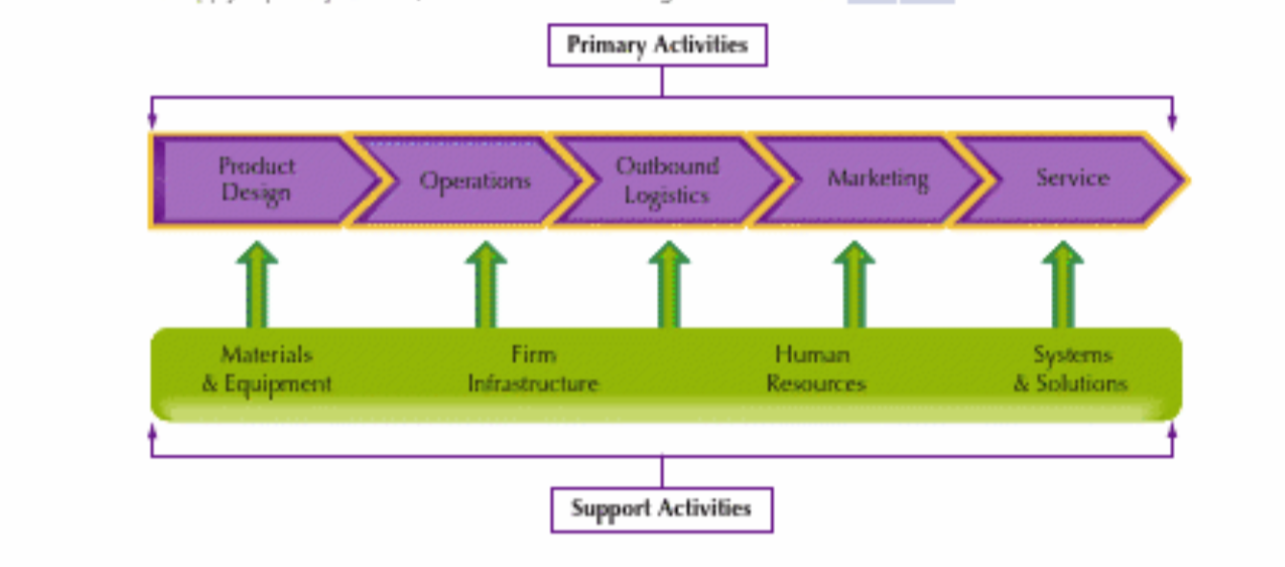
Figure 1. Visualising the Value Chain (Daniels,2019).
The value chain concept is critical for multinational enterprises to maintain a competitive advantage, which can be achieved through cost leadership, differentiation, or combining both to create more value than the costs incurred. Value chain analysis helps management to evaluate a company's strengths and weaknesses when creating, moving, selling, and servicing its products. It breaks down the process of creating value into a step-by-step process and identifies resources and capabilities that improve efficiency and effectiveness. Primary activities are the basic to make and move products, while support activities provide the infrastructure for the company. Both are essential for an organisation's success (Daniels, 2019).
Vodafone spends €24 billion annually with over 9,000 suppliers to meet business and customer needs. The company manages supply chain risk through collaboration and capability building. The global supply chains can be complex, with multiple tiers and intermediaries involved. Vodafone relies on large suppliers such as Nokia, Ericsson, and Huawei, with the investment, capability, and scale to create, construct, install, and maintain network infrastructure equipment for Vodafone and the industry while purchasing products for customers and general business needs. As a large multinational, Vodafone is also a substantial purchaser of goods and services to support Vodafone's general operations and administrative functions, such as marketing, travel, professional advisory services, and catering (Vodafone, 2020).
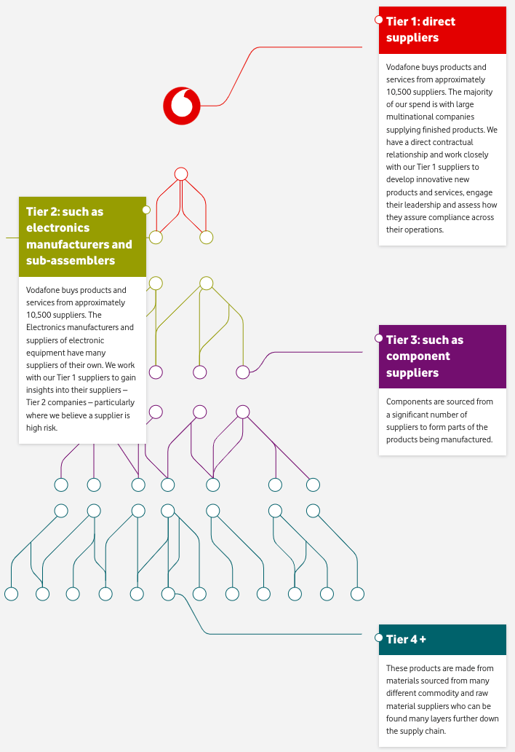
Figure 2. Vodafone supplier chain scheme. (Vodafone, 2020)

Value chain of Vodafone Germany
The global value chain of Vodafone Germany is complex and involves many countries and companies. The following are some of the key participants in the chain:
The Primary activities
1. Network equipment manufacturers: Vodafone Germany had 53% of its equipment from Huawei China in 2020 (Burkitt-Gray, 2020). Also, Ericsson (Sweden) and Nokia (Finland) manufacture the equipment used to build and operate Vodafone Germany's mobile network (Morris, 2019).
2. Device manufacturers:
Vodafone Germany collaborates with many electronic device manufacturers to provide its customers with an extensive selection of devices for its network access. The company offers a range of popular smartphone and tablet brands, such as Apple (USA), Samsung (South Korea), Google (USA), Xiaomi (China), and others, as well as a selection of its own branded smartphones that deliver excellent value for money (Vodafone, 2017).
3. Software development companies
Vodafone Germany works with various software development companies for its telecommunications software, including some local ones such as Accenture (Germany) and SAP (Germany) (SAP and Vodafone Success Story, 2017). Also, Vodafone Germany partners with some well-known international companies such as Wipro (India), NTT Data (Japan), IBM (USA), and Tata Consultancy Services (India) (Vodafone Idea Extends Strategic Partnership with TCS, 2023).
4. Distributors and marketing
Vodafone Germany's products and services are made available to consumers through the assistance of distributors. These companies include well-known German market retailers and online shops like MediaMarkt and Saturn, which offer the general public easy access to Vodafone's offerings (Mediamarkt, 2013).
The Support activities
1. Staffing. Vodafone Germany partners with global recruitment consultancies like Michael Page and Hays and staffing firms like Robert Half, ManpowerGroup, and Randstad to find qualified candidates worldwide, better understand the German labour market, and hire the best talent to achieve its business objectives (Page, 2023).
2. Technology development:
Vodafone Germany collaborates with several international companies to assist with support activities in tech development. IBM is among these firms offering Vodafone Germany IT consulting, application development, and cloud computing. Ericsson and Nokia, both global telecommunications companies, provide network planning, optimisation, and customer support (Ericsson, 2021). Vodafone Germany also partnered with Amdocs from Amazon (USA) to modernise its IT systems and establish an agile and scalable delivery process using cloud technology (Fregoni, 2021). These companies increase Vodafone Germany's efficiency and improve performance in the technology development in the value chain, granting access to a global pool of expertise and keeping the company current with the latest technologies.
Vodafone uses its extensive network of suppliers on a global scale to access optimal pricing and product quality, enabling it to offer diverse products and services in various countries. By sharing resources and data information across its global operations, Vodafone achieves cost savings and improved decision-making capabilities, resulting in added value for its customers, shareholders, and the economy.
Internal Analysis
SWOT analysis of Vodafone
Strengths:
• Global presence: Vodafone operates in over 200 countries with a large customer base.
• Strong brand: Vodafone is a highly recognised and respected company and brand, giving it a competitive advantage.
• Innovation: Vodafone is constantly making new technology investments, which helps it stay ahead of the competition at the forefront of its industry.
• Customer focus: Vodafone is prioritised to provide exceptional customer service, which helps to attract and retain customers (Vodafone, 2019).
Weaknesses:
• Vodafone has accumulated significant debt (33,375 € m), which may impact its financial performance in the coming years (Vodafone, 2023).
• Price wars: Vodafone is experiencing constant and intense competition from other telecom providers, which has led to price wars in specific markets (Philp, 2009).
• Lack of differentiation: Vodafone lacks differentiation in its products and services compared to its competitors, which poses a challenge in standing out in a crowded market and attracting and retaining customers.
• Constant many governments and authority control
Being a global brand Vodafone is subject to ongoing scrutiny and oversight from various international regulatory bodies and governments where it operates.
Opportunities:
• Growth in emerging markets: The telecommunication industry in emerging markets, such as many African countries, is multiplying, which presents an excellent opportunity for Vodafone to expand its business (Vodafone, 2020).
• New technologies: The rise of usage of new technologies, such as 5G in wide ranges of devices, both commercial and personal use, presents a promising opportunity for Vodafone to grow its business.
• M&A: Using the same entry strategy as it did while entering the German market, Vodafone could acquire other foreign telecom providers to expand its reach and market share.
Threats:
• New entrants: New entrants to the telecom market could threaten Vodafone's market share. It is a constant risk that technology giants such as Google, Tesla, Microsoft, and Apple may plan to enter the telecommunications market in the future and create direct competition for Vodafone, see Appendix 5.
• Economic slowdown: A potential global economic slowdown caused by wars, pandemics, or another has the potential to decrease the demand for telecommunications services, which can impact Vodafone income precisely as happened with Vodafone Ukraine in the Ukraine market in 2022-2023 (Vodafone, 2022).
• Regulatory changes: Changes in legislation and industry regulations in countries the company operates could impact Vodafone's business.
From the perspective of the SWOT analysis conducted by the report's author, Vodafone is a prominent and thriving MNE enterprise with numerous strengths. However, it is not exempt from obstacles such as price competition and debt. The company's management must take action to overcome these challenges to sustain growth and prosper. The company's global presence is a significant strength, but it also makes it complex to manage it. A strong brand is a valuable asset, but it needs to be protected from negative impact. Focusing on customer service is vital, but it needs to be balanced with controlling extra expenses. Investing in new technologies is essential for the company's future but carries some risks in increasing its services.
Overall, Vodafone is a well-managed company with a commendable track record.
International Strategies
Creating and implementing an international strategy is crucial for multinational enterprises (MNE) to expand their business globally. Such a strategy involves analysing the global market, identifying available resources, understanding market dynamics, setting goals, planning activities, and developing offerings. It is an ongoing process for enterprises looking to grow and succeed in foreign markets (Daniels, 2019). With the rise of globalisation, different sizes of companies are expanding their business operations abroad. Highly globalised businesses aim to reduce costs as much as possible by offering standardised products worldwide, which creates economies of scale. The Bartlett & Ghoshal Matrix (1989) is a commonly used framework to categorise international enterprises based on their global integration and local responsiveness. Businesses can adopt Global, Multidomestic, Transnational, or International strategies (Bartlett and Ghoshal, 1998).
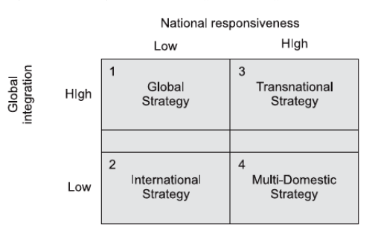
Figure 3. Global Integration Vs. National Responsiveness (Bartlett and Ghoshal, 1998).
• Multidomestic: Low Integration and High Responsiveness
Multi-domestic companies aim to customise their products and services and meet the local market's needs. They operate with a decentralised structure, giving subsidiaries autonomy worldwide.
• Global: High Integration and Low Responsiveness
Global companies offer a standardised product worldwide and aim to maximise efficiencies through centralisation when subsidiaries rely on head offices in decisions and product strategy.
• Transnational: High Integration and High Responsiveness
Transnational enterprises combine global and multi-domestic characteristics to achieve local responsiveness and to use the global integration benefits. They have subsidiaries abroad with strategic roles, expertise exchange, and cost reduction of scale upstream and are adaptive and flexible in downstream activities such as marketing and sales.
• International: Low Integration and Low Responsiveness
An international strategy uses a low integration and low responsiveness exporting approach, where products are produced at home and distributed globally. The subsidiary's primary function is to serve as a local channel for sales to end consumers. (Bartlett and Ghoshal, 1998).
International Strategies of Vodafone
According to the Bartlett & Ghoshal Matrix, the author of this report consider that Vodafone uses a transnational strategy which means that Vodafone seeks abroad to balance global integration and local responsiveness.
Vodafone does this by:
• Standardising products and services: Vodafone offers a core set of products and services standardised worldwide, which helps it to achieve economies of scale and reduce costs.
• Localising products and services: Vodafone also localises and customises its products and services to meet the specific needs of local markets, which includes providing diverse local-language content and services and modifying its marketing materials.
• Building relationships with local partners: Vodafone collaborates closely with local partners in most country it operates. This strategy helps Vodafone to explore and understand the local market, establish customer trust, and quickly increase market share.
• Investing in technology innovation: Vodafone is always one of the first in the industry ready to invest heavily in technology innovation, enabling them to maintain a competitive edge and offer customers top-quality services.
Vodafone's transnational strategy made them a top telecom company offering diverse products and services while catering to international markets, building a strong brand, and growing its customer base.
Vodafone Entry Modes to the Germany market
In 1999, Vodafone entered the German telecommunications market through a merger and acquisition of Mannesmann - a leading player in the industry. This M&A deal was the largest in history, so Vodafone established a significant presence in the German mobile operator market. Despite opposition from certain groups, acquiring Mannesmann proved to be a successful move for Vodafone, ultimately contributing to the company's growth as a prominent telecommunication and mobile provider in Germany (Goldman Sachs, 2013).
Mergers and acquisitions (M&A) refers to the transfer of ownership of companies, including their associated assets and liabilities, to another entity. This process involves planning, research, due diligence, closing, and implementation activities. Mergers and acquisitions between multinational companies are often valued at hundreds of millions and billions of dollars and are becoming more frequent with the involvement of emerging market-based companies.
Advantages of using M&A as an entry mode:
• Fast entry: M&A allows companies to enter new markets quickly, which is critical for taking advantage of market opportunities.
• Increased market share: M&A can help companies gain a weighty market share in new markets.
• Access to assets: M&A can access assets that would otherwise be unattainable through other entry modes.
Disadvantages:
• High cost: M&A can be very costly as the company must pay a premium for the target company and integration expenses.
• Risk: M&A can have issues successfully integrating the target company, and hidden liabilities may surface.
• Regulatory challenges: M&A may encounter regulatory challenges in new markets and seeking government approval. (Wild, 2016).
The author of this report believes that Vodafone chose M&A to enter the German market for several reasons. Firstly, the German market already had four major players at that time, making it difficult for Vodafone to enter through franchising or exporting. Secondly, the German government have strict regulations and requirements on foreign investment in the telecommunications sector, making a greenfield investment challenging for Vodafone. M&A was the best option for Vodafone as it allowed the company to access the German market quickly and gain a significant market share. Additionally, it granted Vodafone full access to Mannesmann's assets, such as its network, customer base, and employees.
Corporate Social Responsibility
Global enterprises should encourage and prioritise ethical business practices through Corporate Social Responsibility (CSR). Rather than solely focusing on maximising profits,
it obligates businesses to align companies' policies with moral standards and respect all stakeholders' rights while emphasising shared responsibility for social and environmental issues (Maurice,2022).
Due to their Sustainability Report, Vodafone's Corporate Social Responsibility (CSR) is about positively affecting its customers' lives and the environment by running a successful values-based business (Vodafone, 2020). Their CSR strategy is based on four pillars:
• Inclusion for all: Vodafone is committed to creating an inclusive and diverse work environment where everyone feels welcome and valued. They promote equality and opportunity for all, regardless of personal characteristics such as race, gender, disability, sexual orientation, or other attributes.
• Planet: Vodafone is committed to reducing its environmental impact and positively contributing to our world. They are working to reduce carbon emissions, improve energy efficiency, and use the newest technologies, such as more sustainable materials.
• Digital Society: Vodafone is committed to using technology to impact society positively. They are working to provide the newest technologies, such as 5G, to enable by that high tech easy and effective access to education, healthcare and promote economic development.
• Operating responsibly: Vodafone is committed to operating responsibly and ethically. They are working to uphold human rights, ensure fair labour practices, and protect the environment globally while operating in more than 200 countries.
Vodafone's CSR strategy is aligned with the UN's SDGs and has set targets for achieving each goal by 2030. Vodafone participates in various CSR initiatives, which promote diversity by increasing the representation of women and people from minority groups in their workforce. They aim to reduce energy consumption by 20% before 2025 and bridge the digital divide by providing access to affordable broadband and mobile services in underserved communities. They also uphold human rights by setting a code of conduct that outlines their expectations for employees and suppliers. The company believes that being responsible and sustainable creates value for all stakeholders (Vodafone, 2020).
Conclusion and recommendations
According to the findings and analyses of this report, Vodafone has used various strategies to expand globally during decades of its internalisation, including acquisitions, joint ventures, and greenfield investments. The company has also focused on centralising certain functions like procurement and marketing, standardising its products and services, and transferring knowledge within Vodafone worldwide, including Vodafone Germany, the one studied in this report. All efforts have helped the company improve its efficiency and performance, making it a world-leading telecommunications provider with a presence in over 200 countries and serving more than 300 million customers. Internalization benefits Vodafone by allowing them to control operations and brand image, achieve economies of scale, enter new markets quickly and reduce risks through partnerships. The German market attracted Vodafone primarily due to its stability, perfect infrastructure and logistics and excellent living standards for people who provide Vodafone with a stable, rich profit flow.
The report's author suggests that Vodafone's management should implement new internalisation strategies to overcome current challenges and sustain their successful business growth. To achieve this, the company could consider:
• Focusing on new emerging markets
• Invest more in advanced technologies like AI and Quantum computing and collaborate with companies like IBM, Intel, and Cambridge Quantum Computing at the forefront of developing these technologies.
• Prioritising customer experience and gaining insights into customer behaviour and preferences through advanced data analytics, similar to what Amazon does using its knowledge management.
• Vodafone should evaluate and correct its global value and supply chain in light of current and future global political changes, such as the ongoing Russian-Ukrainian war and the growing international tension between the West and China.
• The company can improve its internal organisational culture by building a more agile organisational structure, increasing investment in employee training and development, and fostering a strong corporate culture at home and in host countries.
These strategies will enable Vodafone to adapt to global market changes, attract top talent, and maintain success in the future.

References:

Britannica. (2023). In: Encyclopædia Britannica. [online] Available at: https://www.britannica.com/place/Germany [Accessed 24 Jul. 2023].
Burkitt-Gray, A. (2020). Exclusive: four European Vodafone companies are 100% Huawei. [online] Capacity Media. Available at: https://www.capacitymedia.com/article/29otc9t6wy04gbqbcfhts/news/exclusive-four-european-vodafone-companies-are-100-huawei [Accessed 24.Jul. 2023].
CBI. (2023). UK economy set to grow and business investment to rise following a brush with the recession – CBI Economic Forecast | CBI. [online] Available at: https://www.cbi.org.uk/media-centre/articles/uk-economy-set-to-grow-and-business-investment-to-rise-following-brush-with-recession-cbi-economic-forecast/ [Accessed 16 Jul. 2023].
Christopher, A. and Bartlett, S. (1998) Managing Across Borders: The Transnational Solution. Boston: Harvard Business School Press.
Daniels, J.D. (2019) International business: environments & operations. Sixteenth edition, global edition. Harlow, England: Pearson.
Ericsson (2021). Vodafone Germany launches Ericsson 5G Standalone. [online] Available at: https://www.ericsson.com/en/news/3/2021/vodafone-partners-with-ericsson-for-europes-largest-commercial-5g-standalone-network [Accessed 26 Jul. 2023].
Federal Statistical Office. (2023). Gross domestic product: detailed economic performance results for the 1st quarter 2023. [online] Available at: https://www.destatis.de/EN/Press/2023/05/PE23_203_811.html#:~:text=GDP%20in%20the%20first%20quarter,more%20than%20a%20year%20earlier.&text=The%20sharp%20price%20increases%20had,year%2Don%2Dyear%20comparison. [Accessed 24 Jul. 2023].
Feinberg, F. M., Kinnear, T. C., Taylor, J. R. (2013). Modern Marketing Research: Concepts, Methods, and Cases. Cocos (Keeling) Islands: Cengage Learning.
Fregoni, S. (2021) Vodafone Germany goes cloud-native, modernises systems to innovate with Amdocs, SiliconANGLE. Available at: https://siliconangle.com/2021/06/30/vodafone-germany-goes-cloud-native-modernizes-systems-innovate-amdocs-awspublicsectorawards/ (Accessed: 14 August 2023).
Germany / Economic Studies (2020). Germany / Economic Studies - Coface. [online] Available at: https://www.coface.com/Economic-Studies-and-Country-Risks/Germany [Accessed 25 JUL. 2023].
Germany Telecommunications Report (2023) - Q3 2023 - ABI/INFORM Collection - ProQuest. (2023). Proquest.com. uwtsd.ac.uk [online] DOI https://doi.org/%22.
Goldman Sachs (2013). 2000: Vodafone Acquires Mannesmann in the Largest Acquisition in History. [online] Goldman Sachs. Available at: https://www.goldmansachs.com/our-firm/history/moments/2000-vodafone-mannesmann-merger.html [Accessed 17 JUL. 2023].
JPMorgan (2023). 2023 Business Leaders Outlook: Germany | J.P. Morgan. [online] Available at: https://www.jpmorgan.com/insights/outlook/business-leaders-outlook/germany-business-leaders-outlook [Accessed 25 Jul. 2023].
MarketLine (2023). Germany - Telecommunication Services. [online] Available at: https://advantage-marketline-com.ezproxy.uwtsd.ac.uk/Analysis/ViewasPDF/germany-telecommunication-services-168953 [Accessed 23 Jul. 2023].
MarketLine (2023). Macroeconomic Outlook Report: United Kingdom. [online] Available at: https://advantage-marketline-com.ezproxy.uwtsd.ac.uk/Analysis/ViewasPDF/united-kingdom-macroeconomic-outlook-report-59980 [Accessed 16 Jul. 2023].
MarketScreener. (2022). VODAFONE GROUP PLC. [online] Available at: https://www.marketscreener.com/quote/stock/VODAFONE-GROUP-PLC-4006195/company/ [Accessed 14 Jul. 2023].
Maurice, L. C. S. (2022). Corporate Social Responsibility: The Co-Responsibility of Business Along Global Supply Chains. Germany: SPRINGER GABLER.
Mediamarkt (2013). Vodafone Tarife mit Geschenk-Coupon | MediaMarkt Tarifwelt. [online] Available at: https://tarife.mediamarkt.de/tarife/vodafone/ [Accessed 26 Jul. 2023].
Michael Page. (2023). Recruitment services - Legal | Michael Page. [online] Available at: https://www.michaelpage.nl/en/recruitment-services/legal [Accessed 26 Jul. 2023].
Mordorintelligence (2023). Germany Telecom Market Size & Share Analysis - Industry ResearchReportGrowthTrends.[online]Availableat:https://www.mordorintelligence.com/industry-reports/germany-telecom-market [Accessed 23 Jul. 2023].
Morris. I (2019). Nokia Replacing Huawei in Vodafone's German Core | Light Reading. [online] Available at: https://www.lightreading.com/mobile/5g/nokia-replacing-huawei-in-vodafones-german-core/d/d-id/749347 [Accessed 26 Jul. 2023].
Park, N. (2022). Population estimates for the UK, England, Wales, Scotland, and Northern Ireland. [online] Ons.gov.uk. Available at: https://www.ons.gov.uk/peoplepopulationandcommunity/populationandmigration/populationestimates/bulletins/annualmidyearpopulationestimates/mid2021 [Accessed 16 Jul. 2023].
Philp, T. (2009). We can handle price wars & come out on top in the long term: Vodafone.[online]The Economic Times. Available at:https://economictimes.indiatimes.com/opinion/interviews/we-can-handle-price-wars-come-out-on-top-in-long-term-vodafone/articleshow/5334606.cms?from=mdr [Accessed 31 Jul. 2023].
Rugman, A.M. (2012) International business. 6th ed. Harlow, England: Pearson.
SAP and Vodafone Success Story (2017). SAP and Vodafone Success Story | Customer Reviews and Testimonials. [online] Available at: https://www.sap.com/uk/about/customer-stories/vodafone.html [Accessed 26 JUL. 2023].
Tradingeconomics (2023). Germany GDP Growth Rate - 2023 Data - 2024 Forecast - 1970-2022 Historical - Calendar. [online] Available at: https://tradingeconomics.com/germany/gdp-growth [Accessed 16 Jul. 2023].
Tradingeconomics (2023). Germany Population - 2023 Data - 2024 Forecast - 1950-2022 Historical-Chart-News.[online]Available at: https://tradingeconomics.com/germany/population [Accessed 16 Jul. 2023].
Vodafone Idea Extends Strategic Partnership with TCS (2023). [online] Available at: https://www.tcs.com/who-we-are/newsroom/press-release/vodafone-idea-extends-strategic-partnership-tcs-enhance-customer-experience [Accessed 10 Jul. 2023].
Vodafone Plc (2023). About Vodafone UK | Vodafone UK.[online] Available at: https://www.vodafone.co.uk/about-us/about-vodafone-uk [Accessed 14 Jul. 2023].
Vodafone Plc (2023). Available at: https://investors.vodafone.com/sites/vodafone-ir/files/2023-05/Vodafone-FY23-Results-Announcement.pdf.
Vodafone Plc (2023). History - Vodafone UK News Centre. [online] Available at: https://www.vodafone.co.uk/newscentre/about-us/history/ [Accessed 14 Jul. 2023].
Vodafone Plc (2020). How we manage our Supply Chain. [online] Available at: https://www.vodafone.com/sustainable-business/operating-responsibly/responsible-supply-chain/how-we-manage-our-supply-chain [Accessed 26 Jul. 2023].
Vodafone Plc (2023). Our Global Network. [online] Available at: https://www.vodafone.com/business/why-vodafone/our-global-network [Accessed 10 Aug. 2023].
Vodafone Plc (2023). Our purpose and strategy. [online] Available at: https://investors.vodafone.com/about-us/our-purpose-and-strategy [Accessed 14 Jul. 2023].
Vodafone Plc (2020). Sustainability reports. [online] Available at: https://www.vodafone.com/about-vodafone/reporting-centre/sustainability-reports [Accessed 6 Aug. 2023].
Vodafone Plc (2020). Tax and emerging markets. [online] Available at: https://www.vodafone.com/about-vodafone/reporting-centre/tax-and-economic-contribution/tax-and-emerging-markets [Accessed 31 Jul. 2023].
Vodafone Plc (no date) Vodafone.com. Available at: https://investors.vodafone.com/sites/vodafone-ir/files/2023-05/vodafone-fy23-annual-report.pdf (Accessed: 10 August 2023).
Vodafone Plc (2022). Vodafone Ukraine in 2022: impact of war, network reconstruction and rapid digitisation of subscribers Vodafone Україна. [online] Available at: https://www.vodafone.ua/en/company/investors/novini-ta-podiyi/vodafone-ukraine-in-2022-impact-of-war-network-reconstruction-and-rapid-digitization-of-subscribers#:~:text=Warfare%20and%20network%20outage%20in,Ukraine%20made%20up%2015.4%20million. [Accessed 31 Jul. 2023].

Wehrmann, B. (2017). German onshore wind power – output, business, and perspectives. [online] Available at: https://www.cleanenergywire.org/factsheets/german-onshore-wind-power-output-business-and-perspectives [Accessed 24 JUL. 2023].
Wild, J. J. and Wild, K. L. (2015) International business: The challenges of globalisation OLP with e-text, global edition. 8th ed. London, England: Pearson Education.

Appendix:

Appendix 1
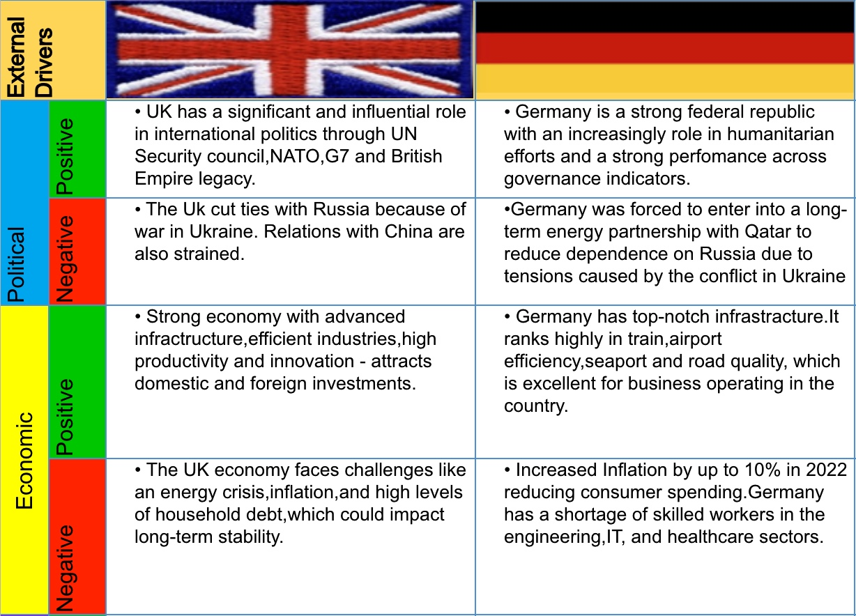

Appendix 2
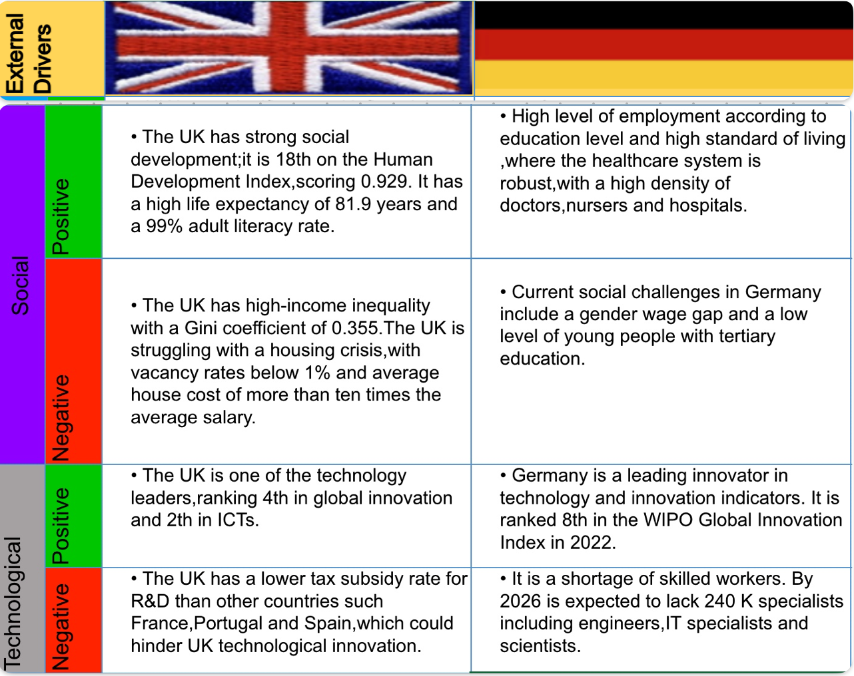

Appendix 3
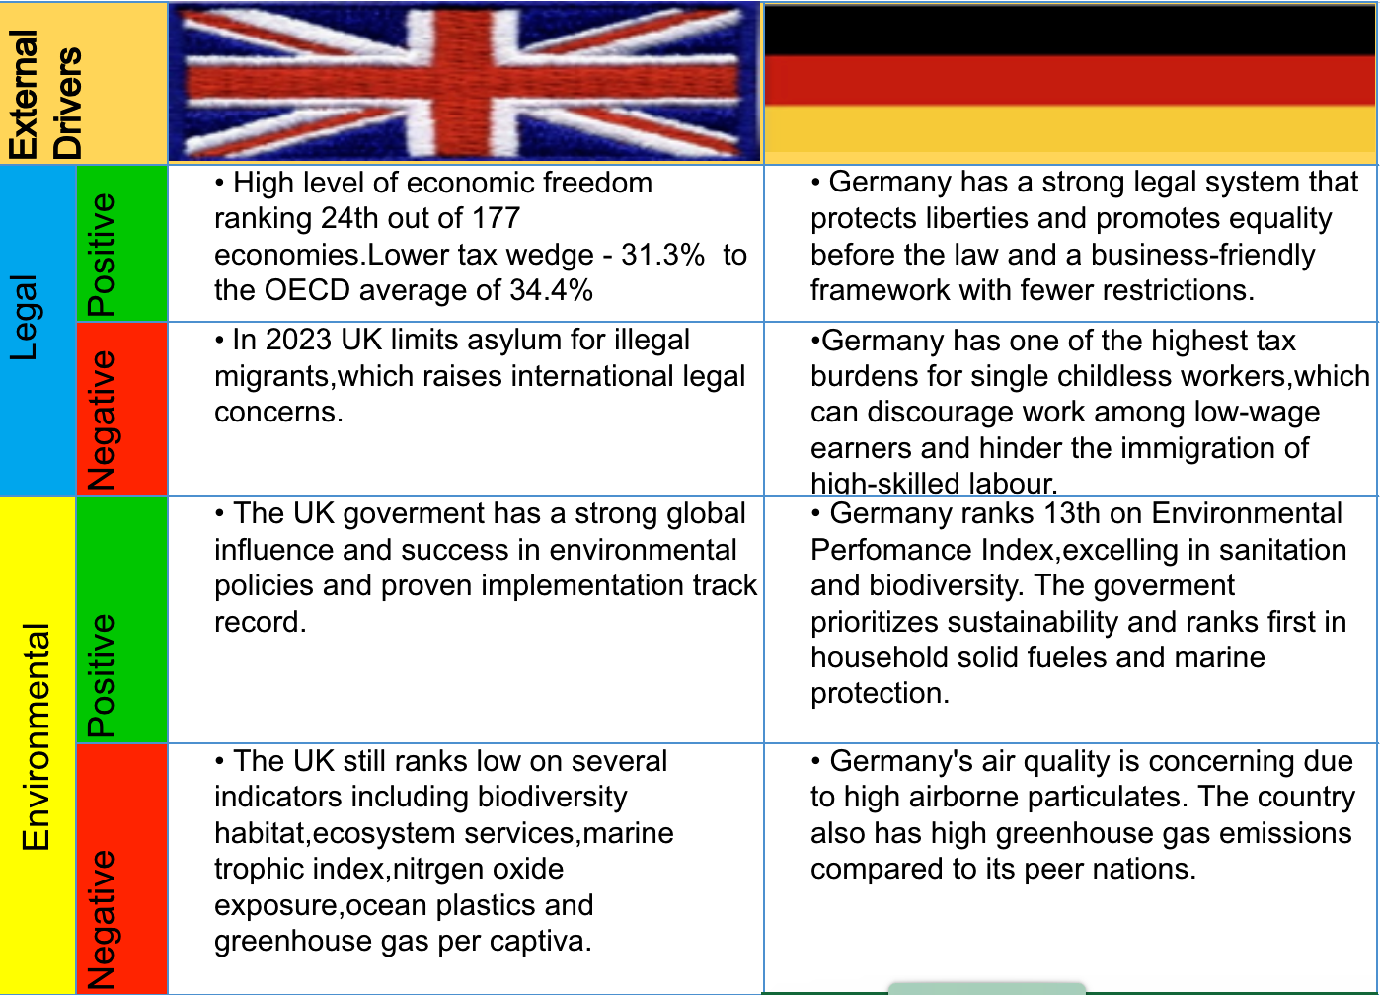

Appendix 5
Porter’s Five Forces (Industry) analysis of The German telecommunications industry.
1. The threat of new entrants: Low level
The German telecommunications industry is currently at low threat levels from potential new entrants because of the high barriers to entry, which include the necessity for significant infrastructure investment and regulatory approval. However, there is a real possibility of new entrants from the technology giants, such as Google and Amazon.
2. Bargaining power of suppliers: Low Level
The German telecommunications industry currently experiences low bargaining power from its suppliers due to high competition, standardised telecommunication equipment and services, and relatively low buyer switching costs.
3. Bargaining power of buyers: Moderate level
The bargaining power of buyers in the German telecommunications industry is moderate because there are a relatively constant and limited number of major telecommunications providers, and buyers have a choice of providers. However, the bargaining power of buyers is also limited by the fact that telecommunications services are essential for most businesses and consumers.
4. The threat of substitute products or services: Moderate Level
The threat of substitute products or services in the German telecommunications industry is moderate. There are substitutes for traditional telecommunications services, such as over-the-top (OTT), Skype, and WhatsApp. However, these substitutes are a minor threat to conventional telecommunications providers. In addition, all those named substitutes use internet data provided mainly by telecommunication companies.
5. Rivalry among existing firms: High Level
The German telecommunications industry is highly competitive, with four major players: Telekom Deutschland, Vodafone Germany,1&1 Drillisch, and Telefónica Germany.
These companies compete on price, service, and features. A high level of innovation also characterises the industry, as companies constantly look for new ways to attract and retain customers (MarketLine, 2023).

Appendix 6
Germany Telecommunication Market Analysis
• According to researchers, the telecommunications market in Germany is expected to grow from USD 77.25 billion in 2023 to USD 101.10 billion by 2028, which means a compound annual growth rate of 5.53% during the forecast period spanning from 2023 to 2028.
•The German telecom market is experiencing a rise in smartphone usage from individual customers and businesses. By 2025, Germany expects to become Europe's largest smartphone market, with USD 105 million connections. Telecom subscriber penetration will rise from 88% in 2021 to 89% in 2025, with smartphone adoption - from 80% to 84% (Mordorintelligence, 2023).
• Germany's largest operators, Deutsche Telekom, Vodafone and O2, reported 129.9 million unique mobile subscriptions at the end of December 2022.
• 1&1 Drillisch, which currently operates as an MVNO through Vodafone and O2's networks, seeks to become the fourth MNO in the country (Germany Telecommunications Report,2023).
•5G is the latest mobile technology, much faster than 4G, allowing for more data transmission and improving advanced technologies like AI, AR, and VR. 5G can also improve IoT and cloud computing systems and is hugely driving the telecom market in Germany.
• Broadband services are in high demand in Germany due to the ongoing digitalisation trend, which is driving the market for telecom vendors. Expanding broadband in Germany is crucial for Industry 4.0, eGovernment, the Internet of Things, improving social welfare and quality of life, and the company's ability to grow and compete.
• The demand for 5G is increasing, and the German government help in easing regulations. Deutsche Telekom plans to launch 5G services using 700 MHz bands, improving mobile coverage in rural Germany. Around 3,000 antennas across 1,100 locations are expected to broadcast 5G on the 700 MHz frequencies.
• The German government launched the 5G Initiative program to deploy 5G networks and applications. The 5G Strategy aims to make Germany a European leader in 5G by 2025. Ericsson predicts that 43% of the population will have 3.5GHz 5G coverage by the end of 2023.
• Social media usage, including Facebook, Instagram, WhatsApp, YouTube, TikTok, etc., is rising in Germany, fuelling data services for telecom-providing companies. For example, YouTube had 72.6 million users in Germany in early 2022, equivalent to 86.5% of the total population (Mordorintelligence, 2023).

