Developing Professional Practice
Sian Govier

Word Count: 4550

Activity one
Developing professional practice is based at the heart of what it means to be a human resource professional. It has become of immense importance for HR professional to be “thinking performers” contributing to an organisation’s objectives and bringing change to develop the company by challenging others diplomatically, while maintaining a professional and ethical approach to their job duties. There are three fundamental component areas of HR:
- Individual Development (personal)
- Career Development (professional)
- Organisational Development.
A good starting point is to manage people within accordance to clear and strong core principles such as:
- Employees are human beings and should be treated with dignity and respect from the start, when the apply for a job to the time they leave the organisation.
- They are or will be potential assets to the organisation.
- Each employee will have different strengths and skills, it is important to develop these and tap into them to benefit the organisation.
- As employees they have the right to gain satisfaction from their job and earn rewards or praise from their contribution to the business.
HR professionals should ensure to add value, a key difference between historical personnel management and what is required for a successful HR function of the components noted above is adding value. In a vast majority of organisations HR provide more that the necessary administrative tasks, they need to add commercial value and more importantly be seen to do this. This can be divided in to four categories, while at work:
- Maintenance activities, ensuring to maintain the function of HR and to keep the show on the road.
- Crisis prevention activity, Crisis prevention is to make sure there are preventions in place to ensure things do not go wrong or if they do, that the resulting damage can be contained. This is where policy and procedures come into place.
- Continuous improvement activities, continuous improvement is where added value begins, because it focuses on the performance of existing task, ensuring they are completed faster, better, or more cheaply in ways that are customer relevant and preferably noticed by the customer. You can introduce and implement continuous improvement in many ways.
- Change management activities, change management is about contributing, managing and proposes perspective changes and implementing them. Making changes happen is a key added value performance indicator.
A final requirement which underpins all of the four above deserves special emphasis, recent high-profile instances of corporate wrongdoing and managerial misbehaviour have emphasized how important it is to use ethical conduct, for organisations for executives and especially managers, for those in the HR function and in general the employee.
According to the CIPD, HR policy and procedure are available to give guidance on a range of employment issues for employees, managers and other individuals within the organisation who are responsible for the people. They help to effectively implement the business HR strategy. They also provide consistency and transparency for employees and managers, allowing emphasis on the psychological contract and to create a positive organisational culture. HR policies are a written source o guidance for employees on a wide range of issues and how they should be dealt with, they will include a description of principles, rights and responsibilities for managers and employees. Their focus is to help support fairness and consistency throughout and to potentially help and protect the organisation against legal claims. However regardless how well the policy and procedure is written, for them to be effective, there needs to be communication and implementation of these policies, meaning they should be available to all and in particular managers should make employees aware of them.
HR policies should support the wider strategy through adopting a tailored approach which reflects the size and culture of the business.
A HR strategy is a statement or framework which shows how HR can help support and develop the organisations objectives, focusing on longer term people issues and macro-concerns about structure, values and matching resources to future needs.
HR policies, provide general practice advice and guidance for managers and staff on a range of employment issues.
HR procedures support and supplement HR policies where appropriate by giving step by step account of specific arrangements that apply to a particular circumstance.
HR policies play a role in supporting cultures of trust, policies should be reviewed regularly for the following reasons:
- To stay in line and reflect changes of legislation and case law.
- To support business strategy.
- To follow updated developments in effective people management.
- To deal with internal changes.
- To comply with head office/company guidance and to keep up with competitors.
- For smaller organisation changes will allow for a more formal development and consistent approach that will meet their growing needs.

HR policies are changed on a regular basis, although there is no set formula to help an organisation to determine their point in their development, which is why people professionals are employed. There are a range of policies in an organisation, which may be helpful in the course of employment life cycle, beginning employment during employment and leaving employment. These are as follows:
- Beginning employment, an organisation can have a distinct policy which outlines the criteria for employment selection along with relevant policies for new starting employees such as an induction.
- During employment there are many different policies to consider, reward which may cover how jobs are graded and how employee performance is rewarded, along with pension schemes and additional voluntary contributions and company benefits.
- Employee relations and general HR issues, which will include disciplinary and grievance policies.
- Learning and development issues that may be covered by policies, this area would include course and secondment issue and talent development.
- Other issues such as diverse areas related to wider business needs or those associated with emerging technology and new ways of working.
- Ending employment, there are several reasons why employment could cease, from voluntarily resignations, dismissals, redundancy, and retirement.
When developing new policies or updating older ones, numerous sources of information are available:
- CIPD resources, there are many factsheets and guidelines provided through the CIPD for what could be incorporated in a particular policy, for CIPD members, their employment law Q+As have full details on legal requirements.
- External organisations, (particularly in the public sector) some make their policy manual available via the internet, these are often a goo starting point to draw on inspiration, although it is important to check the reliability of the source. Many commercial organisations offer ready made policy solutions, usually for a fee, which they will then adapt to suit the employer. However, it is again important to assess the suitability of the source. It is very important to check any relevant codes of practice to ensure compliance with legal requirements.
Key resources for learners attending the CIPD course are our core text books which we can buy and also have the option to rent from the college library, Moodle also have learning resources and links which relate to the module on the course. The lecturer and assessor has also stated they are available and have provided contact details and email addresses.
Please see questionnaire below:

 | Question | Answer
1. | When, where and at what time will the course be delivered? | Once a month in class at Coleg sir gar from 9am till 4:30pm, although this changed to online classes due to Covid19.
2. | How many modules form part of the programme? | 16
3. | What are the term dates for this year? | Were 25th 2019 Sept to 21st May 2021.
4. | What is Moodle? | Moodle is an open-source learning management system.
5. | What is Eduroam? | This is a secure worldwide roaming access source.
6. | What is Turnitin? | This is a web-based plagiarism prevention system used by most universities in the UK.
7. | Do you know when you are required to hand in work? | Yes, to follow the submissions deadline dates on the timetable.
8. | What are the core texts for this programme? | Studying Human resource management by Taylor and Woodham and Human Resource management: People and the organisations by Taylor and Woodham.
9. | Do you know how to access the library catalogue? | Yes.
10. | Do you know who to go to if you have a question/concern about the course? | Yes, min lecturer Julie Thomas and the assigned assessor.
11. | What is the name of the Training Adviser? | Allison Williams now Nicola Julian.
12. | What is the name of the course lecturer? | Julie Thomas.
13. | Will you be expected to complete work outside lessons? | Yes.
14. | Do you need to be a member of the CIPD? | Yes.
15. | What support is available for study skills? | Support groups organised by the lecturer and through the university, study skills support.
16. | Do you know where the fire-exits and first aid points are for the building? | Yes.
17. | How many credits is the programme? | 90 cedits.
18. | What is the length of the programme? | 2 years
19. | Do you know where to find the student handbook and timetable? Where? | Yes, online and a copy of the timetable has been provided.
20. | What academic level is this qualification? | Level 5 diploma

Activity Two
According to the CIPD the profession map sets the international benchmark for the people profession, it is used to make better decisions, act with confidence, perform at your peak, drive change in your organisation and progress in your career, the profession map is relevant to all even if the person is not a CIPD member. The profession map provides a foundation for people professionals at the heart of the organisation to gain guidelines in their work, weather they are HR professionals or Learning and Development. It allows them to act with confidence and to drive change for meaningful contributions to the organisation, resulting in championing better work and better lives. The map is driven by research and work around professional values, the map can be applied to daily work tasks. It can be applied to fit all industries and can be useful to assist the people professional in their own career.
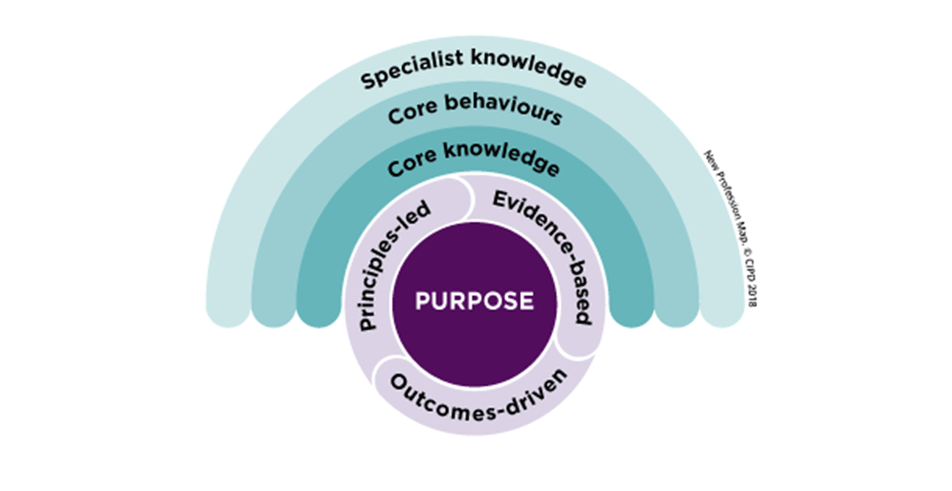
The purpose is at the centre, which is the heart of the map. It leads on to principles-led, which means to see beyond rules to do what’s right while taking into consideration that work matters, people matter and professionalism matters. Evidence-based, will add weight to professional judgement by supporting your case with strong evidence from diverse sources. Outcomes-driven are to champion better work and working lives by making a positive difference on every level, personal, professional and social.
Core knowledge are the things that every professional will need regardless of their role, this will help you with your work and to help classify yourself as an expert on people, work and change.
Core behaviours are the ways of thinking and acting within your job role, to be considered an effective people professional, this will be identified through academic research and feedback from the profession.
Specialist Knowledge the CIPD have identified nine area of specialist expertise with the people profession, across HR, L+D, OD and beyond. The Nine specialist disciplines are:
- Employee experience
- Employee relations
- Inclusion and Diversity
- Learning and Development
- Organisation development design
- People analytics
- Resourcing
- Reward
- Talent management
The people profession has a wide range for opportunity, regardless of what level you are at, the specialised knowledge allows you to apply your expertise to make a positive impact in the world of work.
HR apply ethical values within an organisation, scandals, workplace harassment and poor treatment of workers have emphasized what can happen when ethics are not integrated to the operations of an organisation. HR have a unique access to staff their careers and opportunities to influence the organisations strategy and the way they manage their workforce. Ethics are at the centre of professionalism, to create cultures of transparency and trust. Ethical values will affect organisational behaviour, it applies to all aspects of conduct, including corporate governance, employment practices, sales techniques, and corporate responsibilities. Ethical practice is important for an organisation to ensure that they do the right thing because it is the right thing to do. The institute of business ethics research shows the benefits of ethical values in an organisation particularly when taken seriously, an open culture will improve Morale, Good relations with customers lead to an enhanced reputation and ethical companies outperform their peers financially over a long-term period. To establish an ethical culture these values, need to be brought in to play on a day-to-day basis, to operate ethical an organisation needs ethics programmes to support and bring its values to life, this can be formal or an informal programme but will depend on the size of the business, it is important to include a code of ethics as the key element. Core values will exist in business, this can be because of existing values and leadership or purely by chance, regardless of what policy and procedures are in place, the organisations values provide the framework for culture and decision making. The world of work frequently changes, therefore there is no set rule or best practice to help practitioners in some dilemmas. The ability to exercise situational judgment can be crucial to operate efficiently and effectively by making the best possible decisions by including knowledge and sensitivity to the ethical choices. The HR and people professionals are responsible for key systems and processes in the organisation, delivering the effective message of the organisations ethical values. The HR professional can help to integrate ethics in the following company processes:
- Recruitment and induction.
- Diversity and inclusion.
- Learning and development.
- Performance management.
- Reward, including bonuses and incentives.
People professionals are also responsible and can introduce specific activities to familiarise employees with ethical issues such as anti-bribery, modern slavery, and data protection training. People professional should reassure employees that they can raise any concerns and they will be treated with full confidentiality. Organisations should assess and reward ethical behaviours, this can be done via performance management which requires commitment to organisations ethical values and performance reviews, they should seek ways in which staff and their department have supported these values, such as how difficult decisions have been made. Demonstrate how staff have contributed to the organisation and included in decisions regarding bonuses or promotions. Assessing an employee’s application in ethical values can encourage them to behave ethically and to monitor the effectiveness of the ethics programme to allow focus on further training. HR professionals and senior management need to be clear on the core expectations of ethics as well as any organisations representatives and what consequences may arise if those ethics are not followed.

Activity 3
Due to supervision compliance being low and annual leave not being booked sufficiently with new starters, HR have now stepped in to support managers by sending annual leave booking forms which include the name of the service, hours that the new employee will need to book and if the new employee has declared that they will need time off at the interview stage, I then give the managers a week to complete the annual leave booking form and email managers to remind them to send the annual leave booking form back to HR to update annual leave on our Carval software, which will ensure that the new employee receives their annual leave allowance. For supervision compliance the manager will receive an induction pack to complete with the new starter employee with supervision and probation dates already set for a six-month period, should the manager be unavailable to complete the supervision HR will then complete a keep in touch supervision with the new employee, this will allow for a cultural change within the organisation and compliance will be met. Please find a copy of the Annual leave booking form and the page from the induction form which shows the pre booked dates for supervisions and probations.
Activity 4
Group dynamics is the study, analysis and understanding of the behaviours and psychology surrounding group interactions. The field typically differentiates between interactions within and between social groups (intragroup and intergroup dynamics). It is based on beliefs that the whole can be more complex than some parts and that understanding how groups operate has a fundamental effect on a company and their public policy. HR decisions can be pushed by the knowledge of what motivates people and successful teams, allowing the organisation to create a happier workplace for their employees. Historically Sigmund Freud (1921) based his preliminary description on Le Bon’s work but went on to develop his own, original theory. Freud wrote the book Group psychology and the analysis of the ego with an in-depth summary of group psychology, He states that individuals gain immense power by being part of a group, he argues that individuals feel safer in mass and that an individual derives security from being part of a group. Kurt Lewin in the early (1940s) state that people often take on distinct roles and behaviours within a group. “Group Dynamics” describes the effects of these roles and behaviours on other group members and on the group as a whole.
Recent researchers have taken on and built ideas based on Lewin’s and work has become central to good management practice. A group with a positive dynamic is easy to spot, team members will trust each other, they will work together for a particular focus or decision and will hold one and other accountable for making decisions happen. Researchers have also noted that a positive team dynamic reflects in their work by being twice as creative. A group with a poor dynamic will reflect in disruptive work, as a result the group may not come to any firm decisions or could lead to wrong choices due to them not being able to explore options effectively.
According to the CIPD, all CIPD members must commit to upholding and maintaining the standards and behaviour of their code of professional conduct document. This standard applies to all who are a CIPD member regardless of their working level. The obligations are grouped under four principles:
- Professional competence and behaviour
- Ethical standards and integrity
- Representative of the profession
- Stewardship
Groups and teams naturally occur in an organisation as they are working towards a common goal. All members of a team will bring in their own experiences which can result in complex dynamics within the organisation. Ideally group dynamics should lead to improved organisational performance, according to Jackson and Carter (2000). A group or team should be stable, interactive with each other and have a positive relationship which will result in maximum potential to achieve their common goal. However, some teams or groups can be faced with conflict, confusion, and irritation. Groups or teams will be made up of very diverse individuals, of different ages, gender, background, including nationality and culture, these will have different experiences, skills, knowledge, views, and agendas. Groups and teams have been common in working within an organisation. There are several theories on why humans tend to live and work with others, which Clegg et al (2005) gives a synopsis of, while enhancing the safety of individuals in an evolutionary term and the need to belong that human beings seem to have, also known as the “social animal”.

There are significant differences between teams and groups:
Working in groups
Groups will consist of several members, who will portray themselves and recognise each other as being part of that group. In mutual interactions group members will define boundaries of the group and the group rules (Schein 1988). There are different types of groups such as formal groups, these are people who are intentionally and permanently created to achieve a set goal or temporary groups who are non-permanent and short lived such as committees. Formal groups can lead to informal groups which are dynamic, inventive and can reshape an organisation by goal-oriented entity and could therefore utilize team leaders to support the success of the organisation’s goals (Luthans 2005). Informal groups may amplify the success to the structure of the organisation by filling in gaps with their knowledge and skills, reducing the managers workload and improve communication.
Working in teams
Teams can be defied as a group whose members have complementary skills and are committed to a common purpose or set of performance goals for which they a=hols themselves manually accountable (Greenberg and Baron 1997) therefore a team is dependent on both individual and team contributions and the members will take a shared responsibility for the results. Share responsibility seems to be key in separating teams from groups. Team members will also enter into a psychological contract with each other that group members do not (Clegg et al 2005).
There are both disadvantages and advantages to working as part of a team.
Advantages | Disadvantages
Team decisions may provide a wider choice of answers and results. | Team meetings can be costly, although important enough to affect the company’s effectiveness.
Team participation may result in better outcomes. | Pressure to conform may result in rash, snap decisions and inferior management.
Team discussions can gain more feedback and can decrease timing in communication. | Personal agenda may result in conflict and poor-quality outcomes.
Team membership is known to increase overall effort. | Extreme cause of cohesiveness may lead to “groupthink”.
(Haynes 2008, Hall 1991 and Janis 1972).

Belbin (1981, 2007) states the theory of team roles is dependant on the person and who they interact with others in different ways and demonstrate different behaviours, he identifies different roles that team members acquire, which will depend on them, on personality and partly on team dynamics. These roles can be displayed in three different ways, task related, team related and individual or thinking related.
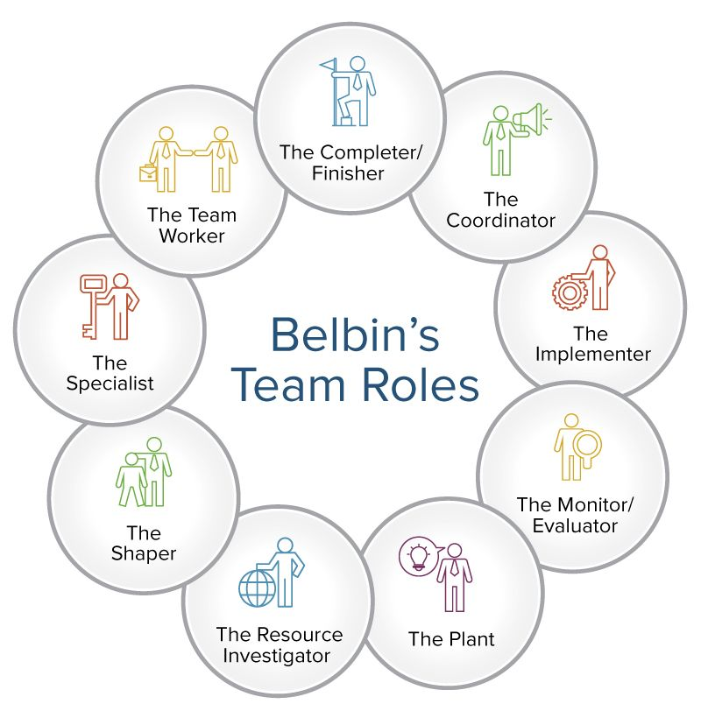
Task related – Sharper, Implementer, Complete fisher.
Team related – Resource investigator, Co-ordinator, Team worker.
The individual – Plant, Monitor Evaluator, Specialist.

Political behaviour was described by H.D. Laswell (1936) as who gets what, when and how, this simple explanation suggests that different preferences in conflicts over the allocation of valued resources. Politics represents the mechanism of solving problems such as new information or the use of rules. Results show that most political decisions involved interdepartmental coordination, promotions and transfers and the delegation of authority.
Developing a strategy for performance appraisal is an important step for any business and to ensure that political bias is avoided, although politics is not necessary a bad thing for a business as it can be a push to get things done. Organizational politics is a natural, although unhealthy politics can cause lack of employee commitment and a negative on performance and employee satisfaction leading to a detrimental effect to an employee’s health and wellbeing, which will also lower productivity.
The impact of political behaviour on achieving organisational goals is that it can lead to healthy or unhealthy co petition, increased or decreased productivity or overall performance.

Activity 5
Communication Style Questionnaire
This questionnaire is designed to help you assess your preferred communication style.
Thinking about your behaviour at work, write a score against each statement to represent which best typifies your behaviour where
4 = agree strongly, 3 = agree somewhat, 2 = disagree somewhat, and 1 = disagree strongly.
As with all questionnaires, the level of your honesty and self-awareness will impact on the accuracy of the outcome…so, be truthful to yourself!

- I express my opinions in an honest and appropriate manner. 3
- I can get angry and let this show. 1
- I find it difficult to say ‘no’. 4
- If I do not agree with a task that my boss has given me, I find a way of dragging my feet on it. 1
- I feel comfortable in asking for help from someone if they know more than me. 4
- I feel guilty if I leave on time for a valid reason and other people are still working. 3
- I can be sarcastic. 1
- I think my way of doing things is better than other people’s. 2
- If someone takes advantage of me, I find a way of evening the score. 1
- I feel I have a right to say no to other people’s requests and to negotiate a compromise. 2
- If I am in a large meeting, I find I do not speak up. 2
- I like to be in control of a situation. 3
- I stare people down. 2
- I make good eye contact with other people. 3
- If I am unsure about a task that I have been given, I find it uncomfortable to ask for help. 2
- I talk about other people behind their backs. 1
- When I have to deal with someone in authority, I find it difficult to look them directly in the eye. 2
- I am a good listener and equally other people listen to what I have to say. 3
- Rather than confronting someone about an issue, I would rather give them the cold shoulder or drop hints to other people that I am not happy. 2
- I am not afraid to be direct with someone, even if they think I am being rude. 3

Self-Assessment: Results

To assess your preferred communication style, transfer the scores you have given to each statement to the boxes below.
Then total each column downwards.
Look at the column where your score is the highest.
This is the communication style you use most of the time.

Q1  3 | Q3  4 | Q4  1 | Q2  1
Q5  4 | Q6  3 | Q7  1 | Q8  2
Q10  2 | Q11  2 | Q9  1 | Q12  3
Q14  3 | Q15  2 | Q16  1 | Q13  2
Q18  3 | Q17  2 | Q19  2 | Q20  3
Total 15 | Total 13 | Total 6 | Total 11
Assertive   | Passive | Passive Aggressive | Aggressive

I have completed the CPD assessment. Screenshot of the dashboard page will be included to evidence all completed assessments.

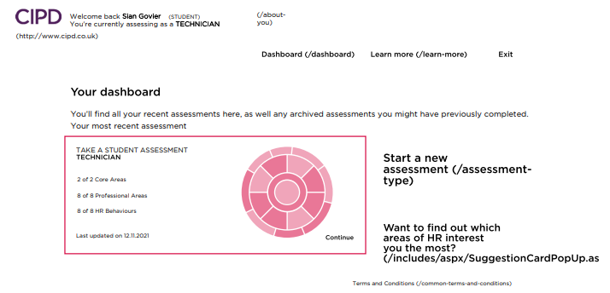

Activity 6
I have enjoyed the course, particularly the Business Law Module, I feel I need to and would like to focus on progressing my experience in actioning more changes within an organisation. I would also like to gain more experience on employee engagement.

References Taylor, S. and Woodham, C. (2016) studying Human Resource Management. 2nd Edition. London: CIPD Exploring HR Management (no date) Key Components of Human Resource Development. Available at: http://www.explorehr.org/articles/HR_Planning/Key_Components_of_Human_Resource_Development.html#:~:text=Key%20Components%20of%20Human%20Resource%20Development%20There%20are,development%20%28personal%29%2C%20career%20development%20%28professional%29%2C%20and%20organizational%20development. (Accessed 08/11/21). CIPD (no date) Explore the profession map. Available at: https://peopleprofession.cipd.org/profession-map (Accessed 08/11/21). CIPD (2020) Ethical Practice and the Role of HR. Available at: https://moodle.uwtsd.ac.uk/pluginfile.php/427541/mod_resource/content/0/Ethical%20Practice%20and%20the%20role%20of%20HR%20Factsheet%20%28Mandatory%20Reading%29.pdf (Accessed 09/11/21). CIPD (2021) HR Policies. Available at: https://www.cipd.co.uk/knowledge/fundamentals/people/hr/policies-factsheet . (Accessed 09/11/21). HR Zone (no date) Group dynamics. Available at: https://www.hrzone.com/hr-glossary/what-are-group-dynamics (Accessed 10/11/21). The international Journal (2012) Key components of Human Resource Development. Available at: http://www.theinternationaljournal.org/ojs/index.php?journal=tij&page=article&op=viewFile&path%5B%5D=532&path%5B%5D=pdf (Accessed 09/10/21). Mind Tools (no date) Improving Group Dynamics. Available at: https://www.mindtools.com/pages/article/improving-group-dynamics.htm#:~:text=Kurt%20Lewin%2C%20a%20social%20psychologist%20and%20change%20management,members%2C%20and%20on%20the%20group%20as%20a%20whole. (Accessed 10/11/21). Freud, S. (1921) Group Psychology and the Analysis of the Ego. Available at: https://www.sigmundfreud.net/group-psychology-and-the-analysis-of-the-ego.jsp#:~:text=Freud%20agrees%20with%20the%20theories%20of%20this%20sociologist%2C,derives%20security%20from%20being%20part%20of%20a%20group. (Accessed 10/11/21). CIPD (no date) Code of Professional Conduct. Available at: https://www.cipd.co.uk/about/what-we-do/professional-standards/code (Accessed 10/11/21). Watson, G. & Reissner, S Effective team building and communication. Available at: https://moodle.uwtsd.ac.uk/pluginfile.php/167744/mod_resource/content/1/BMPD5000WAT209.pdf (Accessed 10/11/21). Organizational Behaviour (no date) Political Behaviour in Organizations. Available at: https://opentextbc.ca/organizationalbehavioropenstax/chapter/political-behavior-in-organizations/#ch13rfin-15 (Accessed 10/11/21). Iqbal, I (2018) Political Behaviour in Organisations. Available at: https://iffatiqbal.wordpress.com/2018/12/15/political-behaviour-in-organisations/#:~:text=The%20impact%20of%20%E2%80%98political%E2%80%99%20behaviour%20on%20achieving%20organisational,detriments%20to%20organisations%2C%20L%26D%20departments%20and%20people%20collaboration. (Accessed 10/11/21). 

