Student name : Frentusca Ana-Maria

Student number:2120534

Module name: Foreign Languages & Cultural
Awareness (BMIH5003)
Mandarin
Module tutor: Qiang Wen

酒店活动广告
HOTEL EVENT ADVERTISMENT

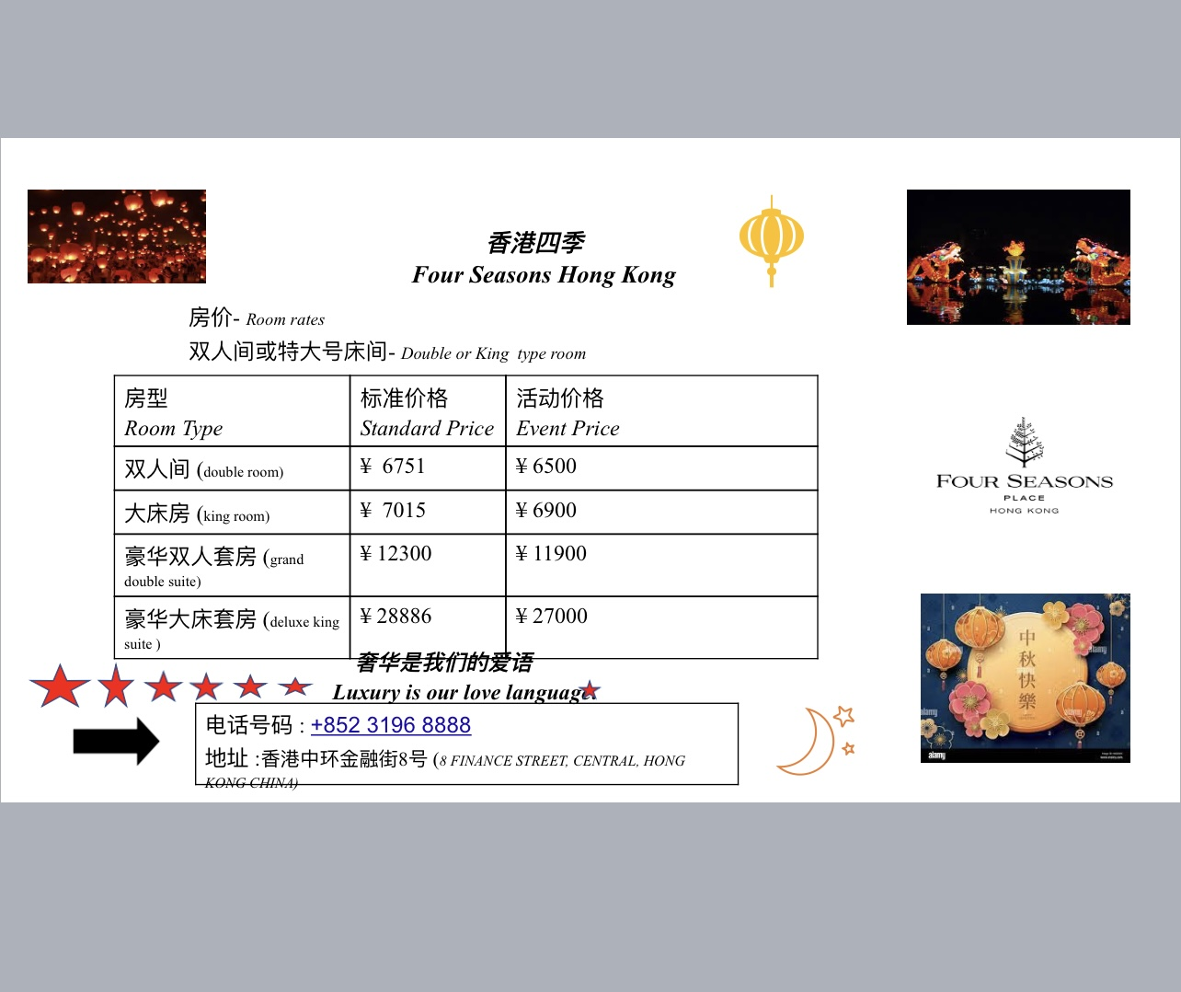

活动名称是中秋节. (The name of the event is mid autumn Chinese festival).)
香港四季酒店是我选择的酒店。(Four Seasons Hong Kong is the hotel that I choose)
这家酒店提供各种双人间和特大号床间。(This hotel offer just variety of double and king room).

酒店拥有七颗米其林星。(The hotel has seven Michelin stars. )

