University of Wales Trinity Saint David
Certificate of Higher Education in Skills for The Workplace
Professional Career Development
Module-BMSK 4005, Term-3 (Group-1)
Student Name- Mohammed Zakariya
Student ID-1605432
Teacher- Dr Sylvia Hoffmann

Table of Contents

Introduction 3
Description of learning styles 3
Discussion on the personal key skills 8
Analysis of personal strength and weaknesses 9
Discussion of a PDP (Personal Development Plan) 11
Analysis of the induction programmes in Chop House 11
Investigation of the organisation 12
Revaluation of PDP (Personal Development Plan) 13
Analysis of the performance through log entries 14
The final discussion of personal development and learning 16
Reviewing the PDP (Personal Development Plan) 16
Conclusion 17
Reference Lists 18

Introduction
Learning helps in self-development, which supports in meeting the day-to-day needs in life. It also helps in meeting any kind of contingent situation in the organisation. Self-learning is one of the most important modern forms of learning. It has been proved to be the most effective, fast and convenient type of learning. After the process of learning, evaluating one-self is the most important thing that can be done by an individual. The main objective of this study is to analyse and reflect the strengths, weaknesses, skills and to make developmental plantings by learning from the experiences. A person can gain lifelong learning because of experiences. This can be academic learning or experience-based learning. It supports in analysing one’s own strengths and weaknesses in order to make improvements in the performance. Self-evaluation helps both the students and the teachers to acknowledge the strengths and weaknesses an individual have. Though this evaluation system, each individual gets an opportunity to examine them and improve their skills further.

Description of learning styles
During my academic career, I have learned through several activities that were being conducted in the classrooms. The two activities include:
Problem based learning: In this type of learning, students can learn about a particular topic through their experience of solving open-ended problem (Savery, 2015). Solving the case studies in turn helped me to enhance my problem-solving skills and analysing skills. We were being given several case studies to provide solutions to the problems. This helped me to enhance my problem-solving skills and analysing skills. The solutions were being connected to the existing theories which helped in drawing conclusions.
Experiential learning:
Experiential learning is that type of learning, which helps students to think critically, think and make decisions in such a way that is relevant for them (Jackson, T.P. and Oliver, S., 2018). The most effective way by which we can learn is from our past experiences (Easterby-Smith and Cunliffe, 2017). Role-plays were being conducted in the classrooms in order to replicate some workplace situations or the real life problems. A situation is being provided to each of the groups. The students were required to play different roles based on the situations. It helped me to enhance my teamwork skills and intellectual skills in order to meet any kind of contingent situation in future (Pianta, R.C., 2018).
There are several learning theories based on which learning can be done:
Kolb’s theory (1984):
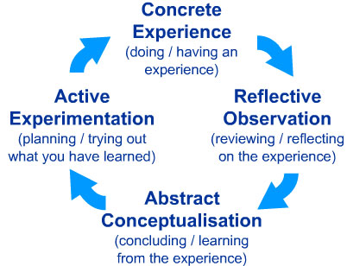
Figure1: Kolb’s Model
(Source: DeCoux, 2016)
According to this theory, there is a cyclic pattern based on which learning can be done. It includes doing, reviewing, concluding and planning (DeCoux, 2016). Doing includes encountering a new situation. Reviewing consists of analysing the difference between experience and understanding. Concluding includes reflection that helps in new idea generations or making modifications in the concepts. Planning includes the application of learning in the world to see the results (Misra, R.K. and Khurana, K., 2018).
Honey & Mumford (1995):
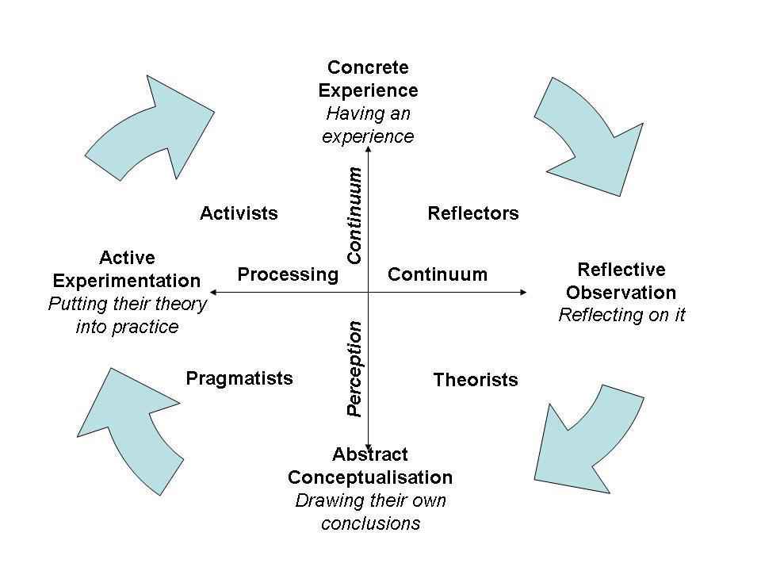
Figure 2: Honey & Mumford
(Source: Truong., 2016)
Alan Mumford and Peter Honey developed learning styles based on Kolb’s theory. According to them the learning styles are of four kinds’ activist, theorist, pragmatist and reflector (AV, N. and Aithal, P.S., 2018). Activist learners learn by doing things on their own. It can be obtained by role play, group discussions. Theorist learners learn by analysing the theories for the actions. Models and applying theories can be used for such kind of learning. Pragmatist learners learn by putting the academic learning into practice that is beneficial in real world. Case studies can be used to promote such learning. Reflector learners learn by observations and analysis on the cases. Paired discussions and observation method can help in such learning (Hirschi, A., 2018).
Felder & Silverman (1988):
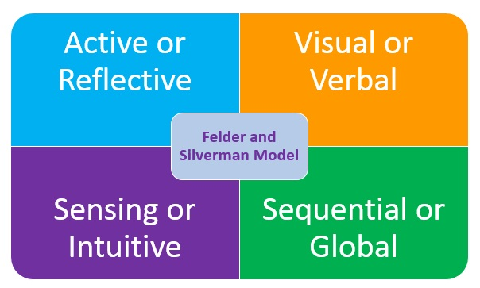
Figure 3: Felder and Silverman model
(Source: Joseph and Abraham, 2017)
According to Felder &Silverman learning consists of four areas of personality. It includes active or reflective, sequential or global, sensing or intuitive, visual or verbal (Joseph and Abraham, 2017). Sensing or intuitive personality describes how a person prefers to perceive the information. Active reflective personality describes how a person prefers to process the formation. Visual verbal describes how a person prefers to present the information. Sequential-Global determines how a person prefers to progress and organise understanding the information (Hasnan, K.A., 2018)
From the above learning styles, I think the learning style by Honey and Mumford is the most appropriate style of learning which can be applied in the organisation and day to day activities. This style is easy to understand and can be connected to changing scenario of the organisation. From the above style personality and perception play a major role in the learning activity.
I would prefer to learn by Honey and Mumford style of learning as it is easy to understand and effective in personality development. For making developments in my learning process, enhance my problem-solving skills and interpersonal skills. For doing that I need to solve several case studies, actively participate in group discussions.
From the above discussed theories, I would prefer the Fielder & Silverman theory to be one of the best. By learning this theory properly, I can perceive information very clearly, which will be followed by the processing of information. The visual verbal skill according to this theory, will help me to present my idea and any other information in the most effective way, which in turn will lead to my huge success.
Discussion on the personal key skills
Self-management skills
Self-management skills are used to evaluate certain range of academic skills and manage time in the most effective manner (Gill, R.J., 2018). During both my academic as well as professional career, I have learnt many things, which include SWOT analysis, based on my performance in a task. I have rated myself based on my skills. During the lecture sessions, several case studies and real-life examples have helped me to understand various concepts and theories of learning. I have analysed all such concepts on my own by meeting the code of ethics. Although, in some cases, expert advice was also required to understand and analyse a concept.
Management of learning
I can highly manage my learning process and can take huge responsibilities of my own learning. I have developed certain learning strategies and evaluated myself according to my skills. Throughout my entire career, I have studied various theories and this session has helped me a lot to apply those theories, which will help me further in future.
Problem solving skill
I have identified the key features of problems in general. In this session, I have learnt about my problems very seriously. I lag in various data handling skills and I thought about my problem laterally. I have improved myself regarding the problem-solving skills in this project session by reading some books and articles of scholars. Thus, the role plays in this session and various organizational experiences have helped me to enhance my problem-solving skill.
Communication skill
I have excellent communication skill both verbal and written communication. By using this skill, I have led my entire team. In this session, while working with my co-workers and other customers, helped me to enhance my communication skill and provided me scope for further improvements in this area by implementing several strategies and formulations.
Skills of working with others
I always respect the views of others and give value to others, though I am working with them or not. I took initiative of leading my team. I have high negotiating power, which helped me to work with others in the most effective way. Team work helped me to work towards collective goals. Though I have high skill in this area, I need to learn more and become much more efficient in collaborating with others in a team.
Data handling skills
I have recorded and interpreted the results of this session. I have weal data handling power and thus I need to adapt this skill much more. I must understand the use of various tools, which are used in data handling, by reading several books, magazines and articles of scholars. I must use appropriate theoretical information, by which I can learn the process of effective data handling. I have evaluated myself and thus it can be said that I must adopt many strategies for getting a vivid understanding in this field and an expert assistance is necessary to learn data and information handling effectively.
My key strengths are communication skills, ability to work with the team, problem solving skills and learning management. These strengths can be improved by handling more assignments and taking part in presentations. My weaknesses include data handling ability and self-management. It can be improved by getting training from the experts and making developmental plans to meet the future needs. The ratings have been done prior to my experience gained in the organisation and academic career.

Analysis of personal strength and weaknesses
A SWOT analysis has been done to analyse the areas where I can make further improvements and what are my strong areas that can be applied in the organisation for career growth.
Strengths | Weaknesses
- Analytical skills  - Communication skills  - Ability to handle a team | - Lack of data handling skills  - Ability to meet the workplace pressure
Opportunities | Threats
- Team leading  - Handling foreign assignments  - Career growth | - Meeting the deadlines on time  - Opportunities to other competent employees

Table 2: SWOT analysis of self
(Source: Created by author)
Reflective comments based on the Strengths, Weaknesses, Opportunities and Threats:
Strengths:
After completion of this session, I came to know about myself a lot. I can evaluate myself based on my task. I have a very strong and high communication skill, which helped me to work with others of my team. I have strong analytical skills as well. Both skill sets helped me to handle my team in the most effective way.
Weaknesses:
Apart from noting down the points of my strength, I have some weak points as well. I lag in the data handling skills, which in turn gives me much more stress and pressure. I am not that good in handling pressures within my workplace. Thus, I must improve this area by learning through various articles and taking help from teachers as well as from internet. I believe that learning is a continuous method and through learning, an individual can have a good grasp on the most difficult thing. So, I will learn to overcome my weaknesses and improve myself further.
Opportunities:
There are several opportunities waiting for me after successful completion of this task. According to my skills, I may have some team leading opportunities. Several foreign assignments shall be given to me and I have to handle the team in order to complete those assignments. A huge career growth is waiting for me and in order to achieve this growth, I have to perform effectively.
Threats:
Apart from opportunities, there are certain threats waiting for me as well. All the assignments, which I will be in charge of the completion will have to be finished within the stipulated time and I have to grab high time management skill, so that I may complete tasks within the deadline.

Discussion of a PDP (Personal Development Plan)
Goals | Action | Success criteria | By when date
To improve the data handling skills | Taking training from the technical experts | Training from the experts in MS excel will help me to learn about the application of tools in order to apply them in near future. | 3 months (by 14thnovember)
To make improvements in self management | Preparing a proper SWOT analysis and making strategies to overcome the weakness and threats. | Following the strategy in accordance to the SWOT analysis will help in making improvements for self-management. | 1 months (by 13thseptember)
To make job expansion | By enhancing the roles and responsibilities in the organisation with training | Training from the experts will support in understanding the roles and responsibilities of new job | 6 months (by 13thfebruary)

Table 3: Personal development plan
(Source: Created by author)

Analysis of the induction programmes in Chop House
Chop House in South Place is one of the most famous "British Eating House" in an excellent sense that makes the democratic eating more confident, eclectic, and delicious yet simple. Management of this restaurant is looking for a passionate and severe restaurant manager, who will be able to deliver excellent 5-star services to the guests confidently. The manager also will know the drink and food for leading the restaurant services correctly. As per the advertisement, he or she will be responsible for delivering an outstanding experience to the guests. As discussed earlier I have strong communication skill, more or less I am doing good while executing the job. As a restaurant manager, one has to be very much extrovert and communicative with others on a daily basis, being an extrovert I think I can be able to do justice for this post. Moreover, I also have excellent problem solving and team handling capacity that I believe make my perfect choice for the job. I have got a good induction program on the first day of my post that includes the commitment and hours required, absence procedures, the location of the services.
Even if it were a fair exercise, it would get better if there was more time as a lot of segments like lifting regulations, essential policies, holiday entitlement, training policies get untouched. After working for a few days in this organisation, I would like to change training policies and holiday entitlement program of the company. For growth and development of the organisation, the management must sponsor for the capable students that will be helpful for both trainees and management. On the other hand, due to the opaque holiday policies, there is confusion, mass bunk and increased leaves are increasing day by day. As described by Becan et al. (2015), induction program illustrates an organisation itself by developing an idea about the organisational structures, policies, rules and regulations, opportunities to a new entrant. It also gives a clear concept about the grievances and complaint procedures, quality assurance, smoking protocols, equal opportunities and dress codes. As per the TPI theory, organisational induction program must be including the development of the practical and theoretical skills besides the capabilities of meeting the interaction requirements, which exist among the new employees. As per the experiences, I also get some in-depth knowledge about the company's structure and practical skills of handling any scenarios. As I have some problems regarding handling the stress and adaptability of the problematic situations, I might need to work on those to secure a strong position in the career world.

Investigation of the organisation
The main aim of the company is to deliver the tasty, delicious yet straightforward food in London. Superlative brunches are on the weekends make the famous eatery Chop House popular to become a most visited place at its right. The primary objective of this company provides an ever-changing and uncomplicated menu dedicated to the carefully sourced and seasonal cuts of meat and freshly caught fish that is modernised with seasoning and continental flavours. Among others, this organisation has a development plan of hiring a passionate restaurant manager, who will be responsible for delivering exceptional 5-star services to the guests. The company has core values of providing fresh foods with those are environmentally friendly, organic and sustainable to the customers. The bright lines of the responsibilities and communication of the organisational structure are not presented here. Thus it is difficult to draw a proper diagram of the people’s responsibilities at work.
Being a management trainee in the hotelier industry, I have a list of duties like management of customers, keeping the details of the products, money management etc. I have to report one of my senior officials, who will also help in preparing me for doing the job more efficiently. It supports in analysing one's strengths and weaknesses to make improvements in the performance. Workplace learning adds values to the organisations and the employers. Employees should not only know the jobs for performance but should also possess intellectual skills, communication skills, adaptability skills, problem solving skills. He helps me a lot in upgrading my interpersonal and management skills and in training to do the work acceptably. At some point in time, I was very much unsure about the job, and the hectic schedule makes me frustrated and confident less. Experiences from my colleagues and senior professionals, the proper confidence in handling the situation by loving it makes me confident and ultra sure about the success. The manager also will know the drink and food for leading the restaurant services correctly. As per the advertisement, he or she will be responsible for delivering an outstanding experience to the guests. After recent promotion and praising from the colleagues, I get to know that style of work on the right track, and I can improve myself better if I overcome the issues related to the adaptability of situations and stress. There is a feedback system in the company that evaluates the performances of the employees and help them in making it more professional and efficient in the work. While I get demoralised and frustrated, this feedback and appraisal system gains my motivation and makes me enthusiastic about doing my job.

Revaluation of PDP (Personal Development Plan)
As discussed earlier, to improve myself I need to revise the Personal Development Plan as per the requirements of the workplace. The main reason for revisiting the plan is to make myself more comfortable and confident in the workflow. My weaknesses include data handling ability and self-management. It can be improved by getting training from the experts and making developmental plans to meet the future needs. As this is the restaurant industry, one must have a substantial problem solving and interpersonal skill for handling all type of situations. For making developments in my learning process; enhance my problem solving skills and interpersonal skills. For doing that I need to address several case studies, actively participate in group discussions. I already have my development plan with my supervisor for further guidance and motivation. All of my projects are both achievable and realistic and besides, these goals I also want to brush my academic knowledge about my job and to join different courses on management and leadership to gain experiences. Both my colleagues and high officials help me in motivating in my direction of work and make me confident to achieve the targets or goals.

Analysis of the performance through log entries
My performance has been analysed in this project report with the help of learning logs. The description, feelings and detailed evaluation has been critically analysed in a form of table, shown hereafter.

 | Log 1 | Log 2 | Log 3 | Log 4 | Log 5 | Log 6
Description | Previously I have faced some problems regarding handling the teams that make some nervous and increases confusion in the workplace. | Due to lack of interpersonal ability, I sometimes faced problems in expressing myself in the last projects. | Due to the interpersonal skills, I faced the confusion at work, while neither I understand the views nor I get the confidence to ask for it. | Lack of confidence at the time of giving a presentation often prevents me from getting my success. | Some days back I faced problems in handling the team meeting due to the lack of proper problem solving skill. | Lack of problem solving skill, I sometimes faced the challenge with my colleagues.
Feelings | I was feeling nervous as well as helpless. | I was feeling confused. | I was feeling confident less, and maybe the impressions of others get affected. | I might handle the situation better if I practised it more. | I would have handled the team more efficiently if I get more time. | I was confused and pointless at the same time.
Evaluation | - Learning of proper handling of the teams  - Embarrassment | - Understand the importance of the importance of interpersonal skill  - Confusion at work | - Importance of expressing views  - Lacking confidence while handling the situations | - The significance of practices before the presentation  - Lack of confidence | - Influence of the team handling  - Lack of efficiency in the workplace | - Importance of the colleagues  - Lack of confidence
Conclusion | - Positive | - Contrary, if this happens again, I would handle it differently. | - Positive | - Positive | - Positive | - Must be adequately handled in future
Action Plan | I must have reconciled myself by gathering experiences from the seniors. | I must have joined in the courses for getting the in-depth knowledge. | I have to identify the problematic areas and overcome the issues. | I need proper practices and academic knowledge before conducting a presentation. | Proper communication with the teammates is necessary for this procedure. | Proper knowledge of problem solving skill must be needed in this issue.

The final discussion of personal development and learning
During the coursework, I have achieved many experiences regarding the handling of the team as well as individual. I also came to know about the importance of the leadership skills, interpersonal skills and communication in an organisation. As per the experiences, I also get some in-depth knowledge about the company's structure and practical skills of handling any scenarios. As I have some problems regarding handling the stress and adaptability of the problematic situations, I might need to work on those to secure a strong position in the career world. As I have some problems regarding handling the stress and adaptability of the problematic situations, I might need to work on those to secure a strong position in the career world. I have already discussed that I have some problems of handling stress while I am in any complex situation. In order to overcome this fact, I have to learn more from various scholar articles and I need to attend some sessions, which will help me to gain confidence in those fields, where I lag behind.

Reviewing the PDP (Personal Development Plan)
In initial development plan, there was a gap between handling stress and lacking ability in handling the stressful situations. By using the reflective logs, feedback and self-assessments from the employees will help me understand the problematic areas. Moreover, further academic study, research and guidance from an experienced person will help me in growth and development. Lastly, the training and development program and part-time services in other companies will probably help me in placements in future work and experienced goals. However, I have excellent analytical and problem solving skills that will help me to reach in my targets more effectively. I have to brush my positive skills and cover up all the issues to make the full growth and development in both personal as well as professional front.

Conclusion
The process of independent learning is one of the most challenging tasks. Students need to adapt various attitudes and skills, which is required for their successful and independent study. In this project report, a self-evaluation has been conducted according to independent learning. Before understanding about a particular topic, it is highly essential for a student to understand their own-self, which will help them to become successful in near future.

Reference Lists
AV, N. and Aithal, P.S., 2018. Employability Skill Traits Management Quotient [ESMQ]-A Conceptual Model Proposal.
Becan, J.E., Knight, D.K., Crawley, R.D., Joe, G.W. and Flynn, P.M., 2015. Effectiveness of the Treatment Readiness and Induction Program for increasing adolescent motivation for change. Journal of substance abuse treatment, 50, pp.38-49.
DeCoux, V.M., 2016. Kolb's learning style inventory: A review of its applications in nursing research. Journal of Nursing Education, 29(5), pp.202-207.
Gill, R.J., 2018. Building employability skills for higher education students: An Australian example. Journal of Teaching and Learning for Graduate Employability, 9(1), pp.84-92.
Hasnan, K.A., 2018. Development of Employability Skills Measurement Model Among Engineering Graduates of Community College Using Delphi Technique and Confirmatory Factor Analysis. Advanced Science Letters, 24(4), pp.2660-2664.
Hirschi, A., 2018. The Fourth Industrial Revolution: Issues and Implications for Career Research and Practice. Career Development Quarterly.
Husebø, S.E., O'Regan, S. and Nestel, D., 2015. Reflective practice and its role in simulation. Clinical Simulation in Nursing, 11(8), pp.368-375.
Jackson, T.P. and Oliver, S., 2018. Adaptive learning program for developing employability skills. Journal of pedagogic development.
Joseph, L. and Abraham, S., 2017, July. Instructional design for learning path identification in an e-learning environment using felder-silverman learning styles model. In Networks & Advances in Computational Technologies (NetACT), 2017 International Conference on (pp. 215-220). IEEE.
Misra, R.K. and Khurana, K., 2018. Analysis of Employability Skill Gap in Information Technology Professionals. International Journal of Human Capital and Information Technology Professionals (IJHCITP), 9(3), pp.53-69.
Pianta, R.C., 2018. Does professional development reduce the influence of teacher stress on teacher–child interactions in pre-kindergarten classrooms?. Early Childhood Research Quarterly, 42, pp.280-290.
Truong, H.M., 2016. Integrating learning styles and adaptive e-learning system: Current developments, problems and opportunities. Computers in human behavior, 55, pp.1185-1193.

