Chapter 4 – Analysis of Results

For my dissertation project I decided to carry out research to answer the question “Is discrimination faced by officers in South Wales Police a major problem and if so, are particular groups of staff more affected than others”.
I designed a questionnaire with multiple choice answers that would be quick to answer to encourage replies, and prior to its public release I had a number of trusted colleagues peer review it in order to clarify questions and give initial feedback. I also had a number of individuals who were comfortable to give 121 interviews with me should I not get enough responses.
Given this was sent to both officers and staff I will be referring to the respondents as officers for simplicity.
I received 95 individual responses, and I think this number was sufficient to extrapolate sufficient useful results from them so I did not undertake any 121 interviews.
Given discrimination is often gender based, I set some questions about experiences to be answered by male officers only and a different set for female officers only as well as a set to be answered by all. I also included open ended questions in case respondents wanted to expand on their answers with personal experiences. The initial set of experiences were aimed at officers who had experienced them personally, but I also added some for those who had seen it happen to a colleague rather than themselves.
Given that the responses being requested were subjective, the data collected was generally qualitative in nature in that the officers were asked how they felt about the experiences, but I used the qualitative data, being the number of responses in a series of preset categories in order to make some analytical comments.
Analysis of Results
- 95 total responses, 38 from female officers, 55 from male officers, one nonbinary officer and one who preferred not to say.

- 9 officers were in their first year in the job, 30 were officers with 3-5 years (so including probationary officers), 16 were officers with 6-10 years of service and 41 were long serving officers with more than 11 years of service. This was interesting as I was expecting less response from this last category, as I had assumed these officers to be inured to discrimination.

- Most of the questions required one of multiple choice answers as per the chart below. Since I was asking for people’s perceptions about discrimination in general, these choices enabled respondents to define the severity of their experience. I used the response numbers to calculate total numbers of officers who had experienced some discrimination, even if rarely.
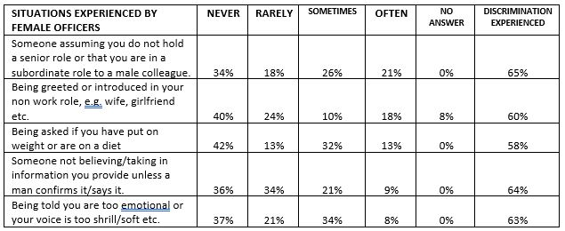

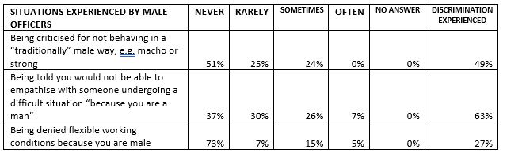
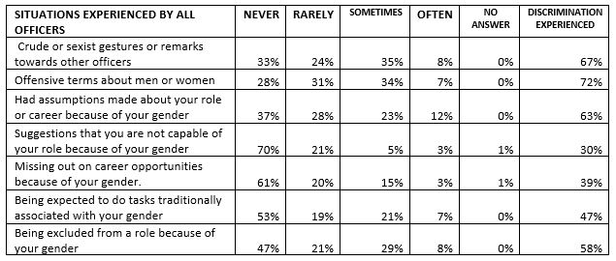

The results show that far more female officers face some discrimination, on average 62%, than male officers at an average of 46%, despite male officers responding in greater numbers.
- Finally, I asked for responses about situations that had been seen happen to colleagues as well as having experienced them personally. I enabled a more specific choice for responses and respondents could choose more than one answer so I have used numbers rather than percentages here. Not all respondents answered all the following questions, but 74 of 95 answered at least one.

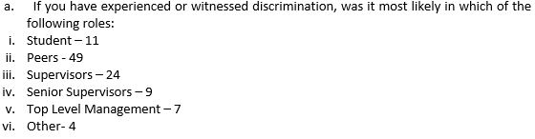

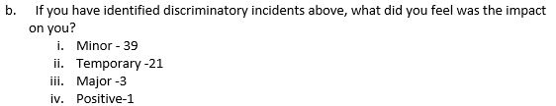

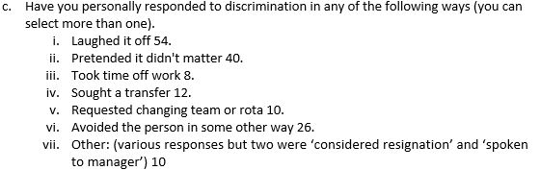

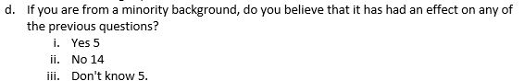

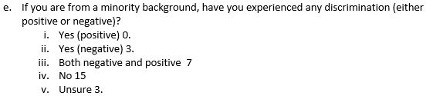

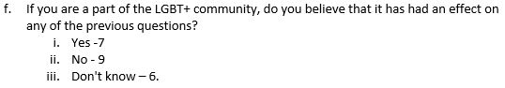

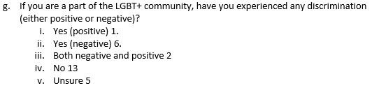

- The open ended section enabled respondents to give free form answers and given the limited number of words available in this Thesis Chapter, I have chosen to create a Word Cloud from the responses, both to hide any potentially identifiable responses, but also to show words used most commonly in the responses.

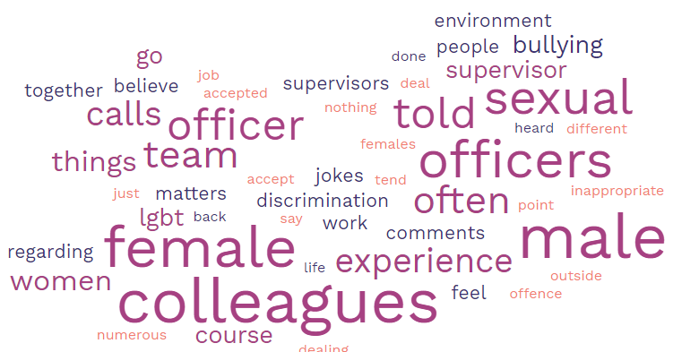

The Word Cloud generator identified 442 separate words in the responses, excluding joining words such as ‘and’, ‘the’ etc. The number of times each word appeared contributed to its size in the resultant picture, i.e. the larger the word, the more times the word appeared in the responses.
Some of my observations from the resulting word cloud are:
- The words FEMALE and MALE occurred a similar number of times.
- COLLEAGUES appeared more often.
- TEAM appeared less than individual terms, which was interesting as policing is considered to be very much a team activity.
- FEMALE appeared more times than WOMAN which appears to show that perhaps Female Officers prefer not to be called women, and/or that men prefer not to identify a colleague as a woman for a variety of reasons.
- BULLYING appeared more often than JOKES which I would take to mean that people are now recognising that jokes aren’t always funny and can be bullying instead.
- As noted below, discrimination is not always SEXUAL but the word itself appeared quite a lot so is clearly of concern.
General Observations
An interesting piece of data is that the balance of gender shifted between the length of service groups who responded, with it being an even split in groups 0-1, and 2-5 but a more males replying within the other categories. Whether this is indicative of recruitment or job retention between genders is hard to say but I felt that the observation was interesting and could be evaluated further in the future.
There have been a small number of replies that have responded that they have not witnessed discrimination. One respondent wrote that what is discussed within my questionnaire is not discrimination but what they have deemed jokes or playing into natural strengths of each gender. However this is more than offset by the other responses as well as feedback I have had personally from people who have spoken to me privately following publication of questionnaire. But it does highlight ignorance of the issue is still present even in a small portion of the force.
Other than this a number of officers made mention of other discrimination that they have faced that was not captured in this survey. Notably age related discrimination but also that of hidden disabilities such as mental health, and minority groups regarding hobbies/music tastes.
In conclusion, I am happy with the quantitative data obtained however it does show that despite improvements there is still actual and perceived discrimination happening within the work force. I will be further evaluating the data and making recommendations on my findings in the next chapter of the Thesis project.

1029 words excluding pictures as per instructions.

