

Module Name: Changemakers: Creativity and Value Creation (BMHP5014)
Student Name: Rosangela Maria De Sousa Rodrigues- Varkucs
Student Number: 2326619
Lecture Name: Dr Laila Salami

Date: 03/ 12/ 2025

Table of Contents
Introduction 3
Defining Key Concepts in Practice 3
Mind Map 4
Self-Reflection of Group Activity 5
Case Study Analysis of a UK Innovation 5
Research Task 6
Exploring Digital Innovation in Health and Social Care 6
Understanding the NHS Leadership Framework 7
Leadership Behaviour: Leading with Care 8
Self-Reflection Journal Entry 8
References 10

Introduction
This portfolio explores key concepts of creativity, innovation, value creation, and change in the UK health and social care sector. Every task is a combination of theory and practical examples from the National Health Service (NHS) to demonstrate how creative and evidence-based practices can improve patient outcomes, workforce well-being, and organisational performance. The portfolio reflects and analyses the way to sustain improvement through digital transformation, leadership, and collaborative thinking. It also emphasizes the significance of reflective learning and moral leadership towards developing value-driven, compassionate innovation. Ultimately, the portfolio demonstrates that creativity and innovation are crucial towards the realization of the vision of the NHS to provide high-quality, equitable, and person-centered care throughout the United Kingdom.
Defining Key Concepts in Practice
Innovation: Innovation in health and social care is the use of a new idea, technique or technology, which improves patient outcomes, organizational performance, or effectiveness at the system level. NHS England (2023) defines innovation as the process of transforming ideas into better services and patient outcomes. It plays a crucial role in addressing long-term issues like the shortage of workforce, service backlog and growing patient demand. As an example, in the case of the COVID-19 pandemic, the adoption of virtual consultations in a short time altered the principles of access to primary care and continuity of care, which proved that digital tools increase the clinical reach and ensure safety and quality (Mould et al., 2021).
Creativity: Creativity is the ability to generate new and significant ideas that can be used to address the complex or emergent challenges (Amabile and Pratt, 2016). In social care, creativity promotes emotional well-being and interaction among service users. Volkmer (2016) emphasizes that creative, art-based interventions, including music therapy, painting, and storytelling, assist the person with dementia to remember and build social connections. These methods make healthcare humanized by incorporating emotional, cognitive and social aspects of care.
Value Creation: Value creation is the provision of quantifiable patient, staff, and organizational benefit by means of sound service design and innovation. According to Elliott (2017), healthcare value is the optimal outcomes in comparison to the available resources. The Quality, Innovation, Productivity and Prevention (QIPP) programme is an example of this principle because it facilitates efficiency without a reduction in patient care. Value creation is achieved through innovation, prevention and collaboration to bring about sustainable changes in both quality and cost-effectiveness.
Change: Change is a systematic movement of an operational process into a superior and efficient model (Kluttz and Fligstein, 2016). The use of Electronic Health Records (EHRs) in the NHS is one of the successful stories of managed organisational change. Under the three steps of the three-stage model of change as developed by Lewin, which include unfreeze, change, and refreeze, trusts have incorporated digital systems in enhancing the accuracy of data, teamwork, and service delivery.
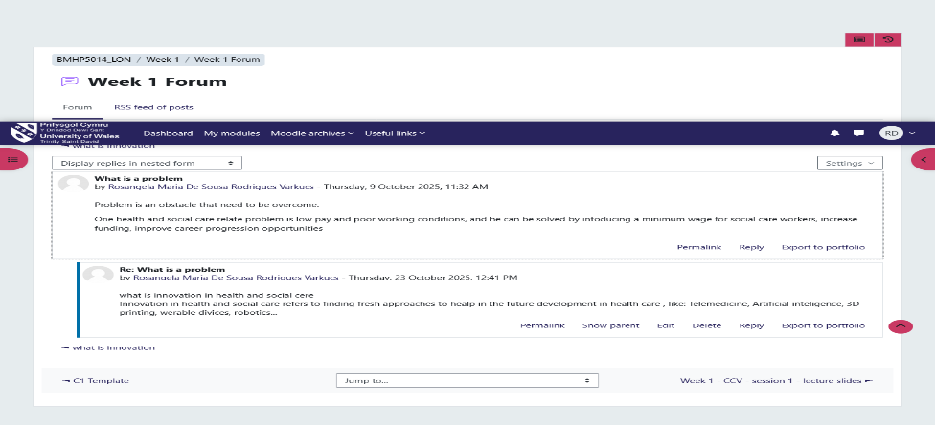
Mind Map
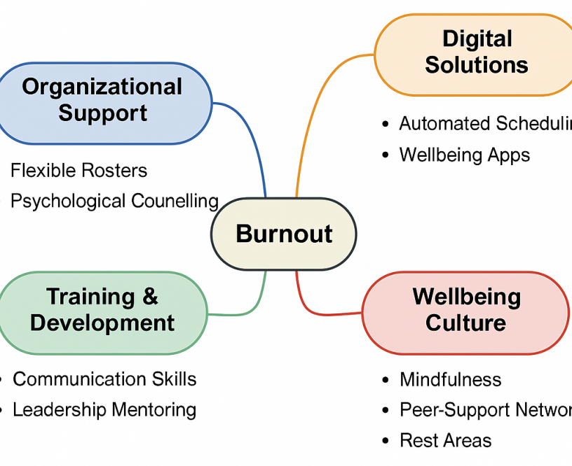
Figure 1: Mind Map – Reducing Staff Burnout in the NHS
Source: Self
The problem of staff burnout in the NHS is identified as the central one. The mind map puts Burnout at its center, which has sub-branches of Organizational Support, Digital Solutions, Training and Development, and Wellbeing Culture. Organizational support comprises flexible routes as well as psychological counselling. The digital solutions include fatigue-monitoring and automated-scheduling apps. The focus of training is the mentoring of leaders and communication. The culture of wellbeing instils peer networks, mindfulness, and rest spaces. All the branches are interconnected to show that the creativity and innovation of the system are needed to reduce burnout. This interdisciplinary practice, in line with the NHS people plan (2023), prioritizes compassionate, sustainable workforce management, emphasizing the need to consider staff wellbeing as a component of quality patient care rather than a voluntary program.
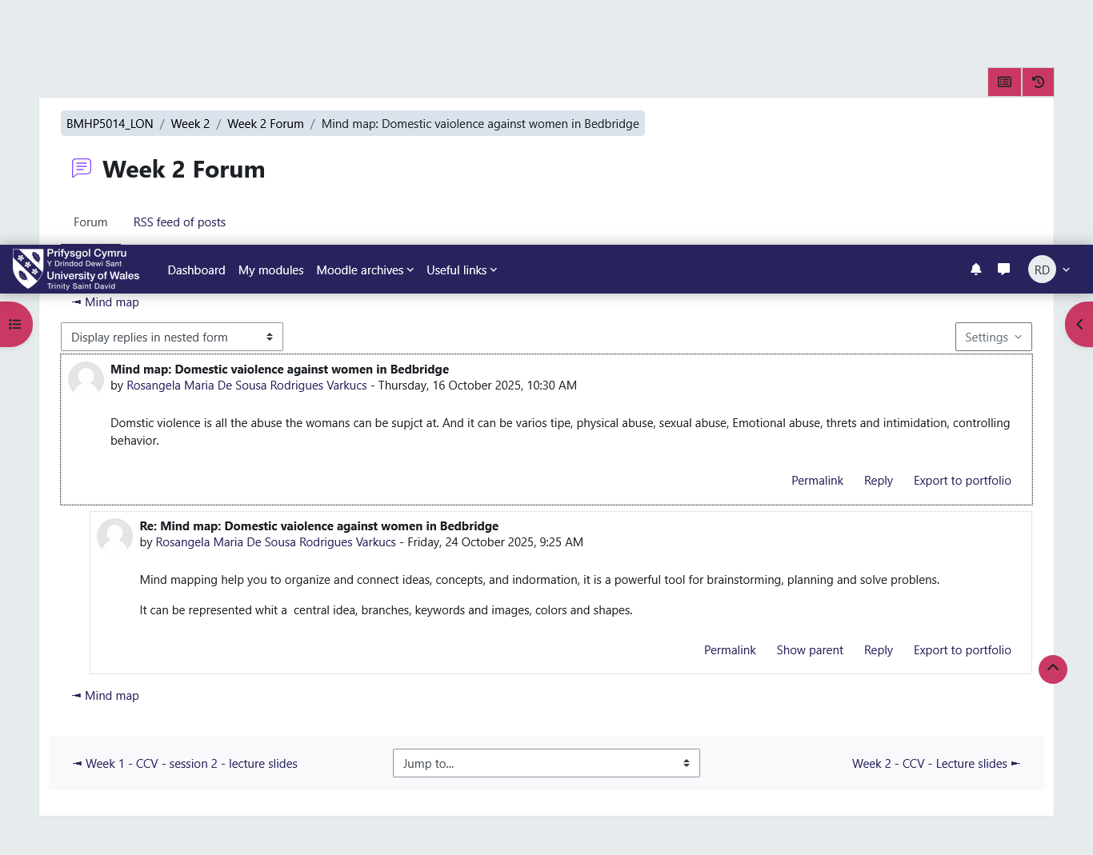

Self-Reflection of Group Activity
I used the Reflective Cycle by Gibbs to reflect on the Convergent and Divergent Thinking group activity. Convergent thinking is the process of logical thinking to come up with one efficient solution, whereas divergent thinking encourages the creation of several creative solutions (Runco, 2014). In the early stages of my career, I used convergent methods extensively and was not ready to consider unorthodox recommendations. Nevertheless, group work made me apply divergent approaches, i.e. brainstorming in an open environment and without judgment, which resulted in creative ideas on how to enhance patient experience.
In the process of reflection, I realised that appropriate problem-solving in health and social care relies on the combination of both types of thinking. Creativity and innovation are encouraged by divergent thinking, and feasibility and evidence-based solutions are guaranteed by convergent thinking. This balance is the reflection of NHS innovation processes, in which creative proposals are put to the test in the form of structured evaluation. It has enhanced my levels of teamwork, flexibility, and reflection, which is why teamwork is essential in creating a meaningful change. I also got to know that sustainable healthcare innovation is based on creativity and critical thinking.
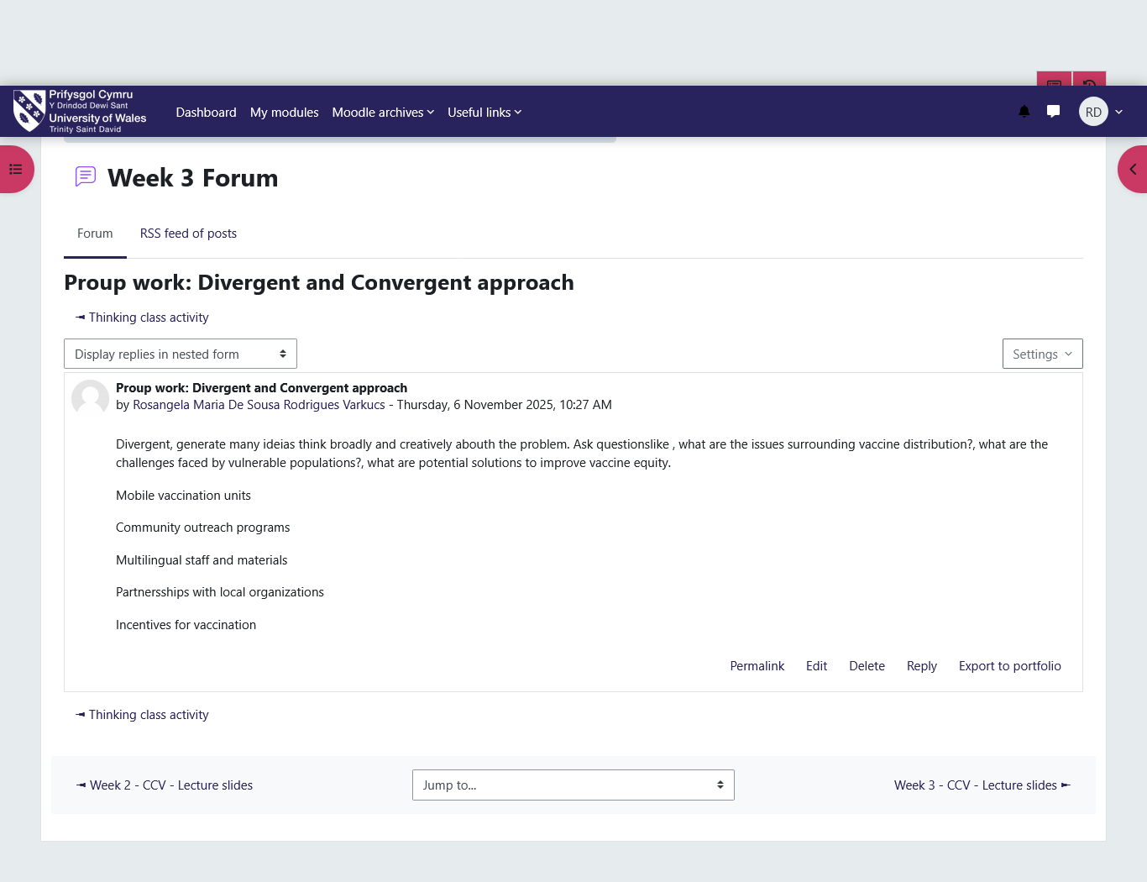
Case Study Analysis of a UK Innovation
The NHS COVID-19 App is a major UK innovation, which was introduced in 2020 to aid in contact tracing and controlling the infection. The project demonstrated digital creativity using Bluetooth Low Energy technology and decentralized data storage that ensured the privacy of the users (BBC News, 2020). The main issue that was solved was the fast recognition of the exposure chains to minimize the spread. The partnerships between NHSX, Apple, and Google proved the successful cross-sector innovation in the provision of public health.
The app generated quantifiable value through improving communication, making test notifications faster, and avoiding thousands of infections (NHS Digital, 2021). The article in Nature had a chance to verify the existence of a gigantic reduction in the degree of dissemination and an increase in the degree of interest in digital health tools among the population. The project has demonstrated that the NHS was capable of considering behavioural insight, openness and innovative technology to provide a solution that would be citizen-based. Finally, the example of the NHS COVID-19 App shows that innovation and collaboration could contribute to the efficient, safe, and resilient healthcare system of the community in the UK.

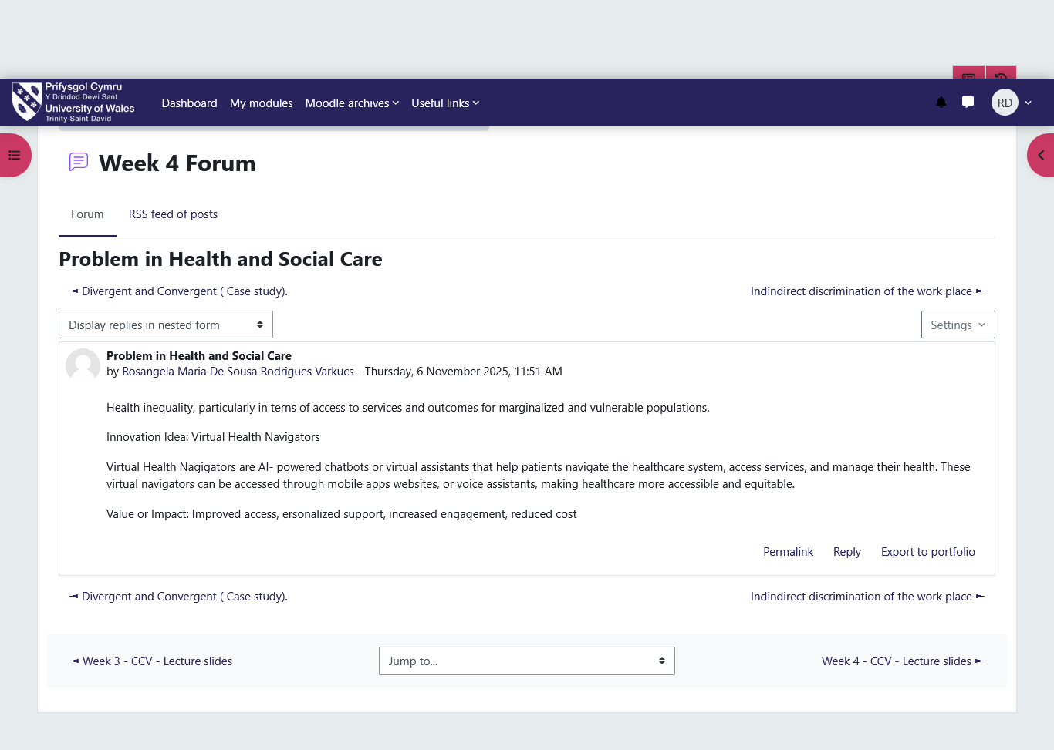
Research Task
Issue: Staff Burnout in the NHS
The issue of staff burnout is also still acute in the NHS because it is triggered by overworking, emotional pressures, and a lack of resources. The authors West, Bailey and Williams (2020) have discovered that one of the main reasons that leads to low morale and high turnover rate of nurses and midwives is the existence of chronic stress and emotional fatigue. Their research identifies the significance of compassionate leadership and peer-support systems in safeguarding the welfare of the employees and the continuity of the quality of services. Equally, Hall et al. (2016) have established that burnout is directly related to poor patient safety and high clinical errors as well. The two articles re-establish the importance of holistic wellbeing interventions, such as work flexibility and reflective practice, and psychological support. These strategies introduce resiliency and organizational culture. All the facts point to the fact that burnout is not a problem of an individual but a system failure that needs structural change. Maintaining equal staffing ratios, rest, and combined mental health services aligns with the current goal of the NHS to provide compassionate leadership and high-quality, patient-centred care.
Exploring Digital Innovation in Health and Social Care
a) Wearable Health Technologies: One of the most important innovations in personalized care is wearable health technologies, including smartwatches and continuous glucose monitors. These devices allow one to monitor physiological indicators (like heart rate, oxygen saturation, or blood-glucose levels) constantly and relay real-time data to medical workers. Feng et al. (2021) concluded that self-tracking enhances health awareness, medication adherence, and patient interaction. The wearable has been integrated into the rehabilitation programme in the NHS to add value to post-surgical monitoring and chronic disease management. As an example, the readmission rates and outcomes were reduced and better among cardiac patients who wore Fitbit-related systems (Feenstra et al., 2023). These are the innovations that are value creation manifested in personalisation and early detection, and which can assist the NHS to transition into a proactive versus a reactive treatment of diseases.
b) Electronic Health Records (EHRs): Electronic Health Records (EHRs) may be described as the systems that may be utilised to store information about patients in such a way that healthcare professionals are able to access current information by using various systems. As Wachter (2016) pointed out, medication errors and improved care coordination and multidisciplinary communication may be prevented with the help of EHRs. The EHRs adopted by the NHS hospitals in the Epic and Cerner systems assist in safer prescriptions, quicker referrals and more precise data. The flow of information to the clinicians has been made timely and complete since primary and secondary care are interoperable to enable clinicians to make more informed decisions. It can also be used to analyse population health using EHRs, and this can be achieved through the digitalisation of records, and thus the managers are able to identify trends which can be used to manage the resources optimally.
c) Preventive Care and Health Promotion: Digital technologies are disruptive in the sense that they enable preventive healthcare and health promotion. This is what befell the NHS Digital Weight Management Programme, which provides personalised online guidance and the monitoring of the progress of the promotion of healthy lifestyle change. Feenstra et al. (2023) explain the digital tools to be used to implement behavioural change due to their availability and real-time feedback. There is an increasing trend of predictive analytics and an artificial intelligence system to intervene at an early stage to contain individuals who are susceptible to acquiring chronic illnesses. Technology can be utilised in the national plans, like the NHS Long Term Plan, which focuses on prevention rather than cure. All these digital solutions can contribute to the value creation through the enhancement of health outcomes of the population and decreasing the cost of long-term care.
Understanding the NHS Leadership Framework
The NHS Leadership Framework, which is introduced as the Healthcare Leadership Model, is the seven core behaviours of an effective leader in the UK health and social care, including Inspiring Shared Purpose, Leading with Care, Evaluating Information, Connecting Our Service, Sharing the Vision, Engaging the Team, and Holding to Account (NHS Leadership Academy, 2021). All of them are the core principles of caring and inclusive leadership that promote collaboration, innovation, and quality care in the ranks of the NHS. The model enhances accountability, integrity, and emotional intelligence, and aims at patient-centered outcomes and long-term enhancement.
The greatest objective of the framework is to make sure that all the healthcare leaders, irrespective of his/her rank, promote the idea of compassion and inclusivity in decision-making. It promotes contemplation, communication and emotional sensitivity to bring psychological stability among teams. Such safety enables people to exchange ideas without fear of sharing them, and people need to encourage creativity and innovative thinking in the healthcare sector. The leaders are supposed to use both analytical thinking and empathy to guide them through the uncertainty and to bring a positive change in the complex care settings.
Leadership Behaviour: Leading with Care
According to Leading with Care, one should be caring, respectful and considerate of the well-being of the staff. According to Hughes (2019), the Freedom to Speak Up programs help the NHS staff to share their ideas and voice their concerns without any fear of punishment. Such efforts create an understandable and trusting culture that assists in team building and innovation. The caring leaders are resilient, motivation-oriented, and transform the working environment to be more creative compared to compliance-oriented leaders. Strategic leadership and compassion can help NHS leaders to enhance staff satisfaction and patient outcomes.
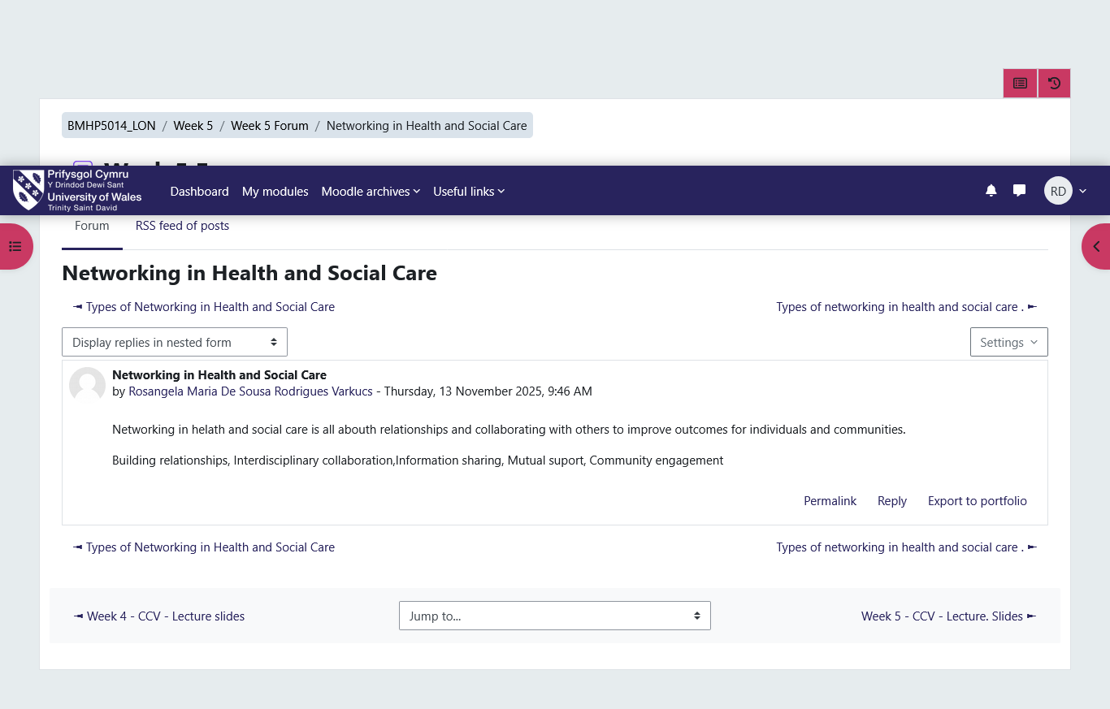
Self-Reflection Journal Entry
The module has broadened my knowledge of creativity and value creation in UK health and social care. I used to view creativity as the expression of art only, but I now view it as a strategic way of thinking that would lead to innovation, teamwork, and caring practice. The example of the NHS, including the COVID-19 App and wearable health technologies, helped me to realize that small, evidence-based ideas may result in massive transformations in patient care. The reflection in the model proposed by Gibbs enhanced my critical understanding of the role of empathy and collaboration in sustainable change. I also came to learn that leadership is based on leading with care, and this creates trust and promotes innovative problem-solving. In the future, I would like to use reflective practice, inclusive leadership, and digital awareness to drive innovation and high-quality and person-centered results in any professional health or social-care setting that I may practice in.
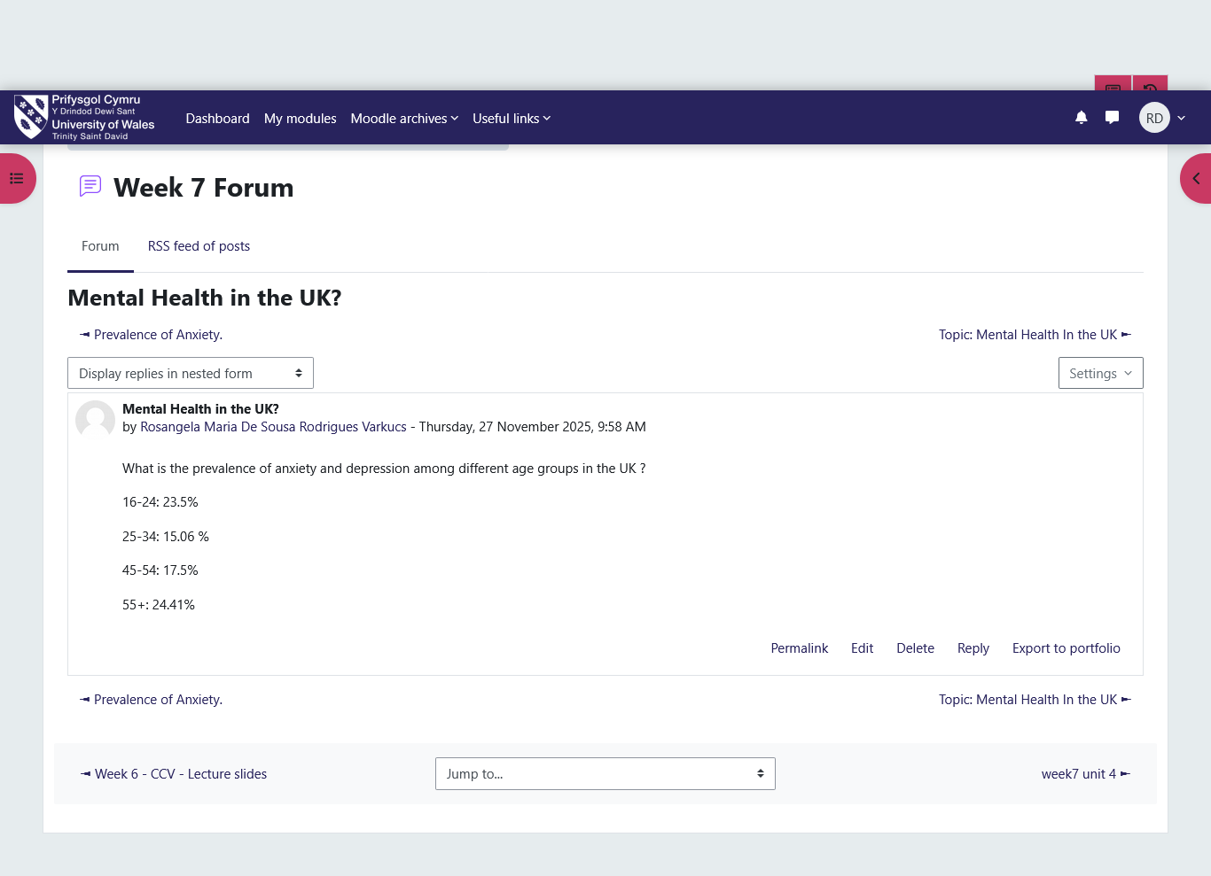
References
Amabile, T.M. and Pratt, M.G. (2016). The dynamic componential model of creativity and innovation in organizations: Making progress, making meaning. Research in OrganisationalBehaviour, 36, pp.157–183.
BBC News (2020). NHS Covid-19 app: How England and Wales’ contact-tracing service works. [Online] Available at: http://bbc.com/news/technology-54250736 [Accessed 18 Oct. 2025].
Elliott, M.J. (2017). What is Value in Healthcare. London: Gresham College.
Feenstra, M., Zuidema, S.U. and Janus, S.I. (2023). Long-term care needs guidance for the implementation of digital health technologies. Age and Ageing, 52(12), p.afad223.
Feng, S., Mäntymäki, M., Dhir, A. and Salmela, H. (2021). How self-tracking and the quantified self promote health and well-being: systematic review. Journal of Medical Internet Research, 23(9), p.e25171.
Hall, L.H., Johnson, J., Watt, I., Tsipa, A. and O’Connor, D.B. (2016). Healthcare staff wellbeing, burnout, and patient safety: a systematic review. PLOS One, 11(7), p.e0159015.
Hughes, H. (2019). Freedom to speak up – the role of freedom to speak up guardians and the National Guardian’s Office in England. Future Healthcare Journal, 6(3), pp.186–189.
Kluttz, D.N. and Fligstein, N. (2016). Varieties of sociological field theory. In Handbook of Contemporary Sociological Theory (pp.185–204). Cham: Springer International Publishing.
Mold, F., Cooke, D., Ip, A., Roy, P., Denton, S. and Armes, J. (2021). COVID-19 and beyond: virtual consultations in primary care—reflecting on the evidence base for implementation and ensuring reach: commentary article. BMJ Health & Care Informatics, 28(1), p.e100256.
NHS Digital (2021). The epidemiological impact of the NHS COVID-19 App. Nature, 594. doe: https://doi.org/10.1038/s41586-021-03606-z.
NHS England (2023). Innovation and Improvement. [Online] Available at: https://www.england.nhs.uk/innovation
Runco, M.A. (2014). Creativity: Theories and Themes: Research, Development, and Practice. Academic Press.
Stan, R.S., Albert, C.N., Holonec, L., Simonca, V., Colisar, A., Rebreanu, F. and Sîngeorzan, S. (2021). Learning by doing – a method for practical activities. In EDULEARN21 Proceedings (pp.11032–11038). IATED.
Volkmer, L. (2016). Psychosocial and creative approaches to dementia care. In Communication and Ageing: Creative Approaches to Improving the Quality of Life, pp.207–231.
Wachter, R. (2016). Making IT Work: Harnessing the Power of Health Information Technology to Improve Care in England. London: Department of Health, pp.1–71.
West, M., Bailey, S. and Williams, E. (2020). The Courage of Compassion: Supporting Nurses and Midwives to Deliver High-Quality Care. London: The King’s Fund.

