Proposal for Modernising Information Systems at Kalori Ltd.
BA (Hons) Leadership and Management Skills for the Workplace| Managing Business Information| LCLM5004| Component 2| Shazad Iqbal (206671).
2026
Contents
1. Introduction 3
2. Evaluation of Existing Systems 4
2.1 Current Information Systems Landscape 4
2.2 Identified Inefficiencies and Gaps 4
a. Inventory Management Failures 4
b. Fragmented Customer Data 5
c. Inefficient Decision‑Making 6
d. Poor System Integration 6
e. GDPR and Cybersecurity Risks 6
Evaluation of Existing Systems 7
3. Recommended Solution 7
3.1 Proposed Information System: Integrated ERP with CRM 7
3.2 Justification for the Recommendation 8
a. Alignment with Business Needs 8
b. Improved Efficiency and Automation 8
c. Scalability for Future Growth 8
d. Cost‑Effectiveness 8
e. Enhanced Data Security and GDPR Compliance 9
3.3 How the System Will Improve Operations 9
a. Inventory Management 9
b. Customer Relationship Management 10
c. Decision‑Making and Reporting 11
d. Departmental Integration 12
How the systems will improve operations 12
4. Implementation Plan 13
4.1 Implementation Steps 13
4.2 Integration with Existing Infrastructure 14
4.3 Potential Challenges and Mitigation Strategies 14
5. Conclusion 14
Reference List 16

Proposal for Modernising Information Systems at Kalori Ltd.

1. Introduction
Kalori Ltd. is a rapidly expanding consumer electronics retailer operating 30 physical stores alongside a growing e‑commerce platform. While the company has achieved strong sales performance and brand recognition, its operational efficiency has not kept pace with its commercial growth. The organisation currently relies on outdated, fragmented, and manual information systems that are no longer suitable for a multi‑store, omnichannel retail environment. These weaknesses are now constraining growth, reducing customer satisfaction, and exposing the company to regulatory and cybersecurity risks. As the company continues to scale, these inefficiencies are becoming increasingly unsustainable.
The most pressing challenges include inaccurate manual inventory tracking, disconnected customer data systems, inefficient reporting processes, poor departmental integration, and non‑compliance with data protection regulations such as GDPR. These issues have resulted in stock discrepancies, customer complaints, slow decision‑making, and increased operational costs. As the company plans further expansion, the CEO recognises the urgent need for a modern, integrated information system capable of supporting scalable, data‑driven operations.
Modernising information systems is essential for organisations seeking competitive advantage, operational efficiency, and improved customer experience (Porter & Heppelmann, 2015; Stair & Reynolds, 2020). In the retail sector, digital transformation is no longer optional; it is a strategic necessity. Retailers increasingly rely on integrated systems to manage inventory, customer relationships, supply chains, and analytics in real time. Without such systems, organisations struggle to compete with digitally mature competitors who can offer faster service, personalised marketing, and seamless omnichannel experiences.
This proposal evaluates Kalori Ltd.’s existing systems, identifies critical inefficiencies, and recommends the adoption of a comprehensive Enterprise Resource Planning (ERP) system with integrated Customer Relationship Management (CRM) capabilities. The proposed solution aims to streamline operations, enhance data accuracy, support regulatory compliance, and enable long‑term scalability. By adopting a modern ERP‑CRM platform, Kalori Ltd. can transition from reactive, manual processes to initiative-taking, data‑driven decision‑making.

2. Evaluation of Existing Systems

2.1 Current Information Systems Landscape
Kalori Ltd. currently relies on a mixture of manual processes, spreadsheets, and disconnected software tools across departments. The key systems in place include:
- Manual inventory tracking in physical stores
- Separate customer databases used by marketing, sales, and customer support.
- Spreadsheet‑based sales reporting.
- Department‑specific software for finance, sales, and inventory
- Basic access controls that do not meet GDPR standards.
These systems were adequate when the company operated fewer stores and had lower transaction volumes. However, as the organisation has expanded, the limitations of these systems have become increasingly apparent. Research shows that fragmented systems significantly reduce operational efficiency and increase error rates (Bocij et al., 2019). In retail environments, where real‑time data accuracy is essential for stock management, customer service, and forecasting, reliance on manual processes creates bottlenecks and inconsistencies.
Furthermore, the lack of integration between systems means that data must be manually transferred between departments, increasing the risk of duplication, inconsistency, and human error. This creates a reactive operational environment where staff spend considerable time correcting errors rather than focusing on strategic tasks. As Kalori Ltd. continues to grow, these inefficiencies will scale proportionally, creating operational strain and limiting the company’s ability to compete effectively.

2.2 Identified Inefficiencies and Gaps

a. Inventory Management Failures
Manual stock tracking leads to:
- Frequent discrepancies between online and in‑store stock levels
- Customer dissatisfaction due to cancelled or delayed orders
- Overstocking or understocking
- Delays in order fulfilment
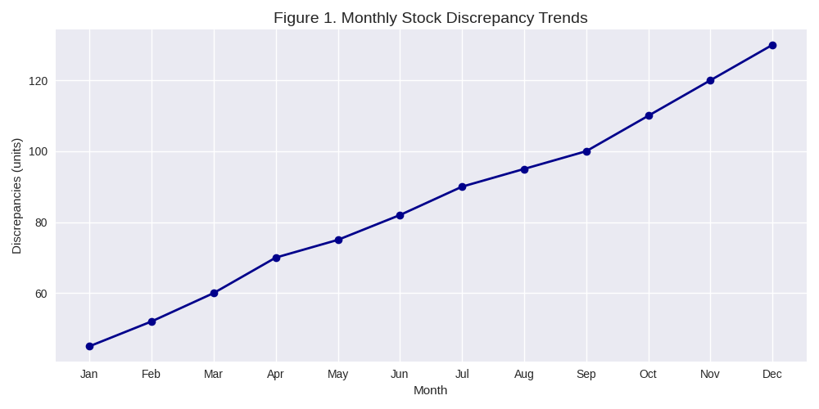
A line graph showing increasing discrepancies between recorded stock and actual stock levels.
Retailers increasingly rely on real‑time inventory systems to avoid such issues (Christopher, 2016). Without automation, Kalori Ltd. cannot maintain accurate stock visibility across its 30 stores and online platform. This results in lost sales, increased carrying costs, and reputational damage. The lack of real‑time data also prevents accurate forecasting, making it difficult to predict demand patterns or optimise stock replenishment.

b. Fragmented Customer Data
Customer information is stored across multiple unconnected systems, preventing:
- A unified view of customer purchase history
- Personalised marketing
- Efficient complaint resolution
- Accurate customer segmentation
CRM integration is essential for customer‑centric retail strategies (Payne & Frow, 2017). Without a centralised customer database, Kalori Ltd. cannot deliver personalised experiences or targeted promotions both of which are critical in the competitive consumer electronics market. Fragmented data also limits the company’s ability to analyse customer behaviour, identify trends, or develop loyalty programmes.

c. Inefficient Decision‑Making.
Sales reports are manually compiled, often containing errors and outdated information. This leads to:
- Slow decision‑making.
- Poor forecasting accuracy
- Missed revenue opportunities.
- Limited visibility of store‑level performance
Real‑time analytics are critical for modern retail competitiveness (Laudon & Laudon, 2022). The current reporting process prevents managers from making timely, data‑driven decisions. Without automated dashboards, senior leaders lack visibility into key performance indicators (KPIs), making it difficult to identify underperforming stores or respond quickly to market changes.

d. Poor System Integration
Departments use different software systems that do not communicate. This results in:
- Manual data transfers
- Increased human error.
- Time‑consuming administrative tasks
- Lack of organisational transparency
ERP systems are designed to eliminate such silos by integrating all business functions into a single platform (Monk & Wagner, 2018). Kalori Ltd.’s current setup prevents cross‑departmental collaboration and slows down operational workflows. For example, the finance team cannot access real‑time sales data, and customer service staff cannot view up‑to‑date inventory levels.

e. GDPR and Cybersecurity Risks
The current system lacks:
- Secure access controls
- Audit trails
- Data encryption
- Centralised data governance
Non‑compliance exposes the company to legal penalties and reputational damage (ICO, 2023). As customer data volumes increase, the risks associated with outdated security measures become more severe. Without proper access controls, sensitive information may be accessible to unauthorised staff, increasing the risk of data breaches.

Evaluation of Existing Systems
Another major limitation of the current information systems landscape is the lack of real‑time synchronisation between physical stores and the online platform. Because stock levels are updated manually, there is often a delay of several hours or even days before inventory changes are reflected online. This creates a situation where customers place orders for items that are in stock but are actually unavailable. Such discrepancies not only lead to cancelled orders but also damage customer trust and reduce repeat purchases. In the consumer electronics sector, where customers expect fast and accurate service, these failures can significantly impact brand reputation.
Additionally, the absence of integrated systems means that store managers have limited visibility of performance metrics beyond basic sales figures. They cannot easily access information such as product profitability, customer lifetime value, or store‑level conversion rates. This lack of insight prevents managers from identifying underperforming product lines or adjusting staffing levels based on demand patterns. As a result, operational decisions are often based on intuition rather than data, increasing the likelihood of inefficiencies.
The company’s reliance on spreadsheets also introduces risks related to version control and data integrity. Different departments often maintain their own versions of key documents, leading to inconsistencies and confusion. For example, the finance team may use a different sales report from the one used by the marketing team, resulting in conflicting interpretations of performance. These inconsistencies slow down strategic planning and create unnecessary administrative work.
Finally, the current systems do not support mobile or remote access, which limits flexibility for managers and field staff. In modern retail environments, mobile access to dashboards, inventory data, and customer information is essential for efficient operations. Without this capability, staff must rely on static reports or return to office terminals to access information, reducing productivity and responsiveness.

3. Recommended Solution

3.1 Proposed Information System: Integrated ERP with CRM
To address the identified challenges, this proposal recommends implementing a cloud‑based ERP system with integrated CRM, such as Microsoft Dynamics 365, SAP Business One, or Oracle NetSuite. ERP systems centralise business processes, improve data accuracy, and support real‑time decision‑making (Stair & Reynolds, 2020). The integrated CRM module enhances customer engagement, marketing effectiveness, and service quality.
Cloud‑based ERP solutions also reduce the need for on‑premises hardware, lower IT maintenance costs, and provide automatic updates. This ensures that Kalori Ltd. remains technologically current without requiring significant internal IT resources.

3.2 Justification for the Recommendation

a. Alignment with Business Needs
An ERP system centralises all core business functions—inventory, sales, finance, procurement, and HR into a single platform. The integrated CRM module provides:
- A unified customer database
- Personalised marketing capabilities
- Improved customer service workflows
- Enhanced loyalty programme management
This aligns with Kalori Ltd.’s strategic goals of improving customer experience and operational efficiency.

b. Improved Efficiency and Automation
ERP systems automate key processes such as:
- Real‑time inventory updates
- Automated stock replenishment
- Centralised sales reporting
- Workflow automation across departments
Automation reduces human error and increases productivity (Chaffey & White, 2019). Staff can focus on value‑adding tasks rather than manual data entry.

c. Scalability for Future Growth
Cloud‑based ERP solutions scale easily as the company expands into new stores or markets. Additional modules can be added without major system overhauls.

d. Cost‑Effectiveness
Although ERP implementation requires upfront investment, long‑term benefits include:
- Reduced labour costs
- Lower error‑related losses
- Improved forecasting and sales performance
- Reduced IT maintenance costs
ERP systems often deliver a strong return on investment within two to three years (Monk & Wagner, 2018).

e. Enhanced Data Security and GDPR Compliance
Modern ERP systems include:
- Role‑based access controls
- Data encryption
- Automated audit logs
- Centralised data governance
These features support GDPR compliance and reduce cybersecurity risks (ICO, 2023).

3.3 How the System Will Improve Operations

a. Inventory Management
- Real‑time stock visibility across all stores
- Automated stock level alerts
- Accurate forecasting
- Reduced stockouts and overstocking
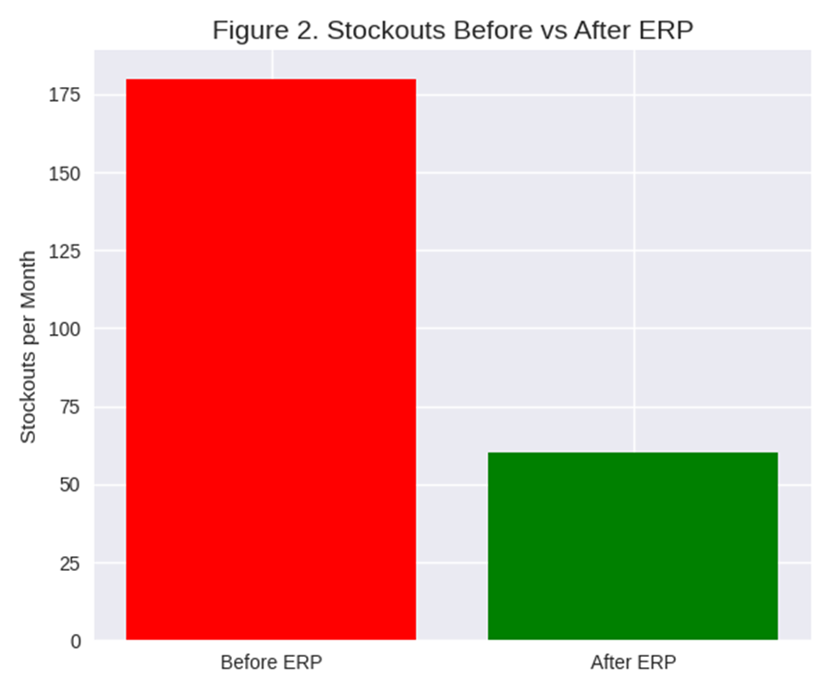
A bar chart comparing stockouts before and after ERP adoption.

b. Customer Relationship Management
- Centralised customer profiles
- Personalised marketing campaigns
- Faster complaint resolution
- Improved customer loyalty
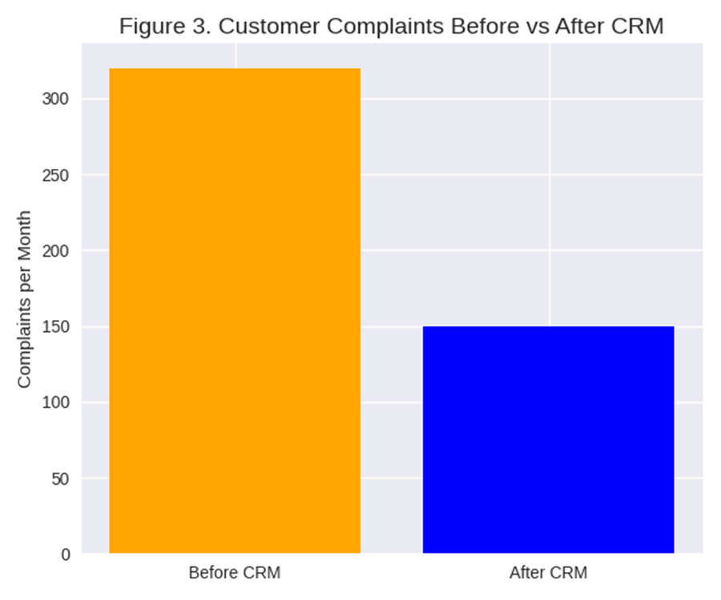
Complaints are projected to drop from 320 to 150 per month.

c. Decision‑Making and Reporting
- Real‑time dashboards
- Data‑driven forecasting
- Faster reporting cycles
- Improved strategic planning.
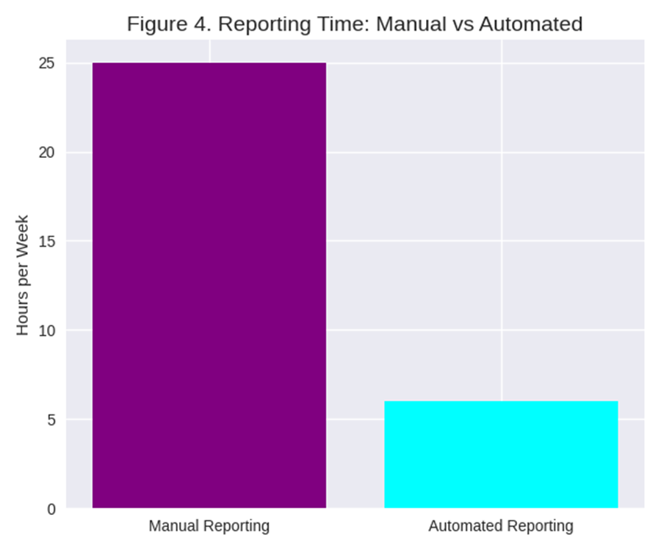
Reporting time decreases from 25 to 6 hours per week.

d. Departmental Integration
- Seamless data flow
- Reduced manual data entry.
- Improved collaboration
- Greater organisational transparency

How the systems will improve operations
The introduction of an ERP‑CRM system will also significantly enhance supply chain coordination. By integrating procurement, inventory, and sales data, the system will enable Kalori Ltd. to optimise supplier relationships, negotiate better pricing, and reduce lead times. Automated purchase orders can be triggered when stock levels fall below predefined thresholds, ensuring that high‑demand items are always available. This reduces the risk of lost sales and improves overall supply chain resilience.
Furthermore, the ERP system will support advanced analytics and business intelligence. Managers will have access to dashboards that display real‑time KPIs such as sales trends, customer behaviour, and store performance. Predictive analytics tools can identify emerging trends, enabling the company to adjust pricing strategies, launch targeted promotions, or optimise product assortments. This level of insight is essential for competing in a fast‑moving retail environment.
The CRM component will also enable Kalori Ltd. to implement omnichannel customer experiences. Customers will be able to check stock availability online, reserve items for in‑store pickup, or return online purchases in physical stores. These capabilities are increasingly expected by consumers and can significantly improve customer satisfaction and loyalty.

4. Implementation Plan
A successful ERP implementation also requires a strong change management strategy. Employees may be resistant to new systems, especially if they are accustomed to manual processes. To address this, Kalori Ltd. should appoint internal “change champions” within each department who can support colleagues, provide feedback to the project team, and promote adoption. Regular communication about the benefits of the new system will also help reduce resistance and build enthusiasm.
During the data migration phase, it is essential to conduct data quality audits to identify duplicate, incomplete, or outdated records. Poor‑quality data can undermine the effectiveness of the new system, so cleansing and validation must be prioritised. This may involve standardising product codes, merge duplicate customer profiles, and remove obsolete inventory records.
Post‑implementation, the company should conduct a post‑go‑live review to assess system performance, identify issues, and implement improvements. Continuous monitoring will ensure that the system evolves alongside the business and continues to deliver value.

4.1 Implementation Steps
Requirements Analysis
- Workshops with each department to identify needs and workflows.
Vendor Selection
- Evaluate ERP providers based on cost, scalability, features, and support.
System Design and Customisation
- Configure modules for inventory, CRM, finance, and reporting.
Data Migration
- Clean and consolidate existing customer, inventory, and sales data.
Staff Training
- Provide role‑specific training sessions and user guides.
System Testing
- Conduct functional, integration, and user acceptance testing.
Go‑Live and Monitoring
- Launch the system in phases and monitor performance.

4.2 Integration with Existing Infrastructure
The ERP system will integrate with:
- Existing POS systems.
- The e‑commerce platform.
- Financial systems.
This ensures continuity of operations during the transition.

4.3 Potential Challenges and Mitigation Strategies
- Resistance to change Provide comprehensive training.
- Data migration errors Conduct thorough data cleansing.
- Implementation delays Use phased rollout.
- Cost overruns Set clear budgets and monitor progress.

5. Conclusion
Kalori Ltd.’s rapid growth has exposed significant weaknesses in its outdated and fragmented information systems. Manual inventory tracking disconnected customer data, inefficient reporting, and poor system integration are major barriers to operational efficiency and customer satisfaction. Implementing a cloud‑based ERP system with integrated CRM capabilities will transform operations by providing real‑time inventory visibility, centralised customer data, automated reporting, and secure data management.
In addition to resolving current inefficiencies, the proposed ERP‑CRM system will position Kalori Ltd. to embrace future technological advancements such as AI‑driven demand forecasting, automated customer segmentation, and predictive maintenance for store equipment. These capabilities will enable the company to operate more proactively, anticipate customer needs, and respond quickly to market changes. The system will also support long‑term strategic initiatives such as international expansion, new product lines, or enhanced loyalty programmes.
With a structured implementation plan including requirements analysis, vendor selection, customisation, training, and phased rollout Kalori Ltd. can modernise its information systems and position itself for long‑term growth and competitiveness. The proposed ERP solution will not only resolve current inefficiencies but also provide a scalable, secure, and future‑proof foundation for the company’s continued expansion. By investing in modern information systems, Kalori Ltd. is not simply upgrading its technology it is transforming its organisational capabilities. The shift from manual, reactive processes to integrated, data‑driven operations will create a more agile, efficient, and customer‑focused business. This transformation is essential for sustaining growth in an increasingly competitive retail landscape.

Reference List
Bocij, P., Greasley, A. and Hickie, S. (2019) Business Information Systems: Technology, Development and Management. 6th edn. Pearson.
Chaffey, D. and White, G. (2019) Business Information Management. 3rd edn. Pearson.
Christopher, M. (2016) Logistics and Supply Chain Management. 5th edn. Pearson.
ICO (2023) Guide to the UK General Data Protection Regulation (UK GDPR). Available at: https://ico.org.uk
Laudon, K.C. and Laudon, J.P. (2022) Management Information Systems: Managing the Digital Firm. 17th edn. Pearson.
Microsoft (2023) Dynamics 365 for Retail. Available at: https://www.microsoft.com
Monk, E., and Wagner, B. (2018) Concepts in Enterprise Resource Planning. 4th edn. Cengage Learning.
Oracle (2023) NetSuite ERP Overview. Available at: https://www.netsuite.com
Payne, A. and Frow, P. (2017) Strategic Customer Management: Integrating Relationship Marketing and CRM. Cambridge University Press.
Porter, M.E. and Heppelmann, J.E. (2015) ‘How smart, connected products are transforming companies’, Harvard Business Review, 93(10), pp. 96–114.
Stair, R., and Reynolds, G. (2020) Principles of Information Systems. 13th edn. Cengage Learning.
SAP (2023) SAP Business One for Retail. Available at: https://www.sap.com

