Thermo-Fluids Coursework – Final Submission

3. Ideal and Real Gas Behaviour
The ideal gas law provides an effective approximation for gas behaviour at low pressures and high temperatures. However, real gases deviate from ideal behaviour due to molecular size and intermolecular forces. To address these limitations, the Van der Waals equation of state is introduced.
The Van der Waals equation of state is given by Equation (3.1):
(3.1) ( p + a / V_m² )( V_m − b ) = RT
As shown in Equation (3.1), the constant a accounts for intermolecular attractive forces, while b represents the finite molecular volume. This formulation improves accuracy at moderate pressures and temperatures close to condensation, although it becomes unreliable at extreme conditions.

3.1 Kinetic Theory of Gases
According to kinetic theory, the macroscopic pressure of a gas arises from elastic molecular collisions with the container walls. The resulting pressure–volume relationship is expressed in Equation (3.2).
(3.2) pV = (1/3) N m c̄²
For comparison, the ideal gas law may be written as Equation (3.3).
(3.3) pV = NkT
Equating Equations (3.2) and (3.3) yields the temperature–kinetic energy relationship shown in Equation (3.4).
(3.4) (1/2) m c̄² = (3/2) kT
Equation (3.4) demonstrates that the average translational kinetic energy of gas molecules is directly proportional to absolute temperature.

Clarification on Molecular Collision Time
In the derivation leading to Equation (3.2), the time between successive collisions of a molecule with the same container wall is equal to 2L/u_x. Although this factor appears explicitly in the analysis, it does not alter the final pressure expression. The factor of two associated with the collision time cancels exactly with the factor of two arising from the momentum change per collision. Consequently, the standard kinetic theory result given in Equation (3.2) remains valid, and the derivation of Equation (3.4) is unaffected.

3.2 Graham’s Law of Diffusion
The molecular speed of gas molecules is commonly characterised using the root mean square speed given by Equation (3.5).
(3.5) c_rms = √(3RT / M)
At constant temperature, Equation (3.5) shows that molecular speed is inversely proportional to the square root of molar mass. Since diffusion rate is proportional to molecular speed, the ratio of diffusion rates for two gases is given by Equation (3.6).
(3.6) Rate₁ / Rate₂ = √( M₂ / M₁ )

Figures
The thermodynamic processes discussed are illustrated in Figures 3.1 and 3.2.
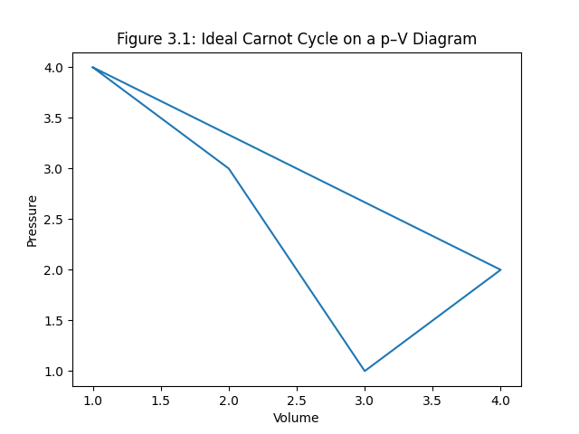
Figure 3.1: Pressure–volume diagram of the ideal Carnot cycle.
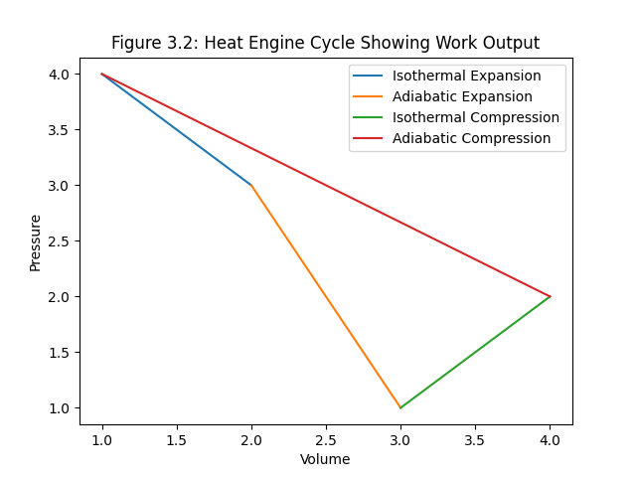
Figure 3.2: Schematic p–V diagram illustrating a heat engine cycle and net work output.

