Managing Health and Safety and welfare in construction


(Anon, 2020)
Module: Managing Health and safety in a project
Module Code: EG568

Written By: Sean Hazelby
Level 4

Contents
Site Brief / Introduction 3
1. Location 3
2. Site Access 4
Health and safety at work act 1974 4
CDM 2015 5
COSHH 8
Corporate man slaughter act 2007 9
Personal Protective Equipment (PPE) 9
Working at hight regulation 2005 10
Conclusion 10
Reference List 10
Appendices 11
1. Risk Assessments 11
2. Method statements 15
3. Construction Phase Plan 27

Site Brief / Introduction
The University have decided to build a single, two storey detached domestic building with a loft room and is 9to be used as the caretaker’s house in order to live in a convenient location close to the university. It is intended to be built adjacent to the new student accommodation in SA1 with a highway that is directly accessible. The foundations are planned to be concrete strip to a depth of 1m. Work is proposed to start on the 6th of May 2021.

Location
The site is located on the entrance of SA1 from Fabian Way and will be located adjacent the new student accommodation. The site is located within the red Rectangle as seen below.
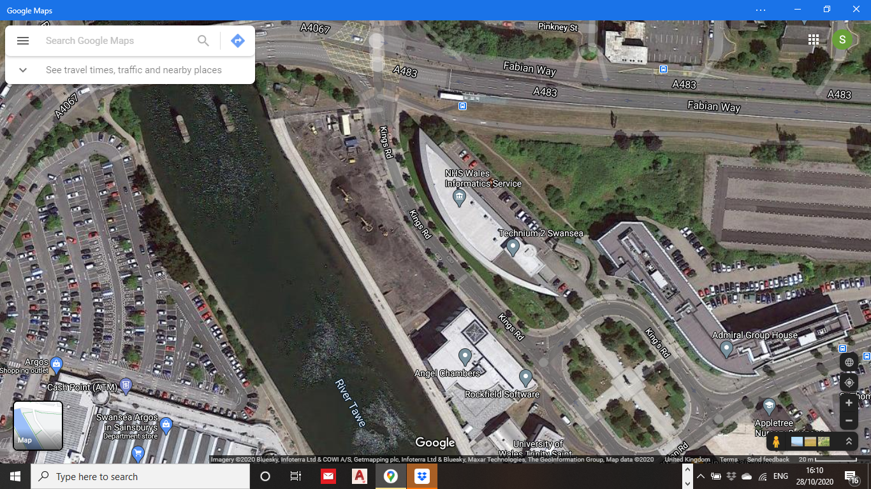

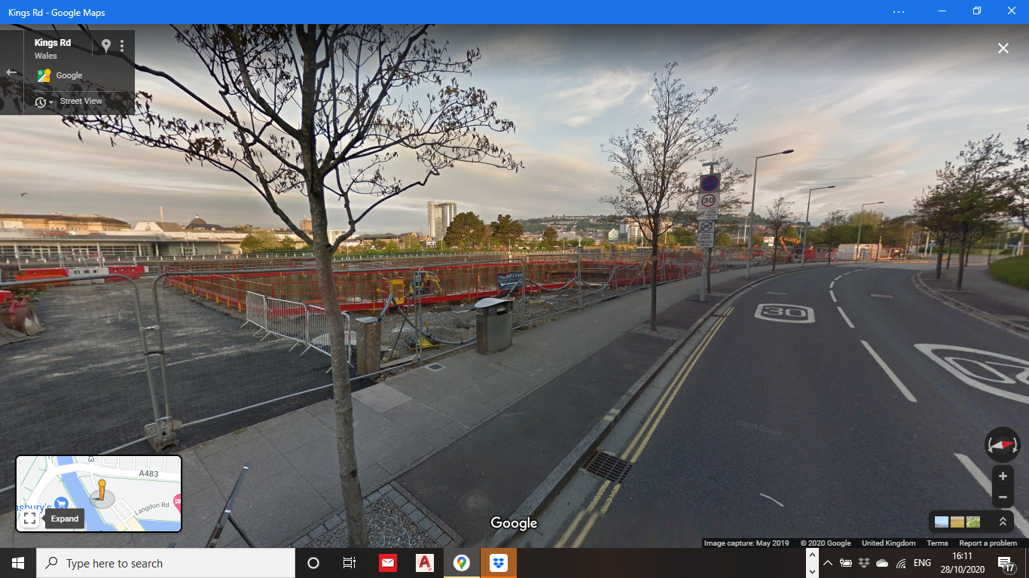
View from kings Rd facing west
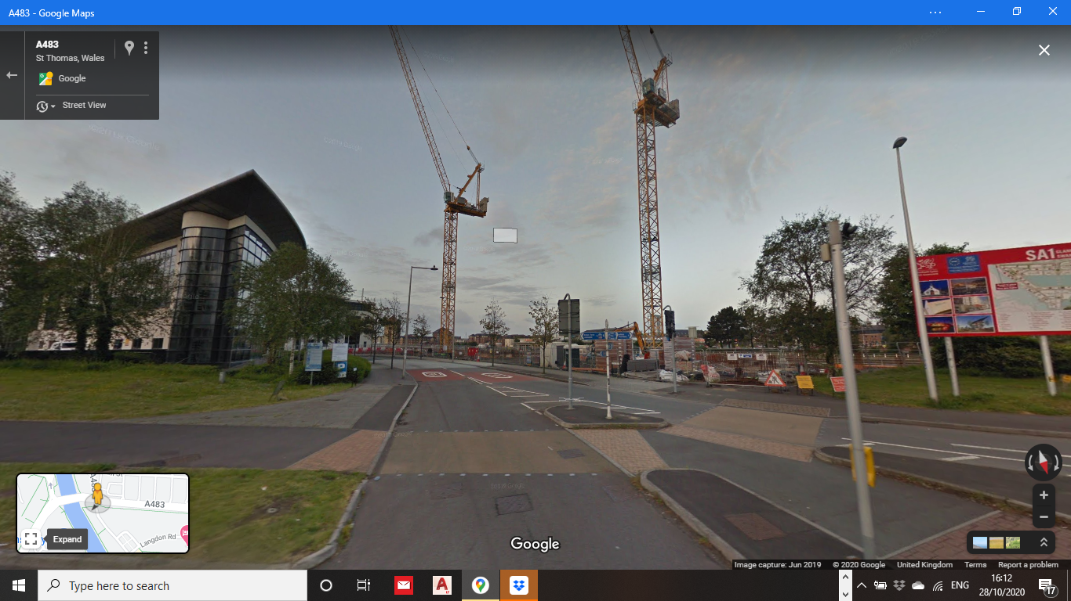
View from Fabian way facing South west

Site Access

Excess

Access

Health and safety at work act 1974
The health and safety at work act 1974 applies to everyone in the working sector in the United Kingdom. This legislation by parliament is to set duties from employers and employees. It states that every employer has the responsibility to offer welfare with the addition of health and safety to all their employees. The aim of the HSWA is to ensure that all workers in the country do not have to work in an environment where their health is severely at risk. The legislation outlined the responsibilities of the employer and the employee in ensuring that the environment of works is a safe one.

Employee
It is the employee’s responsibility to ensure that they are working in a way that is safe for them and others. You must use the gear provided in the way it was intended e.g health and safety gear. You must cooperate with your employer by wearing correct PPE and undergoing training. You must report if you feel in danger or if you have obtained an injury due to bad health and safety on site.
Employer
You must ensure that your staff are all competent and have undergone health and safety training. You must provide full PPE to your staff. You must make sure all your facilitates reach minimal health and safety policy and make sure the policy is up to date. Your facilities must reach health and safety requirements for ventilation, temperature and noise. Make sure equipment is safe to use and give appropriate warning signs of the hazards of the equipment You must provide first aid facilities.
(Bitesize, 2020)

CDM 2015

The Construction design and management regulations 2015 is aimed to help you whatever your role is in the construction industry. It helps you to;
- “sensibly plan the work so the risks involved are managed from start to finish
- have the right people for the right job at the right time
- cooperate and coordinate your work with others
- have the right information about the risks and how they are being managed
- communicate this information effectively to those who need to know
- consult and engage with workers about the risks and how they are being managed” (HSE, CDM 2015, 2015).

CDM applies to everybody withing the construction industry all times within the process of the project and states that each duty holder must comply with the law so that everybody is kept safe and ensures the wellbeing of every member on the construction process (HSE, CDM 2015, 2015). There must be a notice on site with the details of the principle designer, principle contractor and client clearly shown.

The roles of CDM 2015
The roles of clients, Principle designers and principle contactors all have their own set of responsibilities under CDM regulation 2015. Workers will also have their own responsibilities but will be referred as duty holders.

The rules from CDM 2015 slightly differ from CDM 2007.

Client
The client is the person who is having the work carried out. This usually od the person who is paying the contractor to complete the project for them. The client does not have to be commercial but instead he could also be a domestic client which for example is having work done on their house e.g a private job (HAS, 2015). It is the clients responsibility for welfare facilities. The client will pay the contractor to provide facilities which will include; separate toilets for men and women, canteen, lighting, ventilation, heating, rest facilities.

Responsibilities
- “Appoint the principal designer
- Appoint the principal contractor
- Make suitable arrangements for managing the project
- Allocate enough time and resources
- Ensure welfare facilities are provided
- Provide pre-construction information
- Notify the HSE (if required when there is more than 5 people working on site)
- Make sure the principal designer and principal contractor comply with their CDM duties
- Ensure the construction phase plan is provided
- Ensure the health and safety file is prepared
- Keep the health and safety file and pass it on to any future owner of the building” (HAS, 2015).
It is the clients duty to ensure that the required duty holders are appointed for the job. The client is not expected to manage the project but is expected to make sure that the work is carried out safely by making suitable arrangement to the site. It is also their responsibility that the principle designer and the principle contractor carry out their duties under CDM 2015 regulations (HAS, 2015).
Principle designer
The principle designer is required when a project has more than one contractor or designer involved. This person is the designer in overall control of the pre-construction phase. A principle designer is required on most construction projects. They must make sure that the designers obey the designer duties and during the planning of the project will take charge of the health and safety matters (HAS, 2015).
Responsibilities
- “Plan, manage and monitor the pre-construction phase Plan, manage and monitor the pre-construction phase
- Coordinate health and safety during the pre-construction phase
- Identify and eliminate or control risks to anyone constructing, maintaining or using the designed structure
- Ensure all designers comply with their duties
- Coordinate cooperations between the team with the client, the principal designer and each other
- Assist the client in the provision of the pre-construction information
- Provide pre-construction information to designers and contractors
- Liaise with the principal contractor and share information
- Prepare the health and safety file” (HAS, 2015)
It is the principle designers responsibility to plan, manage and importantly to coordinate health and safety in the pre-construction phase. This will include making sure that the duty holders know their task and role and providing relevant information for their duties. This also includes the identification of risks with further elimination or controlling the risks. This also includes making sure that the designers carry out their tasks and liaising with the principle contractor to help plan, manage and monitor the construction phase of the project. The principle designer has these duties on top of the duties which a regular designer would have (HAS, 2015).
Principle Contractor
Similarly to the principle designer, the principle contractor is required where there are more than one contractors or subcontractors on site. The principle contractor will be appointed by the client and will be in total control over the construction phase of the project. The responsibility of site safety, site rules and the planning of the work is safely competed without harm to personnel on site and off site lies with the principle contractor (HAS, 2015).
Responsibilities
- “Plan, manage and monitor the construction phase
- Coordinate health and safety during the construction phase
- Organise cooperation between contractors
- Ensure contractors comply with legal requirements for health and safety
- Prepare the construction phase plan
- Apply and ensure others apply the principles of prevention
- Enforce compliance with the construction phase plan
- Provide a suitable site induction
- Prevent unauthorised access
- Ensure welfare facilities are provided
- Liaise with the principal designer and share information” (HAS, 2015).
The planning, managing, monitoring and coordinating the phase of the construction process lies with the principle contractor. They must liaise with the client and the principle designer. This will also include that site inductions are carried out to a good standard and must prevent access of unauthorised personnel to site. They must provide welfare facilities for the workers and make workers aware of the health and safety matters within the industry. The principle contractor must also carry out the duties of the contactor on top of the allocated duties of the principle contractor (HAS, 2015).
Designers
Anybody who modifies a design an any way in the construction project will classify as a designer under CDM. Differently to the principle designers, there can be more than one designer on a project. On some occasions a contractor may have some of the duties of the designer where they will provide some sort of design to the design (HAS, 2015).
Responsibilities
- “Be satisfied that the client is aware of their client duties
- Take into account the general principles of prevention
- Take into account any pre-construction information
- Eliminate, reduce or control foreseeable risks to the health or safety of any person constructing, using or maintaining the structure
- Provide information about any remaining risks to the principal designer
- Ensure appropriate information is included in the health and safety file
- Provide information to assist the client, other designers and contractors” (HAS, 2015).
When altering the design of the project they must be aware of all the foreseeable risks that will occur when the change has been made and after it has been made but more importantly before is has been made. This will include the maintenance when preparing to modify the design as well. They must also provide relevant information to other members of the project team (HAS, 2015).
Contractors
There can be more than one contactor involved in a project unlike the principle contractor. If there is only one contractor involved in the project they have additional responsibilities to comply with, All contractors have duties under CDM (HAS, 2015).
Responsibilities
- “Be satisfied that the client is aware of their client duties
- Plan, manage and monitor construction work carried out either by the contractor or by workers under the contractor’s control, to ensure it is carried out without risks to health and safety
- Comply with any directions given by the principal designer or the principal contractor
- Comply with the construction phase plan
- If there is only one contractor, prepare the construction phase plan
- Only employ or appoint people with the necessary skills, knowledge, training and experience to carry out the work
- Provide each worker under their control with appropriate supervision, instructions and information
- Provide a suitable site induction, where not already provided by the principal contractor
- Provide information on risks to health and safety
- Provide emergency procedures
- Ensure reasonable steps have been taken to prevent unauthorised access
- Ensure welfare facilities have been provided” (HAS, 2015).
The contactor will comply with instructions given to them by the principle contractor or principle designer. They must plan, manage and monitor the works that are under their control without the risks to health and safety of personnel. They must also coordinate their activities with orders from the project team. If there is only one contractor on a given project, they will have to prepare a construction phase plan for the works (HAS, 2015).
Workers
It is the workers right to receive welfare facilities and they must be made aware of actions which may affect their health. Their health and safety is at their own responsibility and those who may be affected by their actions. They must report anything they feel that is endangering their health and safety or others on site. It is the workers responsibility to cooperate with their contractor and other duty holders (HAS, 2015).

COSHH

Control Of Substances Hazardous to Health is very important for the wellbeing of personnel in the short term and long term. The aim of COSHH is to protect workers from hazardous substances that are likely to be present in the workplace (Allianz, 2020). In terms of construction there are numerous harmful substances to health, safety and wellbeing on a building site. All personnel must be aware of the dangers of each harmful substance and how to handle and control them. Substances must be stored properly with liquids being stored on the bottom and dusts being stored at the top to ensure a leaking liquid will not react with the dusty substance. All personnel must be aware of the updated danger signs and their meanings;

Oxidiser
Flammable
Danger

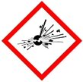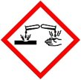
Corrosive
Compressed air or liquified gas
Explosive

Corporate man slaughter act 2007
“The Corporate Manslaughter and Corporate Homicide Act 2007 is a landmark in law. For the first time, companies and organisations can be found guilty of corporate manslaughter as a result of serious management failures resulting in a gross breach of a duty of care” (HSE, 2007). This is serious law and contractors can be put to jail if the incorrect measures are in place when somebody dies on site.

Personal Protective Equipment (PPE)

It is a common misinterpretation in the UK that the employee is the one who is responsible for providing their own PPE. This is not true; your employer must provide PPE for you. Personal Protective Equipment will help protect the user from hazards in the workplace. It is important to know that PPE is considered a last resort control measure. In construction it will include the following;
- High visibility clothing
High visibility clothing will help you be seen by others so they can avoid you accordingly.
- Hard hat (in date)
Hard hats will help protect your head from falling objects or when you slip or trip
- Boots
Boots will help protect your feet if you drop heavy objects onto them (steel toe caps)
- Gloves
Gloves will protect your hands from hot surfaces or rough materials which may cut the skin. It also gives more grip for when carrying objects.
- Face mask (COVID 19)
Face masks will lower the chance of the spread of COVID 19
- Glasses (optional)
Glasses will protect your eyes from substances, dusts and metal splash
- Dust mask (optional)
Dust masks will help prevent inhaling dust, gases and deadly vapours
(HSE, 2020)

Working at hight regulation 2005

Falling from hight holds the highest number of fatalities and injuries on a building site. According to HSE statistics, in 2017/2018 falling from hight accounted for 8% of all workplace injuries and of that 8%, 26% were fatal. (Petty, 2014)
The purpose of the working at hight regulations 2005 is to prevent fatalities and injuries from a fall from hight. If you are an employer or you control the work at hight, then the regulations will apply to you. Planning is majorly important when working at hight. Employers must do this in order to control the activity. You must use the correct equipment when doing the task. Lower risk, straightforward tasks will not require as much planning but will still require correct equipment and PPE.
The employer and those carrying out the task must assess the risks when working at hight.
As the employee, you have a legal duty to take reasonable care of yourself and other who may be affected by actions of the task you are attempting to complete. You must co-operate with the employer and comply with their health and safety requirements (HSE, 2005).

Conclusion
The site is potentially going to be hard for access due to the single road down SA1. This may cause traffic during busy periods of the day when deliveries are being delivered therefore, we will have to make sure that deliveries happen during quiet parts of the day. CDM 2015 and the work act of 1974 are vital legislations that will have to be complied by before, during and after the works. Every employee on site must have knowledge of these legislations in order to work on site especially the roles under CDM 2015. Adequate welfare facilities and toilets will be available for workers on site. All the Health and safety information will be available anytime in the health and safety handbook and will be updated as the works will commence and progress if laws are changed or altered.

Reference List

Citation | URL | First opened
(Allianz, 2020) | https://www.allianz.co.uk/risk-management/support/legislation/substances-hazardous-to-health.html | 4/11/20
(Bitesize, 2020) | https://www.bbc.co.uk/bitesize/guides/zcs4ng8/  revision/4#:~:text=The%20Health%20and%20  Safety%20at%20Work%20Act%201974,there%20is  %20a%20safe%20working%20environment.%  201%202 | 18/10/20
(HAS, 2015) | https://www.haspod.com/blog/cdm/  cdm-2015-rolesresponsibilities#:~:text=CDM%202015%20  Roles%20And%20Responsibilities%201%  20Client.%20The,Designers.%20...%205%20C  ontractors.%20...%206%20Workers.%20 | 13/10/20
(HSE, Corporate Man slaughter, 2007) | https://www.hse.gov.uk/corpmanslaughter/ | 10/10/20
(HSE, CDM 2015, 2015) | https://www.hse.gov.uk/pubns/books/l153.htm | 12/10/20
(HSE, Corporate Man slaughter, 2007) | https://www.hse.gov.uk/corpmanslaughter/ | 31/10/20
(HSE, Risk at work - Personal protective equiptment, 2020) | https://www.hse.gov.uk/toolbox/ppe.htm | 30/10/20
(HSE, The Law, 2005) | https://www.hse.gov.uk/work-at-height/the-law.htm | 30/10/20
(Petty, 2014) | https://www.highspeedtraining.co.uk/hub/  working-at-height-rules-regulations/#:~:text=Under%20the%20  working%20at%20height%20regulations%2C%20e  mployers%20must%3A,so%20or%2C%20if%20b  eing%20...%20More%20items...%20 | 4/11/20
(Anon, 2020) | https://www.designingbuildings.co.uk/wiki/Health_and_safety_file | 22/11/20

Appendices

Risk Assessments

Activity to be Assessed |  |  |  |  |  |  |  |  |  |  |  |  |  |  |  |  |  |  |  | Assessment Number
Fitting a lintel |  |  |  |  |  |  |  |  |  |  |  |  |  |  |  |  |  |  |  | 4544
Persons undertaking or affected by the activity
 |  | * | Employees |  |  | Contractor |  |  |  | Public |  |  |  |  |  |  | Service User
 |  |  | Other …………………………………………………………………………………………….
Identified Hazards and Associated Risks |  |  |  |  |  |  |  |  |  |  | Likelihood |  |  |  |  |  |  |  |  | Severity |  |  |  |  |  |  |  |  | Risk Level
1 | Dropping the lintel |  |  |  |  |  |  |  |  |  | 3 |  |  |  |  |  |  |  |  | 4 |  |  |  |  |  |  |  |  | 12
2 | Falling from hight |  |  |  |  |  |  |  |  |  | 2 |  |  |  |  |  |  |  |  | 5 |  |  |  |  |  |  |  |  | 10
3 | Manual lifting |  |  |  |  |  |  |  |  |  | 3 |  |  |  |  |  |  |  |  | 3 |  |  |  |  |  |  |  |  | 9
4 | Slipping and Tripping on scaffold or debris |  |  |  |  |  |  |  |  |  | 2 |  |  |  |  |  |  |  |  | 4 |  |  |  |  |  |  |  |  | 8
5 | Lifting a lintel up a scaffold |  |  |  |  |  |  |  |  |  | 2 |  |  |  |  |  |  |  |  | 5 |  |  |  |  |  |  |  |  | 10
6
Existing Control Measures / Additional Control Measures Required
1 | Ensure 2 people are carrying the lintel on both ends and are wearing gloves for grip and protection
2 | Ensure scaffolding to industry standards with fencing and netting if possible
3 | Do not lift more than you can handle, ask for help if needed
4 | Ensure scaffold is clean and your boot laces are tied
5 | Do not lift a lintel up a scaffold, get a machine driver to do so for you
6
Reassessment of Activity Hazards |  |  |  |  |  |  |  |  |  |  | Likelihood |  |  |  |  |  |  |  |  | Severity |  |  |  |  |  |  |  |  | Risk Level
1 | Dropping the lintel with control measures |  |  |  |  |  |  |  |  |  | 1 |  |  |  |  |  |  |  |  | 4 |  |  |  |  |  |  |  |  | 4
2 | Falling from hight with control measures |  |  |  |  |  |  |  |  |  | 1 |  |  |  |  |  |  |  |  | 5 |  |  |  |  |  |  |  |  | 5
3 | Manual lifting with control measures |  |  |  |  |  |  |  |  |  | 1 |  |  |  |  |  |  |  |  | 3 |  |  |  |  |  |  |  |  | 3
4 | Tripping on scaffold with control measures |  |  |  |  |  |  |  |  |  | 1 |  |  |  |  |  |  |  |  | 4 |  |  |  |  |  |  |  |  | 4
5 | Lifting a lintel up a scaffold with control measures |  |  |  |  |  |  |  |  |  | 1 |  |  |  |  |  |  |  |  | 5 |  |  |  |  |  |  |  |  | 5
6
Name Sean Hazelby  Position |  |  |  |  |  |  | Signed |  |  |  |  |  |  |  |  |  |  |  |  | Date of Completion: 21/10/2020
Reviews |  |  |  | Key
Review Date: |  |  |  | Likelihood |  |  |  | Severity |  |  | Severity of Injury |  |  | 5 | 5Y |  |  |  |  |  | 10R |  |  |  |  | 15 |  |  |  | 20 |  |  | 25
Reviewed by: |  |  |  | 1 very unlikely  2 unlikely  3 likely  4 very likely  5 certainty |  |  |  | 1 nuisance  2 minor  3 medical treatment  4 major  5 fatal |  |  |  |  |  | 4 | 4 |  |  |  |  |  | 8 |  |  |  |  | 12 |  |  |  | 16 |  |  | 20
Review Date : |  |  |  |  |  |  |  |  |  |  |  |  |  | 3 | 3 |  |  |  |  |  | 6G |  |  |  |  | 9 |  |  |  | 12 |  |  | 15
Reviewed by: |  |  |  |  |  |  |  |  |  |  |  |  |  | 2 | 2 |  |  |  |  |  | 4 |  |  |  |  | 6Y |  |  |  | 8 |  |  | 10Y
Review Date : |  |  |  |  |  |  |  |  |  |  |  |  |  | 1 | 1 |  |  |  |  |  | 2 |  |  |  |  | 3 |  |  |  | 4 |  |  | 5G
Reviewed by: |  |  |  |  |  |  |  |  |  |  |  |  |  | 0 | 1 |  |  |  |  |  | 2 |  |  |  |  | 3 |  |  |  | 4 |  |  | 5
Review Date : |  |  |  |  |  |  |  |  |  |  |  |  |  |  | Likelihood of Injury
Reviewed by: |  |  |  |  |  |  |  |  |  |  |  |  | Low Risk |  |  |  |  |  |  |  |  | Medium Risk |  |  |  |  |  |  |  |  | High Risk
Activity to be Assessed |  |  |  |  |  |  |  |  |  |  |  |  |  |  |  |  |  |  |  | Assessment Number
Mixing cement with cement mixer |  |  |  |  |  |  |  |  |  |  |  |  |  |  |  |  |  |  |  | 5467
Persons undertaking or affected by the activity
 |  | * | Employees |  |  | Contractor |  |  | * | Public |  |  |  |  |  |  | Service User
 |  |  | Other …………………………………………………………………………………………….
Identified Hazards and Associated Risks |  |  |  |  |  |  |  |  |  |  |  | Likelihood |  |  |  |  |  |  |  | Severity |  |  |  |  |  |  |  |  | Risk Level
1 | Exposure to cement products |  |  |  |  |  |  |  |  |  |  | 4 |  |  |  |  |  |  |  | 3 |  |  |  |  |  |  |  |  | 12
2 | Rotating object cause injury |  |  |  |  |  |  |  |  |  |  | 2 |  |  |  |  |  |  |  | 4 |  |  |  |  |  |  |  |  | 8
3 | Breathing in dust |  |  |  |  |  |  |  |  |  |  | 4 |  |  |  |  |  |  |  | 4 |  |  |  |  |  |  |  |  | 16
4 | Mixer falling over when turning |  |  |  |  |  |  |  |  |  |  | 2 |  |  |  |  |  |  |  | 4 |  |  |  |  |  |  |  |  | 8
5 | Electric shock |  |  |  |  |  |  |  |  |  |  | 2 |  |  |  |  |  |  |  | 4 |  |  |  |  |  |  |  |  | 8
6 | Engine steel hood jam fingers |  |  |  |  |  |  |  |  |  |  | 2 |  |  |  |  |  |  |  | 3 |  |  |  |  |  |  |  |  | 6
Existing Control Measures / Additional Control Measures Required
1 | Ensure that gloves and correct PPE are worn during the activity and after work creams are used at the end of the day
2 | Do not stick arms or shovels/trowels inside the mixer when it is rotating
3 | Ensure PPE is worn including a mask to stop the inhaling of dust and making sure of the direction of wind
4 | Mixer must be on stable ground without leaning or tipping in a certain way and make sure wheels are braced.
5 | Make sure all equipment is 110V fitted with RCD
6 | Ensure Steel hood has been hooked to the latch when in use
Reassessment of Activity Hazards |  |  |  |  |  |  |  |  |  |  |  | Likelihood |  |  |  |  |  |  |  | Severity |  |  |  |  |  |  |  |  | Risk Level
1 | Exposure to cement products with control measures |  |  |  |  |  |  |  |  |  |  | 2 |  |  |  |  |  |  |  | 3 |  |  |  |  |  |  |  |  | 6
2 | Rotating object cause injury with control measures |  |  |  |  |  |  |  |  |  |  | 1 |  |  |  |  |  |  |  | 4 |  |  |  |  |  |  |  |  | 4
3 | Breathing in dust with control measures |  |  |  |  |  |  |  |  |  |  | 1 |  |  |  |  |  |  |  | 4 |  |  |  |  |  |  |  |  | 4
4 | Mixer falling over when turning with control measures |  |  |  |  |  |  |  |  |  |  | 1 |  |  |  |  |  |  |  | 4 |  |  |  |  |  |  |  |  | 4
5 | Electric shock with control measures |  |  |  |  |  |  |  |  |  |  | 1 |  |  |  |  |  |  |  | 4 |  |  |  |  |  |  |  |  | 4
6 | Engine steel hood jam fingers with control measures |  |  |  |  |  |  |  |  |  |  | 1 |  |  |  |  |  |  |  | 3 |  |  |  |  |  |  |  |  | 3
Name Sean Hazelby  Position |  |  |  |  |  |  | Signed |  |  |  |  |  |  |  |  |  |  |  |  | Date of Completion: 21/10/2020
Reviews |  |  |  | Key
Review Date: |  |  |  | Likelihood |  |  |  | Severity |  |  |  | Severity of Injury |  |  |  | 5 |  | 5Y |  |  |  |  |  | 10R |  |  |  | 15 |  |  | 20 |  |  |  | 25
Reviewed by: |  |  |  | 1 very unlikely  2 unlikely  3 likely  4 very likely  5 certainty |  |  |  | 1 nuisance  2 minor  3 medical treatment  4 major  5 fatal |  |  |  |  |  |  |  | 4 |  | 4 |  |  |  |  |  | 8 |  |  |  | 12 |  |  | 16 |  |  |  | 20
Review Date : |  |  |  |  |  |  |  |  |  |  |  |  |  |  |  | 3 |  | 3 |  |  |  |  |  | 6G |  |  |  | 9 |  |  | 12 |  |  |  | 15
Reviewed by: |  |  |  |  |  |  |  |  |  |  |  |  |  |  |  | 2 |  | 2 |  |  |  |  |  | 4 |  |  |  | 6Y |  |  | 8 |  |  |  | 10Y
Review Date : |  |  |  |  |  |  |  |  |  |  |  |  |  |  |  | 1 |  | 1 |  |  |  |  |  | 2 |  |  |  | 3 |  |  | 4 |  |  |  | 5G
Reviewed by: |  |  |  |  |  |  |  |  |  |  |  |  |  |  |  | 0 |  | 1 |  |  |  |  |  | 2 |  |  |  | 3 |  |  | 4 |  |  |  | 5
Review Date : |  |  |  |  |  |  |  |  |  |  |  |  |  |  |  | Likelihood of Injury
Reviewed by: |  |  |  |  |  |  |  |  |  |  |  |  |  |  |  | Low Risk |  |  |  |  |  |  |  |  | Medium Risk |  |  |  |  |  |  |  |  | High Risk

Activity to be Assessed |  |  |  |  |  |  |  |  |  |  |  |  |  |  |  |  | Assessment Number
Tiling a roof |  |  |  |  |  |  |  |  |  |  |  |  |  |  |  |  | 5638
Persons undertaking or affected by the activity
 |  | * | Employees |  |  | Contractor |  |  | * | Public |  |  |  |  | Service User
 |  |  | Other …………………………………………………………………………………………….
Identified Hazards and Associated Risks |  |  |  |  |  |  |  |  |  |  | Likelihood |  |  |  |  |  | Severity |  |  |  |  | Risk Level
1 | Falling from hight |  |  |  |  |  |  |  |  |  | 3 |  |  |  |  |  | 5 |  |  |  |  | 15
2 | Tiles slipping off building |  |  |  |  |  |  |  |  |  | 2 |  |  |  |  |  | 5 |  |  |  |  | 10
3 | Windy weather |  |  |  |  |  |  |  |  |  | 3 |  |  |  |  |  | 4 |  |  |  |  | 12
4 | Wet weather |  |  |  |  |  |  |  |  |  | 4 |  |  |  |  |  | 4 |  |  |  |  | 16
5 | Electricity lines |  |  |  |  |  |  |  |  |  | 3 |  |  |  |  |  | 5 |  |  |  |  | 15
6 | Power tools |  |  |  |  |  |  |  |  |  | 3 |  |  |  |  |  | 5 |  |  |  |  | 15
Existing Control Measures / Additional Control Measures Required
1 | Wear a harness and have scaffolding in place
2 | Ensure a competent person is doing the task and fits them by construction standards
3 | Do not start work tiling a roof when it is windy
4 | Do not start work tiling a roof when it is raining
5 | Ensure it is made clear about the hazards of electricity and the location of the electricity lines
6 | Ensure a ‘tool talk’ has been done
Reassessment of Activity Hazards |  |  |  |  |  |  |  |  |  |  | Likelihood |  |  |  |  |  | Severity |  |  |  |  | Risk Level
1 | Falling from hight with control measures |  |  |  |  |  |  |  |  |  | 3 |  |  |  |  |  | 1 |  |  |  |  | 3
2 | Tiles slipping of building with control measures |  |  |  |  |  |  |  |  |  | 1 |  |  |  |  |  | 5 |  |  |  |  | 5
3 | Windy weather with control measures |  |  |  |  |  |  |  |  |  | 1 |  |  |  |  |  | 4 |  |  |  |  | 4
4 | Wet weather with control measures |  |  |  |  |  |  |  |  |  | 1 |  |  |  |  |  | 4 |  |  |  |  | 4
5 | Electricity lines with control measures |  |  |  |  |  |  |  |  |  | 1 |  |  |  |  |  | 5 |  |  |  |  | 5
6 |  |  |  |  |  |  |  |  |  |  | 1 |  |  |  |  |  | 5 |  |  |  |  | 5
Name Sean Hazelby  Position … |  |  |  |  |  |  | Signed |  |  |  |  |  |  |  |  |  | Date of Completion: 20/10/2020
Reviews |  |  |  | Key
Review Date: |  |  |  | Likelihood |  |  |  | Severity |  |  | Severity of Injury |  | 5 | 5Y |  |  |  | 10R |  | 15 |  |  | 20 |  | 25
Reviewed by: |  |  |  | 1 very unlikely  2 unlikely  3 likely  4 very likely  5 certainty |  |  |  | 1 nuisance  2 minor  3 medical treatment  4 major  5 fatal |  |  |  |  | 4 | 4 |  |  |  | 8 |  | 12 |  |  | 16 |  | 20
Review Date : |  |  |  |  |  |  |  |  |  |  |  |  | 3 | 3 |  |  |  | 6G |  | 9 |  |  | 12 |  | 15
Reviewed by: |  |  |  |  |  |  |  |  |  |  |  |  | 2 | 2 |  |  |  | 4 |  | 6Y |  |  | 8 |  | 10Y
Review Date : |  |  |  |  |  |  |  |  |  |  |  |  | 1 | 1 |  |  |  | 2 |  | 3 |  |  | 4 |  | 5G
Reviewed by: |  |  |  |  |  |  |  |  |  |  |  |  | 0 | 1 |  |  |  | 2 |  | 3 |  |  | 4 |  | 5
Review Date : |  |  |  |  |  |  |  |  |  |  |  |  |  | Likelihood of Injury
Reviewed by: |  |  |  |  |  |  |  |  |  |  |  | Low Risk |  |  |  |  |  |  | Medium Risk |  |  |  |  | High Risk

Method statements
Tiling a roof
UWTSD
Address:SA1
Tel: 01559 87645
Mobile: 07963554276
Project/Contract | Caretakers House
Contractor | UWTSD
Site Address | SA1
Project Start Date | 6th May 2021
Expected Duration | 1 year
Projected Completion Date | 6th May 2022

 | Name | Title | Signature | Date
Document Author | Sean Hazelby | Mr
Authorised by
Authorised by
Authorised by (for Client)

Emergency Contact Details
Contact  Tel  Mobile | Gary Smith  0155974635  07865443695 | Paul Jones  0155956399  07975443671 | John Philips  0155965416  07864667853

Data Protection Statement
The information and data provided herein shall not be duplicated, disclosed or disseminated by the recipient in whole or in part for any purpose whatsoever without the prior written permission from UWTSD.

Staff Information Sheet
The following method statement has been developed to provide a safe system of work and must always be adhered to, any significant deviation from this system must first be authorised by your manager or safety representative. Please read the entire sheet before beginning the procedure, if you have any questions please contact your manager or safety representative.

Task Description
This method statement describes the work process for the installation of tiling on a roof. It covers the hazards and steps necessary in order to keep you and your co-workers safe while carrying out the task.

The main hazards to your safety and health are;
- Falling from hight
- Tiles slipping off building
- Windy weather
- Wet weather
- Electricity lines
- Power tools

Preventative Measures you must take;
- Wear a harness and have scaffolding in place
- Ensure a competent person is doing the task and fits them by construction standards
- Do not start work tiling a roof when it is windy
- Do not start work tiling a roof when it is raining
- Ensure it is made clear about the hazards of electricity and the location of the electricity lines
- Ensure a ‘tool talk’ has been done

Personal Protective Equipment you must wear;
- High visibility Overalls
- Gloves
- Safety boots
- Hard hat
- Safety Glasses (optional)
- Dust mask (optional)

Environmental Protection Measures you must take;
- You must dispose of waste and spoil to the designated area or skip provided for waste.

Quality Control;
- Adhere strictly to the following procedure to ensure quality of service
- If in doubt contact your manager for clarification before proceeding.

Staff & Training
The projects will be carried out by staff from UWTSD. All members of staff are experienced and hold the following qualifications; List Qualifications. A site manager will be appointed to each contract who will be responsible for quality and safety. Apprentices and young workers will be supervised and are not allowed to carry out tasks for which they have not been trained

PPE
All site workers will wear Safety boots Hi Visibility Vests, Hard Hats and protective clothing at all times, other items of PPE such as eye protection, and gloves are available to be worn as and when necessary.

Preparation & Induction
A risk assessment will be carried out for all tasks which will be discussed with members of staff and the sub-contractors, any queries or concerns will be raised with the contract manager who will ensure it is dealt with. Staff and sub-contractors will be inducted onto site by the principal contractor and will follow all site rules and safety procedures.

Welfare
The principal contractor is responsible for providing adequate washing, toilet, drying and refreshment facilities for staff and sub-contractors, staff and contractors are responsible for ensuring that such welfare facilities are maintained in a clean and wholesome manner. This will be your responsibility when you are the principal contractor, it may be necessary occasionally for your company to identify suitable local amenities.

First Aid
It is the responsibility of all sub-contractors to ensure adequate first aid provision for its staff. Adequate means provision of a trained first aider, suitable first aid equipment and/or the provision of an appointed person at the minimum.

A trained first aider will be a suitable person who has attended an HSE approved course of at least four days' duration and he/she will re-train at least every three years on a course of not less than two days.

An Appointed Person is a person provided by the employer to take charge of the situation (e.g. to call an ambulance) if a serious injury/illness occurs in the absence of a first aider. The Appointed Person can render emergency first aid if trained to do so. Often principal contractors will ensure sufficient first aid cover for sites under their control

Scaffold & Access to height
Scaffold is to be made to industry standards with ladders equip

Work at Height
Scaffold need to be made to industry standards and need to make sure that the risk of dropping the lintel is less harmful by adding barriers or netting to protect workers below or members of the public walking on the sidewalk.

Tiling a Roof

Step by step procedure following industry standards

  - Make sure all hazards and risks are known before work is commenced in order to keep yourself safe and other around you safe while performing the task
  - Make sure that you are a competent person to carry out the task with qualifications
  - Correct PPE must always be worn as stated above
  - Planning must occur before stepping foot on the scaffold
  - Remove the older existing roofing if its applicable
  - Repair and reinforce the roof if its applicable
  - You must install an underlayment
  - Work around obstacles like chimneys by using metal flashing
  - Install battens if this is applicable to the method of the task needed
  - Install the tiles in a safe and intelligent way by tightly interlocking them for strength and stability. We do not want water to run down the cracks as dampness will enter the house
  - Make sure to cut tiles for tight spots
  - The surfaces of the roof will need to be capped by installing ridge tiles

UWTSD
Mixing cement
Address:SA1
Tel: 01559 87645
Mobile: 07963554276
Project/Contract | Caretakers House
Contractor | UWTSD
Site Address | SA1
Project Start Date | 6th May 2021
Expected Duration | 1 year
Projected Completion Date | 6th May 2022

 | Name | Title | Signature | Date
Document Author | Sean Hazelby | H&S
Authorised by
Authorised by
Authorised by (for Client)

Emergency Contact Details
Contact  Tel  Mobile | Gary Smith  0155974635  07865443695 | Paul Jones  0155956399  07975443671 | John Philips  0155965416  07864667853

Data Protection Statement
The information and data provided herein shall not be duplicated, disclosed or disseminated by the recipient in whole or in part for any purpose whatsoever without the prior written permission from UWTSD

Staff Information Sheet

The following method statement has been developed to provide a safe system of work and must always be adhered to, any significant deviation from this system must first be authorised by your manager or safety representative. Please read the entire sheet before beginning the procedure, if you have any questions please contact your manager or safety representative.

Task Description

This method statement describes the work process for mixing cement in a cement mixer. It included the risks, hazards and ways to overcome the hazards in order to complete the works safely to prevent harming you or the other around you.
The main hazards to your safety and health are;
- Exposure to cement products
- Rotating object cause injury
- Breathing in dust
- Mixer falling over when turning
- Electric shock
- Engine steel hood jam fingers

Preventative Measures you must take;
- Ensure that gloves and correct PPE are worn during the activity and after work creams are used at the end of the day
- Do not stick arms or shovels/trowels inside mixer when it is rotating
- Ensure PPE is worn including a mask to stop the inhaling of dust and making sure of the direction of wind
- Mixer must be on stable ground without leaning or tipping in a certain way and make sure wheels are braced
- Make sure all equipment is 110V fitted with RCD
- Ensure steel hood has been hooked to the latch when in use

Personal Protective Equipment you must wear;
- Safety Glasses
- Dust mask
- High visibility overalls
- Gloves
- Safety boots

Environmental Protection Measures you must take;
- You must dispose of cement waste to the designated stop or skip
- Ensure you mix the correct amount avoiding waste of cement
- Ensure you place mixer on tar poling in order to stop cement contaminating the soil

Quality Control;
- Adhere strictly to the following procedure to ensure quality of service
- If in doubt contact your manager for clarification before proceeding.

Staff & Training
The projects will be carried out by staff from UWTSD. All members of staff are experienced and hold the following qualifications; List Qualifications. A site manager will be appointed to each contract who will be responsible for quality and safety. Apprentices and young workers will be supervised and are not allowed to carry out tasks for which they have not been trained. If this is to happen serious consequences are to be pressed.
PPE
All site workers will wear Safety boots High Visibility Vests, Hard Hats and protective clothing at all times, other items of PPE such as eye protection, and gloves are available to be worn as and when necessary.

Preparation & Induction
A risk assessment will be carried out for all tasks which will be discussed with members of staff and the sub contractors, any queries or concerns will be raised with the contract manager who will ensure it is dealt with. Staff and sub contractors will be inducted onto site by the principal contractor and will follow all site rules and safety procedures.

Welfare
The principal contractor is responsible for providing adequate washing, toilet, drying and refreshment facilities for staff and sub-contractors, staff and contractors are responsible for ensuring that such welfare facilities are maintained in a clean and wholesome manner. This will be your responsibility when you are the principal contractor, it may be necessary occasionally for your company to identify suitable local amenities.

First Aid
It is the responsibility of all sub contractors to ensure adequate first aid provision for its staff. Adequate means provision of a trained first aider, suitable first aid equipment and/or the provision of an appointed person at the minimum.

A trained first aider will be a suitable person who has attended an HSE approved course of at least four days' duration and he/she will re-train at least every three years on a course of not less than two days.

An Appointed Person is a person provided by the employer to take charge of the situation (e.g. to call an ambulance) if a serious injury/illness occurs in the absence of a first aider. The Appointed Person can render emergency first aid if trained to do so. Often principal contractors will ensure sufficient first aid cover for sites under their control.

Materials needed
You will need cement in bags, a shovel, supply of sand and water, mixer, diesel, oil, FEBMIX, buckets, wheelbarrow

Inductions
Site inductions will happen on your first day on site by the site manager in order to get you to know where everything is. This includes toilets and fire procedures. This vital that every personnel on site is to know the precautions when needed in order to avoid the risk of injury or even fatality.

PPE required
For this task you will need to wear full PPE with a mask and goggles to protect the eyes and lungs from dust
Machinery shutdown and lock off procedures
Shut down the cement mixer after use as long periods if it being on will waste diesel and is a hazard to you and the public. It us a hazard because it is moving and also a hazard as it is very noisy and can harm peoples hearing making communication very difficult.

Site Access and Egress
Site access and egress is clearly stated on the site map

Material Handling
Make sure to use gloves when handling cement products as it is harmful to the skin.

Manual Handling
It is your responsibility to not lift more than you can handle. If you are unable to handle the task, then ask for help from a colleague. If you lift more than you can handle there is a risk of injury for you and other around you. You must not lift more than 25kg.

Task:
Mixing cement in a cement mixer

Step by step procedure

  - Ensure the knowledge of the hazards and control measures have been obtained
  - Ensure a competent person who can do the job is allocated
  - Ensure mixer is positioned on level ground and facing in appropriate direction

  - Ensure the cement mixer is clean and ready to mix
  - Pour approximately 1 gallon of water into the drum
  - Open the cement bag from the top and pour entire contents into cement mixer
  - Plug the mixer in and begin to leg the mixer turn in order to mix the contents within the drum
  - Make sure to add Feb mix into the drum in order to enhance the working properties through a reduced demand of mixing water
  - Make sure to add sand or gravel in the ration 4:1 with the cement
  - Add more water if needed but if mix is to wet make sure to add more cement and sand
  - Ensure that the correct ratio of mix has been made
  - Turn cement mixer off before pouring content into wheelbarrow
  - Pour into wheelbarrow in order to transport conveniently across the building site. If you are building at high, it may be better to pour into tub and get machine driver to lift up to the area needed.
  - Use a trowel to scrape as much out of the mixer as possible in order to avoid waste
  - Make sure to wash mixer after use with water in order for it to be clean for the next time as it’s very hard to clean cement that has dried inside a mixer

Installing a Lintel

UWTSD
Address:SA1
Tel: 01559 87645
Mobile: 07963554276
Project/Contract | Caretakers House
Contractor | UWTSD
Site Address | SA1
Project Start Date | 6th May 2021
Expected Duration | 1 year
Projected Completion Date | 6th May 2022

 | Name | Title | Signature | Date
Document Author | Sean Hazelby | Mr
Authorised by
Authorised by
Authorised by (for Client)

Emergency Contact Details
Contact  Tel  Mobile | Gary Smith  0155974635  07865443695 | Paul Jones  0155956399  07975443671 | John Philips  0155965416  07864667853

Data Protection Statement
The information and data provided herein shall not be duplicated, disclosed or disseminated by the recipient in whole or in part for any purpose whatsoever without the prior written permission from UWTSD

Staff Information Sheet
The following method statement has been developed to provide a safe system of work and must be adhered to at all times, any significant deviation from this system must first be authorised by your manager or safety representative. Please read the entire sheet before beginning the procedure, if you have any questions please contact your manager or safety representative.

Task Description

This method statement describes the work process for the installation of lintel on door and windows. This goes through the hazards and methods to make the works safer along with a step by step guide to how the works should be performed at hight. The risks and hazards must be known to the people carrying out the task for their safety and the safety of others around them.

The main hazards to your safety and health are;
- Dropping the lintel
- Falling from hight
- Manual lifting
- Slipping and tripping on scaffold or debris
- Lifting a lintel up scaffold

Preventative Measures you must take;
- Ensure 2 people are carrying the lintel on both ends and are wearing gloves for grip and protection
- Ensure scaffolding to industry standards with fencing and netting if possible
- Do not lift more than you can handle, ask for help if needed
- Do not lift a lintel up a scaffold. Get a machine driver to do so for you

Personal Protective Equipment you must wear;
- High visibility Overalls
- Gloves
- Safety boots
- Hard hat
- Safety Glasses (optional)
- Dust mask (optional)

Environmental Protection Measures you must take;
- You must dispose of waste and spoil to the designated area or skip provided for waste.
- If lintel is being cut downsize with a disk cutter. You must use water pump alongside the disk cutter in order to stop dust from being released to the atmosphere

Quality Control;
- Adhere strictly to the following procedure to ensure quality of service
- If in doubt contact your manager for clarification before proceeding.
- Make sure you are capable of competing the task to a good standard

Staff & Training
The projects will be carried out by staff from UWTSD. All members of staff are experienced and hold the following qualifications; List Qualifications. A site manager will be appointed to each contract who will be responsible for quality and safety. Apprentices and young workers will be supervised and are not allowed to carry out tasks for which they have not been trained

PPE
All site workers will wear Safety boots High Visibility Vests, Hard Hats and protective clothing at all times, other items of PPE such as eye protection, and gloves are available to be worn as and when necessary.

Preparation & Induction
A risk assessment will be carried out for all tasks which will be discussed with members of staff and the sub-contractors, any queries or concerns will be raised with the contract manager who will ensure it is dealt with. Staff and sub-contractors will be inducted onto site by the principal contractor and will follow all site rules and safety procedures.

Welfare
The principal contractor is responsible for providing adequate washing, toilet, drying and refreshment facilities for staff and sub-contractors, staff and contractors are responsible for ensuring that such welfare facilities are maintained in a clean and wholesome manner. This will be your responsibility when you are the principal contractor, it may be necessary occasionally for your company to identify suitable local amenities.

First Aid
It is the responsibility of all sub-contractors to ensure adequate first aid provision for its staff. Adequate means provision of a trained first aider, suitable first aid equipment and/or the provision of an appointed person at the minimum.

A trained first aider will be a suitable person who has attended an HSE approved course of at least four days' duration and he/she will re-train at least every three years on a course of not less than two days.

An Appointed Person is a person provided by the employer to take charge of the situation (e.g. to call an ambulance) if a serious injury/illness occurs in the absence of a first aider. The Appointed Person can render emergency first aid if trained to do so. Often principal contractors will ensure sufficient first aid cover for sites under their control

Inductions
Site inductions will happen on your first day on site by the site manager in order to get you to know where everything is. This includes toilets and fire procedures. This vital that every personnel on site is to know the precautions when needed in order to avoid the risk of injury or even fatality.

Site Access and Egress
Site access and egress is clearly stated on the site map

Material Handling
Correct PPE must be worn. Make sure to use gloves in order to have more grip on the lintel and to avoid damaging the skin from sharp cuts in the lintel

Manual Handling
Make sure that you can perform the task without lifting more than u No person can lift more than 25kg at waist hight. If it is being lifted at extended arm’s length or shoulder hight then then the maximum lifting weight is 5kg

Scaffold & Access to height
Scaffold is to be made to industry standards with ladders equip.

Work at Height
Scaffold need to be made to industry standards and need to make sure that the risk of dropping the lintel is less harmful by adding barriers or netting to protect workers below or members of the public walking on the sidewalk.

Fitting a Lintel
Step by step procedure

  - You must assess the work environment taking into account the hazards and risks that are present,
  - Ensure you are wearing the correct PPE and that you are a competent person for the task.
  - Do not lift more than you can handle
  - Protection of the exposed steel reinforcement
  - Establish the work platforms such as scaffolding
  - Positioning and the handling of the lintel bars in brickwork
  - Propping the lintel temporarily for support
  - Remove the temporary support of the lintel
  - Working from hight when fitting the lintel into place
  - Full PPE must be worn (mask and goggles not essential)
  - Conducting a hazard identification of the task
  - Must comply with Code of practice and controls per regulation
  - Asses how the lintel installation will affect others on site

Construction Phase Plan

Construction Phase Plan (CDM 2015)

Under the Construction (Design and Management) Regulations 2015 (CDM 2015) a construction phase plan is required for every construction project. If you are working for a domestic client, you will be in control of the project if you are the only contractor or the principal contractor.

You will be responsible for:
- preparing a plan;
- organizing the work; and
- working together with others to ensure health and safety.

You could be a builder, plumber or other tradesman, doing small-scale routine work such as:
- installing a kitchen or bathroom;
- structural alterations, eg chimney breast removal;
- roofing work, including dormer windows;
- extension or loft conversion.

A simple plan before the work starts is usually enough to show that you have thought about health and safety.

If the job will last longer than 500 person days or 30 working days (with more than 20 people working at the same time) it will need to be notified to HSE and it is likely to be too complex for this simple plan format.

The list of essential points below will help you to plan and organize the job, and work together with others involved to make sure that the work is carried out without risks to health and safety. It will also help you to comply with CDM 2015.

Nearest hospital with A&E services

The nearest hospital that provides A&E is Moriston hospital which is a total of miles 5.6 away which is a 12 min drive from site. It has 750 beds and will treat you if you have suffered big injuries. If you have minor injuries, you will be sent to Singleton hospital which is a total of miles 3.5 away which is a 9 min drive from site.

Plan

Your name/company | UWTSD
Name and address of client Contact details of architect or principal designer: | Paul Jones  94, Bushgardens rd  Sa31 4BZ
What is the job? Is there anything the client has made you aware of? | Caretakers house for caretaker and family
Key dates: Start, Finish, Other | 6th May 2021 start  6th May 2022 finish  Services connected 3 December 2021
Where is your toilet, washing and rest facilities? | Toilets Adjacent to the site office. Rest facilities opposite Site office.  - Men’s and female toilets available  - Rest facilities with adequate standards will be provided  - COVID regulations apply for social distancing

Working together

Who else is on site – and their contact details? | Gary Smith – Site manager  - Responsible person on site + qualified first aider
Who will be the principal contractor? | John Philips
How will you keep everyone on site updated during the job? | - Health and safety file to be updated regularly when changes happen  - Daily update for everyone’s task

Organize

What are the main dangers on site, eg: | What controls do you have?
Falls from height | - Scaffolding made to industry standards carried out by competent people  - Make sure scaffolding is clean and clear to minimize risks of trips and falls  - Make sure ladders are in good condition, at the correct angle and secured  - Prevent people and materials falling from roofs, gable ends, working platforms and other open edges using guardrails, midrails and toeboards
Collapse of excavations | - Soil investigation in order to determine the strength of the soil.  - Digging to be carried out by a competent person  - Shore excavations; either cover or barrier excavations to stop people and plant falling in
Collapse of structures | - Support structures (such as walls, beams, chimney breasts and roofs) with props; ensure props are installed by a competent person
Exposure to building dusts | - Prevent dust by using wet cutting and vacuum extraction on tools; use a vacuum cleaner rather than sweeping; use a suitable, well-fitting mask
Exposure to asbestos | - If you suspect that asbestos might be present, don’t start work until a demolition/refurbishment survey has been carried out  - Make sure everyone on the site is aware of the results
Activities or workers requiring supervision | - All workers work will be supervised and checked by site manager
Electricity | - Turn electricity supply and other services off before drilling into walls  - Do not use excavators or power tools near suspected buried services
Risks to members of the public, the client and others | - Keep the site secure to prevent unauthorized access; net scaffolds, use rubbish

