Effective Team Work and Communication

Student ID:
Myumyun FERAD 2025893
Moodle BMSW4002 BIRM
Lecture: DR Richmond

Contents
Introduction 2
Types of understanding the communication 3
Effective way of communication 5
Emails 7
Letters 8
Apps 8
Poor ways for communications 8
Conclusion 10
Reference list 11

Introduction

In today’s environment it is not a strange thing to see a group of people working together towards achieving their goals. When we are still young, parents and teachers encourage us to work as a team with our friends and classmates using a lot of different of methods. Whether it's a sports team, a classroom team, or an extracurricular activity, parents, teachers, and other authority figures begin by introducing teamwork and teaching the value of working together to achieve a common goal. As people go through the different obstacles and various stages of their life, everyone continues to try and communicate. Being able to communicate is a part of everyone's daily life. It can be overlooked in some areas, but communication is vital in a team environment (Lester,2021).
But what exactly is teamwork? Teamwork is often referred to as a formal workgroup made up of people who work intensely together to achieve a common group goal." A group becomes a team when members commit to each other to achieve a common goal. There is a high degree of unity and top performance in the team. If we put it simpler, two heads are almost always better than just one. Teamwork can help us improve our communication in very different ways. Using computers is sometimes a good thing because it can help improve your communication skills. Teamwork requires a type of collective action based on words and deeds. In effective teams, there is an exchange of pieces of information and a lot of different opinions that improve the way you communicate within a team and between the team and the company they work for (Lester,2021).

Types of understanding the communication
Visual – Visual communication is portrayed as using a variety of eye-catching things to make someone feel a type of emotion. You can use pictures, presentations, videos, and many other things. It consists, on the one hand, in the design of communication, creating a message that educates, motivates, and attracts, and on the other hand, in graphic design, using design principles to communicate that message in a clear and striking way. A rule for effective visual communication is that it must be engaging and informative.
Auditory – The best way to stimulate learning and communication in an auditory learner is through discussion, group chat, and in the classroom. Presentations and oral exams help with this type of learning or reading and recitation of what is read or heard. Since auditory learners cannot learn by visual means, they must repeat what they see. Do you remember the Ikea table? Better to give it with complete instructions or better yet; Read them out loud as representing with a graph doesn't work as well. How do you communicate with an auditory learner? Well, just by talking to them. However, if you are in a meeting or conference situation, try to vary his tone of voice so that his speech is fluid and interesting. You can also highlight and type key phrases when the pronunciation is not obvious to make sure they get the correct result.
Physical – Physical communication is as important as any other form of communication. While it is often underestimated, it is just as important as speaking or listening. It complements verbal communication and produces wonderful results when effectively combined with it. Your ability to communicate physically is very important in certain professions and positions. Consultants, motivational speakers, and public relations officers, etc. Use physical communication skills when addressing the audience. In addition to speaking eloquently, great speakers have physical communication skills that will help capture the attention of their audience.
Verbal – Verbal communique consists of sounds, words, speech, and language. Speaking is a powerful manner of speaking and allows us to explicit our feelings in words. This form of communique can most effectively take vicinity if greater than human beings are involved. Here the variety of human beings can be small sufficient so that every player can have interaction and chat with the others. Press conferences, board conferences, and crew conferences are examples of institution communique. If a selected subject matter isn't always discussed, small institution discussions may be chaotic and tough for every person to interpret. This put off incomplete understanding (Lupina‐Wegener,2021)
Logical – Logical communication is not used very frequently. It consists of patterns, statistics, etc. Making people believe something by giving straight facts is what makes this learning style logical.
Social-If you have a strong social style, you will communicate well with people, both verbally and non-verbally. People listen to you or come to you for advice, and you are sensitive to their motivations, feelings, or moods. You listen well and understand other people's opinions. Perhaps you like to care for or advise others (Lupina‐Wegener,2021)
As a general rule, they prefer to study in a group or class or enjoy spending a lot of time with a teacher. They try and increase their learning by listening to how others react and what emotions do they show. They would often prefer to work on issues, ideas, and problems in a group (Keyton,2021).
Solitary – A single learner, also known as an intrapersonal learner, is someone who prefers to study alone. These types of students are self-motivated like to work independently and learn best when working alone. Students who study in isolation spend a lot of time on self-reflection and enjoy working on themselves. These students also prefer a quiet environment both in their personal and academic lives.
Figure 1
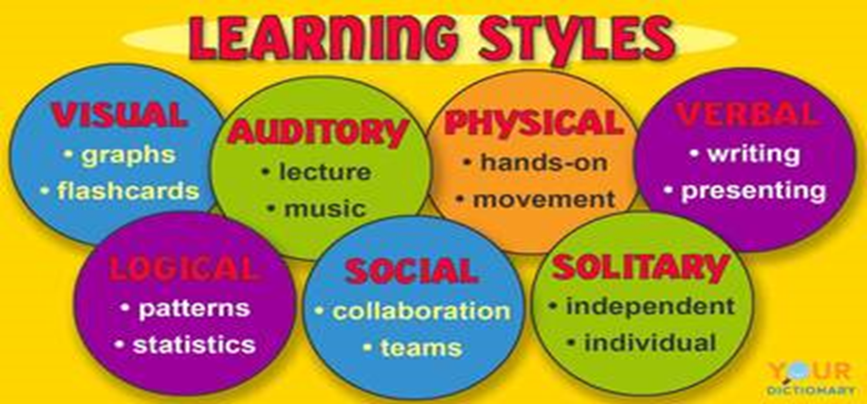
(Keyton,2021).

Effective way of communication

Of course, the way you present yourself and how you convey a message is very important. However, how you receive the message, the way you listen to people is just as important. Shutting someone up and listening to them is not the same as being there with your thoughts and emotions, being a very good listener. We present ourselves and our real messages through our words and movements Next time you are sharing your opinion try these (Beecher,2021).
Communication is about the way you express yourself to others. It is about sharing your personal thoughts and opinions with other people and the way they react to them. You can also say yes to yourself, that is, you defend your beliefs and respect the opinions of others.
While we are talking to each other we rarely feel the need to use only words. Very often, we use our own body language. It includes our gestures, eye movements, our gaze, etc. Learn to use it correctly to convey our message with the utmost precision. as possible. As you learn to read and use body language, it becomes easier for you to connect with others and develop relationships, as everyone wants to communicate with someone who really listens to them, cares about them, and understands them (Sukthankar,2021).
When we are having a conversation and a sensitive topic occurs, we tend to get emotional. At most times we later even forget the whole topic of that conversation but this leads us to an awkward and embarrassing situation. Strongs feelings like love or hate can mess up with our minds and we do not act rationally when we feel them. In these situations, emotional management techniques can help us return to a relaxed and rational state and relate to others without losing our cool (Feitosa,2021).
Last but not certainly not least, the words we say and the way we convey our message is crucial to our communications skills. For example, if you are a team leader and you want your team to know that you are together, use pronouns like "we" and "we" when you speak. That way, they will see themselves more as part of the team and less as an individual part of the company. Bottom line: words can be powerful if you know how to use them and when to use them (Beecher,2021).
Figure 2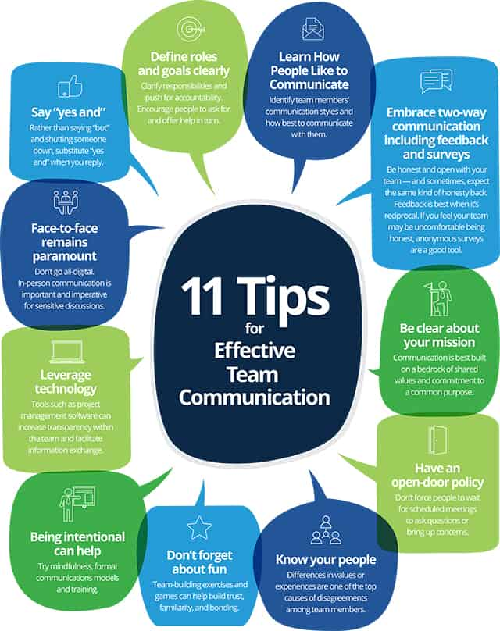
(Brulin, C., 2021).

Emails

One of the oldest and most popular forms of electronic communication is email, which allows users to send messages and files over the Internet. One of the best things about email is that you don't have to wait weeks to receive it. This type of email arrives moments after it is sent (Sukthankar,2021).
Emailing is used in many different ways:
- Communicate with clients or other employees
- Stay in touch with friends and family
- Send files to someone else as attachments
- Send marketing messages to potential clients.

Letters

Although it is already an old way to convey a message there are still people that prefer it. Letters are practical for storage because you can out them in a box in your attic and go and see them years later. They will certainly not look as they used to, but it is a very sweet and romantic gesture that warms your heart (Feitosa,2021).

Apps

In this era of technological Improvements, there are many messaging apps that customers can choose from. Almost everyone uses a mobile phone with internet, and we all use apps. There are a lot of different apps that you can use and they are very convenient. Apps can be easily downloaded on your telephone and you can use them every second of the day to check on friends and family or have business online meeting (Sukthankar,2021).

Poor ways for communications

When there is a misunderstanding there comes poor communication. In other words, the person being communicated misunderstood what you were saying and what did you want him to do or feel. Understanding is no longer mutual and is in no way beneficial. Good communication is when you can share your personal thoughts and emotions with the people surrounding you. When communication is effective, a communicator is able to express himself in an understandable way and the people who communicate with him understand what he wants to do (Feitosa,2021).
- Unconfirmed Understanding: When communicating with others, you should ask questions to make sure understands you clearly. It is important to check your understanding each time you speak.
- Poor communication skills: Sometimes when you send an email or use an app to share some information with someone it may not sound well. Vagueness, multiple interpretations, and inappropriate grammar are all things that stop the communication from being good. Good written communication is hard to achieve but not impossible. You need good grammar and the right words.
- Lack of clear objectives: Employees should know what you want from them. Give them goals that they can achieve. Give them clear directions that they can follow (Feitosa,2021).
- Inadequate Leadership: Bad leaders often are not very well informed and they can't answer their staff's questions and this makes the whole atmosphere frustrating. Good leaders have the confidence to answer questions or seek resources when unsure of the answers.
- Fear of punishment: When employees are afraid of their leader everything goes downhill. There is no longer a bond between you and them and they do not trust you. This can make communication very hard.
- Gossip: It is best to keep your employees up-to-date because if they are not informed they may start rumors. And a lot of people believe rumors which creates miscommunication (Beecher,2021).

Figure 3
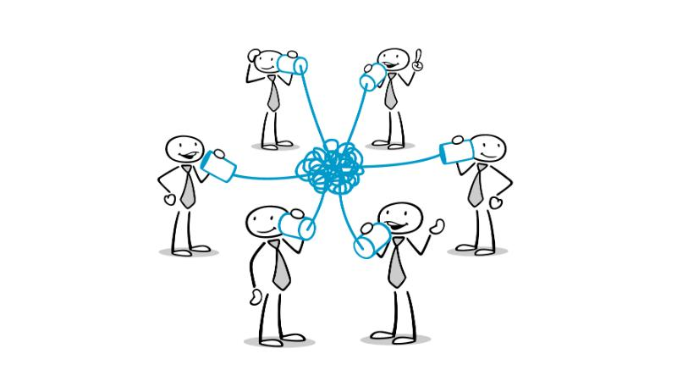
(Ahsan, A., 2021).

Conclusion

Teamwork is becoming well spread and very important thing in modern organizations and as long as teams are formed, managed, and implemented effectively, they can work together to create the best version of what they can present. However, when teams are assigned inappropriate tasks, managed ineffectively, or lack the support, resources, and autonomy to carry out their duties, the effects of teamwork can be counterproductive. A team is a group assigned to formal management with a common goal. There are differences between teams and groups; a group can exist without a team, but a team cannot exist without a group. Therefore, behavioral impacts and group dynamics will have a significant impact on the overall performance of the team. Therefore, management must be aware of the existence of groups that create their own personal norms and goals that may differ from the team's goals. Therefore, teamwork can be a complex area of ​​management, but when done effectively, the results can be very rewarding.

Reference list

Beecher, G.A., 2021. Follower Descriptions of Team Leader Communication Behaviors in Team Engagement (Doctoral dissertation, Grand Canyon University).
Davis, A.S., Kafka, A.M., González-Morales, M.G. and Feitosa, J., 2021. Team Belonging: Integrating Teamwork and Diversity Training Through Emotions. Small Group Research, p.10464964211044813.
Enayet, A. and Sukthankar, G., 2021, January. Analyzing team performance with embeddings from multiparty dialogues. In 2021 IEEE 15th International Conference on Semantic Computing (ICSC) (pp. 33-39). IEEE.
Newman, S.A. and Ford, R.C., 2021. Five Steps to Leading Your Team in the Virtual COVID-19 Workplace. Organizational Dynamics, 50(1), p.100802.
Paige, J.T., Kerdolff, K.E., Rogers, C.L., Garbee, D.D., Yu, Q., Cao, W., Rusnak, S. and Bonanno, L.S., 2021. Improvement in student-led debriefing analysis after simulation-based team training using a revised teamwork assessment tool. Surgery.
Ploeger-Lyons, N.A. and Keyton, J., 2021. Work Processes in Teams. In The Emerald Handbook of Group and Team Communication Research. Emerald Publishing Limited.
Saville, J.D., Spain, R.D., Johnston, J.H. and Lester, J.C., 2021, July. Exploration of team communication behaviors from a live training event. In International Conference on Applied Human Factors and Ergonomics (pp. 101-108). Springer, Cham.
Shan, J., Konishi, M., Pullin, P. and Lupina‐Wegener, A., 2021. Effects of cultural intelligence on multicultural team effectiveness: The chain mediation role of common ingroup identity and communication quality. Journal of Theoretical Social Psychology.
Wise, S., Duffield, C., Fry, M. and Roche, M., 2021. A team mental model approach to understanding team effectiveness in an emergency department: A qualitative study. Journal of health services research & policy, p.13558196211031285.

