Persian Empire – Timeline

Pre- 559 BCE
- Many Iranian tribes were ruled over by the Medes who ultimately came to rule over a large area, including the region of Persia, from the main city of Ecbatana

559 BCE
- Cyrus II becomes leader of a Persian tribe, the Pasargadae, and begins uniting all of the Persian tribes against the Medes (outlined in red on map)

553 – 550 BCE
- Cyrus II (“the Great”) led an uprising of the, now united, Persian tribes against his grandfather, Astyages, at Ecbatana, ultimately winning and gaining control over the undefined empire previously ruled over by the Medes
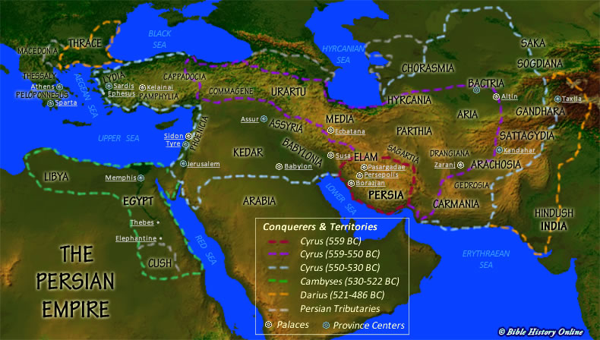
- Establishes the Achaemenid Empire of Persia (outlined in purple on map)

550 – 530 BCE
- King Cyrus II continues to expand the Persian Empire (outlined in blue on map)

539 BCE
- Cyrus II conquers Babylon, ends the ‘Babylonian Exile’

529 BCE
- Cyrus II is succeeded by his son Cambyses II

525 BCE
- Cambyses II conquers Egypt (outlined in green on map)

522 BCE
- Cambyses II is succeeded by Darius I

515 BCE
- The capital of Persia is moved to Persepolis

513 BCE
- Darius I invades Asia Minor

499 – 495 BCE
- The Greek colonies in Asia Minor revolt against Persian rule but ultimately fail

492 – 490 BCE
- Darius I fails in his invasion of Greece

486 – 485 BCE
- Darius I is succeeded by his son Xerxes I

480 – 479 BCE
- Xerxes I fails to invade Greece

448 BCE
- The Ionian cities (in the Asia Minor) become independent from Persia

465 BCE
- Xerxes I and his heir Darius are murdered, Xerxes I is succeeded to the throne by his younger son Artaxerxes I

424 BCE
- Artaxerxes I is succeeded by his son Xerxes II
- Xerxes II is murdered then succeeded by his brother Sogdianus

423 BCE
- Sogdianus is killed and the succeede by his (and Xerxes II’s) other brother Ochus who became Darius II

404 BCE
- Darius II is succeeded by his son Artaxerxes II
- Egypt separates from the Persian Empire as Amyrtaeus declares himself Pharaoh following the death of Darius II

358 BCE
- Artaxerxes II succeeded by his son Artaxerxes III

343 BCE
- Artaxerxes III regains Egypt under Persian Rule

338 BCE
- Artaxerxes III succeeded by his son Arses (Artaxerxes IV)

336 BCE
- Arses succeeded by Darius III

334 BCE
- Alexander the Great of Macedonia begins conquering Persian territories

330 BCE
- Darius III dies the last Persian King

  - This timeline was mainly constructed using the book ‘History of the Persian Empire’ by A. T. Olmstead (Olmstead, 2001)

Media was not the only large power in the region (Chaldea, Lydian and Egypt also held large areas under their control), but it was the only one that could be considered an empire (Olmstead, 2001)
Cambyses used an interesting method against the Egyptians, mainly using their reverence and fear of their goddess Bastet against them, at the battle of Pelusium (Mark, 2019)

