
Skills for the Workplace
Module Assignment Submission
Student Name: | Medi Williams
Student Number: | 2025488
Module No: | BMSK6001
Module Title: | Emergent Leadership Skills for the Work Place

Statement of Confirmation of Authenticity
By the act of making this submission, the student declares that this is the work of the student named above. The work has not, in whole or in part, been knowingly presented elsewhere for assessment, or where assessment has been built on a previous assessment, this has been identified. Where materials have been used from other sources it has been properly acknowledged. If this statement is untrue, the student acknowledges that an assessment offence has been committed.
Attention is drawn to the plagiarism and unfair practice policies of both the University and of ILM.
Permission for ILM to use this script
ILM uses learners’ submissions – on an anonymous basis – for assessment standardisation. By submitting, both the centre and the learner agree that ILM may use this script on condition that identifying information is removed. However, if you are unwilling to allow ILM use this script, please refuse by ticking the box: □

Table of Contents
Introduction 1
1.0 Critically assess a recognised leadership model or theory in relation to its ability to impact on individual workplace performance. 1
1.1 Leadership Skills 1
1.2 Leadership Models Competencies and influences in organisational structure 2
1.3 The STAR Model and organisational relationship to Jaguar Land Rover (JLR) and contrasting organisations 3
1.4 Motivational Theory 4
1.5 In achieving higher goals, does that mean individuals have the confidence and capability to perform? 5
2.0 Evaluate your own ability to use a range of leadership styles, in different situations and with different types of people to fulfil the leadership role. 7
3.0 Assess your own ability to set direction, motivate, delegate and empower others to bring about a workplace change. 8
3.1 Direction 8
3.2 Empower 9
3.3 Motivation 10
3.4 Delegate – 10
Conclusion - 11
References 12
Appendix A 15
Appendix B 16
Appendix C 21
Appendix D 37
Appendix E 38

Introduction

1.0 Critically assess a recognised leadership model or theory in relation to its ability to impact on individual workplace performance.
Asserted by Northouse (2013) “Leadership is a process whereby an individual influences a group of individuals to achieve a common goal”. (Northouse 2013: p.5) In examining the styles, behaviours and traits of leadership including that of their own, this report will also review its impact both positively and negatively within organisations. How fostering the wrong leadership style can manifest into dysfunctionality of a team and how adapting leadership style should be deployed to be productive and effective within workplace performance.

1.1 Leadership Skills
The author is an active leader and likes to lead with example. During the period where remote working was essential due to the pandemic, they undertook several tasks with the team to support, due to the lack of confidence of staff in undertaking them remotely. By supporting the staff in this way, it built their confidence and motivated them. Accessing directly into work internal systems and recognising the appropriate methods, without corrupting or interfering with college software and financial systems, gave them empowerment to undertake these duties, creating effective teamwork and performance. Attributed to the authors clear communication and guidance which are reflective of traits identified and evidenced in the authors’ research. Accentuated in the example is the authors ability to motivate and empower others by leading by example, showcasing an ability to act in various capacities within an organisation, depicting a distributed leadership type, creating opportunities and mobilising their expertise.
Kouzes and Posner (1987) recognise ten leadership commitments that are classed as traits, and further accentuate results of their research also identified five best exemplar practice modes of implementation, providing meaningful and influential attributes, to become an effective leader within the workplace who motivates and empowers employees. Modelling the way – whereby a leader contributes towards tasks actively showing they are a “doing” leader, inspiring a shared vision, encouraging all to share values, focus and belief, also undertaking process challenges to ensure it is the right way for efficiency and productivity to meet successful outcomes, imparting employees with the tools to enable problem solving and finally by encouraging the heart through acknowledging employees’ successes and in some instances rewarding them. (Kouzes & Posner, 1987)
This being said, in contrast, Charteris-Black (2006), asserts that it is vison that dominates new leadership as recognised in their research, explaining further, the ability to formulate, communicate and act on visions has now become a centric component. However, further into their research, it is claimed that whilst studies argue its centric positioning, very few clearly define in what manner. (Charteris-Black, 2006) In this report, the authors own research will examine the claims in their validity in respect of the authors leadership.
However, in recognising leadership one must also consider the influencing factors such as leadership traits which can hinder or define leadership styles and actively affect performance.
It is stated by House et al (1991) that at individual level, traits are said to influence the seeking of, and fit with, managerial advancement (House, Howard, & Walker, 1991) Resulting in greater organisational status, advancement and wage increase. (Becker, 1975) Again, reiterated by (Locke, 1991) that understanding of one’s own skillset can reinforce its effectiveness as a leader (Locke, E.A. 1991). Identified in the author’s own workplace, whereby as a hierarchical structure, an effective leader will be recognised, acknowledged and recommended for higher positions or secondment to higher positions. (Becker, G.S. 1975). However, clear communication from a flat structure creates a greater opportunity of direct communication interaction. An example can be seen in networks, skills and performance which relate to communication. However, the author identifies further communication traits such as family, networks and mentoring which they feel are all communication led, dialogue and discourse enriches leadership and upskilling by undertaking others’ viewpoints, when engaging with the team. Ascertaining their views on certain processes can bring new perspective to meeting objectives and targets, give more effective and productive processes whilst also creating an opportunity for staff to buy-in to change, not dissimilar to that of Kotters change model. (Kotter, John P. 1996).
Many layers apply to leadership skills, to be considered and embraced to be a successful and effective leader. As reported by Tharenou, leadership skills are driven by the undercurrent goals, measures, organisations, management skills and success. Responding further by asserting “they need to be committed towards vision and goals, they need to acquire an efficient understanding of their job duties and responsibilities, demonstrate honesty and integrity, set an example in terms of their jobs, understand how to motivate others and stimulate their mind-sets, generate awareness in terms of measures to cope with problems and challenges, exercise control on psychological problems, provide solutions to various types of problems and challenges, promote mutual understanding and create an amiable environment within the workplace”. (Tharenou, P. 1997). The author advocates it would be prudent for an organisational leader to consider such influencing factors to draw on the correct and appropriate leadership style in undertaking leadership direction, ensuring best and most effective ways in achieving optimum performance from an individual. Identified in the authors workplace through hierarchal structure, organisational or departmental staffing structure, investment in recruitment and training and organisational culture and vision, the organisation invest in such areas to provide growth, productivity and talent pipeline, underpinning quality in service delivery for learners.
In conclusion, the author agrees with the above research which underpins their own experience and posits several theories/models need to be used by a leader to effectively deal with arising circumstances and situations within their workplace, dependant on characteristics and personality of their team to draw on the best results and performance outcomes. It also illustrates the need for a leader to be cognisant of emotional intelligence in undertaking the correct methodology to address the challenges faced. Moreover, concluding to be an effective leader within an organisation to support performance achievement one must comprehend how influencing factors can influence directional leadership styles and models used.

1.2 Leadership Models Competencies and influences in organisational structure
Various competencies direct and influence leadership models, each with distinctive focuses: -
Competency models: Whereby the focus is workplace skills, qualities and competencies, where characteristics may advise the competency framework and leadership styles.
Theoretical models: Based with an academic focus deriving from scholarly research. academic knowledge provides theoretical insights to effective leadership.
Value models: Comparable to the competency model with more accentuation on values and behaviours of individuals.
Effectiveness models: Identifies the effectiveness of a broad range of attributes, skills and competencies to specific situations to evaluating outcomes.
Purpose models: Specific and measurable with a focus on projects.
Applicative models: Designed on knowledge of workplace and overall industry perspective/vision.
It is appropriate to say, that each have a bearing on the need for leadership dependant on situation. Again, the author recognises the similarity to that of leadership skills, in essence a leader will need to assess situations, be attuned to their emotional intelligence and be perceptive in understanding which to implement to lead to achieve success in the required outcome. (Komives et al., 2011)

1.3 The STAR Model and organisational relationship to Jaguar Land Rover (JLR) and contrasting organisations
The Star Model (Appendix A) is underpinned by five main objectives, emphasising an organisational approach to stakeholder need to determine the leadership direction, for advocate and implement within their organisational teams, policies and structure. Emphasis of direction is driven by organisational strategy and vision. Underpinning this is organisational structure determining power to be where decision making lies with through-flow into defining the way in which processes are governed. Rewards signifies a motivational opportunity for individuals to perform and achieve set goals. However, the significance of people is affiliated to that of policies which influence and define the directive of staff mindsets and skills. (J.R. Galbraith 2011)
This model is indicative of an applicative theory/model, in which directive is pushed from an organisational objective. By way of policies and regulations driving the internal elements and interfaces of the organisation to align with its vision, values and beliefs therefore creating the perspective of employees to meet shared goals. (Bass & BASS, 2008)
However, a hierarchical leadership structure within an organisation can be far removed from that of operational resource and seen as an impersonal approach impacting on performance. Communication channels between leaders and employees can therefore be distorted or silent. In contrast, a flat management structure, comprising of cross departmental managers and leaders, will give way to wider communication whereby they are closer to operational staff to hear their voices. (Carzo & Yanouzas, 1969). Within the authors workplace each department has a manager, responsible for operational meetings, consequently nurturing upper management feedback, initiatives, challenges and solutions presenting an effective and efficient department to who consequentially then interpret, leading visionary change and strategy. Actively aligning both managerial and leadership activities to ensure end goal results.
As an example, JLR, develop their strategies in line with customer need and feedback, in order to undertake an understanding of their micro and macro environs. Analysing, with their results, the influencing factors that determine internal management of time, quality and cost. Defining their process towards that which management and leadership will focus within their organisation vision. (Becker et al, 2011). Comparable to the applicative theory in relation to organisational drive, in addition reflective of the Star model in utilising a circular methodology, from customer through to formulate and implement within processes, policy and organisational strategy.
This can be argued that although it is a trait of the leadership theory has the tendencies of management and not that of a leader whereby as iterated by Kotter (1990) draw their activities based on operational day to day activities, in contrast to a leader which proposes a more strategic approach in setting vision and direction. (Kotter 1990). The author claims it is an experienced leader that has the knowledge and expertise to combine both attributes to provide guidance and support, when necessary, but can motivate others to achieve successful outcomes.
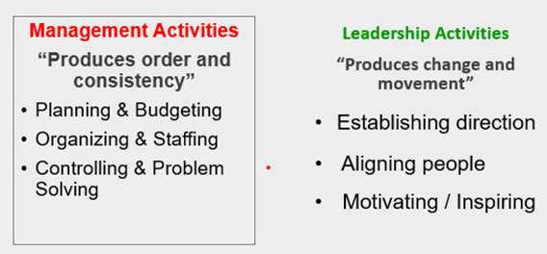
Figure 1 – Source Kotter, John P. (1990). A Force for Change.
Asserted by Nigel Blenkinsop, Director of Operation, JLR (2018). leadership and strategy entwine.
“Change has been a constant feature of life at Solihull. We have succeeded through having clarity of purpose at all levels, developing the systems to support performance, coaching into teams and encouraging talents to be used for the common good.” (Jaguar Land Rover, 2018)
Further confirmed within the research, by the admission of ground floor operational employees resulting in belief that, leadership and strategy permeates to factory floor level. Convincing the article researcher that of “JLR really does want its people to thrive and play their part in the success of JLR.” The Manufacturer (2018)
In conclusion it is evident that The Star Model poses the elements and ethos that drives leadership and change within JLR which is valued by their employees. However, not all organisations are the same and have differential vision and methodologies to support organisational leadership.

1.4 Motivational Theory
In contrast, motivational theories centre around employees, where leaders can create the correct environment to motivate and inspire others to be empowered and instil job satisfaction. It can be intrinsic and extrinsic to some individuals. People may be career driven to manoeuvre through organisational ranks, others may be motivated by team interaction defining their motivation through social need. (Reykowski, J, 1982)
Autonomy plays a significant part within the motivational theory, where individuals will be empowered by setting their own goals and achieving tasks based on own capability, knowledge and competencies. (Chen et al., 2011). As a leader, the author encourages autonomy within their own department encouraging their own emotional intelligence, decision making and determining a solution-based approach to challenges and barriers. In order to do this, it is a regular agenda item on the team meetings. It motivates staff to come up with individual solutions to address team and departmental challenges. Doing so empowers individuals in posing their own solutions, the author also recognises as a leader, this is fundamental in encouraging and motivating staff to feel heard, be included and that differential team culture can bring insight and fresh perspective to addressing issues. (Kanat-Maymon et al., 2020). Within their workplace they encourage individuals to set two objectives in their annual review, giving opportunity of ownership and self-motivation to achieve individual goals in addition to those set by manager. The purpose is to give autonomy, be a part of the process and moreover, increase knowledge and skillset, which in turn is invested within the department, improving organisational productivity.
1.5 In achieving higher goals, does that mean individuals have the confidence and capability to perform?
Sometimes, ego within an individual, may hinder progression and organisational growth. In thinking they know all, poses problematic issues in terms of team dynamics as identified within Lencioni’s Dysfunctional team theory. (Lencioni, 2002). Similarly, recognised as a hindering factor within Tuckman’s theory. (Tuckman, B. 1965). He identified a period of storming which can be replicant of situations where an individual’s voice is higher than others, by way of controlling the situation and asserting their solution above others, projecting dominance within a team. In doing so leaders convey to others an autocratic leadership style, the author posits this does not support group moral. Furthermore, others perspective can be informative and contribute to effectiveness of processes, in addition to projecting solutions to overcome challenges.
‘Hawthorne effect’ (Mayo, 1933/2010) resulted from a study in the 1920’s, theoretically improving working conditions for individuals, whether by increased lighting or increased rest / break periods to measure productivity and effectiveness of the individuals. Results once returned to its former state, indicated that absenteeism had plummeted and productivity at its highest, however, not from the changes but from the attention being given. (Morse & Landsberger, 1961). Additionally, research indicated that individuals forfeited individual performance, replacing with group activity playing a team achievement as opposed to standing out from others irrespective of their ability and success. Research also indicated that supervision had little or no effect. Concluding, that giving attention can motivate individuals, creating greater output and increased productivity. Essentially, defining that man is motivated by social need. (Sedgwick & Greenwood, 2015).
In contrast to JLR, Coca Cola’s leadership approach is attuned to a motivational theory and takes an empathetical approach to benefit and reward for employees. “Our vision is to craft the brands and choice of drinks that people love, to refresh them in body & spirit. And done in ways that create a more sustainable business and better shared future that makes a difference in people’s lives, communities and our planet.” (The Coca-Cola Company, 2022). As a global organisation, it is imperative that countries and culture play a part in their leadership manifesto. Coca Cola’s approach to developing strategy and vision centred around that of employee’s thoughts and feedback.
James R. Quincey, the then Chairman & Chief Executive Officer (CEO), undertook an inclusive exercise in forming their strategy, whereby he sent a personal letter to employees, outlining his vision but encouraged staff to feedback or ask questions directly. (Quiney 2019) (Appendix B). A portrayal indicating hierarchy are open to suggestions and influence by way of input from all employees. In addition, Coca Cola have adopted inclusive methods to capture an organisational viewpoint and feedback on practices, policy and procedures. Conducting an Employee Insight Survey every year, introducing blogs, and digital formats to capture all employees’ values and beliefs. Highlighting their commitment to embrace the culture within the organisation. In doing so employees feel fostered trust and empowerment and motivated. In addition, to further motivate employees, Coca Cola also offer merit based annual reviews, whereby performance is measured and compensated with merit raises. Additionally, backing up their words of conviction to support the lives of communities, it offers employee’s children an opportunity to qualify for a scholarship fund. (Dwilson S.D. (2018). Accentuating that leadership in contrast to JLR can be led from a hierarchical perspective therefore their approach is replicant of a motivation theoretical approach.
Divergently, Herzberg’s theory imparts an intrinsic approach, a non-financial two-part theory, Motivational and Hygiene. Motivation factors such as acknowledging employees’ achievement and fulfilling, challenging and rewarding work encouraging job enrichment, giving additional depth to the job role in acknowledging employee’s success. However, the hygiene factors, he stresses as being the factors that an organisation must ensure is present as without would demotivate individuals. Key factors such as, working conditions inappropriate or lack of clear leadership guidance or correct company policies. Hertzberg advocated job enrichment giving greater challenge to the role, rewarding individuals, giving autonomy through less supervision and trust in individuals to undertake their duties and fulfil their roles (Riley, n.d.)
Contrarywise an example whereby this was not apparent in their leadership direction in the company’s infancy is the organisation Brewdog. Brewdog customer orientation is at a younger audience, however, was not without a polemical marketing and leadership approach. Expansion of the company into supermarkets in 2008 created an autocratic leadership behaviour, unconscious its employees’ culture or its ethical approach. Subsequently, a letter from the employees was published on the social media platform Twitter, exposing a culture of fear from employees indicating a sense of demotivation from employees. James Watt, co-founder responded with an embarrassed but acknowledging statement: -
"Our focus now is not on contradicting or contesting the details of that letter, but to listen, learn and act. As a fast-growing business, we have always tried to do the best by our team - we do have thousands of employees with positive stories to tell as a result. The tweet by former staff proved that "on many occasions we haven't got it right. We are committed to doing better, not just as a reaction to this, but always; and we are going to reach out to our entire team past and present to learn more. But most of all, right now, we are sorry." (BBC, 2021).
Arguably, Brewdog created dissatisfaction and demoralisation in employees lacked hygiene factors needed for job enrichment, such as Herzberg’s theory with inadequate policies and lack of culture and respect. Acting on employees’ actions, Brewdog undertook the implementation of a code of ethics policy, setting organisational values, business culture and practices. (www.brewdog.com, n.d.).
Conclusively, research undertaken, recognises circumstance has determined the best theoretical approach and fluctuation between models used are driven by organisation and leadership traits. Not all will achieve the desired goal, unless implemented correctly by leaders, with employees responding positively, creating a harmonious team to build productivity, efficiency and empowering others to succeed.

2.0 Evaluate your own ability to use a range of leadership styles, in different situations and with different types of people to fulfil the leadership role.
The author undertook an assessment to determine their own leadership style, categorising traits, skills, process and behaviour endeavouring to identify the prominence of each to the author within their own leadership. The use of Northouse, P.G. (2016) leadership questionnaires, the results of which can be seen in Appendix C, defines the authors leadership style for use within this report as a benchmark for analysis for evaluation purposes.
The undertaking of the leadership skills analysis results posits a conceptual style leader tendency with democratic leadership as a main characteristic. Through undertaking such a questionnaire, where peers reviewed their perception of the author, was reassuring and insightful in understanding of their leadership style and influence. Whilst peers’ results indicated a high level of leadership understanding of behaviour, characteristics and the ability of the author to be a fair and motivating leader, as a relatively new member of the department, it was both reassuring and also quite humbling for the author to recognise the impact made in a short period.
The author undertakes her duties as both manager and leader by establishing an understanding of their team. Identifying skills, potential, characteristics and knowledge. An attuned leader will also recognise their need to be understanding of emotional intelligence, in order to create the correct conditions to motivate, empower, delegate, offer autonomy and gain trust. (Daft, 2022).
Within their previous position, the author, as an initial activity within a new organisation, undertook a skills and capacity audit of the team. Giving opportunity to identify employee’s potential ability and skills. Undertaking such an activity and meeting the employees on a one-to-one basis gave insight into understanding what employees wanted from their roles, where they felt difficulties lay, their achievements, moreover, it gave way to discussion on what was expected from them. (Heim & Sardar-Drenda, 2020). It is recognisable from this example the author portrays tendencies of relationship theories by way of motivating and empowering others, inspiring staff to build self-confidence to achieve set objectives, thus giving autonomy to the team.
The above examples within the authors workplace, signifies their democratic leadership style, involvement of the teams, justifies their feeling empowered valued and unified. Creating a team that feels they are contributing to the processes. Identified also within the questionnaires undertaken by their peers. (Hilton et al., 2021).
Authoritarian leadership offers a very dictatorial approach to leadership, although not a main leadership style used by the author, it is recognised the need to flex to this style in certain circumstances. Although the author feels it is important that staff have significant autonomy, there are instances within leading a team that a need has arisen to use an Authoritarian leadership style. Often used to impose high standards and performance on subordinates advising on introducing more work ethos into their performance. (Chen et al., 2018).
On occasion too much autonomy can result in negative performance within the authors workplace, invariably seen with younger inexperienced professionals. An incident whereby an individual perpetually turning up late and then not achieving set tasks which impacted on team performance, required authoritarian leadership. In this instance the author met on a one-to-one basis. to instil how the individual’s actions had impacted on the departmental goals in addition to that of breaking organisational policy. Still offering the individual autonomy and an opportunity to redeem themselves as a first warning stage, they requested a plan of action from the individual to reimburse hours lost and to meet tasks. Action planning in this way was driven by the individual who had ownership in fulfilling the proposed actions. Monitored closely by the author until performance was resumed and an equilibrium with other team members was achieved. In contrast to the individuals peer who performs without direction and close monitoring, identifies to McGregor’s X and Y theory whereby x needs to be pushed to gain results, opposing effect being Y where individuals can motivate themselves to achieve tasks and results. (McGregor, 1960).
Covid 19 pandemic, threw the world into turmoil, with varied levels of change to leadership being undertaken, in a reaction to mitigate organisational risk. Outlined in research, it is leaders with the ability to be mindful of economic factors that can impart leadership traits and styles that portray conceptual leadership. (Ingsih et al, 2021).
A conceptual leader will account for environmental influences that can impact on organisational performance, evaluating correct leadership style to be implemented. (Manderscheid & Ardichvili, 2008) During the pandemic the author experienced a need to motivate through conceptual leadership undertaking decisions and varied leadership styles. Due to the nature of the pandemic, it was imperative they adopted an empathetical approach to situations, understanding the diversity amongst the team and undertaking an ethical leadership approach. Ensuring religious holidays were considered and team meetings did not conflict with payer times, normally accommodated with an appropriate prayer room in the workplace. When moral was low and team family members, where taken ill by the infection, reverting to a charismatic leadership approach ensured they raised enthusiasm and motivation, by introducing staff quiz and get togethers online on a Thursday lunchtime to just talk or engage on a social level. In doing so creating opportunity for the author to identify those needing additional support. Undertaking, at times distributional leadership to achieve team performance when staff absenteeism was invariable a contender during pandemic ensuring all task and goals were achieved, and duties covered. All of which show the authors expertise as a leader to undertake a conceptual leadership style. It is also responsive to that of the 3 Circle approach set by Adair recognising all factors that are comprised within a team, their characters, achievements, understanding of all individual’s contribution, additionally their different levels of skills. (John Eric Adair, 2011).
It is apparent the author can adapt to change and undertake different leadership styles to respond to given situations and circumstance with ease, to gain enthusiasm, and performance from a team.

3.0 Assess your own ability to set direction, motivate, delegate and empower others to bring about a workplace change.

3.1 Direction
Setting direction can involve instructing on strategic change which may involve taking risks or challenging the norm. However, leaders need to direct, based on evidence, identifying new intelligence to back up need for change and be aware and prepared for any unintended consequence. (Gurr et al, 2020).
Asserted by Bennis (2015) effective and triumphant leaders can contextualise objectives or new processes regardless of how disruptive or the disorder it brings to operational dynamics. (Bennis 2015). In agreement with this research, the author posits successful leaders will process the change and adapt to task format, to convey direction to their peers, team and hierarchy. Knowledge and experience have a significant role to play within mastering this ability.
Within an organisational and workplace context, the author has reason to adjust process methodologies in line with circumstantial or situational change. As a leader within an academic institution, governing structures influence change such as Welsh Government and a Board of Governors structure. Formulation of both can invariably influence strategy, organisational vision and mission. However, an instance where this has significantly impacted on directional change, was during an instruction from Welsh Government to adapt to online learning and working from home during the covid pandemic. Whilst lucky enough to have had two weeks’ notice there was no strategy to implement change. As a leader the author immediately undertook a resource gap analysis (Appendix D) to evaluate current situation and identify areas of deficiency. Simultaneously developed a short action plan ensuring resources and task were identified with timebound smart objectives (Appendix E), in order to prepare to undertake the transformational change and convey the new method of service delivery for their team endeavouring to put in place a clear communication and process structure. In doing so, this formulated the vision for implementation, removing obstacles and as methodically thought through gave reassurance and confidence to the team once implemented. This method is resonant of Kotters transformation change model in essence the 3 phase approach of creating the sense of urgency, introducing the new behaviour and relating the change into the organisation. The author’s approach was embraced and accepted warmly and with the interventions of support transitioned into a successful implementation with the team being able to perform their duties with clear guidance of tasks, achieving a substantial £3million of claims to the Welsh European Office within this period. (Kotter, 1996).

3.2 Empower
Leadership empowerment or employee empowerment is a critical factor within organisation in team or employee development (Wallach & Mueller, 2006) Research also identified empowering leaders inspire the creation of organisational or departmental vision, by way of division of power and augmenting autonomy. (Mary, N. L. 2005).
Within an organisation such as the authors workplace, autonomy is encouraged but is driven by job responsibility. As an advocate of employee empowerment as a leader the author takes opportunity to offer the team the ability to contribute to processes and in doing so creates the wider opportunity for individuals to carry out work tasks without micromanagement. Whilst there are specific tasks, each team member actively completes within their roles each join to create a circular process to achieve an objective. Whilst the author agrees on the tasks to be undertaken, the autonomy is on the individual in how they complete these to achieve the task objective. Furthermore, opportunity is given for employees to reflect in team meetings evaluating positives and negatives, defining efficiency and best practice. In using this methodology, the employees are empowered to contribute without judgement, feeling valued. Whilst this simplistic approach is used, it is not without risk to the leader, as staff given the opportunity for greater responsibility and autonomy can foster egotistical attitudes causing dysfunction in the team. However, the author has only seen positive results and embraces others’ opinions in achieving successful outcomes. (Stacey, R. 2009).

3.3 Motivation
Motivation for an individual, can be born from several factors such as personal development, positive work environment and exciting and challenging work. It is the authors belief that encouraging motivation will stem from all such factors dependant on the individual desire to achieve job satisfaction.
In motivating individuals, the author encourages open communication with staff members in requests for personal development and actively encourages staff to undertake workplace related training, for the purpose of enriching their knowledge aiding organisational career advancement. Team building exercises the author can identify those with the potential to advance within the departmental structure such as achieving Co-ordinator status as a transition from administration. An activity to work in teams using AI technology was introduced and staff were put into groups, consisting of five minutes to actively defuse a bomb. One staff member undertook the visual line of sight through virtual technology, another gave instruction, lastly the other deciphered the control instructions being seen by the participant using the virtual technology. Whilst an interactive and engaging exercise the author was clearly surprised by who stood out in giving clear instruction calmly and decisively. This would be in line with the organisation’s expectation from Co-ordinators.
As a reflection of this activity the author met with individuals to ascertain their goals and aspirations that could be aligned with their appraisals and professional development plans (PDP). In discussion, understanding the individuals needs for motivation also became apparent, not dissimilar to Maslows Motivational Theory, in establishing and observing individual’s own need to be motivated. Cautiously also undertaking an analysis of capability to succeed in much the same vein as that of Potter and Lawlers expectancy theory. (Maslow, 1943) (Porter & Lawler, 1968).
Following this a PDP was identified and as a leader additional appraise of ongoing work activity encouraged using motivators such as recognition of achievement and support through the training. Consequently, two of the three staff originally identified, progressed into higher roles increasing salary and work satisfaction.

3.4 Delegate –
“Delegation occurs when the manager gives an individual the authority and responsibility for making a decision, where prior approval may or may not be required before the decision can be implemented” (YukI, 1998). This can be seen, when an individual is given a direct order to carry out a task by their line manager or senior staff.
Research undertaken also notes the junior staff members perception of managers who delegate, not all will accept delegation when they possess an egotistical characteristic, or if they have been in the role for several years and believe they know best. (Bass 1990).
For the author to delegate tasks within their workplace, it would be prevalent to understand the individual’s capabilities and skills. It would be a fruitless exercise to delegate to an individual not possessing the knowledge and understanding of how to complete it successfully, hindering organisational performance and success.
In undertaking delegation when faced with new tasks, the author poses language which is aligned to the individual’s character to ensure it does not portray an autocratic behaviour, such as “Can you take ownership of that task” or “I know this is right up your street, are you ok to carry out this”. Delegating in this manner represents the authors trust in their capability, also giving encouragement to undertake said tasks, as it is often all too common that autocratic leaders will delegate instruct and command tasks to be carried out which can cause hostility. An example of the authors delegation is often seen in team meetings when running through outstanding tasks or indeed offer solutions to overcome issues. The author welcomes new ideas and often delegates the individual to implement solutions with an agreed timeframe to meet and evaluate its success. In this instance the staff feel listened to, trusted and valued for their contribution instilling a good working relationship amongst the team.

Conclusion -
Research evidence substantiates the authors interpretation of emergent leadership where a leader’s role is not linear in its direction. The leader must possess the ability to fluctuate between leadership styles in conjunction with situational circumstance. Experience and knowledge play a significant role in becoming a successful leader. Having the aptitude to understand best use of leadership factors to influence and empower others.

References

(Kotter, John P. 1996). Leading Change. Harvard Business School Press. ISBN 978-0-87584-747-4.
Bass, B. M. (1990). Bass & Stogdill’s Handbook of Leadership: theory, research, and Managerial Applications (3rd ed.). Free Press ; London.
Bass, B. M., & BASS, R. (2008). The Bass Handbook of Leadership: Theory, Research, and Managerial Applications. Simon & Schuster.
BBC (2021). Ex-Brewdog staff allege culture of fear at brewer. BBC News. [online] 10 Jun. Available at: https://www.bbc.co.uk/news/business-57428258.
Becker, G.S. (1975). Human capital. Chicago: University of Chicago Press.
BrewDog (2020). BrewDog Tomorrow: A Sustainability Update. [Online] BrewDog. Available at: https://www.brewdog.com/blog/brewdog-tomorrow-a-sustainability-update.
Carzo, R., & Yanouzas, J. N. (1969). Effects of Flat and Tall Organization Structure. Administrative Science Quarterly, 14(2), 178.
Charteris-Black, J. (2006). The Communication of Leadership: The Design of Leadership Style. In Google Books. Routledge.
Chen, C.-Y., Chen, C.-H. V., & Li, C.-I. (2011). The Influence of Leader’s Spiritual Values of Servant Leadership on Employee Motivational Autonomy and Eudaemonic Well-Being. Journal of Religion and Health, 52(2), 418–438. https://doi.org/10.1007/s10943-011-9479-3
Daft, R. L. (2022). The Leadership Experience (8th ed.). Cengage Learning.
Dwilson, S.D. (2018). What Type of Employee Motivation Does Coca-Cola Offer? [Online] Career Trend. Available at: https://careertrend.com/type-employee-motivation-cocacola-offer-37161.html.
Gurr et al, D. (2020). International Studies in Educational Administration Journal of the Commonwealth Council for Educational Administration & Management. https://edu.thecommonwealth.org/wp-content/uploads/2020/11/ISEA-2020-481.pdf#page=30
Heim, I., & Sardar-Drenda, N. (2020). Assessment of employees’ attitudes toward ongoing organizational transformations. Journal of Organizational Change Management, ahead-of-print(ahead-of-print). https://doi.org/10.1108/jocm-04-2019-0119
Hilton, S. K., Arkorful, H., & Martins, A. (2021). Democratic Leadership and Organizational Performance: The Moderating Effect of Contingent Reward. Management Research Review, 44(7), 1042–1058. EMERALD. https://doi.org/10.1108/mrr-04-2020-0237
House, R.J., Howard, A., & Walker, G. (1991). The prediction of managerial success. Academy of Management Best Paper Proceedings, 51,215-21
Howard, A., & Bray, D.W. (1990). Predictions of managerial success over long periods of time. In K.E. Clark & M.B. Clark (Eds.), Measures of leadership (pp. 113-130). West Orange, NJ: Leadership Library of America
Ingsih et al. (2021). Transformational leadership style and organizational commitment in pandemic Covid-19. Contaduría Y Administración.
J.R. Galbraith,(2011) The STAR Model
Jaguar Land Rover. (2018). Jaguar Land Rover: Leading the way to growth. The Manufacturer.
John Eric Adair. (2011). The John Adair lexicon of leadership: the definitive guide to leadership skills and knowledge. Kogan Page.
Kanat-Maymon, Y., Elimelech, M., & Roth, G. (2020). Work motivations as antecedents and outcomes of leadership: Integrating self-determination theory and the full range leadership theory. European Management Journal, 38(4), 555–564.
Komives, S. R., Dugan, J. P., Owen, J. E., Slack, C., Wagner, W., & Programs (NCLP), N. C. of L. (2011). The Handbook for Student Leadership Development. In Google Books. John Wiley & Sons.
Kotter, J. P. (1990). Force For Change : How Leadership Differs from Management. Free Press.
Kotter, John P. (1990). A Force for Change. Free Press. ISBN 0029184657.
Kouzes, J. M., & Posner, B. Z. (1987). The Leadership Challenge. Jossey-Bass.
Lencioni, P. M. (2002). The Five Dysfunctions of a Team. John Wiley & Sons.
Locke, E.A. (1991). The essence of leadership. New York: Management Journal, 26,608-625. act. Populutwn Research and Policy Review, 11, 2149. Psychologist, 49,428436. Lexington
Manderscheid, S. V., & Ardichvili, A. (2008). A conceptual model for leadership transition. Performance Improvement Quarterly, 20(3-4), 113–129. https://doi.org/10.1002/piq.20006
Mary, N. L. (2005). Transformational leadership in human service organizations. Administration in Social Work, 29(2), 105–118.
Maslow, A. H. (1943). A Theory of Human Motivation. Psychological Review, 50(4), 370–396.
Mayo, E. (2010). The human problems of an industrial civilization. Routledge, Repr. (Original work published 1933)
McGregor, D. M. (1960). The Human Side of Enterprise. Mcgraw-Hill.
Morse, L. T., & Landsberger, H. A. (1961). Hawthorne Revisited. The American Catholic Sociological Review, 22(1), 76. https://doi.org/10.2307/3708156
Northouse, P. (2017). Introduction to Leadership: Concepts and Practice | SAGE Companion. Sagepub.com. https://edge.sagepub.com/northouseintro4e
Northouse, P. G. (2013). Leadership: Theory and Practice (Sixth Edition). Thousand Oaks, CA: Sage Publications
Northouse, P. G. (2016). Northouse, Introduction to Leadership + Northouse, Introduction to Leadership 4th Ed. Interactive Ebook Access Code. Sage Pubns.
Porter, L. W., & Lawler, E. E. (1968). Managerial Attitudes and Performance. Administrative Science Quarterly, 13(1), 177. https://doi.org/10.2307/2391269
Quincey, J. (2019). THE PURPOSE OF OUR COMPANY CHAIRMAN & CHIEF EXECUTIVE OFFICER THE COCA-COLA COMPANY. [Online] Available at: https://www.coca-colacompany.com/content/dam/journey/us/en/our-company/purpose-and-vision/james-quincey-letter-to-employees-coca-cola-company-purpose-dec-2019.pdf.
Reykawski, J. (1982) Social Motivation Annual Review of Psychology Vol. 33:123-154 (Volume publication date February 1982)
Riley, J. (n.d.). Motivation Theory - Maslow’s Hierarchy of Needs. Www.youtube.com. Retrieved May 25, 2023, from https://www.youtube.com/watch?v=3St5OoLYTJ0&list=RDLVf-qbGAvR4EU
Sedgwick, P., & Greenwood, N. (2015). Understanding the Hawthorne effect. BMJ, 351(1), h4672.
Stacey, R. (2009). Complexity and organizational reality: Uncertainty and the need to rethink management after the collapse of investment capitalism. Oxford, England: Routledge.
Tharenou, P. (1997). Explanations of Managerial Career Advancement. Australian Psychologist, 32(1), 19–28.
The Coca-Cola Company (2022). Our Culture | The Coca-Cola Company. [Online] www.coca-colacompany.com. Available at: https://www.coca-colacompany.com/careers/our-culture.
The Manufacturer. (2018). Jaguar Land Rover: Leading the way to growth. The Manufacturer.
Wallach, V. A., & Mueller, C. W. (2006). Job characteristics and organizational predictors of psychological empowerment among paraprofessionals within human service organizations. Administration in Social Work, 30(1), 95–115.
Yukl, G. (2013). Leadership in organizations. Prentice-Hall.

Appendix A

Source - The STAR Model, J.R. Galbraith (2011)

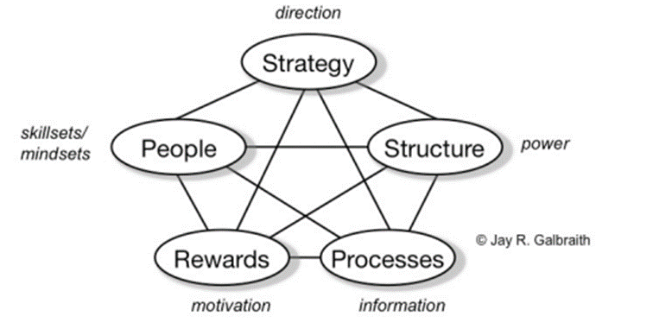

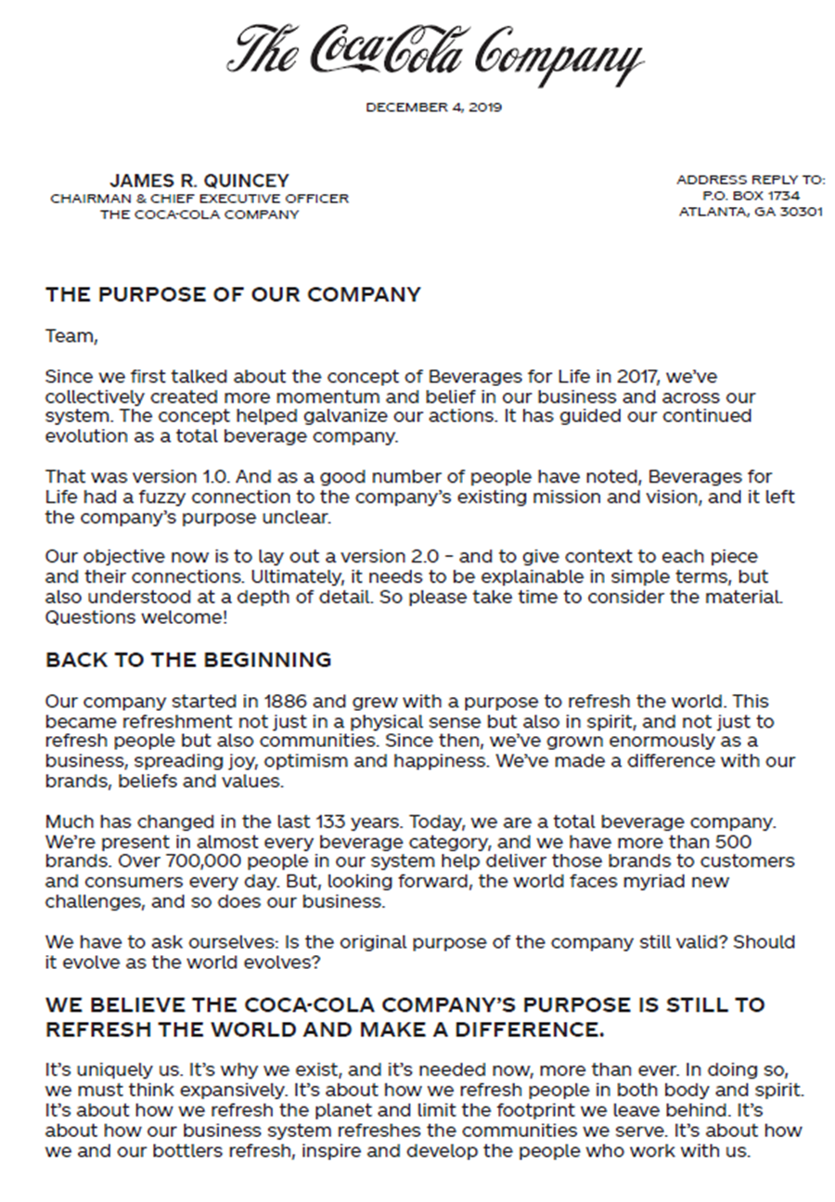
Appendix B
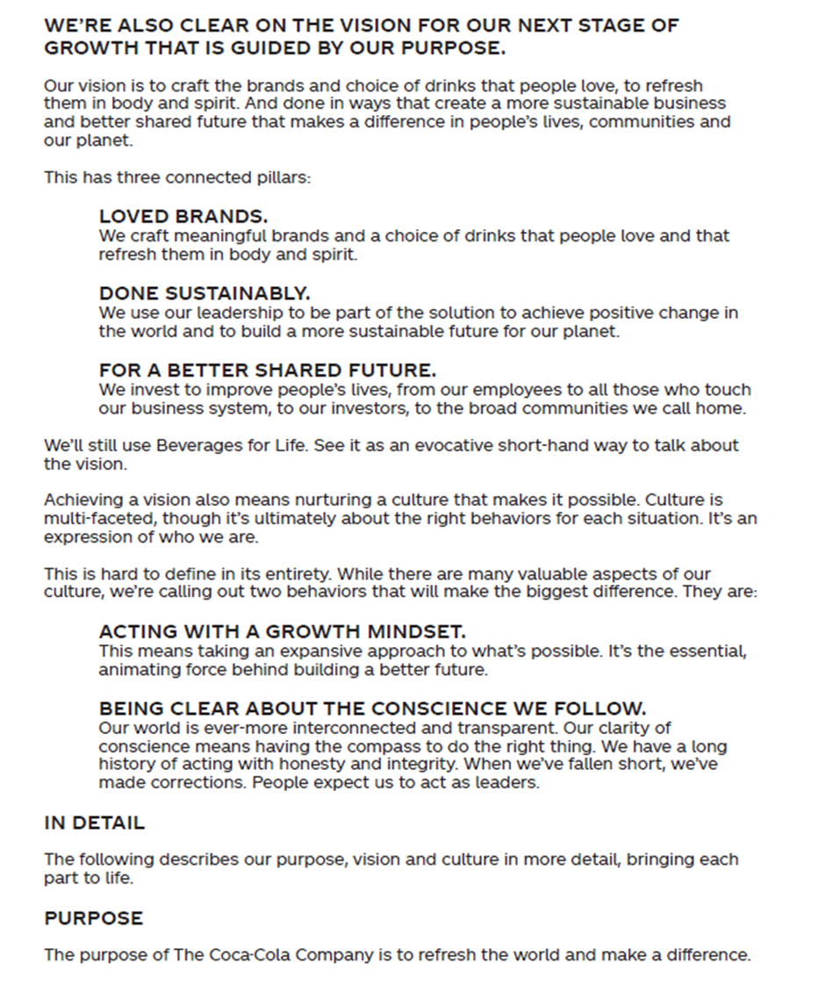
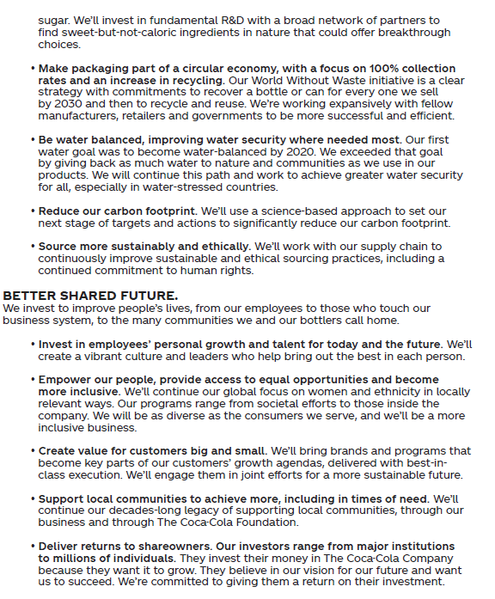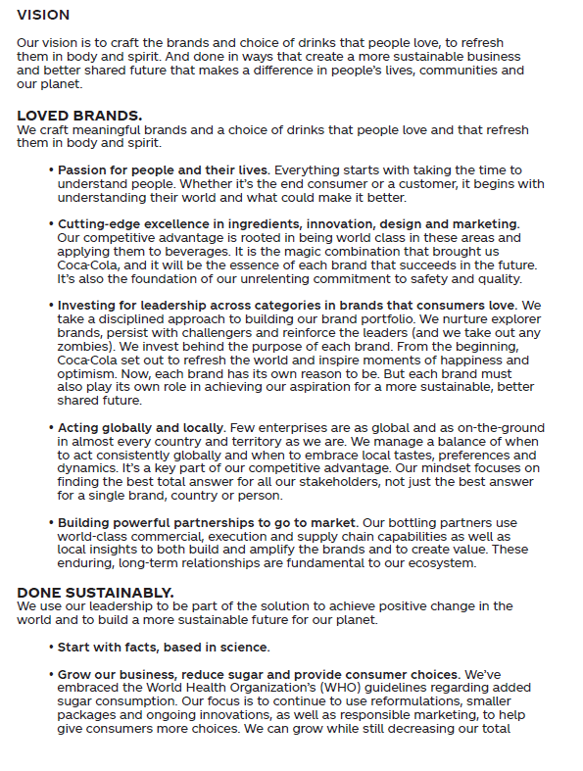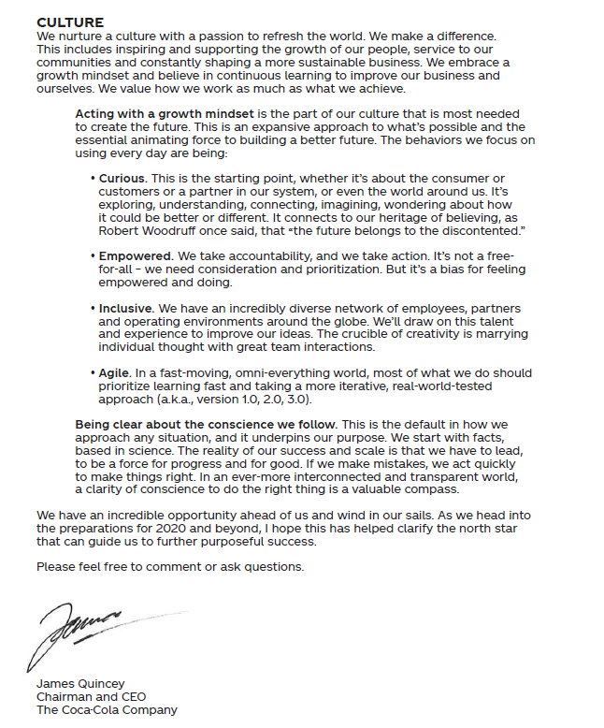

Appendix C

Source - Northouse, P. (2017). Introduction to Leadership: Concepts and Practice | SAGE Companion.

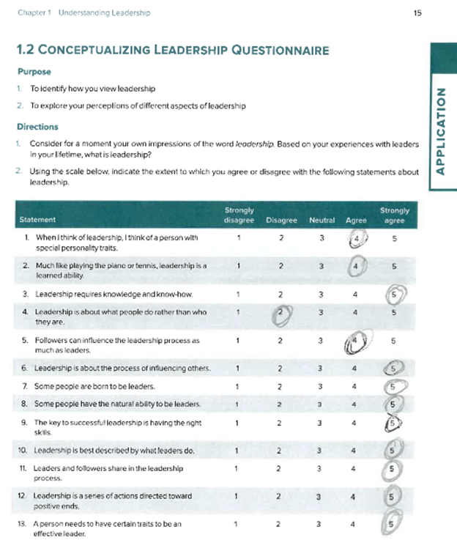
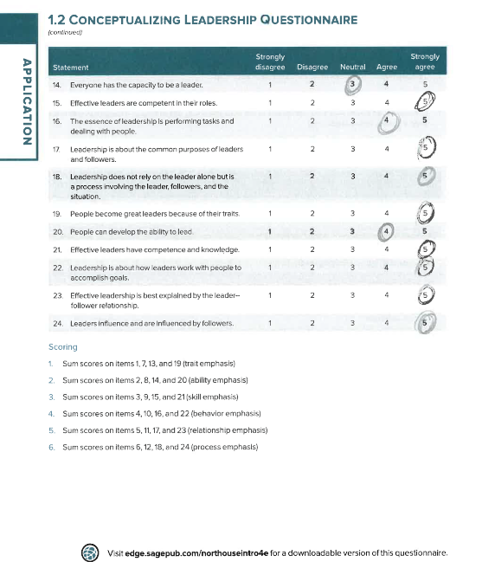

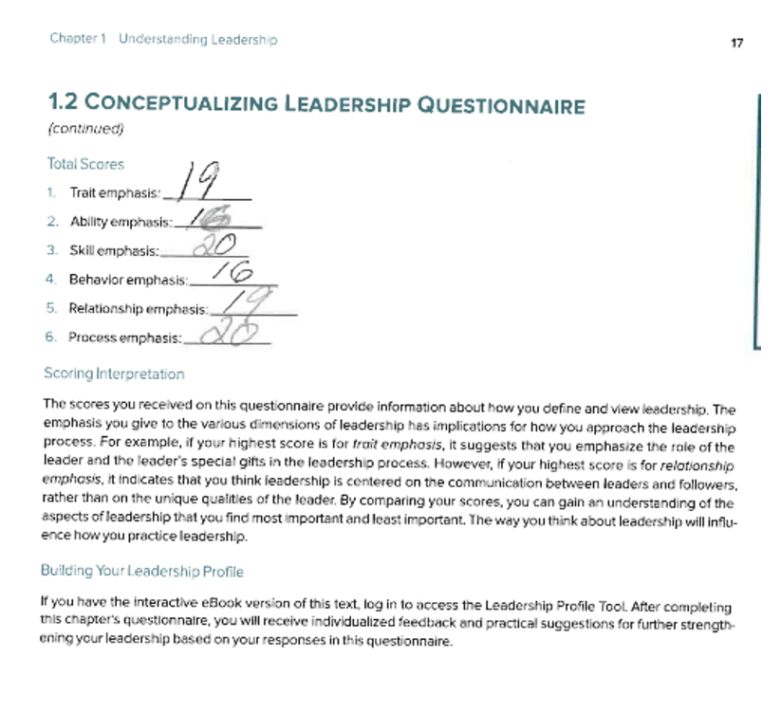
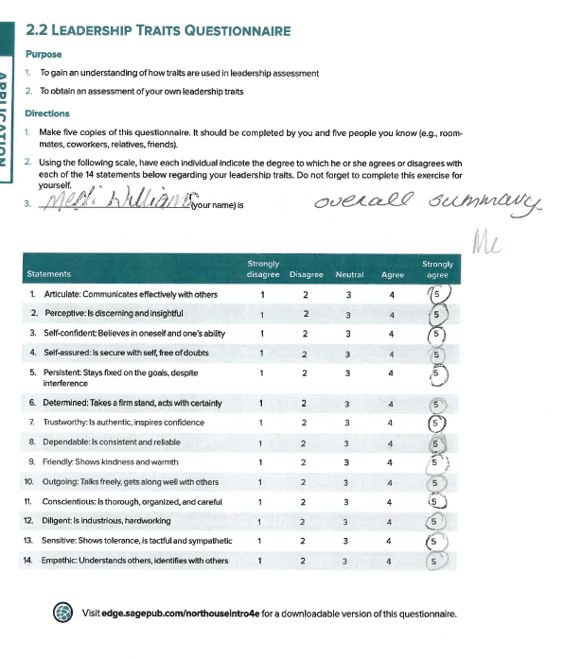

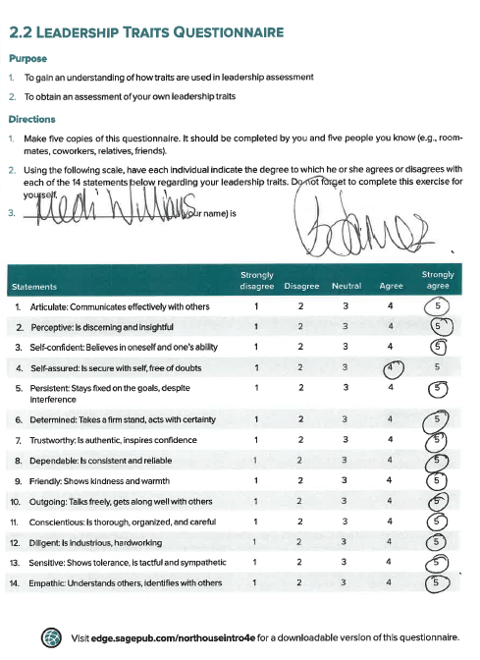

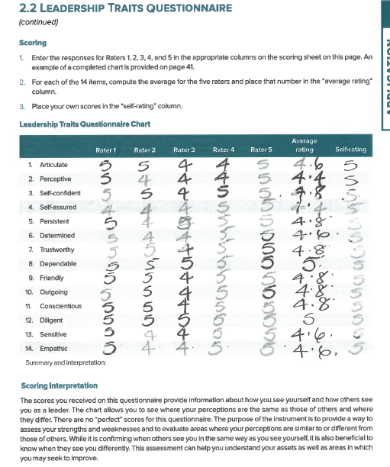
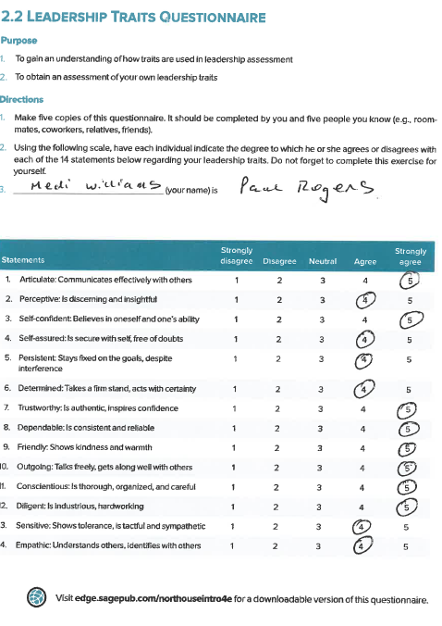
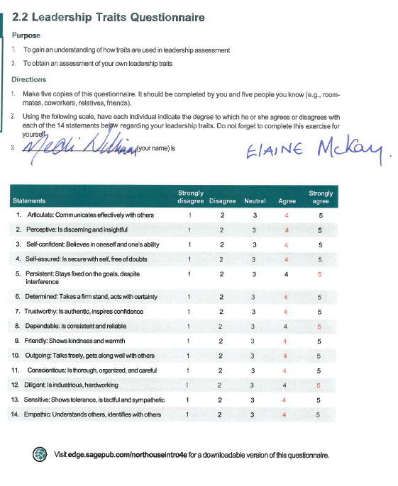
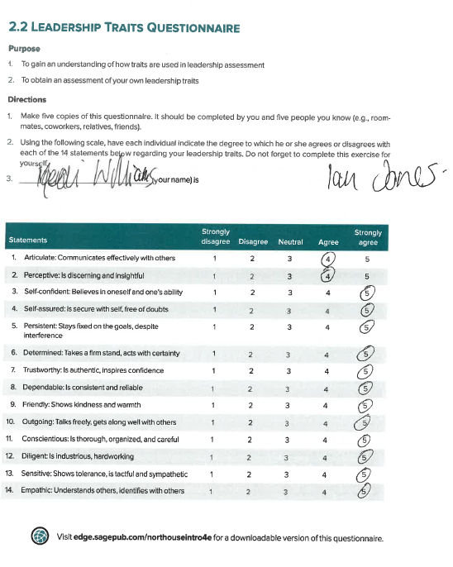
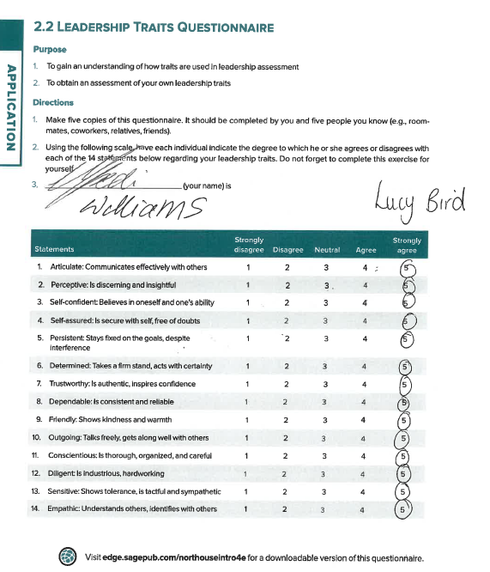
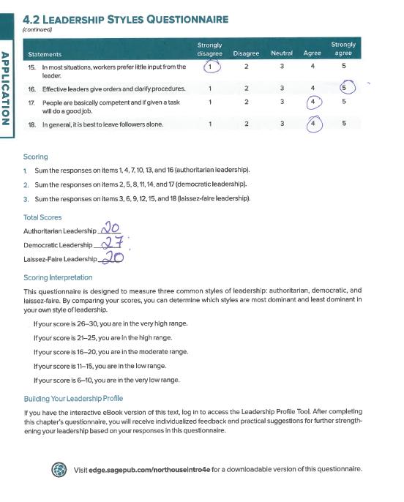
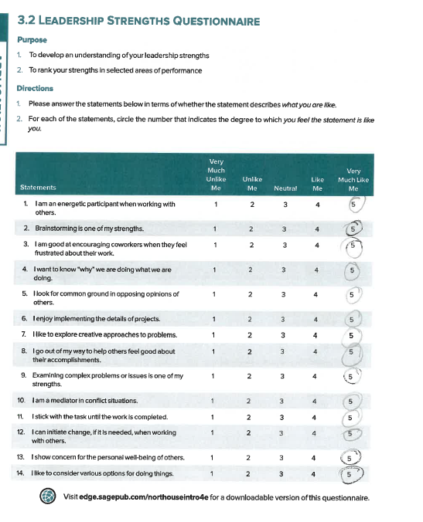
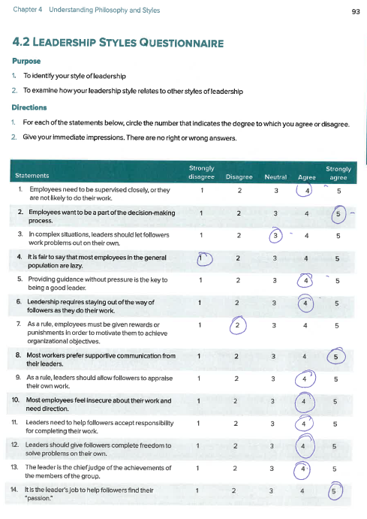
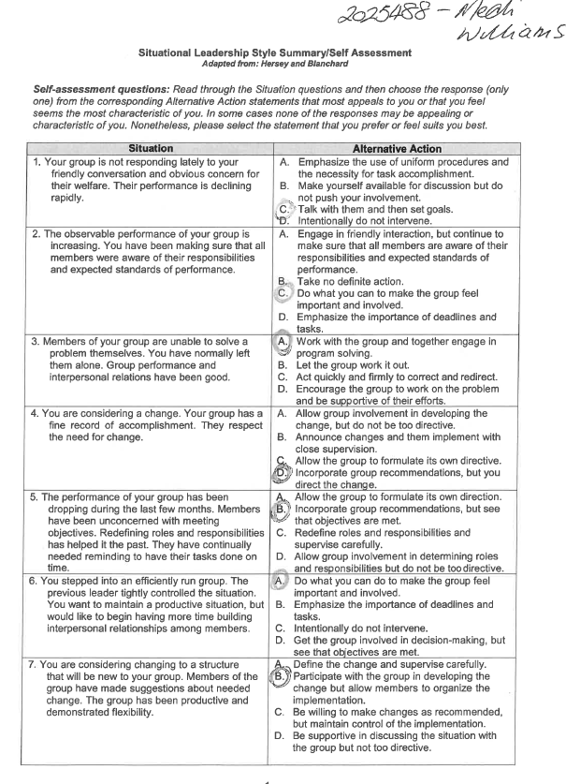
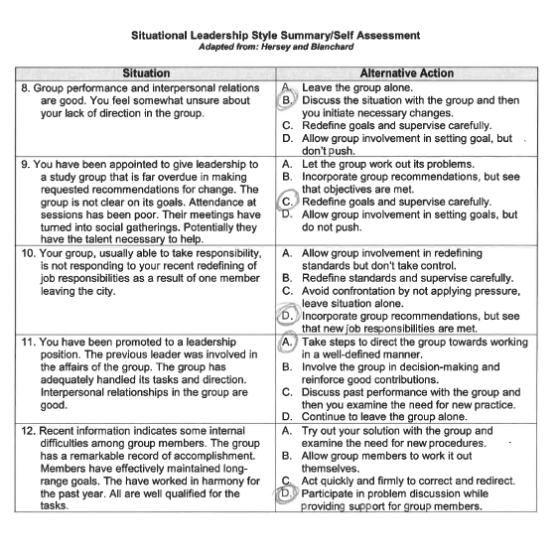

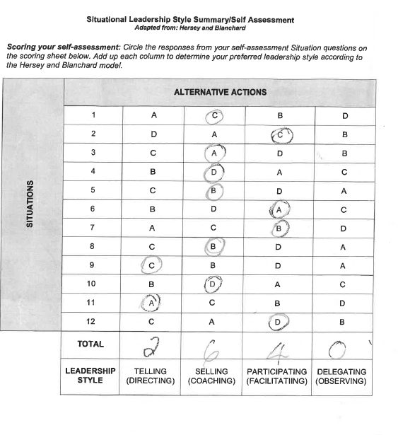

Appendix D

Source - Gap analysis Medi Williams
Objective | Current Position | Deficiency | Action
What do I want to do | What can I already do | What am I lacking | How can I fix this?
Regular Team meetings | Face to Face fortnightly project team meetings | Greater contact to ensure wellbeing and address any issues arising | Set times for each project team meetings
Clear tasks and deadlines | Set out tasks and monitor throughout the day/week | Clear written task lists for each team | Develop a task list template setting clear deadline and when I need to have them returned to monitor completion
Make sure staff have access to relevant equipment | Staff have access to PC’s within the department | Evaluate staff equipment and need | Circulate a document that captures the digital devices staff have access to or need
Clear forms of communication | Use of shared documents | Software for all to communicate remotely | Report requirements to IT department so that software is accessible to all staff
Create a timetable of communication times | Set out times in the day/week | Knowing staff home environment and lifestyles | Speak to staff to establish working patterns
Ensure staff well being | Takeaway Thursday (where staff stop at lunch and take time to switch off from the work pressures) | Staff not in one location | Set a regular time and day for staff get together/social break and downtime from the busy work environment
Paper documentation is available | Access the office audit files | Computerised format of documentation | Scan relevant documents so staff can access and complete claim deadlines and tasks

Appendix E
Action Plan – Source Medi Williams
Objectives | Tasks | Success Criteria | Time Frame | Resources
Goals | What does the department need to achieve this | Outcomes | Deadlines | Additional support/equipment etc
Electronic Versions of paperwork | Develop electronic versions of participant documentation | Full suite of documentation complete and translated for all projects | 1 month | IT department and reprographics
Central financial network file for collaborative access | Authorisation from both departments and a protected file | File Created | 2 weeks | IT department, finance director authorisation and External Funding Manager authorisation
Centralised Payroll information file | Authorisation from both departments and a protected file | File Created | 2 weeks | Payroll department  authorisation and External Funding Manager authorisation
Centralised HR information file | Authorisation from both departments and a protected file | File Created | 2 weeks | HR department  authorisation and External Funding Manager authorisation
Remote Network access for all staff | Work with IT for all PC’s to be allocated to relevant staff | Staff check access routes | 2 weeks | External Funding Manager permission and IT department to action
All software for Microsoft software to be available to all staff | Work with Head of IT to ensure staff have the most up to date version installed on their PC’s | Staff to check access and use | 3 weeks | External Funding Manager permission and IT department to action
Laptops for all staff | Utilise new funding allocation to purchase | Distribute to staff | 4 weeks | External Funding Manager requisition

