

IT Systems Proposal for Maldiva Ltd.
Overcoming Operational Challenges Through an Integrated Information System

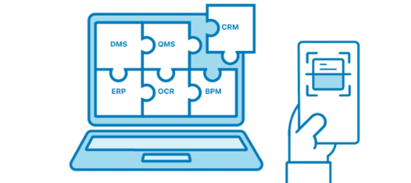
Prepared by:
Student Name – Alhaji Abu Bakar Bangura
Student ID - 2428995
Model Code: Managing Business Information.
Date of Submission: 18th August 2026

Table of Contents
1. Introduction 3
2. Evaluation of Existing Systems 3
3. Recommended Solution 5
3.1 Overview of the Recommendation 5
3.2 Solving the Inventory Problem 5
3.3 Solving the CRM and Marketing Problem 5
3.4 Solving the Reporting and Decision-Making Problem 5
3.5 Solving the Compliance and Security Problem 6
3.6 Solving the Integration Problem, and Cost/Scalability Justification 6
4. Implementation Plan 6
4.1 Phase 1 – Assessment and Vendor Selection (Weeks 1–4) 6
4.2 Phase 2 – Data Migration and Configuration (Weeks 5–10) 7
4.3 Phase 3 – Integration and Pilot (Weeks 11–14) 7
4.4 Phase 4 – Training and Change Management (Weeks 13–16, overlapping pilot) 7
4.5 Phase 5 – Full Rollout and Post-Implementation Review (Weeks 17–22) 7
4.6 Key Risks and Mitigations 7
5. Conclusion 8
References 9

1. Introduction
Maldiva Ltd. is a rapidly expanding consumer electronics retailer operating 30 physical stores alongside an e-commerce platform. The company has enjoyed strong sales growth over the past year, but this growth has exposed serious weaknesses in its underlying information systems (Stair, R., Reynolds, G., Aldcorn, J. and Neufeld, D., 2015). As the CEO's appointed IT consultants, this proposal analyses those weaknesses and recommends a modern, integrated information system capable of supporting Maldiva Ltd.'s continued expansion.
Five interconnected challenges have been identified. First, inventory is tracked manually, causing discrepancies between store shelves and online stock records (Kang, Y. and Gershwin, S.B., 2005); customers frequently order items online that are already out of stock, resulting in complaints, refunds, and reputational damage. Second, customer data is fragmented across multiple, disconnected systems, preventing marketing from running targeted campaigns and preventing support staff from viewing a customer's full purchase history when handling complaints (Dyché, J. and Levy, E., 2006). Third, sales reporting relies on manually compiled spreadsheets, which are slow, error-prone, and fail to give management (Vutukuru, K., 2026) a real-time view of trading performance, undermining forecasting and strategic decision-making. Fourth, Maldiva Ltd. is not fully compliant with GDPR, largely because the current systems (GDPR, E., 2018) lack secure, role-based access controls, exposing the business to regulatory and reputational risk. Fifth, the sales, finance, and inventory departments each run separate, non-communicating software, forcing staff to re-key data manually between systems, which wastes time and introduces further errors.
Taken together, these issues point to a single root cause: Maldiva Ltd. is trying to run a modern, omnichannel retail operation on a set of fragmented, largely manual legacy tools. The remainder of this proposal evaluates the existing systems in more detail before recommending a way forward.

2. Evaluation of Existing Systems
Maldiva Ltd.'s current information landscape can be characterised as a collection of disconnected point solutions rather than a coherent system. Inventory is tracked manually, most likely through spreadsheets or basic till records maintained independently by each of the 30 stores. Because stock counts are not synchronised in real time with the e-commerce platform, the two channels operate on different views of the same inventory, which directly causes the overselling problem described by the CEO. Manual counting is also inherently slow and error-prone, making it difficult for store managers to identify overstocked lines tying up capital or understocked lines causing lost sales.
Customer relationship management (Kumar, V. and Reinartz, W., 2018) is handled through multiple disconnected systems rather than a single customer database. This means the marketing, sales, and customer-support teams each hold partial, inconsistent views of the same customer, making it impossible to build a complete purchase history or to run personalised, data-driven marketing campaigns. Support agents cannot see a customer's prior orders, which slows complaint resolution and damages customer trust.
Decision-making is similarly constrained by manual spreadsheet-based reporting. Sales figures must be compiled by hand from multiple sources, a process that is slow, prone to transcription error, and produces reports that are already out of date by the time management reviews them (March, J.G., 1994). Without real-time dashboards, leadership cannot spot sales trends, adjust stock allocation, or respond quickly to demand shifts, which directly harms forecasting accuracy and revenue capture.
From a governance perspective, the absence of secure, role-based access controls across these fragmented systems leaves customer data exposed to unauthorised access, a direct compliance gap under GDPR (Hill, D.G., 2016). Finally, because sales, finance, and inventory software do not communicate, staff must manually transfer data between departments, duplicating effort, delaying month-end processes, and increasing the risk of inconsistent records across the business. Collectively, these gaps show that Maldiva Ltd. does not need a single point fix but a unified platform that brings inventory, customer data, reporting, and security under one roof.
Table I - Problem-to-Solution Mapping Matrix
No. | Challenge | Root Cause | ERP Solution | Expected Benefit
1 | Inventory Overselling | Manual stock tracking across 30 stores and the e-commerce platform | Cloud ERP Inventory Module with a single real-time stock record | Eliminates overselling, reduces refunds and improves customer satisfaction
2 | Fragmented Customer Data | Customer information is dispersed across Marketing, Sales and Customer Support | Integrated CRM Module creating a single customer profile | Enables targeted marketing and faster complaint resolution
3 | Slow, Manual Reporting | Spreadsheet-based reporting from multiple disconnected sources | Embedded Business Intelligence (BI) with real-time dashboards | Faster and more accurate reporting, forecasting and decision-making
4 | GDPR Compliance Gap | Weak access controls and limited auditability | Role-Based Access Control (RBAC) and audit logging | Strengthens data protection, compliance and regulatory risk management
5 | Poor Integration & Errors | Separate systems for sales, finance and inventory | Shared Database / Integrated Platform | Reduces manual re-keying, errors and duplicated work

3. Recommended Solution
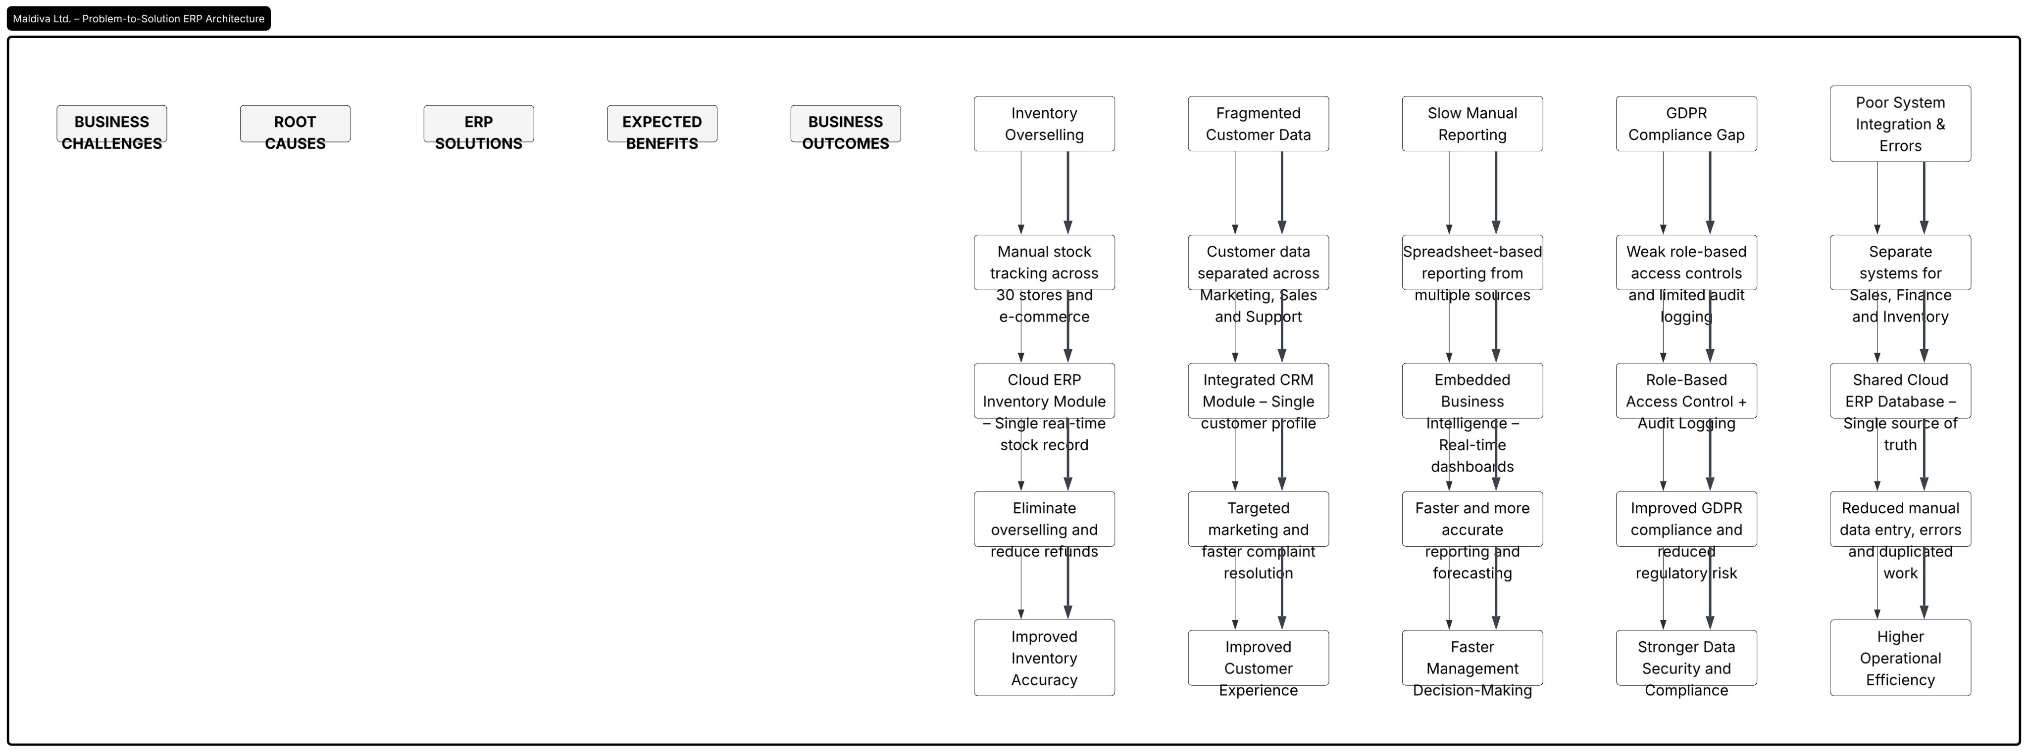

Figure_1.1 - ERP Solutions for Maldiva Ltd. (Developed in Lucid Chart)

3.1 Overview of the Recommendation
It is recommended that Maldiva Ltd. adopt a cloud-based Enterprise Resource Planning (ERP) system with integrated Customer Relationship Management (CRM) and Business Intelligence (BI) modules, such as those offered by providers like Microsoft Dynamics 365, Oracle NetSuite, or retail-focused platforms such as Bright pearl. Rather than replacing each departmental tool with another standalone system, this approach consolidates inventory management, order processing, CRM, financial reporting, and analytics onto a single shared database, directly addressing the root cause of Maldiva Ltd.'s problems: disconnected data.

3.2 Solving the Inventory Problem
A cloud ERP with a retail-tailored inventory module maintains one livestock record shared by every store and the e-commerce platform (Abd Elmonem, M.A., Nasr, E.S. and Geith, M.H., 2016). When a sale occurs anywhere in the business, available stock is updated instantly, so the website can never show an item as available when it has already sold in-store, directly eliminating the overselling and refund problem described in the case. Evidence from U.S. retailers such as Walmart, Target, and Best Buy shows that ERP-driven inventory integration measurably reduces stockouts and improves inventory turnover while increasing customer satisfaction. Built-in forecasting tools also use historical sales data to help store managers rebalance overstocked and understocked lines, reducing both lost sales and unnecessary holding costs.

3.3 Solving the CRM and Marketing Problem
The CRM module consolidates every customer interaction, purchase, and support ticket into a single profile, replacing the fragmented systems currently in use. This gives the marketing team the purchase history needed to run targeted, personalised promotions, and gives customer support instant visibility of a customer's order history when resolving complaints. Academic literature on CRM confirms that unifying customer data materially improves personalisation and customer loyalty and identifies fragmented systems as the single biggest barrier retailers face in delivering a consistent customer experience (Rane, Choudhary and Rane, 2023). A single customer view therefore converts a current weakness into a competitive advantage for Maldiva Ltd. as it expands.

3.4 Solving the Reporting and Decision-Making Problem
Because the ERP holds sales, inventory, and financial data in one place, its embedded BI module can generate real-time dashboards (Palli, S.S., 2023) instead of manually compiled spreadsheets. This gives management live visibility of sales trends across every store and the website, enabling faster, more accurate forecasting and reducing the lost revenue opportunities caused by out-of-date reporting. Retail organisations that have adopted real-time analytics report that decision latency falls sharply, allowing leadership to respond to demand shifts within days rather than waiting for month-end reviews.

3.5 Solving the Compliance and Security Problem
Modern ERP and CRM platforms provide role-based access control, encryption, and detailed audit logging as standard (Hrischev, R., 2020, June), which are core technical measures GDPR expects organisations to have in place. Consolidating customer data onto one governed platform, rather than scattering it across several disconnected systems, also makes it far easier for Maldiva Ltd. to fulfil data-subject requests and demonstrate accountability to regulators, directly closing the compliance gap identified in the case.

3.6 Solving the Integration Problem, and Cost/Scalability Justification
Because sales, finance, and inventory all run on the same underlying database, staff no longer need to manually re-key data between systems, removing both the wasted time and the transcription errors described in the case. A cloud (SaaS) deployment (Wu, C., Buyya, R. and Ramamohanarao, K., 2019) is recommended over an on-premises system because it uses a predictable subscription pricing model rather than a large upfront capital investment, and it scales smoothly as Maldiva Ltd. opens new stores or expands its online catalogue, without the disruptive infrastructure overhauls that on-premises systems require. This combination of lower entry cost, predictable ongoing expense, and elastic scalability makes a cloud ERP the most appropriate fit for a fast-growing 30-store retailer.
Table - I Benefits Assessment - Radar Chart (Parmenter, D., 2010)
KPI | Current State | Expected Future State
Operational Efficiency | 3/10 | 8/10
Customer Satisfaction | 4/10 | 8/10
Inventory Accuracy | 3/10 | 9/10
Data Security & Compliance | 4/10 | 8/10
Management Reporting | 3/10 | 9/10
Marketing Effectiveness | 4/10 | 8/10

4. Implementation Plan
A phased rollout is recommended to control risk and cost while minimising disruption to trading.

4.1 Phase 1 – Assessment and Vendor Selection (Weeks 1–4)
Confirm detailed requirements with each department (inventory, marketing, finance, support), shortlist suitable cloud ERP/CRM vendors, and select a partner based on retail-sector fit, integration capability with the existing e-commerce platform, and total cost of ownership.

4.2 Phase 2 – Data Migration and Configuration (Weeks 5–10)
Cleanse and consolidate existing inventory records and customer data from the current disconnected systems, then migrate this data into the new platform. Configure store, warehouse, and online sales channels within the system, and set up role-based access permissions to satisfy GDPR requirements from day one.

4.3 Phase 3 – Integration and Pilot (Weeks 11–14)
Integrate the new ERP with the existing e-commerce storefront and point-of-sale hardware, then run a pilot in three to five representative stores plus the website to validate stock synchronisation, reporting accuracy, and CRM functionality before wider rollout.

4.4 Phase 4 – Training and Change Management (Weeks 13–16, overlapping pilot)
Deliver role-specific training to store managers, marketing staff, finance staff, and customer support, supported by super-users in each department who can provide day-to-day peer support after go-live. Clear internal communication about why the change is happening will help reduce staff resistance, which is consistently cited as one of the main barriers to successful ERP adoption.

4.5 Phase 5 – Full Rollout and Post-Implementation Review (Weeks 17–22)
Extend the system to all 30 stores in staged waves rather than all at once, monitor stock accuracy, order fulfilment, and system performance closely, and hold a formal review after 90 days to measure results against the objectives set out in this proposal and address any outstanding issues.

Gantt Chart
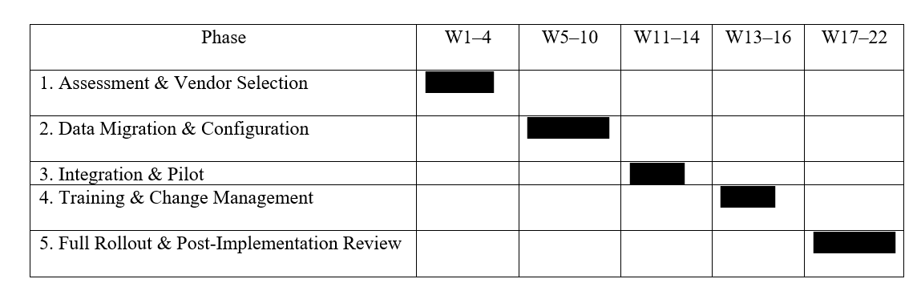

4.6 Key Risks and Mitigations
Anticipated challenges include data quality issues surfacing during migration, temporary productivity dips during training, integration difficulties with legacy point-of-sale hardware, and staff resistance to new ways of working (Taherdoost, H., 2021.). These risks can be mitigated through a thorough data-cleansing stage before migration, a phased store-by-store rollout rather than a single 'big bang' launch, close vendor support during integration testing, and visible sponsorship from senior management throughout the change process.

5. Conclusion
Maldiva Ltd.'s operational difficulties, stock discrepancies, fragmented customer data, slow manual reporting, weak GDPR compliance, and poor cross-departmental integration, all stem from the same underlying problem: a set of disconnected legacy systems that were never designed to support a fast-growing, omnichannel retailer. A cloud-based ERP system with integrated CRM and BI modules directly addresses each of these issues by placing inventory, customer, financial, and sales data on one shared, secure platform. Expected benefits include fewer stockouts and refunds, more personalised and effective marketing, faster and more accurate management reporting, stronger GDPR compliance through built-in access controls, and the removal of manual, error-prone data transfer between departments. Combined with a subscription-based cost model and cloud scalability, this solution positions Maldiva Ltd. to support its continued growth while significantly improving both operational efficiency and customer satisfaction.

References
Stair, R., Reynolds, G., Aldcorn, J. and Neufeld, D., 2015. Principles of information systems. Cengage Learning Canada Inc.
Kang, Y. and Gershwin, S.B., 2005. Information inaccuracy in inventory systems: stock loss and stockout. IIE transactions, 37(9), pp.843-859.
Dyché, J. and Levy, E., 2006. Customer data integration: Reaching a single version of the truth. John Wiley & Sons.
Vutukuru, K., 2026. Evaluating the Evolution of Supply Chain Planning Systems: From Excel Dashboards to Real-Time Control Towers.
GDPR, E., 2018. General data protection regulation (gdpr). Cit. on, 4.
Parmenter, D., 2010. Key performance indicators (KPI): developing, implementing, and using winning KPIs. John Wiley & Sons.
Kumar, V. and Reinartz, W., 2018. Customer relationship management.
March, J.G., 1994. Primer on decision making: How decisions happen. Simon and Schuster.
Hill, D.G., 2016. Data protection: Governance, risk management, and compliance. CRC Press.
Taherdoost, H., 2021. A review on risk management in information systems: Risk policy, control and fraud detection. Electronics, 10(24), p.3065.
Abd Elmonem, M.A., Nasr, E.S. and Geith, M.H., 2016. Benefits and challenges of cloud ERP systems–A systematic literature review. Future Computing and Informatics Journal, 1(1-2), pp.1-9.
Hrischev, R., 2020, June. ERP systems and data security. In IOP Conference Series: Materials Science and Engineering (Vol. 878, No. 1, p. 012009). IOP Publishing.
Wu, C., Buyya, R. and Ramamohanarao, K., 2019. Cloud pricing models: Taxonomy, survey, and interdisciplinary challenges. ACM Computing Surveys (CSUR), 52(6), pp.1-36.
Palli, S.S., 2023. Real-time data integration architectures for operational business intelligence in global enterprises. International Journal of Scientific Research in Computer Science, Engineering and Information Technology (IJSRCSEIT), 9 (1), pp.361-371.

