

Design for Manufacture and Assembly: Component Optimisation
ACMA5002 – Manufacturing Design & Technology
HADDEN Joshua
Purflux Filtration ltd Crown Ave, Tredegar, NP22 4EF
Table of Contents
Table of Figures 2
Abstract 3
Introduction 5
Literature Review 6
Failure Mode and Effect Analysis (FMEA) 6
Quality Function Deployment (QFD) 7
Design of Experiment (DOE) 7
3D Plastic Simulation Software 8
Finite Element Analysis (FEA) 8
Define Customer Requirements 9
Quality Function Deployment (QFD) 10
Failure Mode and Effect Analysis (FMEA) 11
Design of Experiment (DOE) 13
Design and Development 14
Phone Case CAD & Drawing 14
Material Selection 17
Simulation and Validation 19
Cost Calculation Analysis 25
Sustainability Considerations 27
Discussion and Recommendations 29
Conclusion 30
Bibliography 32

Table of Figures
Figure 1 - Phone Housing Variables 9
Figure 2 - Phone Case Design Quality Function Diagram (QFD) 10
Figure 3 - Snapshot of FMEA 11
Figure 4 - DOE Injection Moulding Process Parameters, Mould Temp and Lockover 13
Figure 5 - CAD Model of Mobile Phone Case 14
Figure 6 - Fusion Titled Sketches 15
Figure 7 - S22 Ultra Phone Case Drawing 15
Figure 8 - Material Selection 17
Figure 9 - Material Properties of Laminate Blue Material on Phone Case CAD 17
Figure 10 - Fusion Parameters of Material Qualities 18
Figure 11 - Table of Mechanical Properties of Nylon, Polypropylene and ABS 18
Figure 12 - Key Chart of Mechanical Property Scoring 18
Figure 13 – PP Injection Moulding Set-Up Summary 19
Figure 14 - ABS Injection Moulding Set-Up Summary 19
Figure 15 - Shrinkage Calculation 20
Figure 16 - Injection Moulding Simulation Status 20
Figure 17 - Mould Flow Analysis 21
Figure 18 - Fill Time Mould Analysis 21
Figure 19 - Visual Defect Analysis 22
Figure 20 - Warpage Analysis 22
Figure 21 - Comparison of Two Injection Mould Locations to One Injection Mould Location Between Camera Holes 23
Figure 22 - Comparison Between Two Injection Mould Locations to One Injection Mould Location in Centre of Part 23
Figure 23 - Cost of ABS, PP and Nylon 25

Abstract
This report investigates the redesign and optimization of high-demand mobile phone housing manufactured via injection moulding, applying various tools such as:
- Design for Manufacture (DFM)
- Design for Assembly (DFA) principles
- Quality Function Deployment (QFD)
- Failure Mode and Effect Analysis (FMEA)
- Design of Experiments (DOE)
- CAD Modelling
- Finite Element Analysis Principles
- problem-Solving Techniques and Cost Analysis
- Quality Function Diagram (QFD)
The objective was to develop a product that balances manufacturability, mechanical performance, quality, sustainability and cost while satisfying customer requirements such as:
- Low Weight
- Strength
- Durability
- Surface Finish
- Affordability
- Ventilation Slots
- Snap-Fit Fasteners
- Integrated Mounting Features
QFD was used to translate customer expectations into engineering requirements, while FMEA evaluated manufacturing and design risks using severity, occurrence and detection ratings. Proposed process controls and poka-yoke methods, including dimensional inspection and go/no-go gauging, were identified to reduce manufacturing risk.
The mobile phone housing was modelled using Fusion, with DFM principles incorporated through consideration of wall thickness, parting lines and mould complexity. Polypropylene (PP), ABS and Nylon were compared as potential materials. Nylon provided the strongest overall mechanical-property score, while PP offered significant advantages regarding material cost and sustainability. ABS presented a compromise between mechanical performance and cost.
Injection-moulding simulations were particularly important in refining the design. The original geometry repeatedly failed during simulation; systematic investigation demonstrated that unnecessary chamfers and complex geometry were responsible. Simplifying these features enabled the analysis to be completed successfully. Further simulations investigated gate positioning and identified potential sink marks, weld lines and warpage, demonstrating that additional optimization of wall thickness and geometry would be beneficial.
A four-cavity mould was proposed with an estimated total cycle time of 10.51 seconds. Allowing for an assumed 1% scrap rate, approximately 1.74 million conforming components could theoretically be produced annually, subject to the production assumptions identified in the report. At a selling price of £0.70 per component, the analysis demonstrates the potential commercial viability of high-volume manufacture.
Overall, the investigation demonstrates how integrating DFM/DFA, risk analysis, simulation, material selection and economic assessment can identify design weaknesses before tooling manufacture, reduce production risk and develop a more manufacturable, sustainable and commercially viable mobile phone housing.

Introduction
A leading manufacturing company has requested support in optimizing a high demand consumer product, by redesigning this product using ‘design of manufacture’ (DFM) and ‘design of assembly’ (DFA) principles.
Product: Mobile Phone Housing
Material: Polymer
Manufacturing Process: Injection Moulding

To ensure optimization related to manufacturability, robustness, sustainability and cost efficiency, engineering tools will be used:

- Failure Mode and Effect Analysis (FMEA)
- Quality Function Deployment (QFD)
- Fusion
- Ishikawa
- 5 Why’s
- Plastic Analysis
- Finite Element Analysis (FEA)
- Cost Analysis

The above product will be designed, and a manufacturing plan will be provided from the material selection to quality monitoring, discussing the risks present in manufacturing and potential poke-yokes to reduce RPN scores observed on the FMEA.
(What Is Six Sigma, 2026)

Literature Review
‘Design for Manufacture’ (DFM) and ‘Design for Assembly’ (DFA) are common terminologies which refer to simplifying the manufacturing process by not creating an overly complex design not suitable for creation (E.G not over the wall manufacturing). If optimised early on, the design engineer can ensure the simplicity of assembly / manufacture by:
- Reducing special processes such as welding
- Using less components / less variation of similar components
- Reduce time to manufacture / assemble
- Reduce costs
- Reduce likelihood of quality issues
- Reduce material waste
- Ensure products are more economical at end of life
There are various tools to support in a healthy DFM/DFE approach, including but not limited to the tools below.

Failure Mode and Effect Analysis (FMEA)
An FMEA can either be design (DFMEA) or process (PFMEA) biased. The document is a staple in automotive quality assurance and was originally deployed by the ISA military during World War 2. An FMEA document is commonly included in the ‘Production Part Approval Process’ (PPAP) as part of the ‘Advanced Product Quality Planning’ (APQP) process (Alam, 2026) .
The purpose of the FMEA is to interrogate a production process and determine what failure modes can be created in the process, and what defects can be created because of manufacturing this part incorrectly. For example, if excess material is forced into a tool during injection moulding, you may observe flash on the part.
Every non-conformance is identified on the FMEA and scored for:
- Occurrence – How likely is this defect to occur?
- Detection – How likely is the process to detect a concern?
- Severity – How big of an issue will this defect be if it reaches the end user?
The above attributes are typically measured between 1-10. There are different standards for calculating the FMEA score, but AIAG is the standard typically used in ‘International Automotive Task Force’ (IATF) (British Standards Institution, 2026) . In AIAG, the three scores are multiplied against each other, and the score is labelled the ‘Risk Priority Number’ (RPN).
If the RPN exceeds a defined number, or the severity is above a certain score then an action is required to control this process and reduce the risk for the end user. Typically a risk is controlled by implementing a ‘Poke Yoke’ – the Japanese terminology for fool proofing. A Poke-Yoke can be either to detect an issue, or prevent it from happening in the first place, and remove the likelihood of human error.

Quality Function Deployment (QFD)
A QFD is a tool used to capture the customer requirements and objectify them under a technical specification. The tool is derived from the ‘House of Quality’ (HOQ) tool, which is a Japanese defined tool from the 1960’s.
The concept between the QFD is to prioritise customer requirements and ensure resources are spent when value is added, the tool also enables additional benefits for design engineers such as seeing what attributes correlate with each other and providing opportunities to cross reference products with competitors.

Design of Experiment (DOE)
DOE is a systematic scientific approach to testing various variables in the post optimal way, to ensure as many factors as possible are related to outputs. The DOE approach covers planning, testing and analysis of the variables, and can be used to optimise the manufacturing process, process parameter etc.
Within injection moulding there are various parameters that have an impact on the quality of the parts, such as:
- Temperature
- Pressure
- Speed
- Shot Size
- Hold Time
- Cooling Time
In addition to process parameters, the mould design can be modified in various ways to create an ideal product. There are various approaches to a DOE such as the full factorial design, which checks all variable individually. This is a very resourceful approach. Fractional factorial designs are more frequent in the work environment as the most impactful variables are analysed, and the total tests are significantly more manageable.

3D Plastic Simulation Software
Modern advancements in computer generated formulas has enables software’s such as SolidWorks Plastics and infusion to analyse the flow of polymers, help design mould tools, predict quality concerns and provide the data required for fast and high-quality decision making, while limiting the need of prototypes.
SolidWorks Plastics is a specialised simulation tool via the SolidWorks package and simulates the flow of molten polymer within a mould cavity. It will show if there are clear design concerns early, allowing the convenience of adjusting the CAD and completing various trial and errors. SolidWorks Plastics will support in attributes such as analysing:
- Fill Time
- Pressure Distribution
- Temperature Gradients
- Cooling Behaviour
- Air Traps
- Weld Lines
- Sink Marks
- Warpage

Finite Element Analysis (FEA)
FEA is commonly used to analyse the structural performance and reliability of different engineering components / tooling. It is a numerical method that divides a complicated design into smaller, more manageable designs.
The purpose of FEA is to monitor factors such as stress distribution and displacement, which offering insight into potential failure points and structural weakness. Injection mould tools are very costly, and the process of designing, creating and commissioning them is incredibly time exhaustive, FEA in comparison with the likes simulation software’s like SolidWorks Plastics enables design tweaks that can hugely improve the mould/product design.

Define Customer Requirements
When defining customer requirements, there are specifically requested attributes as well as things the customer hasn’t considered but still requires. A terminology often adopted in professional manufacturing environments is “fit / form / function”; this means a product must fit with any practical applications required, look uniform with no clear defects such as flash or short shots, and meet any mechanical / electrical applications required.
Figure 1 shows the main attributes to consider for the mobile phone housing:
Attribute | Definition | Importance to Design
Lightweight | Improve handling without jeopardising strength | Doesn’t inconvenience user
Good Surface Finish | A professional and smooth finish | Creates a desirable and high quality product
Strong | Ability to withstand mechanical loads / impact | Improve lifetime of product
Durable | Resistance to wear and tear, scratches, sunlight | Improve lifetime of product
Low Costing | Low cost for final product including production | Keep the cost low for final customer
Figure 1 - Phone Housing Variables
In addition to the figure 1, the customer wants the design to include:
- Ventilation Slots
- Snap Fit Fasteners
- Integrated Mounting Slots

Quality Function Deployment (QFD)

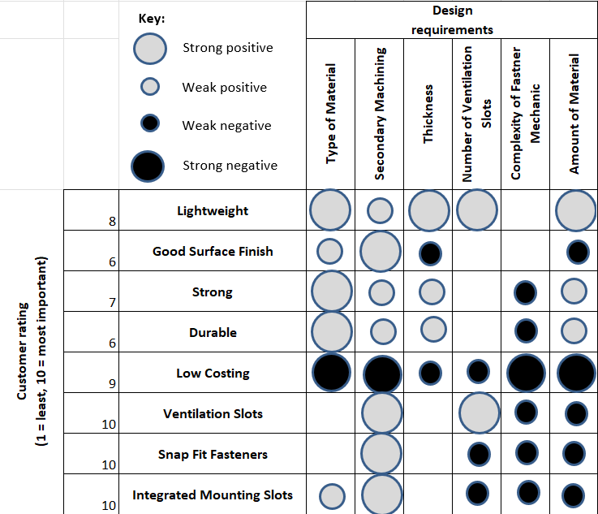
Figure 2 - Phone Case Design Quality Function Diagram (QFD)
Figure 2 highlights the customer requirements along the Y axis, and a number of significant variables with an effect over these requirements along the Y axis. The purpose of a QFD is to translate customer needs into a measurable requirement to ensure the product design is suitable and desirable for its end users.
A QFD advocates the voice of the customer and ensures a team of design and manufacturing engineers are working towards the same goals and definitions. Figure 2 utilises symbols to visually depict the influence variables have over customer requirements, to create a visual aid in where resources are best required.
For example, clip complexity has negative connotations along across all affected customer requirements, therefore making a complex clip feature is strongly discouraged in the design of the final product. A secondary machining process, however, has a positive impact on all customer requirements, however it has a strong impact on cost, so if this is in the budget of production it is strongly encouraged to refine the product after initial manufacturing. The budget, however, will be the overall driver in this decision.

Failure Mode and Effect Analysis (FMEA)
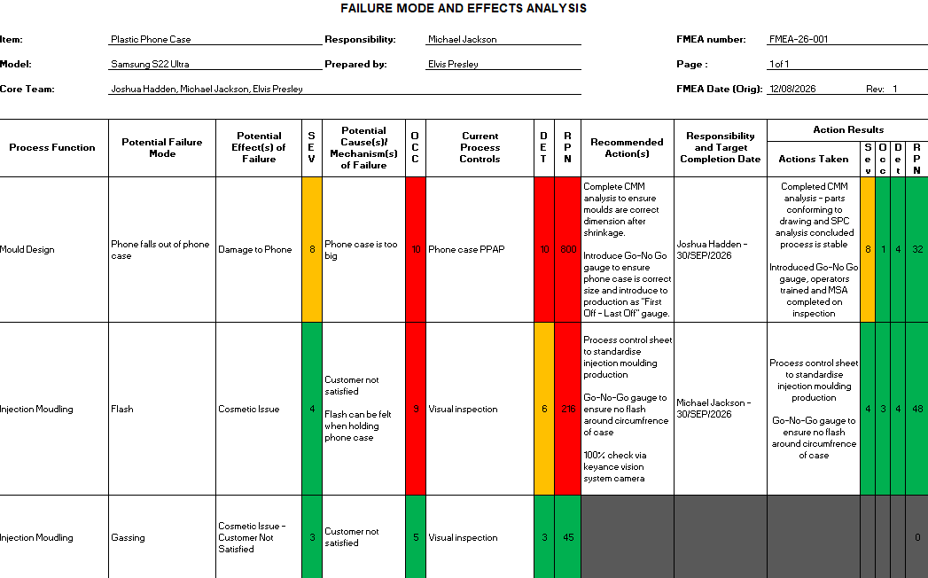
Figure 3 - Snapshot of FMEA
Figure 3 shows a snapshot of the FMEA for the phone case. The administration at the top of the document provides document control, this is a requirement during ISO:9001 and IATF:16949 audits (Doshi, 2026) . The administration identifies who created the process, and who the process owner and core team are, if a new person comes to this process, they have traceability to senior people related to their project. The admin also includes a revision number; good practice is to keep a log of changes made to this document and archives of revision history in case a mistake is made later down the line. Keeping a log of document numbers is also important, as a business grows, this log keeps track of document traceability which is essential during audits.
(Six Sigma Institute, 2018)
Three failure modes have been identified; the top is a systemic concern related to the design of the mould and would be included within a DFMEA (Design Failure Mode and Effect Analysis). If the mould is made wrong and the shrinkage leaves the case too big, phones will fall out of the phone case damaging the customers expensive equipment. This is a high severity, only below physical harm and fatality. The occurrence would affect all parts, so it is rated the maximum score of 10, and the detection although stating the “part product approval process” does not detail inspection of the parts, so it can only be assumed this issue will not be detected due to the lack of detail.
(Tanner, 2024)
The controls recommended detail the inspection of the parts to validate the products using a co-ordinate measurement machine (CMM), this will more than satisfy the validation of the mould and ensure the process is correct from the new product introduction (NPI) stage. To monitor special cause variation or wear and tear in the mould, a go-no go gauge is introduced at the start and end of each product run, to ensure parts are conforming to the customer requirements.
(American Society for Quality, 2024)
After the suggested actions, there is a plan for a deadline, assigning responsibility and the results, followed by another scoring. The RPN is the multiplication of the:
Detection x Occurrence x Severity = RPN
An RPN above 100 requires immediate intervention. In most cases, the severity never changes as the failure result often doesn’t vary for the customer, and worst-case scenario is always assumed. Between an RPN of 60-100 is to the company’s digression and risk appetite.
The second failure mode is flash; this is both cosmetically displeasing and can be felt when held by the customer. This is an injection moulding concern and would be included on a Production Failure Mode and Effect Analysis (PFMEA), this is a live document and should be updated as occurrences are found in production or from the customer, or changes are made to the process.
In this incident, three propose actions are included but only two take effect, the vision system is not included. In manufacturing, risk appetite is considered to determine the resources allocated, the risk was brought down significantly via process controls and GNG checks, so 100% autonomous inspection was not required. The action will remain in the FMEA however, so if issued are incurred on this process and the occurrence / detection is increased, this can potentially be actioned later.

Design of Experiment (DOE)
Run | Mould Temp | Lockover | Condition
1 | 250°C | 500Kn | Flash
2 | 300°C | 600Kn | Gassing
3 | 250°C | 600Kn | No Fault Found
4 | 300°C | 500Kn | Flash + Gassing
Figure 4 - DOE Injection Moulding Process Parameters, Mould Temp and Lockover
A DOE cross analysis variable in a controlled study to see the effects produced and optimise processes. Figure 4 shows a cross analysis of lockover and mould temperature, and the effect these parameters have on the parts. Immediately, increased lockover eliminates the flash defect, and reduced temperature eliminates the gassing defect.
Figure 4 is a fractional factorial study; it only measures a sample of the variables with a reduced resolution. A full factorial DOE would have a significantly more defined resolution, over a larger range (E.G the temperature would be from the minimal temperature the required for the polymer to become molten, (E.G Nylon at 100°C), to the maximum temperature before the material degrades (E.G 400°C), and intervals of 5°C. Naturally, this will yield much finer results, however the additional accuracy may not offer enough benefit the utilisation of such extensive resources.

Design and Development

Phone Case CAD & Drawing
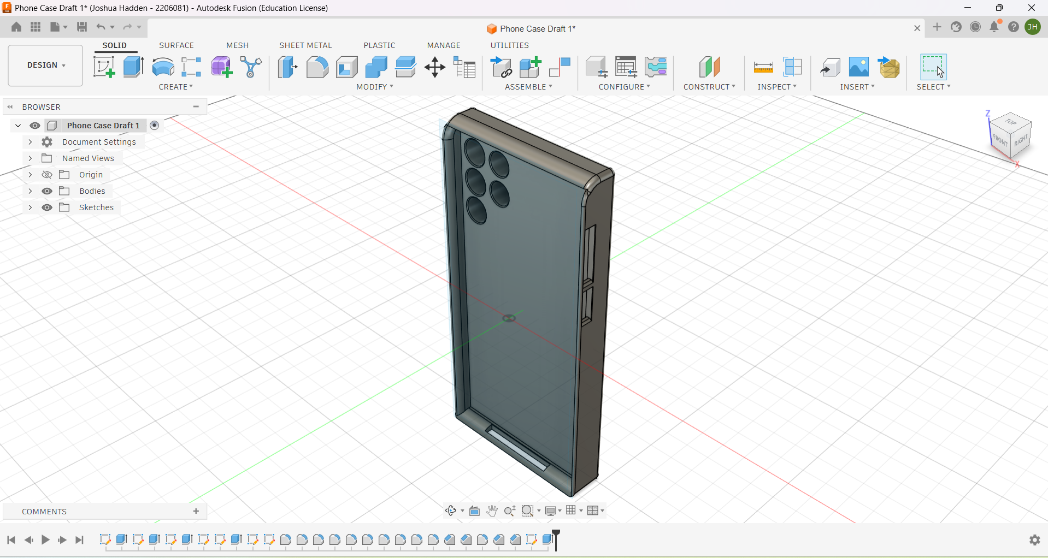
Figure 5 - CAD Model of Mobile Phone Case
Using fusion, a mobile phone case was created based on a Samsung S22 Ultra. The dimensions were taken from measurements on a real Samsung S22 Ultra as the drawing for the original mobile is intellectual property of Samsung.
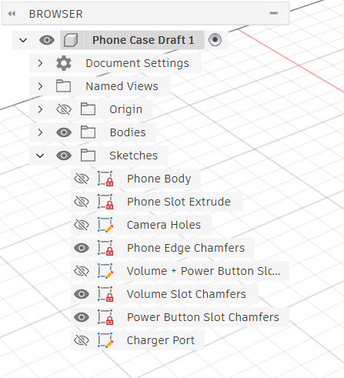
Figure 6 - Fusion Titled Sketches
Following good design practices, individual sketches have been renamed to make it easier for future edits, and multiple design engineers working on the same designs. Other examples of good practices followed include keeping an archive of historic designs, and where necessary, creating different components and assembling them within the CAD software.
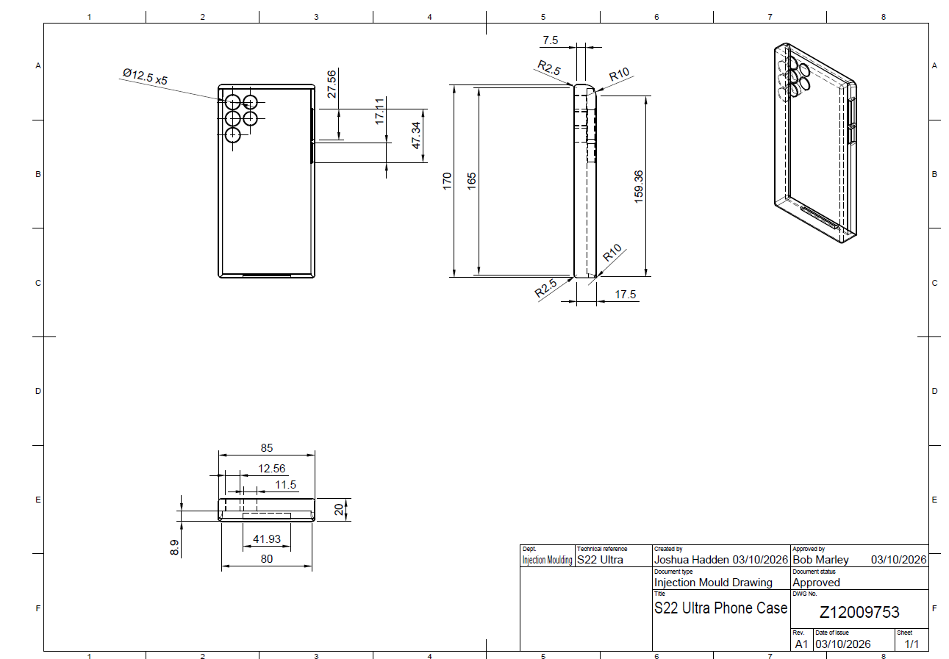
Figure 7 - S22 Ultra Phone Case Drawing
Above is a design drawing of the CAD model created in figure 7. The drawing shows a front facing view, side facing view and a bottom facing view; as well as an isometric view in the top right corner to demonstrate the 3-dimensional relationship between the other three views.
The drawing includes geometrical values. There are no tolerances included because general tolerances are applied to this component, this is a decision made to improve the efficiency of implementing the above drawing, placing a tolerance of 0.1mm on the width of the phone case would provide unnecessary hardship to manufacturing for a dimension that is not going to cause issues to the end user. The true position of the slots is controlled by linear location from the edges of the case and symmetry, so general tolerances are more than suffice for the design without increasing the workload for the design engineer.
The injection mould tool will be made of two sides, a dynamic and a statis side. Half the negative volume of the phone case will be in one side of the mould, and the second half will be in the other end of the mould, the tool will then shut together in the injection moulding press to create the full cavity. The dimensions will be slightly different compared to the drawing to compensate for shrinkage, when the polymer is molten and solidifies, the material expends slightly, there is a calculation for shrinkage to ensure the final dimension is correct.
The final part will have small marks from ejector pins; these are mechanical pins that will extract the phone case from the mould. The final part will also have a small line of flash around the entire body of the case following the mould shutoff, this is called a parting line.
Certain process parameters can be used to limit these two manufacturing defects in processing, such as lockover. Lockover is the force holding the mould together as it is processing a part. If the lockover is weaker (E.G 500Kn), it may allow some plastic to force in between the two moulds and create an exacerbated parting line. If however, the lockover is higher (E.G 1000Kn) then it should limit parting lines to the natural variation in the mould itself.
Inside the mould tool are multiple cavities, which are identical negative designs of the phone case in a single injection mould tool. The polymer fills all cavities in a single cycle, so multiple phone cases are made at one time. Typically, cavities will be either 2, 4 or it may be a family tool that creates multiple components per cycle for assembly. When designing the mould, it is essential the mould is balanced, and the polymer is evenly distributed around the mould. If there are three cavities total, with two to the left of the tool and one to the right, then the material will not evenly spread.
Draft angles are also essential during the design of a mould. A draft angle is a very minor angle on critical areas of a part design to support in its extraction from the mould.

Material Selection
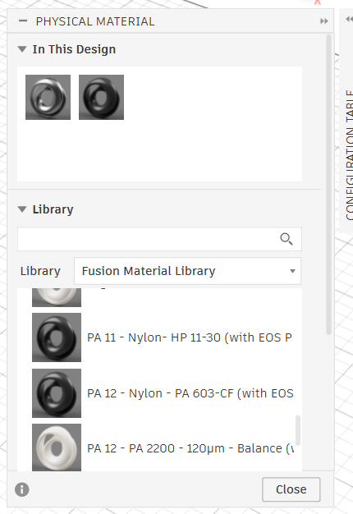
Figure 8 - Material Selection
Below is the built-in material selection tool within fusion, this allows applying the properties of different materials and sub materials, from metals, ceramics and polymers to nylon and polypropylene etc. The material will calculate the volume, mass flow index, density etc, and can apply cosmetic changes to the design to support in generating models. This data can then be extrapolated via various tools to measure the effectiveness of the mould design for injection moulding and determine if there are any major quality or manufacturing concerns to consider.
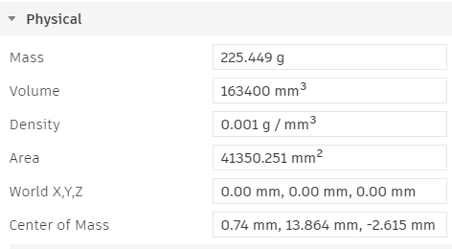
Figure 9 - Material Properties of Laminate Blue Material on Phone Case CAD
Figure 9 Shows data such as the area, mass, volume and centre of mass. This can be calculated for all potential materials, refer to figure 9.

Material | Mass (g) | Volume (mm3) | Centre of Mass (mm)
Polypropylene | 225.449 | 41350.251 | 0.74 x 13.864 x -2.615
ABS Plastic | 163.369 | 163400.000 | 0.74 x 13.864 x -2.615
Nylon | 165.820 | 163400.000 | 0.74 x 13.864 x -2.615
Figure 10 - Fusion Parameters of Material Qualities
The polypropylene material is heavier and denser than the alternative three materials, the additional material being used would have a higher cost in mass production. Nylon and ABS have very similar mass and indices; however standard ABS is lower making it the most practical option of the three choices highlighted.
Property | Nylon (PA) | Polypropylene (PP) | ABS
Tensile strength | High | Low–medium | Medium–high
Stiffness | Medium–high | Low | High
Impact resistance | Excellent | Good–excellent | Very good
Flexibility | Moderate | High | Low–moderate
Wear resistance | Excellent | Good | Moderate
Hardness | Medium–high | Relatively low | High
Density | Medium | Low | Medium
Figure 11 - Table of Mechanical Properties of Nylon, Polypropylene and ABS
Referring to the above table, scores were assigned to each colour score: See key chart below:
Colour | Score
 | 1
 | 2
 | 3
Figure 12 - Key Chart of Mechanical Property Scoring
From figure’s 11 and 12, the mechanical scores were applied to each material:
- Nylon (PA) – 17
- Polypropylene (PP) – 11
- ABS - 15
PP scored the worse out of the three selected materials coming last in four of the seven chosen categories. Nylon and ABS are very close, with Nylon taking the edge due to its exceptional wear and impact resistance qualities.

Simulation and Validation
CAD software’s have various module simulations for analysing the effectiveness of different designs within different practical and manufacturing applications, Fusion includes a software for measuring mould flow analysis and injection moulding properties and even supports in providing recommended process parameters for manufacturing.
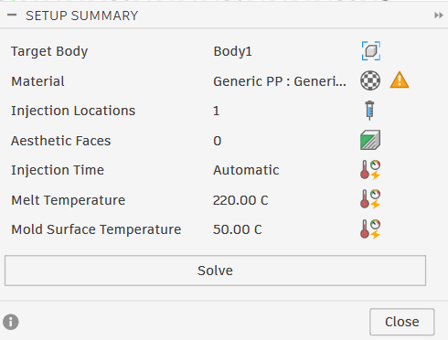
Figure 13 – PP Injection Moulding Set-Up Summary
Figure shows recommended process set up summary for Polypropene material for this design, and suggests to set the mould temperature to 220.0°C, with a mould surface temperature of 50.0°C.
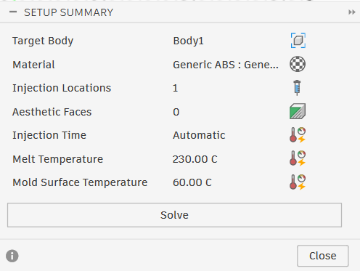
Figure 14 - ABS Injection Moulding Set-Up Summary
Compared to PP, the previously chosen material of ABS suggests increasing the mould temperature by 10.0°C.
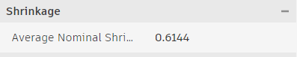
Figure 15 - Shrinkage Calculation
Figure 15 shows the fusion software’s automatic calculation for nominal shrinkage when manufacturing with the generic ABS material.
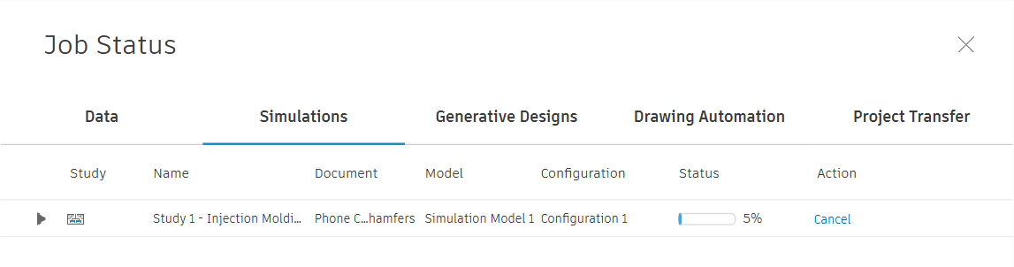
Figure 16 - Injection Moulding Simulation Status
When running a simulation with the original model, the test would fail after 5%. Various fault-finding techniques was applied to understand why:
- Additional injection mould locations were added - There were no improvements
- The material was changed multiple times – There were no improvements.
- A simple block model was tested under the same conditions – it completed the simulation. This proved the issue was with the model design; it was not a feasible design.
- The original model was modified to remove the aesthetic chamfers while retaining all necessary features – This allowed the test to run successfully.
This was a very insightful fault-finding analysis; it confirmed that the design of the mould must be feasible which means ensuring the material can correctly fill the cavity inside the mould without disruption. To create the original design, a secondary manufacturing process would be necessary.
The design would have to be modified from the original to have more of a simplistic shape, however some refining could be made depending on customer needs and requirements to add more simplistic and gradual radiuses compared to the original complex radiuses and chamfers.
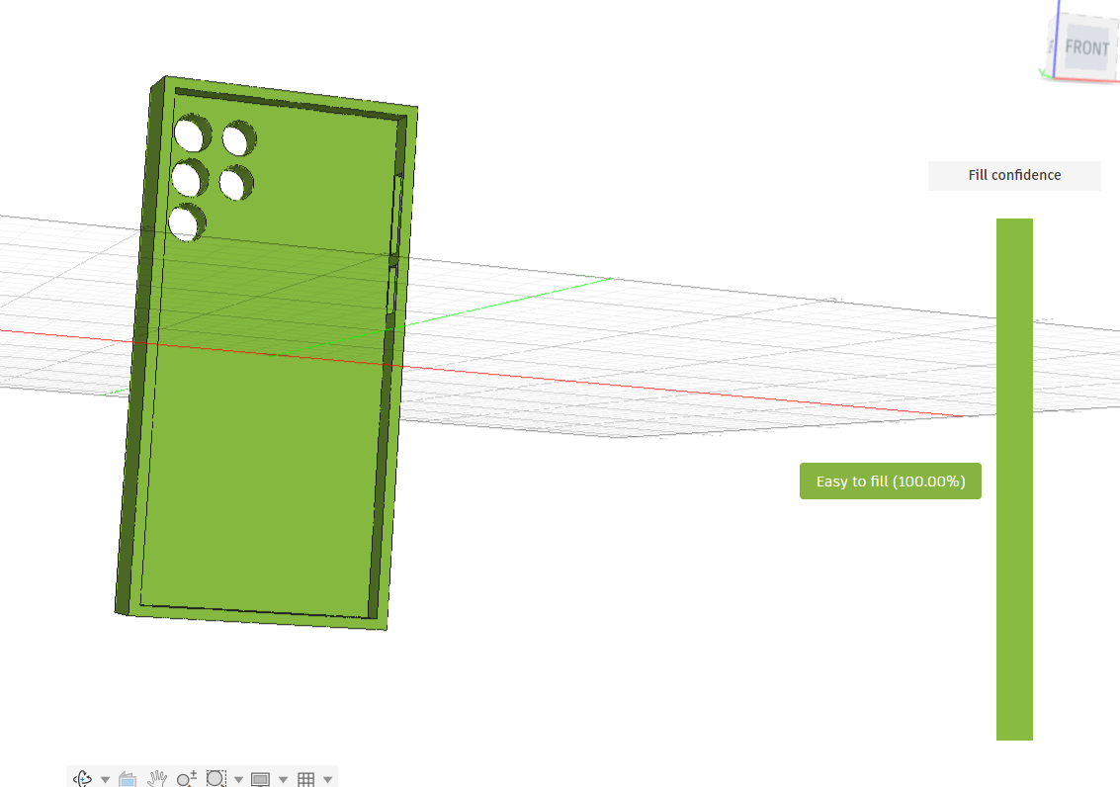
Figure 17 - Mould Flow Analysis
After adjusting the mould design and ensuring there was a mould point in the centre of the camera holes and a second mould point at the bottom of the case, the mould analysis was 100%.
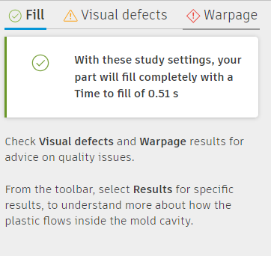
Figure 18 - Fill Time Mould Analysis
The fill time is calculated to be 0.51s. creating an incredibly quick and low risk mould design.
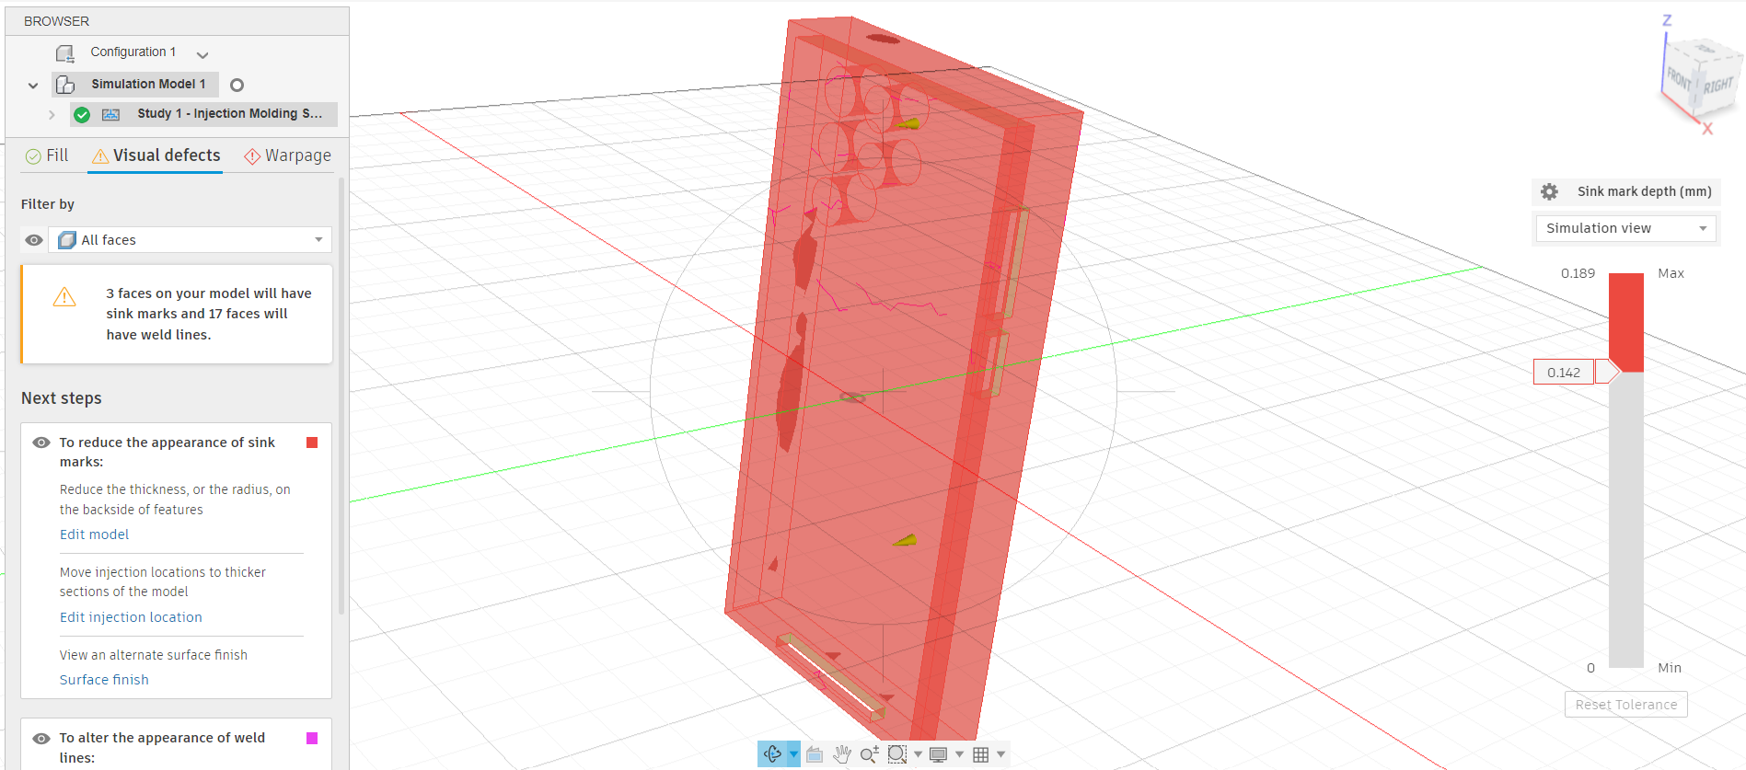
Figure 19 - Visual Defect Analysis
The simulation has flagged a quality concern for sink marks and weld lines on 17 different faces. This could be due to there being two mould locations on a relatively small part, thus overmanipulating the flow of the molten polymer material. Reducing the injection points to 1 could improve the quality of this part, while retaining a similar level cycle time and mould confidence.
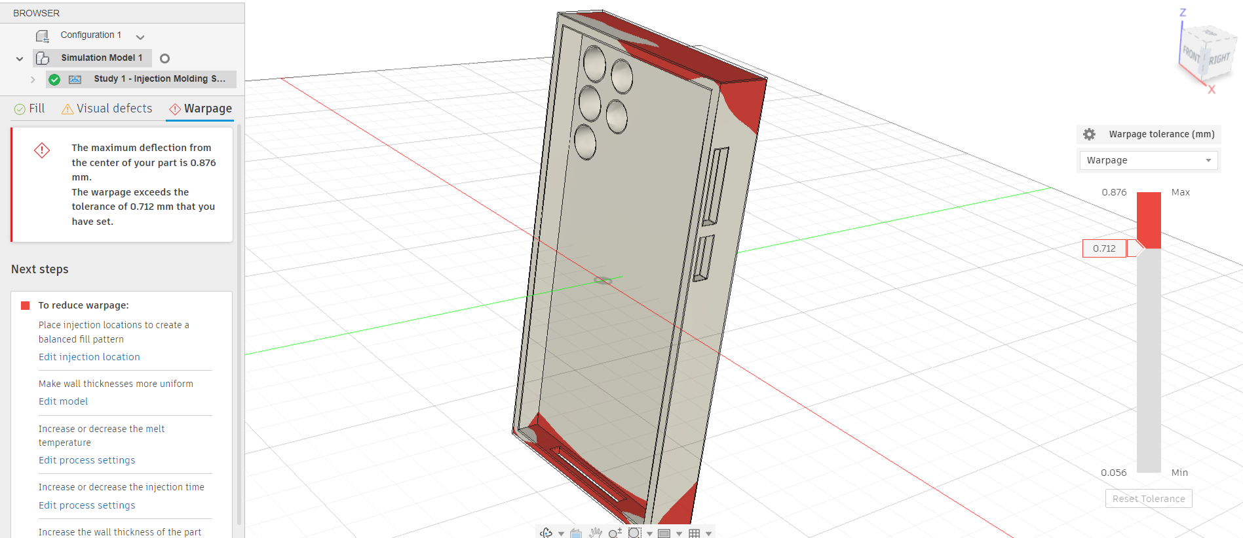
Figure 20 - Warpage Analysis
Additionally, there is a high level of warpage, which is also likely attributed to there being two injection locations on a small component.
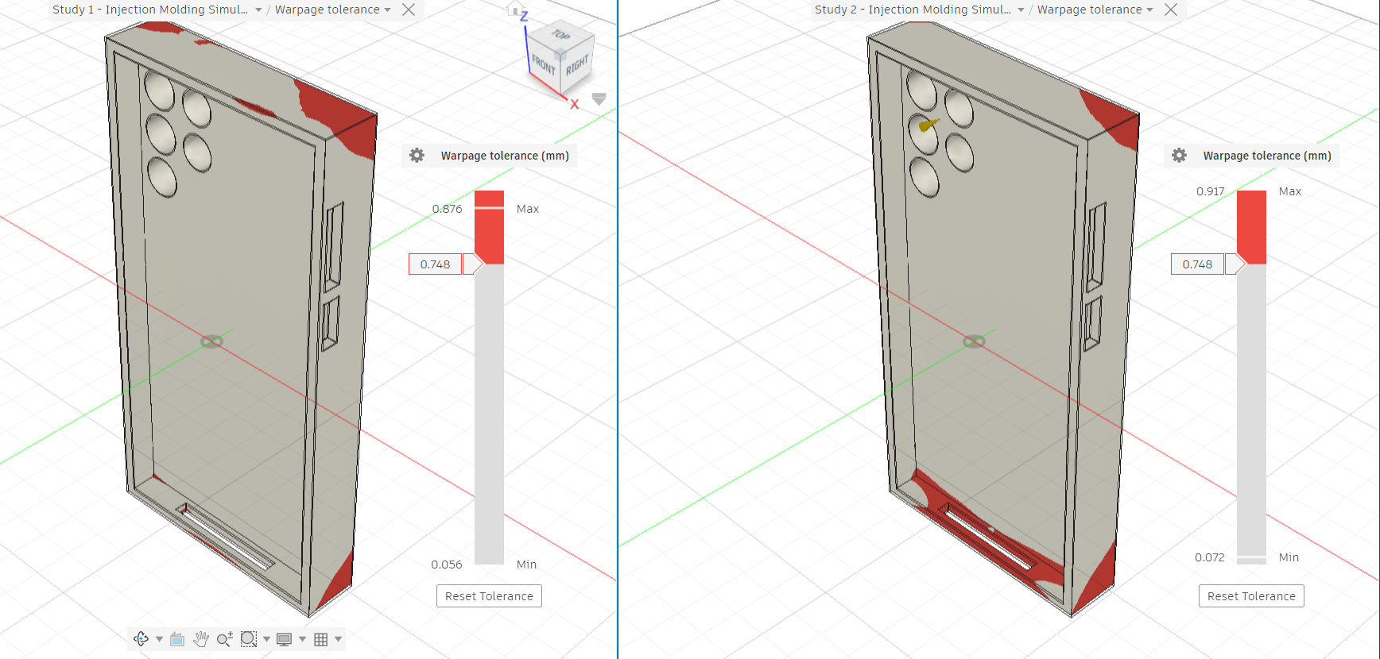
Figure 21 - Comparison of Two Injection Mould Locations to One Injection Mould Location Between Camera Holes
Figure 21 shows the comparison of two simulations. The left simulation used two injection mould locations, one in trouble spot between the camera holes and one in the centre of the phone case. The right comparison had a single mould gate between the second just a single injection gate between the camera holes. The warpage got slightly worse with a single gate in a restricted area. This may improve if the mould gate is placed in the centre of the phone case, a more central location.
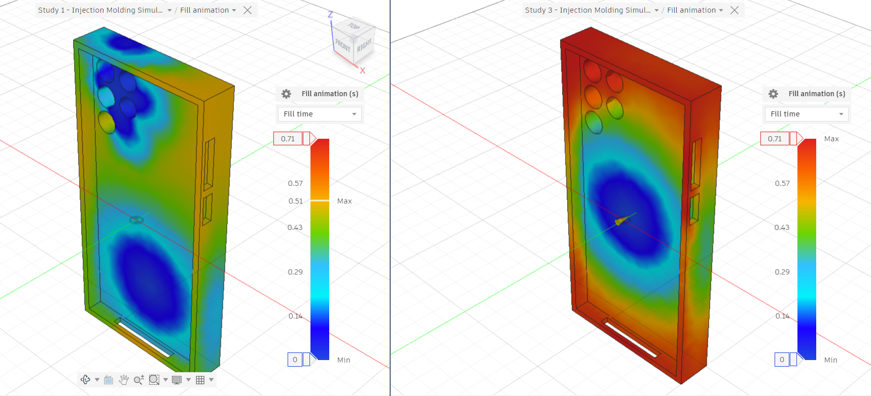
Figure 22 - Comparison Between Two Injection Mould Locations to One Injection Mould Location in Centre of Part
Figure 22 shows a simulation of the mould location in the centre of the part compared to the first simulation with two injection gates. Although the first simulation had signs of sink marks, it is evident in the various simulations completed moving the injection gate do not enable to improvement of the warpage and sink marks alone; therefore, these features can only be improved by modifying the design and ensuring the thickness is more consistent across the part.

Cost Calculation Analysis
Material | Cost (£) | Weight (KG) | Cost per 1KG | Reference
ABS Natural | 79.25 | 5 | 15.85 | ABS Pellets ABS 123-3D ABS Natural Pellets 5 kg 123-3d.co.uk
Polypropylene | 39.74 | 5 | 7.94 | PP Poly Pellets - Poli Plastic Pellets
Nylon | 8.47 | 0.1 | 84.7 | Nylon 6/6 - Pellets 100G | CHE5792SE | SELECT EDUCATION | SE
Figure 23 - Cost of ABS, PP and Nylon
Nylon is a significantly more expensive material than the two alternatives discussed in this report. Polypropylene is the cheapest, ABS is only £7.00 more than PP, however this cost is significant in very high quantities.
The injection moulding tool itself can vary in cost depending on production load, cavity numbers, the size of the part and thus the whole tool, the grade of metal the tool is made from, and the number of turning loops required to commission and finalise the tool. For a simple phone case, the tool should be no more than £15,000, although this does not include the cost of the injection moulding press (£40,000 for mass production to hold a small tool), an injection mould operator £30,000 per year), servicing and maintenance (£1,000 or higher depending on frequency run), electricity cost (0.23KWh, as much as £700 per month). This could be as much as an implementation cost of £56,000 and an additional annual cost of £38,400.
(Walmir Ferreira, 2023)
During mould analysis it was found there would be a fill time of 0.51s, adding 4 seconds for tool open and closing times, 1.5 second for cooling and 0.5 seconds for ejection, 4 seconds of mould fill time; this would be a total cycle time of 10.51 seconds, producing 4 parts per cycle. During a single 37.5-hour work week (subtracting break time), and assuming a productivity rating of 75% factoring in mould cleaning and servicing, maintenance and breakdown (Bidwells, 2022), as well as operator weekends (2 days per week), bank holidays (8 days per year), annual leave (20 days) and sick allowance (average 4.4 days), this would provide 228.6 predicted days of operation. A four-cavity tool would produce 440,458 cycles per year, producing 1,761,808 phone cases annually, or 147,000 per month. Assuming a predicted scrap rate of 1%, as many as 1,468 parts could be scrapped per month, this would bring the total monthly conforming parts down to 145,349 and total conforming annual parts to 1,744,190
Assuming a sell in bulk cost of £0.70 per phone case, this could generate a gross revenue of £101,744.30 and a yearly gross revenue of £1,220,933
Taking the predicted monthly costs of £38,400 and dividing it by 12, this would make the monthly running costs £3,200, subtracting this value from the monthly revenue would yield a monthly profit of £98,544 assuming there is sufficient demand for the product. The original implementation cost for tooling would be paid back in the first month.

Sustainability Considerations
Sustainability is an important consideration when designing the injection-molded phone case, as both the selected material and the manufacturing process affect recyclability, energy consumption and waste generation. The three materials which will be analyzed below for this product are: polypropylene, ABS and nylon.
Polypropylene, ABS and nylon are all thermoplastic, meaning they soften when heated and can potentially be remelted and reprocessed later. For the phone-case application, polypropylene is particularly desirable due to its low cost and high recyclability. Where manufacturing controls and product requirements permit, clean production scrap such as runners, sprues and rejected components may potentially be segregated, reprocessed and incorporated into future production rather than immediately becoming waste.
Energy consumption can be reduced through both component and mould design. The phone case should have a consistent and appropriate wall thickness, avoiding unnecessarily thick sections. This reduces the amount of polymer requiring heating during moulding and can decrease the time required for the component to cool before ejection. Effective cooling also removes heat more efficiently and can reduce the total cycle time. This is particularly significant for high-volume production because small reductions in cycle time can produce substantial energy and productivity benefits across thousands of Moulding cycles. The previously calculated 10.51-second cycle time using a four-cavity tool demonstrates why cycle optimization is important. Producing four components simultaneously also distributes the energy consumed by each moulding cycle across multiple products.
Waste reduction should begin with designing the component to mould correctly first time. Features such as uniform wall thickness, suitable draft angles, appropriate radii and correctly positioned gates can reduce defects such as short shots, warpage, sink marks and incomplete filling. Simulation can therefore be used before manufacturing the physical tooling to identify potential moulding problems and optimize the design without producing repeated physical prototypes.
The successful injection-moulding simulation completed during this project provides evidence that the design can be evaluated before committing to expensive tooling. Further optimization of the runner and gating system can reduce excess material, while reusable thermoplastic process waste may potentially be recovered where quality requirements allow. Combined with process control aimed at maintaining the assumed 1% scrap rate, these measures reduce raw-material consumption, disposal requirements and the environmental impact of manufacturing.
Overall, PP could provide the strongest sustainability case for this phone-case application, if it satisfies the required mechanical and functional performance, while efficient mould cooling, multi-cavity production and design-for-manufacture principles further reduce energy use and waste.

Discussion and Recommendations
The simulations completed show that a 4-cavity tool can produce parts with a total cycle time of 10.51 seconds including machine parameters. Although the material consistently fills out very well with the two mould locations, there is a high susceptibility to warpage and sink marks. However, the high output capabilities mean this product could be produced for a very low cost, and the highly successful production tact time would generate in the products being sold for a significantly low cost, and the sink marks around the corners of the parts are not in a location that would affect the application of the case in retaining the mobile phone.
If the customer requires a product with no sink marks, then trying a stronger material such as a thermoset plastic as opposed to the thermoplastic options discussed above could be a solution, however this would increase the cost of the part, while also making the product less sustainable.
Additionally, it may be possible to improve the sink marks via process controls, such as increasing cooling time, reducing shot size and decreasing plasticization. These options include a higher risk, and for applications such as automotive or aerospace it would not be reasonable to ignore poor simulation results with the intention of improving the product in production (Conro Electronics, 2024) . However, for a low cost, low risk product such as a mass-produced phone case, the risk is minimal. Additionally, considering the application of the phone case moulding around a mobile phone, when equipped the sink marks will be filled out thus reducing the cosmetic element significantly in use.

Conclusion
The objective of this project was to optimize a polymer mobile phone housing for injection mould manufacture using DFM and DFA principles while considering customer requirements, quality, mechanical performance, sustainability and commercial viability. The investigation demonstrates that successful optimization requires consideration of the complete product lifecycle rather than focusing solely on the component's CAD geometry.
QFD established measurable engineering requirements from customer expectations, including strength, durability, appearance, weight and cost. FMEA subsequently identified potential design and production failure modes and provided a structured method for evaluating their associated risk. Controls including CMM verification, go/no-go gauges and strengthened process controls were proposed to reduce RPN values and minimize the possibility of non-conforming products reaching the customer. DOE principles further demonstrated how injection parameters, particularly temperature and lockover force, could be investigated systematically to reduce defects such as flash and gassing.
The Fusion simulation activities provided one of the most significant findings of the investigation. The original phone-case geometry repeatedly failed the injection-moulding analysis. Systematic fault finding demonstrated that the problem originated from the component geometry rather than the selected polymer or simulation conditions. Removal of unnecessary aesthetic chamfers enabled successful simulation, demonstrating the importance of applying DFM during initial product development. Subsequent mould-flow analyses achieved successful filling but identified warpage, weld lines and potential sink marks. Changing gate positions alone did not eliminate these concerns, indicating that further optimization should concentrate on achieving more consistent wall thickness, gradual radii and simplified geometry.
Material selection identified different compromises. Nylon achieved the highest mechanical-property assessment, while ABS provided a strong balance of stiffness, impact resistance and cost. PP offered the lowest investigated purchase price and potentially the strongest sustainability proposition where its mechanical properties remain acceptable for the application. The final selection should therefore be determined from validated product requirements rather than a single material characteristic.
The proposed four-cavity production strategy and 10.51-second estimated cycle time demonstrate the potential for high-volume manufacture. Under the assumptions applied within the analysis, approximately 1.74 million conforming products per year could be manufactured after a 1% scrap allowance. The commercial assessment consequently indicates strong potential profitability, although actual investment decisions should use confirmed industrial quotations for material, tooling, energy, labor, maintenance and equipment.
Overall, the project demonstrates that DFM/DFA should be applied as an iterative process supported by quality tools, simulation and economic analysis. Further development should priorities wall-thickness optimization, validation of the selected polymer, cooling-system design, physical prototype testing and refinement of process parameters before committing to production tooling.

Bibliography
Alam, W. (2026, January). Understanding PPAP, APQP & FMEA in Supplier Quality. https://www.qi-a.com/learning-center/understanding-ppap-apqp-fmea-in-supplier-quality/
American Society for Quality. (2024). What is Six Sigma? American Society for Quality. https://asq.org/quality-resources/six-sigma
Bidwells. (2022, July 13). What is PPM Maintenance? Bidwells. https://www.bidwells.co.uk/what-we-think/what-is-ppm-maintenance/#:~:text=PPM%20stands%20for%20Planned%20preventative,property)%20on%20a%20regular%20basis.
British Standards Institution. (2026). IATF 16949 - Automotive Quality Management System. BSIGroup. https://www.bsigroup.com/en-GB/products-and-services/standards/iatf-16949-automotive-quality-management-system/
Conro Electronics. (2024). Electronic manufacturing supplier terms OEM, EMS, CEM, ODM. Conro Electronics. https://www.conro.com/electronic-manufacturing-supplier-terms-oem-ems-cem-odm/
Doshi, J. (2026, June 20). 10 Key Benefits of IATF 16949 Implementation Beyond Certification. 4C Consulting. https://www.4cpl.com/blog/10-key-benefits-iatf-16949-implementation-beyond-certification/
Six Sigma Institute. (2018). Six Sigma DMAIC Problem Statement & Project Charter. Six Sigma Institute. https://www.sixsigma-institute.org/Six_Sigma_DMAIC_Process_Define_Phase_Six_Sigma_Project_Charter.php
Tanner, S. (2024, March 20). DMAIC Process: The 5 Phases of Lean Sigma You Must Know. Simplilearn. https://www.simplilearn.com/dmaic-process-article
Walmir Ferreira. (2023, February 21). How much does Injection Moulding cost? Get It Made. https://get-it-made.co.uk/resources/how-much-injection-moulding-costs
What Is Six Sigma. (2026). Process Failure Mode Effects Analysis (PFMEA) Explained. What Is Six Sigma. https://www.whatissixsigma.net/pfmea/

