Academic and Employability Skills
(BMSW 4001_LON)

Student: Georgeta Chitu
Student ID: 2109878
Lecturer: Sylvia Hoffmann

Table of Contents
Introduction 3
An overview of Gibb’s reflective model 4
Academic Writing 6
Time management 8
Referencing skills 11
Conclusion 13
References 14
Appendix 16

Introduction
Acquiring proper academic and employability skills can help individuals to enhance their professional as well as academic career. Enhancing employability skills will help individuals to become job-ready and efficient. Moreover, it also helps the individuals to sustain the cutthroat competition of the job market. Individuals with proper academic and Employability skills can get achieve good academic scores as well as good job opportunities in their future life. The following reflective report will analyse those academic and Employability skills which I have gathered through this entire module. Moreover, the context will also discuss the ways through which I have enhanced my reflective learning by implementing Gibb's reflective model. Lastly, the report will also explain those ways through which I will become benefitted in my future academic and professional life after enhancing my academic and employability skills.

An overview of Gibb’s reflective model
Reflective writing is very much important in student life as it helps to find out one's drawbacks and also to identify an individual's strengths. In order to achieve success in life, one must know his or her weakness and also the strengths. Then he or she will be able to give emphasis on the weak zones. In that case, Gibb's model of reflection plays an important role. Gibb's model of reflection was invented in 1988 by Graham Gibb (ed.ac, 2020). The model has six stages. Gibb developed this model so that human beings can analyse his or her past experiences to improve the present situation of the person. Gibb believed that the past experiences of an individual helped him to improve his overall knowledge (Knowles and Tyler, 2016). The six stages of Gibb's model are being discussed as follows;
Description
In the first stage of Gibb's model, an individual provides descriptions about what happened with the person. This stage includes only the factual data and information.
Feeling
In this stage, the person explains his feelings and realisations related to the incident that has happened to him. Questions that are raised in this section are ‘what was the feeling?’ Moreover, the person shares what he felt before the incident, during the incident and after occurring the incident.
Evaluation
In this stage, an individual evaluates the overall incident. Both the positive and negative impacts are being evaluated in that stage. Moreover, the significance of the incident in a person's life is evaluated here.
Analysis
In this stage of Gibb’s model an individual critically analyse the overall incident. The exact meaning of an incident is determined here.
Conclusion
Next, come to conclusion. The individual makes a decision after evaluating and analysing the overall fact. Moreover, the learning outcomes and whole experiences that are gained are summarised.
Action Plan
As per the conclusion the individual make an action plan at last. The action plan is made in order to enhance the performance of the individual and to develop his weak zones.

Academic Writing
The purpose of academic writing is to present writing in a more structured, concise and also in a clear form so that the readers can understand the meaning and aim of the writing clearly. Academic writing helps the student to write in a logical order and to make the writing meaningful. It is important for academic writing that the students are using their own language (wordy, 2020). Moreover, they can take the help of other sources like websites or the writing of other authors but they need to develop the argument in their own language. Moreover, by developing academic skills a student also improves his research skill and also learning skills.
Reflection of Academic Writing
Description
At first, I was not good at academic writing. I was unable to develop my own argument. Moreover, I was unable to present my point of view in a meaningful way.
Feeling
In that context, I felt the importance of academic writing. I felt that due to the absence of my academic writing I will not be able to achieve success and I will not be able to get my desired job.
Evaluation
I evaluated the situation on the basis of my teacher’s and peer’s advice. They provided me with some good and effective suggestions. Along with that, they told me to read others writings more carefully and to read those writings for repeated times. Moreover, I was advised to write more and to check my writings again. My teacher advised me to proofread my writing after completing it (Anon., 2020).
Analysis
After that, I analysed the situation. After getting those bits of advice I tried my level best to improve my writings. I analysed that I need to strengthen my grammar part. I need to invest more time in reading English texts and also in writing. Moreover, I read newspapers in order to strengthen my understanding and learning of the English language.
Conclusion
I followed the above-mentioned ways and I made improvements in my writing. I got positive feedback from my teachers. I understood the effectiveness of those methods in improving my writing skill. In future, I will make an action plan to develop my writing skill more.
Action plan
I have made a schedule and I have broken down my entire schedule into smaller parts. Moreover, I set a deadline. I have now invested more time in reading English text. In order to develop my grammatical sense, I read English storybooks and also English newspapers. I write a lot and ask my teachers to check those writing. I critically analyse those feedback and make changes according to their comment. I am quite confident that by these ways I will be able to improve my writing skills more.

Time management
Time managing is the process of organising and regulating time within specific responsibilities. When faced with obstacles and tight deadlines, effective time management helps to complete a work within a specific time frame. While managing plans and timelines, effective time management skills boost reputation enhancement and professional growth (Sainz, Ferrero and Ugidos, 2019). By aiding inappropriate time deployment for achieving assignments, time management talents facilitate appropriate time management as well as goal attainment. Time management includes the following areas:
1) Organisation
2) Prioritisation
3) Goal Settings
4) Communication
5) Planning
6) Delegation
7) Stress Management
8) Flexibility
Enhancing skills related to time management are important as they help in completing various tasks within the intended deadline. They help in preparing a work schedule and completing it as per priorities. It helps in managing the calendar efficiently by setting timely goals (Rimmer, 2019). It helps in prioritising the assignments and ensuring that the work-life and the personal life is equivalently balanced.
Reflection
Description
I've had a lot of trouble organising my time as I was incompetent in managing my time. I was unable to complete my homework in a timely manner. I didn't have enough time to complete my projects, and I couldn't handle the work pressure before the module and got mingled within my tasks.
Feelings
I was unable to present my work on time and felt disengaged and humiliated. My colleagues had provided me with a poor impression of my tasks, and they believed I need enhance the necessary abilities to be a successful partner. As a result, I am unable to complete a task in a timely manner.
Evaluation
The impact of not being able to submit a task on the deadline is shameful where the others are able to do so. I was embarrassed, and it was visualised by my team members and the professor has provided me with bad feedback and did not check my work properly due to late submission. Thus, all my hard work went in vain, and I was charged a huge penalty due to late submission.
Analysis
In these cases, the professor has the option of rejecting my assignment or imposing a penalty as a punishment. The situation did not turn out well since I was not able to attend the class on time as well as was not able to complete the work by the deadline.
Conclusion
As a result of this humiliating experience, I've gained knowledge from the module that I need to improve my time management abilities in order to avoid such circumstances in the future. In the same situation in the future, I will guarantee that my abilities are sufficiently increased to begin work properly and fulfil deadlines.
Action plan
In the future, I will make sure that I organise my time effectively and that any difficulties with missed deadlines are resolved. I will set boundaries for myself and arrange my tasks as per their priority (Aliaset al. 2019). I will fix my own deadlines for completing a task and ensure that I have gained enough abilities of timer management.

Referencing skills
Referencing is the method that is used in academic writing. Moreover, referencing is an important way to give acknowledgement to the author whose context is used in academic writing. An Individual can reference in their assignments, reports or dissertations to give acknowledgement to authors whose journals are used by an individual. On the other hand, referencing skills are cross-curricular skills which are the major part of the academic areas such as science, arts and technology. The importance of referencing skills is that most universities want students to write proper citations in their writings. Students must use various types of referencing styles in academic writing if they borrow words or ideas from any author. On the other hand, the significance of improving referencing style is to maintain authenticity in academic writings such as reports and thesis. One student can violate academic integrity if he does not reference in his academic writings. The main referencing styles are Harvard, APA, MLA and MHRA (swansea, 2021). The importance of reference skill is that it ensures the validity of the writings. Citation is a major part of referencing and it helps the readers to understand the exact sources of the information.
Reflection:
Description
I have understood that reference skills are very important for developing the content of academic writing. In my early education, I did not know about concepts of referencing skills. I have faced lots of problems in my education career because I could not do proper citation in my academic writing (ed, 2021). I got low marks on my thesis as my contents were not authentic as per the teachers of my university.
Feelings
I feel that referencing styles is an important part of academic writing. I feel that teachers do not accept my assignments if I will not learn about the proper process of referencing styles. In addition to that, my friends did not appreciate my assignments and theses which I submitted to my teachers (cumbria, 2020).
Evaluation
In my early education, I did not know about concepts of referencing styles. There are not any advantages in not referencing academic writing. However, there are many disadvantages to not doing citations in an academic context. On the other hand, I have realised that the referencing style maintains authenticity in academic writings such as reports and thesis. My friends did not appreciate my thesis because I did not do citations in my assignments. I have violated academic integrity because of not referencing my academic content.
Analysis
I have realised that I must use various types of referencing styles in my academic writing if I will borrow words or ideas from any author. I will violate the ethics of the university if I will not learn about the process of references.
Conclusion
I conclude that referencing styles are a major part of academic writing as proper citation helps readers to know about the real sources of information.
Action plan
I will learn about various reference styles such as Harvard, APA, MLA and MHRA to maintain authenticity in my future academic writings.

Conclusion
Presently, the global job market is going through a huge competitive situation. Thus, it has become essential for the students to acquire proper academic and Employability skills for sustaining the market competition. Employability skills are those skills that individuals need to acquire for grabbing better job opportunities in the competitive global job market. Acquiring employability skills will also help individuals to enhance their employment ability. Along with that, academic and Employability skills play an important role in enhancing the productivity level of individuals. Therefore, the above report has analysed the academic and Employability skills which I have gained throughout this process. Moreover, the report has also discussed the ways through which I have enhanced my reflective learning process by applying Gibb’s model of reflection. Lastly, the context has also explained the ways by which I got benefitted after enhancing my academic and employability skills in my personal as well as professional life.

.

References
Books and journals
Alias, A., Noor, N.A.M., Bhkari, N.M. and Ariffin, K., (2019). Student learning time: A needs analysis for university students’ time management skills. In Proceedings of the Regional Conference on Science, Technology and Social Sciences (RCSTSS 2016) (pp. 125-134). Springer, Singapore.
Knowles, Z., Tyler, G., Gilbourne, D. and Eubank, M., (2016). Reflecting on reflection: exploring the practice of sports coaching graduates. Reflective practice, 7(2), pp.163-179.
Rimmer, A., (2019). How do I improve my time management skills?. BMJ, 366.
Sainz, M.A., Ferrero, A.M. and Ugidos, A., (2019). Time management: skills to learn and put into practice. Education+ Training.
Websites
Anon., (2020). Academic writing. [Online] Available at: https://www.skillsyouneed.com/write/academic-writing.html.
cumbria, (2020). Gibbs’ reflective cycle. [Online] Available at: https://my.cumbria.ac.uk/media/MyCumbria/Documents/ReflectiveCycleGibbs.pdf.
ed.ac, (2020). Gibbs' Reflective Cycle. [Online] Available at: https://www.ed.ac.uk/reflection/reflectors-toolkit/reflecting-on-experience/gibbs-reflective-cycle.
ed, (2021). Gibbs' Reflective Cycle. [Online] Available at: https://www.ed.ac.uk/reflection/reflectors-toolkit/reflecting-on-experience/gibbs-reflective-cycle.
swansea, (2021). How do I reference Gibbs' reflective cycle in APA (6th ed.) style? [Online] Available at: https://swansea-uk.libanswers.com/faq/189268.
wordy, (2020). What skills are required for academic writing? [Online] Available at: https://www.wordy.com/writers-workshop/skills-required-academic-writing/.

Appendix
Introduction
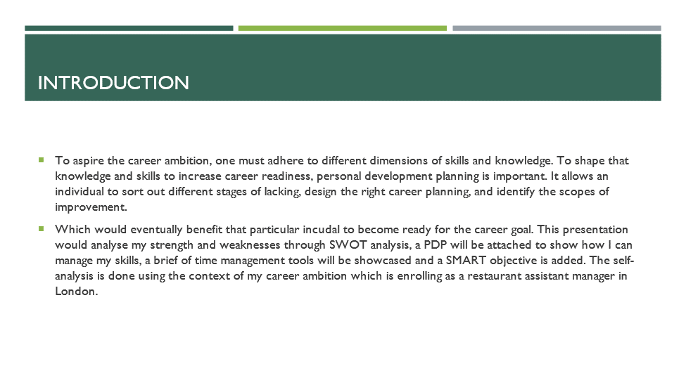
To aspire the career ambition, one must adhere to different dimensions of skills and knowledge. To shape that knowledge and skills to increase career readiness, personal development planning is important. It allows an individual to sort out different stages of lacking, design the right career planning, and identify the scopes of improvement. Which would eventually benefit that particular incudal to become ready for the career goal. This presentation would analyse my strength and weaknesses through SWOT analysis, a PDP will be attached to show how I can manage my skills, a brief of time management tools will be showcased and a SMART objective is added. The self-analysis is done using the context of my career ambition which is enrolling as a restaurant assistant manager in London.

SWOTanalysis
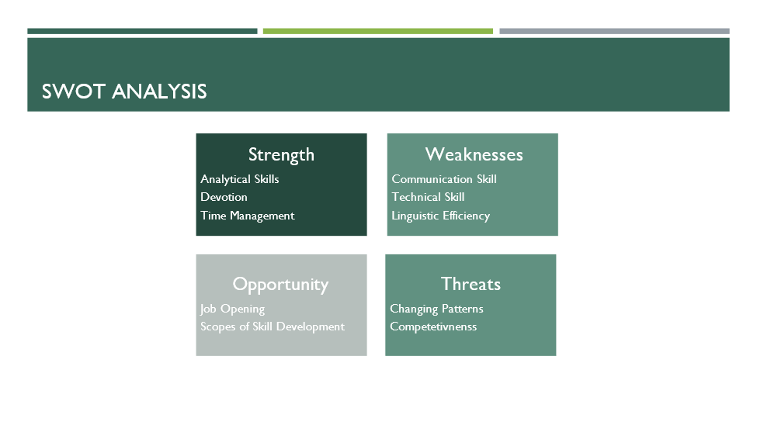
Strength
- Analytical skills: I have the strong analytical skill, which allows me to understand situations, analyse the environment and based on the observation make a suitable action plan.
- Devotion: I have created strong devotion for my educational and professional life. I have always prioritised my work with utmost importance which enabled me to execute those tasks more efficiently and timely manner (Abbott, 2018). Hence despite the complexities of work, I can complete with the highest level of efficiency according to peer review.
- Time management: I have learned the critical aspect of time management in my graduate program. I have enhanced my time management skills during the course curriculum and also applied them in the educational phase (Cameron, 2019).
Weaknesses
- Communication skill: I lack communication skills especially in public speaking. The hesitancy and confusion of choosing the right word, and the stress to speak out in public have created drawbacks in different stages of my life.
- Technical skills: After analysing my career readiness situation, I have dignified that I lack various technical skills which are essential for the job role I aspire to. Such as operating various computer software, supply chain knowledge, hospitality sector-related knowledge etc (Pandi, 2020).
- Linguistic efficiency: After the self-evaluation process and career readiness evaluation, it is understood that my linguistic efficiency is one of the major weaknesses (Chendroyaperumal, 2019). The aspired job role of mine needs proper linguistic efficiency. But I have some lacking in this segment.
Opportunities
- Job opening: After the COVID, there are a huge number of jobs operating in the restaurant manager and assistant manager posts. During the COVID this sector of the hospitality industry has heavily hit, and businesses were shut down. Now the recruitment process is ongoing which widens scopes for me.
- Scopes of skill development: There are various skill development centres, or sources available. By enrolling which one can enhance their skills and reduce the lacking (Chendroyaperumal, 2019). Those courses are designed to support an individual to increase their efficiency.
Threats
- Changing pattern: The corporate need for skills is changing day by day. As the technological integration in the caproate operation is increasing the need for skills is also changing.
- Competitiveness: Increased level of competition in the market poses threat for the job candidates. I aspire for the role of assistant manager in a restaurant in London. The competitiveness has increased; hence the candidates must be properly skilful to get a certain job (MacKellar, 2019). To compete for a job role, one must be skilful and tick all the requirements that employers look for.

SMART Objectives
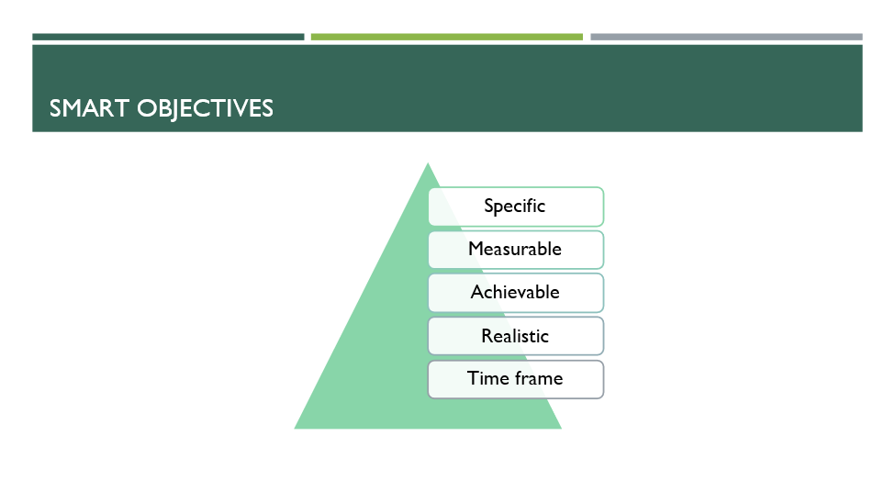
Specific: My specific goal is to enrola restaurant assistant manager in London. My aim is to identify the skills needed for that job role, achieve those and enrol in that position.
Measurable: After completing the different recruitment phases, and getting selected for the job.
Achievable: The job role is very achievable for candidates who fulfil the requirement. To complete the career readiness, I must identify my weaknesses and work to omit those. By enhancing the necessary skill, I can achieve my goal(Chendroyaperumal, 2019).
Realistic:After completing graduation, and acquiring the necessary skills for the job, the career goal is very much relisting.
Time frame: The whole process of completing graduation, acquiring skills through joining different workshops and courses may take 3 years(Broslavska, 2020). Hence enrolling on the position may take 3 years.

Time management tools
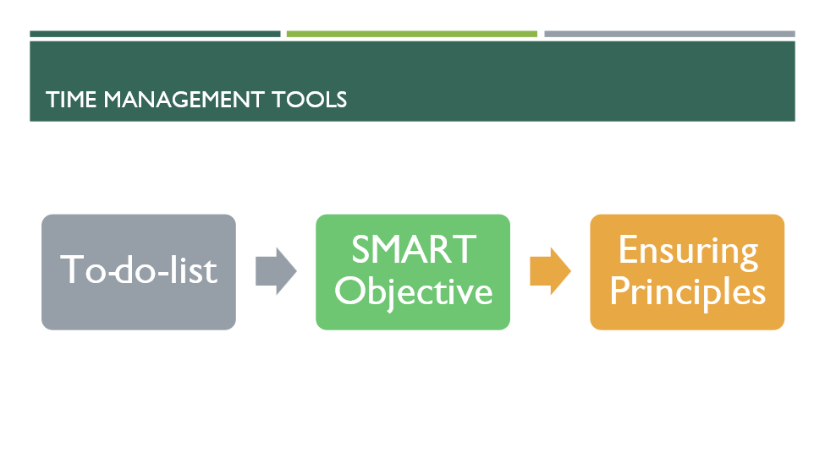
To-Do-List: This is the concise tool of time management. To-do-list allows Individuals to keep account of the task in a structured manner. Based on the time frame of the action to-do list can be created (Broslavska, 2020). And to keep track of time and work this strategy is fruitful. I can use this strategy to control my action plan and development plans.
SMART Objectives: Setting SMART is another element of time management strategy. This is done priorly to planning, hence keeping track of the progress can be measured specifically.
Ensuring Principles: Lastly, there are three components of time management principles. Appropriate measurement, efficient allocation and reduce time wastage (McConalogue, 2019). Following this phase-based strategy also reduces the time consumption of any action plan.

PDP
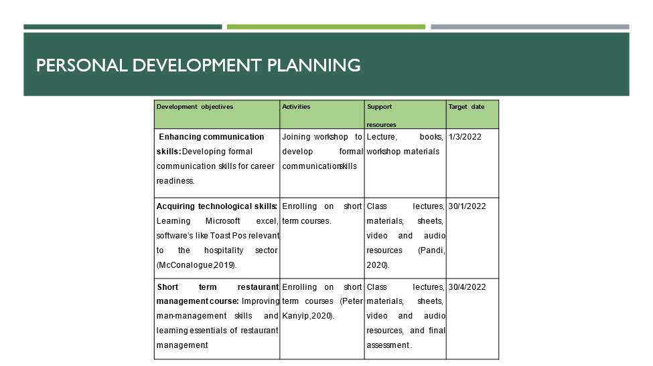
Development objectives | Activities | Support  resources | Target date
Enhancing communication skills: Developing formal communication skills for career readiness. | Joining workshop to develop formal communication skills | Lecture, books, workshop materials. | 1/3/2022
Acquiring technological skills: Learning Microsoft excel, software’s like Toast Pos relevant to the hospitality sector (McConalogue, 2019). | Enrolling on short term courses. | Class lectures, materials, sheets, video and audio resources (Pandi, 2020). | 30/1/2022
Short term restaurant management course: Improving man-management skills and learning essentials of restaurant management. | Enrolling on short term courses (Peter Kanyip, 2020). | Class lectures, materials, sheets, video and audio resources, and final assessment. | 30/4/2022

Conclusion
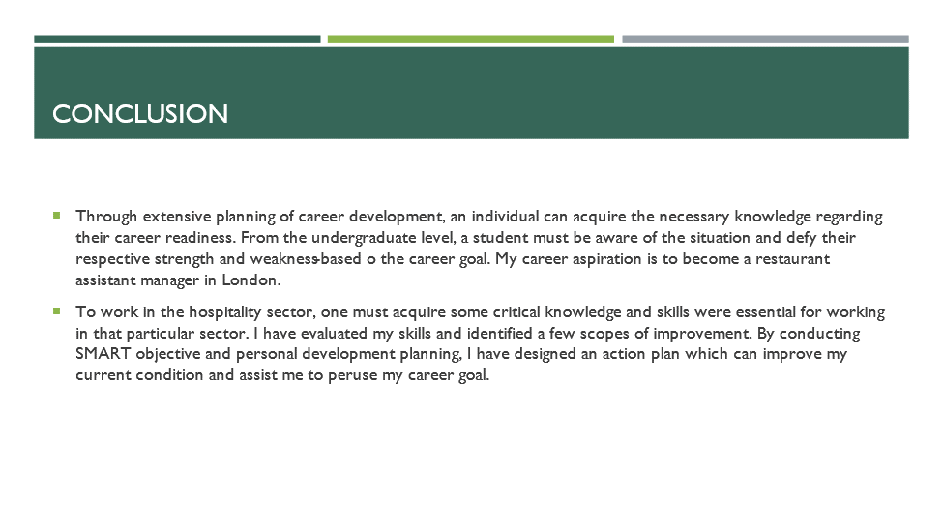
Through extensive planning of career development, an individual can acquire the necessary knowledge regarding their career readiness. From the undergraduate level, a student must be aware of the situation and defy their respective strength and weakness-based o the career goal. My career aspiration is to become a restaurant assistant manager in London. To work in the hospitality sector, one must acquire some critical knowledge and skills were essential for working in that particular sector. I have evaluated my skills and identified a few scopes of improvement. By conducting SMART objective and personal development planning, I have designed an action plan which can improve my current condition and assist me to peruse my career goal.

Reference
Abbott, C., 2018. Personal career development in converged services. Librarian Career Development, 6(3), pp.28-35.
Broslavska, H., 2020. SMART objective factor of the Career Development. Journal of Human Resource, (67), pp.100-107.
Cameron, S., 2019. Professional Development Planning: Hospitality Sector. Journal of Career Development, 2(4), pp.09-12.
Chendroyaperumal, C., 2019. Communication Skill: Placement Perspective. SSRN Electronic Journal,.
MacKellar, G., 2019. Time and resource management: the time plan. Engineering Management Journal, 1(2), p.77.
McConalogue, T., 2019. Developing the Skill of Time Management. Management Decision, 25(1), pp.5-8.
Pandi, D., 2020. SWOT Analysis of Personal Evaluation. International Journal of Human Resource Management, 24(5), pp.1872-1877.
Peter Kanyip, B., 2020. Time Management: An Effective Tool in the Skill Management. Education Journal, 3(4), p.65.

