Learning Journey and Self Awareness through Personal Development

Modul name: Professional Career Development
Module code: BMSK4005_SWAN
Student name: Ionelia Alina Papaman
Student code: 1815979

Table of content:
- Executive summary
- Introduction
3.Main findings
  - Self awareness and methods to identify development needs
-Johari window
-Personal SWOT analysis
  - Conversion strategy
-Personal TOWS analysis
  - Setting goals and measuring progress
-SMART objectives
-GO MAD model
-Personal Development Plan
  - Learning and development
-VARK
-Honey and Mumford
  - Motivational theory
-Herzenberg 2 factors of hygiene theory
  - Self reflection
-Kolb reflective cycle model
4.Conclusion
5.References
6. Appendix

- Executive summary
In this essay I recorded an complex set of theories and technique related with personal development. In this essay you can found self awareness tools like Johari window, SWOT analysis, conversion strategies, setting goals methods like SMART objectives and GO MAD thinking. Explained learning styles, motivational theories and self reflection tools, ways to monitories and measure progress in order to achieve goals, all supported by Harvard style references and personal experiences.
- Introduction
The learning journey it is a complex process and need time, research and investment in order to improve and gain skills for all life necessities, specific for this essay, academic/employability skills and starting a business, skills required to develop proactivity and productivity. “Success is no accident. It is hard work, perseverance, learning, studying, sacrifice and most of all love of what are doing or learning to do”- Pele.
The learning journey will start with self awareness for a better understanding of development needs and checking the actual level.
Using available tools to identify suitable learning styles and motivational theories an person can be able generate an honest work, self reflection in order to create development plans of learning journey starting from self awareness.

- Main findings
  - Self awareness and methods to identify development needs
Self awareness theory it is the process of examining our thoughts, feelings and the motive. The results it’s leading to honest judging your behaviour in accordance with your internal standards in help to identify and achieve develop needs. Because “After all, all knowledge simply means self knowledge”- Bruce Lee

JOHARI WINDOW was created by Joseph Luft and Harry Ingham in 1995, it is a psychological tool for understanding the balance between different life position.
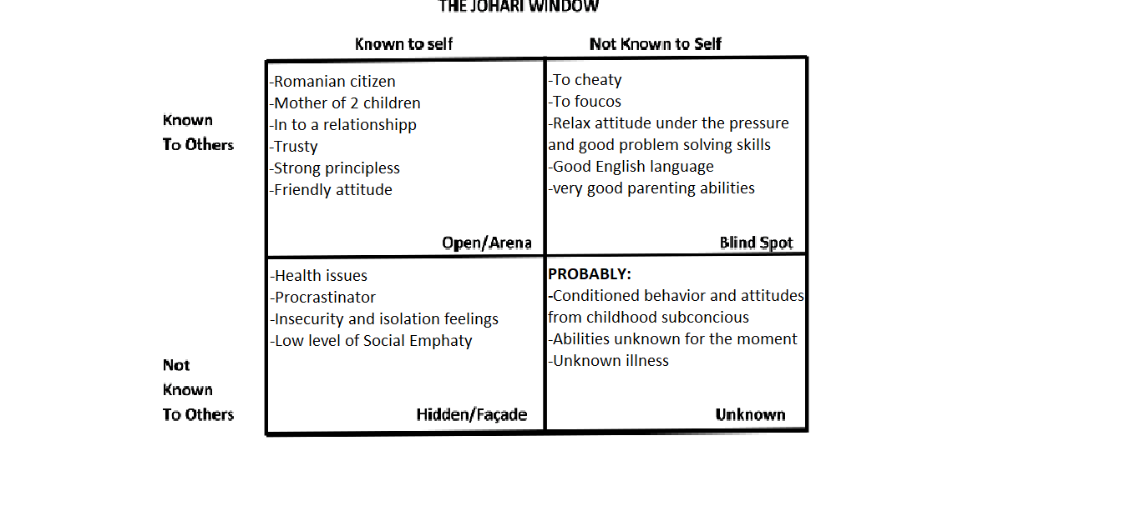
- Open Area: Information by this area can build trust disclosing to others and learn about others.
- Blind Area: The feed back received can be positive or negative and help you to be aware by something and overcome personal issues.
- Hidden Area: Somethings you are aware of but you don’t want to share with others.
- Unknown Area: This area can include subconscious feelings, unknown illness.

The window balance can change anytime. The areas can increase or decrease, for example if you decide to share some things from hiding area your open area increase.
Criticism: Some things it is better not communicated, some people may pass on information further then you desire or have negative reactions.

Personal SWOT analysis: Strengths, Weaknesses, Opportunities, Threats – SWOT

Being a fulltime mom for the last 3 years I must to focus on family life more then career, my goal to achieve it is employability and academic skills and find my career direction. My big plan it is to develop my own business.
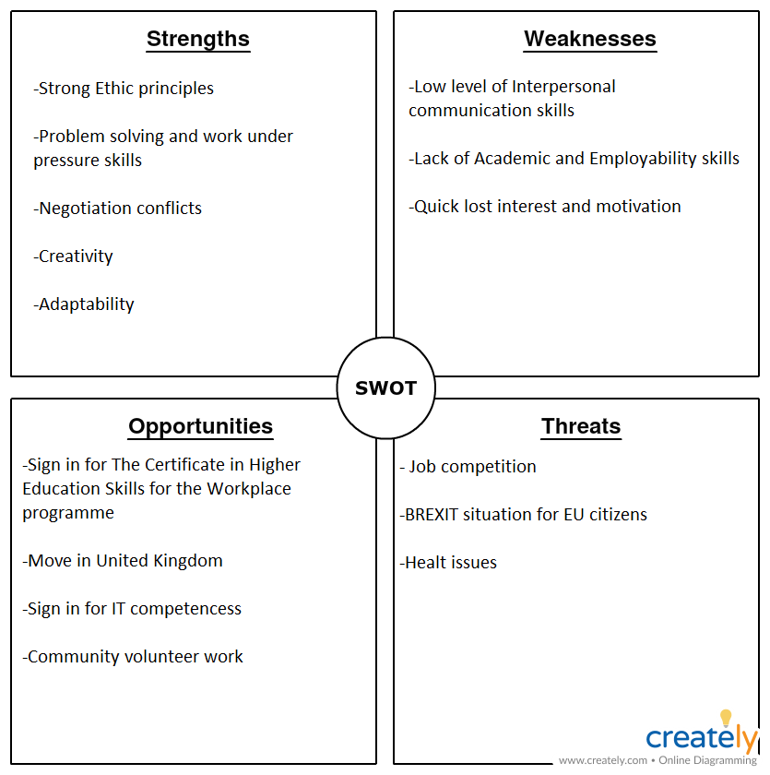
Strengths: family life push me many times in complicated situations which was necessary to find solution under the pressure. This skill can be improved and transferable to the workplace. Adaptability and creativity make me feel confident dealing with new things out of my routine, creativity it is one of the most wanted skill nowadays when the world it is leaded by technology.
Being a martial arts sportive for half of my life, I learn self discipline, self awareness, responsibility, respect and tolerance from a early age, I can transfer this ethic principles at the workplace shaped in conflict negotiation and dealing with people.
Weaknesses: Academic skills it is my lifetime goal, I never had the opportunity to study before and this put me in situation to accept any job even if I hade no satisfaction.
Being an immigrant understanding, writing and spoken English language and grammatic it is hard for me and lead me to poor interpersonal communication and isolation feeling because I can’t express myself in the way I think of feel and sometimes I need to ask twice or more to full understand.
If I fail I lost interest very quick and I became very frustrated when it is about important things and usually took me a wile until I found motivation to start again.

Opportunities: move in UK it was the grates opportunity I ever have, was hard at first, to leave all I know and start a new life but now I feel like I belong here.
I had the opportunity to sign in IT course, the skills earned can be transferred to workplace.
Sign in for Certificate of Higher Education Skills for the Workplace give me the opportunity to gain academic skills and communication improvement and explore a large variety of knowledge.
Volunteering increase my social empathy and earning interpersonal experiences, give me the opportunity to learn more about humanity and my position in the community, avoiding my isolation feelings.

Threats: the actual political situation its concern me because I am a European Citizen and I don’t know if I will have the right to live, work or study in UK after BREXIT.
Job competition it is a real threat for a person with poor employability skills like me. Unqualified jobs have more candidates then specific jobs.
My health issue limited my movements and physical abilities, sometimes this is a criteria to get the job, unfortunately I cant do nothing more then follow the treatment to release the pain.
Criticism: SWOT analysis it is just one stage of planning process for just two factors and doesn’t provide solutions or offer alternatives decision, can create many ideas but not help you choose which one is good.

  - Conversion strategy
TOWS analysis it is a powerful tool to convert the identified external factors from SWOT analysis to overcame weaknesses and minimize threats.
- S-O make the most of opportunities using the strengths: creativity/ adaptability – UWTSD
Using my creativity and adaptability I will do the best I can to be a good student to earn good results, have full attendance, contribute to the group, do individual research to get a Higher Education Certificate.

- S-T use the strengths to minimize the threats
Using my self organisation skills I put in order all the paper I need, up to date passport, identity card, birth certificate, prove of address, P60, P45, to prove my legal right to live, work and study in UK to minimise the BREXIT impact.

- W-O use opportunities to overcame the weaknesses
Doing volunteering I start to improve my interpersonal communication and social empathy skills, being in touch with Wales people, I improve my English language make friends, overcame to my isolation feelings and understand my position in society.

4.W-T minimize weaknesses to avoid potential threats
Improving my employability skills (time management, communication, problem solving, critical thinking) using specific methods and theory, I will decrease job competition if my skills become more specific I can get a better job or start my own business.

  - Setting goals and measuring progress it is the most important step to achieve success. Not all goals are worthy the investment, SMART objective increase your chance to successful achieve goals. SMART stand for Specific, Measurable, Achievement, Relevant and Time-bond. My SMART goal to achieve its Academic skills.
Specific: having a clear, concise goal
- I want to gain a Higher Education Diploma in Business in the next 5 years.
Measurable: tracking the progress and sett milestones
- The assessments grades will be my progress measure and result for each year will be my milestones
Achievement: instead of impossible, goals should be challenging yet achievable.
- My goal it is achievable because I will have full attendance, I will be active on class discussions and group activities, I will complete the class information with individual research and practice in help to progress successfully.
Relevant: be sure your goal it is wort your time and it’s beneficial and relevant to your overall life plans.
- Achieving Academic Skills it is beneficial for my life time career and relative for my other plans, start a business or overcame to an career change necessity.
Time-bound: goals must have a target time attached to them
- In the next 5 years I will be a hard worker student to accomplish the school tasks, support the information with individual research and practical experience to support my learning journey and motivate me until I finish all 5 years, first 3 years undergraduate and the last 2 years postgraduate.
Criticism: Sometimes the goal or the time-bound it is not realistic, then a new goal should take place, failure bring frustration and low motivation to start again.

GO MAD thinking model was invented in 1999 by Andy Gilbert and Ian Chakrovorty for business improvement through leadership thinking and was adopted in many fields. The framework results can improve performance, reduce costs, save time and increase sales.
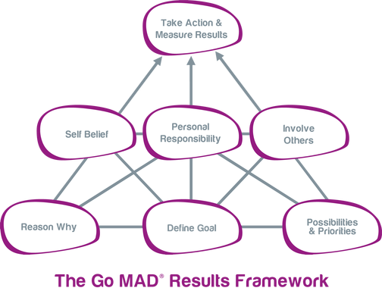

My plan it is to develop my employability skills in helping to open my business, follow my family background in East European bakery food business. A business owner must to have skills like problem solving, critical thinking, interpersonal communication and negotiation to recognize which skills need their employers and hire the right people, to create productive business plans and procced feedback, all in order to develop a productive business. Est European bakery it is famous around the world, appreciated by East European community and easy to introduce to the UK natives. I will follow the GO MAD model to accomplish the goals in starting a bakery business in Swansea.

Step 1: why do you want to make a difference?
It is a big East European community in Swansea I think it is necessary a specific East European bakery here. It is a innovation, it is part of my culture, I have all the knowledge and support I need, I have good custom and can start with a relative small budget.

Step 2: define your goal
Specific: start an East European bakery business in Swansea
Measurable: save the necessary amount to achieve 14.000£ budget required and to get the 3 mounts “Food Hygiene” Certificate.
Achievable: I follow all the specific steps required in order to achieve the goal and overcome the unexpected situations.
Realistic: the goal it is realistic and well sett because I calculate everything and I check others opinion, the results are very realistic: Swansea need an East European specific bakery.
Time-bound: the business will start on 1st March 2020.

Step 3: plans and priorities
First thing to do was to have a chat with East European bakery owners in UK, and I find what paper I need, how the location must be, how many employers I need, what is the best machines brand and how much money I need to start.

Step 4: self belief
Because I have a background of culture and tradition about Est European bakery, I believe I can lead a bakery, this is the reason I start. I have the necessary budget and the right people to support me. Working harder to build my own business it is the most satisfying way to celebrate success.

Step 5: involve others
My key people are, first my husband, he has a large experience in business management and accountability and second one it is my uncle who inherited my grandparents bakery and work for all his life in bakery, he will work with us in the first 6 months and teach us all we need to know.

Step 6: personal responsibility
Until now I’ve done a lot of sacrifices to save money for the bakery budget and I’m still do. Preparing food for a big number of people it is the biggest responsibility, and I am ready to do it in the right way. Coming up with new items and increase custom it is my way to maintaining motivation.

Step 7: take action, measure results and celebrate success
The business will start on 1 March 2020, every 24th of each month will be the day of checking the clients feedback and profit will be another way to measure the progress. The success confirmation will be a business extension like a second location or an affiliation contract, the celebration will be a nice party for all the people involved.
Criticism: The results are limited by unrealistic goals, wrong techniques used to achieve the goals or wrong milestones which will bring disappointment.

Personal Development Plan
“absorb what is useful, discard what is not, add what is uniquely your own.”- Bruce Lee

  - Learning and development
According with Albert Einstein “Everybody is a genius, but if you judge a fish by its ability to climb a tree, it will live its whole life believing that it is stupid”. Learning styles refer to an individual’s way to absorb, process, comprehend and retain information.
I choose to apply VARK (visual, aural, read/write, kinesthetic) and Honey and Mumford questionnaires (*appendix). I explain the results in the following sentences:

VARK- reader/writer remember and process information through reading and writing texts.
Reader/writer people prefer to use printed words to convey and receive information. Use lists, bullet points, numbered paragraphs, use dictionary, read books, write notes, use paraphrasing, convert notes in learnable package, do suggested readings, use handouts.

Honey and Mumford –pragmatist
This tool was created by Peter Honey and Alan Mumford and was designed to find an individual’s preferred learning style.
My results:
Activist-15
Reflector-11
Theorist-8
Pragmatist-15
I prefer the pragmatist because I feel it is the most fit to my personality, I fully agree with pragmatist description, the others fitted me in extraordinary situation but pragmatism it is with me all the time.
All my actions are about trying out ideas, theories and techniques to check if they work. I try to practice all I learn and generate new ideas in order to find solutions and take decisions to overcome my problems.
I am not a competitive person in relationships with others, because I am a pragmatist and I care more about my tasks achievement then people around me, but I am all the time in competition with me in accomplish tasks by take all opportunities show up to me and convert them in to a challenge to become a better version of me.
Criticism: not everyone fit into one single learning style making difficult to determine studying and learning strategy.

  - Motivational theory- have the task to identify what facts lead an individual to work towards a goal or outcome. The target it is to avoid dissatisfaction factors in order to motivate individuals to became more productive.
Because my goals are academic/employability skills and starting my own business, I found Herzenberg’s two factors of hygiene theory it is suitable for both goals and lead to achieve them.
The two factors of hygiene was introduced by Frederick Herzenberg in 1968. He believed that businesses should employees by adopting democratic approach to management and by improving the nature and content the actual job through certain methods of motivation and hygiene. Based on his research he develop the theory, that people job/ task satisfaction depend on two factors:
-satisfaction factors (achievement, recognition, responsibility, the work itself, advancement and growth)
-dissatisfaction factors (company policies, supervision, relationship with superiors and co workers, work conditions, salary, status and security)
The conclusion he drew is: job satisfaction and job dissatisfaction are not opposites, taking away an employer dissatisfaction doesn’t mean he will be satisfied.
Motivating people work when the things they complain about disappear, so its not much point in motivating people if the hygiene factors aren’t take care of.
Creating conditions for satisfaction it is a good way to gain motivated and performant people:
-create condition for good performance
-appreciating opportunities for growth within the organisation
-award the talents and creativity
Criticism:
Because the theory assume job satisfaction equals higher productivity, I disagree because Herzenberg didn’t take in to account while researching the external factors that might influence the motivation and productivity.
  - Self reflection
David Kolb publish his reflective/learning cycle in 1984. Kolb’s experiential theory it is represented by a four stage reflective/learning cycle in which the individual touch all the bases
Rework my assessment will be the subject I will apply Kolb’s reflective cycle.
- Concrete experience:
Create an essay which wasn’t good enough to pass the limit grade put me in situation to rework the essay to gain more grades and pass the assessment.
- Reflective observation of the new experience
The first assessment biggest inconsistence was the tasks misunderstood which lead to missing subjects and incomplete assessment.
- Abstract conceptualisation
After an honest reflection to the old assessment I find what was wrong and I pay more attention to tasks understanding, I’ve done more research and I schedule the time in order to work step by step every day to don’t miss nothing.
- Active experimentation
Schedule the time on to do list for every subject and record all the references it is the new experience in this situation. Schedule the time on every task and follow step by step to accomplish not just student tasks but work and day by day tasks it is my active experimentation to apply what I learn.

“By three methods we may learn wisdom: First, by reflection, which is noblest; Second, by imitation which is easiest; and third, by experience, which is the bitterest”- Confucius

4.In Conclusion the learning journey it is never stop, every day we became a better version of self, using the right tools to find the level we start and the best methods to improve skills and life quality, to accomplish the goals we sett and measure the progress.
Self awareness start can start with a personal SWOT analysis and Johari window to check your level in this moment. Using TOWS conversion strategy to overcome weaknesses and minimize threats will have a better understanding to self and can setup goals using SMART objectives, Go Mad framework and PDP to achieve them and improve any life plan want.
Finding the suitable learning style, using questionnaire, processing information and generate solution and conclusion become easier.
Like Herzenberg said, the motivation start when dissatisfaction factors are take care of, so it is hard to find motivation in dark times but this is the most important in achieving goals.
An honest reflection after the work its done will bring new knowledge to put in your journey and another to be aware of in order to do better next time or in another context.

- References:
- Cameron D Herzberg – still a key to understanding motivation. Training Officer, 32(6), Jul-Aug 1996, pp 184 – 186
- Richard E Boyatzis, David A Kolb – Journal of Managerial Psychology. MCB UP ltd, 1 Aug 1995, 10(5), pp 3 - 17
- Joseph Luft [1969] The Johari Model Of Human Interaction, London, Mayfield Publishing Company
- www.Analectic muse.org.uk - authors: Barbara V. Evers, last update 28 November 2018
- www. Self awareness. Org.uk- last update10 November 2013
- Serchio.Techtarget.com – authors: Margaret Rouse, Mary Pratt, Linda Tucci, last update March 2018
- Crystalball.com – last update 4 August 2018
- Brian Tracey.com- last update 15 January 2019
- VARK- learn.com -last update 23 July 2017
- Simply psychology.org- authors: Saul McLeod, last update 2017
- 12.manage.com – last update 18 July 2017
- Business.com – last update 14 August 2018
- Goodreads.com – last update 22 March 2019
- Skills for learning. Ac.uk – last update March 2015
- UK essays.com – last update April 2019
- Solent Online Learning. Ac.uk – last update March 2019

- Appendix

