LCMB7003 Strategic Management June 23



STRATEGIC MANAGEMENT
(LCMB7003)

NAME : ANSIF ANSARY
STUDENT ID : 2215082
Table of Contents
1. Introduction 3
2. Background of the Company 3
3. Issues faced by the Adidas 4
Risk matrix 5
SWOT analysis 8
4. Strategies and ways to mitigate issues of Adidas 10
STP framework 10
Porter's Five Forces model 11
Green strategy value chain 15
5. Strategies to gain competitive advantages 17
PEST analysis 17
VRIO Framework 20
6. Cooperative Strategy 22
CSR strategy 22
Ansoff matrix 23
BCG matrix 25
7. Conclusion 27
8. Recommendation 27
References list 29

1. Introduction
Adidas is a global footwear and sportswear Company and it is one of the multinational corporations. This study also described the different issues of this organization and evaluated the different strategies to mitigate the issues of Adidas through the STP analysis, porters, and values chain model. Here also described this Company focused on Plastic bottles in Shoes, which is considered one of the innovative concepts in this market and this concept helped this Company to gain competitive advantages. It also evaluated the risk matrix and recommended these companies mitigate the challenges and gain the sustainable development of organizations. Here also described the CSR, BCG, and Ansoff matrix to gain competitive advantages in the Market.

2. Background of the Company
Adidas is a global sportswear and footwear company of sustainable innovation in the fashion industry and it includes its efforts to turn its plastic bottles into shoes. This initiative is an innovative part of Adidas’s huge commitment to its environmental sustainability in order to reduce its carbon footprint (Bogers et al., 2019). Adidas is a multinational corporation and this company has sealed the design of its apparel, accessories, and footwear. Recently it can be stated that Adidas has introduced first first-ever running shoes from upcycled plastic waste and made a partnership with Oceans and Parley. Adidas has produced millions of pairs of such shoes that have been made with various recycled plastic wastes from coastal regions and beaches. It has been also observed that in 2020, Adidas collaborated with Parsley to collect approximately 7000 tons of various plastic waste. Adidas has teamed up with “footwear manufacturer All birds” in order to make the world's cheapest climate-footprint sports shoes (Adidas.co.uk 2023).
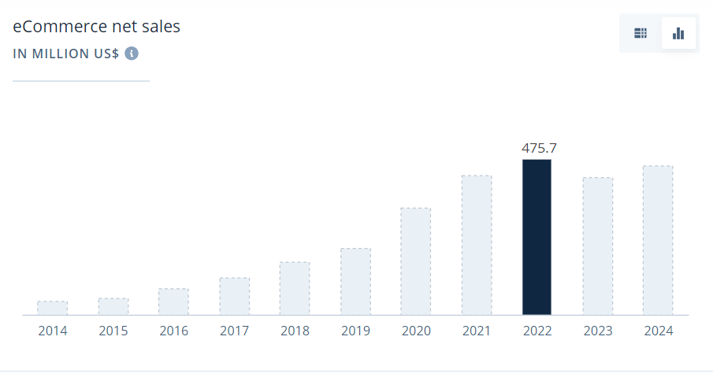
Figure 1: E-commerce net sales of Adidas
(Ecommercedb.com, 2023)
From the above graphical representation, it has been noted that in 2022, e-commerce sales were high (approximately 475.7 dollar) of Adidas and this company has sold its best products and achieved targeted products through e-commerce sites (Ecommercedb.com, 2023). Most customers have preferred to sell products through online platforms to save their valuable time. Besides, Adidas has also expanded its business in the online site.

3. Issues faced by the Adidas
Adidas has faced many issues and challenges due to external and internal factors and some of the key issues are supply chain disruption, competitioṇ, labor issues, e-commerce, and changes in consumer preferences, Adidas has faced intense competition in the athletic and sportswear industry and competitors such as, Nike have also expanded its business in UK market (Hunger, 2020). Adidas is suffering from supply chain disruptions that can be caused by several factors such as trade disputes, natural disasters, and the COVID-19 pandemic. The implications for Adidas are explained: 50% of its resources are materials and it is used in around 900 million products in the market (Forbes.com, 2023). This is necessary to note that the covid 19 has disrupted many retail industries and has led to store closures and decreased consumer spending.
It can be stated that Adidas has adapted its marketing strategies and options to recover and survive. In addition, when e-commerce has provided various opportunities for development and growth, it has also represented various challenges in order to maintain an effective online strategy and deal with many cybersecurity threats (Ferlie and Ongaro, 2022). One of the most vital issues is the environmental impact of plastic waste. Shoes are made with many plastic materials such as soles or synthetic uppers that can be broken by sunlight and water. Economic conditions in the UK such as unemployment, inflation rates, and consumer spending have impacted Adidas’s profitability and sales. Moreover, economic downturns are misleading to reduce consumers spending on essential and non-essential products such as athletic apparels.

Risk matrix
Serial ID | Risk description | Chances | Impact | Severity | Owner | Mitigation strategy
1. | Supply chain disruptions | High | High | High | Information and Operations Management | In order to mitigate supply chain disruption, make a risk map that can highlight high-risk regions for mitigation efforts (Steiss, 2019). In addition, Adidas has developed contingency plans for alternative transportation routes during disruptions.
2. | Financial risks  Lack of proper privacy and insufficient data security | Medium | High | High | Technology Department | To mitigate this risk, Adidas has implemented strict access controls and authorized personnel that can access sensitive data (Wenzel et al., 2020). This brand has also conducted regular security audits and penetration testing in order to determine vulnerabilities.
3. | Shifting in the consumer preferences affecting sales | Medium | High | High | Sales | Adidas needs to monitor and analyze consumer trends in the fashion and sports industry (Wang et al., 2019). They should expand their product line to enhance the huge range of consumer preferences and it may involve collaborating with influencers, and designers to make trendy and innovative products.
8. | Technical challenges | Low | Low | Medium | Technology Department | Adidas should allocate resources to research and development of the technological advancement in the fashion and sportswear industry (Pratama and Hisjam, 2022). In addition, embraces technology to develop internal processes, customer engagement and internal processes. They also need to use AI driven technologies in order to optimize supply chain operations.
9. | Negative social media campaigns have affected business reputation | Low | Medium | Low | Marketing | Negative social media campaigns impact a company's reputation. Adidas needs to observe social media platforms in order to determine negative conversations and negative campaigns of Adidas (Guo, 2023). In addition, they should ensure employees are aware of this situation.
10. | Environmental challenges and environmental regulations | Low | Medium | High | HRM department | Adidas needs to make a public commitment to reduce environmental impacts and use eco-friendly products.
Table 1: Risk Matrix of Adidas
(Source: Created by author)

SWOT analysis
Strengths  - Adidas is a globally respected and recognized brand in the sports and fashion industry.  - The company has offered a huge range of products and includes accessories, and footwear for many lifestyle and sports segments (Li, 2022).  - Adidas is renowned for its innovation in technology and product design such as, Boost cushioning and primeknit resources.  - This company has a strong global presence with an important market share in North America, Asia, and Europe. | Weaknesses  - Adidas has faced challenges related to many supply chain disruptions that can affect product availability.  - Adidas has faced huge competition from competitors such as Puma, and Under Armour and Nike can have a negative impact on market profitability and market share (Hunger, 2020).  - When Adidas makes efforts in order to enhance its responsiveness and agility to consumer needs it struggles in order to keep fashion trends.  - Adidas has operated a complex “global supply chain” with many suppliers, distributors, and manufacturers.
Opportunities  - The rise of online shopping has presented various opportunities for Adidas in order to expand its online e-commerce operations and reach a wide customer base (Pratama and Hisjam, 2022).  - Adidas has also capitalized on the rising of the middle-class populations in markets by enhancing its marketing efforts and retail presence.  - Expanding the product portfolio into new markets.  - This brand has developed strategic collaborations with influencers, celebrities, and other brands to help create unique and fashionable products.  - Adidas has offered customized and personalized products that can help these brands in order to make unique value propositions. | Threats  - Huge competition from competitors such as, Nike, and Puma can decree market share.  - Economic downturns and recessions lead to decreased consumer purchasing power (Li, 2022).  - Adidas has suffered from currency fluctuations that have impacted its monetary performance.  - Arising awareness of social and ecological issues has influenced consumer purchasing decisions.
Table 2: SWOT analysis
(Source: Created by author)

4. Strategies and ways to mitigate issues of Adidas

STP framework

Figure 2: STP framework
(Source: Created by Author)
The STP framework is one of the marketing models that can help Adidas reach the targeted audiences in the market. Adidas uses the STP framework to address the issues of the organizations (Fu, 2022). This organization faced different issues like supply chain issues, labor practices issues, low number of wages, and poor labor conditions created challenges for this organization. For this reason, Adidas can segment its market based on the “physiographic, geographic, and behavioral patterns”.
Segmentation: Adidas segmented its market based on the lifestyle preferences of the customers and focused on the customers who are environmentally conscious. It can help to address the environmental impact issues that will be created by the sustainable eco-friendly products in the market.
Targeting: After creating the segmentation, Adidas set the targeting for the development and growth of the organization. Adidas may appeal to this market by providing functional athleisure clothing that easily transitions from exercise to daily life (Pratama and Hisjam, 2022). Focus on comfort, style, and urban functionality. Adidas can develop its sportswear and footwear through the use of sustainable materials and focus on eco-friendly technology. In 2015, Adidas set the target to produce shoes with plastic bottles, which can help to reduce plastic waste and help to protect the environment from pollutants (Adidas.com, 2023). In 2019, the Adidas expert made 11 million shoes with ocean plastics.
Positioning: Positioning also creates unique brand images in the customers. Adidas set the target audiences to reach into the global market. By promoting its efforts to decrease plastic waste, use recycled materials, and encourage ethical manufacturing, Adidas can establish itself as a pioneer in sustainable sportswear. Due to this, people who care about the environment may choose Adidas with confidence.

Porter's Five Forces model
Factors | Description | Impact
“New Entrants” | Adidas is one of the German multinational Companies. This Company focuses on footwear, clothes, and other different accessories in the market. This Company faced supply chain disruption in the market and faced challenges regarding the wages of the labor in the market. That can create the challenges of this market (Li, 2022). Despite the challenges, this company takes different innovative initiatives such as the use of plastic bottles in shoes, and it is one of the strategies to take a competitive advantage in the market. For the Adidas company, there will be high barriers to new entrants in the market due to the use of innovative strategies, sustainable capital investment in the manufacturing process, distribution, and develop marketing strategies (Ma, 2022). On the other hand, the Adidas company set strong brand values and it also benefited from the economics of the scale, which can create challenges for new entrants into the market. | high
“Bargaining power of suppliers” | The “Bargaining power of the suppliers” is moderate to high. There are a lot of the suppliers of Adidas that provide Rubber, cotton, and Eva. The suppliers of this Company take greater advantage of the suppliers in the market. On the other hand, the supplier is unable to match the brand's reach due to the company's extensive supply chains and distribution channels. Most of the items are frequently outsourced. There will be moderate control of the suppliers to set the prices of the product in the market. Due to the resilience of the high quality of the inputs and the suppliers of the sportswear raw materials and the other components may have some negotiation power. | Moderate
“Bargaining Power of Buyers” | The pricing strategy of any company depends on the bargaining power of the buyers in the market. For the Adidas market, it has been seen that the bargaining power of the buyers is Moderate. The individual buyers do not have significant bargaining power. Brand loyalty and differentiation help Adidas maintain its competitive advantages and mitigate the buyer power of consumers (Nooh, 2022). The bargaining power of the Customers is moderate. | Moderate
“Threats of Substitutes” | The threat of the substitutes of this company is the Moderate. The substitutes also analyze the availability and attractiveness. The substitutes of Adidas have indicated “non-branded software, casual clothing, and nonphysical fitness activities” (Adidas.co.uk 2023). There are a lot of precious brands in their qualities with lower rates of prices. It can also create the threats of substitute goods in the market. | Moderate
“Competitive Rivalry” | The competitive Rivalry of this Company is too high. There are a lot of competitors in this market. The major competitors of this Company are Nike, Puma, and others (Ma et al., 2022). These brands sell their products at high quality and almost maintain the same prices in the market. Major competitors like Nike and Under Armor are striving for market dominance in the fiercely competitive sportswear sector. Innovation, marketing initiatives, and the requirement for ongoing difference are all driven by this competition. For this reason, it can be said that the Competitive Rivalry of this Company is too high. | high
Table 3: “Porter’s five forces analysis”
(Source: Created by Author)

Green strategy value chain
Plastic waste in the environment is considered one of the challenges but Adidas used the wanted plastic to produce their product through the use of the green strategy of the value chain model. The “green strategy of the value chain” model is one of the major ways that can help to reduce carbon dioxide emissions and reduce pollution levels in the country. This strategy helps to adopt the recycling process. Through the use of this model, this company produced 11 million pairs of shoes from Ocean waste plastics in the Shoes. That can help to recover the challenges of this business. The green value chain model helps to build the relationship between the different stakeholders such as the customers, suppliers, shareholders, local Community, and others.
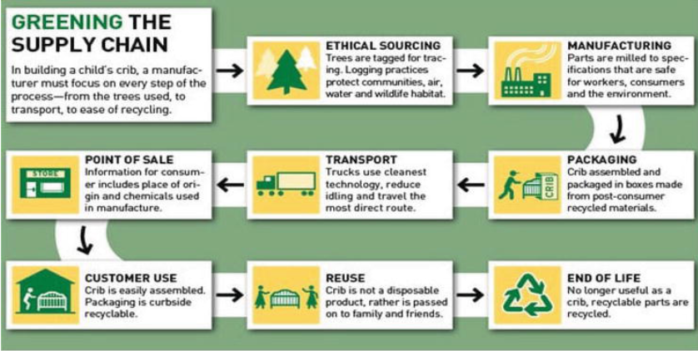
Figure 3: Green strategy value chain
(Source: Garcia‐Navarro et al., 2023)
This Company used this model to create the product and the service development and identify the different sustainable practices in the organization.
“Inbound logistics”: This stage also involves the different sources and materials. This stage focused on the recycling of plastic waste from the Ocean and the Coastal areas. It develops partnerships with the waste collection communities in these areas. Operations: The operations are the other stages of this model. These stages help to improve the production process of the collected plastic waste in the Snickers and the Shoes and should implement eco-friendly materials to minimize resource Consumption and waste generation (Garcia‐Navarro et al., 2023). “Outbound logistics or Packaging”: This stage also considers the distribution of the finished goods of the retailers. This company optimizes its packing systems by the use of sustainable and Eco-friendly materials, which can help to reduce the challenges and help to gain competitive advantages in the market marketing or sales: To develop the marketing or the sales of the Company, implement the marketing campaigns that can positively impact the environment. Human resource management and technological development: As opined by Khanra et al., (2022), this company hires employees who have the knowledge and the skill of green strategy and the knowledge of environmental science and recycling to develop innovative products in the market. To increase the quality and longevity of the products, always develop and improve your recycling processes and materials.

5. Strategies to gain competitive advantages

PEST analysis
Political | - Brexit is leading to changes in trade agreements and it has affected the export and import of products of Adidas.  - UK governments can introduce new regulations that are related to sustainability, labor, and product safety.  - Changes in corporate taxation rates have affected business.  - UK ranked in 77.36% in 2021 for political stability and “absence of violence and terrorism” (Tradingeconomics.com, 2023).  - In the UK, there are no restrictions on foreign exchange restrictions and licenses for import.  - There is no legal right in order to pay for extra work and no statutory levels (Bogers et al., 2019).  - The UK has a well-established regulatory framework that can affect many industries and it can improve business operations.
Economic | - The GDP rate of the UK was 2.2 trillion British pounds, an increase of around 87.4 billion pounds compared to previous years (Statista.com, 2023).  - The consumer price index of the UK in the month of July 2022, was 3.4% (Ons.gov.uk, 2023).  - The Bank of England has managed interest rates and inflation in order to control the economy and these factors have influenced investment, borrowing costs, and consumer spending (Ferlie and Ongaro, 2022).  - The value of GBP has affected international trade and other investments and it is vital for business operations in the UK market.
Social | - The UK population in the year 2021 was estimated to be around 67.0 million (Ons.gov.uk, 2023).  - Consumers of the UK have preferred both online and offline modes for purchasing products or services.  - Social trends such as cultural shifts, and consumer preferences have influenced the product's demands and services in many industries.  - The accessibility and quality of education and healthcare services are vital and can impact the productivity of the population.  - Most organizations in the UK have followed a hierarchical structure for their business purposes.8
Technological | - Most organizations have used AI, IoT, and hybrid IT that can enhance market growth and development. (Wenzel et al., 2023)  - Most retail sectors in the UK have used effective distribution channels in their business operations.  - Approximately 84% of companies in the UK have invested in advanced technology in order to achieve competitive advantages (Statista.com, 2023).  - The UK is reputed for its innovation and research capabilities that can impact on technological progress.
Table 4: PEST analysis
(Source: Created by author)
Political factors
The UK has focused on environmental sustainability. Policies and legislation have been related to plastic waste reduction, sustainable materials, and recycling. It has impacted Adidas’s efforts to use less plastic in their shoes. Brexit has also affected trade dynamics. In addition, changes in trade agreements have influenced the supply chain and costs for Adidas and it has also impacted the source of the sustainable materials (Pratama and Hisjam, 2022). On the other hand, government incentives for sustainable practices and various green incentives have benefited Adidas as they are pursuing eco-friendly shoe production. It can be mentioned that political stability is vital for global brands such as Adidas. As the UK's political stability is good, Adidas has operated its materials that can disrupt supply chain operations. It has also affected the manufacturing process and ensured the uninterrupted business operations.
Economic factors
Consumer purchasing and economic stability have played a vital role in Adidas’s ability to compete in the market and sell a lot of sustainable shoes. At the same time, economic downturns have affected consumer willingness in order to pay for ecological products. As Adidas has operated in the world, exchange rate fluctuations have impacted the cost of exporting products and sourcing materials which can affect the sustainability of shoe production. It has been also observed that Adidas has contributed around 70% of the industry’s revenue (Guo, 2023). Moreover, all products of this company are considered leisure items and it can be stated that leisure products of various categories have competed against each other. In addition, sports products have competed against the music and game industry. It is essentially noted that Adidas ships, distributors, and suppliers have been required in order to extend their international supply chains and follow some political procedures.
Social factors
In the UK, most of the consumers have preferred to purchase eco-friendly products. Besides, Adidas has already made environmentally friendly products by recycling plastics. Adidas has changed the design of their products and designs can attract the interest of counters. All products are available for any age, gender, and lifestyle. Along with that, Adidas has also focused on health-conscious consumers with a love for sports (Bogers et al., 2019). They have kept all preferences with health trends to enhance business growth on a huge level. It can be stated that health-conscious shoppers are the main social factors of Adidas in the UK. Adidas has operated diverse cultural environments including tradition, local customers, and preferences while designing items and implementing many marketing campaigns.
Technological factors
Technological advancements in resource materials have helped Adidas in order to improve new sustainable materials for their shoes. The adoption of these technologies has impacted the company’s ability in order to decrease plastic use. This essentially states that advancements in the manufacturing process led to the cost-effective and efficient production of sustainable shoes. In addition, technology has played a vital role in the marketing process and Adidas leveraged digital platforms and various e-commerce sites in order to reach a huge audience for sustainable products (Hunger, 2020). Adidas is testing its valuable and environmentally friendly products under several conditions. They have tried in order to optimize performance for professionals and coaches in the sports Industry. They have supported online sales through social media and websites. Adidas has used technological advancements to compete with rivals in the global competitive market.

VRIO Framework
Competence/activity  (All Strengths) | Valuable | Rare | Inimitable | Supported by the Organization | Implications (distinctive or Core competence)
Excellent services | ✔ | ✔ | ✔ | ✔ | “Competitive advantages”
Strong brand recognitions and marketing | ✔ |  |  | ✔ | “Competitive advantages”
Strategic Adaptability | ✔ |  |  | ✔ | “Sustainable competitive advantages”
Innovative product Designing | ✔ | ✔ | ✔ | ✔ | “High competence”
Endorsement Partnership | ✔ | ✔ | ✔ | ✔ | “Sustainable competitive advantages”
Advertising | ✔ | ✔ |  | ✔ | “Moderate competence”
Table 5: VRIO Analysis
(Source: Created by Author)
From above this figure, it has been seen this model indicated the competitive advantages and the sustainable Competitive advantages in the market. In the case of the excellent services, this Company gains the Competitive advantages in the market. This Company has strong brand recognition, which is the valuables and helps to gain Competitive advantages in the market. On the other hand, this company has adopted different strategies such as the waste plastic materials in the Ocean areas which are used in the Shoes product. For the development of this business, this Company collaborated with the parley, which is very rare and valuable. In that case, this Company gains sustainable Competitive advantages in the market. Adidas also used advertising to promote the brand values, which are also valuable and rare.

6. Cooperative Strategy

CSR strategy
“CSR strategies” play vital roles in the development of this Company. This is considered one of the corporate strategies. These strategies also help to fulfill the major goals and objectives of the Adidas Company.
Increased brand reputation: The different “CSR initiatives, sustainability goals, and ethical sources” can help to enhance the brand reputation in the market. This strategy can help to enhance business development in the market (Murfree and Police, 2022). The Customer increased their value Campaign increases the brand reputation and on the other hand, it can be said that, the positive reputation increases the customer loyalty and market shares in the market.
Risk mitigation: This organization faced different challenges that can negatively impact the financial position of this business. Effective “CSR strategies” help to mitigate the risks of these business organizations. The CSR strategies help to gain positive advantages in the environment through the use of eco-friendly materials for their products in the market.
Enhances Customer Engagement: Increasing customer engagement in the market is considered one of the major strategies of CSR. such as the different recycling programs, the community partnership helps to increase the involvement of the people in the market and enhances brand loyalty. This strategy helps to gain Competitive advantages in the Global market. In 2015, the Adidas Company collaborated with Parley for the Ocean waste plastics in 2015. The Collaboration of Parsley helps to reduce the risks of this business organization and enhances the market shares of this business (Falah and Rachmawati, 2023). This also indicated the potential development of these business organizations through the use of CSR strategies.
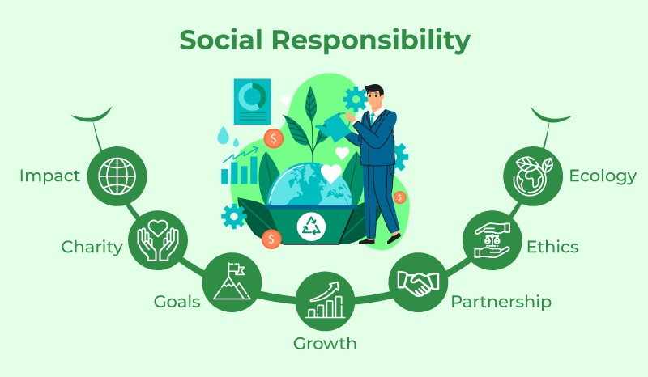
Figure 4: CSR strategies used by Adidas
(Source: Murfree and Police, 2022)
Improve the supply chain relationship: This company faced a lot of challenges regarding supply chain disruptions in the economy that can negatively impact the growth of the economy. On the other hand, it can be said that CSR is one of the important strategies that can help to improve the supply chain relationship between the different stakeholders. On the other hand, the behaviors of the ethical sources benefited the partnerships and improved the supply chain stability in the Market. It can also improve the long-term sustainability of the company and help to address the different social and environmental challenges of this business.

Ansoff matrix
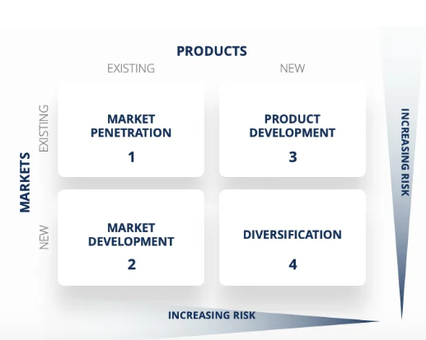
Figure 5: Ansoff Matrix
(Source: Vitulano, 2022)
Ansoff matrix is one of the strategic planning tools that can help the business to determine the growth of the business strategies to increase the sustainable product in the market. This matrix also considers the four strategies in the market.
“Market penetration”: With this method, the economy's existing customers were buying more of the already available goods. This strategy also helps this business to enhance its market share and increase the revenue growth rate in the current market.
“Market development”: The market development of this company is one of the major strategies. This tactic aims to expand the current items in the new market.
“Product development”: Through the use of various tools and processes, this strategy aids the business in developing its product (Vitulano, 2022). In order to adapt to the shifting demands and preferences of the customer, it also entails expanding the product line.
“Diversifications”: This is considered one of the major strategies. This strategy helps Adidas to introduce the new product into the existing market in the economy. This is one of the risk-oriented strategies in the market.
Among these strategies, the Adidas Company follows the market penetration and the product development strategy. The market penetration of the Adidas Company has indicated the enhancement of the market share by identifying the marketing efforts and promoting their existing software product through the use of eco-friendly materials or wasted plastic materials in the Economy. On the other hand, market penetration also carries high risks but it involves the loyalty program, enhances the targeted advertisement process, and increases customer engagement through the use of these strategies. This Company also focuses on creating new and innovative sportswear products in the market as the customer preferences. Adidas focused on the “Advertisement Campaign” and focused on the recycling of plastic waste materials that are used in the Shoe product, which can help to improve the business growth and increase the sales performance of the business.

BCG matrix
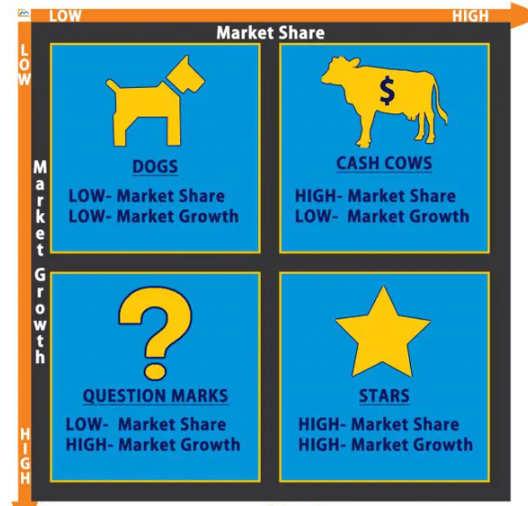
Figure 6: BCG Matrix
(Source: Ulia and Wahdiniwaty, 2023)
The BCG matrix is based on the market share and the market growth rate of this Company. These strategies can help the development of the product portfolio in the market. This matrix also considered the different categories like “Dogs, Cash cows, question marks, and Stars”. The Dogs also indicated the low market share and the low market growth, which indicated the low economic growth rate in the economy. On the other hand, it can be said that the cash Cows have indicated the high market share and the low market growth in the economy. The question marks of this Company have indicated the low market share and the high market growth rate of this Company (Aulia and Wahdiniwaty, 2023). This can also help to reduce the cash flows of these business organizations. It also affected the financial position of this Company. The question mark of the matrix helps to identify the declined market growth rates in the economy. On the other hand, Starts are the other factors of this matrix. The stars also indicated the high market share and the high growth rates of this market. This also indicated the monopolistic practices of the market. It can also help to gain Competitive advantages in the market.
Among the four categories of this matrix, Adidas selected the “Stars of this BCG matrix”, because this indicated the high rate of the market share and the high market growth rates in the economy. The high performances and the innovative shoes are also considered the Stars (Kingsnorth, 2022). This innovative product helps to grow the market shares in the market and boosts to increase the sales growth rate of the business and helps to generate a higher profit growth rate in the market. These strategies help to improve the market shares of this company and fulfill the corporate goals of this business. These strategies also help to improve product development and reach the target audiences in the market.

7. Conclusion
From the above discussion, it has been concluded that Adidas has partnered with Oceans and Parley to introduce the world's first running shoes made from recycled plastic garbage. Millions of pairs of these shoes constructed from recycled materials from beaches and coastal areas have been produced by Adidas. STP framework has shown the target market and positioning of Adidas by addressing many issues. On the other hand, the green strategy has helped Adidas in order to increase environmental sustainability and profitability. It has also helped its company to achieve the target market at a huge level. The green value chain model is helpful in order to make a relationship with stakeholders. It has been observed that CSR strategy also plays a significant role in the competitive market. CSR strategy is one type of way which can establish better practices for a company and it has been concerned with cultures, values, star eggs, and business operations to develop society. This is necessary to note that the Ansoff matrix has been also discussed and it is a strategic planning that can help businesses in order to identify business sustainable factors by implementing various entry modes. Adidas has used market penetration modes as an entry mode in the competitive market. Moreover, all issues have been discussed by Adidas in this study in an effective way.

8. Recommendation
Recommendation 1: Focused on the supply chain of the company
Adidas should address supply chain disruption and the need to diversify its suppliers in order to decrease dependence on a single source. Adidas has also improved contingency plans for many types of disruptions including trade disputes, and natural disasters (Pratama and Hisjam, 2022). They also should invest in technology and data analytics in order to gain better visibility into the supply chain and observe potential risks.
Recommendation 2: Develop sustainable initiatives
Adidas should focus on the sustainable practices by decreasing plastic waste in the manufacturing process and need to explore manufacturing techniques and innovative materials that would be more environmentally friendly (Wang et al., 2019). Adidas needs to communicate these stability efforts in an effective way to customers in order to align with changing consumer preferences for eco-friendly products.
Recommendation 3: Focus on cybersecurity and e-commerce
Adidas should continue to invest in e-commerce capabilities in order to increase the online shopping experiences to enhance the consumer's purchasing power (Li, 2022). This company needs to develop various cybersecurity measures in order to protect customer's data and ensure a secure online environment by enhancing cybersecurity threats.
Recommendation 4: Adapt marketing strategies
Adidas needs to adapt marketing strategies to develop marketing conditions during the COVID-19 pandemic. Marketing strategies have also enhanced companies’ sales revenue and achieved the target market in the international competitive market (Pratama and Hisjam, 2022). Moreover, by implementing marketing strategies, Adidas can attract a huge number of customers at a huge level.

References list
Adidas.co.uk (2023), Available at: https://www.adidas.co.uk/ [Accessed on: 30-08-2023]
Adidas.com, (2023), how we turn plastic bottles into shoes: our partnership with parley for the oceans, Available at: https://www.adidas.com/us/blog/639412-how-we-turn-plastic-bottles-into-shoes-our-partnership-with-parley-for-the-oceans [Accessed on: 30-08-2023]
Aulia, G.M. and Wahdiniwaty, R., 2023, March. Online Shop Minniers' Business Model Development Strategy Using the BCG Matrix Approach. In Proceeding of International Conference on Business, Economics, Social Sciences, and Humanities (Vol. 6, pp. 318-324).
Bogers, M., Chesbrough, H., Heaton, S. and Teece, D.J., 2019. Strategic management of open innovation: A dynamic capabilities perspective. California Management Review, 62(1), pp.77-94.
Businessinsider.in, (2023), Adidas is turning plastic ocean waste into sneakers and sportswear, Available at: /https://www.businessinsider.in/adidas-is-turning-plastic-ocean-waste-into-sneakers-and-sportswear/articleshow/70948890.cms [Accessed on: 30-08-2023]
Ecommercedb.com, 2023. eCommerce revenue analytics. Available at: https://ecommercedb.com/store/adidas.co.uk [Accessed on 30-08-2023]
Falah, A.S.N. and Rachmawati, I., 2023. Pengaruh Aktivitas Corporate Social Responsibility Terhadap Customer Loyalty Adidas Melalui Mediasi Corporate Image. eProceedings of Management, 10(2).
Ferlie, E. and Ongaro, E., 2022. Strategic management in public services organizations: Concepts, schools and contemporary issues. Routledge.
Forbes.com, 2023. Adidas Challenges The Fashion Industry In Sustainability, Pledging Only Recycled Plastic By 2024. Available at: https://www.forbes.com/sites/forbes-personal-shopper/article/summer-shopping-guide/?sh=2e9728962925 [Accessed on 30-08-2023]
Fu, Y., 2022, March. Based on STP Analysis of Consumer Perception in Generation Z, the Influence of Chinese and American Sports Brand Image and the Enlightenment to Chinese Sports Goods Brand---Nike and Li Ning as Examples. In 2022 7th International Conference on Financial Innovation and Economic Development (ICFIED 2022) (pp. 1016-1022). Atlantis Press.
Guo, C., 2023.Leadership and Change Management within Adidas. Academic Journal of Humanities & Social Sciences, 5(17), pp.33-37.
Hunger, J.D., 2020. Essentials of strategic management.
Khanra, S., Kaur, P., Joseph, R.P., Malik, A. and Dhir, A., 2022. A resource‐based view of green innovation as a strategic firm resource: Present status and future directions. Business Strategy and the Environment, 31(4), pp.1395-1413.
Kingsnorth, S., 2022. Digital marketing strategy: an integrated approach to online marketing. Kogan Page Publishers.
Kreutzer, R.T., 2023. Marketing Strategy. In Practice-Oriented Marketing: Basics–Instruments–Case Studies (pp. 187-242). Wiesbaden: Springer Fachmedien Wiesbaden.
Li, H., 2022, April. Research on How Products and Marketing Strategy Affects the Market Shares of Nike and Adidas. In 2022 International paper on Creative Industry and Knowledge Economy (CIKE 2022) (pp. 197-202). Atlantis Press.
Li, Z., 2022, April. The Analysis of the Reasons for the Success of the Under Armour Brand Based on “SWOT” and Porter’s Five Forces. In 2022 7th International Conference on Social Sciences and Economic Development (ICSSED 2022) (pp. 676-680). Atlantis Press.
Ma, H., 2022. Research on Teaching Methods of Enterprise Strategic Management Course. The Educational Review, USA, 6(12), pp.813-821.
Ma, S., Wu, S., Chen, L., Wang, W. and Li, D., 2022. Reasons for the Failure and Revival Strategies of Garment Enterprises Taking Fuguiniao as an Example. Frontiers in Business, Economics and Management, 3(3), pp.5-13.
Murfree, J.R. and Police, C.C., 2022. Adidas× Parley: An Exploration of Corporate Social Responsibility and the Global Plastic Crisis. Case Studies in Sport Management, 11(S1), pp.S19-S24.
Nooh, M.N., 2022. Designing A Sportswear Strategic Marketing Plan: A Data Analytics Approach. ASEAN Entrepreneurship Journal (AEJ).
Ons.gov.uk, 2023. Consumer price inflation, UK: July 2023. Available at: https://www.ons.gov.uk/economy/inflationandpriceindices/bulletins/consumerpriceinflation/july2023 [Accessed on 30-08-2023]
Ons.gov.uk, 2023. Population estimates for the UK, England, Wales, Scotland and Northern Ireland: mid-2021. Available at: https://www.ons.gov.uk/peoplepopulationandcommunity/populationandmigration/populationestimates/bulletins/annualmidyearpopulationestimates/mid2021 [Accessed on 30-08-2023]
Pratama, A.Z. and Hisjam, M., 2022. Comparative Study of Global Business Strategy: Lessons Learned from Excellent Sports-wear Companies (Nike and Adidas). In Proceedings of the International Conference on Industrial Engineering and Operations Management Istanbul, Turkey (pp. 3062-3071).
Pratama, A.Z. and Hisjam, M., 2022. Comparative Study of Global Business Strategy: Lessons Learned from Excellent Sports-wear Companies (Nike and Adidas). In Proceedings of the International Conference on Industrial Engineering and Operations Management Istanbul, Turkey (pp. 3062-3071).
Statista.com, 2023. Gross domestic product of the United Kingdom from 1948 to 2022. Available at: https://www.statista.com/statistics/281744/gdp-of-the-united-kingdom/ [Accessed on 30-08-2023]
Steiss, A.W., 2019. Strategic management for public and nonprofit organizations. Routledge.
Tradingeconomics.com, 2023. United Kingdom - Political Stability And Absence Of Violence/Terrorism: Percentile Rank, Upper Bound Of 90% Confidence Interval. Available at: https://tradingeconomics.com/united-kingdom/political-stability-and-absence-of-violence-terrorism-percentile-rank-upper-bound-of-90percent-confidence-interval-wb-data.html [Accessed on 30-08-2023]
Vitulano, A.M., 2022. The evolution of digital marketing in sportswear brands
Wenzel, M., Stanske, S. and Lieberman, M.B., 2020. Strategic responses to crisis. Strategic Management Journal, 41(7/18), p.3161.

