1. Tutankhamun’s Dagger - Functional Weapon or Symbolic Item?

Was Tutankhamun’s iron dagger a symbolic or functional weapon?

Contents, figure, and table lists

Chapter 1 3
Introduction 3
Chapter 2: Tutankhamun’s Dagger 4
2.1 The dagger 4
Image - Tutankhamun’s dagger, taken from BBC News (2016) 4
2.2 The blade’s composition 6
Table 1 - Samples analyzed by XRF spectroscopy, taken from Comelli, D (2016), P. 1304 7
Chapter 3: Symbolic Item 8
3.1 Ma’at 8
3.2 Ceremonial Weapons 10
Chapter 4: Functional Weapon 11
4.1 Khopesh swords 11
Image - Forms of the khopesh swords, taken from Loads (2010), P.7 11
4.2 Functionality of the blades 13
Image - Tutankhamun’s dagger, taken from BBC News (2016) 13
Chapter 5: Conclusion 15
Bibliography 17

Chapter 1

Introduction

Tutankhamun’s iron dagger is an unusual item, largely due to it being an iron blade during an age when iron working was either very rare or non-existent in Egypt. Iron working during this bronze age period in itself being a very contentious topic, the reasons behind Tutankhamun’s iron dagger being made of such a rare, unusual material are almost entirely unknown, with the material of the blade itself also a contentious issue, having long theorised to be and only very recently confirmed as being iron of meteoric, not terrestrial, origin.

Further, as a functional item used, for example, in battle, a dagger is of little use compared to other weapons common to Egypt’s military, or even other blades used at the time, such as, for example, the one-handed khopesh swords or even axes. A dagger, being such a small, short weapon, was only useful during close-quarter fights, and if it were a practical item why the use of iron of such rarity? Further, why use iron at all when there were more abundant and familiar metals available - such as gold, which was used to make Tutankhamun’s death mask and the ornaments on his iron dagger’s sheath.

Tutankhamun’s iron dagger proves to be a little understood item, despite its importance. In order to attempt to contribute to a possible answer on the question of the significance behind Tutankhamun’s dagger being made of meteorite iron, and what it was used for when compared to the other bladed weapons of the time, such as short swords, it will be examined using sources from a number of different disciplines and approaches; using information from everything from the exact composition of metals in the dagger’s blade to the possible symbolism behind the use of metal of extra-terrestrial origin. In addition, this work will be underpinned by more general readings to provide some information on why Tutankhamun’s dagger and its metal is significant, due to being an iron weapon in a tomb full of gold. What could the dagger have represented? I will compare it to other weapons common to the era in order to determine its function and to try to find an answer if the dagger could have been a symbolical, ceremonial item or a practical weapon.

Due to the specific nature of this project there are three likely outcomes that will be explored;
- That Tutankhamun’s dagger was a purely symbolic object and had no real practical use, nor any real intention for it to be used as a functional, practical weapon at all
- A functional object, intended for use in battle even if it never saw use for that intended purpose
- Or, as is more likely, Tutankhamun’s dagger was some mixture of both.

However, from preliminary work and reading, there is currently not enough information to come to a certain conclusion, if one exists.

Chapter 2: Tutankhamun’s Dagger

2.1 The dagger

Tutankhamun’s dagger was found as part of the tomb goods in his tomb KV62 which was discovered in 1922 by archaeologist Howard Carter.In 1925, Carter found two daggers in the wrappings of the mummy - one made of iron, and the other gold. Among a number of iron objects, such as a set of miniature blades found in Tutankhamun’s tomb, the dagger became the most famous. It was found on the mummy’s thigh, while the golden one was found on the abdomen.

The dagger is one of the few surviving iron pieces from Ancient Egypt. It seems to be unique among the iron objects found in Tutankhamun’s tomb, being the only wieldable iron weapon from a collection that includes a miniature headrest and a bracelet with an eye of iron. Further, its relatively large scale when compared to the other objects found in the tomb is doubly remarkable - iron was a rare material throughout the Bronze Age, being more highly valued than gold, and was often only used for ornamentation.

Image - Tutankhamun’s dagger, taken from BBC News (2016)
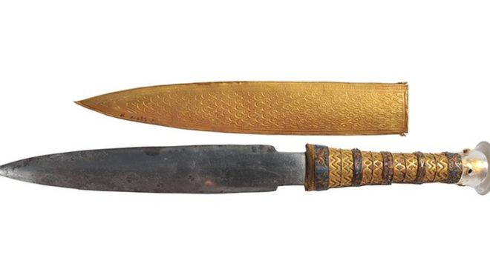
The iron dagger itself is a very ornate weapon, with a handle made of gold that ends in a pommel of rock crystal, with its sheath also being made of gold which is decorated with a lily motif on the one side and feather patterning ending in a jackal’s head on the other. It’s also a very finely crafted blade, being non-rusted and symmetrical with its two sharpened edges either side narrowing to a point at the end of the spine, as well as being an apparently homogenous metal. The full length of the dagger - which includes the blade, handle, and pommel - reaches 34.2 cm.

2.2 The blade’s composition

Nickel is a metal found in high concentrations in iron meteorites, alongside more trace amounts of cobalt, phosphorus, sulfur, and carbon. As such it was long accepted that, due to the blade’s apparent high nickel content, the iron of Tutankhamun’s dagger was of an extra-terrestrial source, such as from a meteorite. The belief had held since the early 1960’s, with one analysis of the metals making up the blade’s composition stating that it was found to “contain nickel in such quantities as to prove their meteor(ic) origin.”

The validity of such conclusions were questioned. An analysis in 1994 of the blade’s composition, for example, showed a nickel content of 2.8 wt%, which the authors Helmi and Barakat considered inconsistent with the nickel content of meteoric iron. Yet the more sensitive tests to determine the actual composition of the blade with any certainty, such as instrumental neutron activation analysis, were destructive, making them deeply impractical. Such investigations were also further hampered by the difficulty in obtaining permission to analyse artefacts, for either destructive or non-destructive testing, at all.

Since the discussion on the true composition of the blade began, however, technological advancements allowed for more sensitive non-destructive analysis of materials and in 2016 the bulk of Tutankhamun’s dagger’s composition was determined using more advanced X-ray fluorescence spectrometry, with the composition of the dagger being compared to samples of eleven meteorites whose composition was well understood and eleven modern terrestrial steels for reference.

Table 1 - Samples analyzed by XRF spectroscopy, taken from Comelli, D (2016), P. 1304
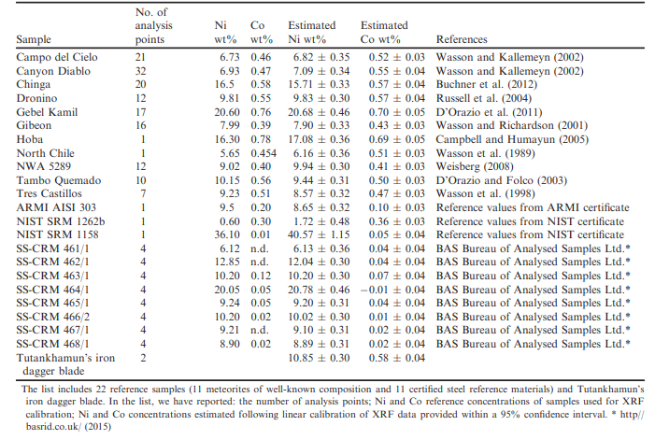

Using X-ray fluorescence spectrometry it was determined that Tutenkhamun’s dagger had a composition of roughly 10.8 wt% nickel and 0.58 wt% Cobalt. Given that the nickel content of the vast majority of iron meteorites has a range of 5 wt% to 35 wt%, whereas iron artifacts predating the 19th century produced from terrestrial ores never exceeds a nickel content of 4 wt%, the nickel content of the dagger’s blade proved to be within the accepted range for meteoric iron; it was thus determined that this high nickel content and the trace amounts of cobalt within the blade of Tutankhamun’s dagger did strongly suggest it was a metal of extra-terrestrial origin, rather than terrestrial.

Further, while the material of the dagger could not be classified to specific chemical or structural groups based on the nickel and cobalt content alone, the nickel and cobalt content of the dagger’s blade was still consistent with that of iron meteorites, further reinforcing its origin as non-terrestrial.

Chapter 3: Symbolic Item

3.1 Ma’at

Ma’at was the central theme and underpinning belief of the Ancient Egyptian’s religion, which encompassed and represented order, truth, justice, etc. The goddess of the same name, the daughter of the sun god Ra, also embodied those same traits, with Ma’at also being the “divine order established at creation and reaffirmed at the accession of each new king of Egypt” and in “setting maat ‘order’ in place of isfet ‘disorder,’ the king played the role of the sun god, the god with the closest links to Maat”.

In this way it may be that Tutankhamun’s meteorite dagger was a tool in order to express or reinforce his divine kingship, through its associations with the sky and the heavens and the deities connected with it.

While translations of the Egyptian word for ‘iron’ vary, many often have associations or references to the sky or to the heavens, with one such translation referring to iron as being the ‘copper from heaven’ - it not only suggests that the Ancient Egyptians were aware of their iron’s extra-terrestrial origins, as most artefacts are made of meteorite iron in Egypt, but also a connection with the gods - Ma’at is the daughter of the sun god Ra, who has the closest links with her, and who travels with him through the sky and into the underworld as well as keeping the course of the sun. She is linked to the sky and the heavens through her connection to Ra - and, in turn, iron is also linked with the sky through translations of its name, with iron being the ‘copper from heaven’. This suggests a possible link between the two, or at the very least that iron might have been associated with divinity.

And throughout the Bronze Age iron was rare, valued higher than gold, and was almost always reserved for ornamental, ritual, or ceremonial items - artefacts like the dagger might have been unsuitable for more utilitarian purposes simply for the cost, but Tutankhamun’s dagger might never have been intended for such a purpose.

Rather than being intended as a practical and functional weapon, which would have it seeing heavy use and likely even damage, Tutankhamun’s meteorite dagger might have functioned more as a political tool to symbolise and reinforce his connection to Ma’at. He ascended to the throne when he was very young, after all, and still a child at the time - a weapon made from a highly valued metal associated with the heavens and, perhaps by proxy, the gods, which included Ma’at, may have reinforced his kingship and his divine right to be king through iron’s possible connection with divinity.

3.2 Ceremonial Weapons

Weapons were also often used in a ceremonial capacity, which sets a precedent for such a use for the dagger. Swords were often used for ritual and ceremonial purposes, often left with blunt edges or in some circumstances formed in such a way to exaggerate that bluntness. The khopesh sword of Ramses II was left blunt, likely for either one such ritual or ceremonial purpose, or perhaps for display, despite the fact that it could have been sharpened into a practical weapon.

Further, in Ancient Egyptian art weapons are often depicted in scenes associated with Ma’at and the establishment or maintenance of order and justice through battle - Ramses II has been depicted smiting a Libyan with his khopesh in the Temple of Beit el Wali, while embossed on gold foil found in his tomb Tutankhamun is also shown smiting his own enemy with a khopesh sword.

This motif of rulers smiting Egypt’s enemies had been a long-standing one in its art, with the Narmer Palette and macehead being a well-known example of such scenes. Even since as early as 2,500BC this association between the might and strength of rulers with weapons had been prominent, with one of the earliest depictions of a khopesh sword being the Stele of the Vultures in the Musee du Louvre in Paris showing the king of Lagash Eannatum brandishing one.

While there is no direct evidence of Tutankhamun’s dagger having such a ceremonial or ritualistic purpose, there nevertheless remains the possibility of such a function through other weapons clearly intended for such use, such as the blunt khopesh swords.

Chapter 4: Functional Weapon

4.1 Khopesh swords

The khopesh sword is a curved, sickle-like sword possibly derived from the epsilon axe, a weapon once common to the Egyptian army and so named because its three point attachments to the haft appeared to look similar to the Greek letter E. A common classification of the khopesh is as a sickle blade; such a classification, however, overlooks some of the key defining features of both the khopesh sword and the sickle blade. Where the cutting edge of a sickle sword is on the inside of the blade’s curve, the cutting edge of a khopesh is on its outside, and the curve of the khopesh’s blade is much shallower and more extended than that of most sickle swords.

Image - Forms of the khopesh swords, taken from Loads (2010), P.7
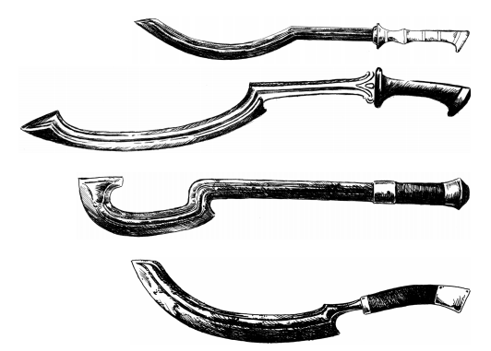

Among Egyptian weaponry the khopesh is also unique in that it’s a weapon designed exclusively for battle - where, for example, axes and spears had uses outside of warfare, swords like the khopesh were almost exclusive to its use in battle. Having a curved blade, for example, the khopesh makes for an excellent cutting, slashing, and chopping offensive weapon.

Both the epsilon axe and its derivative the khopesh were common weapons of the army, and among the many other weapons recovered from Tutankhamun’s tomb in particular two were khopesh swords - both were blades made with bronze and both had ebony grips, though one was larger at roughly 23.2 inches total and the shorter, at an overall length of 15.8 inches, was more decorated, having bands of gold leaf.

The khopesh swords - and Tutankhamun’s two swords in particular - provide a challenge to the idea that Tutankhamun’s meteorite dagger was at all an offensive weapon in combat situations, as well as a basis for comparing the functionality of the two types of weapons; with both being bladed, one-handed weapons the khopesh offers a more accurate comparison than, say, the epsilon axe.

4.2 Functionality of the blades

As already discussed, Tutankhamun owned two khopesh swords which can provide a direct comparison to his dagger in terms of its functionality as a battlefield weapon, with both dagger and khopesh being bladed, one-handed weapons.

Khopesh swords have a curved blade, which allows for both a more efficient cut as well as the ability to neatly slice a target. In one of Tutankhamun’s khopesh swords the point is set at an angle, creating a line from from the shoulder to that point when it is thrust forward, and with the broad curve of the blade and the weight and balance of the sword set just behind the striking point it could deliver powerful strikes. The curve itself also allows for a longer blade than bronze would otherwise be capable of supporting in a straight blade that nevertheless remains reliable and strong - bronze is a relatively brittle metal, and could only support straight blades of short length. This greater length in the khopesh allows for much greater reach, offering a significant advantage in open combat - where for a shorter blade, like the dagger, strikes must be made in close quarters in order for them to land, a longer blade allows for greater distance between the wielder and an opponent’s weapon.

Image - Tutankhamun’s dagger, taken from BBC News (2016)

Both Tutankhamun’s dagger and his two khopesh swords were also cast with a tang, unlike the riveted swords also common at the time whose blades were cast separately and riveted on afterwards. The tang - an extension of the blade into the handle or hilt - makes the whole weapon into a cohesive, single piece which, in turn, makes it a much stronger weapon that is less liable to break apart. In this, both dagger and swords seem to share the same strength - however, on the khopesh swords are hooked spurs made from the tang which prevents the hand from slipping off the handle, and with a pronounced swelling at the base of the blade that does much the same. It offers a security of grip not afforded by the dagger’s handle, whose swelling near the blade is not as pronounced and its pommel is too small to act as an effective stop for the hand.

Further, there may not even be a significant advantage in the use of iron over bronze.

Both iron and bronze can be sharpened, and while iron is an innately tougher metal bronze can be hammer hardened for greater toughness and in order to better retain its edge. Its one real advantage is that iron is much less likely to bend or break - bronze is a more brittle metal when compared with iron or steel, but as an alloy of copper the different sizes of atoms prevents slippage between the atomic layers, with the tin alloy of copper being the toughest, making it a material still fully capable of hard use.

Chapter 5: Conclusion

In asking the question on whether Tutankhamun’s iron dagger was a symbolic or functional item only three answers were proposed - that it was symbolic, that it was functional, or that it was both. From preliminary reading there was no obvious conclusion. From a more detailed analysis of the weapon itself in comparison to other weapons other answers were raised; in examination of the evidence it seems most likely is that Tutankhamun’s dagger was not either: that it was neither an item symbolic of Ma’at nor a functional item intended for battle, but more likely than not it was simply decorative, intended to display status.

This conclusion is borne from a comparison of the dagger to the two khopesh swords also found in Tutankhamun’s tomb, as well as the wall art of the ancient Egyptian kings that features a conspicuous absence of daggers, and the prominence of the khopesh swords, as well as the blunt, heavily decorated swords found in other tombs.

As has already been described, Tutankhamun’s dagger may have served a more symbolic function to present the king and his role as a representative and upholder of Ma’at which is a central aspect of the Ancient Egyptian religion. In this, the dagger could have had a possible connection to Ma’at; a goddess who is the daughter of the sun god Ra. The Egyptian word for iron often refers to it as being a material of the heavens, and with the goddess Ma’at associated with the heavens through her father Ra this not only suggests that the Ancient Egyptians were peripherally aware of the extra-terrestrial origins of meteoric iron, of which the dagger is made, but a connection between the dagger and the heavens, possibly as a heavenly object in its own right. Weapons also served ceremonial roles, and in artwork often served as a representation for this.

And yet in most cases the khopesh sword fulfils the sort of ceremonial roles that the dagger could have held, and if not the khopesh then other weapons of war such as maces and flails - indeed, khopesh have been found with blunt edges and writing on the blade, indicative of ceremonial use - which negates this possibility for the dagger.

However, there remained the possibility for the dagger being a more functional item. Iron is a much tougher metal than bronze, capable of retaining an edge long past the point at which a bronze blade would begin to dull, and there is evidence that iron was coming into common use within Egypt throughout the second millenium BC; the Armana Letters even document the gifting of iron objects including daggers to the Egyptian court from foreign rulers.

However, even that possibility is removed by the fact that a dagger is a very poor offensive weapon, and with little indication that larger weapons were prohibited for everyday use there is little to indicate such a use; the blades in khopesh swords are much larger and longer than that of the dagger, with the curve of their blade both supporting their greater length and endowing them with a greater toughness and a greater cutting effect when swung. Their great length allows for both stronger blows and greater reach, as well as greater defence in combat, and bronze, despite being a softer metal than iron or steel, can be hardened by hammer strikes to significantly increase the toughness and edge-retention capabilities of the blade edge. The hooked spurs on the end of its handle prevent the hand from slipping off, and where it meets the blade the handle swells to provide another effective stop for the hand.

When compared with the necessarily shorter length of the dagger, with its much shorter reach and simple profile, it’s clear which would be the better battlefield weapon even without taking into account the dagger’s handle, which has little flaring at the blade as well as a pommel too small to prevent the hand from sliding off. The metal of the dagger, being iron, did indicate a possible functional use as iron is a material of far greater toughness than the bronze common to the era, but taking into account that Tutankhamun owned two swords clearly much more suited to combat, even having been made of the softer metal of bronze, it cast significant doubt over the veracity of that possibility.

Thus, the dagger likely had neither a symbolic nor practical function by the definitions examined here; neither an offensive weapon nor one to symbolise Ma’at. Taking into account the ornamentation of the dagger, with its gold hilt and sheath, and the evidence for the sharing of gifts made of iron which includes daggers, it seems more likely that it was simply a decorative object, or perhaps a gift.

Bibliography

- BBC News (2016), Tutankhamun's knife was 'made from meteorite iron', Available at: https://www.bbc.co.uk/news/world-middle-east-36432635, Accessed: 6/05/20
- Bedford, D (2001), The Oxford Encyclopedia of Ancient Egypt, Volume 2, Oxford University Press
- Bjorkman, J. K, (1973), “Meteors and Meteorites in the Ancient Near East”, Meteoritics, volume 8, number 2, 91 - 132
- Comelli, D (2016), “The meteoritic origin of Tutankhamun’s iron dagger blade”, Meteoritics & Planetary Science, 51: 1301-1309
- Helmi F, Barakat K, (1996), Proceedings of the First International Conference on Ancient Egyptian Mining & Metallurgy and Conservation of Metallic Artifacts: Cairo, Egypt, 10-12 April 1995, Ministry of Culture, Supreme Council of Antiquities
- Jansen-Winkeln, K (2006), “Tutankhamun”, in: Brill’s New Pauly, Antiquity volumes, Available at: https://referenceworks.brillonline.com/entries/brill-s-new-pauly/tutankhamun-e1223270?s.num=0&s.f.s2_parent=s.f.book.brill-s-new-pauly&s.q=tutankhamun, Accessed: 8/05/20
- Kahl, J (2006), “Maat”, in: Brill’s New Pauly, Antiquity volumes, Available at: https://referenceworks.brillonline.com/entries/brill-s-new-pauly/maat-e715260?s.num=0&s.f.s2_parent=s.f.book.brill-s-new-pauly&s.q=maat, Accessed: 8/05/20
- Loades, M (2010), Swords and Swordsmen, Pen & Sword Military
- Nicholson, P (2000), Ancient Egyptian Materials and Technology, Cambridge University Press
- Strom, C (2018), Khopesh—The Egyptian Sword that Forged an Empire, Accessed: 11/02/20, Available at: https://www.ancient-origins.net/artifacts-other-artifacts/egyptian-sword-khopesh-0011222
- The Editors of Encyclopaedia Britannica (2020), Maat, Available at: https://www.britannica.com/topic/Maat-Egyptian-goddess, Accessed: 7/05/20
- Tyson, J (2001), Sword Components, Available at: https://science.howstuffworks.com/sword-making1.htm, Accessed: 6/05/20
- Wengrow, D (2006), The Archaeology of Early Egypt: Social Transformations in North-East Africa, C.10,000 to 2,650 BC, Cambridge University Press

Comelli, D (2016), P. 1302
Comelli, D (2016), P. 1302
Comelli, D (2016), P. 1302
Comelli, D (2016), P. 1302
Comelli, D (2016), P. 1302
Comelli, D (2016), P. 1302
Comelli, D (2016), P. 1302
Comelli, D (2016), P. 1302
Comelli, D (2016), P. 1302
BBC News (2016)
Comelli, D (2016), P. 1302
Comelli, D (2016), P. 1302
Comelli, D (2016), P. 1302
Comelli, D (2016), P. 1302
Comelli, D (2016), P. 1303
Comelli, D (2016), P. 1303
Bjorkman, J. K, (1973), P. 124
Helmi F, Barakat K, (1996), Pp. 287–289
Comelli, D (2016), P. 1303
Comelli, D (2016), P. 1302
Comelli, D (2016), P. 1304
Comelli, D (2016), P. 1306
Comelli, D (2016), P. 1306
Comelli, D (2016), P. 1306
The Editors of Encyclopaedia Britannica (2020)
The Editors of Encyclopaedia Britannica (2020)
The Editors of Encyclopaedia Britannica (2020)
The Editors of Encyclopaedia Britannica (2020)
Bedford, D (2001), P. 183
Bedford, D (2001), P. 182
Bedford, D (2001), P. 182
Kahl, J (2006)
The Editors of Encyclopaedia Britannica (2020)
Kahl, J (2006)
Comelli, D (2016), P. 1302
Comelli, D (2016), P. 1302
Jansen-Winkeln, K (2006)
Loades, M (2010), P. 9
Loades, M (2010), P. 9
Loades, M (2010), P. 9
Loades, M (2010), P. 9
Wengrow, D (2006), Pp. 41 - 44
Loades, M (2010), P. 8
Loades, M (2010), P. 3
Loades, M (2010), P. 3
Loades, M (2010), P. 7
Strom, C (2018)
Loades, M (2010), P. 1
Loades, M (2010), P. 1
Loades, M (2010), P. 4
Loades, M (2010), P. 6
Loades, M (2010), Pp. 4 - 5
BBC News (2016)
Loades, M (2010), P. 5
Loades, M (2010), P. 5
Tyson, J (2001)
Loades, M (2010), P. 5
Loades, M (2010), P. 6
Nicholson, P (2000), Pp. 167 - 168
Loades, M (2010), P. 18
Loades, M (2010), P. 18
Nicholson, P (2000), Pp. 167 - 168
Bedford, D (2001), P. 183

