Developing an online booking platform for a sexual health service.

Introduction
‘In health services worldwide, from the most advanced to the most rudimentary, issues of access are a common topic of discussion and critique. Challenges in securing consultations are often cited, compelling many individuals in need of healthcare to resort to emergency services’ (Manarte, 2024).
Alturkistani et al., (2023) describe that healthcare systems are complex systems, resulting in significant challenges in their diffusion and adoption. They also reference the digital divide in healthcare adoption, explaining the inequality that arises for the population that lack the means of accessing the benefits that these technologies can bring.
This assessment is to formulate a proposed enhancement to a service in the student’s area of work. Therefore, for the purpose of this assignment, this project will be introduced into the largest Health Board in Wales, which encompasses six counties across North Wales. The Health Board serves a population exceeding 700,000 and employs over 19,000 staff members (Digital Health and Care Wales, 2024). This extensive region is home to three district general hospitals (DGHs), and this project will concentrate on the specific DGH where the student has experience. This DGH notably differs from the others in that it lacks a distinct administrative staff group dedicated solely to managing the appointment line for the service to be described here.
The healthcare department to focus on for this enhancement is an integrated sexual health service. The scope of the integrated service includes including testing and treatment for sexually transmitted infections (STIs), the provision of HIV pre-exposure prophylaxis (PrEP), care of HIV positive patients, and the full range of contraception options available locally. NHS integrated sexual health appointments in North Wales clinics can only be accessed by telephoning the service (or visiting the clinic which is discouraged). This method of access is the most cited reason for a member of the public to raise a complaint against the service. The Health Board operates scheduled appointments only, no drop-in clinics exist- therefore, every appointment requires prior booking. The appointment booking line for the integrated service is available on weekdays from 9am to 1pm, operated by a single administrative team member responsible for scheduling appointments at both the acute site and the two community locations. This same team member is also responsible for booking in the patients that are arriving for clinic appointments; rendering the staff member unavailable to answer every incoming phone call if they are dealing with a patient attendance. There is currently no online provision available.
Ryan, Waller and Marlow, (2019) examined the barriers to booking health appointments via telephone, detailing that their study participants cited difficulties in phoning during limited daytime hours, and in successfully reaching the reception staff. These issues need to be balanced against the research into barriers to digital booking/consultation activities, Gomez-Cano et al., (2020) found low awareness and usage of digital booking methods, with over 40% of their participants aware of online options but only 15% having utilised them; advising care providers to preserve traditional booking avenues while adopting technological advancements to mitigate health inequalities. Consideration must be taken when planning this innovation to ensure that no service users are disadvantaged by actions taken by this project.
The aim of this project is to design a user-friendly online booking service (table 1) that allows the public to schedule appointments at a sexual health clinic in a defined area. The scope of the project will be described (table 2), as will the out-of-scope features (table 3). The expectation is that the addition of an online booking provision would improve the accessibility of the service for the public; therefore, reducing current levels of patient dissatisfaction. The online booking service would be piloted alongside the telephone booking service initially; to terminate the option to telephone the service for an appointment would leave the service open to further criticism. Following a pre-determined length of pilot, an evaluation can then be performed to consider whether both options remain operating concurrently.

Table 1 showing the aims of the proposed project.
Project aims

Easy access to services
Discreet
Convenient
Management of appointments
To reduce barriers to accessing the service
To promote privacy and confidentiality
To ease the administrative burden for staff
To release staff from having to answer numerous telephone calls
To reduce the number of complaints/concerns over inaccessibility of services

Table 2 showing the project scope.
Project scope

Online booking for face-to-face clinic appointments
A dedicated website available in English
Available to book both new and follow up appointments
The ability to cancel appointments
Accessible on desktop/tablet/mobile devices
User required to create an account
The ability to search and filter
To choose clinic location, date, time
Text message appointment reminders
Adhering to accessibility requirements
Training for staff and instruction video for users
Support for staff during implementation and until ‘business as usual’

Table 3 listing the areas that are out of scope for this project.
Out of scope

Online booking for telephone appointments
Non-English languages
Single sign on access for system administrators
Mobile app
The option to book an appointment without creating an account
The option to book an appointment without indicating a reason for the appointment
Integration with any existing systems
An interactive platform with clinic staff

This introduction section highlighted the business problem of service inaccessibility at local sexual health clinics, with the assignment author identifying a service improvement that could be enabled by technology. The technology in this instance is an online appointment booking system. Literature suggests that the use of an online booking system can reduce the workload for administration staff and can increase patient satisfaction, however, it is also worthy to note that an online system in isolation can inadvertently create inequality of access for certain members of the population (Atherton et al., 2024). Manarte, (2024) discusses the complexity of online scheduling, advocating the need for a robust triage system here. They believe that a patient may be unaware of their urgency of their health needs, and that a digital system can be inflexible and inconsistent.

Methods
Having identified the business problem of poor service accessibility, a quality improvement (QI) methodology was chosen to steer the process. Health Foundation, (2021) discuss many QI programmes as all sharing the same principles-
- The identification of a quality issue
- Gaining an understanding of the problem (from a multi-dimensional approach, and to include the use of data)
- Creating the plan for the change
- Identifying and testing solutions
- Implementing the solution.
Silver et al., (2016) state that quality improvement programmes require input from both healthcare staff and stakeholders, though many clinicians lack the necessary training in these methods which poses challenges in progressing the activity.
Antonacci et al., (2018) describe how process mapping as a strand of QI can provide an insight into the improvement possibilities, with those engaged in the process gaining a shared understanding of current processes and enabling them to set project objectives. Antonacci et al., (2021) advise that process mapping has the potential to aid QI projects in healthcare but are unsure if it is being used to its full potential, reasoning that many clinicians lack the necessary knowledge of these methods and are unable to devote sufficient time to this activity.
The current appointment booking process for the North Wales sexual health clinics is detailed (image 1), illustrating the manual steps taken by both the patient and receptionist. With the current ‘as-is’ process mapped, the aim for a new digitalised ‘to-be’ process is to eliminate any blockers to an efficient booking experience. This process mapping activity would require expertise from an individual with a business change background in order to steer the department staff through the process successfully.

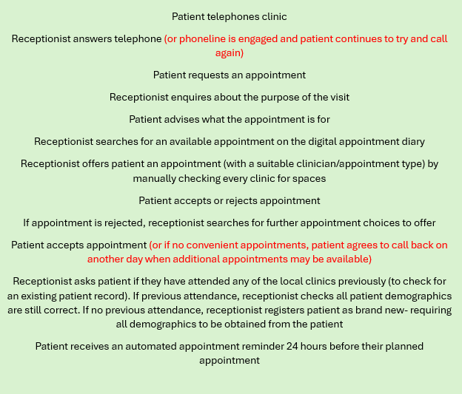
Image 1 showing the current ‘as-is’ process at the North Wales sexual health clinics (red type indicates potential blockers, where further telephone calls are required).
Many QI methods/tools are in existence, one of the most widely used is the Plan-Do-Study-Act (PDSA) cycle (image 2), which identifies the importance of change by implementing plans and ideas into action. The purpose of the PDSA cycle is to rapidly evaluate an implemented change, adjusting where necessary to increase the desired improvement (Reed and Card, 2016). The PDSA cycle is an iterative process, unlike other methods such as Lean. Lean focuses on reducing waste and ensuring value, whilst optimising workflow. The PDSA cycle can appear a simple process, though this can be cited as one of its downfalls as can promote oversimplification leading to poor resource management (Barr and Brannan, 2024).
The PDSA cycle has been selected as the most suitable approach for this project, appearing to be both straightforward and user-friendly. In the absence of a dedicated project team for this process change activity, a project management method would be wholly inappropriate, and would introduce unnecessary anxiety for the departmental staff who are all unaccustomed to such methodologies.
The PDSA cycle employs initial minor modifications to foster agreement and drive momentum for ongoing iterative process enhancement. Bradley et al., (2024) describe how they used a phased approach to their PDSA study, with phase one used for baselining current processes. Their strategy is suitable for addressing the business challenge at hand here, for this instance a paper form for the receptionist to fill out during or immediately after the booking call is an appropriate means for data capture of the current process. The introduction of electronic data collection for this would hinder collection and would prove a barrier to completion.
Baseline information to be gathered would include-
- Date and time of call
- Is the caller a new patient or a returning patient?
- Is the appointment an initial appointment or a follow up appointment?
- Is the appointment for contraception or for sexual health?
- Was there a successful outcome to the call? (i.e. was an appointment made?)
At the end of the designated appointment line each day. the receptionist could record the number of missed calls displayed on the telephone. Though this does not give granular detail as to the purpose of the missed calls, it serves as a measure of the calls the receptionist is unable to attend to. A further baselining activity would be a patient satisfaction survey, with questions asked of their appointment booking experience.
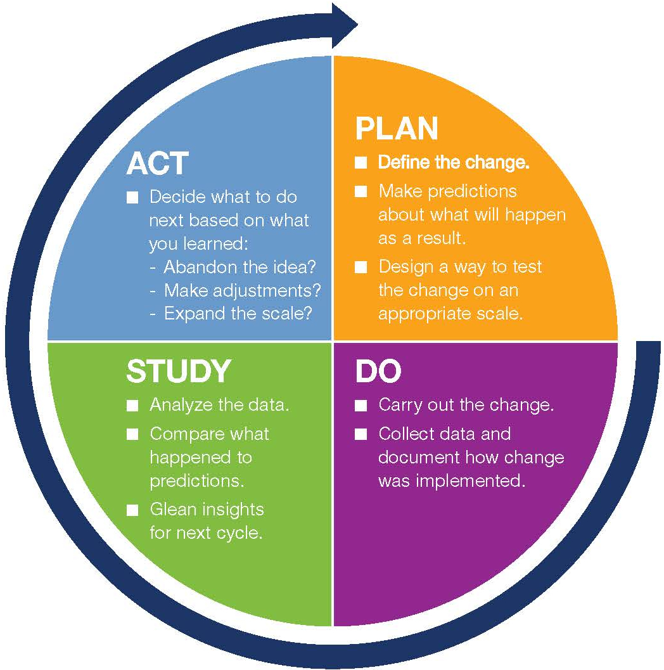
Image 2 showing visual representation of the PDSA cycle (Deming, 1986)

Utilising the PDSA tool, the stages would be populated as follows-

Plan
- To procure an appropriate booking system that fits the service needs
- To release administrative staff from handling manual bookings
- To increase patient satisfaction related to booking ease
- To reduce the number of patient complaints the Health Boards receives regarding poor accessibility
- To pilot the system in one of the three North Wales district general hospital clinics initially
- To define measurement metrics (e.g. percentage of appointments booked online and staff workload changes)
- To determine the roles of staff necessary for the planning and implementation of the project
Do
- To implement the system on a small scale
- To communicate the upcoming changes to the population of North Wales (with the limitations of pilot area scale made clear)
- To launch the system
- To train select ‘superuser’ staff in the department to aid patients
- To record patient satisfaction data
- To record data on the number of appointments booked via the online method

Study
- Analysis of the pilot outcome
- Compare online booking figures against telephone booking figures
- Evaluate patient satisfaction data
- Compare aims to outcomes
- Identify any issues that occurred during the pilot phase

Act
- Address any issues raised during the pilot phase
- Alter approach where necessary
- Make reasonable adjustments to increase potential success of the project
- Expand the implementation to include all clinics
- Continually monitor the service and repeat all steps of PDSA cycle on a regular basis

Discussion
The methods section proposed the changes planned to transition from a telephone-based appointment booking system to an electronic patient-led booking service, and how the PDSA cycle would be utilised to plan this change. This discussion section will now focus on risks to and future potential expansions to the scope of the project.
Within healthcare, numerous complex systems exist, characterised by uncertainty and surprise (Reed et al., 2019). The online booking system proposed in this instance is without doubt classed as complex when considering the definitions of complex systems in the literature. Reed et al., (2018) describe them as consisting of interconnected agents that interact with each other, leading to unpredictable changes as they evolve in response to various influences. The proposed system will need to be designed to manage various factors, including multiple staff members, locations, and appointment types. It will also require functionality to include algorithms for availability, cancellations, and rescheduling, as well as guiding users to appropriate appointments based on their reasons for attendance. The system must also possess the capacity to accommodate an unspecified number of concurrent users, thereby increasing overall complexity.

Multiple risks exist to hinder, or even halt the project-
- Lack of funding from Welsh Government/the Health Board
- Lack of perceived need for the intervention by the public/staff
- Poor engagement with stakeholders (a cohort of long-term patients exist that are resistant to change)
- Poor engagement with department staff (they are a small team that can be resistant to change)
- Network issues
- System downtime
- Security issues- data breaches/cyberattacks
- System support (historically poor for the service as they use limited digital systems)
- Issues with infrastructure
- System flaws/poor usability

Risks aside, the project has the potential to greatly improve the accessibility of the clinics for the population that wish to utilise the online booking method. Stakeholder engagement for this project would be vitally important in promoting awareness of this option being in existence; the only way the online booking can be given fair opportunity to succeed is if stakeholders are aware of it. Concannon et al., (2019) define stakeholders as individuals or groups who are responsible for, or affected by healthcare and healthcare decisions, with stakeholder engagement referring to the activities a researcher can complete with this group. This definition reminds us that stakeholders can be employees and/or the public (De Forcrand et al., 2021).
At present, the sexual health service in North Wales lacks significant digitalisation, particularly in terms of patient use. There are currently no instances where patients use a digital system during their clinic journey, altering this process may cause anxiety and confusion if changes are not communicated effectively. Utilising a stakeholder power/interest grid (image 3) proves valuable for categorising stakeholders based on their respective levels of power and interest in the project (Oguz et al, 2025). By utilising this method, project managers can target their efforts towards the most influential stakeholders. This can then help tailor appropriate engagement strategies for each level of involvement. The stakeholders for consideration in this project are illustrated (image 4) and suitable methods of engagement outlined.
While theories on engagement and relevant literature are useful, recognizing the importance of understanding your audience is crucial, particularly as many attendees at these sexual health clinics are repeat visitors, often remaining under the clinic's care for extended periods due to chronic sexually transmitted infections that necessitate ongoing management. Discussing the proposed changes to access with them will make them feel informed and involved; promoting transparency with them can act as an enabler to this change in process.

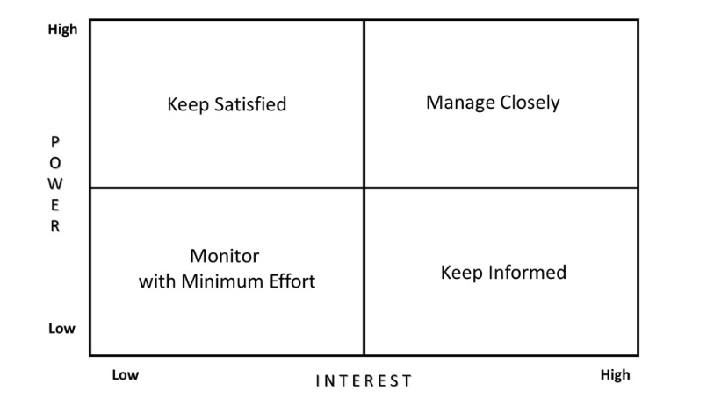
Image 3 showing the stakeholder power/interest matrix (Oguz et al. 2025)

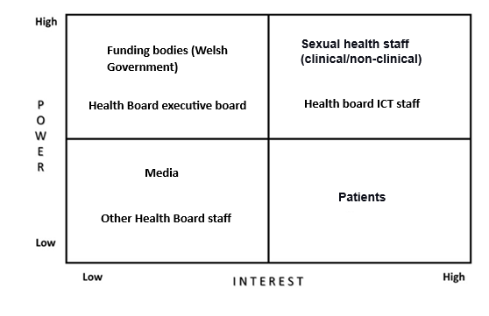
Image 4 showing the specific stakeholders for this project and their placings in the matrix

Ideas for stakeholder engagement-

For the high power/high interest (manage closely) group-
- System demonstration sessions by the system vendor
- Co-designing the product if configuration options are available
- Regular meetings
- Surveys and questionnaires for staff
- Regular staff meetings/workshops/training sessions

For the high power/low interest (keep satisfied) group-
- Compliance reports
- Impact updates
- Minimal engagement

For the low power/high interest (keep informed) group-
- Surveys and questionnaires for patients
- Posters displayed in clinic waiting rooms (with QR code link to further information)
- Text messages to clinic patients with online booking information
- Information on the Health Board website in the sexual health section

For the low power/low interest (monitor with minimum effect) group-
- Shared mailbox for queries
- Intranet bulletins
- Press releases

Assuming a successful implementation, the assignment author is particularly interested in exploring the potential of an effective triage service within the system as a future downstream improvement. The initial implementation of the proposed booking system will lack this functionality, it will only display available appointment slots within specialised, named clinics, which users must interpret correctly to meet their needs. As previously alluded to, this action requires that the user attempts to accurately prioritise their needs. Churruca et al. (2023) examine the role of online and telephone triage systems in healthcare, recognising their potential to enhance the efficiency of service prioritisation and delivery. They also acknowledge that these systems are lacking firm evidence on their level of effectiveness, stating that research has shown no firm consensus. Incorporating this enhancement would increase the system's complexity and necessitate highly rigorous testing prior to its deployment.
In conclusion, the implementation of online booking for sexual health clinics in North Wales could provide the service with significant access improvements, reducing the frustrations experienced by multiple patients when trying to access the restrictive phoneline, and reducing the administrative burden on the departments’ administrative staff. Careful, thorough planning of the requirements is essential to meet the needs of those it affects, the involvement of stakeholders will be essential in promoting collaborative working and could aid in mitigating some of the potential risks associated with a project of this nature. By addressing these risks at the onset, the project has the potential to deliver significant improvements to the sexual health services provided in North Wales.
I confirm this essay is my own original work and does not include text created by a generative artificial intelligence tool.

References
Alturkistani, A. et al. (2023) ‘Cross-sectional analyses of online appointment booking and repeat prescription ordering user characteristics in general practices of England in the years 2018–2020’, BMJ Open, 13(10), p. e068627. Available at: https://doi.org/10.1136/BMJOPEN-2022-068627.
Antonacci, G. et al. (2018) ‘The use of process mapping in healthcare quality improvement projects’, https://doi.org/10.1177/0951484818770411, 31(2), pp. 74–84. Available at: https://doi.org/10.1177/0951484818770411.
Antonacci, G. et al. (2021) ‘Process mapping in healthcare: a systematic review’, BMC Health Services Research 2021 21:1, 21(1), pp. 1–15. Available at: https://doi.org/10.1186/S12913-021-06254-1.
Atherton, H. et al. (2024) ‘Investigating Patient Use and Experience of Online Appointment Booking in Primary Care: Mixed Methods Study’, Journal of Medical Internet Research, 26(1), p. e51931. Available at: https://doi.org/10.2196/51931.
Barr, E. and Brannan, G.D. (2024) ‘Quality Improvement Methods (LEAN, PDSA, SIX SIGMA)’, StatPearls [Preprint]. Available at: https://www.ncbi.nlm.nih.gov/books/NBK599556/ (Accessed: 15 January 2025).
Bradley, C. et al. (2024) ‘Plan-do-study-act (PDSA) interventions to improve real-world endoscopy unit productivity’, Endoscopy International Open, 12(05), pp. E642–E648. Available at: https://doi.org/10.1055/A-2290-0263.
Concannon, T.W. et al. (2019) ‘Practical Guidance for Involving Stakeholders in Health Research’, Journal of General Internal Medicine, 34(3), pp. 458–463. Available at: https://doi.org/10.1007/S11606-018-4738-6/TABLES/2.
Digital Health and Care Wales (2024) About Us - Betsi Cadwaladr University Health Board. Available at: https://bcuhb.nhs.wales/about-us/ (Accessed: 5 February 2025).
De Forcrand, C. et al. (2021) ‘Pragmatic Considerations in Incorporating Stakeholder Engagement into a Palliative Care Transitions Study’, Medical Care, 59, pp. S370–S378. Available at: https://doi.org/10.1097/MLR.0000000000001583.
Gomez-Cano, M. et al. (2020) ‘Awareness and use of online appointment booking in general practice: analysis of GP Patient Survey data’, British Journal of General Practice, 70(suppl 1). Available at: https://doi.org/10.3399/BJGP20X711365.
Health Foundation, T. (2021) ‘Quality improvement made simple What everyone should know about health care quality improvement’. Available at: https://doi.org/10.37829/HF-2021-I05.
Manarte, L. (2024) ‘Technology and Access to Healthcare with Different Scheduling Systems: A Scoping Review’, Healthcare Informatics Research, 30(3), pp. 194–205. Available at: https://doi.org/10.4258/HIR.2024.30.3.194.
Oguz et al (2025) Project Management, 2nd Edition, Kesehatan Masyarakat. MSL Academic Endeavors . Available at: https://repository.poltekkes-smg.ac.id/index.php?p=show_detail&id=23725&keywords (Accessed: 6 February 2025).
Reed, J.E. et al. (2018) ‘Simple rules for evidence translation in complex systems: A qualitative study’, BMC Medicine, 16(1), pp. 1–20. Available at: https://doi.org/10.1186/S12916-018-1076-9/TABLES/3.
Reed, J.E. et al. (2019) ‘Successful Healthcare Improvements From Translating Evidence in complex systems (SHIFT-Evidence): simple rules to guide practice and research’, International Journal for Quality in Health Care, 31(3), pp. 238–244. Available at: https://doi.org/10.1093/INTQHC/MZY160.
Reed, J.E. and Card, A.J. (2016) ‘The problem with plan-do-study-act cycles’, BMJ Qual Saf, 25(3), pp. 147–152. Available at: https://doi.org/10.1136/bmjqs-2015-005076.
Ryan, M., Waller, J. and Marlow, L.A.V. (2019) ‘Could changing invitation and booking processes help women translate their cervical screening intentions into action? A population-based survey of women’s preferences in Great Britain’, BMJ Open, 9(7), p. e028134. Available at: https://doi.org/10.1136/BMJOPEN-2018-028134.
Silver, S.A. et al. (2016) ‘How to begin a quality improvement project’, Clinical Journal of the American Society of Nephrology, 11(5), pp. 893–900. Available at: https://doi.org/10.2215/CJN.11491015.

