Environmental Analysis of Automobile Industry

Name : Paolina Markova

Course: Business Management
Lecturer: Dr. Akinseye Aluko
University : UWTSD, London
Date: 02.02.22

Table of Contents
Introduction 3
Internal analysis of Mercedes Benz using SWOT 3
External analysis of Mercedes Benz using PESTLE 5
Competitive Edge of Mercedes Benz Using Porter's Five Forces 7
Mercedes Benz Value Chain Analysis 10
Conclusion 12

Introduction
The automobile industry began with the invention of the first vehicle by European engineers in the nineteenth, but Mercedes-Benz brand creation started in the 1880s with the release of the first Mercedes-Benz being released in 1926. By 2018, Mercedes achieved the rank of being the best seller of premium vehicles globally (Kayser, 2018), and is currently holding a strong reputation on both quality and durability of their vehicles (Nieuwenhuis, 2017). Based in Germany, the company has managed to achieve a sale of over 2M vehicles worldwide (Junior, 2020). However, the company faces challenges in both internal and external environments. This paper seeks to identify the challenges faced by the Mercedes Benz industry using various strategic planning tools including SWOT, PESTLE, Value Chain, and Porter's Five Forces.

Internal analysis of Mercedes Benz using SWOT
A SWOT analysis is a strategic planning tool used to examine the internal environment of a business. It stands for Strengths, weakness, opportunities, and threats a business face. Below is the internal analysis of Mercedes Benz using the SWOT tool.
Strengths
One of the greatest strengths of Mercedes Benz is ensuring that they have maintained their high level of innovativeness. This strength is evident through the current invention towards the production of environment-friendly vehicles. The achievement has been made possible through investing in detailed research and design by having over 15 research facilities spread across the globe (Madoh et al., 2019). The intensive investment in research has made Mercedes Benz maintain its brand name as the automobile company with the best brand image and the longest supply chain globally.
Weaknesses
Other than being the leading automobile company in maintaining a good brand image, Mercedes Benz suffers from the inflexibility of regional operations resulting from its hierarchical organizational structure. This realization made Mercedes Benz change the alignment of hierarchies to better the company's leadership and improve decision-making in 2017 (Itsuki, 2021). Secondly, the company maintains a culture of secrecy which affects the response time for emergencies (Helmold, 2020).
Opportunities
However, Mercedes Benz still has an opportunity to grow its business in new developing countries where the need for vehicles is on the rise. The company's focus should be on manufacturing more fuel-efficient and electric cars that are environmentally friendly and those that are in high demand across the globe. Mercedes Benz faces internal challenges within its operations that impact the overall performance of its business. These challenges include having over 300,000 employees (Profiroiu et al., 2020), technological developments, and the nature of machinery required to boost production needs (Ohno, 2019). The more a firm experiences growth, the more the investment towards new developments and increased production becomes a priority. The firm must put programs and systems in place to counter the challenges of acquiring additional staff, managing them, and controlling the cost of production.
Threats
On the other hand, Mercedes Benz currently faces the threat of high competition from low-cost automobiles from markets such as Korea, India, and China. Mercedes Benz has adapted to economic challenges such as the oil crisis in the UK, the cause of the drop in sales, pushing them to restructure to maintain their market share (Ohno, 2019). Mercedes Benz competitors such as Toyota, Honda, and GM are actively innovating into modern economical vehicles in competition with Mercedes Benz. Mercedes Benz needs to invest extensively more in research and technology advancement to stay afloat in the automobile industry.

External analysis of Mercedes Benz using PESTLE
To explore the external analysis of a business the PESTLE analysis tool is used. PESTLE analysis entails a study of the external factors affecting an organization. These include the Political, Economic factors, Sociological, Technological, Legal, and Environmental factors. By analyzing each of the six factors, threats and opportunities facing the Mercedes Benz industry in its external environment are outlined which are key in strategy formulation and decision making (Itsuki, 2021). Mercedes Benz must focus on addressing the concerns highlighted in the PESTLE analysis if the company must maintain its current position in the automotive industry. Each of the factors has been discussed below;
Political factors
Political stability in most governments is one of the political factors affecting the business growth of Mercedes Benz Motor Company. It is difficult to grow within areas experiencing political instability since this repels foreign investors (Monden, 2019). In a country with political instability, challenges with human capital are experienced since most employees are forced to skip work due to strikes and protests such as what was witnessed in the UK during Brexit and in the USA during Joe Biden’s election (Clarke et al., 2017; Smith, 2020). Politically stable governments allow for the signing of free trade agreements and admit the use of eco-friendly products that creates an opportunity for the growth of Mercedes Benz company gaining better bargaining power.
Economic factors
Economic factors have a direct impact on the success of the Mercedes Benz Business. Mercedes Benz has to ensure that its brand performs better on the verge of the rising competition from BMW, Ford, and Tesla to maintain a high market share in the automobile industry. This explains the reason why Mercedes Benz has invested in research. Economic recession contributed by the Covid-19 pandemic has affected the buying power of many customers across the globe due to financial insecurity and uncertainty. This pandemic has led to a drop in the annual revenue of Mercedes Benz by 13.59% (Nikbin et al., 2021). The increasing oil prices also affect the economic environment of Mercedes Benz's business where the company has to focus on the large production of electric cars.
Sociological factors
Mercedes Benz has a great opportunity towards meeting the sociocultural factors such as the current increased interest in hybrid, and electric cars but also suffers a threat on the widening wealth gap that results in a decreased middle class who are the major clients of Mercedes Benz products. Vehicle recalling, because of faulty fuel pumps, was one of the challenges that hit the Mercedes Benz brand making customers doubt its credibility (Austen-Smith et al., 2017). The company suffered financial losses but has to consistently prove to its customers that the faulty fuel pumps issue is now fully addressed. Mercedes Benz also faced a safety challenge issue which faulty acceleration system which even after being they recalled the faulty vehicles and rectified the problem, the firm had to convince the consumers who were affected.
Technological factors
Mercedes Benz has embraced technology by investing in research and design to improve its production standards. The production of hydrogen and electric cars has been made possible through this process placing Mercedes Benz high up the rank (Kolbe et al., 2020). However, the company has an opportunity to grab in embrace the current e-commerce and use of mobile technology such as the use of phone apps. This will improve on sales of both vehicles and spare parts and lead to more customer loyalty and engagement.
Environments factors
Factors such as climate change and declining oil reserves are parts of environmental factors affecting the Mercedes Benz Industry. The two factors create an opportunity for Mercedes Benz to invest in environmentally friendly products such as sky-active cars with high fuel efficiency and no carbon emissions (Moro et al., 2018). The production of these cars goes in line with the focus on business sustainability (Nkomo, 2019). Mercedes Benz has to keep innovating to ensure that the firm continues to shine in the current rivalry among existing competitors such as Toyota, BMW, Ford, and Tesla.
Legal factors
Legislative factors have also greatly affected the performance of Mercedes Benz Motor company. It has suffered several legal suits such as those filed when the firm recalled its faulty cars and the German prosecutors due to the diesel emissions scandal. In both cases, Mercedes Benz lost the legal case and paid £700m (R’Mili et al., 2018). Employment legislation, international, and trade regulations also affect the growth of Mercedes Benz business in some countries (Teplická, 2018). Such regulations include the environmental laws on producing environmentally friendly products where Mercedes Benz has already grabbed the opportunity and began the production of electric cars.

Competitive Edge of Mercedes Benz Using Porter's Five Forces
Porter’s Five Forces model is used to focus on factors affecting the profitability and competitive advantage of a business. The following discussion is a competitive analysis of Mercedes Benz Motor Company using Porter’s five forces framework.
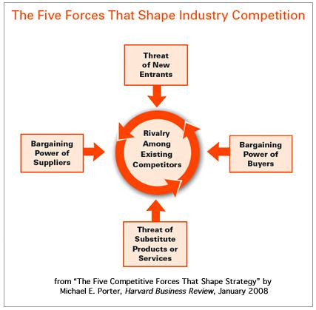
Fig 1: Porter's Five Forces (Varelas, 2017)
The threat of new entrants
The threat of new entrants in the industry that Mercedes Benz operates in is weak. To enter the automobile industry a new player, need to invest a huge amount of capital required to start and manage the automotive business. The cost of the distribution system, the marketing chain, hiring human resources, and the entire management process is highly capital intensive, limiting many new entrants willing to join the market (Varelas, 2017). Mercedes Benz has economies of scale and conquers the regulatory barriers which challenge new entrants to the market.
Bargaining power of suppliers
The bargaining power of suppliers in Mercedes Benz is weak. The suppliers for automobile parts are many and hence Mercedes Benz can source its raw materials from different suppliers. Besides, Mercedes Benz has high brand equity which makes many suppliers will supply the company. This reduces the chances of any competition between the suppliers since Mercedes Benz can easily change a supplier at any one time based on the numerous options at its doorstep and a well-structured supply chain system with its market presence across the globe.
The bargaining power of buyers
The bargaining power of buyers in Mercedes Benz is high. Customers have various other options to choose from based on the price, customer service levels, fuel economy, and environmentally-friendly vehicles. Mercedes Benz competitors such as Tesla offer similar and differentiated products and at similar prices where each customer has a free will to make their individual choices (Ohno, 2019). Hence, Mercedes Benz needs to leverage modern technological innovation to remain competitive.
The threat of substitute products and services
The threat of substitutes in Mercedes Benz is very high. This is because there are several substitutes in the automotive industry for the products manufactured by Mercedes Benz. Most middle and lower-middle-class consumers prefer public modes of transport since it's way cheaper than personal vehicles, which is a threat since a big group of potential customers avoids the cost of maintaining a personal car (Nkomo, 2019). Through the initiative in manufacturing cost-friendly and fuel-efficient vehicles, Mercedes Benz stands has a better market share attracting a majority of the lower-middle-class group.
Rivalry among existing competitors
Rivalry among existing competitors is intense in Mercedes Benz Motor Company. Though there are a few renowned players in the market, features of competition between one brand to the other varieties from fuel efficiency, car safety, design of the car, and innovation used (Neckermann, 2017). Mercedes Benz competitors have invested more in passenger safety, convenience, and innovation. Therefore, Mercedes Benz has to game up by ensuring their customers enjoy convenience and safety with their products.

Mercedes Benz Value Chain Analysis
The value chain analysis focuses on business activities that can create value and competitive advantage for a business. The Mercedes Benz Motor company business activities can be classified into primary activities and support activities where the primary activities focus on internal production and distribution of vehicle parts and finished products where support activities are focused on facilitating the success of the primary activities as shown below.
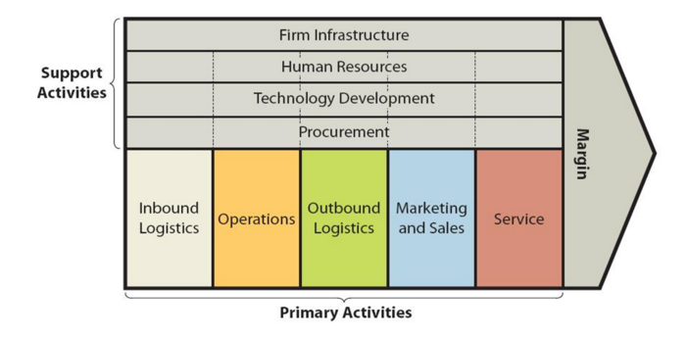
Fig 2. Mercedes Benz value chain (Ohno, 2019).
Mercedes Benz Primary activities comprise inbound logistics, Operations, Outbound Logistics, Marketing, and Sales and Service, while Support activities include firm infrastructure, human resources, technological development, and procurement. Mercedes Benz has also invested in marketing and promotion through its websites, social media, and creating events such as races and motor shows which cost the firm more than 4 billion US dollars between 2015 and 2016 (Wang, 2020). With over 364,000 employees worldwide, the firm majorly focuses on the development of its human resources which forms a major part of its competitive advantage (Profiroiu et al., 2020). The firm has an organized way of purchasing its raw materials from suppliers across the globe which has contributed to local economies globally.

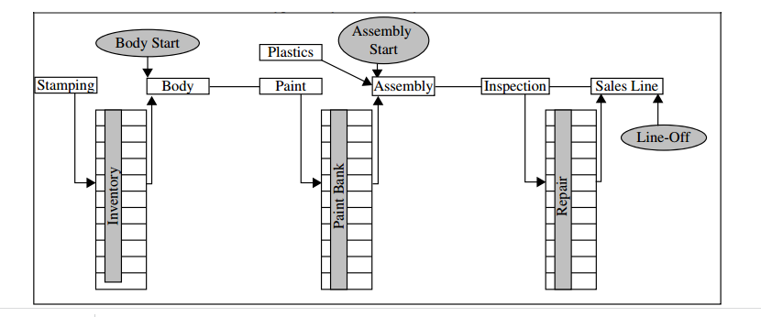
Fig 2. Typical Mercedes Benz assembly plant flow
Competitive advantages in line with their core values on sustainability.
Mercedes Benz's core values are based on the positive belief "we believe we can and we will do great things" (Ohno, 2019). This has placed the firm in a better position compared to its rivals. Mercedes Benz's core values include believing in; every day being an opportunity to improve, a great tomorrow starting today, respecting others, good things standing the test of time, and going the extra mile (Wang, 2021). The core values have enabled Mercedes Benz to excel in measures such as; system economy, product economy, and customer economy.
Through system economy, Mercedes Benz has created units for specific areas in the market whereas using product economy, it can achieve economical production of its parts in small batches making it easy to identify flaws saving time compared to its competitors such as Ford Motors doing mass production (Ohno, 2019). With customer economy, the firm has produced fuel-efficient hybrid vehicles. These measures place the company in a competitive advantage position compared to its rivals.

Conclusion
Mercedes Benz Motor industry has made a brand name across the globe with a large market in the automobile industry. However, the firm still faces challenges in the internal and external business environment, which needs to be addressed in line with the company's core values which are focused on a positive note of believing they can and will do great things. The company still needs to focus more on threats posed by rivals in the automobile industry especially in countries where the wealth gap is pronounced to also target middle- and low-end-income customers as opposed to their high-income ones. Mercedes Benz needs to ride on its competitive advantages and grab opportunities in the market together with continuous marketing and research to achieve more sales, expand and maintain a good brand name.

Reference
Austen-Smith, D., Diermeier, D. and Zemel, E. (2017). Unintended acceleration: Mercedes Benz’s recall crisis. Kellogg School of Management Cases.
Clarke, H.D., Goodwin, M., Goodwin, M.J. and Whiteley, P. (2017). Brexit. Cambridge University Press.
Helmold, M. (2020). The Cultural Change Towards Lean Management. In Lean Management and Kaizen (pp. 15-23). Springer, Cham.
Itsuki, H. (2021). Evaluation on Changes of Strategy and Strategic Direction in Mercedes Benz Motor Company, Japan. Journal of Strategic Management, 5(1), pp.20-29.
Jacobs, A.J. (2019). The Automotive Industry and European Integration: The Divergent Paths of Belgium and Spain. Springer.
Junior, R.F. and Scur, G. (2020). Development of product-service system business model: a study at Mercedes-Benz Brazil (No. 2019-36-0093). SAE Technical Paper.
Kayser, C. (2018). Daimler entering new markets. Business Development, Merger And Crisis Management Of International Firms In Japan: Featuring Case Studies From Fortune 500 Companies, p.91.Varelas, S. and Georgopoulos, N. (2017). Porter’s competitive forces in the modern globalized hospitality sector–the case of a Greek tourism destination. J Tour Res, 18, pp.121-131.
Kolbe, K., Lechtenböhmer, S. and Fischedick, M. (2020). Hydrogen derived from algae and cyanobacteria as a decentralized fueling option for hydrogen-powered cars: Size, space, and cost characteristics of potential bioreactors. International Journal of Sustainable Transportation, 14(5), pp.325-334.
Monden, Y. and Talbot, B. (2019). The Mercedes Benz management system: linking the seven key functional areas. Routledge.
Moro, A. and Lonza, L. (2018). Electricity carbon intensity in the European Member States: Impacts on GHG emissions of electric vehicles. Transportation Research Part D: Transport and Environment, 64, pp.5-14.
Neckermann, L. (2017). Smart cities, smart mobility: transforming the way we live and work. Troubador Publishing Ltd.
Nieuwenhuis, P. (2017). Will durability be a characteristic of future cars?. In PLATE: Product Lifetimes And The Environment (pp. 298-302). IOS Press.
Nikbin, D., Iranmanesh, M., Ghobakhloo, M., and Foroughi, B. (2021). Marketing mix strategies during and after COVID-19 pandemic and recession: a systematic review. Asia-Pacific Journal of Business Administration.
Nkomo, T. (2019). Analysis of Mercedes Benz Motor Corporation.
Ohno, T. and Bodek, N. (2019). Mercedes Benz production system: beyond large-scale production. Productivity Press.
Profiroiu, M., Kaneko, H., Vlad, C., Dutescu, A. and Ishida, H. (2020). Mercedes Benz Motor Corporation's Culture Strategy. Revista de Management Comparat International, 21(4), pp.458-489.
R’Mili, B., Boréave, A., Meme, A., Vernoux, P., Leblanc, M., Noël, L., Raux, S. and D’Anna, B. (2018). Physico-chemical characterization of fine and ultrafine particles emitted during diesel particulate filter active regeneration of Euro5 diesel vehicles. Environmental science & technology, 52(5), pp.3312-3319.
Smith, N. (2020). Should Biden Apologize for Trump? National Remorse and the 2020 US Presidential Election. Society, 57(6), pp.698-703.
Teplická, K. (2018). Factors affecting the performance of enterprises and their impact on macroeconomic indicators of the business environment of Slovakia. acta oeconomica cassoviensia.
Thakkar, J., Jimenez, S. and Rageh, N.S. (2017). AND XEROX.
Wang, C.N., Tibo, H., and Nguyen, H.A. (2020). Malmquist productivity analysis of top global automobile manufacturers. Mathematics, 8(4), p.580.
Wang, Z. (2021). How can Mercedes Benz motor corporation achieve sustainable DEVELOPMENT? Управління розвитком складних систем, (46), pp.141-148.

