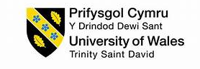

Name: Jamuthra Srikumar
Student Number: 2310736
Module: LCLM5005
Lecturer: David Oyebisi

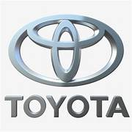

Organisational culture
Organisational culture is basically the shared values, beliefs and everyday practices that shape how people behave and make decisions at work. As Mullins and Christy (2016) explain, culture strongly influences how organisations function from structure and decision making to motivation and job satisfaction. According to Zheng,Yang & Mclean, organisational culture contributed knowledge management and organisational effectiveness than organisational strategy and structure. Johnson (2013) said, embodies the Ethos and Values of a particular organisation, which are expressed through the way it operates and practices it undertakes (From Lecture Slides). If workplace values are considered incorrect, the underlying ethos must be addressed to effectively resolve any issues.
As a global company like TOYOTA, managing such a vast and diverse workforce depends heavily on a consistent and strong culture. This report looks at how Toyota’s culture is built, how it affects structure and decisions, what cultural types it reflects through different frameworks, how it helps Toyota respond to external changes, and how it ultimately impacts performance.

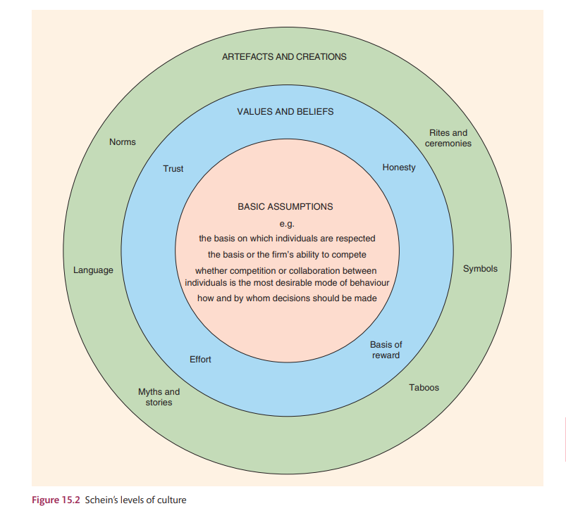

Toyota’s Organisational culture
Toyota way which means set of principles and behaviours that underline the Toyota Motor Corporation’s managerial approach and production system. Toyota first tallied up its philosophy, values and manufacturing ideals in 2001, calling it The Toyota Way 2001. There are fourteen principles and concise under two main headings which are Continuous improvement and Respect for people. Toyota’s culture is best known through The Toyota Way, which rests on key principles continuous improvement (Keizen) and respect for people. These aren’t just slogans; they capture how Toyota runs its operations treats its people. The goal isn’t just to make cars, but to do it with quality, teamwork and a mindset of problem solving and learning. Toyota’s internal document developed The Toyota Way to teach teams and learn from experts to know about the Toyota’s culture. Toyota Way enhanced the growth around the world so fast because when Toyota steeped into global market, they struggled to convey their makes and essence of products.

TOYOTA WAY PRINCIPLES
- Long- term philosophy
- The right process will produce the right results.
- Use pull systems to avoid overproduction.
- Level out the workload.
- Build culture of stopping to fix problems to get quality right the first time.
- Standardized tasks and processes are the foundation for continuous improvement and employee empowerment.
- Use visual control so no problems are hidden.
- Use only reliable, thoroughly tested technology that serves your people and processes.
- Grow leaders who thoroughly understand the work, live the philosophy, and teach it to others.
- Develop exceptional people and teams who follow your company’s philosophy.
- Respect your extended network of partners and suppliers by challenging them and helping them improve.
- Go and see for yourself to thoroughly understand the situation (Genchi Genbutsu)
- Make decisions slowly by consensus, thoroughly considering all options: implement decisions rapidly (nemawashi).
- Become a learning organisation through relentless reflection and continuous improvement. (The Toyota Way)
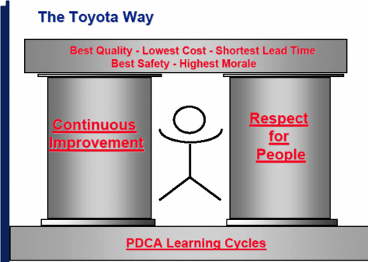

According to Sahein’s model, Toyota’s culture shows up at several levels. The visible artefacts include the Toyota Production System (TPS), Kaizen events and the 5S workplace organisation method. Its espoused values highlight quality, respect, and continuous improvement while its underlying assumptions emphasise long-term thinking and empowering employees. Overall Toyota’s culture is strong, values driven, process oriented and deeply people focused.

How culture shape structure and decision making?
Traditionally, Toyota had a strong hierarchical structure, typical of Japanese companies. However, it has evolved into a divisional model based on products and regions. This structure fits its culture well it balances the need for standardisation with flexibility for local markets.
Toyota’s decision-making process is guided by the principle of Genchi Genbutsu (“go and see”), which emphasizes firsthand understanding of issues before making choices. This approach promotes fact-based, consensus-driven decisions and prioritizes gradual, continuous improvements over drastic changes. Although this method can slow decision-making, it ensures consistency, thorough consideration, and broad support. Such practices reflect Japanese cultural traits, where collectivism influences decision-making to be more consensus oriented.
In contrast, construction projects often face chaotic conditions and tight timelines, making this bottom-up, time-intensive approach less practical. However, one valuable lesson for construction firms is the importance of focusing on the decision-making process rather than rushing to conclusions. In projects where problems frequently arise, consensus-based methods can still be applied to certain decisions. Success depends on active involvement from frontline workers, foremen, and other key stakeholders—the individuals performing most of the value-added work. Their input can be encouraged through collaborative techniques like the 5 Whys, which help identify root causes before decisions are finalized. ( The Toyota way)

Identifying Toyota’s culture through frameworks
Using Handy’s typology, Toyota reflects a mix of role and task cultures structured roles combined with teamwork and problem solving. In Deal and Kennedy’s model, Toyota fits the process culture type, where there’s low risk and slow feedback, focusing on procedures and precision.
Hofstede’s dimensions also shed light on Toyota’s roots in Japanese culture strong collectivism and high uncertainly avoidance contribute to its emphasis on consensus and harmony. The cultural web shows how Toyota reinforces its culture through rituals like Kaizen, stories of successful problem solving and control systems centred on quality and performances.

Understanding Toyota’s organizational culture requires applying established cultural frameworks that reveal its underlying values, behaviours, and practices. Toyota’s culture is deeply influenced by Japanese traditions and its own management philosophy, such as Kaizen (continuous improvement) and Genchi Genbutsu (go and see). Below are key frameworks that help analyse Toyota’s cultural profile:

1. Hofstede’s Cultural Dimensions
- Collectivism vs. Individualism: Toyota demonstrates strong collectivism, emphasizing teamwork and consensus in decision-making.
- Uncertainty Avoidance: High—Toyota relies on structured processes and thorough analysis to minimize risks.
- Long-Term Orientation: Strong—Toyota prioritizes sustainability and continuous improvement over short-term gains.
- Power Distance: Relatively low employees at all levels are encouraged to contribute ideas, reflecting respect for people.
Impact: These dimensions explain Toyota’s preference for consensus-based decisions and incremental improvements, which enhance quality and reliability.

2. Deal & Kennedy’s Cultural Model
- Type: Work-hard, play-hard
Toyota values efficiency, quality, and collaboration, rewarding performance and innovation.
- Values: Respect for people, continuous improvement, and customer-first mindset.
- Heroes: Leaders who embody Kaizen and Genchi Genbutsu principles.
- Rituals: Daily problem-solving meetings, Gemba walks, and quality circles.
Impact: These cultural elements foster strong employee engagement and operational excellence.

3. Schein’s Three Levels of Culture
- Artifacts: Visible practices like Kaizen boards, standardized work procedures, and team huddles.
- Espoused Values: Respect for people, continuous improvement, and consensus-based decision-making.
- Underlying Assumptions: Belief that quality and improvement come from collective effort and long-term thinking.
Impact: Schein’s model highlights Toyota’s deep-rooted assumptions that drive its global success.

4. Competing Values Framework
- Quadrant: Clan Culture
Toyota emphasizes collaboration, employee involvement, and shared values over aggressive competition.
Impact: This explains Toyota’s strong internal cohesion and adaptability in problem-solving.

Across these frameworks, Toyota’s culture emerges as collective, process-oriented, and improvement-driven, with a strong emphasis on respect for people and long-term sustainability. These cultural traits have been instrumental in Toyota’s global reputation for quality, innovation, and operational excellence.

Using culture to adapt to the External environment
Toyota’s culture of Kaizen helps it stay agile and responsive to challenges like sustainability, innovation and market shifts. Its Respect for people principle allows it to effectively manage a multicultural workforce.

The divisional structure gives local teams the authority to make decisions suited to their regions, while the culture of learning ensures Toyota can adapt quickly to crises, regulatory changes and technological developments like electric and autonomous vehicles.

Toyota uses its strong organizational culture to adapt to external environmental changes in several ways:
1. Continuous Improvement (Kaizen)
- Toyota’s culture emphasizes Kaizen, meaning constant incremental improvements.
- This allows the company to quickly respond to market shifts, regulatory changes, and customer preferences by refining processes rather than making disruptive changes.
2. Respect for People
- The culture values collaboration and employee input, enabling Toyota to gather insights from the workforce to adapt to global trends and local market needs.
- This helps in customizing products for different regions while maintaining efficiency.
3. Long-Term Thinking
- Toyota’s philosophy prioritizes sustainability and long-term goals over short-term gains.
- This cultural trait helps the company adapt to external pressures like environmental regulations and the shift toward electric vehicles.
4. Lean Manufacturing
- The Toyota Production System (TPS) is deeply rooted in its culture.
- It ensures flexibility and efficiency, allowing Toyota to adjust production volumes and models based on economic conditions or consumer demand.
5. Innovation and Learning
- Toyota fosters a learning culture, encouraging experimentation and innovation.
- This adaptability is crucial for responding to technological changes, such as autonomous driving and EV development.

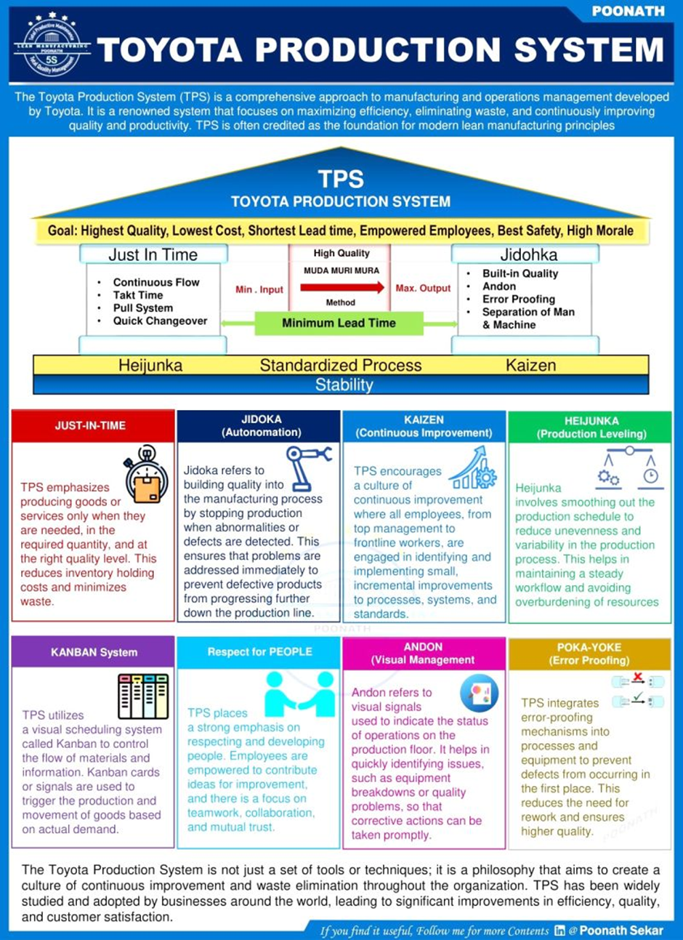

Toyota’s cultural adaptation to external environments:
1. Localization of Operation - In the U.S., Toyota adapted its culture to emphasize customer service and innovation to compete with American brands. It established manufacturing plants locally and integrated American work practices while maintaining core Toyota principles like Kaizen.
2. Embracing Sustainability - In response to global environmental concerns, Toyota’s culture shifted toward eco-friendly innovation, leading to the development of the Toyota Prius and investment in hybrid and electric vehicles.
3. Safety and Quality Focus - After the 2010 recall crisis, Toyota reinforced a culture of accountability and transparency, implementing stricter quality control and communication practices to regain trust.
4. Digital Transformation - To adapt to technological changes, Toyota incorporated agile and collaborative practices into its traditionally structured culture, enabling faster development of connected and autonomous vehicles.
5. Regional Cultural Integration - In India, Toyota adapted its culture to respect local traditions and labour practices while promoting teamwork and continuous improvement, ensuring smooth collaboration with local suppliers.

Toyota's safety culture
1. Safety as a Core Value - Toyota prioritizes safety for employees, customers, and communities. It views safety not as a compliance requirement but as a fundamental principle guiding all decisions.
2. Built-in Safety in Processes - Through the Toyota Production System (TPS), safety is integrated into every step of manufacturing. Jidoka (automation with a human touch) ensures machines stop automatically when an abnormality occurs, preventing accidents.
3. Continuous Improvement (Kaizen) for Safety - Employees are encouraged to identify hazards and suggest improvements. Safety audits and risk assessments are routine, ensuring evolving risks are addressed.

4. Vehicle Safety Innovation - Toyota invests heavily in advanced safety technologies, such as:
  - Toyota Safety Sense (collision avoidance, lane departure alerts)
  - Pre-Collision Systems and Adaptive Cruise Control
these innovations reflect Toyota’s commitment to customer safety.
5. Global Standards and Training - Toyota adapts its safety culture to meet local regulations while maintaining global standards. Employees receive regular safety training and participate in drills to reinforce awareness.
6. Post-Crisis Reinforcement
- After incidents like the 2010 recall crisis, Toyota strengthened its safety culture by:
  - Improving quality control
  - Enhancing transparency and accountability
  - Establishing stricter safety governance systems

How Toyota handle the recall
Toyota handled the major recall crisis (especially the 2009–2010 unintended acceleration issue) through a combination of strategic actions and cultural reinforcement:
1. Immediate Response - Toyota issued massive recalls worldwide, covering millions of vehicles to fix accelerator pedal and floor mat issues. Production and sales of affected models were temporarily halted to prevent further risk.

2. Public Apology and Transparency - Top executives, including the CEO, made public apologies and took responsibility. Toyota increased communication with customers and regulators to restore trust.

3. Strengthening Quality Control - Implemented Global Quality Task Force to monitor and improve safety standards. Introduced stricter quality assurance processes and more rigorous testing.

4. Cultural Reinforcement - Toyota reinforced its Kaizen (continuous improvement) and Genchi Genbutsu (go and see) principles to identify root causes. Employees were encouraged to report issues proactively, creating a stronger safety culture.

5. Technological and Process Changes - Developed advanced safety systems like Toyota Safety Sense. Improved supplier management and internal audits to prevent similar issues.

6. Customer Support - Offered free repairs, extended warranties, and compensation programs. Set up hotlines and service centres for quick customer assistance.

When culture Becomes a barrier,
A strong culture, while valuable can sometimes hold a company back. Toyota’s emphasis on standardisation and hierarchy can make it less agile and slow down innovation.
Cultural traits based on Japanese traditions can sometimes clash with western business expectations, especially in fast – moving markets. Also, a heavy focus on focus on process and perfection can stifle creativity. Striking a balance between global consistency and local flexibility remains on going challenge for Toyota. These are some barriers for Toyota.
1. Slow Decision-Making
- Reason: Toyota’s emphasis on consensus (ringi system) and Genchi Genbutsu requires extensive consultation and fact-finding.
- Impact: In fast-moving markets or crisis situations (e.g., recalls), this can delay critical decisions, reducing responsiveness.

2. Resistance to Radical Change
- Reason: The Kaizen philosophy focuses on incremental improvements rather than disruptive innovation.
- Impact: This cultural trait can hinder rapid adaptation to technological shifts, such as electric vehicles or digital transformation.

3. Global Expansion Challenges
- Reason: Japanese collectivist and hierarchical norms may clash with more individualistic cultures in Western subsidiaries.
- Impact: Misalignment in management styles and communication can lead to inefficiencies and employee dissatisfaction abroad.

4. Crisis Management Limitations
- Example: During the 2010 recall crisis, Toyota’s slow and cautious approach was criticized for lacking transparency and urgency.
- Impact: Cultural preference for harmony and avoiding confrontation delayed public acknowledgment and corrective actions.

5. Innovation vs. Tradition
- Reason: Strong adherence to established processes can stifle creativity.
- Impact: Competing with agile tech-driven firms becomes harder when cultural norms discourage risk-taking.

Toyota’s culture is a competitive advantage in stability and quality but can become a barrier in high-speed environments, global integration, and disruptive innovation. Balancing cultural strengths with flexibility is key to sustaining performance.

Toyota’s culture played a critical role in the 2010 recall crisis, both positively and negatively. Here’s a detailed analysis:

1. Consensus-Based Decision-Making Slowed Response
- Toyota’s reliance on the Ringi system (bottom-up approval) and Genchi Genbutsu (go and see) meant decisions required extensive internal discussion and verification.
- Impact: This slowed the company’s ability to respond quickly to safety concerns, making the crisis appear worse in the eyes of regulators and customers.

2. High Uncertainty Avoidance and Risk Aversion
- Japanese cultural norms favour avoiding mistakes and maintaining harmony.
- Impact: Toyota hesitated to publicly acknowledge problems early, fearing reputational damage. This delay was perceived as lack of transparency.

3. Collectivism and Face-Saving
- In Japanese culture, preserving group harmony and avoiding embarrassment is key.
- Impact: Toyota initially downplayed issues to protect its image and relationships, which backfired internationally where openness is valued.

4. Long-Term Orientation
- Toyota’s focus on long-term reputation and quality led to overconfidence in its processes.
- Impact: Management underestimated the urgency of the crisis, assuming its strong brand would withstand scrutiny.

5. Global Cultural Misalignment
- Toyota’s Japanese approach clashed with Western expectations for speed and transparency.
- Impact: U.S. regulators and media criticized Toyota for being slow and secretive, damaging trust.

Toyota’s cultural strengths—consensus, thoroughness, and harmony—became liabilities during the 2010 crisis. The slow, cautious response and reluctance to admit fault amplified the problem globally. This event highlighted the need for cultural adaptability in crisis management. (The Toyota Way)

Impact of culture on organisational performance

Toyota’s culture is a major driver of its performance. Continuous improvement pushes quality and efficiency, while respect for people boosts employee engagement and loyalty. The Toyota production system reduces waste and enhances reliability contributing to its strong brand reputation and competitiveness.
However, to stay ahead, Toyota needs to keep evolving its culture blending its traditional strengths with greater flexibility, speed and digital innovation. Here is some of impacts discussed about Toyota way:

- Collectivism and Consensus-Based Decisions
Japanese culture emphasizes harmony and group consensus which shapes Toyota’s decision-making processes. This ensures decisions are well-considered, fact-based, and widely supported, reducing risks and fostering long-term stability.
- Continuous Improvement (Kaizen)
The cultural value of incremental progress drives Toyota’s Kaizen philosophy. Employees at all levels are encouraged to identify small improvements, leading to sustained operational excellence and innovation.
- Respect for People
Cultural norms of respect and humility influence Toyota’s approach to employee engagement. Frontline workers are empowered to contribute ideas, improving morale and productivity.
- Long-Term Orientation
Japanese culture prioritizes long-term success over short-term gains. Toyota invests heavily in quality and reliability, which strengthens brand reputation and customer loyalty globally.
- Challenges in Global Context
While consensus and thoroughness work well in Japan, they can slow decision-making in fast-paced markets. Toyota addresses this by adapting its practices internationally while retaining core cultural principles.

Conclusion
Toyota’s culture, rooted in continuous improvement and respect for people, defines how it operates, makes decisions and adapts to the world around it. Frameworks like Schein, Handy and Hofstede reveal how deeply its people centric values are embedded.
This culture has been central to Toyota’s global success, driving quality, efficiency and reputation. Yet, its strength can also be a limitation if it slows change. Moving forward, Toyota should preserve its cultural foundation while embracing innovation and adaptability to meet future challenges.

