3/24/2025
University of Wales Trinity Saint David
London campus
E-Portfolio Link: https://valvdov.dev
Module Name: Learning In the Digital Era
Module Code: ACCA 4025

Student Name: Valerii Vdovin
Student ID: 2510682
Group: 4

Lecturer’s Name: Dipo Dunsin

LDE Assignment 1
E-Portfolio
Table of Contents
Introduction 2
Main Body 2
Task 1: Essential Academic and Employment Skills for the future career Path 2
Task 1 (a): Report on Essential Academic and Employment Skills 2
Task 1 (b): Evaluation of Task 1 (a) based on Similarity report 3
Task 2: Collaborative Mind Map and Individual Poster 4
Mind Map (Collaborative) 4
Poster (Individual) 4
Task 3: Virtual Collaboration and RefWorks 5
Report on Virtual Collaboration 5
Step-by-step process of using RefWorks with visuals 6
Task 4: E-Portfolio Creation and Evaluation 8
Task 4 (a): E-Portfolio Creation 8
Task 4 (b): Illustrative Review of E-Portfolio tool Selection 8
Conclusion 9
References 10
Task 1 References: 10
Task 3 References: 11

Introduction
This paper contains the completed assignments for the Learning in the Digital Era module, including the development of academic skills, teamwork, digital literacy, and research skills. The work includes links to the e-portfolio, poster materials, a report with automatic links, and the results of the team assignment. This document serves as confirmation of the completion of all module requirements and demonstrates my progress in academic writing and professional IT skills.

Main Body

Task 1: Essential Academic and Employment Skills for the future career Path

Task 1 (a): Report on Essential Academic and Employment Skills
Essential skills are skills that are necessary for studying or working. Examples of such skills include:
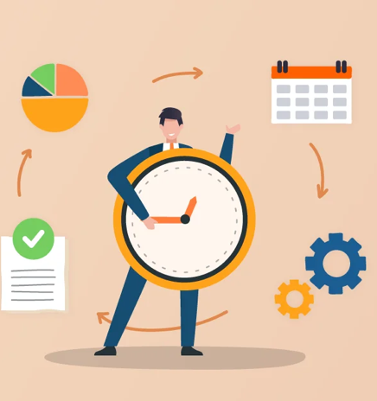
Time management is a collection of behavioral skills that enable effective organization of one's studies and coursework. [1] These skills help learners enhance productivity and reach academic goals. In student life, time management is important for studying successfully, completing all tasks on time, and not missing or being late for classes. The same applies to work skills, which allow us to complete work tasks on time. Personally, for me, since I want to be a software developer, this skill is very important. Completing tasks on time allows me to avoid overworking.
Figure 1: Time management [4]
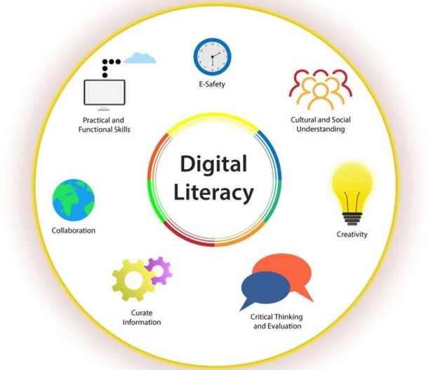
Digital literacy is the ability to use, understand, and create information through digital technologies. [2] It involves reading, writing, and communicating across different digital platforms and media. This skill helps people think critically and participate effectively in today's digital world. Digital literacy helps us find, study, and use information available on the internet and on devices for our studies. We also gain the opportunity to communicate, collaborate, and learn online. In the workplace, this knowledge enhances communication and facilitates more convenient interactions with colleagues. It also helps track tasks. For me, this is one of the most important skills. Without such practical knowledge, it is impossible to work in the IT field.
Figure 2: Digital literacy [5]
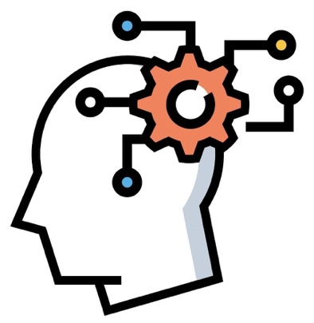
Critical thinking means making clear, reasoned judgments. [3] It relies on interpreting, understanding, applying, and combining evidence from observation, reading, and experiments. Critical thinking is a necessary skill in learning. It allows you not only to memorise information, but also to analyse it and work with various sources. It also develops problem-solving skills.
Figure 3: Critical thinking [6]
Its use in the workplace is also important, as it helps in much the same way as in learning, but allows you not only to solve problems, but also to make the right decisions at work.

Task 1 (b): Evaluation of Task 1 (a) based on Similarity report
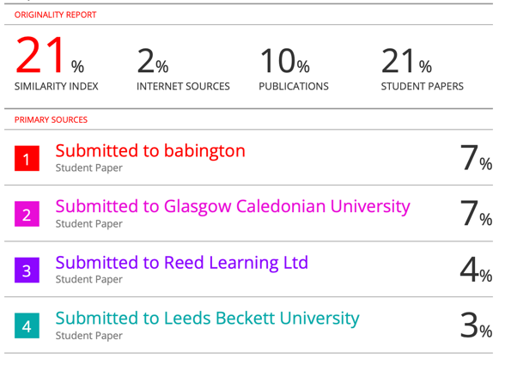
My Turnitin similarity score was 21%. I think this is quite good, but there is still room for improvement. Most of the matches came from the references, which I can’t really change unless I use different sources. Some matches also happened because of common definitions, which raised my percentage a bit. Next time, I’ll try to paraphrase those sections and put the ideas in my own words while keeping the meaning. Overall, I feel my work is clear and well-organised, so I would give myself around 65-70%, which is a ‘Very Good’ grade for this assignment.
Figure 4: Turnitin similarity score (Personal Collection)

Task 2: Collaborative Mind Map and Individual Poster

Mind Map (Collaborative)
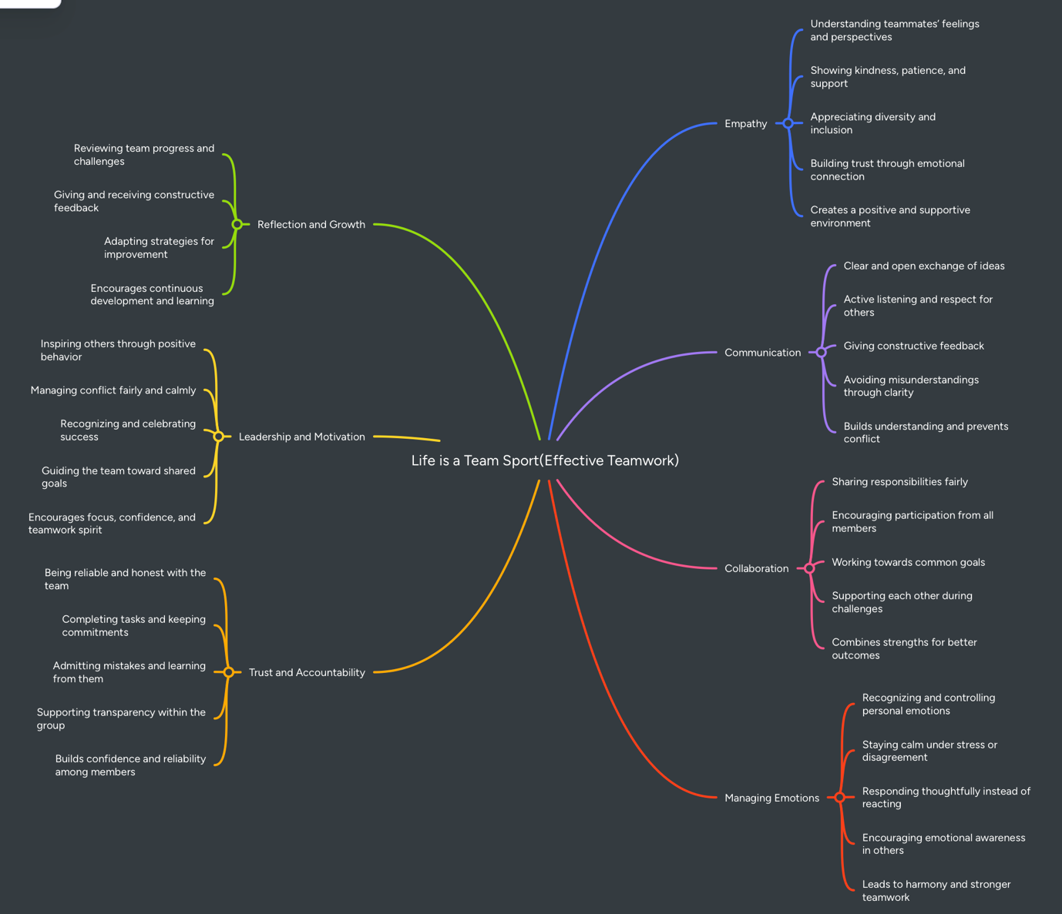
Figure 5: Mind Map
You can find our map here.

Poster (Individual)
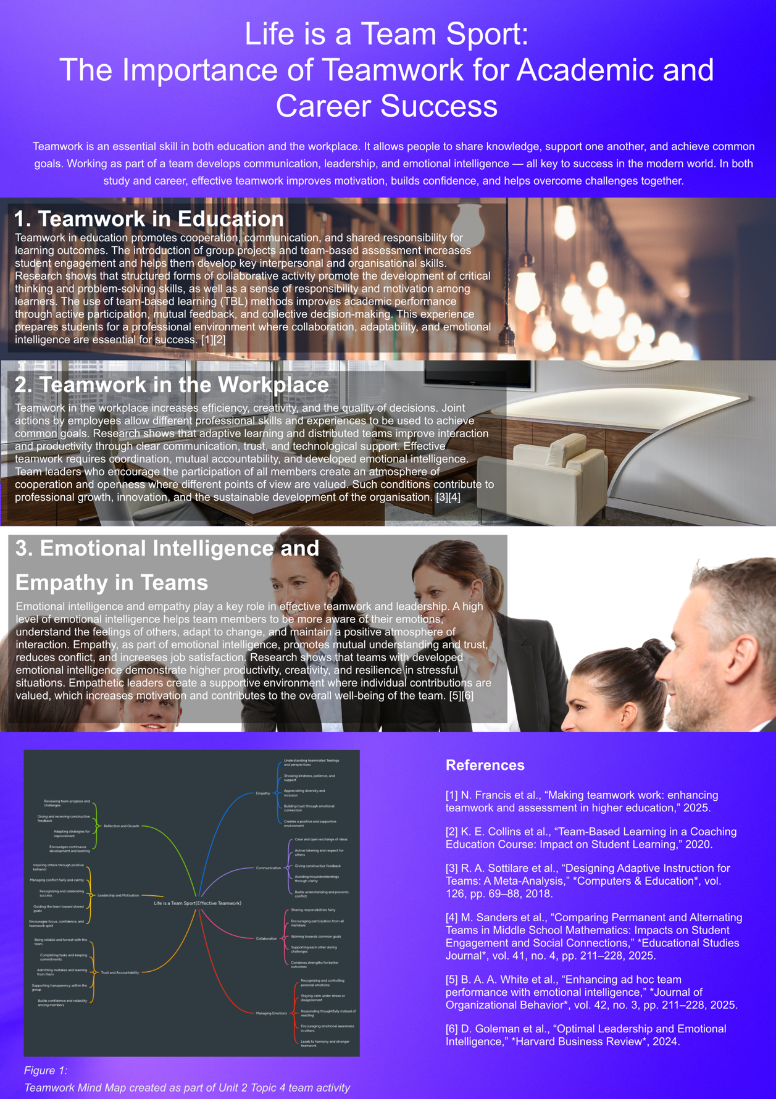
Figure 6: A3 Poster
Poster available online in this link.

Task 3: Virtual Collaboration and RefWorks

Report on Virtual Collaboration
Forming a Team
To complete the assignment for Moodle Unit 3, ‘Virtual Collaboration,’ I chose the topic ‘Forming a Team.’ This topic focuses on the critically important first stage of team development, which is particularly relevant in the context of modern virtual collaboration. The success of a team largely depends on creating positive virtual team dynamics – a mechanism that determines how the behaviour and characteristics of participants influence their interaction and task performance. [5]
Team development is described by Tuckman's model, which, despite its classic nature, remains a relevant framework. At the Forming stage, teams face a number of challenges. Virtual teams are particularly vulnerable to failure due to geographical separation and limited communication channels. A review of the literature shows that these challenges are among the main barriers [3]. In particular, the emergency transition to virtual learning had a significant impact on the dynamics of student teams [2].
To overcome these difficulties, the primary task is to build trust. Effective teams are built on trust, which is the foundation for vulnerability and accountability. Building confidence in virtual teams is challenging due to limited face-to-face interaction, but it plays a central role in improving team effectiveness and promotes the open exchange of knowledge and information. [5]
A key factor for success is psychological safety. This climate assumes that employees can freely express ideas, ask questions, or report mistakes without fear of being judged [5]. Research shows that e-leadership and its impact on team dynamics are an important condition for success [4]. The effective distribution of diverse leadership roles is also important for improving team effectiveness in a virtual learning environment [1].
At the formation stage, it is important to set clear goals. To do this, it is recommended to use the FAST framework, which requires goals to be Frequently Discussed, Ambitious, Specific, and Transparent. [5]

Step-by-step process of using RefWorks with visuals
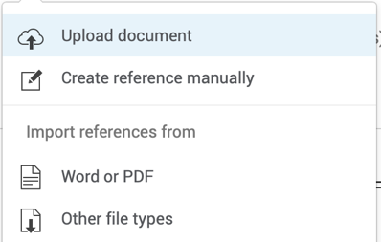
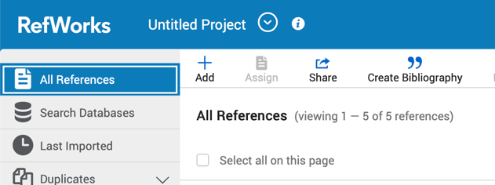
The use of automatic Reference Tools begins with the preliminary download of sources in PDF format, which allows them to be added to the RefWorks library. Integration was achieved by selecting the Add and Upload Document functions, as detailed in Figure 4 and Figure 5.

Figure 5: RefWorks upload document (Personal Collection)
Figure 4: RefWorks (Personal Collection)

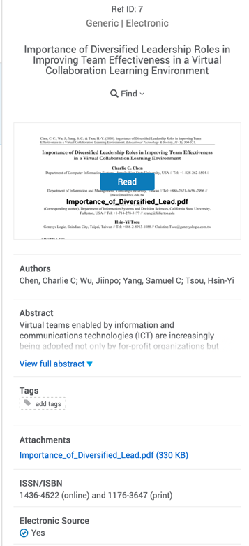
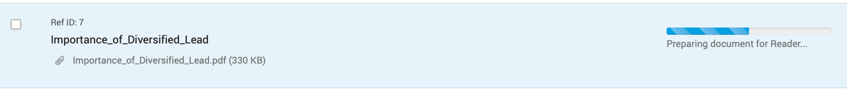
After selecting the downloaded source, the system began automatic processing of the file, as shown in Figure 6.
Figure 6: RefWorks preparing document (Personal Collection)
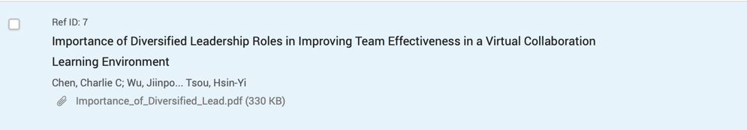
Upon completion of processing, the correct title appeared in RefWorks, along with all the necessary reference data (author, year, title), as illustrated in Figure 7 and Figure 8.
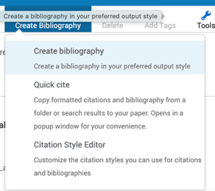
All other sources used for the work were added to the system in the same way.
Figure 7: RefWorks Reference Document (Personal Collection)
The bibliography generation function was used for the final formatting of the reference list. As shown in Figure 9, the ‘Create Bibliography’ function was selected in the top menu to create a reference list. In the new window, the required IEEE style was selected and applied, resulting in the final list of sources used in this work.
Figure 8: Reference Document Info (Personal Collection)
Figure 9: RefWorks Create Bibliography (Personal Collection)
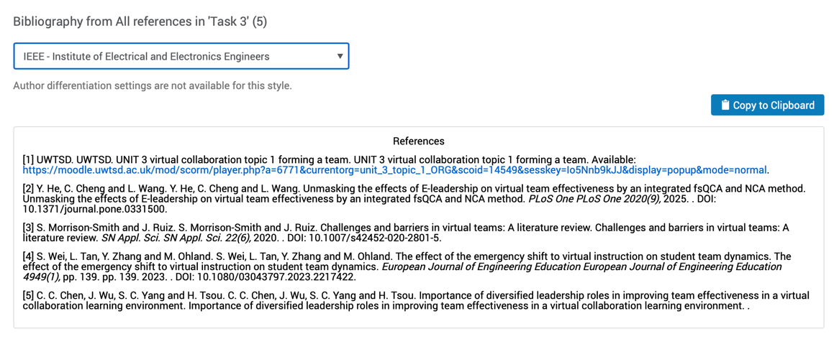
Figure 10 shows how this formatted list looks on the RefWorks website. This process ensures effective reference management and academic integrity when citing all materials used in the work.
Figure 10: RefWorks References List (Personal Collection)

Task 4: E-Portfolio Creation and Evaluation

Task 4 (a): E-Portfolio Creation

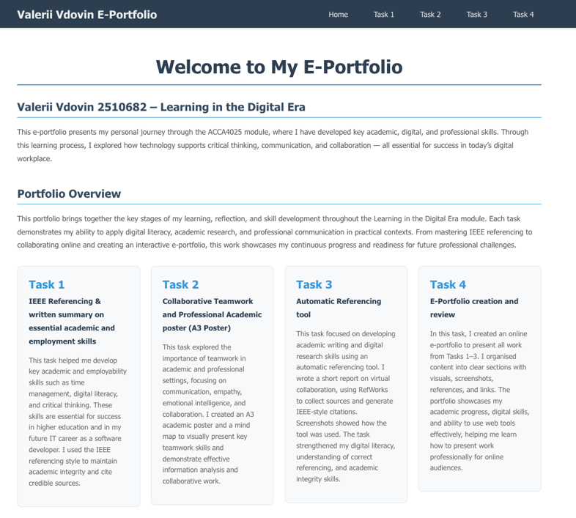
My E-Portfolio Available online here
Figure 11: ePortfolio Home Page (Personal Collection)
The visual materials below demonstrate the structure and content of the e-portfolio I have developed. The Figures 11-18) include the main pages of the site, user interface elements, and posted task components. The materials are shown to confirm the functionality and correct organisation of the e-portfolio.
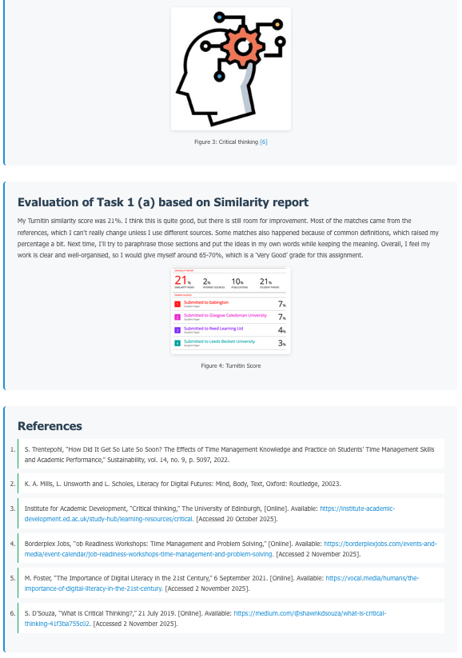
Figure 13: ePortfolio Task 1 Page (Personal Collection)
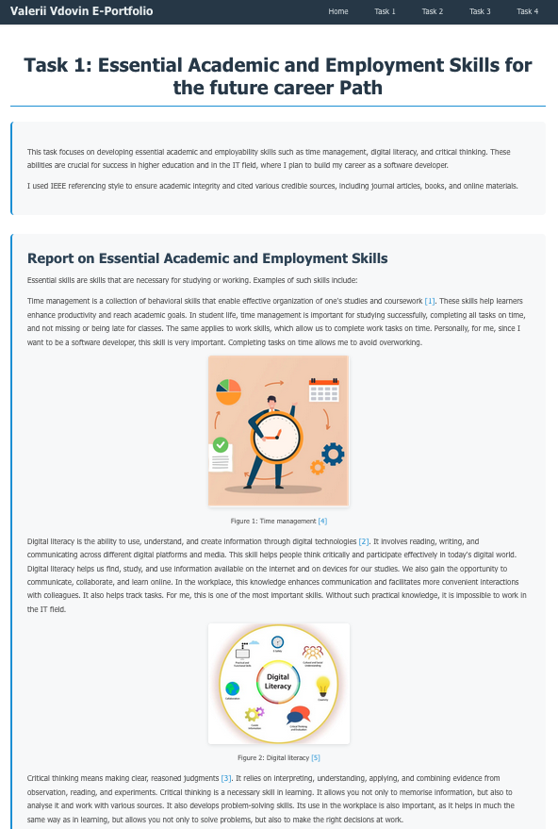
Figure 12: ePortfolio Task 1 Page (Personal Collection)
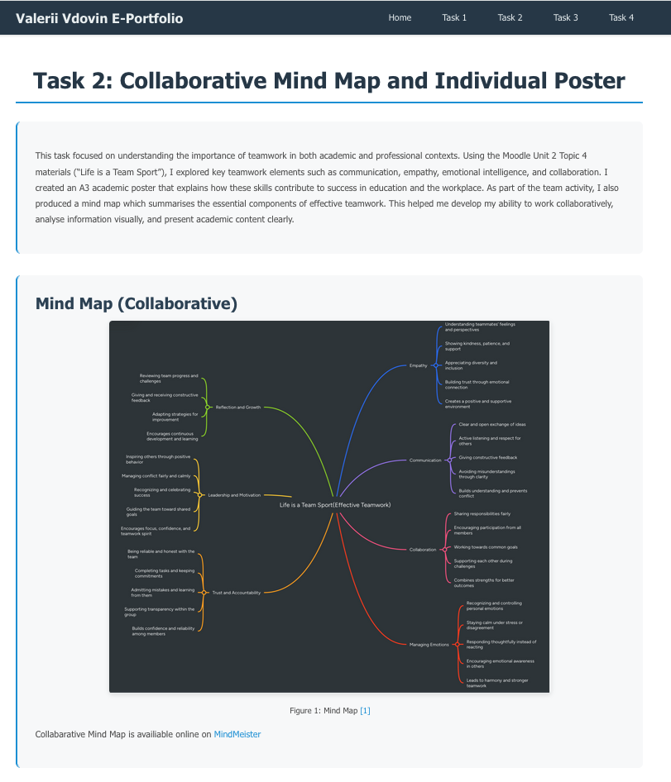
Figure 14 : ePortfolio Task 2 Page (Personal Collection)
Figure 15: ePortfolio Task 2 Page (Personal Collection)
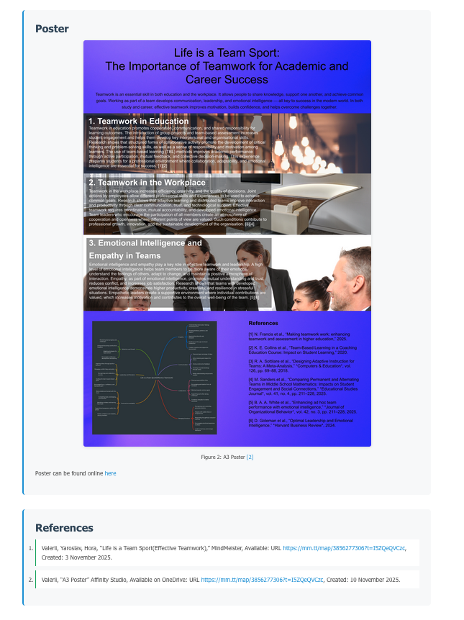
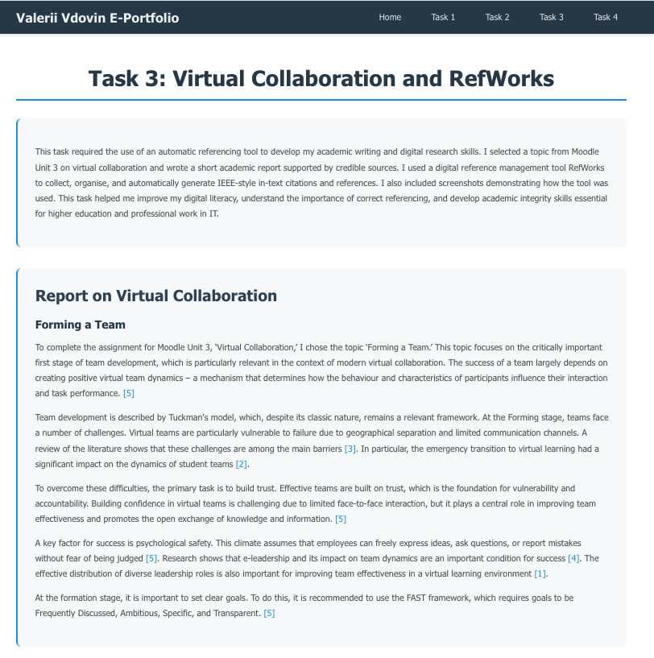
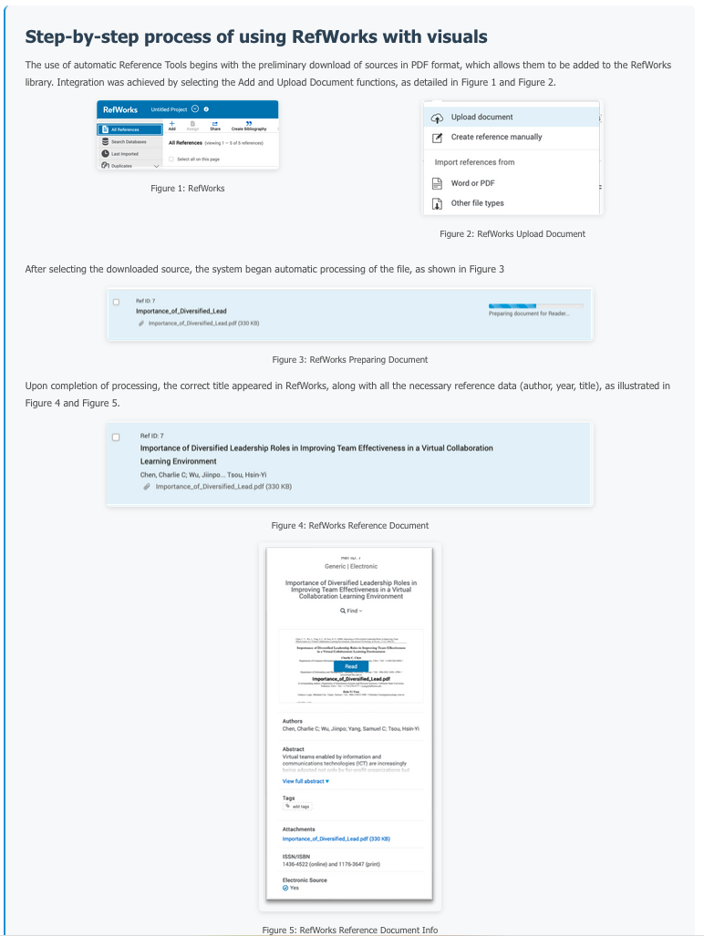
Figure 16: ePortfolio Task 3 Page (Personal Collection)
Figure 17: ePortfolio Task 3 Page (Personal Collection)
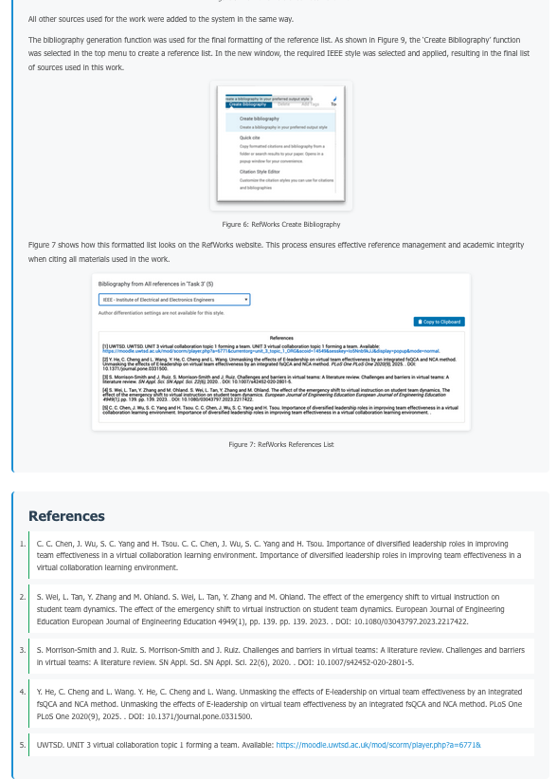

Figure 18: ePortfolio Task 3 Page (Personal Collection)

Task 4 (b): Illustrative Review of E-Portfolio tool Selection
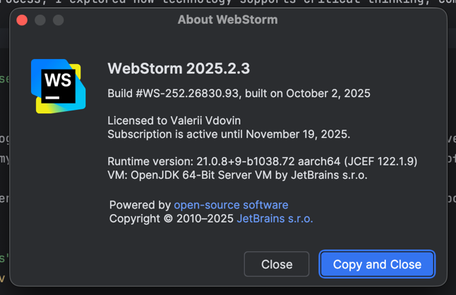
To create my e-portfolio, I used Vite + React, as this stack provides high performance, flexibility, and allows me to create fully customisable web pages. Development was done in WebStrom by JetBrains, which provides advanced functionality for working with components, project structure, and visual interface elements.
Figure 19: WebStorm IDE (Personal Collection)
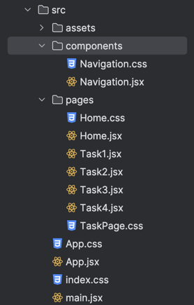
Using React allowed me to create a structured and user-friendly e-portfolio with separate pages for each task. I developed components for text blocks, sections, navigation, and visual materials. Vite ensured fast compilation and instant updates during development, which sped up the work and helped me fine-tune the display of all elements.
Figure 20: Project Structure (Personal Collection)
Working in WebStorm, I used built-in tools for code formatting, autocompletion, error highlighting, and project structure management. This ensured precise customisation of fonts, indents, block placement, and site responsiveness.
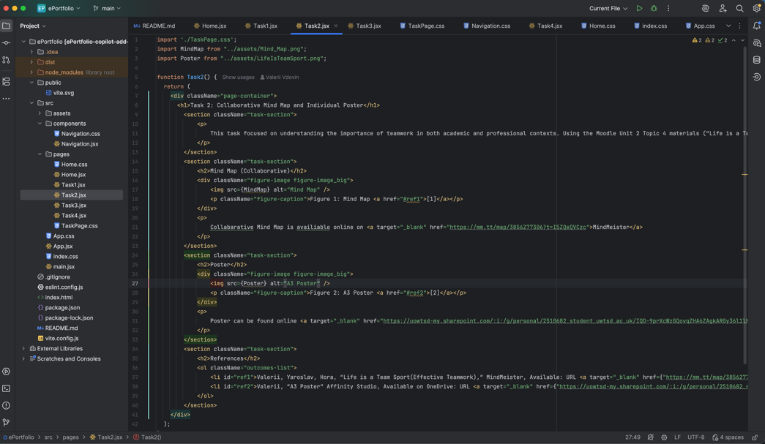
As a result, I created a full-fledged e-portfolio that displays all completed tasks and visual materials, including an A3 poster, mind map, and report with automatic links. This approach allowed me to apply practical front-end development skills and improve my digital competencies in a real project.
Figure 21: WebStorm Task2 page code example (Personal Collection)

Conclusion
Completing all the module assignments allowed me to develop key academic and professional skills, including time management, use of digital tools, teamwork, and correct academic citation. The development of an e-portfolio, academic poster, and report with automatic references helps to present the learning outcomes in a structured way. This document confirms the completion of all module elements and demonstrates my readiness for further learning and professional development in the field of IT.

References

Task 1 References:

[1] | S. Trentepohl, “How Did It Get So Late So Soon? The Effects of Time Management Knowledge and Practice on Students’ Time Management Skills and Academic Performance,” Sustainability, vol. 14, no. 9, p. 5097, 2022.
[2] | K. A. Mills, L. Unsworth and L. Scholes, Literacy for Digital Futures: Mind, Body, Text, Oxford: Routledge, 20023.
[3] | Institute for Academic Development, “Critical thinking,” The University of Edinburgh, [Online]. Available: https://institute-academic-development.ed.ac.uk/study-hub/learning-resources/critical. [Accessed 20 October 2025].
[4] | Borderplex Jobs, “ob Readiness Workshops: Time Management and Problem Solving,” [Online]. Available: https://borderplexjobs.com/events-and-media/event-calendar/job-readiness-workshops-time-management-and-problem-solving. [Accessed 2 November 2025].
[5] | M. Foster, “The Importance of Digital Literacy in the 21st Century,” 6 September 2021. [Online]. Available: https://vocal.media/humans/the-importance-of-digital-literacy-in-the-21st-century. [Accessed 2 November 2025].
[6] | S. D’Souza, “What is Critical Thinking?,” 21 July 2019. [Online]. Available: https://medium.com/@shawnkdsouza/what-is-critical-thinking-41f3ba755c02. [Accessed 2 November 2025].

Task 3 References:
[1] C. C. Chen, J. Wu, S. C. Yang and H. Tsou. C. C. Chen, J. Wu, S. C. Yang and H. Tsou. Importance of diversified leadership roles in improving team effectiveness in a virtual collaboration learning environment. Importance of diversified leadership roles in improving team effectiveness in a virtual collaboration learning environment.
[2] S. Wei, L. Tan, Y. Zhang and M. Ohland. S. Wei, L. Tan, Y. Zhang and M. Ohland. The effect of the emergency shift to virtual instruction on student team dynamics. The effect of the emergency shift to virtual instruction on student team dynamics. European Journal of Engineering Education European Journal of Engineering Education 4949(1), pp. 139. pp. 139. 2023. . DOI: 10.1080/03043797.2023.2217422.
[3] S. Morrison-Smith and J. Ruiz. S. Morrison-Smith and J. Ruiz. Challenges and barriers in virtual teams: A literature review. Challenges and barriers in virtual teams: A literature review. SN Appl. Sci. SN Appl. Sci. 22(6), 2020. . DOI: 10.1007/s42452-020-2801-5.
[4] Y. He, C. Cheng and L. Wang. Y. He, C. Cheng and L. Wang. Unmasking the effects of E-leadership on virtual team effectiveness by an integrated fsQCA and NCA method. Unmasking the effects of E-leadership on virtual team effectiveness by an integrated fsQCA and NCA method. PLoS One PLoS One 2020(9), 2025. . DOI: 10.1371/journal.pone.0331500.
[5] UWTSD. UWTSD. UNIT 3 virtual collaboration topic 1 forming a team. UNIT 3 virtual collaboration topic 1 forming a team. Available: https://moodle.uwtsd.ac.uk/mod/scorm/player.php?a=6771&currentorg=unit_3_topic_1_ORG&scoid=14549&sesskey=Io5Nnb9kJJ&display=popup&mode=normal.

