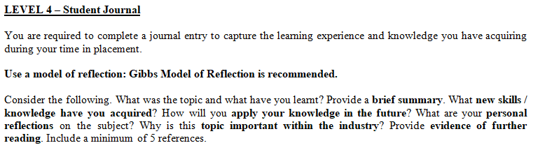
Student Name:Alexandru-Bogdan  Alexie  Student Number: 2227016 | Module: Hotel Placement – Food and Beverage Operations (BMIH4002)  Lecturer: Ffion Cumberpatch, Muhammad Cassamo, Jaliya De Silva

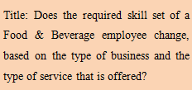
Research and evaluate the skills required for a specific job role in the restaurant industry
The development of various abilities is crucial for quality control managers in the restaurant industry. All restaurant businesses seek qualified quality control managers who can lead the operation to succeed in the cutthroat business environment, which is the reason. (Pirani et al, 2016). Now consider the abilities necessary for a quality control manager in the restaurant industry to be; Food safety and sanitation: Knowing all the responsibilities and guiding principles of food safety and hygiene regulations is crucial for the quality control manager. (Legrand et al, 2016). By doing so, the manager is able to uphold and adhere to all of the HACCP principles and provide additional options for managing food handling, storage, and a variety of other factors. (Oskam et al, 2016). Quality Assurance: For the quality control manager, quality assurance is yet another crucial competence that is required. With the aid of this, the manager may create a quality standard and take action when he or she determines that the moment is suitable to do so in order to raise the calibre of the food and services provided by the restaurant. Ability to analyse and solve problems: The ability to analyse and solve problems is a crucial talent for the quality control manager. (Xiang et al, 2017).

The quality control manager may use this ability to assess all of the difficulties and obstacles that they confront and to find solutions. (Oskam et al, 2016). Therefore, it is crucial for the manager to maintain this problem-solving ability since it aids in resolving any issues. Leadership and Training: The quality control manager has to possess leadership abilities. The manager may inspire both the personnel who serve clients and the whole culinary team with the aid of leadership abilities (Li et al, 2017). The manager must also have the ability to teach others so that they may assist other workers who need training. The personnel may benefit from training by learning all the quality control processes and their responsibilities in preserving the food's quality. (Pirani et al, 2016). Communication abilities For the quality control manager, effective communication is crucial. Therefore, having good communication skills is crucial for the manager of quality control (Pizam et al, 2016). This ability enables a restaurant management to effectively communicate with both staff and customers, which improves the business's brand image as well. A further crucial component for the quality control manager is time management abilities. It is crucial to schedule the time for food preparation and serve the meal promptly in order to provide superior customer service and high-quality cuisine. Therefore, the management must continue to use this talent in order to improve the restaurant's capabilities and ensure its success (Stephenson et al, 2018).

Compare and contrast the skills required for this job role in your chosen restaurants
Famous restaurant food franchises across the globe include "Premier Inn" and "McDonald." These businesses want qualified quality control managers who can improve both the company's profitability and its reputation (Oskam et al, 2016). Compare and contrast the following job requirements for McDonald and Premier Inn' quality control managers; Services to Customers: Both "Premier Inn" and "McDonald" place a high priority on customer service. The rationale is that a company organisation cannot survive in the cutthroat business industry without providing adequate customer service (Tuomi et al, 2019). As a result, it is crucial for "Premier Inn" to provide exceptional client services that might result in further advantages. Better customer service from "McDonald" managers than from other restaurant businesses is necessary for the chain to draw in more clients. (Legrand et al, 2016). Complexity of the menu: "Premier Inn" provides a wide variety of beverages, including hot and cold drinks, custom orders, and seasonal special drinks, all of which draw large crowds and cultivate repeat business for the company (Stephenson et al, 2018). However, "McDonald" distinguishes itself from other businesses by concentrating on fast food products. McDonald's management must carefully watch over every meal item in order to provide customers the highest-quality products possible and foster their loyalty to the business. (Marasco et al, 2018).

Operational Efficiency: In order to succeed, businesses like "Premier Inn" and "McDonald" need to be operationally efficient. (Xiang et al, 2017). The manager of the fast food chain "McDonald" must make sure that orders are placed in a timely manner, maintain the quality of kitchen operations, streamline employee workflow, and guarantee great quality that meets consumer demands. However, in order to extend its client base, "Premier Inn" must maintain the quality of its beverages while also providing excellent customer service (Lin et al, 2020).

REFERENCE LIST
Legrand, W., Sloan, P. and Chen, J.S., (2016). Sustainability in the hospitality industry: Principles of sustainable operations. Routledge.
Li, X., Ma, E. and Qu, H., (2017). Knowledge mapping of hospitality research− A visual analysis using CiteSpace. International Journal of Hospitality Management, 60, pp.77-93.
Lin, N. and Ottenbacher, M., (2020). Past and present streams in international hospitality research.
Marasco, A., De Martino, M., Magnotti, F. and Morvillo, A., (2018). Collaborative innovation in tourism and hospitality: A systematic review of the literature. International Journal of Contemporary Hospitality Management.
Oskam, J. and Boswijk, A., (2016). Airbnb: the future of networked hospitality businesses. Journal of Tourism Futures.
Pirani, S.I. and Arafat, H.A., (2016). Reduction of food waste generation in the hospitality industry. Journal of Cleaner Production, 132, pp.129-145. FB
Pizam, A., Shapoval, V. and Ellis, T., (2016). Customer satisfaction and its measurement in hospitality enterprises: a revisit and update. International Journal of Contemporary Hospitality Management.
Stephenson, M.L. and Ali, N., (2018). Deciphering ‘Arab hospitality’. Routledge Handbook on Tourism in the Middle East and North Africa.
Tuomi, A. and Tussyadiah, I., (2019). ROBOTISED HOSPITALITY-Hack Hospitality-Applications and Implications of AI in Hospitality.
Xiang, Z., Du, Q., Ma, Y. and Fan, W., (2017). A comparative analysis of major online review platforms: Implications for social media analytics in hospitality and tourism. Tourism Management, 58, pp.51-65.

