University of Wales Trinity of Saint David
School of Engineering

Group Project

Open-Wheel Electric Hill Climb Race Car Powertrain Final Report
M5X00400

Daniel Wilcox (1802007), Reza Shafie Pour Motlagh (1810478), George Dalton Brown (1801728), Jefferey Elliss (1802644), Timothy Stanbury (1800702), Steffan Robinson (1801468), Peter Olliffe (1806692)

Contents
1. Introduction 1
2. Project Organisation 1
3. Daniel Wilcox 1802007 2
3.1. Duty Cycle 2
3.2. Driveshafts 3
3.3. Entire Car Model 9
3.4. References 11
4. Reza Shafie Pour Motlagh 1810478 13
4.1. Work Content 13
4.2. Research 14
4.3. Rear Chassis 17
4.4. Battery Boxes 17
4.5. Battery Selection 18
4.6. Group Project Challenges 18
4.7. References 19
5. George Dalton Brown 1801728 20
5.1. Controllers 20
5.2. Development of Torque Vectoring/Launch Control Software 24
5.3. Project Managing 26
5.4. References 27
6. Jefferey Elliss 1802644 28
6.1. Transmission 28
6.2. Group Work 34
6.3. References 35
7. Timothy Stanbury 1800702 36
7.1. My Role 36
7.2. Timing Chart 36
7.3. Work Done 37
7.4. Modelling 38
7.5. Potential Dangers/Drawbacks 39
7.6. Conclusion 40
7.7. References/Websites used 40
8. Steffan Robinson 1801468 41
8.1. External Cooling 41
8.2. Internal Cooling 43
8.3. Diagrams 45
8.4. Cost 46
8.5. References 47
9. Peter Olliffe 1806692 48
9.1. Requirements for V-0 48
10. Achievement and Progress Relative to Initial Plan 51
11. Success and Failures 51
Appendices 52
Meeting Minutes 54

Introduction
The brief of the project was to design an open wheel electric hill climb car to compete in the British hill climb championship. The car had to be competitive and the budget was not fixed so long as a components price was reasonable for the competitiveness of the vehicle. We were given the carbon fibre tub of a Toms race car and were given the deadline of the end of March. The purpose of this project is two-fold; to allow us to experience the trials and tribulations of working in groups for an extended period, and what it takes to excel in a group environment where you need to put the success of the group over individual success. As it turns out, this line of thinking in fact slowed the group progress as the bulk of people did not pull their weight. We, the powertrain group, must liaise with the chassis group to place the motors and batteries, the aero group to determine what foot print we can work with and what downforce generating devise they’ll need to use, and the simulation group to provide them with accurate power, torque, and weight figures to allow them to accurately simulate the driving dynamics of the car. This report shows the progress of the project from each team member and how the project compared against the initial plan of the project. The project will run from October 1st – 23rd March and includes 2 vivas in December and March.

Project Organisation
After the first meeting discussing the aim of the project, each member decided which area of the project they wanted to work on. Then within this discipline, we broke the project down into areas of responsibility. It was also agreed, we were to meet at least once a week to discuss progress and plans for the following week.
With the project in progress, a Gantt chart was drawn (Appendix 1). This gave the group a timeline and a point of reference for discussing success of the project. With the time set and areas of responsibility agreed, it was time to begin working.

Daniel Wilcox 1802007
I assembled the group presentation and group report after reduced communication towards the end of March. However, I managed to organise everyone to write in one format and submit their work on time.

Duty Cycle
Duty Cycle is the requirements on the car in terms of work and operations needed to be done. I focused on the hill climb championship and looking at the competition in the top open wheel class.
Courses
My initial research was into the courses in the British Hill Climb Championship. In particular, I looked into length and number of corners for each track so the battery member could begin getting a rough idea on the energy required to complete the run. I then created a spreadsheet of the courses and their statistics (Appendix 3.1). The greatest course length was Harewood. However, I also included Goodwood Hill Climb which is not part of the BHCC but an invite to the course should be considered. Goodwood is the greatest length of course to consider at 1.87Km.
Records
To be competitive I set the target speeds as the course records. As seen in appendix 3.1 this was assigned for each course and it therefore meant the greatest run time had been found for the car which is of great use to the battery member. The information was found through the British Hill Climb website (2020).
Velocity
Competitive open wheel hill climb teams have not published any data logging values on any of the courses in the championship. From the record run and the length of course, I calculated an average velocity per track as simply length of course divided by record run time. An average ‘average velocity’ across all tracks is useful for the aerodynamics team as this is the point the car needs to be most effective. The average ‘average velocity’ was 34.07m/s. However, a top speed was not published in text. Instead, I found championship video coverage (HillClimb.TV, 2020) which included speeds on certain stretches of the course. This data is valuable for the transmission member as a gear ratio can be planned.
Time on throttle
As no teams had published data logging values, I planned an alternative by observing on-board footage at each course and calculated their time on throttle as a percentage of their total run time. Obviously, every car handles differently and multiplying by the record run time to calculate our car’s time on throttle has large error included but as a percentage an idea of each course is understood. Also, with our estimated time on throttle, heat loss can be calculated, and the amount of power required from the battery can be more closely considered. This will reduce the mass from that initially concepted. Figure 3.1.1. shows the spread of this data with Craigantlet having the most amount of time on throttle and Barbon the least. At Barbon, it could be considered to run a smaller lighter battery pack for competitive advantage.
Figure 3.1.1 shows time on throttle per track
Heat in a run
The efficiencies of components like the motor are known. I also assumed the throttle is binary as either on or off. Then by multiplying the power lost by the time on throttle, I quickly calculated the heat to lose per run in the battery, motor and controller. The greatest heat to lose was at Craigantlet where 3544kJ needed to be dissipated. This is valuable to the cooling member of the team. Where we did some thermodynamics to work out how much water is needed to take 3544Kj of heat and remain in the tolerance of the components which was between 20°C and 80°C. It was then decided the car would not run radiators. (Appendix 3.2)

Driveshafts
After the initial research of duty cycle, I was looking for something to design so I took responsibility of driveshafts. The motor, tyres, gear ratio and rough power output had been specified. My task was to take rotary motion from the output shaft of the gearbox to the rear hub. As two gearboxes had been specified, I only needed to design two identical half-shafts.
Design and Theory
Having never completed any Finite Element Analysis or any real experience with drivelines, I started with torsion in cylinders and researching different driveshaft solutions. I found three main solutions, yoke and spider u-joint, Rzeppa joint, and the Tri-pod joint (Crouse, 1980, p.506). Traditional u-joints are designed to have both in and out faces parallel and therefore commonly seen between a traditional gearbox and rear differential. Rzeppa joint is a constant velocity joint as it does not have to run parallel so can account for suspension travel or steering angle if it were front wheel drive. Rzeppa joint is based on a series of ball bearings held in a ring to achieve change in length (Roethlisberger and Aldrich, 1969). Another example of a CV joint is the tripod which has a spider similar to the traditional u-joint, but rollers fit the spider which slides inside a tripodal body. This movement allows the change in length needed with suspension travel as the driveshaft length will be different to the suspension arm length. CV joints are more complicated as they have to be sealed by dust boots and filled with grease to remain lubricated. According to (Magirius and Booker, 1995) with increase in operating angle there is an increase in mechanical losses as friction from the movement generates heat. However, some angle is useful as movement keeps grease in the needle bearings and in the rollers contact with the body. Roethlisberger and Aldrich, (1969) have used 3° as an operating angle with a Tri-pot CV joint. According to Shigley, (1986, p.399), load ratings on the needle bearings can be calculated and then the dimensions of the needles can be found.
Next, I started looking at cylinders in torsional stress situations. Using formula 3.2.1, I could begin looking into calculations and dimensions of simple cylinders (Hearn, 1997, p.176).
Formula 3.2.2 Torsion formula.
$$J=\frac{πD^{4}}{32}=\frac{π(D^{4}-d^{4})}{32}$$

Formula 3.2.1 Torsion formula.
$$\frac{T}{J}=\frac{τ}{r}=\frac{Gθ}{l}$$

Dimensions
With the gear ratio specified and motor torque known, I calculated torque out of the gear box. I then compared this torque with the greatest torque taken by the tyres at full downforce. The smallest of these values was the torque the driveshaft must withstand and the torque out of the gearbox was the smallest at 2150Nm. I specified a material through Solidworks as 4340 Steel. I then created an Excel sheet entering drive torque and material constants like shear and then rearranged formula 3.2.1 to find the minimum radius of a solid 4340 cylinder (Appendix 3.3). For a solid cylinder, I calculated a radius of 15.75mm to take 2150Nm. Next, I created a simulation on Solidworks of a solid cylinder of the same radius. I held one side of the cylinder and applied a 2150Nm of torque to the other to observe if the material is at yield point as calculated on Excel. Figure 3.2.1 shows the Solidworks result closely matches my calculation completed in Excel. It is also observed the centre of the shaft is not under any load. To save weight I decided to make the shaft hollow. Appendix 3.3 shows a calculated 60% saving in material using hollow shafts.
Figure 3.2.1 shows Solidworks modelled cylinder of 15.75mm radius at 2150Nm torque
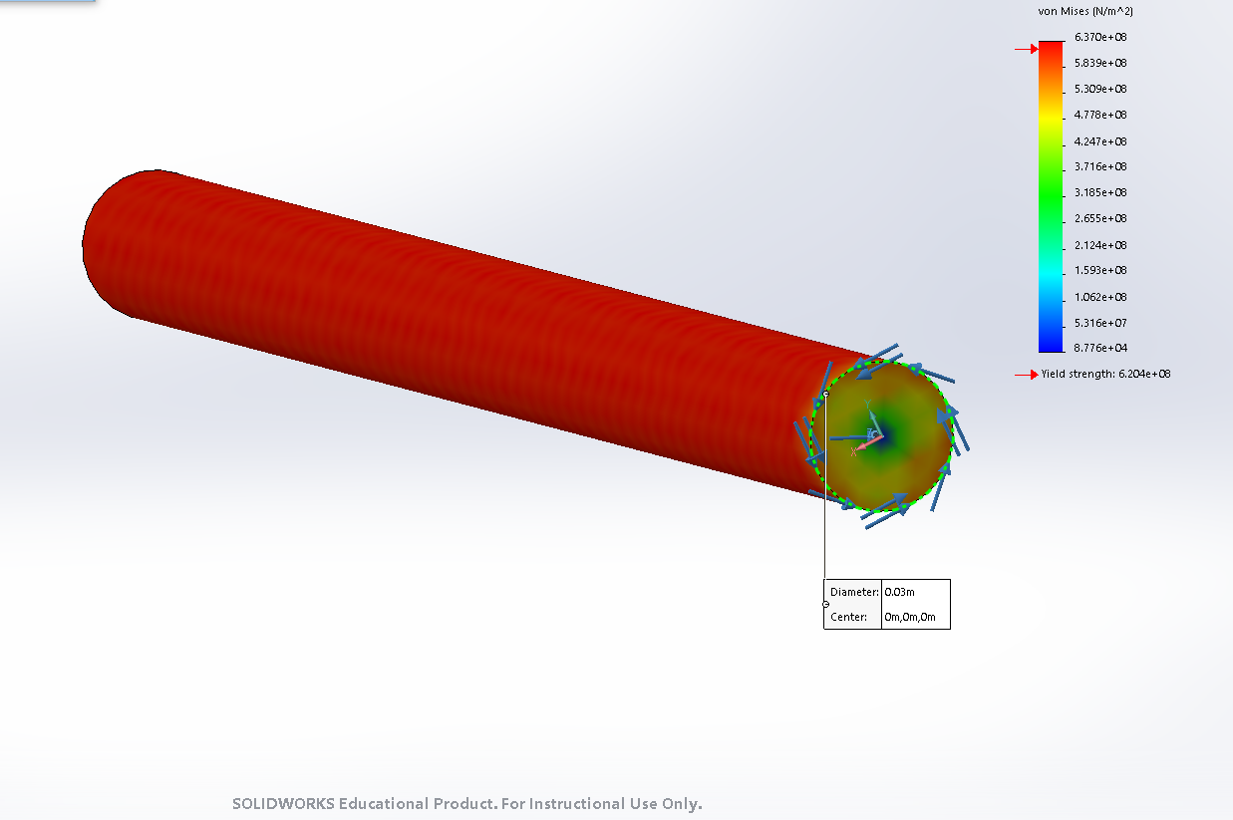

Using formula 3.2.2, I used radius 15.75mm outer and 10.75mm inner and calculated a torque of 1683Nm which means according to my spreadsheet it will be beyond yield, so I need to increase the radius. I then increased the radius in the Excel sheet to 17.5mm outer and 12.5mm inner radius and it could take 2180Nm of torque. To check the maths on the Excel sheet I replicated the shaft in Solidworks and created another simulation and applied 2150Nm of torque to one side. As expected, Figure 3.2.2 shows the shafts is below yield at the peak 2150Nm torque.
Figure 3.2.2 shows Solidworks modelled cylinder of 17.5mm, 12.5mm at 2150Nm torque
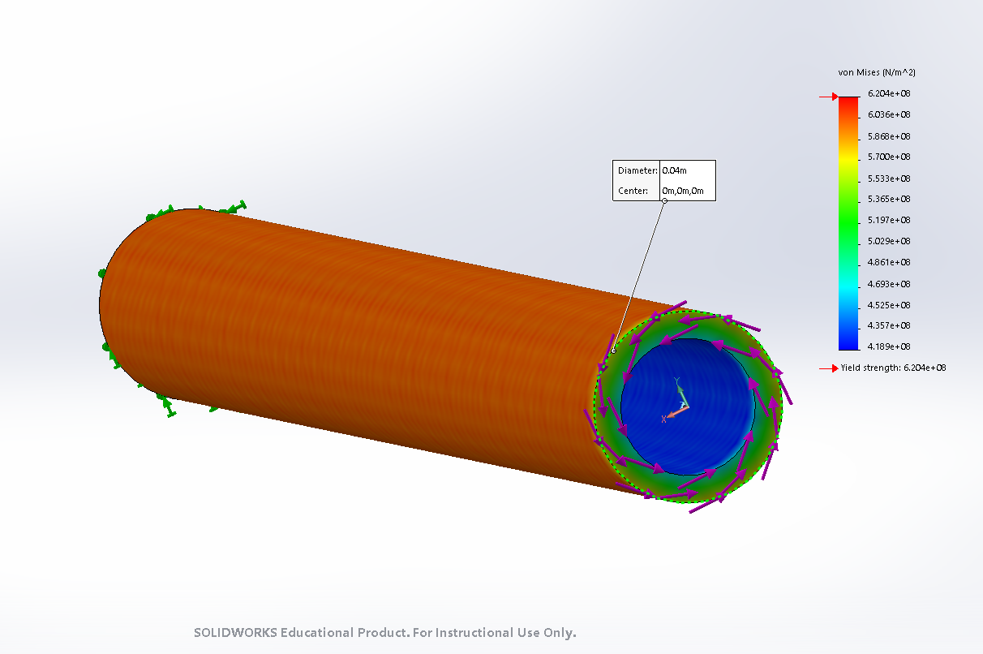

I then turned my attention to the joints in the driveshaft and I initially created a simple yoke and spider u-joint in Solidworks and created a simulation and set the joint material at 4340 steel. Figure 3.2.3 shows the u-joint at yield and has exaggerated deformation. Due to having to keep the outer yokes parallel I decided to use a CV joint. With that, I decided either a quadripod or tripod u-joint as it is simpler to maintain than a Rzeppa joint. Another u-joint alternative using simple couplings is using two u-joints back to back otherwise known as a double cardan joint. This acts as a CV joint and they do not have to run parallel, but these struggle to lubricate so are ideal for shafts which don’t see much movement like a steering rack but not ideal for driveshafts. These joints are also used in high articulation angles like off roaders as they offer more movement than Tripods or Rzeppas (Cooney, 1974).
Figure 3.2.3 shows Solidworks modelled u-joint at 2150Nm
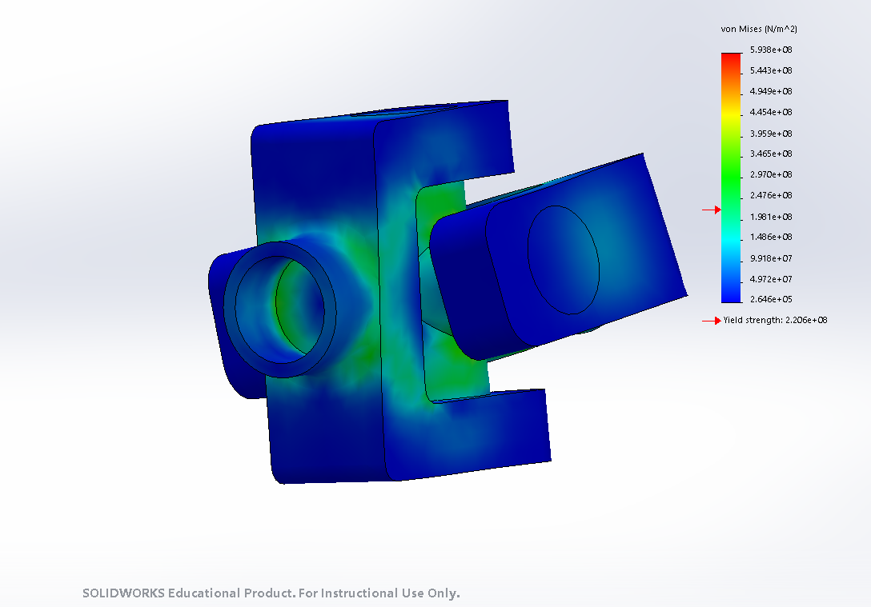

I modelled and tested a quadripod u-joint first as it was simpler to model and less commonly used, so I wanted to see its strengths and weaknesses. As seen in figure 3.2.4, the centre shaft was too narrow and therefore the shaft was beyond yield. The deformed result meant the rollers merged with the body. I adjusted these factors when designing the tripod joint.
Figure 3.2.4 shows initial quadripod u joint under 2150Nm torque and deformation on.
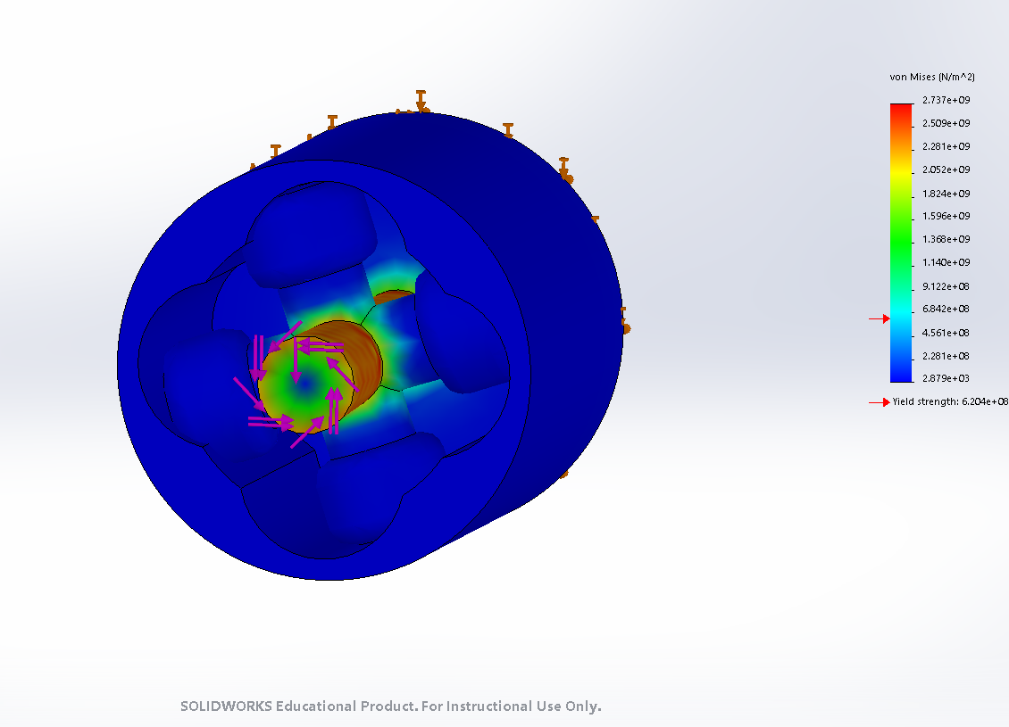

Next, I took what I learnt from the quadripod to model a tripod CV joint. I created a simulation and held the rollers as fixed geometry and applied 2150Nm of torque to the shaft. As shown in figure 3.2.5, the shaft is safely below yield and I applied splines to the shaft to hold the two together. Where the splines are cut into the yoke, Solidworks is expecting greater von-mises stress as the material is thinner. However, it will still be safely below yield.
Figure 3.2.5 shows solidworks model tripod CV joint under 2150Nm torque
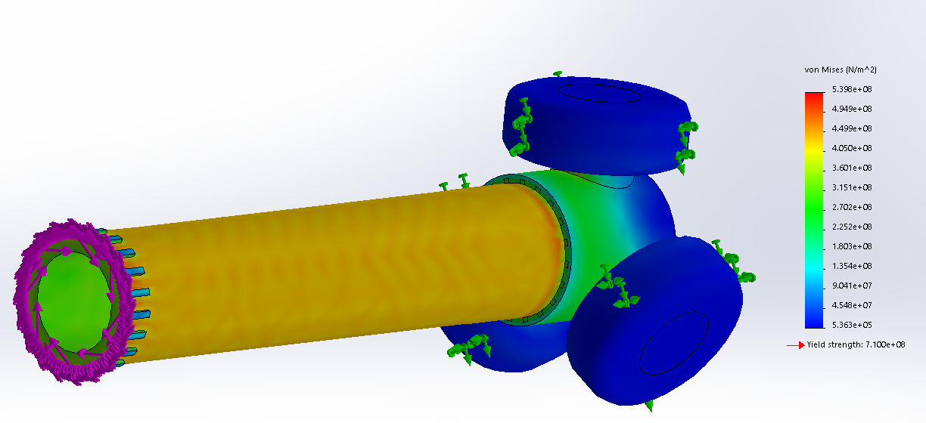

Material
With the steel 4340 below yield I considered using composite like Carbon Fibre. I found the Driveshaft Shop catalogue (2020) and they are not only using composite shafts for race purposes but also road car applications. However, I could not configurate the Solidworks simulation to accurately model composite materials as they are brittle. Solidworks simulation is a non-linear resolver so the results are accurate beyond yield and uses Von-Mises stress prediction which is ideal for ductile materials like steel (Matthews and Rawlings, 1994, p.219). As I could not accurately or reliably model composites, for safety I opted to use 4340 steel even if it was heavier than carbon fibre. Lighter composite driveshafts will have less rotational inertia which is better for performance. With more time, I will look into Gere and Timoshenko’s, (1985, p.155) method of calculating by hand torsion in concentric composite bars to compare dimensions with the 4340 shaft. According to Rastogi, (2004), composite shafts can reduce NVH from the driveline as they have superior vibration dampening in comparison to metal shafts.
Final Design
With Solidworks and my Excel spreadsheet agreeing and the steel driveshaft is safely below yield, it is time to construct the final design and apply it to the full car build. I decided the tripod is the optimum joint for the car and the driveshaft is made of 4340 steel as I could not safely and reliably predict the carbon driveshaft. This will be able to take the load from the Emrax motors and will be able to take shock loads from traction systems or even from uneven road surfaces like potholes on the track.
I modelled a new tripodal body with thread for the hub nut and splines to then drive the hub and therefore the wheel. On the gearbox side the body has splines to mount to the output shaft of the transmission. Rubber boots will seal the grease inside to lubricate the bearings and keep dust and grit out. Rubber will be a sufficient material as there will be low operating angles so the rubber will not see much movement (Magirius and Booker 1995).
Figure 3.2.6 Driveshaft assembly including splines tripod CVJ and analysed driveshaft
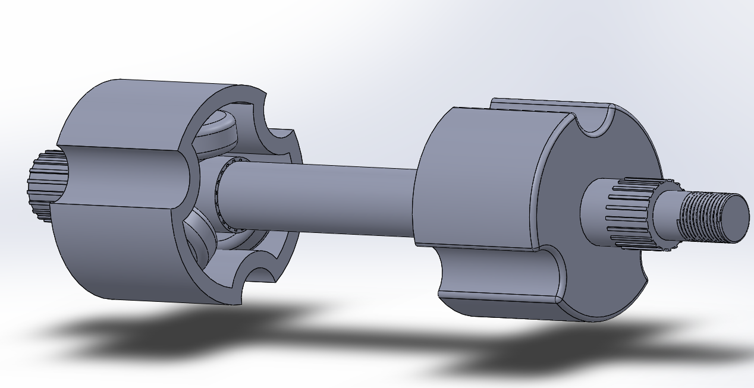

Validation and testing
Every component was tested in the design process other than the splines connecting the CV body to the hub and gearbox. I set up a Solidworks study focusing on the splines to make sure they are safely below the yield point of the 4340 steel. Figure 3.2.7 shows the high stress between the splines, but it is still 3x10⁸ N/m² below the yield of the material. With this final test complete, the driveshaft is ready to drive the car.
Figure 3.2.7 shows simplified Solidworks simulation on splines connecting to gearbox.
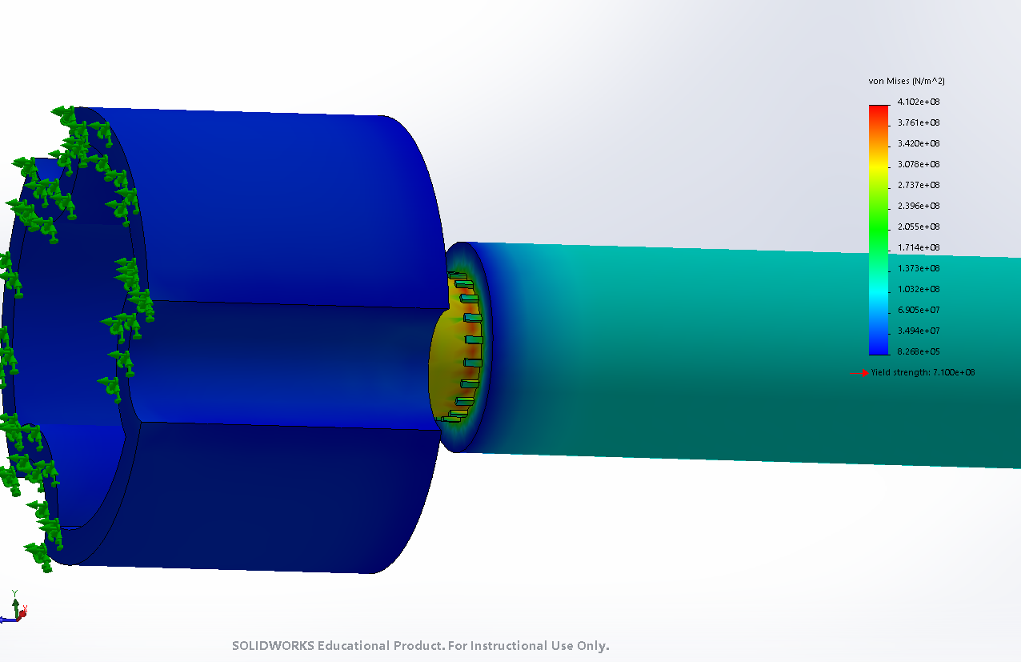

Costing
The driveshaft will be custom manufactured from 4340 steel which costs roughly £0.20 per Kg (MIT 2020). This means in material alone the driveshaft will cost roughly £7 if it was perfectly cast with zero waste as Solidworks has an estimated dry mass of 12.3Kg. This value does seem rather heavy, but this is related to using 4340 steel which is a dense and heavy material.
Manufacturing costs will be considerable as the driveshaft will be machined instead of casting so there will be waste material and skilled labour to manufacture the part. Considering the dust boots, grease, needle bearings and then machining the rollers and housings with splines it can cost hundreds of pounds for two. According to Driveshaft Shop (2020), high quality motorsport driveshafts and Rzeppa CVs are thousands of dollars. A price to manufacture the custom driveline will be dependent on so many variables and contact with a machine shop is needed to truly cost the component.

Entire Car Model
I took responsibility of bringing all the components of the car together in one CAD model. One reason for bringing the car together was to observe any components yet to be created and to then use as a presentation tool. The engineering and discussions were done on each component before it was added to the model. However, the entire car CAD was useful to double check the components even on the simplest of things like scale.
Overall, the car came together well with the rear body fitting over the motors and batteries. However, if the project was to be completed again, I would hold more meetings from the beginning and take reliable meeting minutes. These minutes could then have been checked against the following week to make sure jobs were done. This would have increased team communication and therefore more components would have fitted the car and would have fitted earlier so there would have been enough time to resolve any issues.
Figure 3.3.3 shows this lack of communication and the time constraint at the end of the project as, for example, the sidepods are in the same place as the rear driveline and suspension but there was not enough time to resolve this issue once the components had been sent to me to assemble the model.
Figure 3.3.3 shows the rear of the car
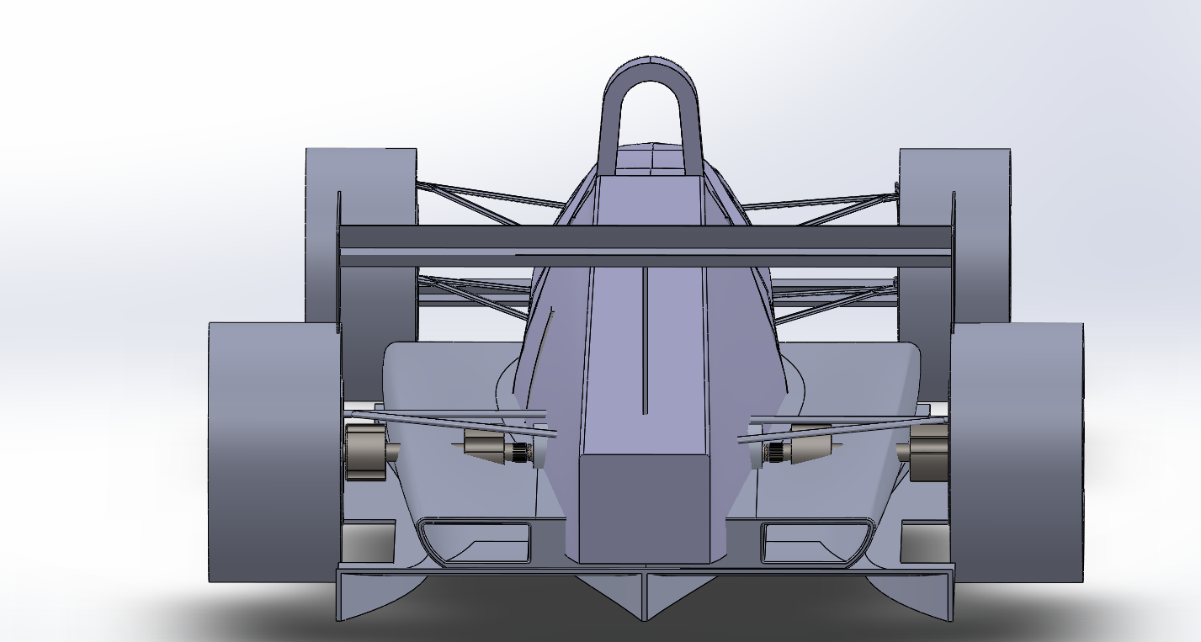
Figure 3.3.2 shows the right of the car
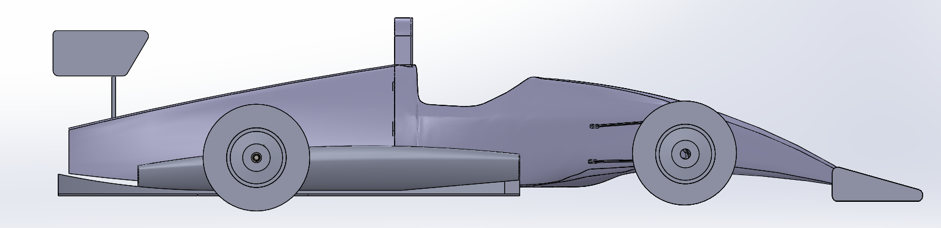
Figure 3.3.1 shows the front of the car including the cooling box.
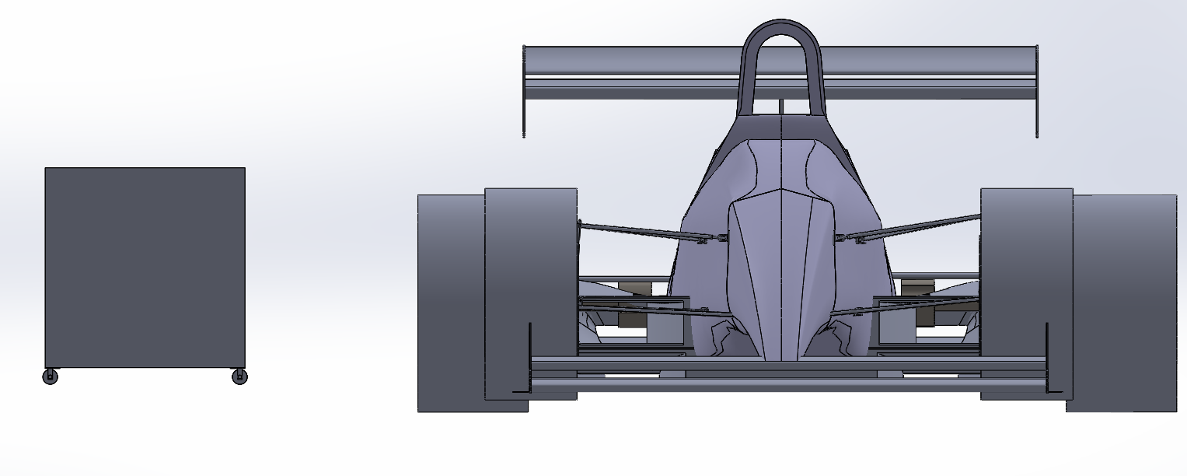

References
- British Hill Climb (2020) Venues and Organising Clubs
Available at: https://www.britishhillclimb.co.uk/venues
(Accessed 17/03/2020)

- Cooney, C (1974) Double Cardan Constant Velocity Universal Joint
Available at: https://saemobilus-sae-org.ezproxy.uwtsd.ac.uk/content/740671/
(Accessed 20/03/2020)

- Crouse. W (1980) Automotive Mechanics 8th Edition
New York: McGraw-Hill Higher Education

- Driveshaft Shop (2020) Catalogue
Available at: https://www.driveshaftshop.com/
(Accessed 17/03/2020)

- Gere, J and Timoshenko, S (1985) Mechanics of Materials Second SI Edition
Belmont: Wadsworth International

- Hearn. E (1997) Mechanics of Materials Volume 1
Oxford: Butterworth Heinemann

- HillClimb.TV (2020) British Hill Climb Championship Livestream
Available at: https://www.youtube.com/channel/UCvGNmByIVMxAWS-96zZr_Jg
(Accessed 15/03/2020)

- Magirius, S and Booker D (1995) High Speed Constant Velocity Joints for Car and Light Truck Driveshafts
Available at: https://saemobilus-sae-org.ezproxy.uwtsd.ac.uk/content/950891/
(Accessed 16/03/20)

- Matthews, F and Rawlings, R (1994) Composite Materials: Engineering and Science
London: Chapman & Hall

- MIT (2020) Material Properties
Available at: http://web.mit.edu/course/3/3.11/www/modules/props.pdf
(Accessed 19/03/20)

- Rastogi, N (2004) Design of Composite Driveshafts for Automotive Applications
Available at: https://saemobilus-sae-org.ezproxy.uwtsd.ac.uk/content/2004-01-0485/
(Accessed 15/03/20)

- Roethlisberger, J and Aldrich, F (1969) The Tri- Pot Universal Joint
Available at: https://saemobilus-sae-org.ezproxy.uwtsd.ac.uk/content/690257/
(Accessed 15/03/20)

- Shigley, J (1986) Mechanical Engineering Design First Metric Edition
New York: McGraw Hill International

Reza Shafie Pour Motlagh 1810478

Work Content
Personal Tasks
After the Christmas break period, the motor selection had been finalized, so I took it upon myself to take up some slack in the other groups. I decided to redesign the battery cage, battery box, rear chassis, and battery selection. As a part of the redesign of the motor cage and rear chassis, I was to run the FEA on the components and see where they could be improved. However, the components I received to run the FEA on were of such an inferior design, that I started clean sheet, and redesigned them to an acceptable level given the time frame I had.

Research
Motors
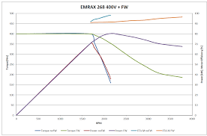
At the beginning the motor selection task seemed like it would be a straightforward and easy task. However, the motor choice changed 4 times depending on how the car was driving in the simulator, and which battery we were using. When we found the Gensace battery, the one that ended up as our final selection, the motor choice was frozen in favour of the Emrax 268, as a bigger motor with more power was too undriveable and needed too many batteries to package properly. The power curve of the 268 was more favourable, as show in figure one, the purple line (power kW), has a linear power curve, much line a naturally aspirated combustion engine, and has a slight drop in power at higher rpm ranges. The green line (torque Nm) has the characteristic electric motor flatness, and drops off at higher rpm. We can use these two factors in determining our gear ratios depending on track, however for the time being the ratio of 1.8:1 has been selected, as it has a good balance between wheel speed, and keeping the motor in its most power efficient range. The downside to such sudden and rapid torque output, from zero rpm, is that the drivetrain compents need to be extremely durable. For example, the driveshafts need to be strong enough to withstand the enormous forces going through them at full power, hot tires, and full aero loads applied on the car. Using 900kg as a target figure, we have a tractive force limit of 7063N. Applying $T=F*D$ the torque limit of the tires, with no aero load, is 2083Nm. The motors can produce 500Nm of torque when running at max output, which equals a total torque output of 1000Nm, before the gear reduction and torque multiplication. Accounting for the drop gear ratio of 1.8:1, the max torque output to the wheels is 1800Nm, meaning we are well under the tractive force limit available to us. The first motor I chose was the Emrax 348, with a maximum torque output of 1000Nm per motor, meaning 3600Nm at the wheels. This figure is much higher than the available traction, at rest and at full aero load. Talking to the simulation group, we discussed how the power level feels, controllability, and confidence. The consensus was that, the car was uncontrollably fast. Two other factors that influenced the choice to go to a smaller motor was brakes and battery quantity. At the bigger motor power level, the brakes were unable to keep up with the brake torque requirements. The quantity of batteries we would need to power the bigger motors was too large, both physically and in mass. With the introduction of the regulation that the batteries need to fit into the existing engine compartment, the quantity of batteries wouldn’t physically fit. During the first phase of the project I found two motors that were suitable for our application, Emrax 268 and the Yasa P400RS. The P400RS was not chosen as the Emrax was far superior, as shown in Table 1.
Figure 1- Emrax 268 power curve (purple line)
Parameter: | Emrax 268 | Yasa P400RS
Cont. Power | 107kW | 20-100kW
Cont. Torque | 250Nm | 200Nm
Peak Power | 230kW | 160kW
Peak Torque | 500Nm | 370Nm
Mass | 20.2KG | 28KG
Efficiency | 98% | 96%
Voltage | 250V | 700V (dangerous)
Table 1- Emrax 268 vs. Yasa P400RS
Thus, two Emrax 268s were chosen to run in parallel, using two motor controllers to control each motor individually. From there, another module will be used to keep the motors in sync and apply the torque vectoring function as and when needed.
Motor Cage Redesign & FEA
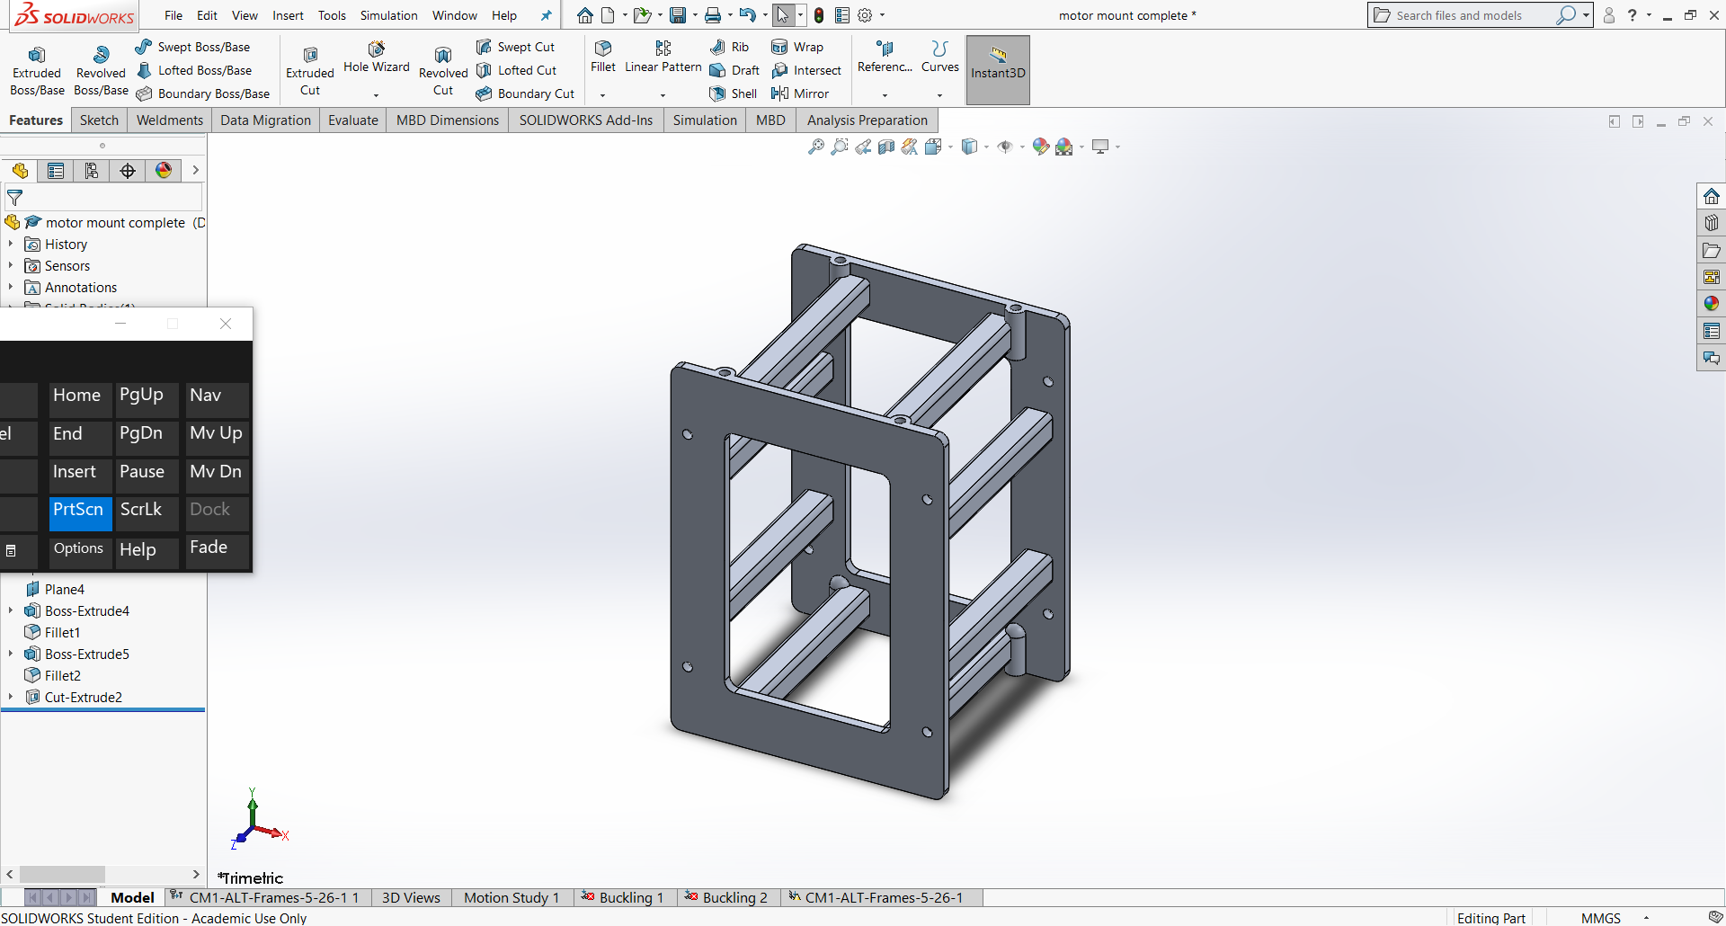
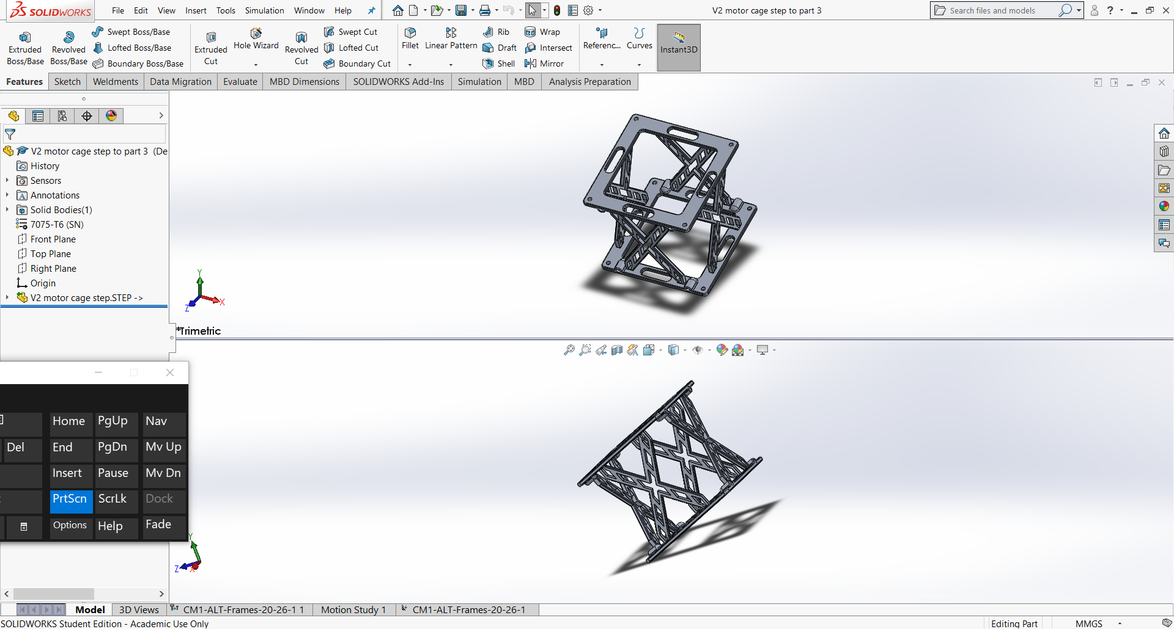
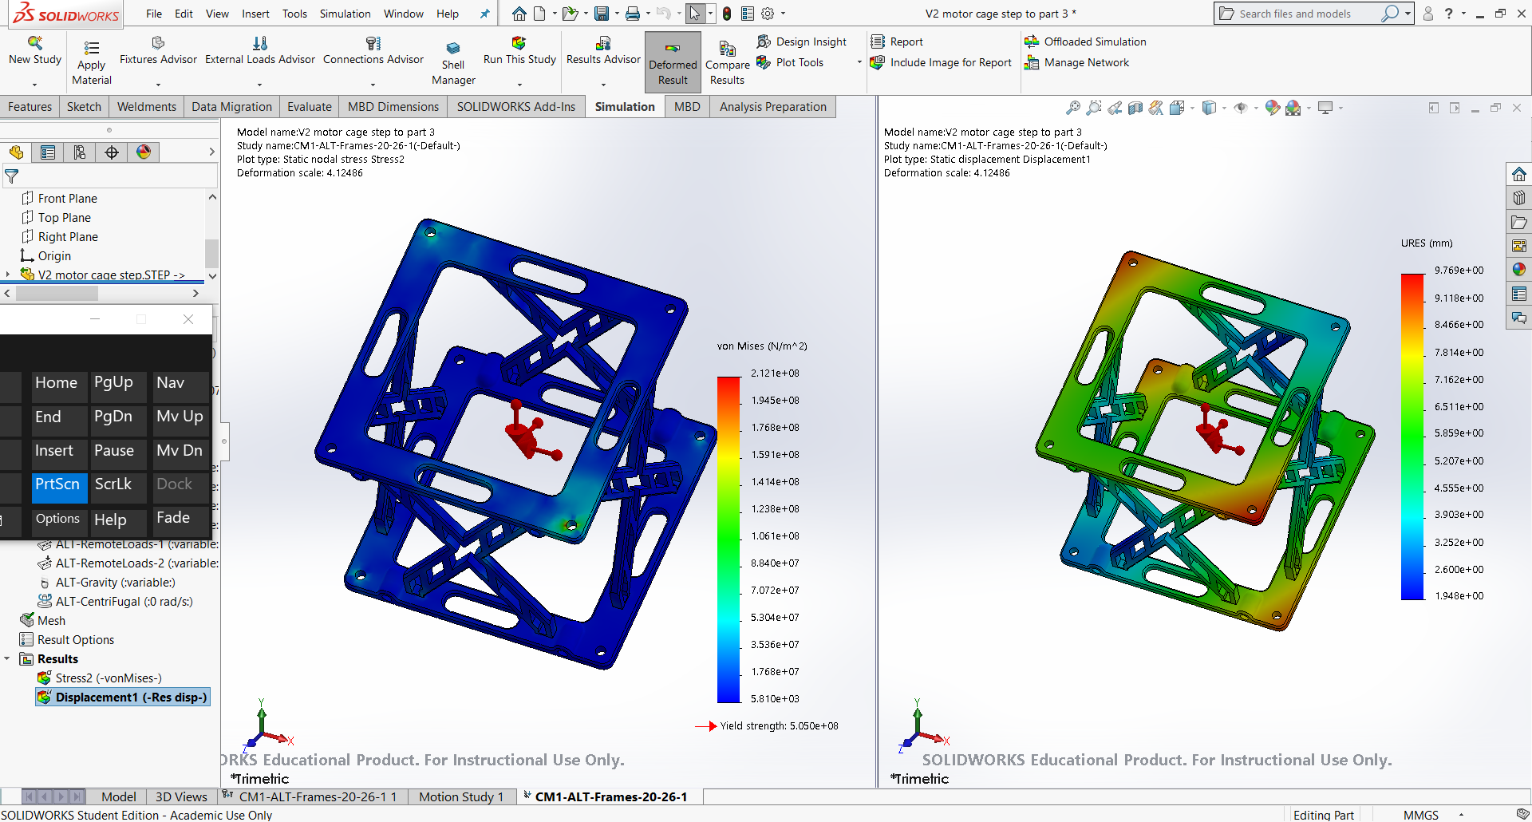
The motor cage is the critical component that links the motor and the chassis together, providing a strong and durable mounting location. The design I was given, as seen in figure 2, was the wrong dimensions, wrong material, and severely “un-engineered”. It was far too heavy and used too much material in places that weren’t required, a factor that can be fixed using FEA. In order to start from scratch, I use the fixed mounting point locations and designed using them as points of reference. There was 4 iterations of my original design and I settled on the design shown in figure 3. In figure 4 we can see the stress test results, left, utilizing the von mises principle as it is the most reliable form of FEA for a known metallic material. (Harish, 2020) The material I decdided to use for the motor cage was a specific Aluminium alloy, 7075-T6. This specific alloy was chosen due to its immense yeild strength which is even comparable to some steels, yet lightweight characteristic being aluminium. (Mitchell, 2018) 7075-T6 is very machineable, and is durable enough to stand up to constant loads and stresses going though it, which the motor cage will certainly face. The corrosion resistance is very high, as with all aluminium alloys. One other small benefit to using aluminum is that it is a very good conductor of heat, leading to the possible use as a heat sink for the motors. One negative to this material is cost, however it is less expensive when compared to titatium, or carbon fiber composites. The design of the cage was guided around the material choice and mounting hard points. I aimed for a safety factor of 2, as it is a competition vehicle, and a test bed for future developments that could have the potential for a dramatic increase in power. A safety factor may seem like overkill at the current power level, and figure 4 shows that less material could be used, however taking the cost of multiple cages as a factor, the weight saving of 1-1.5kg doesn’t not seem beneficial.
Figure 2- Original motor cage provided by chassis group
Figure 3- Final motor cage design
Figure 4- motor cage FEA

Rear Chassis
The rear chassis was a point of contention for much of this project, as it had to encompass many aspects of the car, such as the suspension mountings, motor mounting, battery location, controller mounting, and much more. I worked with the chassis group to come up with a design that utilized effectively an aluminum bulkhead, allowing the footprint of the rear of the tub to be tailored to the battery box I designed, in the following section. This was crucial as the batteries chosen are very long, leading to the challenge of locating them within the old engine compartment. Liaising with chassis group led to the development of a chassis that allowed for the rear inboard suspension mounting points to tie into the motor cage mounting area. If more time was allocated, the FEA would have been performed, however the inability to gain access to university computers after March 16th prevented this. Further developments and research will be needed before this component is suitable for a racing application.

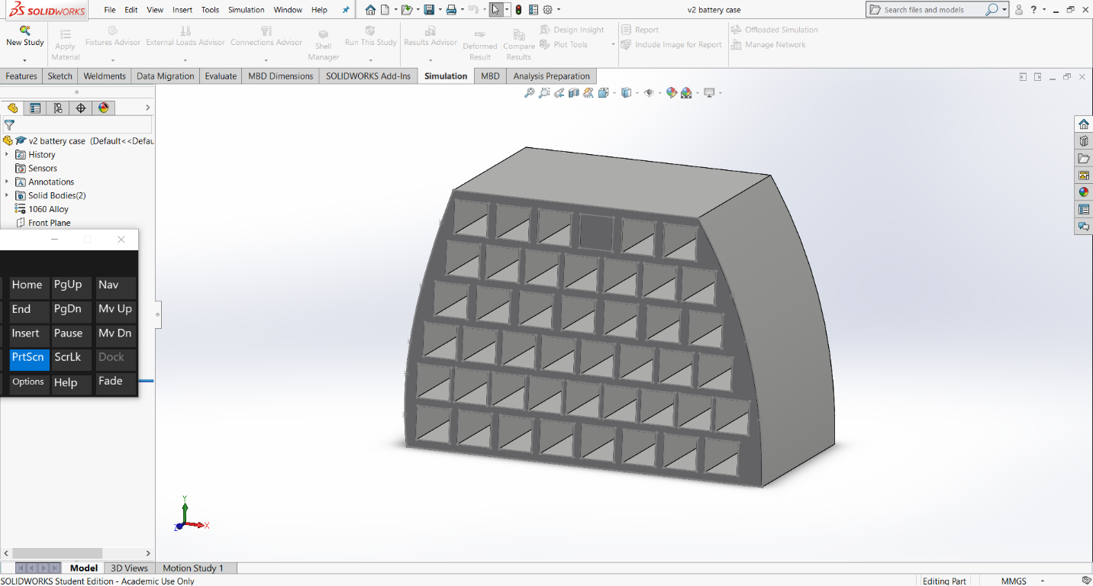
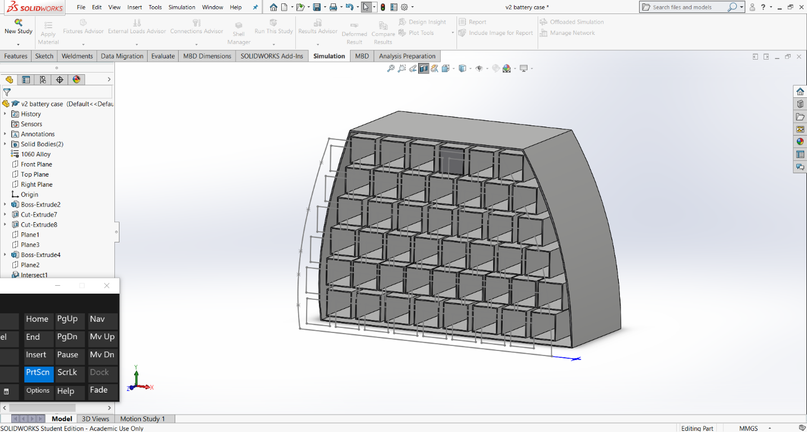
Battery Boxes
Figure 5- Final battery box
Figure 6- Cross section showing water cooling jacket
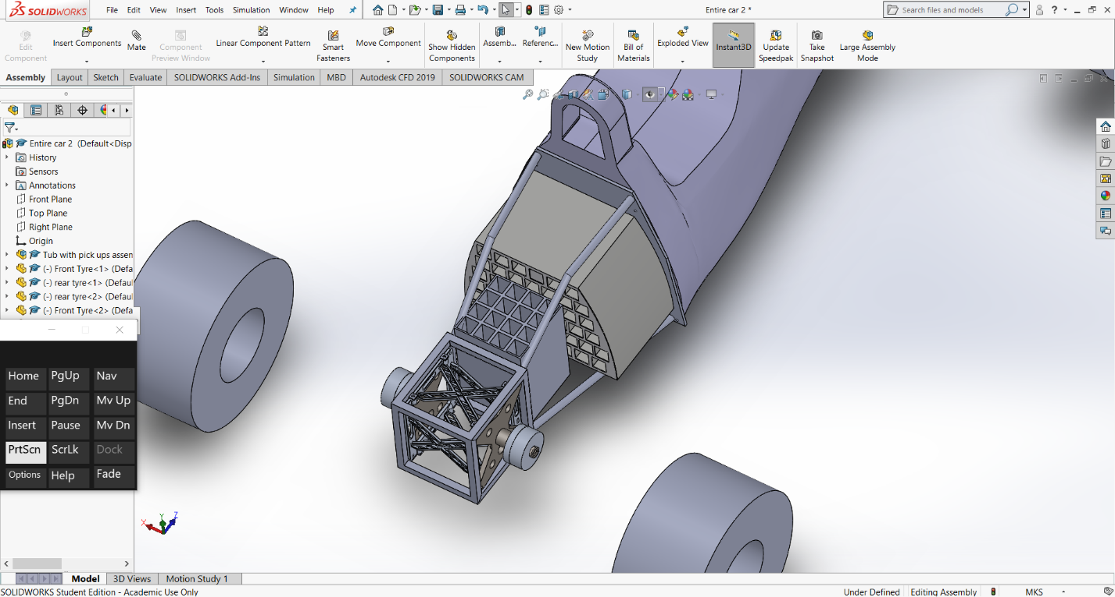
The battery box was a component that posed many challenges. It needed to be light, durable, compact, act as a heatsink, and able to fit into the footprint of the old combustion engine that was used in the original F3 car. My first design was a big bulky component that was water cooled, holding 34kg worth of water. This water-cooling feature was carried over to the current design as it is crucial in order to discharge the batteries at over 300amps. The box will be made of 3mm thick aluminum sheet, welded together to create a structure, as shown in figure 6. There are water inlets and outlets on the back of the box, allowing for quick water circulation when the car is in the pits. We will have a cooling cart, as storage container that will hold super chilled water, with a pump that will suck the warm water from the battery box and other cooling system components and circulate the cold water in its place. This component is not structure, therefore will not have any loads or forces other than the battery and water mass transmitted through it. Location of this box needs to be in the domain of where the old engine once was, leading to a secondary box needed to be used just behind it to locate the rest of the required batteries, as shown in figure 7. Indirect cooling of the battery packs was determined to be the most effecitive and space efficient process, with out having the need for a dedicated radiator for the batteries; an advantage of short hill climb sessions. (Adair, 2014)
Figure 2- battery boxes in location

Battery Selection
The primary concern for my battery selection input, is the inability to provide the motors with enough power with the size constraints we are under. A special pouch cell has been determined to be enough for our power requirements. These cells are Gensace 44.4 12s cells, that can discharge at a rate of 300-600A continuous with temperature monitoring. This allows us to only need 60 batteries, giving a total weight of 90kg. The Emrax 268 motors will require, at a worst case scenario (a yellow flag half way up a run meaning we need to turn around and start again), 50mJ of energy, and the batteries we have selected in the quantity we have chosen will be able to provide 5mJ of power, more than enough. 90kg is an acceptable mass for the battery packs, as the motors themselves only weigh 20kg each. If you compare these figures to the engine, gearbox, and fuel system that was in the car originally, which came to approximately 225kg, the weight of the batteries, motors, and motor controllers is very comparable. We have an estimated weight figure of 150kg for these components, and for an EV, this is a very competitive power storage and motor. Utilizing these batteries allowed us to have enough power density while maintaining a competitive weight.

Group Project Challenges
There were many challenges work through this group project. The main problem was general laziness of the group. Many individuals in the cohort did not take the project seriously, and it hampered the ability to get things done because we constantly had to wait for simple remedial tasks to be completed. This is when, towards the end of the project, a few of us decided to just start taking on other people’s tasks and complete them in due time, and to a higher standard of work. The second main problem was the lack of a project manager with a “backbone”. This is crucial in group tasks as it forces people to stick to deadlines and doesn’t allow excuses to be made for not having your individual task done. A major let down by the project leader was the inability to enforce deadlines, for example to freeze designs so that the details could be worked out, and the supporting jobs be completed. When a small number of us took over, the tasks were completed quickly and without the need for constant meetings and discussion. The general conclusion from group members who contributed significantly, and staff, was there was an air of laziness in the group.

References

- Adair, d., 2014. Thermal Management Of Lithium-Ion Battery Packs.

- Harish, a., 2020. What Is The Von Mises Stress And The Yield Criterion?. [online] SimScale. Available at: <https://www.simscale.com/blog/2017/04/von-mises-stress/> [Accessed 21 March 2020].

- Mitchell, j., 2018. 7075-T6 Aluminium: Overview & Properties | Engineeringclicks. [online] EngineeringClicks. Available at: <https://www.engineeringclicks.com/7075-t6-aluminium/> [Accessed 21 March 2020].

George Dalton Brown 1801728

Controllers
My time on this project was split between two roles, the first being selecting the controllers for the project within the powertrain sub-group and the second being project manager of the project as a whole.
The job of the motor controller within an electric vehicle setup is to “control the application of this [the motor’s] power” (Advanced Vehicle Testing Activity, 2020) This is obviously a key component within any EV application, therefore the selection of this component is a imperative in ensuring that the motors perform at an optimal level which will help achieve the best results for the car.
The first job that is required when choosing a motor controller was to meet with Reza who oversees the motors within this EV project. The reason for this is that certain motor controllers are only compatible with particular motor controllers, the number of controllers needed depend on the motor orientation. During the waiting period while Reza made his decision it was my responsibility to find other important sensors for monitoring the vehicle to ensure the safety of the driver and to troubleshoot issues, as well as assisting with finding the cause of anomalies with regard to the performance of the vehicle and also to support the methods that I would later be using to help implement traction control and torque vectoring.
Before the actual motor itself was selected it was first important for the powertrain group to decide on the orientation that we would use the motors in. We concluded that it was going to be best to use to separate motors which were each driving a gearbox whose driveshaft was connected to the rear wheels of the vehicle. This meant that two motor controllers would need to be used in order to drive each motor separately.
While waiting for the motors to be chosen there was now time to find other more generic sensors that can be placed on the vehicle for the reasons stated above. I began this process by creating a list of sensors that would be needed and then doing some internet-based searches in order to find some solutions. I decided initially that I would definitely need a wheel speed, a ground speed and a yaw sensor in order to run the traction control/launch control programmes for this vehicle. A steering angle sensor would also be needed in order to work with the above sensors to monitor the driver’s intention. It was recommended that the tyre and engine bay temperatures were also monitored to optimize tyre performance and for driver safety. After making this list and finding some sensors online then I started to investigate the placement of these sensors. I already knew where the accelerometer and steering angle sensors would be located on the vehicle as the accelerometer needs to central within the vehicle and the steering angle sensor also needs to remain on the steering column. I then started looking into the placement of the tyre temperature sensor after a quick google search the image below was found and after speaking to Alex Baldwin from the aerodynamics group this was the placement that was decided.
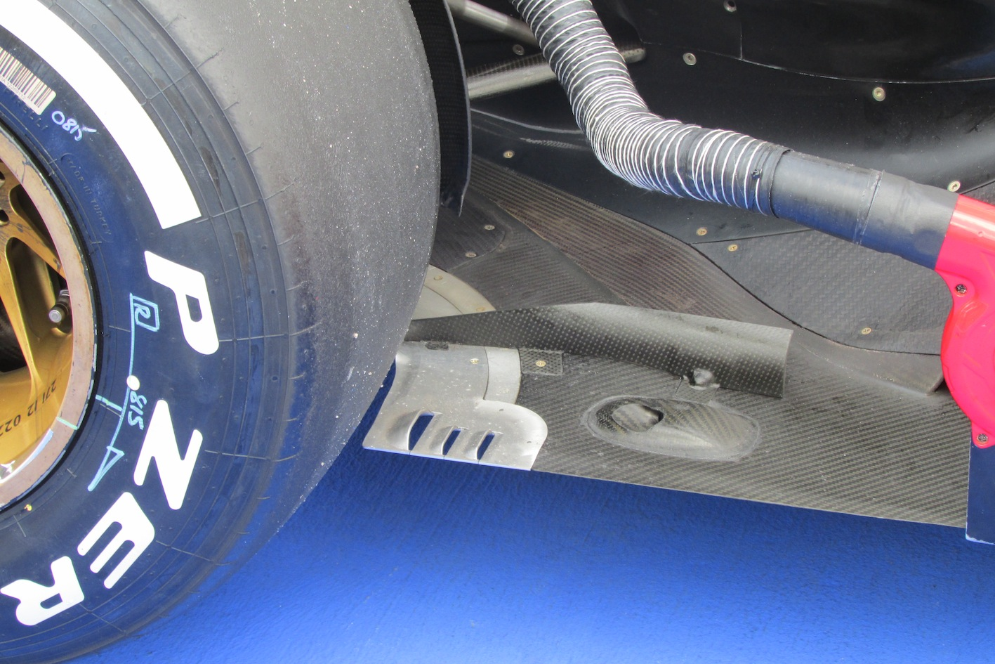
[Figure 5.1.1 – the photo for which my tyre temperature sensor placement is based off] (Scarborough, 2014)

It was initially decided that the motor to use was the Yasa P400RS this was changed a matter of weeks days later to the Emrax 348. Helpfully on the Emrax user manual PDF that can be found on their website there is a list of motor controllers that are compatible with their motors, an excel table was downloaded off this website and the Cascadia (Rinehart) PM250DZ was selected but, as previously stated, two would be needed. The reason that the PM250DZ model was selected was that it was the only controller on the list with a peak power rating that was above the goal of 360kW per wheel that was initially set.

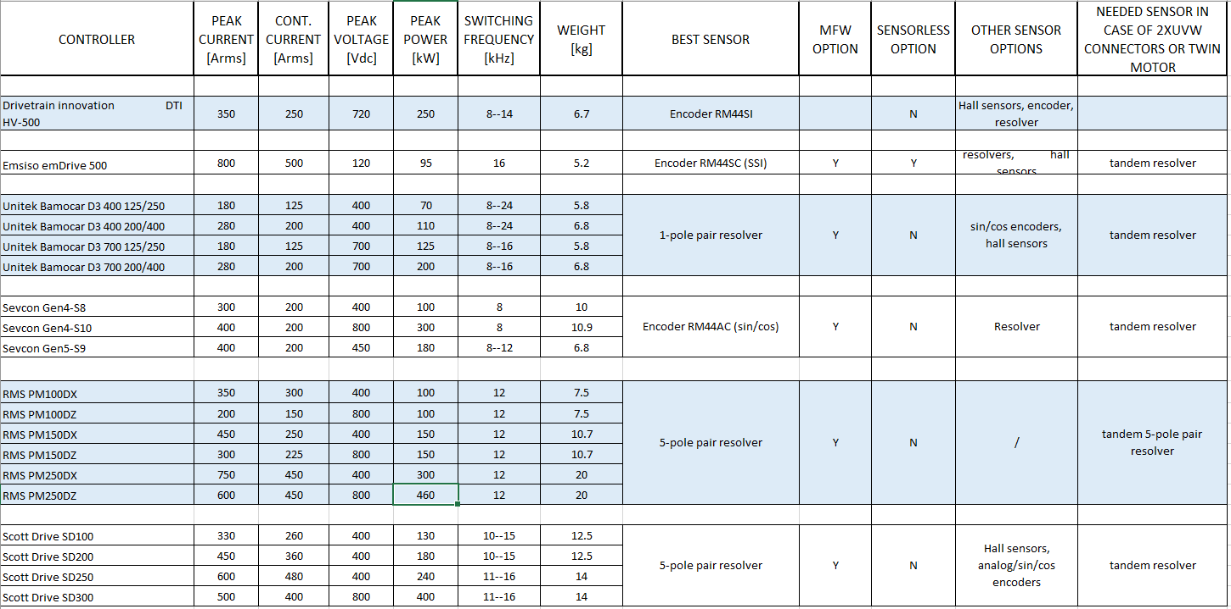
[Figure 5.1.2 – A screenshot of the compatible controllers table that can be found on the emrax website]
This controller was then found on the stealth EV website in order to try and find a user manual for the controller itself:

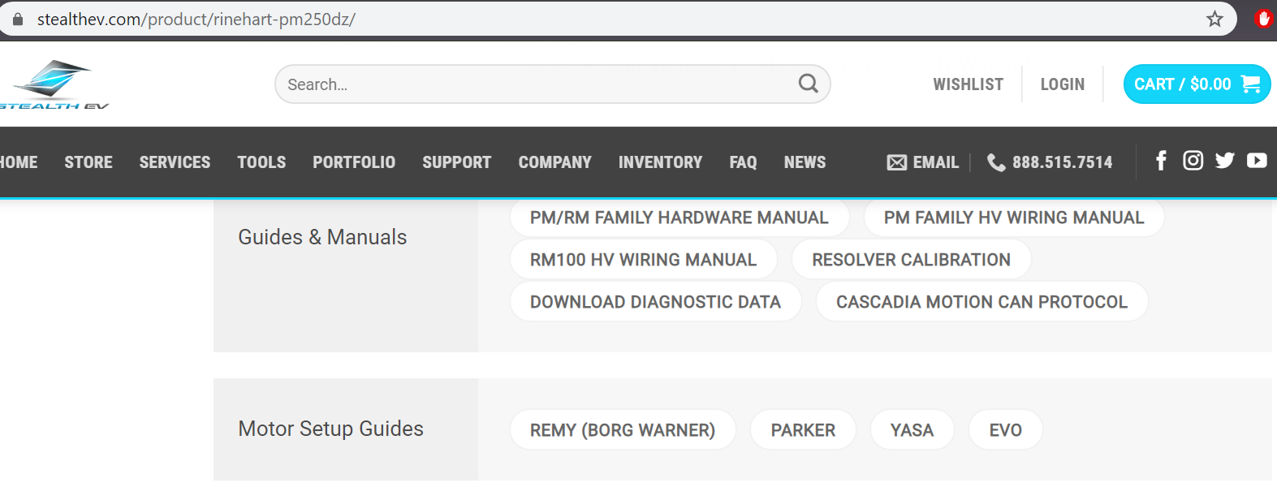
[Figure 5.1.3 – A photo of the motor set up guides available on the stealth EV website]
As seen above I encountered a rather large issue here, in that there is no guide on this website for using the Rinehart pm250dz alongside an Emrax motor, this reason I needed this user manual was in order to help deduce the recommended pins for using this motor. Due to this hindrance I decided that the best way forward would be to make tables based off the information that’s is on the stealth EV website on the user manuals for the other motors. Below are screenshots of the pin diagrams that were created.

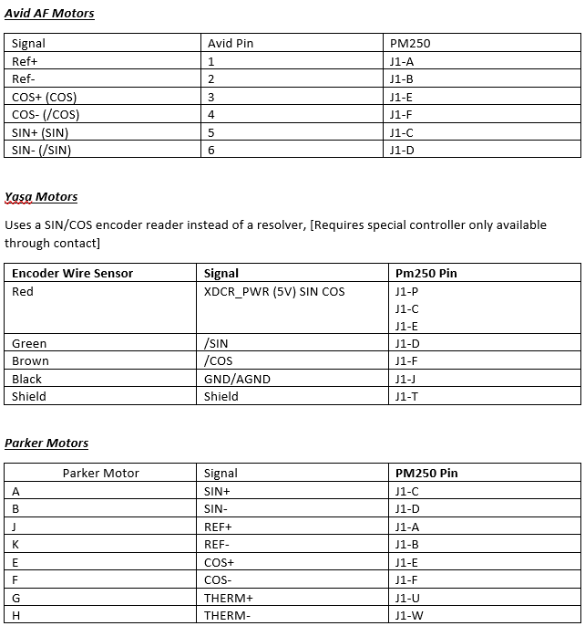
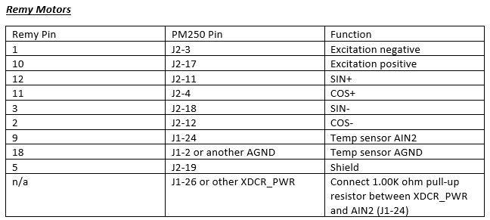
[Figure 5.1.4 –A screenshots of the pin arrangements for similar motors]
After these tables were created it was then decided by the entire group as a whole that the amount of power that the vehicle was producing was too high, this lead then lead to the decision that a lower power motor and therefore less batteries were needed in order to make the car more driveable.

The motor was now changed to the Emrax 268, this was good for the motor controller selection as all of the previous work had not gone to waste as the same controller could potentially still be used. Until it was noted that it now may be worth using motor controllers that are less powerful than the PM250DZ in order to save weight. The controller was then changed to the Sevcon Gen4 S10 due to the fact that it’s on the recommended controller list and can deal with the now lower peak power
rating of 260kW. The weight saving impact of this decision was to the magnitude of 18.2 kg which is the equivalent of 45.5% of the original weight of the controllers now saved.

Development of Torque Vectoring/Launch Control Software
I decided that I now had to begin working on the launch control and torque vectoring side of this project. The idea is to have the software running on an Arduino M0 Adalogger microprocessor in order to receive the information real time and then adjust the torque distribution accordingly.
The microprocessor would be placed in a such a location within the throttle circuitry that it intercepts the 5V signal being sent from the tandem resolver and will adjust this signal, using one of its own PWM outputs, to each motor controller. The information that the processor would need to receive would be things like the speed of each individual wheel and the ground speed for the launch control aspect and then it would need all of these previous inputs and the steering wheel input in order to run the torque vectoring programme.
The data would need to be inputted into the Arduino microprocessor which would then use some very simple logic and calculations to adjust vehicle behaviour. The basic idea is that on a launch each tyre should not exceed 15% over the ground speed. The value of 15% was decided based off information taught last year in Pedro Monteiro Ferreira’s Vehicle Technology lectures. The wheel speeds would also not exceed over 1% of one another, this is to ensure the best launch is achieved and it is achieved in a straight line. The launch control software would be activated using a button and would be deactivated once the accelerator pedal was lifted or if a steering input was made by the driver that is bigger than 25 of degrees of steering wheel input, this ensures that the launch control programme will not continue running when the driver is trying to driver the vehicle around a corner. The launch control would also need to have separate modes for wet and dry conditions as the friction coefficient value between the tyres and the ground may need to be slightly altered depending on these conditions.
The torque vectoring software would use similar programming to the launch control but would only be activated once the launch control was no longer running. The main biggest difference between the two is that the torque vectoring software would need to be calibrated to the vehicle’s steering angle sensor in order to create a formula for generating the corner radius that the driver was trying to manoeuvre the vehicle through to ensure that the proportion of torque was distributed correctly for every corner. This calibration would need to be investigated by the means of a steady state cornering test. In which the vehicle would be driven around a selection of circles of known radii and the outside wheel would be accelerated until the car becomes unstable/undriveable. After this steady state calibration was completed the gaps could be filled in using basic mathematics before on track testing would be undertaken in order to finely tune the software for driver under transient cornering conditions.
Similarly to the previous launch control software the torque vectoring calculations would again need to be adjusted for wet or dry conditions, these modes could be selected by the driver at the start of the run using a basic switch.
Below is a screenshot of an excel sheet that was created to show similar values to the actual values that the launch control software would both run based off

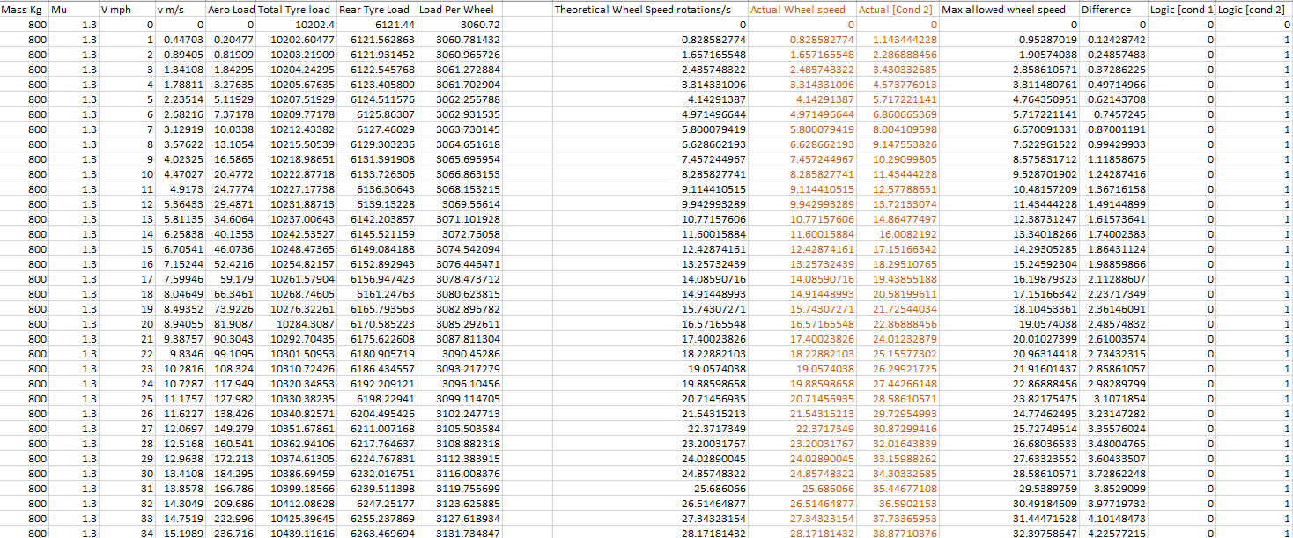
[Figure 5.2.1 – A rough Representation of the mathematics that the launch control software would run based on]

Project Managing
In January it was decided by the group that it was now imperative that a project manager was appointed to try and streamline the design process as much as possible. I volunteered for the role in order to gain some experience within engineering management as I would eventually be aiming towards becoming a project engineer, a role of which people-management is of an upmost importance.
The main responsibility as project manager is to direct the meetings in order to get all involved focussed on the same goal, this was also the perfect time to get sub-groups to communicate with one another. The meetings were opened by asking for one member from every sub-group to update the group as a whole with their general progress, this was followed by checking that every member of the group had completely the task that they had been set last week. Next it was important to set the tasks for the current week and finally there was time for any questions at the end of these meetings. The biggest struggle within these meetings was definitely a lack of respect from certain members of the group towards me. The weekly meetings were a struggle to get started and members would use every available moment to talk between themselves about things that often weren’t related to this project. It often seemed like certain sub groups within this project were also using the short breaks when they were not being spoken to, as an opportunity to have a small meeting of their own, which again halted the progress of the meeting as they were often loud enough to the point where people were needing to repeat themselves making the process infuriating for all involved.
In addition to chairing the weekly meetings I believed that it was important for me to attend, but not chair, as many other sub-group meetings as possible, this was to give myself the best overall idea of what every group was looking at in detail to keep track of the progress of the project as a whole. As well as obtaining information during these smaller meetings I also contributed by answering questions that could only be answered by someone with a good understanding of every development of every group regarding the project as a whole, this reduced time between decisions being made as some decisions would not have to wait days for a response to a question. I did encounter a problem here where three out of four sub groups were having a weekly meeting however one group was struggling to find the time, this lead to a lot of their work being undertaken at a slow pace and effecting other groups who needed some key information off this group, based off the work that they should have been doing.
During Mark Sandford’s “Engineering Management and Sustainability” lecture on the 12th of March 2020, everybody in the class took a test to see what type of manager they are. I scored 41 on theory X and 59 on theory Y, meaning that my managerial style is slightly more laid-back and optimistic than it is intense and pessimistic. “Theory Y managers have an optimistic, positive opinion of their people, and they use a decentralized, participative management style. This encourages a more collaborative , trust-based relationship between managers and their team members.” (Mind Tools Content Team, 2006). Personally, I think that this managing style is more suited to the work place than it is a university group project as students are inherently lazy and often not fully invested in every single aspect of the course that they are studying. This could be seen in the big group project meetings as often when I asked members if they had completed the task the answer was often “no” from repeating members every week. In addition to this there were multiple members who missed the Monday meetings and Friday sessions when everyone would get together.
In the workplace however I think that the stakes are a lot higher for employees as they rely on their jobs in order to keep money coming into their household, there for it is imperative that they perform well in order to keep their jobs and potentially progress within a company. This managing style lead to more committed members of the group giving up hope and at times becoming rude and very standoffish towards me, which although understandable, did halt progress even further as they lost the will to cooperate due to the lack of commitment form lazier members of the group.
The result of this laid-back managerial approach did lead to excellent periods of teamwork during the Friday morning sessions as members that had lacked effort earlier on in the project could now begin delegating their work to other members who didn’t have as much work to do. This meant that people who were weak in CAD skills could give their CAD related jobs to other members, this meant that the majority of CAD models were completed by team members who had the most confidence doing so.
If I had to manage a similar project in the future I would definitely have to change my managing style towards more of a type X approach however this would be difficult as I, as a fellow student, do not posses any authority over my peers. Therefore the issue of a lack of respect from my peers towards me would still be present as there is nothing I can do if they are not willing to put the effort in themselves.

References

Avt.inl.gov. 2020. Advanced Vehicle Testing Activity. [online] Available at: <https://avt.inl.gov/sites/default/files/pdf/fsev/power.pdf> [Accessed 17 March 2020].

Mind Tools Content Team, 2006. Theory X And Theory Y: Understanding People's Motivations. [online] Mindtools.com. Available at: <https://www.mindtools.com/pages/article/newLDR_74.htm> [Accessed 20 March 2020].

Scarborough, C., 2014. Tyre Temperature Sensors. [online] High Power Media. Available at: <https://www.highpowermedia.com/Archive/tyre-temperature-sensors> [Accessed 17 March 2020].

Jefferey Elliss 1802644

Transmission
Transmission Requirements

A gearbox must transmit the torque produced by the motor to the wheels in the most efficient manner possible while being reliable and having an appropriate ratio or rang of ratios to ensure the maximum torque is available at the contact patch.

Calculations
Maximum Forces

The vehicle is subject to significant aerodynamic loading meaning that the maximum grip available only increases with speed. The peak downforce target for the car supplied by the aero group was 6000N over the rear axle. I used this to calculate the maximum force at the contact patch.
$F_{max}= F_{vertical}* μ$ Equation 1-Maximum force at the contact patch

Table 1-Force and mu target values
Variable | Value
μ | 1.6
Aerodynamic Load | 6000N
Mass on rear axle | 540kg

These values were put into a spreadsheet in preparation for any changes to targets or final values becoming available to allow quick updating of the required torque values.
Initially the Emrax 348 motor was selected which was able to overcome the available grip up to a higher velocity the revised choice of the emrax 268 motors. The change was made due to energy storage and power output limitations.

Gear Selection

Initially it was convenient to use HPC gears selection equation which uses a speed factor, a time factor, a pitch factor, face width and a strength factor. This equation gives a conservative estimate of the gear size required. The equation is based on a gear which runs in a machine for 24 hours a day 7 days a week.

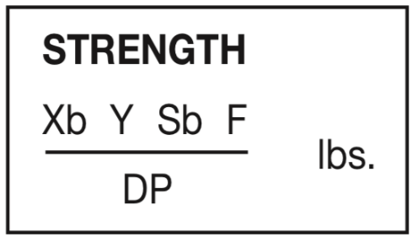Equation 2-HPC Strength Equation
Using this equation HPC recommends to us 2.5 module gears made of normalized 4340 steel. I used this estimate to begin designing an appropriate gearbox for the large 348 motors. To validate these calculations, I have run some FEA on gear models to ensure that the whole system would be adequately strong. Furthermore, I have used equation 3 to check the results of equation 2 and my FEA results.
$W_{t}=(S*F*Y)/D_{p}$Equation 3-Tooth Strength Calculation
Bearing Loads
With the gears selected and the pressure angles it is fairly simple to calculate bearing loads using equation 4.
$K_{s}= K_{t}\tan{α}$Equation 4-Basic Bearing Load calculation
However according to Han(2009) because of vibration and other dynamic issues the loads on any given bearing may be far higher than those calculated theoretically. It is possible to model these forces however I have not instead applying a safety factor to account for the extra forces. AST bearings helpfully provide a table of safety factors and a calculation system to assist with this.

Table 2-Bearings, part numbers and total needed
Part | Number
NK15/20 | 3
NK28/30 | 2
Total | 5

Design Considerations

The primary decisions that I needed to make at the beginning of the project were whether we would need more than one ration in a run and what the required ratios between tracks might be, linked with this is deciding whether or not it would be necessary to have multiple gear sets to change ratios between events.
To make these decisions I considered, the maximum traction available, radius of the tyres, max speed at each event and the motor specifications. Considering that with the traction available and the torque and rpm specifications of the 348 motor, the highest usable ratio would have been 4.8 to 1. This would make any single mesh step down gear very large and difficult to use and due to the nature of electric motors torque curves it is not necessary to have multiple gear ratios. This greatly simplifies any gearbox design and reduces the mass as no shift mechanism or linkage will be necessary. A planetary gear set allows for the same ratio to be significantly more compact than a simple single mesh. For this reason the final design is a single planetary gear set run in a star configuration.
When deciding on what ratios may be required I sent a set of ratios t the simulation team and requested that they perform some test to find out if having multiple ratios was a significant performance factor or not. However, data was not forthcoming and as such I have made my decision purely based on the range of electric vehicles available and the specifications of our vehicle.

Modelling and Analysis

At this point I started creating a model as I had gear and bearing dimensions decided and could begin analyzing individual parts such as the planet carrier and any parts created to house the gears.
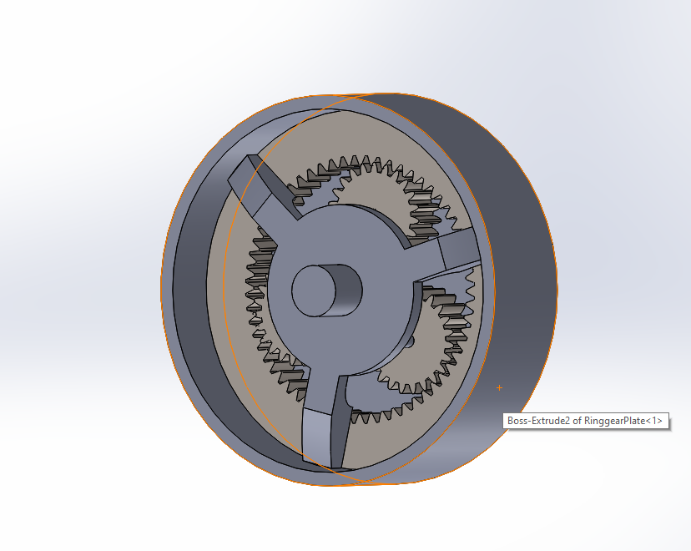
Figure 6.1.1-Initial Model For 348 Motors
Figure 1 shows the incomplete initial model for a gearbox for the larger motor selection, the design concept is the same as the up to date model however this one was abandoned before completion as the motor selection changed and this significantly altered the peak torque and gear ratio requirements. The output of the gearbox is taken from the ring gear, the planets are held by a carrier and the sun is free to turn.

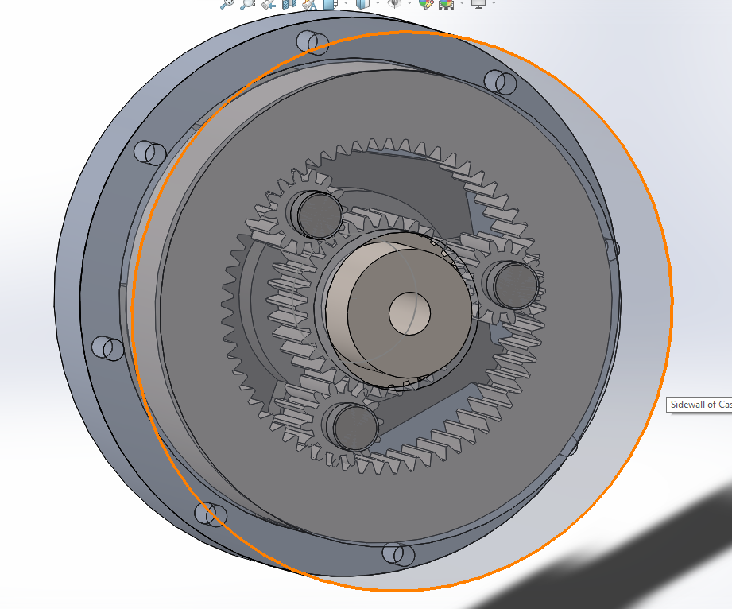
Figure 6.1.2-Final model for the emrax 268 motor gear set
Figure 2 is the final assembly of the gearbox for the final selection of motors, it uses 1.25 module gears with a face width of 25mm. The planetary set is arranged in a solar form, the planets are held stationary the outer ring gear is used as the output and the sun in the center is the input.
The carrier for the planets has a central hole to support the opposite end of the sun gears shaft. This allows the output flange to be wholly independent from all but the ring gear. Minimizing the number of different forces acting on each component.

Table 3-Gear Costs
Gear | Cost (£) | Number | Total (£)
Sun (23 Teeth) | 21.10 | 1 | 21.10
Planet (14 Teeth) | 17.48 | 3 | 52.44
Ring ( 60 Teeth) | 44.68 | 1 | 44.68
 |  |  | 118.22

When modelling the components which connect the ring gear to the driveshaft and the motor to the sun gear Finite Element Analysis was used to ensure that each part would be strong enough to perform its operation. As well as this using the load paths feature in solidworks I identified efficient uses of material for each part.

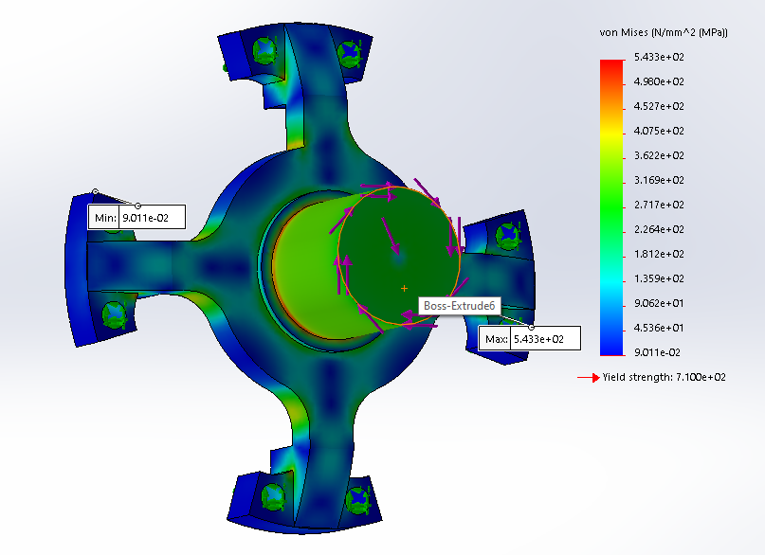
Figure 6.1.3-Fea plot of the first output flange model
Figure 3 shows the first analysis of an output flange, at this stage I was learning how the solidworks FEA tools operated and experimenting to figure out the best way to apply loads and constrain the part. Figure 3 shows the part to be strong enough for the design requirements however the part is heavier than it needs to be. Also, it shows clearly some load paths which reveal where material needs to be and where it is not adding any additional strength. As well as this it does not include the correct splined output to match with the CV joints of the driveshafts.

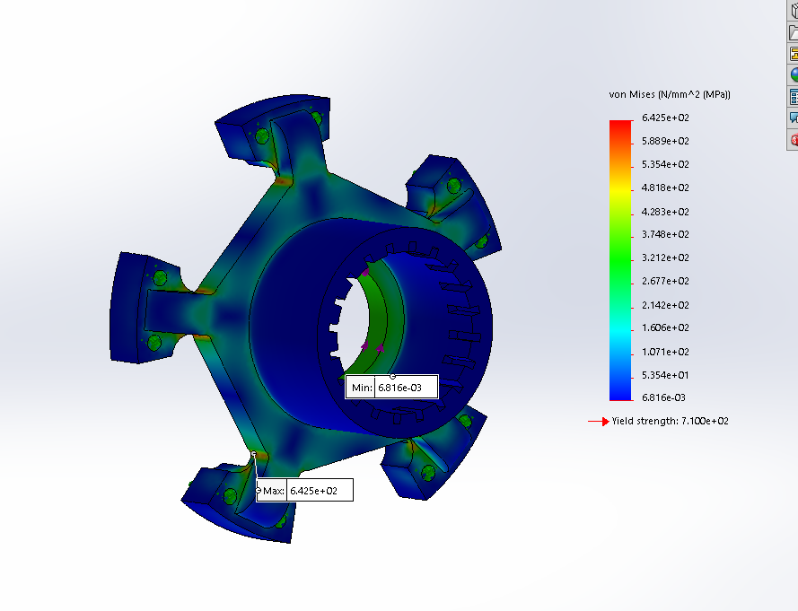
Figure 6.1.4-FEA of the final output flange
Figure 4 shows the final output flange which matches to the driveshaft. However, this plot is inaccurate as the torque was applied to the inner ring rather than the splines where the driveshaft would interface with the part.

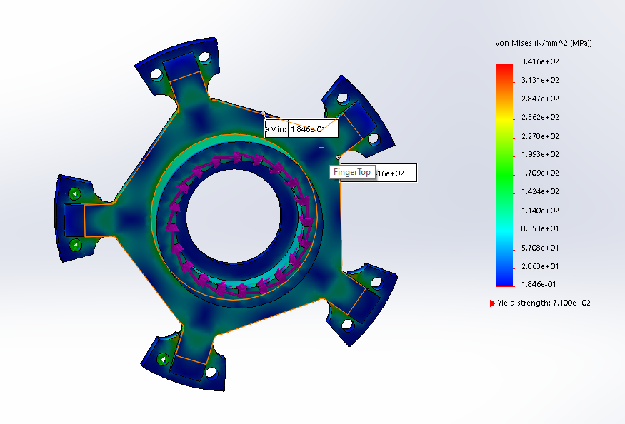
Figure 6.1.5-Re-run output flange, forces on splines
Figure 5 gives a much more accurate picture of the performance of the part. Plots like this were used when creating the models for the carrier and other parts as well as to check the gear specification. One important think to not on all of these plots is that the mesh is not particularly fine although it is as fine as solidworks will allow. This may create errors around the splines for example where more complex and smaller geometries exist.

Analysis of The Whole Model
After completing the gearbox assembly and completing a basic motion study in solidworks to check its operation there was an issue with the velocities at the output shaft being inconsistent as well as the torque at the output being inconsistent. After some investigation this appears to be due to the profile of the teeth on solidworks toolbox gears being slightly odd. If the tooth profiles were corrected to be involute profiles the gears would better represent the actual gears specified from KHK gears. An involute profile ensures that the pressure angle between two meshing gears is constant which in turn means that the torque transmitted from the drive to the output will be constant.

Group Work
Towards the last few weeks of the project I realized that one primary reason for the lack of work done was ill-defined short-term objectives. As such during group meetings George and I began to take a specific weekly objective from each individual and check it the next week in the group meeting. However, this was ineffective with people making an objective and then either failing to complete it or not attempting to complete it. In the final two weeks before everything was closed due to the coronavirus, I made a specific list of objectives for the powertrain group only and we came together on the Friday in order to complete them. During the time in university as a group I spent my time doing mostly my own work. However, I spent a significant amount of time motivating the group to make quick decisions as at that stage we were approaching a deadline and were very behind on our workload. For example rather than spending two or three hours deciding on the exact coolant amount I advised Steffan to quickly make a conservative assumption and move on. This is not ideal as it opens up opportunities for mistakes however, being careful about what we assume reduces that risk.
This method of creating a specific achievable list on the Thursday and executing it on the Friday was very successful and more work got done in the two Fridays when we did this than in any other period of the project.
I also spent some time researching sections that my teammates were struggling to complete including, battery management, charging solutions and circuit diagram planning and creation.
Battery Management
When charging lithium ion batteries, it is important to monitor individual cells for safety purposes. Checking that all of them are charging in a balanced way ensures that no damaged cell will be overcharged and cause damage to other cells or a fire. When investigating this I found that a viable way of monitoring all the cells is to have one monitoring circuit per pack of ten cells. This neglects the need for a charger with many connections for external monitoring systems and makes it much simpler to charge the vehicle. There are microchips available which can balance a set number of cells without needing an overall controller. For example, the Maxim Integrated, MAX1555EZK +T is freely available and can monitor up to six cells at a time. With appropriate PCB for each pack, ten of these would be sufficient to monitor the entire battery pack while charging.
Control Systems Circuit Planning
I worked with George Dalton Brown to specify and plan out a circuit diagram for the torque vectoring system and the data acquisition systems. To that end I have constructed a basic circuit diagram by hand detailing the required inputs and outputs for each sensor and the type of device and any extra components needed for its operation. The main sensors needed for wheel speed etc are simple devices such as hall effect sensors which can be very easily connected to almost any microcontroller or device with digital input pins. I created this circuit plan with the idea that I could give it to George and he could then more easily put it into a circuit design package such as KiCAD however as we are no longer able to get into uni to work together and have reached our deadline this was not possible.

References

Kohera Gear Company(2015), KHKGears.com Available at:https://khkgears.net/new/gear_calculator.html

HPC Gears(2019), HPCGears.com Available at : https://www.hpcgears.com/pdf_c33/17.8.pdf

AST Bearings(2018), www.astbearings.com Available at: https://www.astbearings.com/catalog.html?cid=precision_needle_roller_metric

B.K.Han (2009) Prediction of Vibrating Forces On Meshing Gears For A Gear Rattle Using A New Multi-Body Dynamic Model Available At: https://link-springer-com.ezproxy.uwtsd.ac.uk/content/pdf/10.1007/s12239-009-0053-x.pdf (Accessed: 02/01/2020)

Farnell(2019) www.Farnell.com Available at: https://uk.farnell.com/c/semiconductors-ics/power-management-ics-pmic/battery-management/battery-charger-ics?battery-type=li-ion&CMP=KNC-GUK-GEN-KWL-CONTROL&mckv=_dc%7Cpcrid%7C423140876080%7C&gclid=EAIaIQobChMI8eGY7fCp6AIVR7TtCh1hCA86EAAYAyAAEgJni_D_BwE

Timothy Stanbury 1800702

My Role

My responsibility is for the energy storage system. Therefore, using estimated power, energy and voltage required I had to come up with a sufficient storage method. This included looking into batteries, supercapacitors and modules to find out the most efficient combination, along with how the final system could interact with the car. To assist with my role, I needed the help of several other members of the group, for example it was key that my batteries could work with the motors and could also be stored and cooled efficiently. My role also required that I worked alongside members of other groups, such as the chassis group, as they needed to know the weight and size of the batteries so they could work around them.
Other members
- George – George’s area of responsibility was the controllers; therefore, it was essential for both packaging and data that he knew the specs of the batteries.
- Reza – Reza’s area of responsibility was the motors; therefore, a fair bit of work was done between me and Reza as every change done to either the batteries or motors affected both of us.
- Jeff – Jeff’s area of responsibility was the transmission; therefore, most of the work I did with Reza was also related to his work.
- Dan – Dan’s area of responsibility was the duty cycle; therefore Dan’s research was very useful as it allowed the group to see how much time on throttle and how long each run would last in order to know how much power/energy we needed.
- Steff – Steff’s area of responsibility was the cooling; therefore, me and Steff had a decent amount of communication to allow for the cooling requirements of the batteries to be achieved.
- Pete – Pete’s area of responsibility was for the rules and regulations; therefore, it was important that Pete let the group know if any regulations restricted what we were doing, as it could affect the whole project.

Timing Chart

Research of energy storage | 15 hrs
Finding the batteries | 15 hrs
Identify quantity and parameters | 6 hrs
Create CAD model | 20 hrs
Buy the batteries | 10 hrs
Test the batteries | 20 hrs
fit the battery packs into the car | 30 hrs

Work Done

Research
Probably the largest section of work done for the batteries was done through research, as it was key that we used the best, most efficient storage system for the car. Therefore, before conducting my main body of research it was key that I identified potential energy storage methods. These included supercapacitors, battery cells, battery modules or a potential mix of multiple methods. This research was assisted by parameters being set by the group, such as the peak power (initially 600kw, lowered to 400kw), the energy required (50MJ) and the voltage required (initially 360V, lowered to roughly 250V).
The first main bit of research done was done looking at what large companies are currently doing with their electric cars, such as Tesla, Nissan and Volkswagen. A lot of research was done looking into Tesla battery storage as well as the Volkswagen ID R hillclimb car. The main conclusion of this research was that our car would require a lot of power for its hillclimb purpose.
The next key bit of research was identifying the storage system we would eventually use, which turned out to take a lot longer than anticipated. A fair bit of research was also done on potential rechargeable batteries. For example, certain companies such as LG and Panasonic do large battery modules which had a lot of potential. There was also potential to use rechargeable 18650 batteries and create our own battery packs like what Tesla do with their Panasonic battery packs. Another potential option was to use a supercapacitor or supercapacitor and battery combination in order to achieve both the power and energy requirements. I also looked into pouch cells using the Battery University as they state that ‘the pouch cell offers a simple, flexible and lightweight solution to battery design’.

Initial Battery selection
Finding the correct batteries was done by using my previous research to find which is the most suitable option for the energy storage. Eventually I decided on using a Sony VTC5A cell, as it was capable of discharging at 35A and with 3400 of them was also capable of meeting the power and energy requirements of the car. This meant that we needed roughly 3400 batteries, weighing 165kg, which would be arranged in lines of 10 in packs to achieve the estimated voltage of 350V.

Areas for Concern
My first area of concern with these batteries was the requirements needed. More specifically the power (500-600kW), energy (50MJ) and voltage (370V) requirements. Therefore, to reach these requirements a lot of high-powered batteries were needed. The specific batteries operated at 3.6V, 35A and 2600Mah, the main problem with this was that before testing them it is hard to know whether the data provided on them is true or not, as small 18650 batteries being able to discharge at 35A is uncommon. In order to avoid any concern, it would be best for me to do some testing on an individual cell to see if it is capable of the numbers suggested.
Another area of concern is with the overall parameters of the battery packs. Due to 3400 batteries needed the parameters are certainly not small, especially with cooling devices integrated into the packs. The batteries will be arranged in several rows of 10 in their packs, therefore considering each battery is 18mm wide and 65mm tall, this takes up a significant space. Another issue with the parameters is the weight of the 3400 batteries, which comes to around 165kg. This weight was without including a potential battery pack, which would have added another 10-30kg.

New Batteries
Due to the problems with the old batteries it was key that new batteries were identified fast. This meant further research into rechargeable batteries. This included looking further into electric car battery packs such as the Nissan Leaf, and the Tesla Model S. However eventually I decided that these batteries would not support the needs of our car. We also required a change to the motors as the previous ones were far too powerful and would not have worked. This meant that the new motors only required 230Kw each (2 of them needed) and run at a lower 250V. Eventually I decided on using batteries from RC cars to power our vehicle.

The batteries come from a German company called gensace and are capable of discharging at 300A, with a voltage of 44.4V and a capacity of 5000mAh. These batteries are LiPo batteries (Lithium Polymer). I worked out that 60 of these batteries were needed to get the power, energy and voltage requirements. These would be arranged into 10 packs of 6 in order to achieve the voltage, and with a battery case included would weigh around 110kg. The main reason for this selection was the power that these batteries could achieve, meaning we could use a lot less and be more efficient. As shown in the picture they are fairly large measuring 320*50*50 (L*W*H), however the power made by them makes up for this, and the overall space taken up is far smaller than the previous batteries.

Modelling

The main piece of modelling that I assisted with was the battery casing. Using the parameters provided on the website a case was initially made by me, and was later improved by Reza, which allowed for all 60 batteries to fit in the allocated space which we were provided with by the chassis group. This case would also be water cooled due to the heating of the batteries; therefore, Steff also assisted us to allow for this to be achievable.
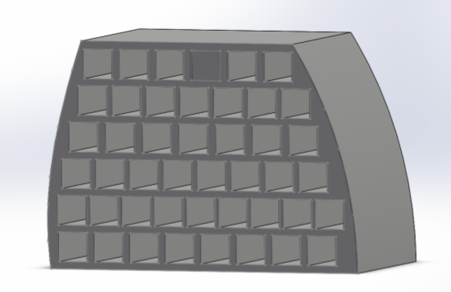

Potential Dangers/Drawbacks

The LiPo (lithium polymer) batteries used come with several potential dangers/drawbacks that need to be taken into consideration.
- The first of these is the recharge life, which is about 300-400 cycles. Luckily with our hillclimb car, it would most likely do no more than 5 runs a time. This therefore shouldn’t be too much of an issue, as the 300-400 cycles would last a considerable amount of time. Once the batteries reach this number of cycles it won’t be an issue changing them round due to the battery pack allowing for easy access to the batteries.
- The second of these is that its chemistry leads to fires when the batteries get punctured. Our method of combating this is to have every battery individually sealed therefore significantly reducing the risk of punctures. There is also water being transferred through the case which assists with cooling the batteries. In addition to this the regulations state that for an electric car we should have a fire extinguisher on hand just in case.
- The third of these potential dangers is that the batteries require special care when charging, discharging and storing. To combat this our batteries will be charged individually to reduce risk. They will also be discharged in packs of 6 to achieve the 260V required by the motors. The battery pack has space between the batteries, which makes the storage system safer as the heated batteries will never come into contact with each other.
- The last of the potential dangers/drawbacks, is the cost of the batteries. As LiPo batteries cost roughly double Li-Ion batteries it was important to use as little as possible to reduce the costs. The total price of the LiPo batteries came out as £12851.32, which is much better than the £20300 which we would have spent on the original batteries.

Conclusion

To conclude, the battery research and modelling went well. Even though there were a few problems encountered, as a group we worked well through them as we were able to communicate well between us to mitigate and potential changes which could affect the whole project. We all attended each group project meeting, which allowed for further communication when needed and allowed for any issues to be solved as a group rather than as individuals. Overall, the project, in terms of the powertrain, went very well as all of our specific sections were done to the best of our abilities.

References/Websites used

- Author: Unknown (2011) Pouch Cell – Small but not Trouble Free (online) batteryuniversity.com
- Pedro Lima (2019) CATL achieves 304Wh/kg in new battery cells (online) pushevs.com
- www.maxwell.com/products/ultracapacitor
- 18650.uk/product/Panasonic
- 18650.uk/product/sony-vtc5a-18650-battery
- Gensace.de

Steffan Robinson 1801468
Introduction
I was responsible for the cooling aspect of the group project. I would be responsible for any active and external cooling for the vehicle. I would have to decide whether air cool would be sufficient enough or whether I’d need use liquid cooling to help maintain optimum temperature. If we were to use liquid cooling, I had to think of how the system would operate, would there be need for a radiator? Or would it be better to have a small reservoir? In terms of external cooling I had to think of efficient enough method that could cool the car enough to go out for another run an hour or so later.

External Cooling
There were a few methods to externally cool the car. The three main systems that would need to be cooled were the motor controllers, batteries and motors. There were a few methods early on about how we would do this, some of which were: fans and dry ice. We would place fans around and above the car to try and cool everything down, however that would just be using the air around us to cool it which would be anywhere from 10-20⁰c. Dry ice would be a much better solution. We would have the reservoirs in the side pods and place the dry ice next to the tanks to cool the liquid flowing around the system. Dry ice has a surface temperature of around -78.5⁰c therefore it would be a much more effective means of cooling the system along with dry ice, another idea is having a cooling rig. Here’s one I created on Solidworks:
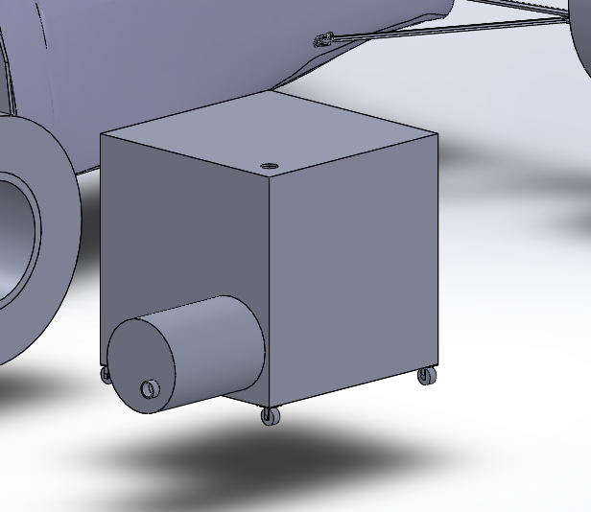
Plug at the top for warm coolant to enter
160l tank
Xylem Jabsco, 1.6 bar Direct Coupling W Water Pump 20L/min
4 Wheels for easy transportation

I created this 160l capacity cooling rig so that there would be cold coolant ready in the pits for when the car finishes the run. We would simply attach it up with pipes like a filling a car up with petrol and pump the cold coolant through the system replacing the warm fluid. Also, as the warm fluid flows back into the tank I made sure to give it such a large capacity so that the warm coolant would have a chance to cool before being recirculated around the system. The warm coolant would enter through a plug at the top and because cold water is more dense than warm water, and that the coolant is a 50:50 mix of coolant and water, the warm coolant would stay at the top and when it begins to cool it would sink down towards the pump at the bottom ready to be recirculated.
We would connect the pipe from the cooling rig to the car through a coupling body. We would have two inlets and two outlets. We would need a value panel mount coupling for the inlet and outlet and a valved in-line PTF coupling body for the inlet and outlet. Therefore, we would need 4 valved panel mounts and two inline coupling body which would be just shy of $150.
These are the specs:

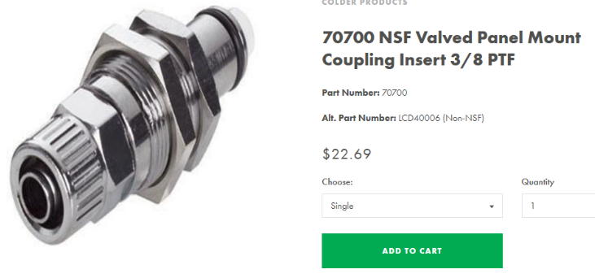
The panel mount couplings would be placed just inside the bodywork for both inlet and outlet and then the valved in-line coupling would be placed at the end of the pipe, a little like a hose and would attach straight to the panel mount couplings. These are ideal because it would save time if we could just get the car back and attach two hoses and then the car is being cooled. These can also be used with one hand and can tackle high temperatures and high pressures which is ideal for our application.
In terms of the pump that we will be using for the cooling rig is a Xylem Flojet pump which has a flow rate of 23l/min and a output connection of 3/8 which therefore means it can match up with the valved mounts, and also has a good enough flow rate to help compliment the need for the motor controller and battery pack flow rates.
We would use a Y shaped fitting to join each outlet flows to be paired into one so that it could fit into the top of the cooling rig.
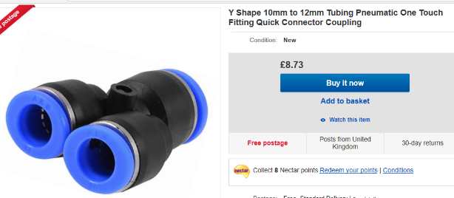
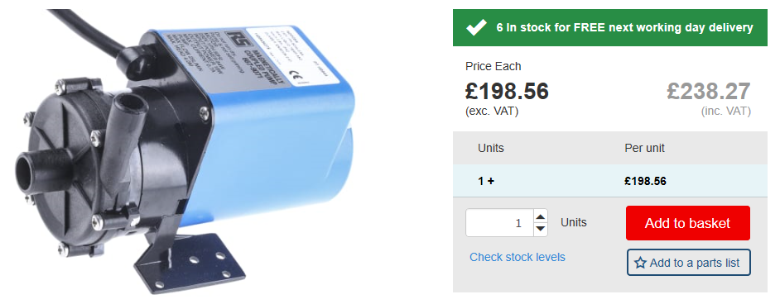


Piping is also something that needed to be spec and obviously this would need to be a 3/8-inch pipe to connect to the inside of the panel mount couplings. This pipe would then run around most of the system with exception to the motors piping which is narrower. This is the pipe we would use internally and externally for the car. I decided to run a flexible plastic pipe rather than metal because it would be much cheaper and much more flexible to fit around the car.

Internal Cooling
Better My Understanding
There needed to be a few specifications before I could begin making any reasonable calculations on the internal cooling such as product selection. I couldn’t begin to make any calculations without the spec of the motor, motor controller and batteries. However, I could do some research into Formula E and to identify how they cooled their vehicles. I found that they used the air flow to go through the side pods and cool liquid filled radiators, they will have two separate systems, radiator for the massive battery pack and one radiator for the rest of the electronics on board. There are then two separate coolant flows dictated by two separate water pumps.
After everything had been specified Dan manage to create an average heat to lose per run in kJ on each track depending on how much time we were running on the throttle. He managed to calculate that the highest amount of heat we’d have to lose at a track was 3543kJ at Craigantlet. This was a lot of heat and after researching more into Formula E and heat dissipation it was clear that air cooling alone wasn’t going to be enough and therefore, I made the decision that this needed to be a liquid cooled car.
The next step was working out whether there were need for any radiators. Even though we have to lose a lot of heat because of the very short running time I decided that there would be no need for radiators because they would take up to much space and wouldn’t be beneficial enough as the liquid wouldn’t have much time to cool in there anyway. And to add to this we had some very good external cooling for when the car came back to the pits anyway. Therefore, now I roughly knew how the system would look and what it would consist of. It would consist of two small reservoirs in the sidepods with two separate pumps similar to the formula E setup, one going to the batteries and one going to the motor controller and motor. I decided that the batteries would need their own system because their discharge rate they would get very warm and would need to stay at a working temperature.
Battery
The batteries we chose were pouches and did not have their own integrated system to be cooled. There was a cage created by Reza so that all the batteries could fit in the back of the car. It is a cage which allows coolant to fill up the surroundings of the batteries and allows the coolant to flow through. The batteries will be placed in their own system because of the volume of coolant required to fill the battery cage and the rate at which the volume of coolant can be pulled in and out of the cage would impact the cooling on the other components. There weren’t any cooling parameters for the batteries because I don’t think they are designed to have so many in a small space and there was no way of working out an internal resistance to help discover its actual heat dissipation. What I would do because of the high discharge rate I’ll run similar parameters as the motor controller because of the energy required from the batteries is high.
Motor
The motor that’s been chosen is the Emrax 268. The motor was one of the first things to get finalised, it had its own integrated cooling system, where all you needed to do was pump coolant into it. The motor needs a coolant flow of around 6-8l/min at maximum inlet temperature of 50⁰c and a maximum pressure of 1bar. In terms of cooling the motor is going to be the simplest because it requires the least amount of energy and flow rate and has all the specs required. However, it is key that I still meet these specs because the motors are obviously driving the car, they need to be at optimum temperature to be competitive in the competition.
Motor Controller
The motor controller chosen was the Sevcon Gen4 S10, there would be two of these motor controllers to cool, one for each motor. The controller did come with its own integrated cooling system however there were no specs to this without making an enquiry therefore I had to make the assumption that the cooling regulations were the same as the old controller we were going to use as it has very similar features in terms of energy and power usages. All that was different were the dimensions the new controller was slightly smaller. Therefore, I had to use the cooling specs of the PM250dz. The cooling requirements for this controller were that it needed 18-20l/min (because of its smaller dimensions) of coolant flow and that it need a pressure between 1.3-2.75bar and that its operating temperature was between -40⁰c and +80⁰c. If it got above 80⁰c it would start to derate until it hit 105⁰c where it would stop working altogether. I knew this had to be in a different system to the batteries because they would both get very hot and are both large components and therefore would require their own individual system.

Entire system
In terms of mapping the entire system as I’ve mentioned it would be a case of two systems one system including: small reservoir (12L capacity), a pump 18l/min and hosing for the system including the motor controllers and motor. It would be a case of water from the reservoir getting pushed by the pump into the inlet of one controller then out then back into the other one and out again then as the coolant makes its way to the motor we use a Y shaped coupling so that the flow would be halved so that the flow would be 9l/min just over the recommended value so that each motor can get cooled efficiently. For the outlets of the motors we would use the Y shaped coupling valve again so that the flow would re-join and flow back to the reservoir. We would then use another Y shaped fitting so that we could separate the flow so that when we take it back some of the warm coolant would split and go back into the cooling rig.
We would then fill the reservoir in between runs with a connector going from the outside into the reservoir. We would use the Y shaped fitting for the outlet cooling which joins the both outlets to help it fit in the cooling rig.
For the second system it’s a slightly different case because the battery pack case can be used as a slight reservoir anyway because it can hold around 36L of water at max capacity. This system would include a pump and hosing and a couple of the Y shaped fittings. We would fill the bigger battery case with coolant from the outside and then when its full and it starts operating we would use the pump to push the flow into the second pack and into a Y shaped fitting one to carry on through the system and one to split off to the outlet. We would then use another to for the inlet and the recirculation.

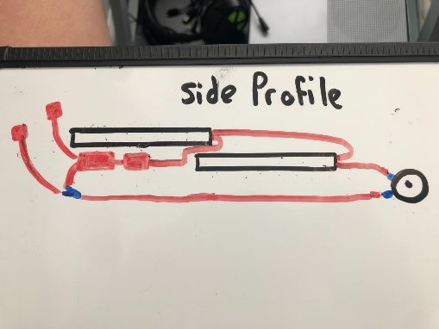

Diagrams
As a key, black are the components (motors and controllers), red are the cooling components (reservoir, pipes and pumps) and blue are the Y shaped fittings
One reservoir
One pump
Three Y shaped fittings
Motor controller
Motors
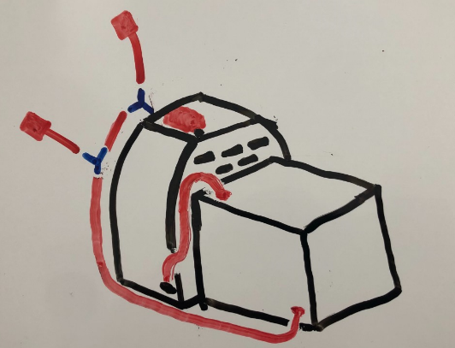
This is the system with the two motor controllers and motor I’ve tried to sketch a side profile of the rear of the car without overcomplicating it

This follows the same key
One pump
Two Y shaped fittings
Battery cages
This is the system which just cools the batteries, this is a 3D sketch, and these sit under the motor controllers and in front of the motors. I felt it easier to sketch it separately to give a better understanding. On both these sketches they have two pipes leading up. These are the inlets and outlet for the fresh coolant to go in and warm coolant to be replaced. These Y shaped fittings can be closed during the run and then open when back in the pits.

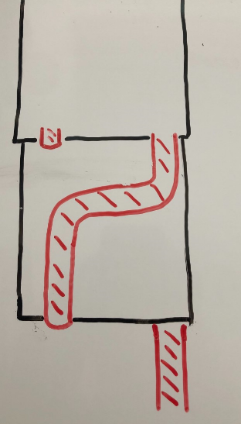
This is a sketch of the motor controllers by looking down on top of them. The small pipe in the top left comes from the pump underneath the top controller. The coolant would flow internally through the first controller then out the first outlet in the top right, it would then flow from there back into the next controller, flow through there internally and then come out the outlet at the bottom left. This then goes towards the motors.

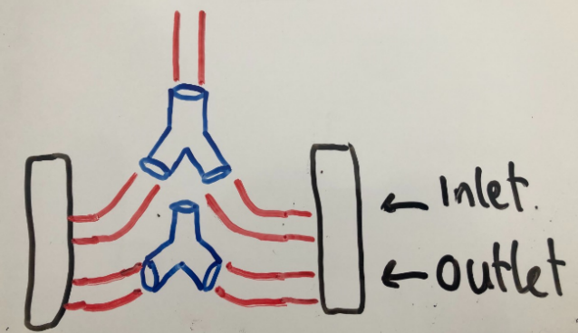

This is an exaggerated view of the rear of the car. The coolant would flow from the top pipe down and split into each motor. It would then get flown around the motor and back through the outlet and join back up towards the start again. The split would decrease the flow rate to a better rate for cooling the motor.

Cost
This is a list of everything that would be needed for the cooling system.
Item | Quantity | Price (£) | Total Price (£)
Pump (Xylem Flojet) | 1 | 198 | 198
Panel mounts | 4 | 19.45 | 77.8
Inline valves | 4 | 22.54 | 90.16
Pipes (5ft) | 4 | 15.92 | 63.68
Water reservoir (12L) | 1 | 21.67 | 21.67
Pump (Xylem LMV) | 1 | 43.58 | 43.58
Pump (Xylem Jabsco) | 1 | 590.54 | 590.54
Y shaped fittings | 5 | 8.73 | 43.65
Total |  |  | 1,129.08

References
https://www.freshwatersystems.com/products/lcd13006-valved-in-line-ptf-coupling-body-3-8-ptf
https://www.freshwatersystems.com/products/70700-nsf-valved-panel-mount-coupling-insert-3-8-ptf
https://uk.rs-online.com/web/p/water-pumps/6679071/
https://www.ebay.co.uk/itm/372970333959
https://www.tanks-direct.co.uk/12-litre-water-tank-t12na-4.html
https://www.ebay.co.uk/itm/5-ft-3-8-ID-FlexFab-5526-Blue-Silicone-Heater-Hose-10mm-350F-Radiator-Coolant/263278056527?epid=1629793759&_trkparms=ispr%3D1&hash=item3d4c98544f:g:fAsAAOSwhDBZ7qOv&enc=AQAEAAACUBPxNw%2BVj6nta7CKEs3N0qV9ABBjjAa27MDhcq3iLBkZTI6r8buZ1DiBLVV6etLWpsQzDaQA1Iwj7OV7ZXba%2Bw9oPjUpwyEth0dxU7cwUO5aNiQPsfiilBuLQzC9iF0wa6fPuBwjLSbN5MC7YDcD%2BW1TcD632fOwOo8nkJMOSDlLqphGlainC4Y58%2FbKHCZU1MOZ%2FYnnUVTEoiuFsL1jKRT8irF50%2FipCycem9dkDwK3XuE0LNd9qhwo4jr8sAHYjo3e%2FAd081W7wmkqjHAANXGLd7H3O1zqTj6Isg6MommXmYAVPmUGJQFSexsMZJAOLYW%2BlXt8Bb2lNljQnPusnizrlZEEfzM6bdyPcVQ2kyYSmCvpQLhL%2BOE%2B615qbXmD5ZO7qf5LRcmQsdi3mBaDcfFzVYkVE1619C7xaVu9Rz58NgSE7w9%2B3KLSl2VWq9Q%2FKqvF%2BL0XPkM2DDFT%2Bn1hGTDmQUG56UkhCkFDHOQlH1wHhCdsi26iAxP7Hx70R28hEEL3eM14LybyPSs%2FWjrwKOJa72Av8uUkTPdMbPzlyYFBiI55%2FOO4smHahV7SDN5N9impG3%2B%2BOfByY3ZiFb8sm%2ForkMjjbxG2Jzh3mv%2BTIOMbXKqvNst27SXB9vPjkw10iQZLu9qDNt34TtdjtJEyxaQVc%2B76Ces4S7qGu%2F2A99%2FhguRBFqvH9F6Wvh%2BJKfgajIQASpuIaht7gljSVjyYMcTlIXoCUyaYm6rStSeXpIAmwv2VSlmekS5qFGkj0oUMoGR4Ahl6D5Csl0%2BsGc4XjiY%3D&checksum=263278056527d8945a41a60b48a48b39bf84ab205355
https://uk.rs-online.com/web/p/water-pumps/6679129/
https://uk.rs-online.com/web/c/plumbing-pipeline/central-heating-process-pumps/water-pumps/?searchTerm=water%20pump&applied-dimensions=4294533568

Peter Olliffe 1806692
My area to focus on for the group project was the regulations and safety of the vehicle. Therefore it was my duty to inform other members of the powertrain group what features and specifications are allowed under the Electric vehicle class for hill climbs. The main things to consider for an electric vehicle are charging and run time requirements and matching this to when charging would be available for the vehicle. Also the safety of the lithium ion batteries which we expected to be using was key in the event of a crash of the vehicle as if a pack splits and is exposed to air the lithium reacts and will cause a fire.

My first task was to try and gather a set of regulations from similar motorsport categories. For this I gathered safety regulations from Formula E and then technical regulations from general hill climb single seater cars. While the safety aspect was adequate trying to manage the development of a competitive hill climb car with no regulations for the ability of the drive system gave me 2 options. Leave it unregulated and allow the motor and battery specialists choose whatever power and setup they like in conjunction with the sim and chassis group for what is appropriate or match the power level to an equivalent combustion engine vehicle. The decision was made to target hill climb records and we chose to match the power to the expected available traction. While this was the target it left me no regulations on the powertrain aside from the safety requirements.
Primary focuses of safety in the powertrain is electric shock and a fire in the battery enclosure.
Article 7.1 of the FIA 2019 yearbook formula E regs mentions “Each module must be fixed to the safety cell with its own fixing devices. In case of any failure of one of the modules or cells, the RESS must disconnect from the power circuit automatically and it must be ensured that fire cannot spread from the ignited cell. The RESS compartment must be made of a fire-resistant (according to the UL94 V0 standard), robust and RESS fluid tight material”
Source: 2018-2019_Formula E_TechRegs_Yearbook2019
The UL94 V-0 standard is an industry test for flammability and is tested as follows;
A blue 20 mm high flame is applied to the center of the lower edge of the specimen for 10 seconds and removed. If burning ceases within 30 seconds, the flame is reapplied for an additional 10 seconds. If the specimen drips, particles are allowed to fall onto a layer of dry absorbent surgical cotton placed 300 mm below the specimen.
  - Requirements for V-0
- The specimens may not burn with flaming combustion for more than 10 seconds after either application of the test flame.
- The total flaming combustion time may not exceed 50 seconds for the 10 flame applications for each set of 5 specimens.
- The specimens may not burn with flaming or glowing combustion up to the holding clamp.
- The specimens may not drip flaming particles that ignite the dry absorbent surgical cotton located 300 mm below the test specimen.
- The specimens may not have glowing combustion that persists for more than 30 seconds after the second removal of the test flame.
Source: http://web.rtpcompany.com/info/ul/ul94v012.htm
In addition to this any batteries used have to be certified to UN transportation standards for fire and toxicity and the FIA must have certificate of this 3 months before the first even that the vehicle participates in.
I also found that the battery management system and any motor controllers had to be powered by an auxiliary battery and not off the rechargeable energy storage system. This meat a further battery must be fitted to the car and if required, a charger in order for the RESS to provide sufficient energy for the auxiliary battery to maintain appropriate state of charge for the whole run.

In addition to this there was the requirement for the battery pack to be isolated from the power circuit. Some of the conditions include;
- A trigger the driver can reach and operate while in race suit and fully belted in
- By a Marshall via a switch or button near the centreline of the car around the driver cockpit
- In the event of a crash detected by contacts or sensors
Any of these events must trip a general circuit breaker that must not be placed such that it could easily be switched back on when not desired by the driver, crew or track staff. This circuit breaker must also be tripped if the battery management system detects that the RESS may be earthing or short circuiting through the low voltage auxiliary circuit for the controllers.

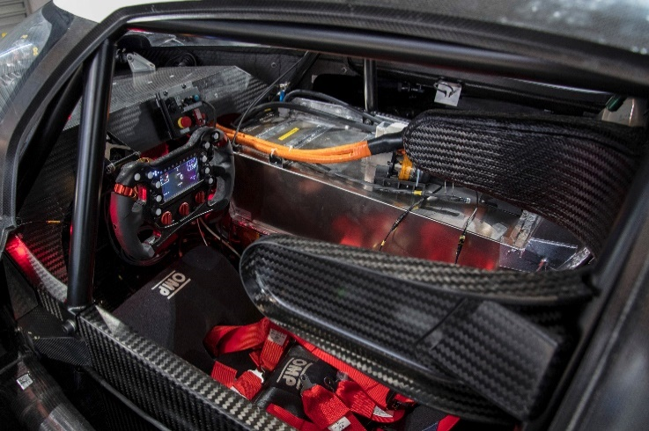
Furthermore any RESS or motor wiring must use thick gauge orange cable to allow it to be easily identified by crew and marshals as seen in the interior shot of the VW IDR electric car. It must be attached to the vehicle with non abrasive clips such as rubber covered p clips that will not damage the cable insulation and risk electric shock or performance failure.
Status Lights
RESS status light
All cars must be fitted with a RESS status light which: - is in working order throughout the event even if the main hydraulic or pneumatic on the car have failed; - faces upwards and is recessed into the top of the survival cell no more than 200 mm from the car centre line and the front of the cockpit opening; - remains powered for at least 15 minutes after the general circuit breaker is activated. - is marked with a “HIGH VOLTAGE” symbol.
Light Status – Green, RESS - status Safe
Light Status - Red, RESS – Danger system defect

Ready-to-move light
IIn order to indicate that the car can move if the throttle pedal is activated, a white light fitted on the top of the roll hoop, illuminating the front of the car parallel to the centre line of the car, will light up. Whilst charging with the control system powered, the ready to-move light must flash “on” for 0.05 seconds and “off” for 2 seconds. It must flash "on" for 0.5 seconds and "off" for 0.5 seconds if, when the system has been requested to energise, the bus voltage has not exceeded 50 V.

This covered most of the main requirements we had until the FIA updated the regulations with a provisional section on electric vehicles in march 2020.
This imposed a number of technical regulations on top of the safety regulations that I had taken from formula E.
These involved
- 250kw RESS draw cap
- 2WD through single differential with no torque vectoring
- Single RESS pack per vehicle and no capacitors
- Battery management must monitor 25% of the cells for condition and be able to isolate any cell in the event of a failure.
The car now fell under a bespoke category which caused these regulations. Production vehicles could be over 250kw and have torque vectoring if fitted from standard but if the powertrain is modified then this is exempt and falls into the bespoke category. This makes the powertrain aspect of the vehicle a very weak area of the motorsport and more interest will be focused on making the vehicle lighter and more handling based if the powertrain is capped t 250kw all cars will be very similar in regards to straight line performance.
For this reason, for the purpose of this project we decided to continue specifying the car to previous standards as redesigning the car for less than half the target power level was unachievable at the stage of development the car was at. All of the safety precautions remain mostly the same with the new legislation and therefore this remains unchanged.

My final task was to assist in the design of the battery charging system in order to keep all the packs and cells safe. Ideally each cell would be monitored and charged individually however charging each battery with a conventional charger would mean using 60 chargers with a positive and negative feed and balance channels for every battery meaning 120 power wires and 840 balance channels would have to be on multiplugs for charging. Because of this a full custom charging unit would be required in order to safely charge and balance every one of the 720 cells in the RESS. This could be on board and compromise weight but simplify the wiring or external and still require the 960 connections.
Overall the main issue withing the project was the change of regulations. It meant that after 6 months of work on the powertrain it was all obsolete and would not be able to run in any competitive event and therefore not worth investment from any component or material suppliers as sponsors.

Achievement and Progress Relative to Initial Plan
Towards the end of the project, I believe there was strong teamwork and good communication as the majority of members began to meet on a Friday to work together. This meant if there were any issues or a member did not quite understand something there was always easy communication and the quality group work was completed. However, this teamwork happened a little too late and therefore not as much work as initially planned was completed. If the car were to have been assembled at least on CAD a month earlier there would have been plenty of time to adjust and correct aspects of the car.
As seen in the appendix of the minutes, towards the end of the project useful meeting minutes were recorded where each member would say their plans for the week and then the following week these plans were checked to see if the members had completed their tasks. This minute taking encouraged work, so we caught up towards the initial plan.

Success and Failures

Starting with failures, I think communication was the biggest issue for the entire project. Not so much for the powertrain group as our weekly meetings solved most issues. Instead, the communication between groups was the biggest issue and took well after Christmas for this to be resolved. The Monday morning meetings and minute taking did begin to solve this issue, but I believe the project would have been more successful if this started earlier. An example of this is visible in figure 3.3, where the communication between all three groups about rear suspension and drivelines amongst the rear bodywork was too late to which there was insufficient time to fix the rear body and recalculate in CFD or push back the rear suspension and driveline.
Another failure of the project was lack of sticking to deadlines. Within the groups, we wrote Gantt charts to keep the project on time but as a group we did not enforce these deadlines enough. Therefore, the deadlines were missed, and the project fell behind schedule early on, which was hard to recover from.
A struggle of the project was the change in FIA regulations halfway through the project. This change in regulation led to confusion amongst the group about what rules the car was meant to be built to. This therefore led to a loss in motivation as some members felt the project was becoming irrelevant. More communication in the group would have resolved this issue faster if we specified what regulations the car is to be built to.
A success of the project was teamwork towards the end of the project. Once as a group, we worked out we needed to organise and attend Friday sessions to complete work. The teamwork, communication and spirit amongst the group was good. This therefore led to more quality work being completed.

Appendices
Appendix 1: Powertrain group Gantt Chart. Produced on Microsoft Project at the start of the project.
Appendix 3.3 Driveshaft initial dimension sheet.
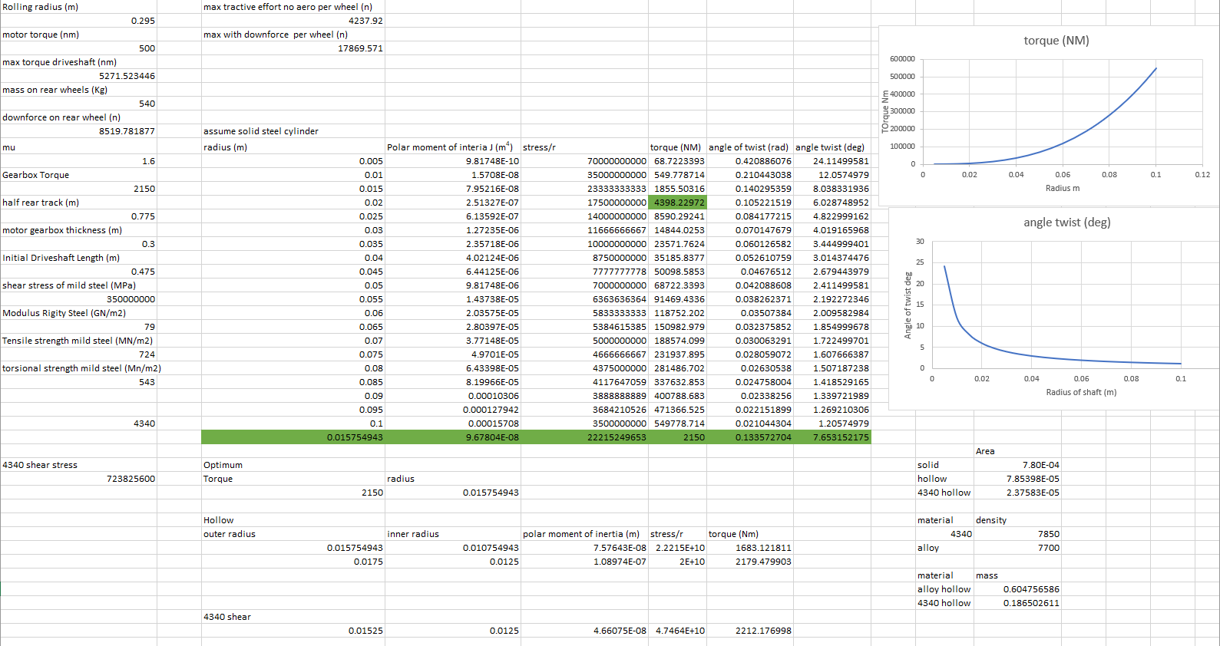
Appendix 3.2. Hill Climb statistics spreadsheet extra workings looking into cooling, gearing and traction
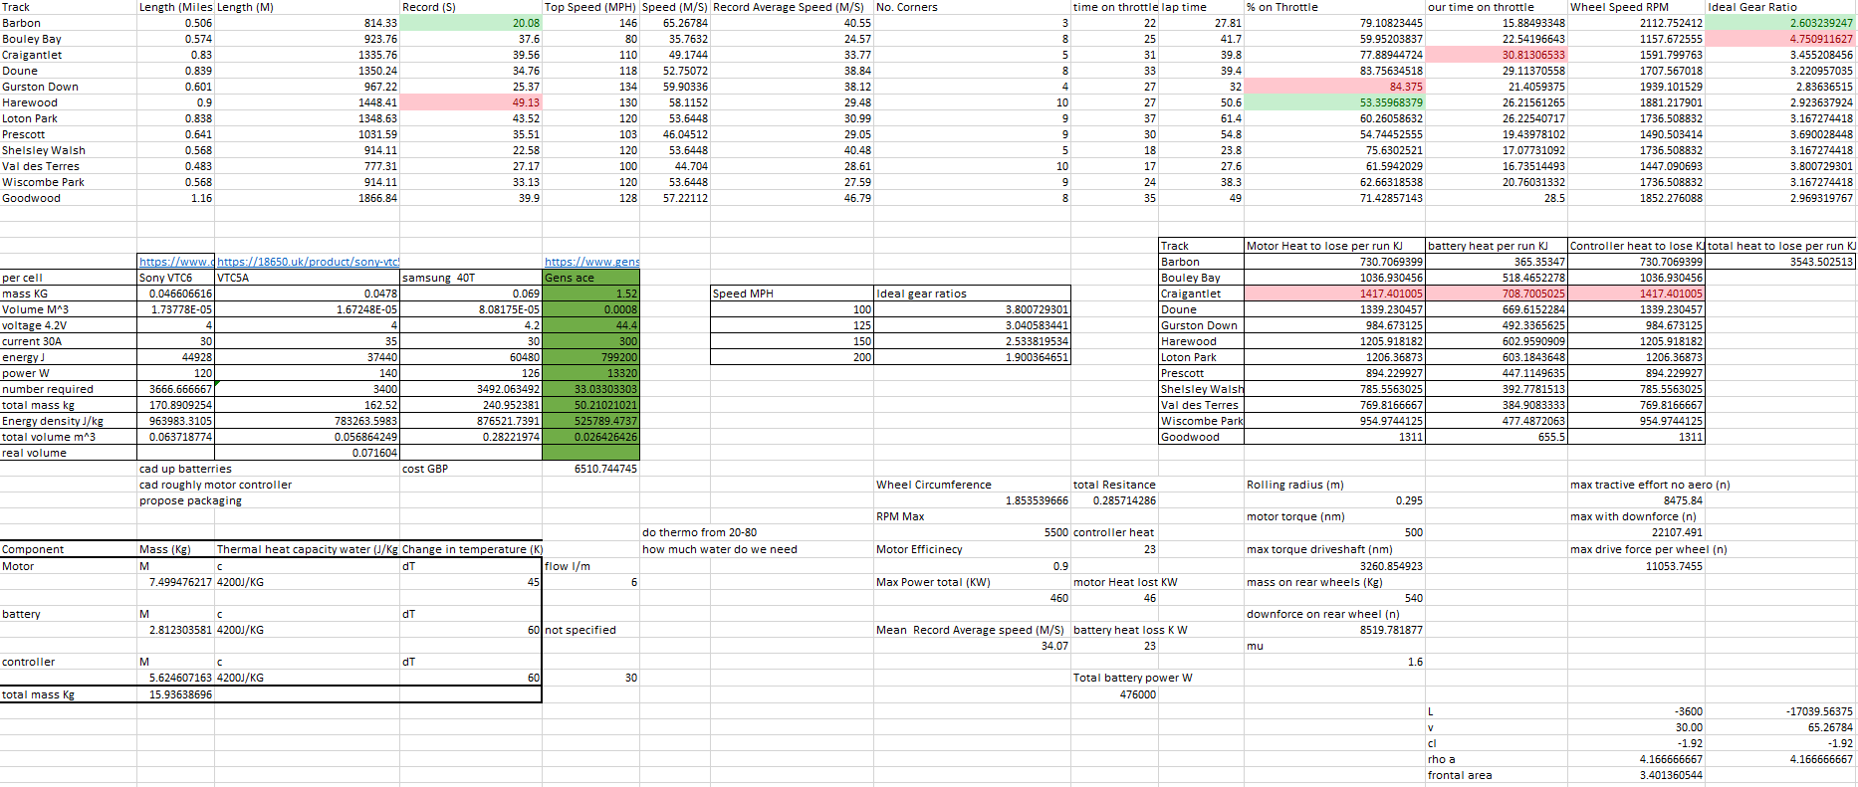
Appendix 3.1. Hill Climb statistics spreadsheet including other workings.

Meeting Minutes

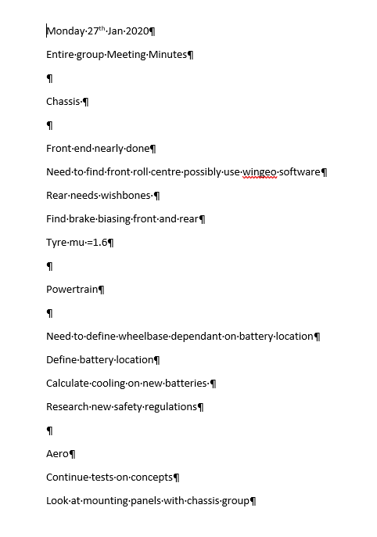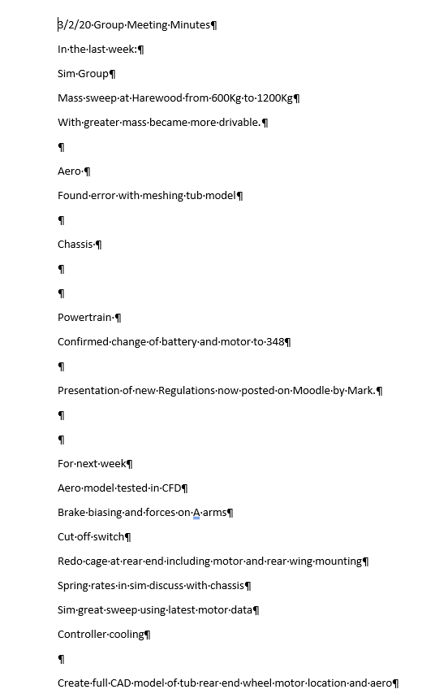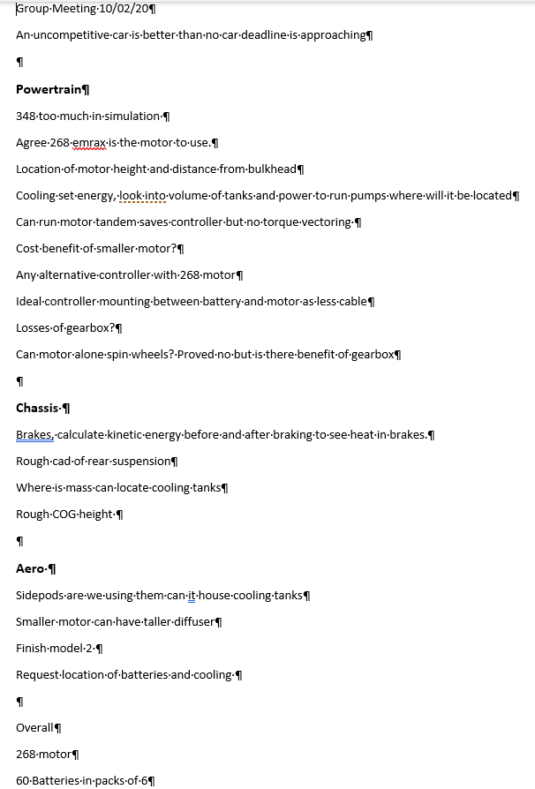
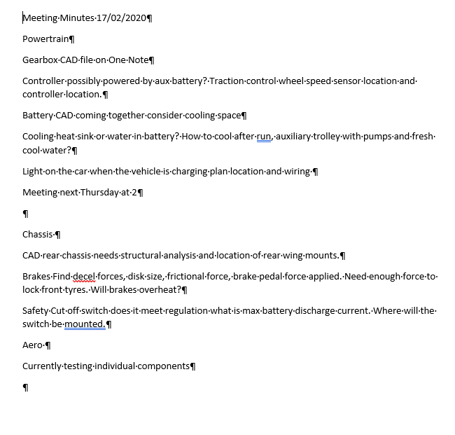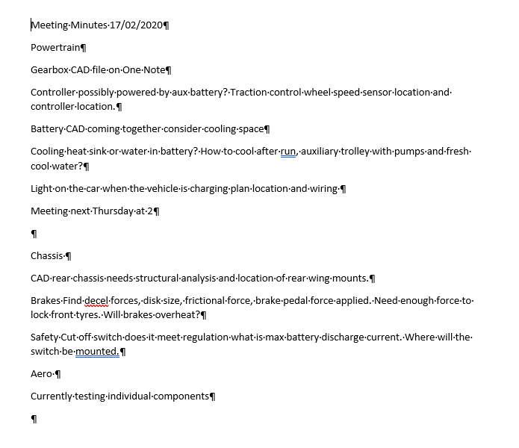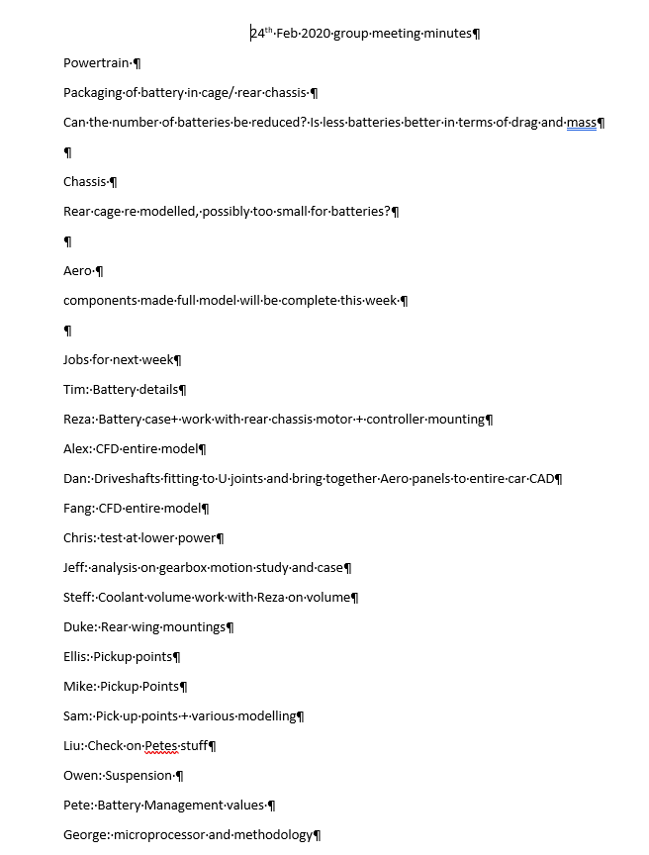
Appendix 12 Meeting Minutes from January to March which increased work.

