Internet of Things a Technical Report
M4X01498

Name: Tanisha Bath
Student Number: 1905383
Course: Electrical and Electronic Engineering (Foundation Entry)
Word Count: 1,380 words

Abstract
Within this report I will be showing how the internet of things helps to improve our lives mainly focusing on the ideas of current and possible future uses to improve transportation. Within this report I will include a counter argument alongside the advantages covered.

Contents
1. 0 Introduction
2. 0 Different Possibilities
2. 1 Smart Helmets
2. 2 Intelligent Cars
2. 3 Smart Roads / Self Driving Cars
3. 0 Pros and Cons
3. 1 Smart Helmets
3. 2 Intelligent Cars
3. 3 Smart Roads
4. 0 Conclusion
5. 0 Acknowledgement
6. 0 Bibliography

1. 0 Introduction
In this report I will be discussing how different devices and ideas that are included under the internet of things can help people with their travels on the road, whether the device has already been made or just a possibility in the future.
To begin this report, we must first understand what the internet of things is and what it stands for. Many of you may not know what internet of things is but the majority of you most likely use it on a daily basis, the internet of things is a large and ever-growing concept that describes devices that are able to connect to the internet and have the ability to identify and connect to other devices. These devices allow us to connect to others around the world, make our lives easier and see the world in a new light and far beyond.
In just one year from June 2018 to June 2019 there have been an estimated “27,820 deaths or seriously injured” on the road and although it’s declining as stated “2018 – 26,724 a 5% decline” ⁽¹⁾ it’s not decreasing quickly enough. This is where the internet of things could be a great help and could be more, I will be exploring this with further research.

2. 0 Different Possibilities
There are different possible ways internet of things could help our lives while travelling be it by car, van, truck, motorbike or bicycle like;

2. 1 Smart Helmets
This idea could be implemented into bicycle helmets, other safety helmets and other devices; I believe that this idea could save a lot of people from accidents.
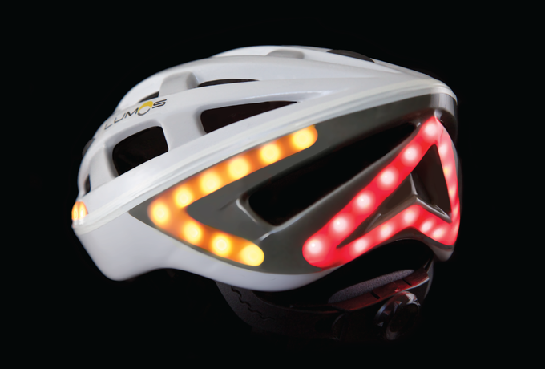
This “smart helmet” for cyclists has lights within the helmet which you can see clearly (right) are connected to their bike with the help of Bluetooth that changes the colour of the lights in the helmet, so they would change red when the cyclist breaks. This helmet could include a small keypad to attach to the bike for indicators so one side of the helmet will flash yellow when they turn to alert cars behind them to know not to overtake. This “smart helmet” could also include a small USB port or just a small compartment containing medical and contact details. ^{Photo Bike Helmet} ^{(2) (Above)}
Another scenario is of a family member for example they are going to climb Mount Everest and will be back by a certain date, that date comes and goes and there’s been no contact, the emergency services would take time locating this family member but with a built in GPS into their helmet they would be more easily locatable, and with 31 GPS satellites in orbit there is a very low chance of getting something like this wrong. ⁽³⁾
Or;

2. 2 Intelligent Cars
Another idea is to have “intelligent cars” so to speak; this idea could possibly stop motorway pile ups and should stop more vehicles being involved in the initial accident. The idea being called Multi-Car Collision Avoidance (MuCCA) ⁽⁴⁾ which is a combination of AI and Vehicle-to-Vehicle (V2V), with this technology working together it allows vehicles to communicate and make decisions.
In this instance there has been an accident on the motorway and the vehicles involved communicates with other vehicles showing their position on the motorway which will allow the other vehicles to find another route by “talking” to the AI connected, to help find the best route and or decision as not to cause more incidents, doing this would allow room for emergency service vehicles to reach the scene of the accident quicker.
There are also many incidents when the driver of a vehicle falls asleep behind the wheel, this idea could incorporate a small system in the car that could possibly sense when the driver is falling asleep, which would stop a few more accidents.
This could also make it easier to find and recover stolen vehicles as it has a GPS system incorporated, the owner of the vehicle could state that the vehicle has been stolen and the police could track the thief (this idea could include an automatic locking system which locks the thief in the vehicle and stop all control e.g. not allowing the thief to steer or break and such).
Or;

2. 3 Smart Roads / Self Driving Cars
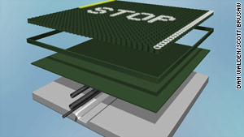
At some point we could have the cars connected to the roads themselves, it is a bit of a long shot but we already have some ideas for smart roads that could melt ice ^{(5) Photo of Smart Road} ^{(6) (Right)}, in turn stopping accidents involving black ice, but for this idea I am taking a bit of inspiration from Disney film Wall-E. Picture Wide shot of Wall-E Seats (7) (Below, Left)
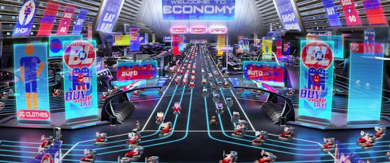
It should work side by side with “intelligent cars” and has the same concept but ideally self-driving cars controlled by GPS with said concept would probably work the best in my opinion. (This is where Wall-E comes in) Picture the seats used in the film like cars, now if our roads were like this we could in all technicality cut out car crashes all together (as in vehicle with vehicle, not vehicle with someone walking onto the road) even if there was some sort of accident there could be precautionary measure such as in this video ⁽⁸⁾ at 1:04 – 1:12 https://youtu.be/s-kdRdzxdZQ?t=64 Picture of YouTube video (9) (Below)
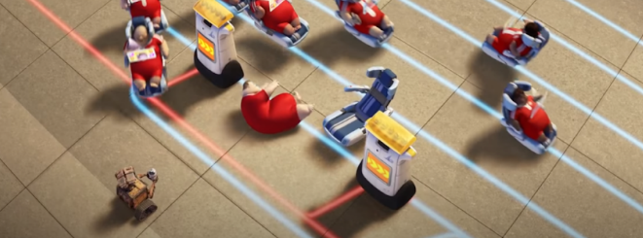
I believe this would be more efficient compared to what happens currently with road traffic collisions where it can take up to and over an hour just mainly due to people slowing down to see what has happened which in turn is dangerous in itself as distractions cause more accidents.

3. 0 Pros and Cons
Of course, there would be pros and cons to every idea, and these are the pros and cons of these ideas. (Said pros and cons are my opinion and are up for debate)

3. 1 Smart Helmets
Pros | Cons
The possibility to find a missing person faster | Can’t really be seen during the day
Less accidents on the road | GPS could possibly be seen by someone unsavoury
Has details in helmet for the emergency services | Could be damaged
It’s a light up helmet | Cost

3. 2 Intelligent Cars
Pros | Cons
Should cause less accidents on roads | Could possibly malfunction
Should not get lost | Could possibly stop working in tunnels
Should be able to recover from thieves | Cost

3. 3 Smart Roads
Pros | Cons
Could catch up on much needed rest (no more falling asleep behind the wheel) | Could possibly stop working
Should stop all vehicle against vehicle accidents | If something did stop working the people in the vehicle may not know how to drive it manually
Shouldn’t get lost | Cost

4. 0 Conclusion
In conclusion, the data clearly shows that the internet of things is changing our world and lives for the better, especially when it comes to the ways in which we travel. Not only does the internet of things make our travel systems easier to traverse, it also makes our travel safer overall, however the cost of these provisions greatly decreases the usability allowing for more deaths where they could be prevented.

5. 0 Acknowledgement
I would like to express my gratitude towards my teachers, especially John Rees, and the faculty team for sharing all and what knowledge they had on the Internet of things.
I would like to thank my uncle for helping me spell check my work and offering what help he could and a thanks to those who have contributed in the completion of this report directly or indirectly.

6. 0 Bibliography
⁽¹⁾ Death count
‌Assets.publishing.service.gov.uk. 2020. There Were 1,870 Road Deaths In The Year Ending. [online] Available at: <https://assets.publishing.service.gov.uk/government/uploads/system/uploads/attachment_data/file/848485/road-casualties-year-ending-june-2019.pdf> [Accessed 22 April 2020].

⁽²⁾ Light up Bike helmet
McCoy, S., 2020. Bike Helmet With Brake Lights | Gearjunkie. [online] GearJunkie. Available at: <https://gearjunkie.com/lumos-bike-helmet> [Accessed 22 April 2020].

⁽³⁾ Number of GPS satellites
Gps.gov. 2020. GPS.Gov: Space Segment. [online] Available at: <https://www.gps.gov/systems/gps/space/> [Accessed 23 April 2020].

⁽⁴⁾ “Smart Cars”
Daws, R., 2020. UK Connected Car Project Aims To Halt Motorway Pileups For Good - Internet Of Things News. [online] Internet of Things News. Available at: <https://iottechnews.com/news/2020/mar/27/uk-connected-car-project-motorway-pileups/> [Accessed 23 April 2020].

⁽⁵⁾ “Smart Roads”
Patterson, T., 2020. Solar-Powered 'Smart' Roads Could Zap Snow, Ice. [online] Edition.cnn.com. Available at: <http://edition.cnn.com/2011/TECH/innovation/01/19/smart.roads/index.html> [Accessed 23 April 2020].
⁽⁶⁾ “Smart Roads” Picture
Patterson, T., 2020. Solar-Powered 'Smart' Roads Could Zap Snow, Ice. [online] Edition.cnn.com. Available at: <http://edition.cnn.com/2011/TECH/innovation/01/19/smart.roads/index.html> [Accessed 23 April 2020].

⁽⁷⁾ Pixar Seat Picture
Newstatesman.com. 2020. A List Of Ways Our Society Is Already Like Pixar’S Dystopia In WALL·E. [online] Available at: <https://www.newstatesman.com/culture/film/2016/09/list-ways-our-society-already-pixar-s-dystopia-wall-e> [Accessed 23 April 2020].

⁽⁸⁾ Pixar YouTube Video
Juggler, F., 2020. Fitless Humans (WALL·E). [online] Available at: <https://www.youtube.com/watch?v=s-kdRdzxdZQ&feature=youtu.be&t=70> [Accessed 24 April 2020].

⁽⁹⁾ Pixar Image from YouTube Video
Juggler, F., 2020. Fitless Humans (WALL·E). [online] Available at: <https://youtu.be/s-kdRdzxdZQ?t=64> [Accessed 24 April 2020].

