Attention Deficit Hyperactive disorder and how it impacts a child’s life…
What have Studies found?
How does ADHD impact the child’s school life?
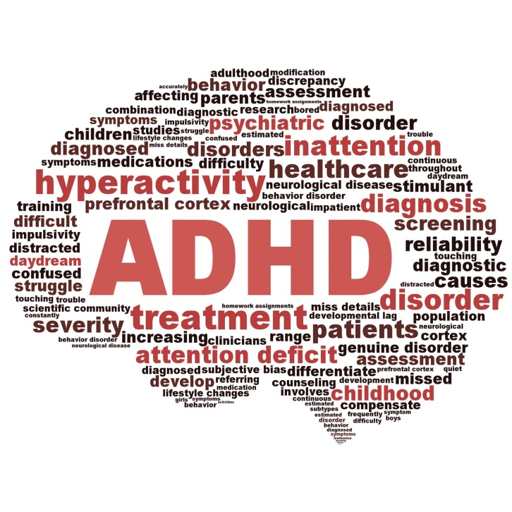
Information for parents and teachers and other professionals on how children are impacted by ADHD in different areas of their lives…
How does ADHD impact the child’s well being?

Attention deficit hyperactive disorder or ADHD, a behavioral disorder that is commonly seen in children from an early age. Often children with ADHD are seen to be disobedient or naughty, however ADHD is a very real and often destressing disorder.
Often symptoms become more obvious when a child starts school, many children may display symptoms however behavior of a child with ADHD is likely to differ to other children of the same age:

Typical characteristic of ADHD are:
- Chaotic behavior
- Inattentiveness
- Careless mistakes
- Changing activities or tasks
- Easily distracted
- Lack of organisation skills
- Hyperactive behavior
- Fidgeting
- Restlessness
- Impulsive, thoughtless and actions
- Short attention span
- Constant talking or interrupting
- Unfocused on simple tasks (NHS, 2018)

What is ADHD?
What causes ADHD?

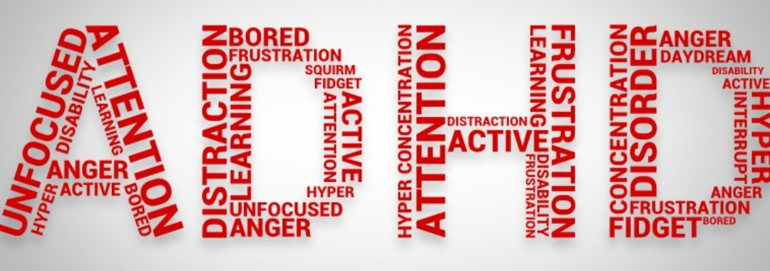
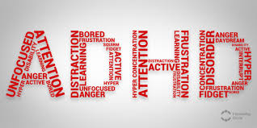
Genetic factors strongly influence the likelihood of developing ADHD. One of the main causes of the disorder is the dysfunction of the frontal lobe of the child brain, often found to be slightly smaller than average .Other parts of the child’s brain may be larger than average. (Bennett, 2011 ) The balance of neurotransmitters are also a contributing factor to the onset of ADHD (NHS, 2018)

What Causes ADHD?
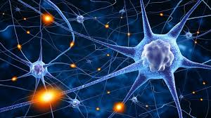
Often ADHD goes unrecognized especially in girls. Often, the condition is mistakenly diagnosed for something else. The NICE (2018) guidelines states that childhood prevalence rates of ADHD are between 3 and 5 % however in many countries around 5 % of children are often just under the threshold to meet the diagnosis criteria, prevalence of ADHD is increasing more over time. (Sayal, 2018)
Premature birth, epilepsy or having a learning disability can increase the probability of the onset of ADHD (NHS 2018)
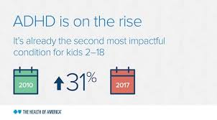

What is the prevalence rate?

Common problems that the child with ADHD faces..
- Poor sleep or disturbed sleep
- Injury as a result of impulsive actions
- Becoming stress when doing simple activities
- Conflict with siblings or parents
- Having to avoid certain foods that influence poor behavior
- Everyday activities can be exhausting and escalate easily
- The child finds themselves ‘told off ‘frequently which can affect self-esteem.
- Loosing items of importance, causing destress
- Unable to retain important information
- Inability to apply themselves to a recreational activity, due to lack of focus, likelihood of injury.
( Harpin 2005)

How does ADHD impacts a child’s well-being?

A Study carried out by Peasgood et al (2016) found that children with a diagnosis of ADHD were experiencing poorer family life and lower well-being than non ADHD children used in the study. The children with ADHD reported 52 minutes less sleep per night, which could contribute to symptoms of irritability. The ADHD children in the study were found to have poorer outcomes with feeling annoyed and reported to struggle with their daily routine.

What have studies found?

Dr Ali Mohammed (2016) Reported in his study that children with ADHD have weaker cognitive abilities and skills, compared to children without a diagnosis. their logical thinking is impaired and communication skills found to be weaker.

School life for any child can be challenging enough.. ADHD can make things even harder for a child… problems could include:
- Problems with interacting with others
- Rejection by peers, lack of friends
- Low self esteem
- Academic failure or poor grades
- Poor performance in test situations
- Difficulties maintaining friendships
- Difficulty paying attention to lessons, calling out
- Tiredness due and inability to concentrate
- Unable to wait their turn, shouting out in class.
- Limited concept of danger, frequent injury.
- Being sent out of lessons , isolated due to poor behavior
NHS (2018)
How Is ADHD impacting the child’s school life?
Did you know ?...
A child with ADHD is 3-7 times more likely to require special education, be expelled or suspended, or need to repeat a school grade. (NICE 2018)

Problems in the classroom…
ADHD can affect a child's ability to carry out simple tasks in the class room such as listening to the teacher, waiting their turn to speak or take part in an activity, or even staying in their seat.. They may call out, interrupt and fidget constantly.. (NHS,2018)

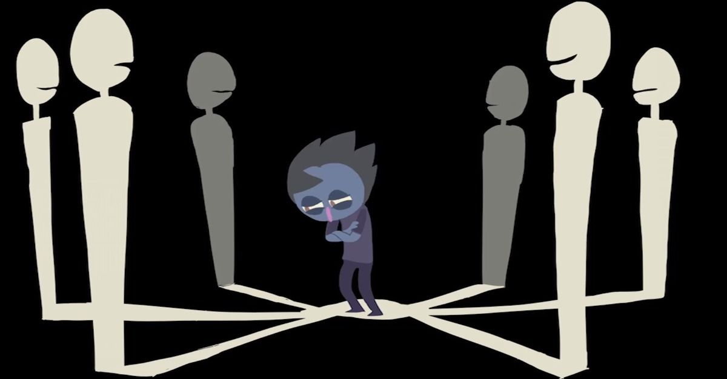

The Bullied child…
A study carried out by Taylor (2010) on 238 children age between 3-7 years, which involved parents and children completing self reports to measure bullying and victimization. The study found that a child with ADHD is more likely to act out towards their peers in frustration or impulsive thought of efforts in an attempt to become part of a group, without thinking through the consequences. If victimized by their peers , children in the study where found to retaliate before thinking through their actions. The study also found that children with ADHD were at greater risk of developing other mental health disorders later in life.

Parenting or supporting a child with ADHD can be daunting, stressful and emotionally draining..
Getting support…
There is help available for anyone who life or well- being is impacted by ADHD. The NHS (2018) recommends speaking to your doctor, school if you believe your child’s behaviour is different to others the same age, and is displaying symptoms of ADHD.
There are many help groups that can be found online:
Young minds foundation ;https://youngminds.org.uk/find-help/for-parents/parents-guide-to-support-a-z/parents-guide-to-support-adhd/
ADHD foundation https://www.adhdfoundation.org.uk/information/parents/
The UK ADHD support group https://www.ukadhd.com/support-groups.htm

References
Bennett. P (2011) Abnormal and Clinical Psychology second edition. McGaw hill. Maidenhead London
National Institute for health care and excellence . NICE (2018). Attention Deficit Disorder. Clinical guideline [CG31]. Available: https://www.nice.org.uk/guidance/conditions-and-diseases/mental-health-and-behavioural-conditions/attention-deficit-disorder

Harpin, V. A. (2005). The effect of ADHD on the life of an individual, their family, and community from preschool to adult life. Archives of disease in childhood, 90(suppl 1), i2-i7.
Mohammed, A. M. H. (2016). The Cognitive Abilities and Skills of Children Who Suffer from Attention Deficit and Hyperactivity Disorder (ADHD) in Kuwait State. Journal of Education and Practice, 7(17), 149-155.
NHS (2018) Overview, Attention Deficit Hyperactive Disorder . Available at; www.NHS.uk. Last accessed; 27/02.20
Peasgood, T., Bhardwaj, A., Biggs, K., Brazier, J. E., Coghill, D., Cooper, C. L., ... & Nadkarni, A. (2016). The impact of ADHD on the health and well-being of ADHD children and their siblings. European child & adolescent psychiatry, 25(11), 1217-1231.
Sayal, K., Prasad, V., Daley, D., Ford, T., & Coghill, D. (2018). ADHD in children and young people: prevalence, care pathways, and service provision. The Lancet Psychiatry, 5(2), 175-186.
Taylor, L. A., Saylor, C., Twyman, K., & Macias, M. (2010). Adding insult to injury: Bullying experiences of youth with attention deficit hyperactivity disorder. Children's Health Care, 39(1), 59-72.

