Scenic construction is the development of the scenery used in both theatre and film. They take designs that the designer has created for the production and create it to be used in the production. This construction could be using objects that already exist and repurposing them into other things e.g., boxes into cupboards or creating something completely brand new from scratch.

Safety in a workshop setting:

When working in and around a workshop setting, it is very important to consider your personal safety and the safety of others. Factors that need to be considered are operating machinery, sharp objects, trip hazards, falling objects as well as other environmental factors depending on the location.

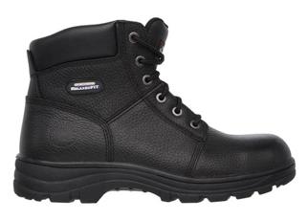
When operating machinery, it is imperative to not only use them responsibly and as is intended. This means not using materials which the equipment isn’t designed to be used on and operating them according to the instructions which the manufacturer had sent with them. Equipment like this can be hazardous to the operator if protection isn’t worn; eye goggles and ear defenders can help prevent damages to the eyes and ears respectively if the machines are very loud or spit things such as sawdust and sparks out. Also, tying long hair back and removing any loose jewellery, such as necklaces and non-studded earrings, will prevent any accidents caused by them getting tangled within the machine. Wearing steel toe boots protects the foot from heavy objects that may have been dropped onto it, and consequently saving the foot from being broken. Work boots also protect the foot from liquids that may have been dropped and may not be safe for skin contact. The U.K government requires protective footwear to be worn in a construction site and these rules usually will apply to a workshop setting also.
Steel cap boots

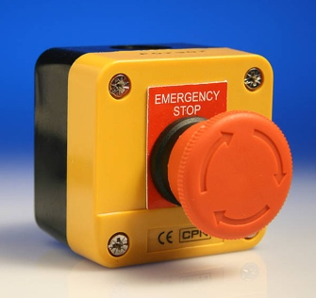
Furthermore, when operating machinery in a workshop, it is essential to know where the stop buttons on the equipment are. As some equipment don’t automatically stop once the trigger has been pressed, you will need to manually stop it with the button. Also, knowing where the emergency stop button which cuts power to all tools and machines connected to the mains of the building is useful to know in case of an injury or incident within the workspace. These buttons will always be red with yellow background as to be a velar distinction from other nearby buttons. They may also be labelled with “Emergency Stop” depending on the manufacturer of the button.
Emergency stop button

Being aware of your surroundings plays a major role in workshop safety as there can be many trip hazards such as wires running along the floor, materials that have been stored on the floors and smaller objects which may not always be immediately noticeable such as nails and screws. Ensuring that wires are not in potential walkways as well as clearing up after oneself helps prevent incidents from happening.

Flats:

Flats are pieces of scenery which go at the back of the production to show location. These can be decorated and modified to suit the productions need. These are usually created from plywood in two forms: Hollywood and Broadway. The difference between the two flats is in the construction of the frame: Hollywood flats have the frames attached to the sheet wood on their side whilst the Broadway flat has it attached on the side with extra support braces in the corners. In a group with two others, we built both flats.

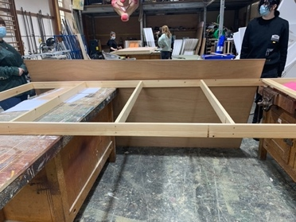
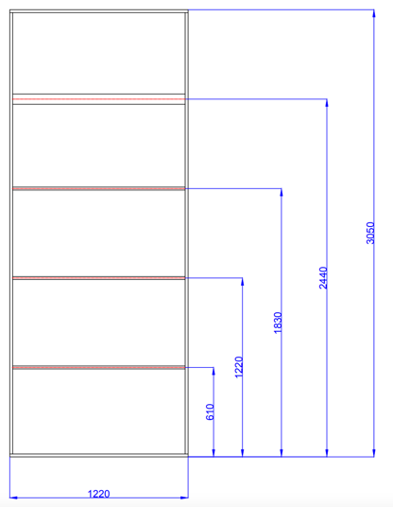
To create the Hollywood flat we initially got our cutting list from the dimensions that we were given which included 8 pieces of wood (4x 1180 mm, 2x 1220mm, and 4x 3010mm) and then we cut these out on the chop saw. We did this by measuring the lengths we needed on the panel of wood we were cutting and cutting each size one at a time as this allows for the sizing to be accurate and allowing less room for mistakes and therefore waste. These pieces would come together to create the frame which would be 10 by 4 foot in size. Once all the pieces were cut out, we placed them over two work benches to create the shape of the frame, using a square tool to ensure all angles were 90 ° before gluing them together. We had four panels going down the frame to support it. Three of the panels matched the outside structure of the frame with them being placed on their side but the last, top, panel was placed flat as this is where the two sheets of plywood meet.
Hollywood flat frame + Hollywood flat dimensions

As the glue was drying, we began to create our pilot holes. Pilot holes are holes drilled into to wood which are used as a guide for placing screws as well as prevention the wood from cracking. We drilled pilot holes in the places the panels of wood met as this is where we wanted to place the screws to secure the frame together. We drilled two screws per join to secure it thoroughly. We rechecked that everything was correct and square before we moved to place the sheets of plywood.

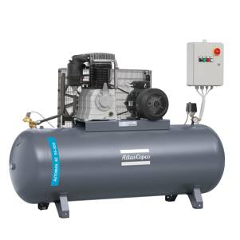
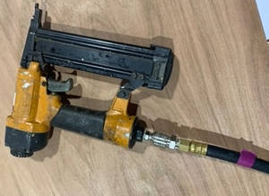
The first sheet we placed was a standard 8 by 4 foot in size and was pre-cut to that size when we acquired it so we started by placing wood glue on the areas it would cover on the frame, making sure that the tallest toggle, the one they laid flat, wasn’t completed covered by the sheet, and place it on the frame. We then secure it using an air pressure staple gun which was connected to a compressor. The compressor is linked to the tools as provides pressurised air to increase power. We stapled along the sheet over where the frame was underneath the two, connecting them. We stapled along the grain as this add extra strength to the flat.
Compressor + Staple gun

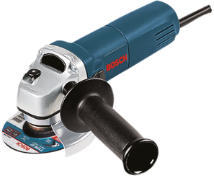
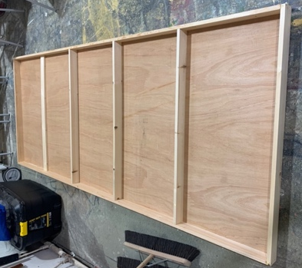
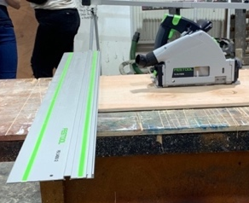
Afterwards, we then cut our second sheet of plywood to fill the gap at the top. This sheet needed to be 2 by 4 foot in length. We, firstly, measured this piece of wood against the gap we had to ensure the sizing was correct before marking it out in pencil. We used pencil instead of pen as pencil is erasable and it doesn’t stain or show through paint as pen does. We then cut the wood using a rail saw, or a track saw. These handheld saws run on a track, or a rail, hence their name. We ran the saw just to the side of the mark we had made, ensuring that the saw running into the off cuts instead of the piece we needed to use. By doing this, it allows for the wood we need not to be cut just a little too short on accident. Once we had the right size wood, we repeated our actions with the wood glue and the staples, securing the pieces together. Afterwards, there was some staples showing through the flat, so we used an angle grinder to get rid of the imperfections which finished the flat.
Rail saw + angle grinder
Hollywood Flat - finished

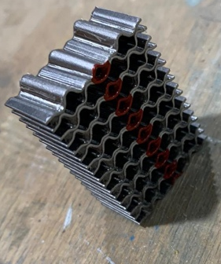
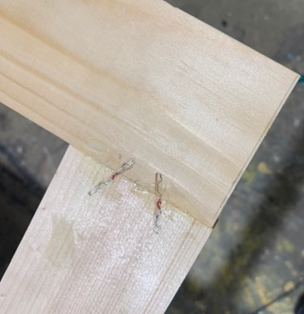
To create the Broadway flat, we once again cut out the wood for the frame using 8 by 1s to cut out 2 lengths of 1220mm, 2 lengths of 2304mm and 1 length 1084mm. We initially build the frame similarly to the Hollywood flat but instead of laying the panels on their side, we laid them on their side. Instead of fastening the wood with glue and screws like we did on the first flat, we used glue and wiggle pins as the screws we were using would’ve have been able to penetrate the depth of the wood as it laid flat. We fastened the panel in the middle in this way too, ensuring before we fastened each corner that each of them were square.
Wiggle pins + wiggle pins in corner joint
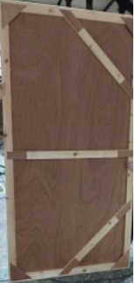
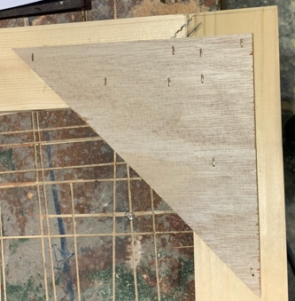
Unlike the Hollywood flat, the Broadway flats only have one vertical panel in the middle supporting the structure. Instead of having multiple horizontal panels, the middle one is accompanied by a diagonal panel at the top of the flat and another one at the bottom. On top of the diagonal panels, we installed corner blocks pieces to add more strength to the flat. We did this by cutting squares, and then halfling those squares, from the same sheet plywood we would later attach to the flat to finish it off. We also 2 attached long, thin rectangles from the same plywood to the toggle in the middle to add strength to them also. To finish off the flat, we attached the last sheet of plywood which was 8 by 4 foot in length; we attached this in the same way we did the Hollywood flat by first gluing the sides which the sheet of wood would meet the frame, placing the sheet down and then using the staple gun to attach the pieces together.
Corner blocks and finished Broadway flat

Initially, I found this process hard to grasp when creating the Hollywood flat as this was my first time using new tools such as the saws and staple guns, but after I had started, I found it much easier to continue with. As I made the Broadway flat second, I found that easier to complete as I had learnt and began to practice the techniques needed when creating the Hollywood flat. I also found the process quite fun to complete as I do tend to like the problem-solving aspects of construction.

Treads:

Treads are what stairs are called in a theatre production. Sometimes there are there for purely aesthetical reasons, some practical and often a mixture of both. Treads, if being moved on set need to be both lightweight, string and durable as they will need to be moved around, and will also be climbed, danced, jumped, and walked upon numerous times. They need to be very durable because if they break under the actor in use it can resort in injury.

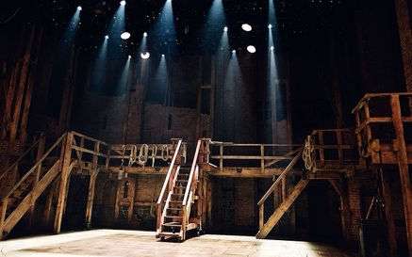
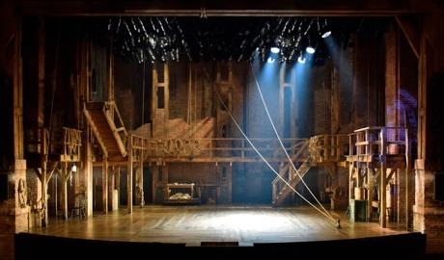
Treads are often used in theatre productions to give ease of access between different platforms without having to go on and then back on stage. The production of ‘Hamilton’ is very well known for their use of treads as there is a lot of them visible from the audiences perspective.
Set of ‘Hamilton’
Most treats for theatres are made from plywood as it is a durable material which is readily available and light enough to be transported, other types are constructed from lumber, or some even have metal frames with wooden steps on them. They need to be built wide enough for performers and crew to be able to safely walk up and down without a major risk of falling. Adding a non-skid strip to each tread also helps reduce this risk. They also need to have the correct supports built into them to be able to support the weight of whoever will be standing upon them as well as being structurally sound enough to not fall apart after one or two uses. Treads can also be attached to the stage with cleats, or otherwise known as tread bracket, to stop movement on stage. Treats over three steps also need to have a railing or support attached to the side for the user to grasp whilst climbing or descending the treads.

The angle for the treads must also be considered during construction, the safest angle for the treads to be is between 30-35° but angles between 20° and 50° can also be considered. This is called the critical angle. Have this angle used in the design of the treads lowers the risk of the stairs being too steep and increasing the risk of falling or being too shallow and risking similar outcomes. Also, the tread and riser size should be easy to climb up and not too strenuous they may easily tire the user of the tread. It is also imperative to keep all treads on one production built to the same size in case they are switched.
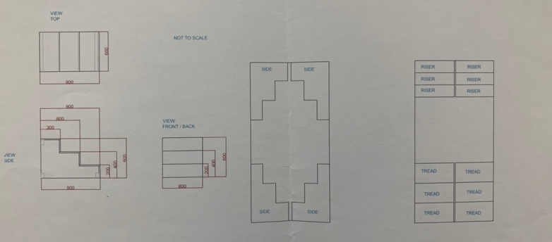
We worked in groups of three to construct our treads from this 1:25 scale drawing. We then translated this into a 1:1 scale with scale rulers. This translated up to being 582mm tall and 882mm wide. The treads were 600 by 300mm and the risers were 600 by 200mm. We had initially measured the risers to be 600 by 182mm but this was incorrect due to an issue with the plans we were given so this was corrected when we discovered the mistake. We used 18mm plywood for the construction of the treads.
Plans for the treads

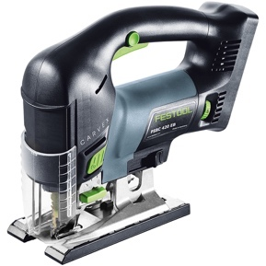
Initially, we measured the wood to thew dimensions we needed and then used the rail saw to start to cut the wood. We used this for the far edges of the sides of the treads until we reached the sharp corners where we switched the rail saw for a jigsaw for better access for the corners. We used the jigsaw for better access as they are controlled by the direction the user sends them in and are not stuck to angles such as the chop saw, and the table saw. After using the jigsaw, we moved onto the table saw for the treads and the risers to cut them out quickly and with ease.
Jigsaw

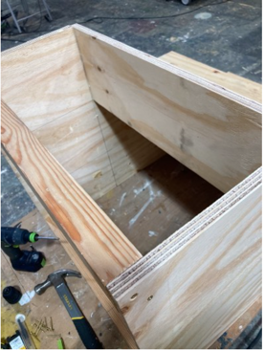
Once the pieces were cut out, we started to construct the treads. We used support beams to attach the two sides together. These beams were made from 3 by 2 pieces of wood which we cut to be 564 mm long. We glued and then screwed these at the top, bottom left and bottom right corners of the treads. We then followed this by attaching the risers and the treads by gluing them and then using the staple gun to properly attach them to the frame. We did this by doing the first riser and then the first tread, repeating this until we were out of pieces to attach. Furthermore, by adding the glue, it did not only help us properly attach the staples, but it also reduced the noise made on the treads when in use.
Tread support beam
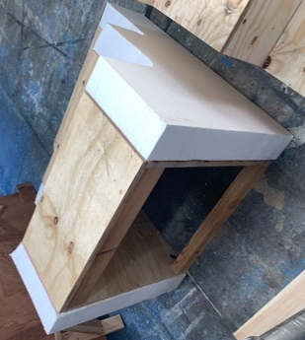
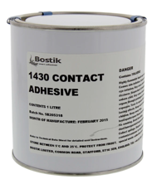
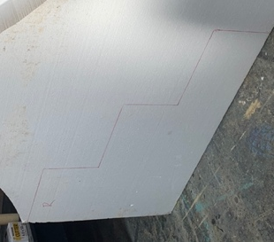
After the treads were constructed, we began to work with polystyrene to attach to the sides of the treads, this was to create a stone wall pattern and texture to the treads for the criteria and expectations which were placed on the project. To get the shape we traced the side of the tread into the polystyrene with a Sharpie and then we cut it out using the jigsaw again, this time we changed the blade out for another to be able to cut through the polystyrene with ease. We repeated this for the other side of the tread. To attach to polystyrene to the wooden tread, we used a high contact adhesive which is specifically designed to be used on polystyrene as other types can melt though it.
Polystyrene adhesive
Polystyrene outline and
Polystyrene cut + attached to treads
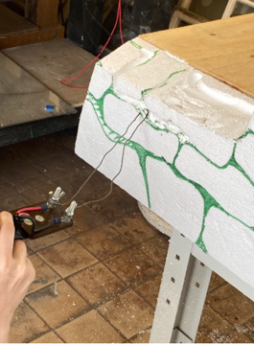
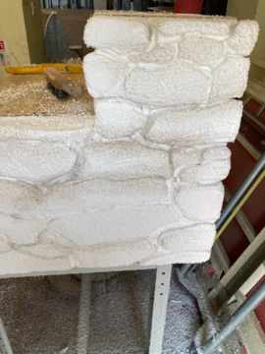
To make the treads have the desired look and texture of a stonewall, pictures were used as a reference to make them look more realistic, and the shapes were drawn into the polystyrene and cut out using a hot wire tool. We also carved out the sides using this tool to gain a more realistic and a less stiff look. To add more texture, we used wire brushes over the individual stone shapes, which finished up the treads.
During + after of carving the polystyrene

I found the treads to be easier to complete than the flats as I had already began growing my skills with the tools used. I didn’t, however, enjoy using the jigsaw as I found it hard to grasp and use and therefore my work with it was not as precise as I would’ve like it to have been.

200 Project:

We, in a group of three other, were assigned to make a box which could safely story a lighting control panel for an outdoor display. We made the box out of MDF as it is a waterproof material and therefore safe enough to house electricals outside.

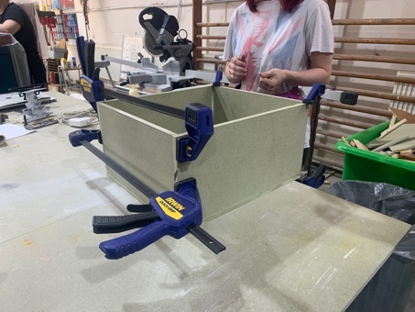
To begin with, we started by measuring the control panel to gain a rough idea about the size of the box we would be making. It was not precise from the measurement as we had to add room around where to panel would go as to leave room to store wires when not in use and to ensure that the panel didn’t overheat when it was turned on. Our cutting list ended up being 2x 354mm by 206mm, 2x 420mm by 206mm and 2x 420mm by 384mm rectangles.

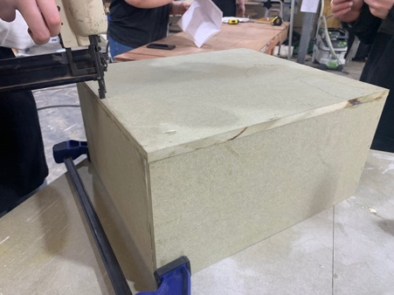
We used the rail saw to cut these pieces out to size. To attach the first five pieces together, we initially used wood glue on the edges before using clamps to hold the pieces into shape. Next, we used the staple gun to staple the MDF (medium-density fibreboard) together, we had some issue getting the staples to go in properly, so we had to hammer some of them down to ensure that everything was flush with each other. After we had stapled the five sides together, we made 8 triangles from 50mm by 50mm pieces of scrap MDF as these would sit inside the box for the lid to rest upon. We glued them onto the lide before stapling them into place also. The last piece of MDF to be attached was the lid of the box, this wasn’t stapled but hinges were used to allow easy access to the lighting panel once it was placed inside the box.

Rostra:

A rostra, or rostrum, is a raised structures which are used for some form of performance, ranging from a public speaking addressing a crowd to a performer to their audience. Rostras go back many years, originally, they were built from wood. There are many types of rostra, but the standard is a 2440mm by 1220mm rostrum which is constructed from 18mm plywood. They have a flat top which is where the user will stand with solid supports on all four sides and running underneath to give it strength. This types, especially when made from plywood, have a very similar if not identical, structure to flats.

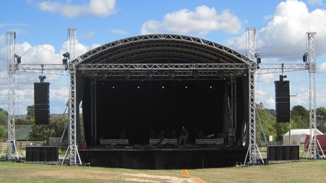
Modular steel rostrums are more adaptable than the standard plywood rostrum as it usually comes with corner sockets for the legs which can therefore be changed out and the height adjusted. This, combined with the long life and durability of steel, compared to plywood also makes it a much economic option for theatres to use. Steel is, however, a much more expensive material which makes having a steel rostrum a bigger investment than a plywood one. Steel is also more weatherproof than plywood making steel a better option for large risers such as outdoor temporary stages. These types of stages are used in outdoor concerts and/or music festivals.
Outdoor stage

A gate-leg rostra is made in a similar fashion to the standard plywood rostrum. They are made from 25 by 75mm or 32 by 75mm softwood. They are made from flats which are hinged together to make one structure. Due to the construction of this rostra, it makes it easier than other types of rostra to put away as it can fold up unlike others which are just one solid structure. This type of rostra is easily converted into a truck with a simple modification adding the gate and hinge mechanism to a low-level truck.

Circular Rostrum:

We, in a group, were assigned to make a circular rostrum which would be able to support the weight of people using it to dance upon. The diameter of the stage had to be 2.4m in total. We made it out of plywood and 3 by 2 strips of wood cut to be supports underneath. For the main platforms, we cut two semi circles from a sheet of wood. We used the jigsaw to achieve the circular edge and used the rail saw for the supports underneath.

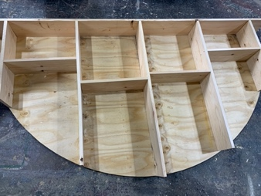
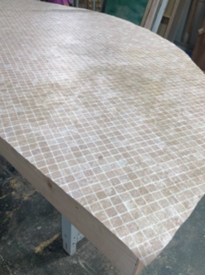
To start the construction, we started attaching the supports to one semicircle. We used wood glue as well as screws to keep it together. We also had to staple the wood in places for extra strength and then use the angle grinder to grind the staples which hadn’t gone in properly away. Next, we added a linoleum top using a contact adhesive. After repeating this step for the other semicircle, we bolted the two pieces together. For the edges, we used a think piece of plywood to wrap around the entire structure. Before attaching, we used a planer to smooth the edges down. We attached this using staples and therefore finishing the rostrum.
Supports of circular rostra + Linoleum top

Theatre Trucks:

Theatre trucks are rostrums which have been placed on wheels allowing them to be moved to and from the stage with ease. (Theatre trucks are also referred to as scenery wagons when hosting scenery on them). They can be moved by actors or stage crew moving them during the production. Handles can be attached, or they can be manoeuvred by themselves without any additions.

Breaking methods also need to be considered when using a theatre truck. There are multiple methods to consider. Using a drop bolt by drilling holes in the stage is a quick and cheap way to brink the truck to a break but it is easy to miss the holes if the theatre is dark or it hasn’t been rehearsed enough. Using foot breaks allows for a more versatile braking system as it allows for the truck to be used anywhere on stage instead of being restricted to certain spots.
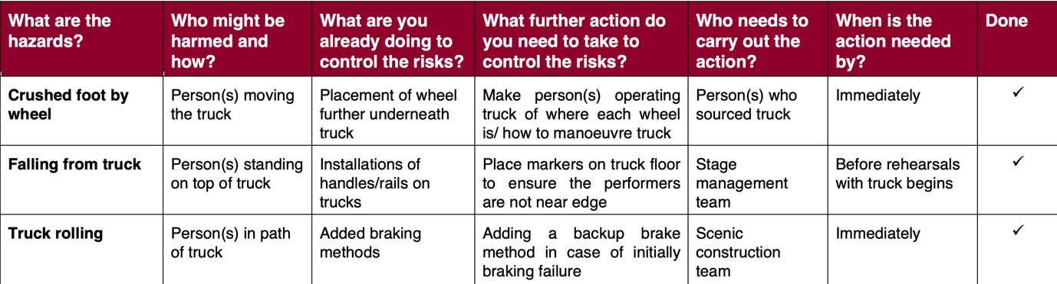
For a theatre truck to be used, a risk assessment needs to be filled out to ensure safe usage. I completed this one using the resources available on the Health and Safety Executive website.

Revolves:

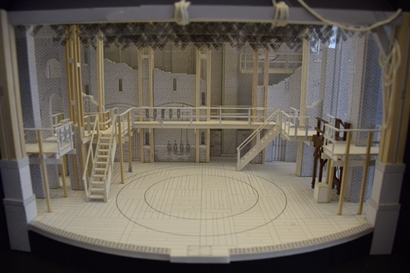
Revolves, or a revolving stage, are a circular stage which rotates around a central point. Revolves are motorised and are controlled through an automated process, most likely through a computer. Revolving stages were first created in the 1700’s for the use in the Kabuki theatre in Japan. By the late 19th century, it began to be introduced in Western theatres and productions and is now a commonly used theatrical tool. One of the most commonly known use of a revolve in a theatre show is in the production of ‘Hamilton’ where it is used throughout the show to aid in both the plot and the choreography.
Set and revolve of ‘Hamilton’

Making a revolve on a raked stage is possible, but less simplistic than it would be if it was made on a flat stage like most revolves are. Firstly, a raked stage is a stage that tilts upwards the more upstage it goes. Personally, I have thought of two ways to create a revolve on a raked stage: the first being that the revolve doesn’t sit flush on the upwards angle of the stage and instead sits flat. This would be easier to manufacture into the raked stage as the angle of the mechanisms would have to be less of a pressing issue, as well as making sure that the revolve could spin upwards with things placed on top of it. However, by having the revolve sit flat on a tilted stage creates a further element to consider with the risk assessments as the different heights would create a height differences between the two platforms and therefore becomes a tripping hazard.

My second thought was to have the revolve sit flush with the stage. This would eliminate the potential risk I had set forth in my first potential idea, but it would also make the stage look more aesthetically pleasing as a whole as it would not have random parts sticking out from it. The revolve could potentially be placed on a track to stop it from losing momentum during its usage which would, hopefully, also be possible with the raked stage element involved.

Metal to build scenery:

Metal is often used as a component or the majority material when it comes to building sets even though it is a more expensive, and sometimes harder to source, option compared to other options including plywood. This is because metal has different elements to it which can make it a more practical option compared to others.

Firstly, metal is more structurally sound material compared to wood and other common materials used to construct sets and scenery such as plastic. Due to the strength and the structure of metal, it makes it last longer than other materials meaning that the upkeep and maintenance for a metal structure. Furthermore, having a metal structure means that the scenery would be able to hold more weight as metal is more load bearing than most other materials. The strength that metal brings to scenery also means that it more resilient to natural wear-and-tear and therefore has to replaced far less than other materials may have had to have been. Metal is a more expensive option for initial purchases than using wood, plastic, or other materials but due to its durability metal needs less upkeep and replenishments to last a long time which makes it a far more economical option.
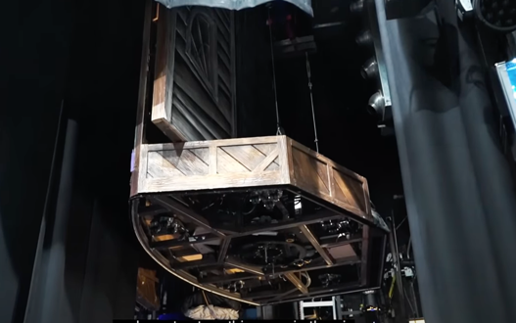
This photo is from the musical ‘Beetlejuice’, more specifically it is one of the piece which is stored suspended in the air. This being made from metal give its more strength to be hung whilst also receiving less damage whilst doing so.
Suspended scenery from ‘Beetlejuice’

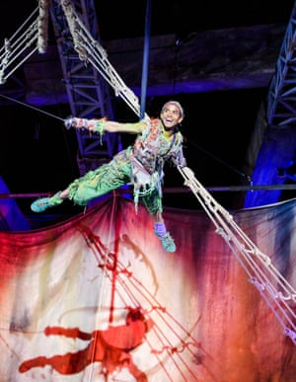
Metal, especially steel, is a more weatherproof material compared to other common building materials as it doesn’t absorb water and it does not rust. This makes it an ideal building material when working and creating pieces of scenery which will be placed outdoors. By having weatherproof scenery, there can be less consideration to the short-term storage of the scenery during bad weather as it won’t need as much upkeep or replenishment as something which could not stand such conditions as welk as the metal could. By having weatherproof materials used to create scenery, it also leads to the possibilities to having the production being set outdoors without the weather hindering the performance. The 2015 production of ‘Peter Pan’ which was held in Regents Park’s open aired theatre has metal structure both incorporated and supporting the set which would have been kept up between performances.
Photo from ‘Peter Pan’
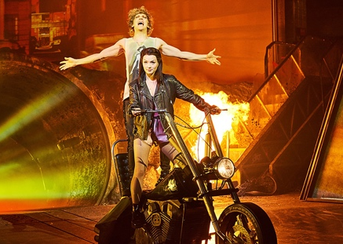
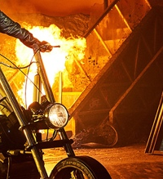
Using metal for scenery is a good option when working with pyrotechnics as most metals, especially ones used for set and scenery construction. Wood is a very common material to use when it comes to sets for both film and theatre but that runs a great fire risk when using pyrotechnics so using metal is a safer choice. This photo is from the West End production of ‘Bat Out of Hell’ where metal can be clearly seen as the main material near all of the pyrotechnics.
Photo from ‘Bat Out of Hell

Welding and Metal:

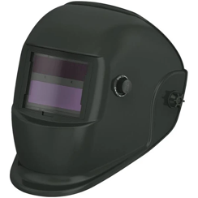
Welding is the process if combining, through fusion, two or more pieces of metal together. This reaction is caused by heat and/or pressure. Welding can also be used on thermoplastics which are a type of polymer which can become pliable when a certain temperature, depending on the type of polymer, is reached. There are four main types of welding metal, they are as follows: MTG (gas metal arc welding), Stick (shield metal arc welding), TIG (gas tungsten arc welding) and flux cored arc welding. When welding, it is important to wear a proper safety equipment such as a welding helmet to stop sparks from flying into the eyes and from the light emitted as well as well wearing gloves to also reduce risk of burns through the sparks.
Welding helmet

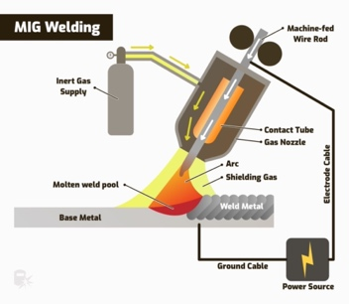
MIG, or gas metal arc welding, is a common form of welding and is used on building construction and vehicular repairs. It works by creating an electric arc between a wire electrode and the metal being welded. An electrode is a metal wire of which is coated. This causes the metal to melt and therefore fuse together.
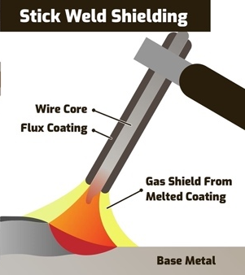
Stick, or shielded metal arc welding, is used across many sectors including construction, repairs, and work on underwater pipes. Stick welding has the benefits of being more accessible as it is portable due to it being able to be connected to a battery pack. Stick welding works by the electrode, which is consumable, connecting with a covered metal electrode and the metal which is being welded, creating the arc, and then fusing.
MIG, Stick, TIG and Flux Cored welding inner-workings
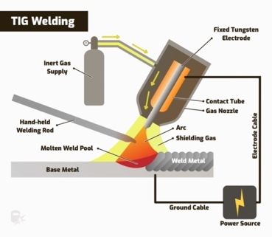
TIG, or gas tungsten arc welding, is similar to MIG welding as it uses an electric arc like MIG does. It is used primarily for vehicular and outdoor equipment. TIG, however, uses an electrode made from tungsten, hence it’s name. Tungsten does not reduce in the welding process like other electrodes may as tungsten is a stronger metal. TIG welding also uses gases which have to be sourced like helium and argon unlike stick welding which uses gases already in the surrounding air.
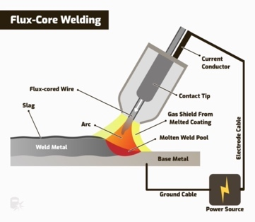
Flux cored (arc) welding is again similar to MIG welding due to its use of continuous wire. Flux cored welding works by using a hollow electrode filled with flux (a cleaning agent). Flux cored welding is a great option to use when welding outdoors as well as in machinery.

Cost of materials:

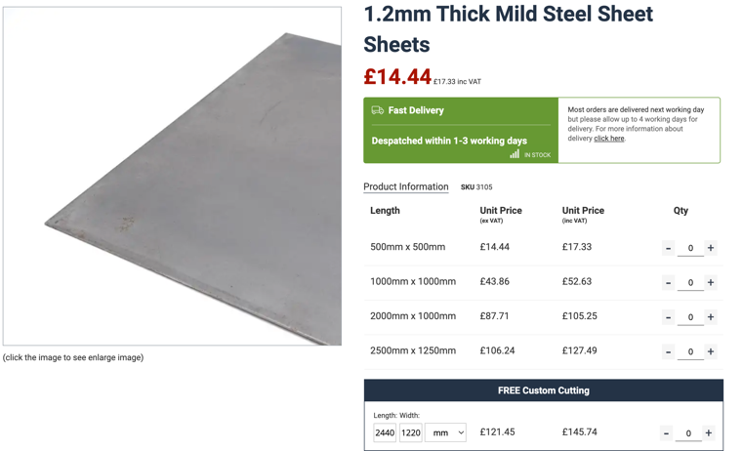
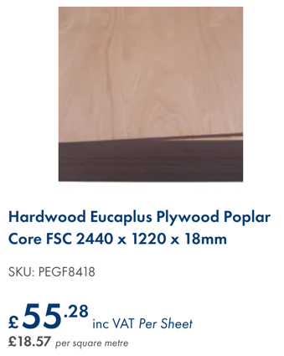
There is a significant cost difference between wood and metal with metal being the more expensive option of the two, especially when buying in smaller quantities. I compared the two price points between both options by estimating the cost to buy the materials needed, excluded the tools, to make a 1220mm by 3000mm flat. For this flat, I would need 2x 1220mm lengths, 2x 2980 lengths, 2x 1060 lengths and a sheet which totalled 1220mm by 3000mm. I added the potential costs for each flat with the wood totalling £106.50 whilst the metal variant totalled £138.47. This is a good place to start comparing the costs between both metal and wood if an estimate for an entire set would be needed. However, if the set being built had more components to it, it would become cheaper to purchase the materials needed due to buying power.
Example price points

Set joints:

Sets, due to how they are constructed, have to be joined together in the theatre so it is important to incorporate methods to attach set pieces and/or flats together and making sure that they all line up and work during the construction period. There are four main types of joinery used in sets which include cleats, throw lines, ratchet straps, and pin hinges.

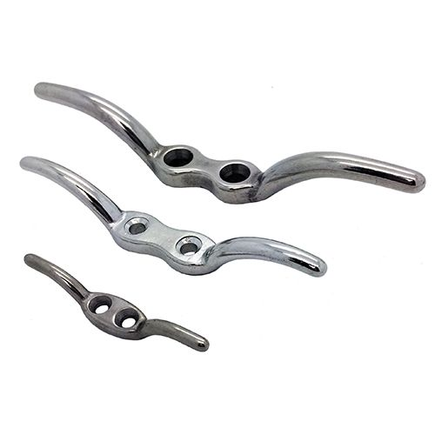
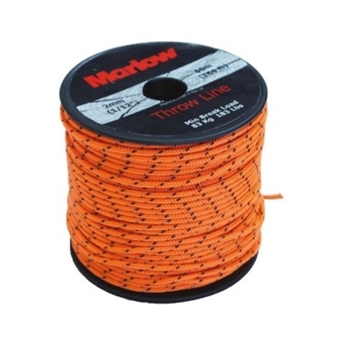
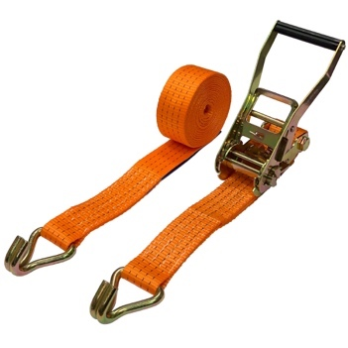
Cleats are pieces of metal, or sometimes wood or plastic, of which ropes are threaded through and attached too. These ropes are then pulled together, bringing whatever the cleat is attached to together. This type of joinery would be useful for sets which need to be moved or often rearranged such as ones used by a travelling theatre show or a set piece which come sand goes from the stage during a performance. However, due to rope being a key element for this form of binding, it would need to be changed regularly as rope, especially when pulled tight as would be needed here, can easily start to wear down and break and snap. Failure to do so could lead to the set/flats failing apart during construction, rehearsals or even performances. Throw lines are wires or ropes which attach to cleats in the ground or walls to hoist and stabilise pieces of sets or flats, similarly to how a tent is hung with guy ropes. This method of suspension us great for sets which may need to be erected or taken down quickly like, for example, during an interval. Throw lines are restricted by if they can be connected to the ground with cleats as not all venues may allow or have the facilities to accommodate them as well as if they can be attached to other pieces of scenery without changing to quality and the appearance. It also relies on these cleats being installed in the same place which may not be available in all venues due to varying stage sizes and shapes.
Throw line
Cleats

Ratchet straps are material straps which connect to flats and/or scenery and pull them together. Typically, ratchet straps are used to tie and hold down materials or objects, but they are certainly useful for keeping things upright, stable, and erect. Ratchet straps are adjustable which means that they can be used across a variety of sets and locations without having to repurchase new straps. However, due to the straps being made of material, it means that they can fray and break easily from natural wear and tear.
Ratchet Straps
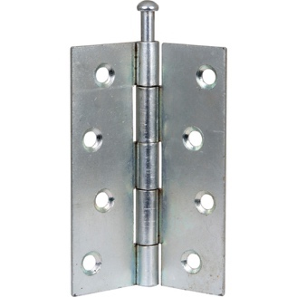
Pin hinges are hinges which are commonly found on door and cabinetry. They are metal and consists of two pieces which are connected too and rotate around a single pin, hence its name. These hinges are great to use if the sets need to have pieces move within a 180 radius but if the piece is needed to be stationary, there will need to be some form of block placed to ensure that the set/flat doesn’t move when/where it isn’t supposed too.
Pin Hinges

For a more permanent solution, using nails and screws to attach basic flats together also work but it is important to accommodate for the extra weight and ensure that there are adequate supports in place.

Theoretical Tree Construction:

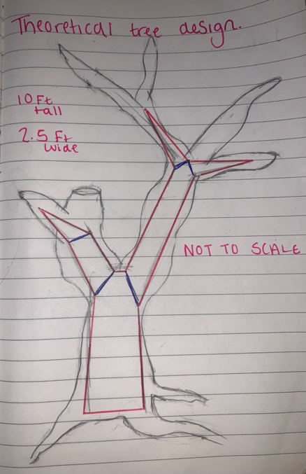
To create and construct a tree which would be fitting for cast members to climb upon, I would firstly have parts of the tree designed to hold the weight of one or two actors when they climb. To do this I would have the majority of the weight of the tree, as well as the centre of gravity, directed towards the bottom of the tree and its base as this would help prevent the tree from falling over from the weight of the cast members climbing on it. As for the climbing aspect, I would design the tree to have specific branch designated for climbing; these branches would be low down on the tree as to lower the chance of serious injury if an actor were to fall down. I would also add extra reinforcements to the frame of these branches as to ensure that they do not snap under the weights on them. To further lower the risk of falling, I would add anti-slip stickers and grips to the branches where the actor would be climbing as to give them something more to grip upon.
A sketch of my idea for a climbable tree

I would make the base/trunk of the tree from steel with the branches which would be used by the cast members also made from steel. These parts are highlighted in red pen. The blue lines are where I would weld the steel together it to give it the shape of a tree. The higher branches would purely aesthetical so they would be made from foam or a similar, lightweight material. I would most likely use foam or polystyrene for this as they are both light as well as easily manipulable and customisable. I would also cover the truck and the majority of the branches (excluding where the grips would go) in this as to make it look more cohesive. All of this is marked in pencil, making the shape of the tree. To not make the tree to prominent and overwhelming compared to the rest of the stage and the scenery, I would keep my design and the aesthetics of the tree minimal but in theme with the rest of the scenery. This would ensure that I didn’t look out of place. This would also allow the tree to become the focal point if needed by working with the lighting designer to draw the audiences attention towards the tree (this would also work for the opposite and draw attention away from the tree if it was required). To attach the tree to the stage I would use a combination of cleats and throw lines as this would allow it to be moved on and off stage (when attached to a truck due to its weight) with relative ease.

Regarding costs, I cannot attempt to make a somewhat accurate estimate into the time needed to construct the tree and what the materials cost. I attempted to hazard a guess using metal4you.co.uk’s custom metal ordering to get a price point. For a tree which would be 10 feet tall, I would presume that the steel would be around 8 feet tall, with another 4 to 8 foot needed to accommodate the branches. This could cost anywhere upwards of £260 with VAT included for the metal alone. Adding together the other materials is more challenging due to the unknown variables that come with hypotheticals, but I roughly worked it out to be an additional £274 making the estimated total for the raw materials to be £534.

Cad drawing:

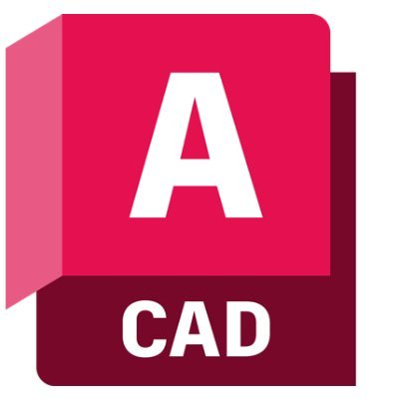
AutoCAD, or as it is usually referred to as CAD, is a computer software which is the industry standard for scenic plans, lighting arrangement plans, props, scenic art, floor plans, costuming and more. It is the standard across film, TV, theatre, festivals as well as other forms of live and recorded entertainment. My interactions with CAD have been through looking, interacting and then building from plans designed in the program.
AutoCAD Mac logo

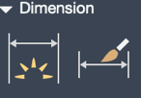
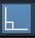

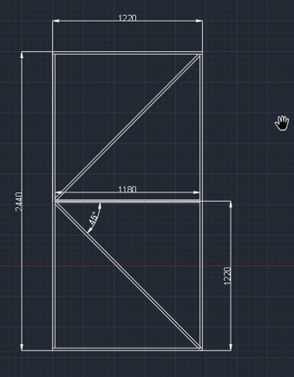
In my usage of the program, I created the plan to the Broadway flat we constructed at the beginning of the module to test out, and then become familiar with the software. To begin with, I loaded the software and then loaded the pre-set template ‘acadISO.dwt.’ I then turned on ‘Ortho Mode’ which restricts drawing to be made with horizontal and vertical lines only. Selecting the ‘Line’ tool, I began to draw the flat. When drawing, a number box appears with the currant length of the line; I changed that to be 2440 to match the dimensions of the flat. I did this for all four sides. Then, using the ‘Dimension’ tool, I duplicated the lines inwards to represent the rails and the styles. I the repeated that to make the toggles. Next, I used the ‘Trim’ tool to remove any unnecessary lines to clean the drawing up. I then used the ‘Dimension Style’ interface to get the size of the flat to be represented in the drawing.
CAD tools + CAD drawing of Broadway flat

Cladding materials:


Cladding is a material which is attached to a framework to give it a solid surface. Typically, for flats, cladding is plywood or canvas material, but cladding can also be sheet-metal, shingles, and tiles (although, tiling would have to be accompanied by another form of cladding to ensure that they are attached properly). For safety reasons, cladding where possible should be made of fireproof or inflammable materials. Protective coatings on cladding or an extradition to protect the cladding that they cover. But they also add extra strength for the cladding as a whole. There are specific types of protective coverings for different materials which provide protection and strength based on the different materials used. Furthermore, protective coatings can also make flammable objects inflammable, and therefore make them favoured to use in a stage show lots of heat and other risks that may start a fire are used during the production.
Protective coating for metal cladding

Scaffolding:

Scaffolding is a great tool when working in construction. It is also essential when working at heights due to safety reasons as it provides some protection. There is both indoor and outdoor scaffolding. In theatre, scaffold has two main uses: one being that scaffold can be used as a part of the scenery; scaffold can be used by actors can you give them a height which could not be using rostras or other platforms. It can also be used to host flats as well as tarps or other forms of decoration which need to be suspended from a height. The either use a scaffold in theatre is the more traditional use of giving labourers and crew members access to heights which cannot be safely reached via ladder.
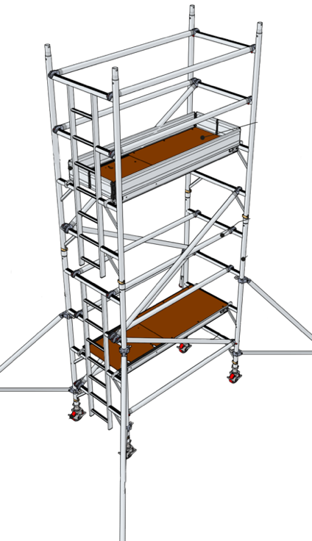
To erect a two-story indoor scaffold, you start by attaching to castor wheels with extendable legs to rung frame, ensuring the castors are in a locked position (if the scaffold need sot remain stationary, there are other feet which can be attached instead of the castors to give this support. Next, attach a horizontal brace to the rung ladder followed by a second brace and then another rung ladder with the wheels attached. It is important to ensure that this is level with a spirit level before continuing. Next, the hatch platform needs to be attached as well as two diagonal braces from the first to the third rung as well as four horizontal braces going across the third and fourth rung. Following that, stabilisers need to be attached next to ensure that the scaffold doesn’t move when fully constructed as well as being able to hold weight at heights before adding the next two sets of rung frames. The second hatch platform is then attached to the sixth rung before adding the guard rails and then the braces for said rails. Lastly, the toe board needs to be attached around all edges of the secondary hatch.
Illustration of two-story scaffolding fully constructed

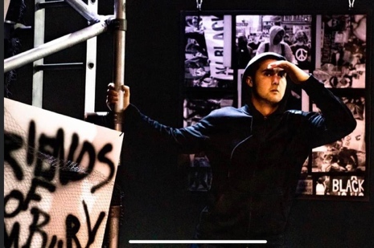
The third-year production of ‘Little Revolution’ uses scaffolding as a part of its scenery. It is incorporated behind the seating but still accessible to the performers which hang from it and use it to create noise during the show. The scenery for this show was very minimal, so even though the scaffolding was in the back corner of the black box theatre, it was a very prominent part of the set. Due to the themes and the nature of the show, the scaffolding didn’t need to be covered to fit in with the other scenery which was rough and urban aesthetically.
Photo from ‘Little Revolutions’

Set examples:
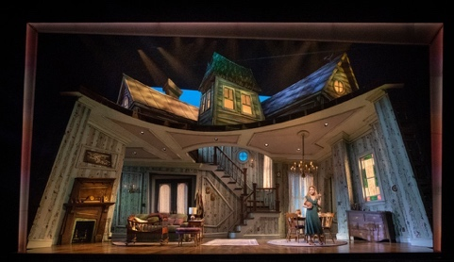
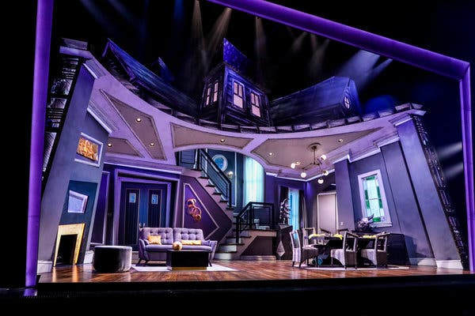
Beetlejuice: One of my favourite theatre sets is from the production of ‘Beetlejuice’ on Broadway. David Korins designed the movie-based musical set by taking inspiration from the 1988 film, describing his creation as “holistically Burtonian.” This set is not only set in the whimsical style of Tim Burton, but it also holds easter eggs from Burton’s films. As well as incorporating the auteur’s style, Korins also included his own, wanting to separate the stage show from the movie, establishing it on its own front.
All three editions of the house set in ‘Beetlejuice’

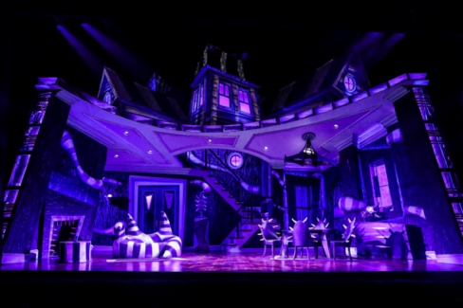
I am really fond of this set as it has been created very cleverly. Most of the production is set in one room, the living room of the home. The set, however, changes throughout the show starting with the homey, if somewhat bland style of the Maitland’s, then to the edgy and modern style of the Deetz and then finally to the chaos-ridden demonic nature of ‘Beetlejuice.’ These sets are a great depiction of the personalities which are currently in control of the home without having to spend time stating these in the script; this leaves the audience more familiar with the characters. These changes happen as each new set of people take over. I think this was cleverly designed as all of the furniture is kept in the same place, showing clear development from one interior to the next. I think the juxtaposition between them makes their impact even more effective.

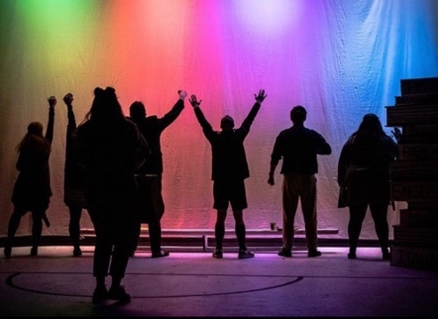
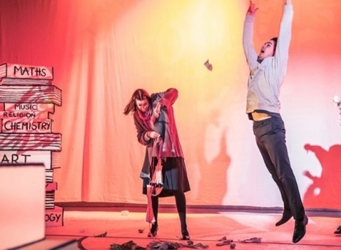
Education, Education, Education: I saw a third-year production ‘Education, Education, Education’ which was based upon and inspired by Tony Blair and his pledge to education. I really like the simplistic set of this show. I found it allowed more interpretation from the audience as they could relate their own experiences within their secondary schools upon to the stage and the cast. The set was comprised mainly from wooden boxes painted white with black detailing to make them resemble textbooks. I also apricated the cyclorama which gave room for lighting choices and projections to also become a part of the scenery. The simplistic scenery also allowed for more focus to be placed into what was being used, the books for example, some of them had references to the script and themes covered throughout the play placed upon them.
Photos from ‘Education, Education, Education.’

Reference list
Alderson, M. (2010). Scene shop. [online] www.ia470.com. Available at: https://www.ia470.com/primer/shop.htm.
Byrne, M. (2012). Quick guide to strange theatre terms. [online] www.mtc.com.au. Available at: https://www.mtc.com.au/discover-more/mtc-now/quick-guide-to-strange-theatre-terms/.
Climber, P.T. (2020). The Basics of Using a Throw Line and Weight. [online] Bartlett Arborist Supply. Available at: https://www.bartlettman.com/blogs/news/how-to-use-throw-lines.
Collins Dictionary (n.d.). Definition of ‘rostra’. [online] Collins Dictionary. Available at: https://www.collinsdictionary.com/dictionary/english/rostra#:~:text=1.,2..
Crown Decorating Centres. (n.d.). Crown Trade Protective Coatings Fast Drying Cladding Finish | Cladding. [online] Available at: https://www.crowndecoratingcentres.co.uk/paints/exterior/cladding/crown-trade-protective-coatings-fast-drying-cladding-finish/15141.
Designing buildings (2015). Cladding for buildings - Designing Buildings Wiki. [online] Designingbuildings.co.uk. Available at: https://www.designingbuildings.co.uk/wiki/Cladding_for_buildings
Encyclopedia Britannica. (n.d.). Revolving stage | theatre. [online] Available at: https://www.britannica.com/art/revolving-stage
Fronius Perfect Welding (2019). Arc welding. [online] www.youtube.com. Available at: https://www.youtube.com/watch?v=IfDXpcufc1M.
Glossary. (n.d.). What is Pin Hinge? | Definition of Pin Hinge. [online] Available at: https://kitchencabinetkings.com/glossary/pin-hinge/.
Graham, L. (2010). Drama InfoWeb - Stage Trucks. [online] www.dramainfoweb.co.uk. Available at: http://www.dramainfoweb.co.uk/pages/scenery_1.html.
Grill, J. (2019). Welding Electrode: Chart and Selection. [online] Weld Guru. Available at: https://weldguru.com/welding-electrode/#:~:text=An%20electrode%20is%20a%20metal%20wire%20that%20is%20coated.&text=SMAW%20or%20stick%20electrodes%20are.
Grill, J. (2022). MIG vs TIG Welding: The Main Differences. [online] Weld Guru. Available at: https://weldguru.com/mig-vs-tig-welding/.
Guardian Staff (2001). Full text of Tony Blair’s speech on education. [online] the Guardian. Available at: https://www.theguardian.com/politics/2001/may/23/labour.tonyblair.
Hallsworth, C. (2019). Tuskbond Sprayable Contact Adhesives - Indasol. [online] www.indasol.co.uk. Available at: https://www.indasol.co.uk/products/adhesives-and-sealants-2/tuskbond-contact-adhesives/#:~:text=Tuskbond%20FD170%20polystyrene%20adhesive%20is.
Harper, D. (2021). Why Do Welders Wear Masks? All You Need To Know. [online] Welding Troop. Available at: https://weldingtroop.com/why-do-welders-wear-masks/.
HarperCollins (n.d.). Rostra Definition. [online] www.collinsdictionary.com/. Available at: https://www.collinsdictionary.com/dictionary/english/rostra#:~:text=1.,2..
Health and Safety Executive (2019). Risk assessment: Template and examples - HSE. [online] Hse.gov.uk. Available at: https://www.hse.gov.uk/simple-health-safety/risk/risk-assessment-template-and-examples.htm.
Health Safety Executive (2015). Causes and prevention - Slips and trips - HSE. [online] Hse.gov.uk. Available at: https://www.hse.gov.uk/slips/preventing.htm.
Health Safety Executive (n.d.). FAQs – Construction general - Personal Protective Equipment. [online] www.hse.gov.uk. Available at: https://www.hse.gov.uk/construction/faq-ppe.htm#:~:text=Steel%20toecaps%20(or%20equivalent)%20protect.
Hedash, K. (2020). Hamilton: Here’s What The Show’s Rotating Set Really Means. [online] ScreenRant. Available at: https://screenrant.com/hamilton-musical-set-stage-rotate-ships-wall-meaning/.
Hendrickson, A. (2015). Mechanical design for the stage. Focal.
iHASCO (n.d.). General Workshop Safety FAQs and Resources | iHASCO. [online] www.ihasco.co.uk. Available at: https://www.ihasco.co.uk/support/resources/entry/general-workshop-safety#:~:text=Don.
Iowa Valley Community College District. (2021). What are the 4 Types of Welding? [online] Available at: https://www.iavalley.edu/blog/2021/03/11/what-are-the-4-types-of-welding/#:~:text=There%20are%20four%20main%20types.
Kenton, A. photographs by T. (2020). Great outdoors: the magic of Regent’s Park Open Air theatre – in pictures. The Guardian. [online] 19 Aug. Available at: https://www.theguardian.com/stage/gallery/2020/aug/19/great-outdoors-the-magic-of-regents-park-open-air-theatre-in-pictures.
Ltd, N.P. (n.d.). h2g2 - Theatre Stage Machinery - Edited Entry. [online] h2g2.com. Available at: https://h2g2.com/edited_entry/A1304821.
Mather, W. (2017). A Roman rostrum. [online] Australian National Maritime Museum. Available at: https://www.sea.museum/2017/05/29/a-roman-rostrum#:~:text=The%20rostrum%20is%20made%20of.
McHone Industries, Inc. (2020). Keeping manufacturing costs down is a balancing act in sheet metal manufacturing. Dive into how four elements of sheet metal size impact your bottom line. [online] Mchone Industries. Available at: https://www.mchoneind.com/standard-sizes-of-sheet-metal/.
Mytee Products Blog. (2021). A Guide on How to Use Ratchet Straps | Using Ratchet Straps. [online] Available at: https://www.myteeproducts.com/blog/how-to-use-ratchet-straps/.
Open Air Theatre. (n.d.). Regent’s Park Open Air Theatre. [online] Available at: https://openairtheatre.com/.
Ortiz, P. (2021). Parts of a Drill (Explained with Pictures). [online] House Grail. Available at: https://housegrail.com/parts-of-a-drill/.
penelope.uchicago.edu. (n.d.). The Rostra. [online] Available at: https://penelope.uchicago.edu/~grout/encyclopaedia_romana/romanforum/rostra.html.
Point, H. (2020). Uses For Indoor Scaffolding. [online] Hi Point Access. Available at: https://hi-pointscaffolding.co.uk/blog/some-indoor-uses-for-scaffolding/.
Pop Up Product LTD (n.d.). 3T ASSEMBLY GUIDE - SINGLE WIDTH. [online] Available at: https://pasma.co.uk/wp-content/uploads/2019/11/Pop-Up-Products-EIGER-500-3T-SW.pdf.
Quincy Compressor (2020). Types of Tools Powered by Air Compressors. [online] Quincy Compressor. Available at: https://www.quincycompressor.com/types-tools-can-powered-air-compressors-work/.
Rcs.ac.uk. (2012). TSM Project 2008 - Raked Revolve - paperclip. [online] Available at: https://paperclip.rcs.ac.uk/index.php/TSM_Project_2008_-_Raked_Revolve.
Rigelsford, J. (2002). Welder’s Handbook. Emerald Group Publishing.
Rutti, C. (2017). StackPath. [online] www.ehstoday.com. Available at: https://www.ehstoday.com/ppe/eye-face-head/article/21919193/eye-and-face-protection-tips-for-choosing-the-right-autodarkening-welding-helmet#:~:text=A%20welding%20helmet%2C%20commonly%20referred.
Saxby, K. (2020). How does a revolve work? [online] www.mtc.com.au. Available at: https://www.mtc.com.au/discover-more/mtc-now/how-does-a-revolve-work/#:~:text=A%20standard%20revolve%20is%20a.
Stage Concepts. (n.d.). Stage Concepts - Stage Systems, Lighting Truss, Exhibition Stands UK. [online] Available at: https://stageconcepts.co.uk/?gclid=CjwKCAjwjZmTBhB4EiwAynRmDyiZztYwpIXBGVYGY0WX17RTR4jlCJdqEYaA55R323Bk2pV0x_KUVhoCCNAQAvD_BwE.
Stage Right (2019). Best Portable Stage Layouts for Different Types of Events. [online] StageRight Performance. Available at: https://performance.stageright.com/blog/best-portable-stage-layouts-for-different-types-of-events/.
Taylor, B.D. (n.d.). Creative Theatrical Ideas: Creating Trees for the Stage. [online] www.pioneerdrama.com. Available at: https://www.pioneerdrama.com/Newsletter/Articles/Stage_Trees.asp.
Teague, B. (2004). How to Build Theater Stairs - An Illustrated Guide. [online] Available at: https://inspectapedia.com/hazmat/Theatre_Stairs_Teague.pdf.
Theatrecrafts.com. (n.d.). Glossary of Technical Theatre Terms - Scenic. [online] Available at: https://www.theatrecrafts.com/pages/home/topics/scenic-stage-design/glossary/.
thewardrobeensemble. (n.d.). Education, Education, Education. [online] Available at: https://www.thewardrobeensemble.com/education-education-education.
Troubridge, E. and Blaikie, T. (2002). Scenic art and construction. Marlborough: Crowood.
United States Institute for Theatre Technology, Inc. (n.d.). Hamilton’s turntable and ring stage: a revolving stage isn’t new to theatre, but Hamilton’s innovative use makes it a critical storytelling device to bring the characters’ tumultuous world to life. - Free Online Library. [online] www.thefreelibrary.com. Available at: https://www.thefreelibrary.com/Hamilton%27s+turntable+and+ring+stage%3A+a+revolving+stage+isn%27t+new+to...-a0497053721.
up.yalecollege.yale.edu. (n.d.). Scenic Designer | Yale Undergraduate Production. [online] Available at: https://up.yalecollege.yale.edu/roles-responsibilities/scenic-designer.
UTI Corporate. (n.d.). What Is MIG (GMAW) Welding? [online] Available at: https://www.uti.edu/blog/welding/gmaw-mig-welding#:~:text=Gas%20metal%20arc%20welding%20(GMAW.
Vanden Berge, G. (n.d.). Dangers Using Wood Stair Cleats - Stair Building. [online] stairs4u.com. Available at: https://stairs4u.com/articles/dangers_using_wood_stair_cleats.htm.
Vanden Berge, G. (n.d.). Stair Treads. [online] stairs4u.com. Available at: https://stairs4u.com/stairtreads.htm.
White, G. (2017). The Advantages & Disadvantages Of Steel Frame Construction. [online] Glwengineering.co.uk. Available at: https://blog.glwengineering.co.uk/the-advantages-disadvantages-of-steel-frame-construction.
Whitlock, C. (2019). How Set Designer David Korins Brought Beetlejuice to Broadway. [online] Architectural Digest. Available at: https://www.architecturaldigest.com/story/set-designer-david-korins-beetlejuice-on-broadway.
Wonkee Donkee Tools. (n.d.). What is a pilot hole? [online] Available at: https://www.wonkeedonkeetools.co.uk/screws/what-is-a-pilot-hole
www.abbreviations.com. (n.d.). What does MDF stand for? [online] Available at: https://www.abbreviations.com/MDF.
www.autodesk.co.uk. (n.d.). Download AutoCAD 2021 Software & Toolsets | Free Trial | Autodesk. [online] Available at: https://www.autodesk.co.uk/products/autocad/free-trial.
www.bbc.co.uk. (2020). Temporary Stages and Rostra. [online] Available at: https://www.bbc.co.uk/safety/resources/aztopics/temporary-stages-and-rostras/.
www.benningtonmetalfurniture.co.uk. (n.d.). Advantages of Metal furniture. [online] Available at: https://www.benningtonmetalfurniture.co.uk/advantages-of-metal-furniture#:~:text=Metal%20furniture%20is%20far%20more.
www.thistothat.com. (n.d.). This to That. [online] Available at: http://www.thistothat.com/cgi-bin/glue.cgi?this=Styrofoam&that=Metal.
www.twi-global.com. (n.d.). What is a Thermoplastic? (Definition and Examples). [online] Available at: https://www.twi-global.com/technical-knowledge/faqs/what-is-a-thermoplastic#:~:text=A%20thermoplastic%20is%20a%20class.
www.twi-global.com. (n.d.). What is Welding? - Definition, Processes and Types of Welds. [online] Available at: https://www.twi-global.com/technical-knowledge/faqs/what-is-welding#:~:text=Welding%20is%20a%20fabrication%20process.
Young, J. (2020). Newsies Set Design and Construction. [online] www.youtube.com. Available at: https://www.youtube.com/watch?v=UKi1a0uFgyM
Zilliacus, A. (2016). 16 Materials Every Architect Needs to Know (And Where to Learn About Them). [online] ArchDaily. Available at: https://www.archdaily.com/801545/16-materials-every-architect-needs-to-know-and-where-to-learn-about-them.

