Creating a high performance culture
A Siemens case study

Introduction

Organisational culture and values
The culture of an organisation is the typical way of doing things in the organisation. It particularly relates to behaviour patterns and relationships.
The culture of an organisation develops over time. It is created by the people that work for the organisation its managers and workforce. What the organisation stands for (its values) and the dreams that it seeks to turn into reality (its vision) are fundamental in creating a dynamic culture.
A 'high performance culture' exists when everyone in the organisation shares the same vision and where they trust and value each other's contribution.
This case study looks at how the Siemens organisation is built on a high performance culture. This is shared by everyone from the most senior executive to the newest trainee.

Background to Siemens
Siemens AG is a global electrical and electronics business with a turnover of nearly £60 billion. The company employs just under half a million people around the world. It is based in Munich, Germany. In the UK, Siemens has its headquarters in Bracknell, Berkshire and has around 100 sites across the UK employing 20,000 people.
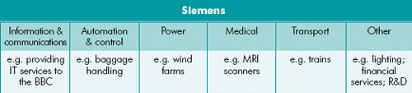Siemens' products affect our lives in many ways. We can toast bread in a Siemens toaster powered by electricity generated and distributed by Siemens. Traffic lights are made by Siemens and people in hospitals have life-saving MRI scans using Siemens advanced medical imaging technology.

Delivering the human resource development strategy
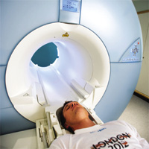Human resource development is all about helping people to fulfil themselves at work. Development is concerned with encouraging employees to identify ways in which they want to improve their careers and other aspects of their working lives. For example, they may want to attend training courses, they may want to do more interesting work, or they may simply want to have a better work/life balance.
An organisation is nothing without its people. As an employer of one of the world's most efficient and motivated workforces, Siemens is committed to its employees. Its half a million employees work in a broad range of roles. These include:
- information technology specialists
- mechanical and electrical engineers
- researchers
- new product developers
- managers and business executives
- administrators
- security guards and health and safety experts
- human resource specialists.

What is 'engagement'?
If people are properly managed, they will motivate themselves to do a good job. Siemens believes in the full engagement of people in the workplace. Excellent people need to be managed in an excellent way. Siemens believes that engagement combines commitment and organisational citizenship. Engagement is another way of saying actively involved.

Human resource development strategy
All organisations need to have a sense of direction which is put into action through a plan. This plan is referred to as a business strategy.
A key pillar of the Siemens' strategy, alongside performance and portfolio, operational excellence and corporate responsibility, is the way it manages, develops and motivates its employees.

The importance of people in the organisation
The part of the Siemens' business strategy that relates to people management is referred to as People Excellence. At the heart of People Excellence is the building of a high performance culture. Nothing helps an individual more than to be given responsibility and to know they are trusted.
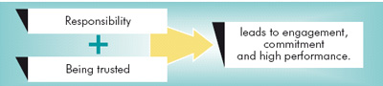
Almost without exception, people management theorists have shown that real motivation comes from within an individual. Individuals develop such motivation when they feel that their efforts are valued and that they are doing something worthwhile. This is why People Excellence at Siemens is so important.
Feeling part of a successful team is part of the engagement process. Individuals who feel valued want to contribute to the success of the organisation.
For Siemens, people, like its technology and innovation, are a source of competitive advantage. To make the most of this advantage, Siemens makes sure that its employees work on developing the company's heritage of innovation.
Siemens believes that there are many ways to make people feel valued and engaged. These range from a pat on the back, a personal letter or a special mention in a meeting, to a promotion or a higher salary.

Creating a high performance culture
Siemens' operations are based on a teamwork culture. This emphasis on the team is set out clearly in a quote from the global Chief Executive Officer of Siemens, Klaus Kleinfeld:
'Many times in my life I have seen how one individual can make a big difference, particularly when working in a great team. The quality of our people and of our teams is our most valuable resource, particularly in today's changing world where knowledge flows round the globe with lightning speed and is easily available.'

Siemens wants all of its employees to be truly involved in the business and to feel part of its success. Employees therefore need to know how they fit into the business. With this in mind Siemens establishes clear expectations.

Team and individual targets
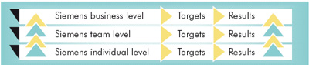Targets for individuals are related to targets for the whole business. Everyone plays their part in achieving great results.
Siemens states that 'our business success depends on the performance of each individual, our teams and the total organisation'.
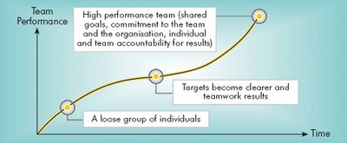A high performance team is one in which all members of the team work towards shared targets and have a sense of shared responsibility for the results the team achieves. As the team performance improves over time, the better the results.

People Excellence
People Excellence is the part of Siemens' global action plan concerned with human resource development. It consists of four main elements:
- achieving a high performance culture
- increasing the global talent pool
- strengthening expert careers
- Siemens' Leadership Excellence Programme(SLE).
The high performance culture is the way of working at Siemens and it involves everyone. The global talent pool is made up of all Siemens' employees. Within Siemens everyone has the opportunity to develop their own specialisms and to acquire further expertise. The SLE provides the highest calibre leadership and management training.

Talent management - managing people
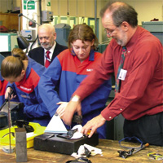People Excellence involves developing everybody that works for your organisation not just the high-fliers.
Siemens' talent management philosophy involves making sure that every employee is provided with the guidance and support to achieve their full potential. This aids them to do their best, every day.

Everyone works together to achieve the organisation's objectives as well as meeting their own personal goals. Everyone shares the same vision and dreams. Within this culture they are able to progress and take on greater responsibility within the company.

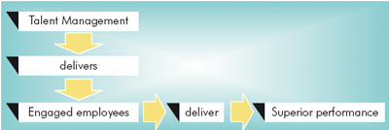

Talent Managment
Everyone has talent. For Siemens, matching talent with tasks produces competitive advantage.
Each individual at Siemens can make best use of their talents, whatever they may be. Talent Management enables both:
- job enrichment, where individuals are encouraged to take on extra tasks and
- responsibilities within an existing job role to make work more rewarding and
- job enlargement, where the scope of the existing job is extended to give a broader range of responsibility, plus extra knowledge and skills development.
Talent Management is a global philosophy that is a key part of supporting each of the elements of the Siemens' business strategy. Talent Management enables Siemens' managers to engage and motivate employees throughout the organisation.

The benefits of talent management
By applying talent management to all staff:
- all customer-facing staff are engaged, so all customers benefit
- everyone has the opportunity and choices to achieve their full potential
- the pipeline of highfliers is sustained.

Performance management
Siemens has created a standard process for managing the performance and development of all employees. This is referred to as the Performance Management Process.
The process creates a direct link between the strategy of the whole organisation and plans for each individual. Every individual is given targets based on their role and responsibility within the organisation. It is through meeting personal targets that the individual is best able to help the organisation to achieve its targets.
Performance management is a systematic process that creates trust and open communication by:
- setting objectives
- monitoring progress made
- creating an ongoing dialogue between each team member and his/her manager
- enabling forthright discussion.
Performance management in Siemens is the engine that drives Talent Management. It is the cornerstone of its high performance culture. When carried out in a consistent way, this system makes sure that everyone is told honestly about their performance.
Employees are clear about the impact of their performance and what the consequences are for their development. Everyone within the organisation is pulling together to achieve the business strategy.

Conclusion
People really matter. Organisational results stem from high performance. People only perform well when they operate in a culture which nurtures and supports them and helps them to work towards the achievement of their ambitions.
Siemens' high performance culture provides the framework and support in which high performance people can show their commitment to a high performance organisation.

Questions:
1. What do you understand by ‘Organisational Culture’ as it is used in the case study?

2. Identify and explain the which kind of ‘Organisational Culture’ is in action at Siemens

3. How would you relate Siemens ‘high performance culture’ drive to theories of motivation? Do you think the strategy helps to motivate staff? If so, how?

4. Explain what is meant by Siemens ‘talent management philosophy’?

5. Draft a statement on behalf of Siemens, summarising the HR philosophy of the business and saying why it is an excellent company to work for.

