

Student name: Iman El Makkaoui Benzina
Student ID:2524370

Module name: Introduction to Health and Social Care
Module code: (LCHS4003_LON)
Lecturer name Dr Jolly Nwankwo



Introduction
Pharmacy services are an important part of the healthcare system in the UK (NHS England,2024). Community pharmacies provide patients with access to medicine, health advice, and support for a wide range of health conditions. Pharmacists are highly trained healthcare professionals who help people use medicines safely and effectively while promoting good health and wellbeing (Royal Pharmaceutical Society,2024). Over the years, pharmacy services have expanded beyond dispensing medicines to include vaccinations, health screenings, and support for managing long term conditions. This poster explores the history of pharmacy services, how they operate today, and the challenges they currently face whit the NHS. Pharmacy services also contribute to preventing illness and improving public health. Pharmacists educate patients about healthy lifestyles, safe medicine use, and disease prevention. They work closely with GPs, nurses, dentists and hospitals to ensure patients receive coordinated care. Their accessibility makes community pharmacies one of the first places people seek healthcare advice, reducing unnecessary pressure on emergency departments and GP surgeries.

Timeline
1948
- The National Health Services was established (NHS England,2024).
- Community pharmacies became part of the NHS healthcare system.
1980-1990s
- Pharmacists began providing more health advice rather than only dispensing medicines (Royal Pharmaceutical Society,2024).
2005
- The NHS Community Pharmacy Contract introduced enhanced clinical services
- Today
- Pharmacies play an important role in primary healthcare and help reduce pressure on GP surgeries and hospitals.
Pharmacy services

Current functions
Community pharmacies are one of the most accessible healthcare services in the UK (NHS England,2024). Unlike GP surgeries, most pharmacies do not require an appointment, allowing patients to receive advice and treatment quickly. This easy access helps reduce pressure on hospitals and GP practices by treating minor illnesses within the community. Pharmacists are highly trained healthcare professionals who can assess symptoms, recommend appropriate treatments, and refer patients to other healthcare services when necessary.
One of the main responsibilities of pharmacists is to ensure the safe and effective use of medicines (General Pharmaceutical Council,2024). They check prescriptions and explain how medicines should be taken correctly. Pharmacists also provide advice about side effects, storage of medicines and what to do if a dose is missed. This support helps improve patients safely and encourages better adherence to treatment plans. Community pharmacies also play an important role in preventing illness and promoting healthier lifestyles. They provide services such as blood pressure monitoring, smoking cessation programmes, weight management advice, emergency contraception and seasonal flu and COVID-19 vaccinations. These preventive services help detect health problems early and reduce the risk of serious diseases, improving the overall health of the population. Another important service in the NHS pharmacy first programme, which allows pharmacist to assess and treat several common conditions without patients needing to see a GP. This service improves access to healthcare and enables patients to receive treatment more quickly. It also allows doctors to spend more time caring for people with more serious or complex medical conditions.
Community pharmacies provide a wide range of NHS services. Their main roles ensure patients receive medicines safely and understand how to use them correctly.
- Dispensing NHS prescriptions
- Advice for minor illnesses
- NHS Pharmacy First service
- Blood pressure checks
- Flu and COVID-19 vaccinations
- Emergency medicine supply
- Smoking cessation support
- Healthy lifestyle advice

Challenge 2 Workforce shortages
Many pharmacies in the UK face shortages of pharmacists and pharmacy technicians. This increases the workload for existing staff and can lead to longer waiting time for patients. Recruiting and retaining pharmacists remains one of the biggest challenges facing the profession, particularly in community pharmacy (Royal Pharmaceutical Society,2024).
IMPACT
- Longer waiting times
- Increased pressure on staff
- Less time for patient consultations
Challenge 1 INCRESING DEMAND
More people are using community pharmacies because GP appointments are often difficult to obtain. Pharmacists now provide many additional NHS services. This growing demand highlights the need for continued investment in the community pharmacy services and additional funding to maintain high quality patient care (NHS England,2024).
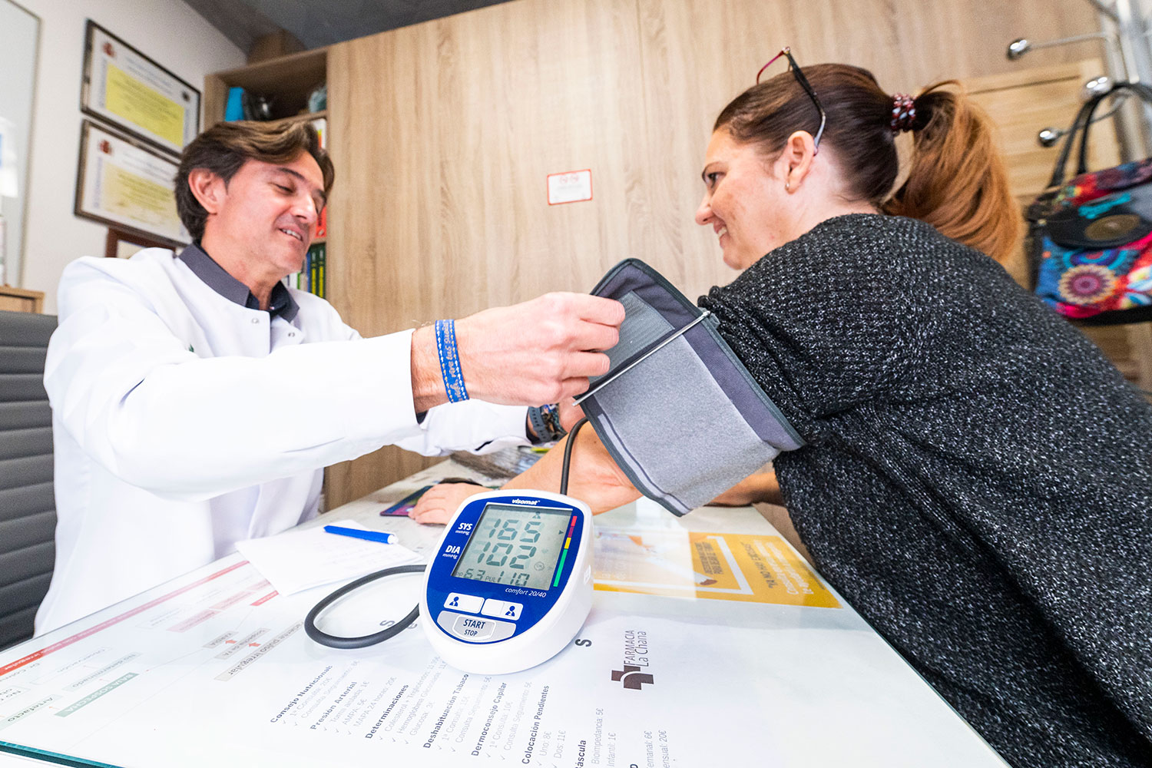

- Higher workload
- Increased pressure on NHS funding
- Need for more trained staff

COMMUNITY MENTAL HEALTH SERVICES
Introduction

Community Mental Health Services are an important part of health and social care in the United Kingdom. They provide support and treatment for people with mental health problems while they continue living in their own homes and communities. These services help people improve their mental health, remain independent, and reduce the need for hospital admission (NHS England, 2023).
Origins and Historical Development
In the past, many people with mental health conditions were treated in large psychiatric hospitals. These hospitals were often isolated from the community, and patients stayed there for long periods. During the 1980s, the UK government introduced the Care in the Community policy. The aim was to help people receive treatment closer to home instead of living in hospitals for many years (Department of Health, 1989).
This change helped people become more independent and allowed them to stay connected with their families and local communities. Community Mental Health Services continued to develop over the years. Today, they are an important part of the NHS and social care system. The Mental Health Act and the Care Act 2014 also support the rights of people with mental health conditions and promote person-centred care.
How the Service Functions Today
Community Mental Health Services provide assessment, treatment, and ongoing support for people with different mental health conditions such as depression, anxiety, bipolar disorder, schizophrenia, and other illnesses (NHS England, 2023).
The service includes a multidisciplinary team. This team may include psychiatrists, psychologists, mental health nurses, social workers, occupational therapists, and support workers. Each professional has a different role, but they work together to provide the best care for the service user.
The services offered include mental health assessments, counselling, psychological therapies, medication management, crisis support, and recovery planning. Some people receive support at community mental health centres, while others are visited in their own homes if necessary.
Community Mental Health Services also work with GPs, hospitals, local authorities, and voluntary organisations to make sure people receive coordinated care. This helps improve communication between professionals and provides better support for service users.
Importance of Community Mental Health Services
Community Mental Health Services play an important role in improving people’s quality of life. They help people manage their mental health while remaining in familiar surroundings. Staying at home can reduce stress and help people maintain relationships with family and friends.
These services also promote independence by supporting people to develop daily living skills, return to education or employment, and participate in community activities. Early intervention can prevent mental health problems from becoming more serious and reduce the number of emergency hospital admissions (NICE, 2022).
However, Community Mental Health Services also face challenges. One challenge is the increasing demand for mental health support, which has led to long waiting times in some areas. Another challenge is staff shortages, making it difficult to provide services quickly and effectively (The King’s Fund, 2023).
Despite these challenges, Community Mental Health Services continue to make a positive difference in people’s lives. They provide person-centred care that focuses on recovery, dignity, and wellbeing.
In conclusion, Community Mental Health Services are an essential part of health and social care in the UK. They have changed significantly since the introduction of the Care in the Community policy and now provide a wide range of services to support people with mental health conditions. Although there are challenges such as high demand and staff shortages, these services remain important for improving health, promoting independence, and supporting recovery.

REFERENCES
- Department of Health (1989) Caring for People: Community Care in the Next Decade and Beyond. London: HMSO.

- NHS England (2023) Community Mental Health Services. Available at: https://www.england.nhs.uk (Accessed: 14 July 2026).

- NICE (2022) Rehabilitation for Adults with Complex Psychosis. Available at: https://www.nice.org.uk (Accessed: 14 July 2026).

- The King’s Fund (2023) Mental Health Services in England. Available at: https://www.kingsfund.org.uk (Accessed: 14 July 2026).

- General Pharmaceutical Council (2024) Standards for pharmacy professionals. Available at: https://www.pharmacyregulation.org (Accessed: 14 July 2026).

- NHS (2024) Pharmacy First. Available at: https://www.nhs.uk (Accessed: 14 July 2026).

- NHS England (2024) Community Pharmacy Services. Available at: https://www.england.nhs.uk (Accessed: 14 July 2026).

