New Build Dwelling:
Technical Report with Drawings

2008886
Jenny Stroud

Module Tutor:
Gavin Traylor
Contents

1.0 - Introduction 3
2.0 - Land 3
3.0 - Ground Floor 3
3.1 - External Walls 3
3.2 - Under Floor Heating 4
4.0 - First Floor 4
5.0 - Windows and Doors 5
6.0 - Roof Construction and Eaves 5
6.1 - Alternative Roof Construction 6
7.0 - Condensation 7
7.1 - Ventilation to Prevent Condensation 7
8.0 - References 8

1.0 - Introduction

This report will outline different information for a single domestic building that is two stories.

2.0 - Land

The land was previously used for agricultural purposes, this means it would have been used for livestock this could be either animals or growing plants. The land is also a reclaimed site, it has been made level by placing soil to create the flat ground.

3.0 - Ground Floor

The drawing above is the ground floors external wall, window and flooring, it also includes the raft foundation in grey that the building will have.

3.1 - External Walls

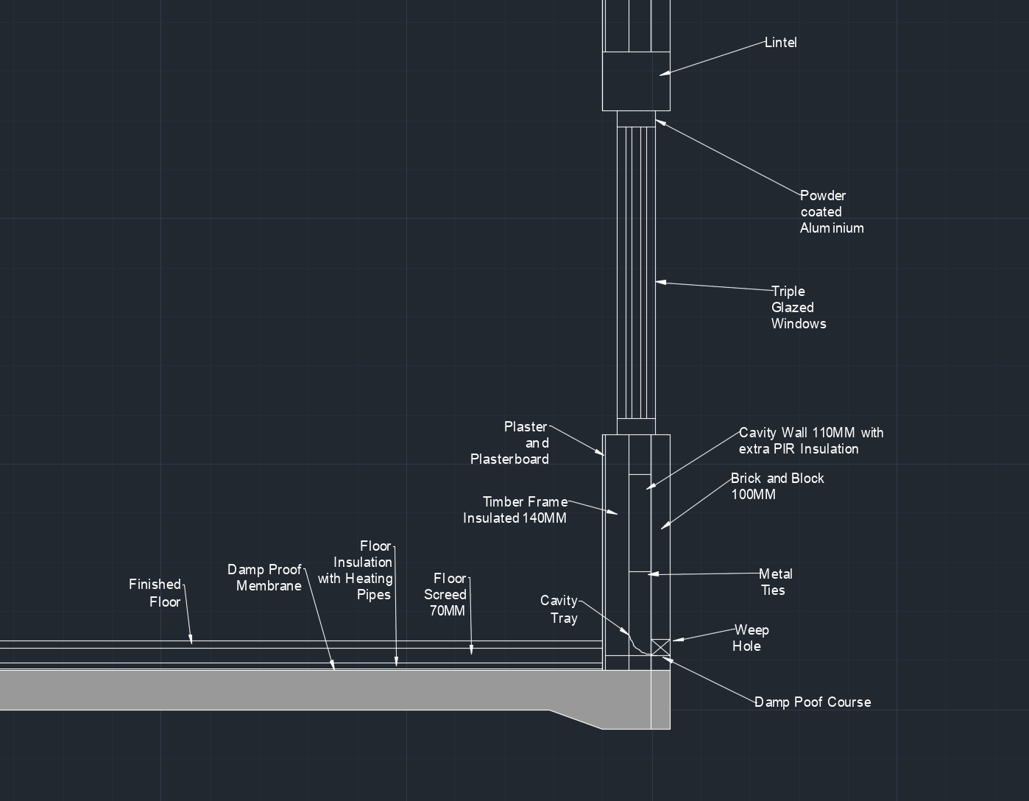
The external walls will be a total of 350mm thick, the outer layer will be 100mm for the brick and block work and the block work will be rendered. The cavity wall between the brick and the C16 timber frame will be 110mm wide, the timber frame walls will arrive at the site already made and having a thickness of 140mm. The timber frame will be made off-site as individual panels that will be connected at the site together to become the building. The cavity wall has a hollow centre between the two walls, the cavity is put in place with extra PIR insulation (polyisocyanurate) to increase thermal insulation to the building. The cavity wall will also included multiple metal ties to hold the outer and inner wall construction together, this will be all the way through the cavity wall (Designing Buildings, October 2020). The timber frame will have plasterboard on top and then will be plastered.

Placed at the bottom by the rafter foundation will be a sheet of damp proof course, this will also have weep holes on top along the bottom of the building with a cavity tray to let any water or liquids come out through the weep holes.
Due to the building regulations part A, each cavity should be at least 50mm wide and the wall ties should have a “horizontal spacing of 900mm and a vertical spacing of 450mm” and be about 250mm from edges of openings and moving joints. The brick and block work also has to be at least 1/16of the house storey height thick (Building Regulations).

3.2 - Underfloor Heating

There will be a damp proof membrane will be placed on top of the raft foundation, this will then be topped by floor insulation to help the with the heating pipes placed on top. The floor screed will then be put on top at 70MM thick, the finished floor will then be placed on top. This can also been seen in the drawing above (Home Building, October 2020).

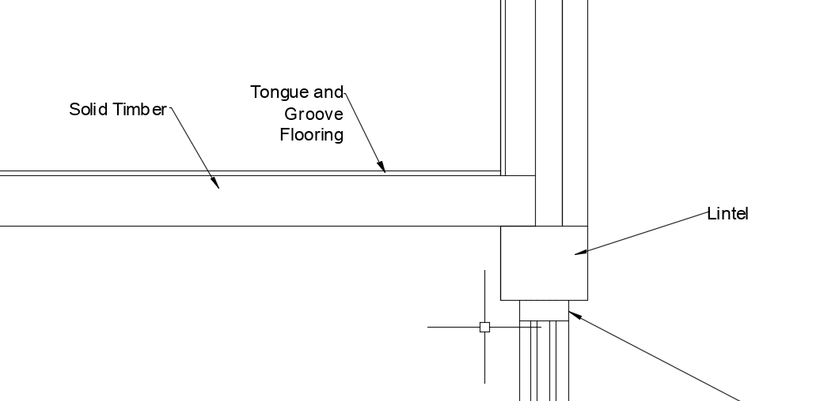
When installing underfloor heating there will need to checks to make sure that it is fitting the building regulations part L, even though part L isn’t for underfloor heating it can relate to the flooring. “The regulations demand that floors on new homes have a U-value of less than 0.25w/m2k” (Warmafloor, 2020), when the heating system is being installed they need to have the correct level of insulation beneath the heating, this will help limit the heat loss downwards (Warmafloor, 2020).

4.0 - First Floor

The first floor will be solid timber that will sit on top of the lintel which will take the majority of the weight, the solid timber will be held in place by connecting the solid timber floor to the internal wall. this will then have tongue and groove flooring on top to finish, this is a hardwood that has edges that will slide and fit into each other to create the flooring.

5.0 - Windows and Doors

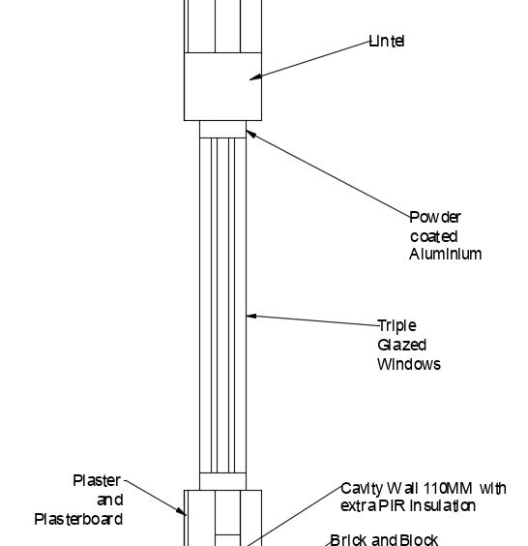
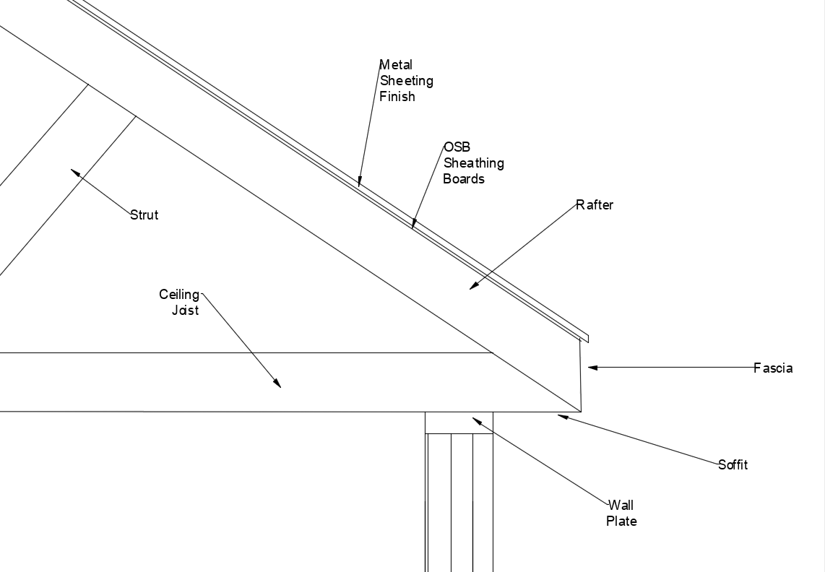
The drawing above shows a section drawing of what the windows will look like, both windows and doors will have powder coated aluminium frame. The powder coated aluminium is low maintenance and has a weather resistance surface (Velfac). Each window in the house will be a triple glazed unit, the drawing above shows the three pieces of glass separated by a small space between each one. On the top of the window there is a lintel this will also be used above the door, this lintel is used to take the load bearing at vulnerable weight parts of the building (Designing Buildings C, November 2020).

6.0 - Roof Construction and Eaves

The roof has trusted rafters as the main structure it will take the shape of a triangle, most roofs like this will have been made off-site and delivered as multiple triangles to be connected. There will be a wall plate sitting on top of the external wall to act as a closure of the cavity wall, the wall plate is used on timber construction and it will help take the roofs load-bearing weight on the building. Sitting on top of the wall plate will be the ceiling joist this will help hold the rafter, this will also be supported by struts that will be placed through-out the roof to help maintain the roofs shape. Placed on top of the rafter will be the OSB sheathing boards. The boards will then have the metal sheeting above which will hand over the fascia, this is to cause any rain fall to drain straight into the guttering that will be attached to the fascia (Designing Buildings D, October 2020). The top of the roof cannot go above 15m due to the building regulations on part A, they cannot reach above this because of the wind speeds and “site exposure conditions” (Building Regulations).

The advantage to have metal sheeting has a long lasting life and shouldn’t need to be replaced as they are resistant to multiple things for example rot and harsh weather. The metal roofing is also very light weight and wouldn’t cause any stress to the building for being heavy, it is also easy and quick to install as they come in panels (Designing Buildings E, September 2020).

The disadvantages to have a metal roof can be the cost as it has such a long life line the cost to buy it first can be rather high. An issue that can come from the metal roof is the noise, as if it was to rain or have strong winds you would be able to hear it. The metal is able to dent, expand and contract, it will contract and expand during the cold and heat making it a potential chance that the fastening of the metal may come loose (Designing Buildings E, September 2020).

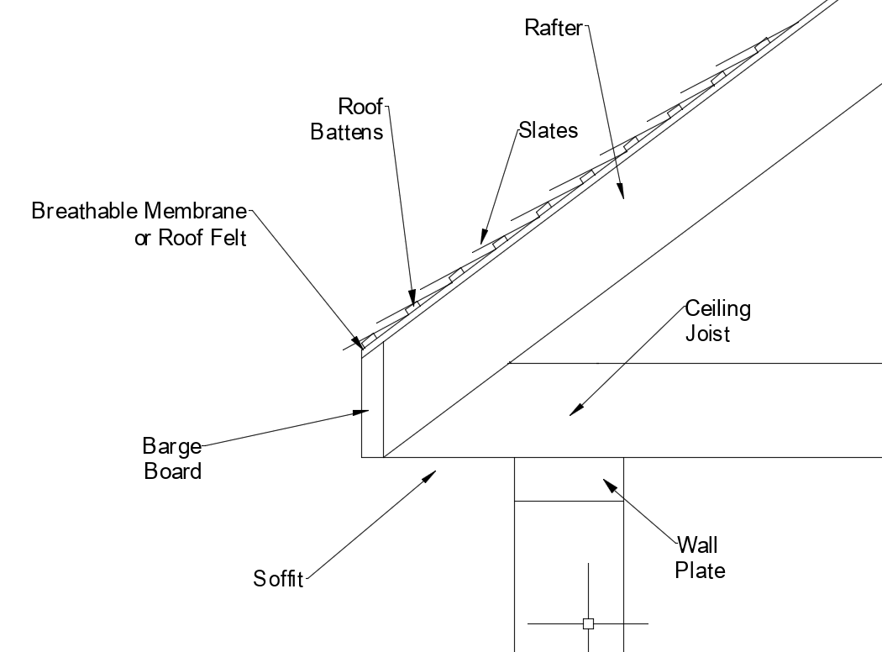
6.1 - Alternative Roof Construction

This is a slate roof, the roof will have a rafter against the ceiling joist the same as the metal profile sheeting. Above the rafter will be a breathable membrane or roof felt will be used, there will then be roof battens to help hold the slates in place. The slates will be put on top with the last slate hanging over the edge for water to drain into the guttering.

The advantages for slate is that it is fire resistant because slate is natural stone making it resistant to temperatures as well as high heat. Slates life span as long as it is well looked after and cared it can last many years, it will also be low maintenance and looking after the roof should only be looking to change any that may have broke or been damaged (NSW Slate Roofing, August 2020).

The drawbacks are that some slates can be very heavy and may need extra reinforcement on the roof when being installed. Slates can be very expensive to buy, but is a good investment because of its long life. When having the slates installed you will be required to have specialised people to place them as it is complex process that normal roofers cannot complete (NSW Slate Roofing, August 2020).

7.0 - Condensation

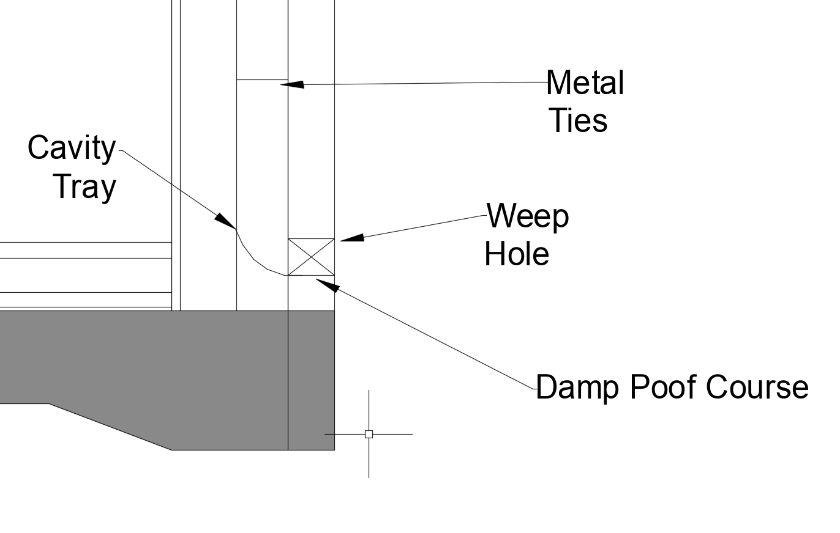
Condensation occurs when warm air come into contact with cold surfaces, most issues with condensation happen in the winter due to the warmth in the house and the cool outside. Many things can cause the warm air like heating systems, cooking and showering. The warm moisture air will break down into water once it hits the cooled surface. If the condensation isn’t dealt with it can cause issue to the building fabric of the house, as one of the biggest issues are mould and damp. If rooms are not properly ventilated then the mould and moisture will grow and this could potentially cause rot, if the rot was to get onto the timber frame this could cause the structures strength to decrease and the house owners would have to pay to get the timber replaced (Building Conservation, 2019).

7.1 - Ventilation to Prevent Condensation

In the external wall by adding the damp proof course and a weep hole, this allows the moisture and any water that may have developed from the windows condensation to travel down to the cavity tray letting any moisture or water leave through the weep hole (Designing Buildings B, October 2020). As not ventilating the cavity will also let the timber develop rot and will damaging the inner walls of the house.

As seen in the building regulations part F for ventilation shows that all bathrooms and kitchens need to have an extractor, the purpose of this is to extract the warm humid air to the outside. They are required in these rooms as they tend to get more humidity due to showing or boiling pans (HM Government, 2015).
8.0 - References

(Building Conservation, 2019), Building Conservation, https://www.buildingconservation.com/articles/condensation/condensation.htm accessed on 28th December 2020

(Building Regulations), Labc, https://www.labc.co.uk/sites/default/files/EXT.Approved-Document-A-Structure.JMCN_.v1.030417.pdf accessed on 15th January 2021

(Designing Buildings A, October 2020), Designing Buildings Wiki, https://www.designingbuildings.co.uk/wiki/Cavity_wall accessed on 28th December 2020

(Designing Buildings B, October 2020), Designing Buildings, https://www.designingbuildings.co.uk/wiki/Cavity_tray accessed on 28th December 2020

(Designing Buildings C, November 2020), Designing Buildings, https://www.designingbuildings.co.uk/wiki/Lintel accessed on 2nd January 2021

(Designing Buildings D, October 2020), Designing Buildings, https://www.designingbuildings.co.uk/wiki/Timber_roof accessed on 7th January 2021

(Designing Buildings E, September 2020), Designing Buildings, https://www.designingbuildings.co.uk/wiki/Metal_roofing#Advantages_of_metal_roofs accessed on 11th January 2021

(Home Building, October 2020), Home Building & Renovating, https://www.homebuilding.co.uk/advice/underfloor-heating-guide accessed on 12th January 2021

(HM Government, 2015), HM Government Publications, https://assets.publishing.service.gov.uk/government/uploads/system/uploads/attachment_data/file/468871/ADF_LOCKED.pdf accessed on 31st December 2020

(NSW Slate Roofing, August 2020), NSW Slate Roofing, https://nswslateroofing.com.au/advantages-disadvantages-of-a-slate-roof/ accessed on 12th January 2021

(Velfac), Velfac, https://velfac.co.uk/domestic/windows-doors/windows-velfac-200/powder-coated-wood-aluminium-windows/ accessed on 31st December 2020

(Warmafloor, 2020), Warmafloor, https://warmafloor.co.uk/news/part-l-building-regulations-underfloor-heating/ accessed on 15th January 2021

