

University of Wales Trinity Saint David
School of Engineering

Heat Exchanger Laboratory Analysis

Michael Anderson
P151178

20/03/2019

Thermofluid Mechanics – M5X00406

Rob Goodson
Contents
1) Introduction 1
2) Background Research 2
2.1 Parallel Heat Exchangers 2
2.2 Counter Flow Heat Exchangers 2
2.3 Cross Flow Heat Exchangers 2
3) Equations 3
3.1 Mass Water Flow Rate [Kg/s] 3
3.2 Mass Air Flow Rate [Kg/s] 3
3.3 Average Water Temperature [°C] 3
3.4 Average Air Temperature [°C] 3
3.5 Specific Heat Capacity of Water (At Average Temperature) [J/Kg.K] 3
3.6 Specific Heat Capacity of Air [J/Kg.K] 4
3.7 Density of Air [Kg/m³] 4
3.8 Density of Water [Kg/m³] 4
3.9 Heat/Power Emitted by Water (QW) [W] 4
3.10 Heat/Power Emitted by Air (QA) [W] 4
3.11 Energy Balance Coefficient (C_{EB}) 5
3.12 Temperature Efficiency of Water (η_{W}) [%] 5
3.12 Temperature Efficiency of Air (η_{A}) [%] 5
3.12 Mean Temperature Efficiency (η) [%] 5
3.13 Logarithmic Mean Temperature Difference (LMTD) [°C] 5
3.14 Heat Transfer Coefficient (U) 5
4) Methodology 6
3.1 Experiment 1 – The Effect of Varying Water Flow Rate 6
3.2 Experiment 2 – The Effect of Varying Air Flow Rate 7
3.3 Experiment 3 – The Effect of Varying Temperature 7
5) Results 8
4.1 Experiment 1 8
4.1.1 Table of Results 8
4.1.2 Graphical Results 10
4.2 Experiment 2 12
4.2.1 Table of Results 12
4.2.2 Graphical Results 14
4.3 Experiment 3 16
4.3.1 Table of Results 16
4.3.2 Graphical Results 18
6) Conclusion 20
7) References 21

Figure 1 - Parallel and Counter Flow Directions (Engineers Edge, 2019) 2
Figure 2 - Experiment 1 Results Table Part 1 8
Figure 3 - Experiment 1 Results Table Part 2 9
Figure 4 - Experiment 1 Results Table Part 3 9
Figure 5 - Power Transferred vs Mass Flow Water Rate 10
Figure 6 - Mean, Water and Air Efficiencies vs Mass Flow Water Rate 10
Figure 7 - Heat Transfer Coefficient vs Mass Flow Water Rate 11
Figure 8 - Experiment 2 Results Table Part 1 12
Figure 9 - Experiment 2 Results Table Part 2 13
Figure 10 - Experiment 2 Results Table Part 3 13
Figure 11 - Power Transferred vs Mass Air Flow Rate 14
Figure 12 – Mean, Water and Air Efficiencies vs Mass Air Flow Rate 14
Figure 13 - Heat Transfer Coefficient vs Mass Air Flow Rate 15
Figure 14 - Experiment 3 Results Table Part 1 16
Figure 15 - Experiment 3 Results Table Part 2 17
Figure 16 - Experiment 3 Results Table Part 3 17
Figure 17 - Power Transfer vs Mass Air Flow Rate 18
Figure 18 - Mean, Water and Air Efficiencies vs Mass Air Flow Rate 18
Figure 19 - Heat Transfer Coefficient vs Mass Air Flow Rate 19

Equation 1 - Mass Flow Rate 3
Equation 2 - Mass Air Flow Rate 3
Equation 3 - Average Water Temperature 3
Equation 4 - Average Air Temperature 3
Equation 5 - Specific Heat Capacity of Water 3
Equation 6 - Density of Air 4
Equation 7 - Density of Water 4
Equation 8 - Heat/Power Emitted by Water 4
Equation 9 - Heat/Power Emitted by Air 4
Equation 10 - Energy Balance Coefficient 5
Equation 11 - Temperature Efficiency of Water 5
Equation 12 - Temperature Efficiency of Air 5
Equation 13 - Mean Temperature Efficiency 5
Equation 14 - Logarithmic Mean Temperature Difference 5
Equation 15 - Heat Transfer Coefficient 5

Introduction
For this report, a series of experiments was conducted using a cross-flow arranged ‘TD1007 Water to Air Heat Exchanger’ (TecQuipment Ltd, 2014)
Background research was performed to understand the different types of heat exchangers that are used within the real world.
The purpose was to analyse the thermodynamic effects of heat transfer between two fluids: air at ambient pressure and temperature, and a flow of hot water set at either 60°C or 45°C depending on the experiment undertaken.
The investigation conducted was to discuss how altering the flow rates of either fluid and then the change of temperature of the hot water, have upon the heat transfer within the fluids and the overall efficiency of the heat exchanger.
The results from these experiments, as well as the corresponding graphs are detailed at the end of this report. Within section 3 are the equations used to calculate the necessary values to determine an accurate analysis.

Background Research

2.1 Parallel Heat Exchangers
“In general, parallel flow heat exchangers considered less efficient than counter flow heat exchangers in terms of transferring heat from one fluid to another. However, there are applications where parallel flow has its benefits, such as when limiting the transfer of heat is recommended.” (Brazetek, 2019)
Parallel heat exchangers are arranged so that the cooling fluid is in the same direction as the hot fluid, they are rarely used as other methods are more effective, but parallel flow will enable a more uniform wall temperature within the heat exchanger.

2.2 Counter Flow Heat Exchangers
“Under comparable conditions, more heat is transferred in a counter-flow arrangement than in a parallel flow heat exchanger”. (Engineers Edge, 2019)
Within a Counter flow system, the hot and cold fluids are both travelling in opposite directions, ensuring a more evenly distributed heat transfer leading to a more effective heat exchanger.

2.3 Cross Flow Heat Exchangers
“The Cross-Flow Heat Exchanger is commonly used in applications such as heating, ventilating and air conditioning. It is also encountered as vehicle engine radiator.” (Armfield, 2019)
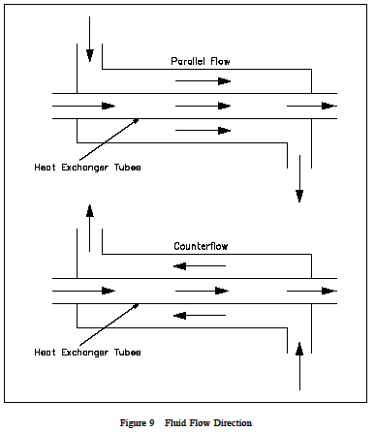
Cross-flow heat exchangers are arranged in such a fashion that the cooling fluid runs perpendicular to the hot fluid needing to be cooled. The efficiency is usually situated between Parallel and Counter flow heat exchangers, but since it is easier to situate inlet and outlet connections with small packages.
Figure 1 - Parallel and Counter Flow Directions (Engineers Edge, 2019)

Equations

3.1 Mass Water Flow Rate [Kg/s]

$$=\left(\frac{Hot water Flow\left[\frac{L}{min}\right]}{60000}\right)*Density of Water \left[\frac{Kg}{m^{3}}\right]$$
Equation 1 - Mass Flow Rate

3.2 Mass Air Flow Rate [Kg/s]

$$=\left(Orifice Discharge Coefficient*Orifice Area\left[m^{2}\right]\right)*\sqrt{\left(Pressure Drop \left[Pa\right]*2*Density of Air \left[\frac{Kg}{m^{3}}\right]\right)}$$
Equation 2 - Mass Air Flow Rate

3.3 Average Water Temperature [°C]

$$=\frac{Water Temp 1 [°C]+Water Temp 2 [°C]}{2}$$
Equation 3 - Average Water Temperature

3.4 Average Air Temperature [°C]

$$=\frac{Water Temp 1 [°C]+Water Temp 2 [°C]}{2}$$
Equation 4 - Average Air Temperature

3.5 Specific Heat Capacity of Water (At Average Temperature) [J/Kg.K]

$$=4185.5*\left(0.996185+\left(0.0002874{\left(\frac{T+100}{100}\right)}^{5.26}\right)+\left(0.011160*{10}^{-0.036*T}\right)\right)$$
Equation 5 - Specific Heat Capacity of Water

Where:
Specific heat capacity of water (CpW) at 15°C is 4185.5 [J/Kg.K].
‘T’ stands for average water temperature [°C].
All other numbers used are constants, discovered through experimentations by professionals.

3.6 Specific Heat Capacity of Air [J/Kg.K]

Specific heat capacity of air (CpA) is assumed to stay constant at 1005 [J/Kg.K].

3.7 Density of Air [Kg/m³]

$$=\frac{Ambient Pressure [Pa] }{Specific Gas Constant of Air \left[\frac{J}{Kg}.K\right]*\left(Avg Air Temp [°C]+273\right)}$$
Equation 6 - Density of Air

3.8 Density of Water [Kg/m³]

$\frac{999.839+\left(16.952*T\right)-\left(7.99{10}^{-6}*T^{2}\right)-\left(46.241{10}^{-6}*T^{3}\right)+\left(105.846{10}^{-9}*T^{4} \right)-\left(281.03{*10}^{-12}*T^{5} \right)}{1+\left(16.887{10}^{-3}*T\right)}$
Equation 7 - Density of Water
Where ‘T’ stands for average water temperature [°C].

3.9 Heat/Power Emitted by Water (QW) [W]

$$=Mass Flow Water\left[\frac{Kg}{s}\right]*Specific Heat Capacity Water\left[\frac{J}{Kg}.K\right]*Difference in Water Temp\left[°C\right]$$
Equation 8 - Heat/Power Emitted by Water

3.10 Heat/Power Emitted by Air (QA) [W]

$$=Mass Flow Air\left[\frac{Kg}{s}\right]*Specific Heat Capacity Air\left[\frac{J}{Kg}.K\right]*Difference in Air Temp\left[°C\right]$$
Equation 9 - Heat/Power Emitted by Air

3.11 Energy Balance Coefficient (C_{EB})

$$=\frac{Heat Emitted by Air \left(QA\right) \left[W\right]}{Heat Emitted by Water \left(QW\right) \left[W\right]}$$
Equation 10 - Energy Balance Coefficient

3.12 Temperature Efficiency of Water (η_{W}) [%]

$$=\frac{Water Temp 1 \left[°C\right]-Water Temp 2 \left[°C\right]}{Water Temp 1 \left[°C\right]-Air Temp 1 \left[°C\right]}*100$$
Equation 11 - Temperature Efficiency of Water

3.12 Temperature Efficiency of Air (η_{A}) [%]

$$=\frac{Air Temp 2 \left[°C\right]-Air Temp 1 \left[°C\right]}{Water Temp 1-Air Temp 1 \left[°C\right]}*100$$
Equation 12 - Temperature Efficiency of Air

3.12 Mean Temperature Efficiency (η) [%]

$$=\frac{Temperature Efficiency of Water \left[\%\right]+Temperature Efficiency of Air \left[\%\right]}{2}$$
Equation 13 - Mean Temperature Efficiency

3.13 Logarithmic Mean Temperature Difference (LMTD) [°C]

$$=\frac{\left(\left(Water Temp 2 \left[°C\right]-Air Temp 2 \left[°C\right]\right)-\left(Water Temp 1 \left[°C\right]-Air Temp 1 \left[°C\right]\right)\right)}{ln⁡(\frac{Water Temp 2 \left[°C\right]-Air Temp 2 \left[°C\right]}{\left(Water Temp 1 \left[°C\right]-Air Temp 1 \left[°C\right]\right)}}$$
Equation 14 - Logarithmic Mean Temperature Difference

3.14 Heat Transfer Coefficient (U)
$$=\frac{Heat Emitted by Water \left(QW\right) \left[W\right]}{Heat Exchanger Surface Area \left[m^{2}\right]* Logarithmic Mean Temperature Difference \left[°C\right]}$$
Equation 15 - Heat Transfer Coefficient

Methodology

3.1 Experiment 1 – The Effect of Varying Water Flow Rate
This experiment was conducted in order to find out how the behaviour, performance and overall efficiency of a heat exchanger is affected, as the flow rate of the hot water was reduced incrementally during the investigation, considering that the mass air flow stayed constant throughout.
To begin, the water tank temperature was set to 60°C using the digital thermostat, also ensuring that the flow rate of the hot water was initially set to 2.25L/min by adjusting the valve directly. The air flow through the heat exchange is required for experiment 1 to be set at a constant pressure drop of 250Pa.
It was required to allow the heat exchanger to settle accordingly for a minimum of 5 minutes before any readings were taken. This ensured that the temperatures being recorded, did not fluctuate, causing errors within the calculations.
Temperatures of both the air and water inlet and outlets were documented throughout the experiment, as the water flow rate was reduced from 2.25L/min in increments of 0.5 until the final flow rate of 0.25L/min was achieved and recorded.
Other basic information which remained constant throughout the investigation, such as; ambient air pressure, specific gas constant of air, orifice diameter, orifice discharge coefficient, as well as the heat exchanger surface area, were noted down. See below within the ‘Results’ section.
An Excel table was produced, inputting both the air and water temperatures, the water flow rate, along with the constant variables previously mentioned. From these, equations provided within the “TD1007 Water to Heat Exchanger User Guide” (TecQuipment Ltd, 2014) could be used to calculate vital information.
Using the values calculated within the table, three graphs were produced comparing the mass flow rate of water vs: the power transferred and absorbed, the efficiencies of the air and water, as well as the heat transfer coefficient. These graphs provided fundamental comparisons and characteristics which would help an individual to understand and analyse the heat exchangers performance.

3.2 Experiment 2 – The Effect of Varying Air Flow Rate
This investigation was run to assess the same performance characteristics of the heat exchanger as previously assessed, but this time, the hot water flow rate remained constant while it was the air pressure differential that was reduced at each stage.
The same process was conducted as previously done within Experiment 1. The water tank temperature was set to 60°C, while the water flow rate was set to a constant 0.25L/min by adjusting the valve. As before the air pressure drop was set to an initial 250Pa before any changes were made.
The heat exchanger was left to stabilize for a minimum of 5 minutes after the settings were adjusted before each temperature was recorded to reduce any fluctuations within the recorded data.
Both the inlet and outlet temperatures were recorded for the air and water within the system, at each interval, this time the air pressure drop was the parameter that was reduced down from 250Pa, in increments of 50 until the minimum of 50Pa was achieved.
All data was then recorded into an Excel table as before, creating graphs of the same variables to analyse the efficiency, but this time they were plotted against mass air flow instead of water.

3.3 Experiment 3 – The Effect of Varying Temperature
The purpose this third investigation is to directly compare the difference in performance and efficiency when the only variable to have changed is the temperature of the hot water.
The third procedure was undertaken using the exact same process and variables as in experiment 2, this time however, the water tank temperature was set to 45°C instead of the original 60°C.
The air pressure drop was dropped from 250Pa in the same increments until 50Pa was accomplished, recording the temperatures of the air and water inlets and outlets at each step, waiting at least 5 minutes after reducing the pressure drop to confirm the system had stabilised sufficiently.
The results were once again imputed into an Excel table, creating graphs for the heat transfer coefficient, power transmitted and absorbed, and the efficiencies, plotted against mass air flow on the x-axis for analysation.

Results

4.1 Experiment 1

4.1.1 Table of Results
Figure 2 - Experiment 1 Results Table Part 1

Figure 3 - Experiment 1 Results Table Part 2

Figure 4 - Experiment 1 Results Table Part 3

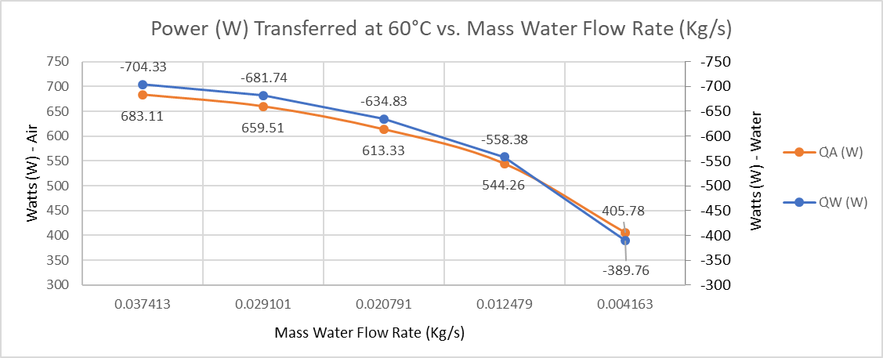
4.1.2 Graphical Results
Figure 5 - Power Transferred vs Mass Flow Water Rate
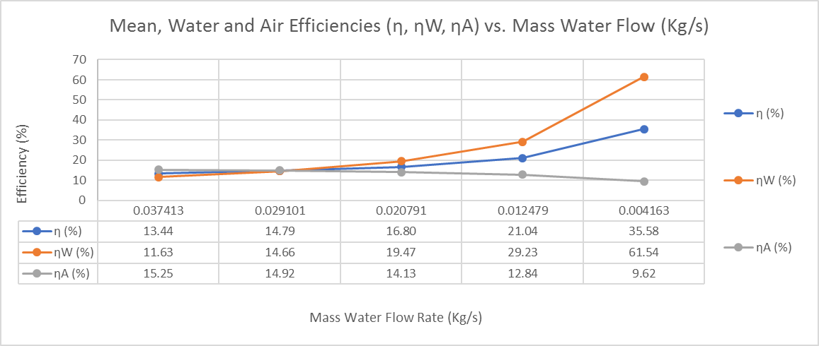
As observed from above, as the mass flow rate of water decreases so too does power transferred between the water and the air. It follows a gentle curve, where the water is higher than the air, until the final water flow rate in which a significant drop is observed, it is also at this point at which the heat absorbed by the air is higher than the heat emitted by the water. This is most likely an error within the data, because the air is only receiving its’ heat from the water, so this data point will have to be take again to verify that it is correct or not.
Figure 6 - Mean, Water and Air Efficiencies vs Mass Flow Water Rate
The graph displays the correlation between the hot water flow and the efficiencies (Air, Mean & Water). A few points of interest are shown on this graph, to begin with, the first data recorded during the highest mass water flow rate shows that the air efficiency is higher than the water. Then by the second data set, the values are nearly identical. By the third data set, the order of the values have switch so that the water efficiency is increasing as the air efficiency decreases. This trend continues until the last data set where the water efficiency increases dramatically.

It is noticed from the values of the heat transfer coefficient that as the hot water mass flow rate decreases, so too does the heat transfer coefficient. There wasn’t much of an initial drop in the values between the first and second mass water flow rates, hinting that the values have ‘plateaued’, which suggests that if the mass flow rate was increased to 2.75L/min that the value couldn’t see much of an increase in value.
Figure 7 - Heat Transfer Coefficient vs Mass Flow Water Rate

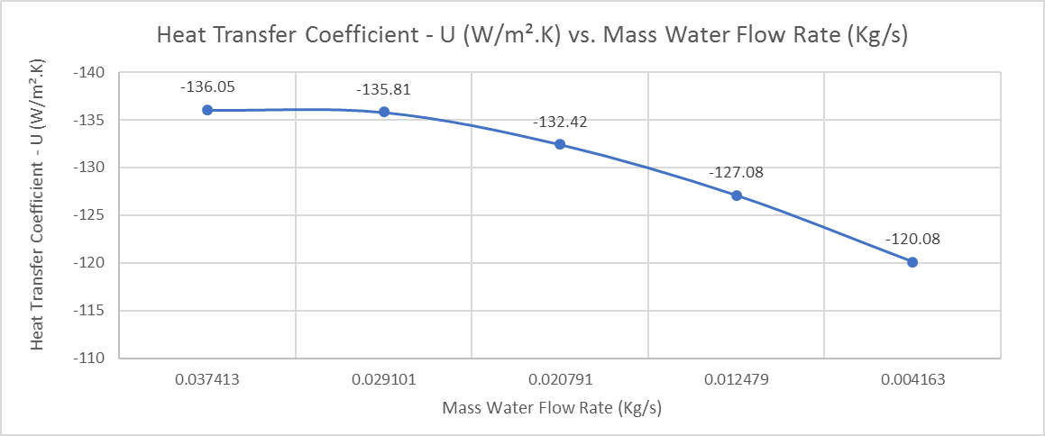

4.2 Experiment 2

4.2.1 Table of Results

Figure 8 - Experiment 2 Results Table Part 1

Figure 9 - Experiment 2 Results Table Part 2

Figure 10 - Experiment 2 Results Table Part 3

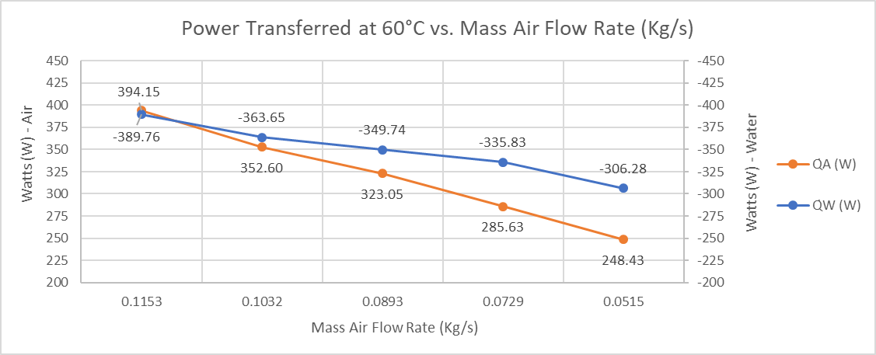
4.2.2 Graphical Results
Figure 11 - Power Transferred vs Mass Air Flow Rate
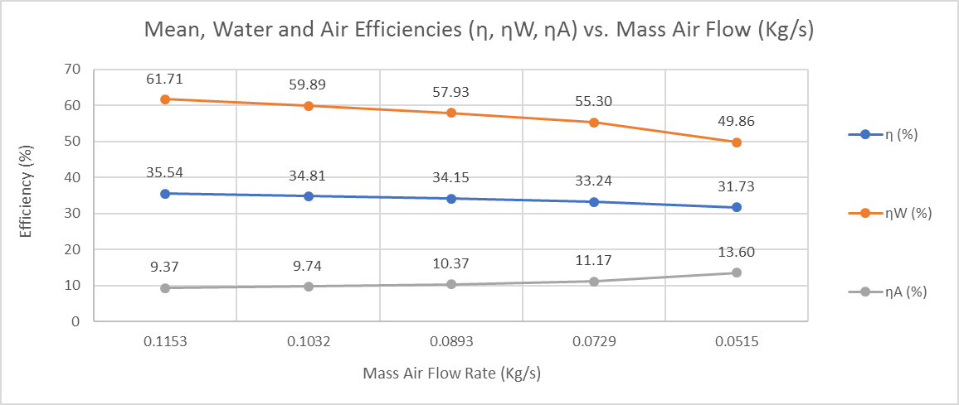
As the mass air flow decreases, so too does the power transfer between the fluids. Again with the first data point there may be an error due to the air absorbing more power than the water is emitting, leading to the validity of this experiment being I question. As the mass air flow decreases throughout the experiment, the larger the difference between the air and water power heat transfer showing that more power was lost to the surrounding environment.
Figure 12 – Mean, Water and Air Efficiencies vs Mass Air Flow Rate
The efficiencies graph provided data displaying evidence that as the mass air flow decreases, the difference between the air and water efficiencies becomes smaller, where on the last data set, that difference decreases rapidly. The mean efficiency only slightly drops overall and shows a fairly slight gradient, which without the values on each data point, could easily be mistaken for a flat line.

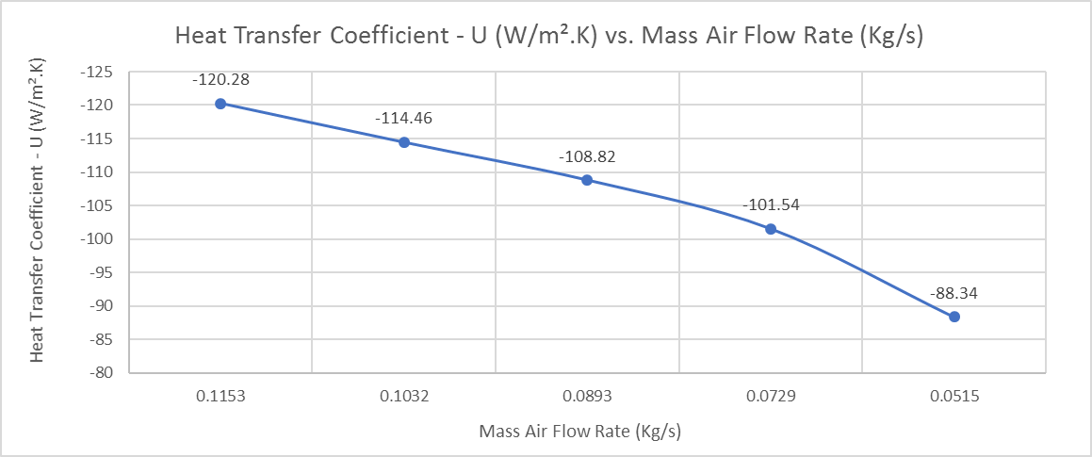
Experiment 3 provided a near linear decrease of heat transfer coefficient with the decrease in mass air flow rate. As seen by the last data point, there is a rather drastic decrease in the heat transfer coefficient compared to the previous values, which upsets the trend of the results.
Figure 13 - Heat Transfer Coefficient vs Mass Air Flow Rate

4.3 Experiment 3

4.3.1 Table of Results
Figure 14 - Experiment 3 Results Table Part 1

Figure 15 - Experiment 3 Results Table Part 2

Figure 16 - Experiment 3 Results Table Part 3

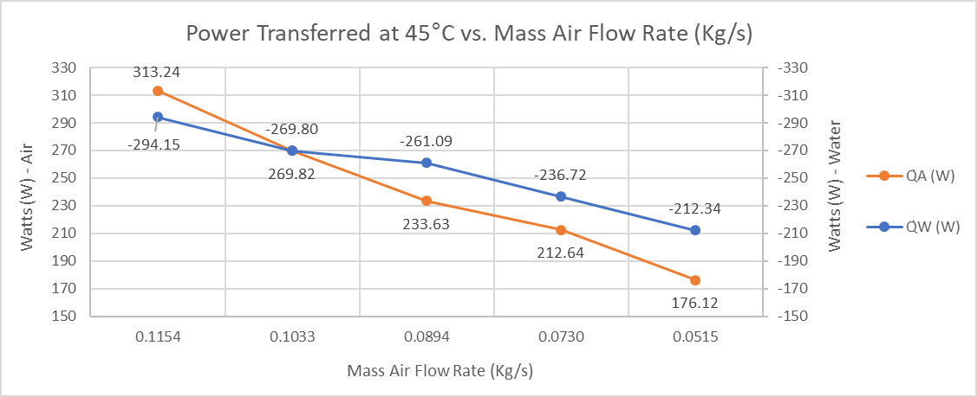
4.3.2 Graphical Results
Figure 17 - Power Transfer vs Mass Air Flow Rate
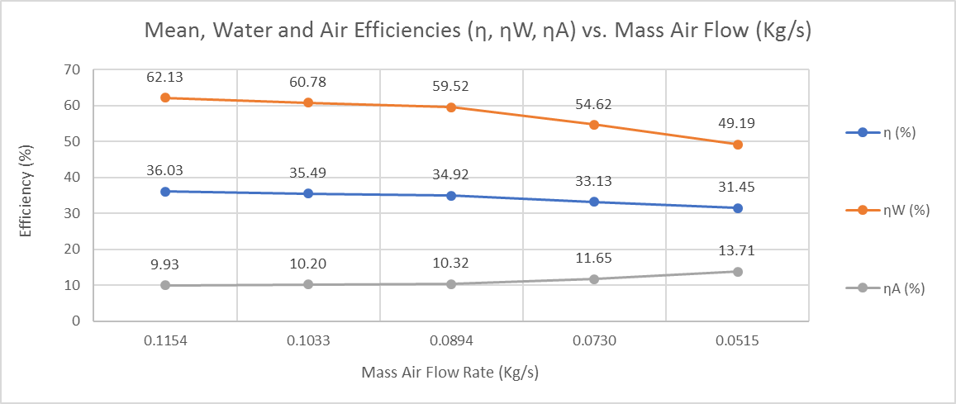
This experiment didn’t provide accurate results, it was observed that even though the thermostat was set to 45°C, the inlet water temp higher was consistently higher. This proves that the results from this experiment aren’t valid, which may be down to a faulty sensor within the system. The observed water temperatures on the inlet ranged from 47.7°C up to 49.7°C. As is shown by the graph, the results possess a skewed trend, where the heat absorbed by the air is higher than the heat emitted by the water (yet again) calling the validity of this experiment procedure into question. The second data point shows they are nearly precise but the air still possessed 0.02W more power than the water. Otherwise, the graph shows that the power transferred between the fluids have an equal and opposite relationship, where, as one decreases the other increases.
Figure 18 - Mean, Water and Air Efficiencies vs Mass Air Flow Rate
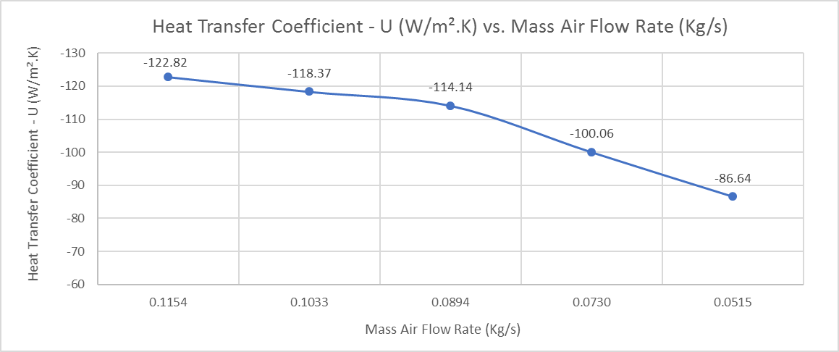
As in the previous experiment, as the mass air flow rate decreases, the difference between the efficiencies of the fluids decreases. The overall mean temperature efficiency shows a steady 0.5% decreases throughout the first 3 data sets, until a sharper descent is observed in data point 4, which coincides with the sharp decrease in the water efficiency. It provided a fairly similar graph to experiment 3, other than the value of each data point, which decreased due to the lower temperature, therefore, having less energy within the fluid’s molecules.
Figure 19 - Heat Transfer Coefficient vs Mass Air Flow Rate
The trend is a bit tricky to describe with experiment 3’s heat transfer coefficient. Data point 3 is slightly higher than would be predicted considering the other results, had this point been slightly lower, there would’ve been a gentle curved descent as the mass air flow decreased, but this has hence provided a camel’s hump.

Conclusion
It is unknown whether any of the data recorded during the three experiments was valid due to the anomalies experienced throughout the heat exchanger investigation. It may have been factors out of our control, such as a faulty sensor which may have caused adverse effects or unexplained understandings to do with thermofluid dynamics and principles.
As seen from each experiment, both the heat transfer coefficient and the power transferred values decreased relative to the decrease in the mass flow rates of both fluid, depending on which variable remained constant and which was dynamic throughout the investigations.
The trends within the heat transfer coefficient graphs are fairly similar to one another, besides the fact that the values at each data point are different they all show a steady descent, albeit with few exceptions.
Experiment 1’s power transferred graph displays a similar trend between both fluids as well as a close gap between the values. Because of this, it is incomparable to experiments 2 & 3, where they both show similar trends and a significant gap between each result. The only way you can compare the 3 graphs is that at 1 point, the air is absorbing more power than the water is emitting, this again brings into question the validity of the results.
The efficiencies of the fluids within experiment 1 proved to the group that as the water flow is decreased, the temperature efficiency of the water increased dramatically, although the air efficiency slightly dropped. Experiments 2 & 3 are more comparable to each other, the values and trends are nearly identical to each other’s, which shows the temperature difference between the two investigations has little difference or effect on fluid temperature efficiency.
Should this investigation be repeated, more due care and attention to the accuracy of the data recording would be taken. The 5 minute time difference between the data readings sometimes proved more than enough time for the heat exchanger to settle, but in others it’s apparent that more time, possibly double, was required.

References

Armfield, 2019. HEAT TRANSFER AND THERMODYNAMICS. [Online]
Available at: http://discoverarmfield.com/en/products/view/ht35/cross-flow-heat-exchanger
Brazetek, 2019. Parallel Flow Heat Exchangers. [Online]
Available at: https://www.brazetek.com/articles/112-parallel-flow-heat-exchangers
Engineers Edge, 2019. Parallel and Counter Flow Designs. [Online]
Available at: https://www.engineersedge.com/heat_transfer/parallel_counter_flow_designs.htm
iitdelhi, 2012. Classification of Heat Exchangers, Delhi: iitdelhi.
TecQuipment Ltd, 2014. TD1007 Water to Air Heat Exchanger User Guide. s.l.:TecQuipment Ltd.
Thomas, 2019. Understanding Heat Exchangers. [Online]
Available at: https://www.thomasnet.com/articles/process-equipment/understanding-heat-exchangers

